Leonard Maynard & Oliver Fleischmann

<https://github.com/lhmaynard/CS1632_Deliverable3>

CS 1632 - DELIVERABLE 3: Unit Testing

Summary: Over the course of writing these tests, our biggest challenge was our unfamiliarity with selenium. As we progressed, we became more comfortable with the language and how to do thinks like find elements on the webpage and the work progressed more smoothly. The issues we found in the page all dealt with improper handling of improper input, so we will continue to closely examine elements which deal with inputs when we test future code. In the future when we attempt more complex tests, we expect coordinating waits so all our code runs in the proper order to be our next challenge.

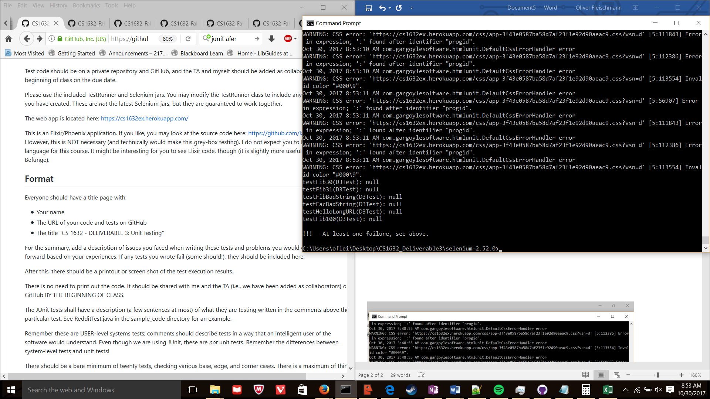

**DEFECTS:**

Summary: Hello page does not work with a very large trailing value

Description: If 525 D’s are used as a trailing value

Reproduction steps: Open Mozilla Firefox

Go to url “<https://cs1632ex.herokuapp.com/hello/>{}" where {} is replaced with 525 D’s

Expected behavior: Webpage displays “Hello CS1632, from {}!” Where {} represents 525 D’s

Observed behavior: The webpage does not render

Summary: Entering alphabet characters causes internal server error

Description: When “F” is entered into the factorial page the page displays “internal server error”

Reproduction steps: Open Mozilla Firefox

Go to url “<https://cs1632ex.herokuapp.com/fact>"

Click on text box

Type “F”

Click submit button

Expected Behavior: Page displays “Factorial of F is -1!”

Observed Behavior: Page only displays “internal server error”

Summary: Fibonacci function does not calculate results past 30

Description: When an integer higher than 30 is entered into the fibonacci page the result given is always 1

Reproduction steps: Open Mozilla Firefox

Go to url “<https://cs1632ex.herokuapp.com/fib>"

Click on text box

Type “31”

Click submit button

Expected Behavior: Page displays “Factorial of 31 is 1346269!”

Observed Behavior: Page only displays “Factorial of 31 is 1!”

|  |  |  |  |  |  |  |  |  |
| --- | --- | --- | --- | --- | --- | --- | --- | --- |
| Traceability Matrix | | | | | | | | |
| **Test\Requirement** | **1** | **2** | **3** | **4** | **5** | **6** | **7** | **8** |
| **testFib1** |  |  |  | X |  |  |  |  |
| **testFib100** |  |  |  | X |  |  |  |  |
| **testFib30** |  |  |  | X |  |  |  |  |
| **testFib31** |  |  |  | X |  |  |  |  |
| **testFibBadNeg1** |  |  |  |  | X |  |  |  |
| **testFacBadNeg1** |  |  |  |  | X |  |  |  |
| **testFibBadTooLarge** |  |  |  |  | X |  |  |  |
| **testFacBadTooLarge** |  |  |  |  | X |  |  |  |
| **testFibBadString** |  |  |  |  | X |  |  |  |
| **testFacBadString** |  |  |  |  | X |  |  |  |
| **testHelloLenny** |  |  |  |  |  |  | X |  |
| **testHelloLongURL** |  |  |  |  |  |  | X |  |
| **testWelcomeMessage** | X |  |  |  |  |  |  |  |
| **testUsedByMessage** | X |  |  |  |  |  |  |  |
| **testHomeLink** |  | X |  |  |  |  |  |  |
| **testFactorialLink** |  | X |  |  |  |  |  |  |
| **testFibonacciLink** |  | X |  |  |  |  |  |  |
| **testHelloLink** |  | X |  |  |  |  |  |  |
| **testCathedralLink** |  | X |  |  |  |  |  |  |
| **testFactorial1** |  |  | X |  |  |  |  |  |
| **testFactorial100** |  |  | X |  |  |  |  |  |
| **testFactorial50** |  |  | X |  |  |  |  |  |
| **testHelloEmpty** |  |  |  |  |  | X |  |  |
| **testCathyPage** |  |  |  |  |  |  |  | X |