Project-Report

**(Fall 2023)**

**CS-424 _A**

**Course Title:**

Parallel and Distributed Computing

**Submitted To:**

Dr. Umer Shoaib

**Submission Time and Date:**

11:45 am Jan 17, 2024

**Submitted BY:**

**(Group-11)**

Muhammad Nauman **(20021519-090)**

Muhammad Fahad  **(20021519-109)**

**BS-Computer Science 7th Semester**



**Faculty of Computing and Information Technology**

**Table of Contents**

1. Introduction:- 1

2. Neural Networks:- 1

3. Dataset:- 2

4. Parallelism:- 2

4. Message Passing Interface:- 3

5. Experiments:- 4

6. Results:- 4

7. Conclusion:- 4

# 1. Introduction:-

In the last few years, the field of Machine Learning has grown exponentially and has produced some state of the art results in computer vision and natural language processing etc. area. The part of this progress comes from deep neural network based models, also called deep learning/ deep neural nets.

Deep learning models are very powerful because of their ability to learn a high and low-level representation of the data (image, voice, language, etc.), but this comes at cost of large training time and mind-boggling compute require- ment. This is primarily because any deep learning model is grounded in learning parameters over the entire parameter space hundreds of times. And, this process is nothing but large matrix multiplication operations. Computing these large matrices takes a lot of time and power. This project explores a basic parallel deep neural network models and applies them over Fashion MNSIT dataset. I have developed two version of this model using Python – sequential and parallel version.

# 2. Neural Networks:-

Neural networks are computing systems that are loosely inspired by biological neurons. They are the building blocks of Deep learning models. In the last

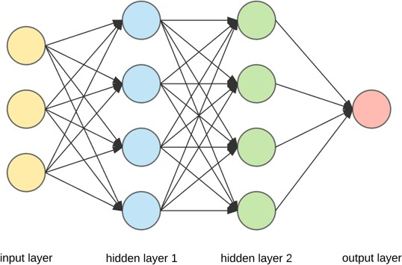

Figure 1: Neural Network with 2-hidden layers

decade or so, they have completely revolutionized the machine learning. Intu- itively, neural networks are the nothing but the nonlinear function, which passes non-linearity to the output as input propagates through them. Any neural net- work is consist of multiple layers, in which all the layers can have a different number of neural units. When these layers are stacked on top of each other, increasing the depth of the model thus we call them deep neural nets. All these layers are connected to the previous/ next layer through weights.

Each layer learns some high/ low-level representation of the data. Thus, by adding more layers we can learn more abstraction of the data and thus leading to better performance. But, adding more layers increases the complexity of the model and thus leads to high compute time and power.

Neural networks are computationally intensive because they need to update millions of parameters numerous times in order to minimize error and produce an accurate model. Those updates are basically nothing but large matrix mul- tiplication operations. The only way to train neural networks on very large datasets is to give them lots of time, lots of cores, or both.

# 3. Dataset:-

The Fashion-MNIST is a dataset of Zalando’s articles images – consisting of a training set of 60,000 examples and a test set of 10,000 examples. Each example is 28X28 grayscale image, associated with a label from 10 classes.

|  |  |
| --- | --- |
| Target Class | Definition |
| 0 | T-shirt |
| 1 | Trouser |
| 2 | Pullover |
| 3 | Dress |
| 4 | Coat |
| 5 | Sandal |
| 6 | Shirt |
| 7 | Sneaker |
| 8 | Bag |
| 9 | Ankle Boot |

The dataset was divided into 3 parts – training set, validation set, and testing set. All the different versions of different models were trained on training data first and then evaluated using the validation set. Only the best models were used to test the testing data set.

# 4. Parallelism:-

Neural networks based models can be parallelized in two ways: Model-based parallelism and Data-based parallelism. We have specifically focused on data- based parallelism method.

**Data Parallelism:**

Data parallelism is basically when you use the same model for every thread, but feed it with different parts of the data and model parallelism is when you use the same data for every thread, but split the model among threads. For neural networks, this means that data parallelism uses the same weights and but different mini-batches in each thread and the gradients need to be synchronized,

i.e. averaged, after each pass through a mini-batch.

**Model Parallelism:**

Model parallelism splits the weights of the net equally among the threads and all threads work on a single mini-batch; here the generated output after each layer needs to be synchronized, i.e. stacked, to provide the input to the next layer.

Parallelizing the neural network in this way (either of the methods) can significantly reduce the training time for the model I have used MPI to implement data parallelism. The core concept is to split the input dataset, distribute the subsets to the work nodes, and collect the results.

# 4. Message Passing Interface:-

MPI is a specification for the developers and users of message passing libraries

By itself, it is NOT a library - but rather the specification of what such a library should be.

MPI primarily addresses the message-passing parallel programming model: data is moved from the address space of one process to that of another process through cooperative operations on each process.

MPI standard provides many operations that can be used to distribute the workload/ task parallelly among different processes in the same machine or in a cluster. Some of the operations that I have used in this project are: broadcast, scatter and gather. I have specifically used MPI for Python package (mpi4py) to execute above mentioned MPI operation in my model.

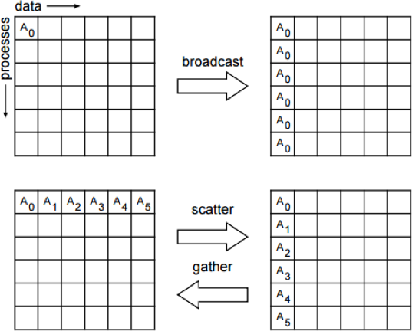

Figure 3: Some of MPI collective functions

To distribute dataset to worknodes (Scatter) in mpi4py. The scatter function splits a dataset into several subsets and makes the subsets evenly distributed to a group of processes. To collect training results of worknodes (Gather) in mpi4py. the gather function does the opposite, collects data from a group of processes, and reassembles the collected data into a complete dataset. To syn- chronize the weights of neural network among worknodes (Bcast) using mpi4py. The broadcast function helps a process share information with the other pro- cesses. All the processes will get a copy of the data assigned by the broadcast function.

# 5. Experiments:-

In order to measure speed up, we have tried different experiments with different models on different hardware CPU. We have trained our parallel and sequential neural network models on CPU.

* Data parallelism vs Sequential execution: with CPU

Any typical neural network model typically comprises of many parameters which needs to be optimized. We have tried various combinations of parameters and have reported just the one that worked best for our model.

The parameters of the learning algorithm:

* Learning rate: 0.01
* Gradient descent iteration: 60
* Activation function: sigmoid

# 6. Results:-

Figure below show the results of data parallelism performance comparison be- tween sequential and parallel models.

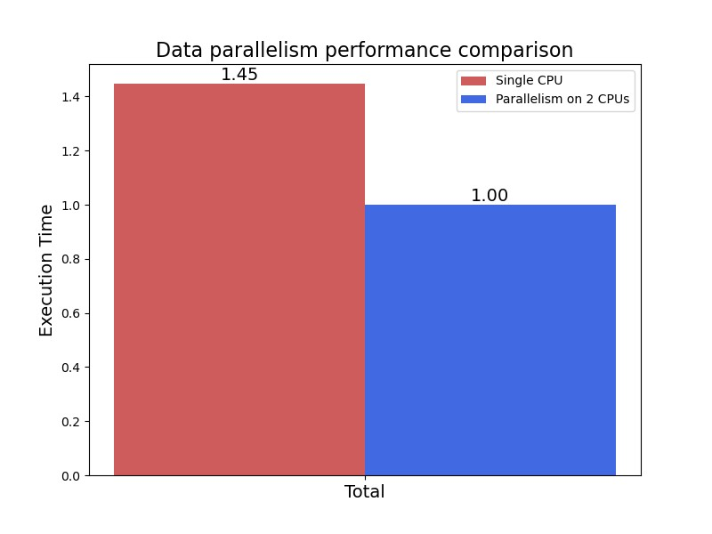

Figure 4: Data parallelism performance comparison

# 7. Conclusion:-

Among all experiments, parallel model is getting more speedup as compared to sequential model. On CPU based computing, we are getting nearly 50% speedup and on GPU based computing we are getting more than 50% speedup. This is in line with what is expected when you distribute your workload and parallelize your learning/ training process.

I believe we can achieve more speed up if we use large dataset and or have a more complex/ deep model.