FINAL PROJECT REPORT – WEEK 4
Comprehensive Data Analysis, Reporting and Presentation using R
Integrated Titanic Dataset Analysis | Weeks 1–4
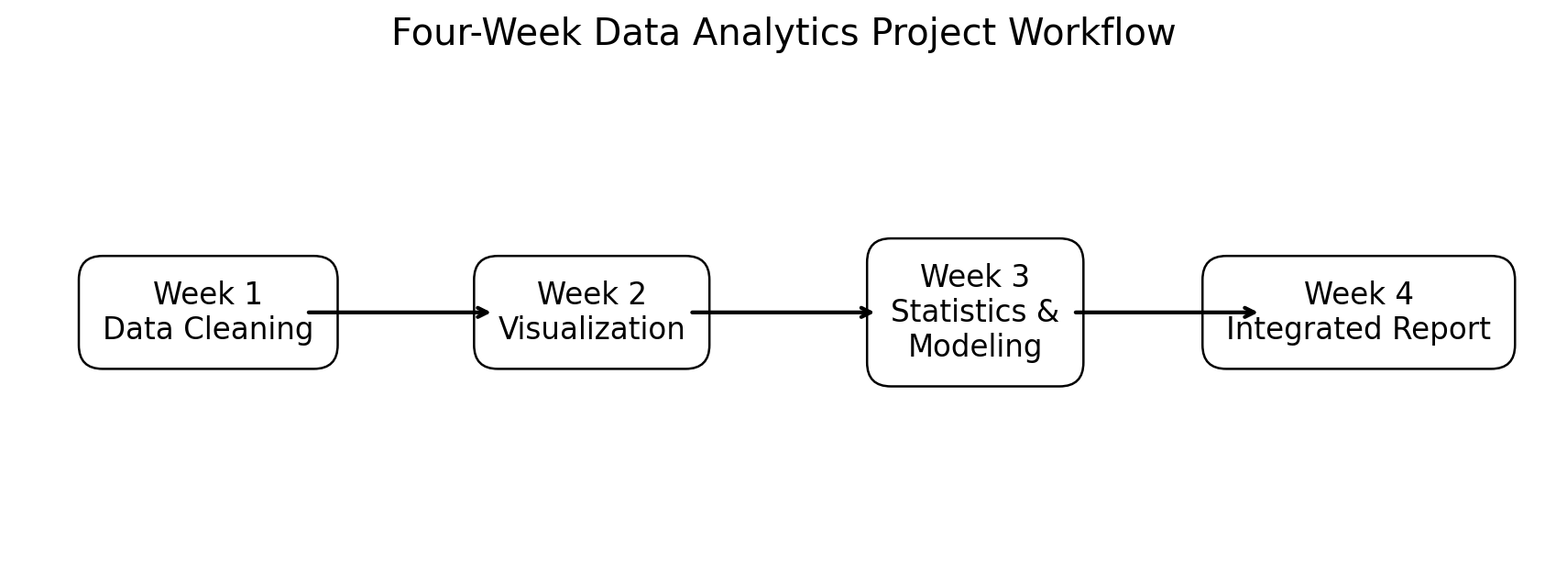

1. Executive Summary
This final report consolidates four weeks of data-analysis work into a single end-to-end project. The analysis uses the Titanic passenger dataset to demonstrate data preparation, exploratory visualization, statistical inference, and predictive modeling in R. The project begins with raw data inspection and cleaning, progresses to visual communication of patterns, and concludes with hypothesis testing and a logistic regression model evaluated using stratified 5-fold cross-validation. The integrated approach demonstrates how different analytical methods complement one another: cleaning improves data quality, visualization reveals patterns, statistical tests quantify evidence, and predictive modeling evaluates whether the observed variables can support outcome prediction.

2. Introduction
A data-driven workflow is most effective when analysis is treated as a connected process rather than a collection of isolated charts or statistical tests. This project therefore integrates the work completed in Weeks 1–3. The Titanic dataset was retained across all weeks to maintain consistency and to demonstrate progression from data quality management to insight communication and predictive analysis.
The dataset contains 891 passenger observations and <docx.text.paragraph.Paragraph object at 0x7fd7f2602a40> variables. The main outcome is passenger survival, represented by a binary variable. Predictor variables include passenger class, sex, age, family-related counts, fare, and embarkation port.

3. Dataset and Analytical Questions
The dataset was selected because it combines numerical and categorical variables, includes missing values, and contains a binary outcome that is appropriate for classification. The project addresses four broad questions: (1) How can the raw data be cleaned and prepared? (2) What patterns and relationships can be communicated visually? (3) Which relationships are statistically supported? and (4) How well can passenger characteristics predict survival?

4. Methodology Overview
- Week 1 – Data cleaning: structure inspection, missing-value assessment, imputation, duplicate checking, outlier analysis, normalization and categorical encoding.
- Week 2 – Visualization: bar charts, scatter plots, histograms, line charts, boxplots and stacked/grouped comparisons using R visualization tools.
- Week 3 – Statistical analysis: hypothesis tests, normality assessment, correlation analysis and logistic regression with stratified 5-fold cross-validation.
- Week 4 – Integration: synthesis of methods and findings into a coherent report with interpretation, limitations, implications and future directions.

5. Data Preparation and Cleaning
The first stage involved examining variable types, dimensions, summary statistics and missingness. Missing values were not treated as ordinary observations; numerical missing values were handled using median-based imputation in the modeling workflow, while categorical missing values were handled using the most frequent category. This approach preserves observations while reducing the influence of extreme values on imputation.
Missing-value counts in the raw dataset include Age = 177, Cabin = 687, and Embarked = 2. The cleaning stage also included duplicate checks, IQR-based outlier detection, numerical standardization, and categorical encoding.

6. Exploratory Visualization and Insights
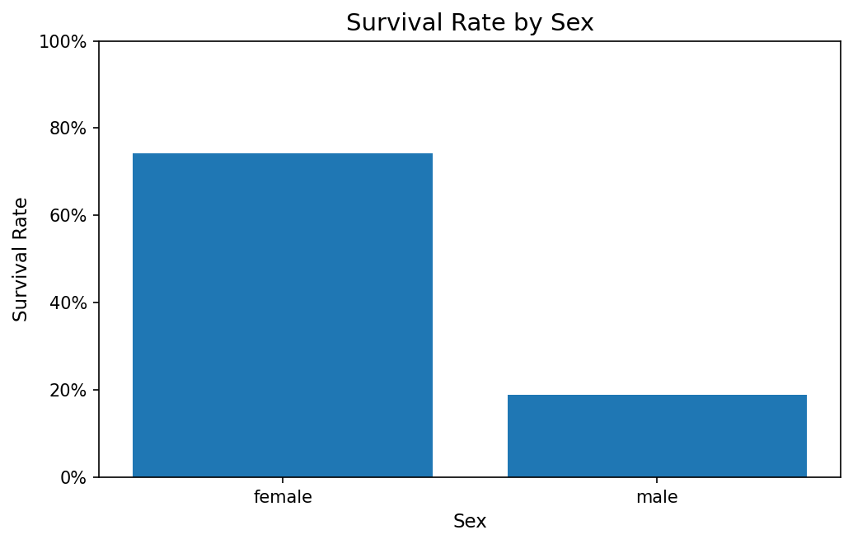
Survival by Sex: This comparison shows a substantial difference in survival proportions between the passenger sex groups, motivating the formal chi-square test in Week 3.
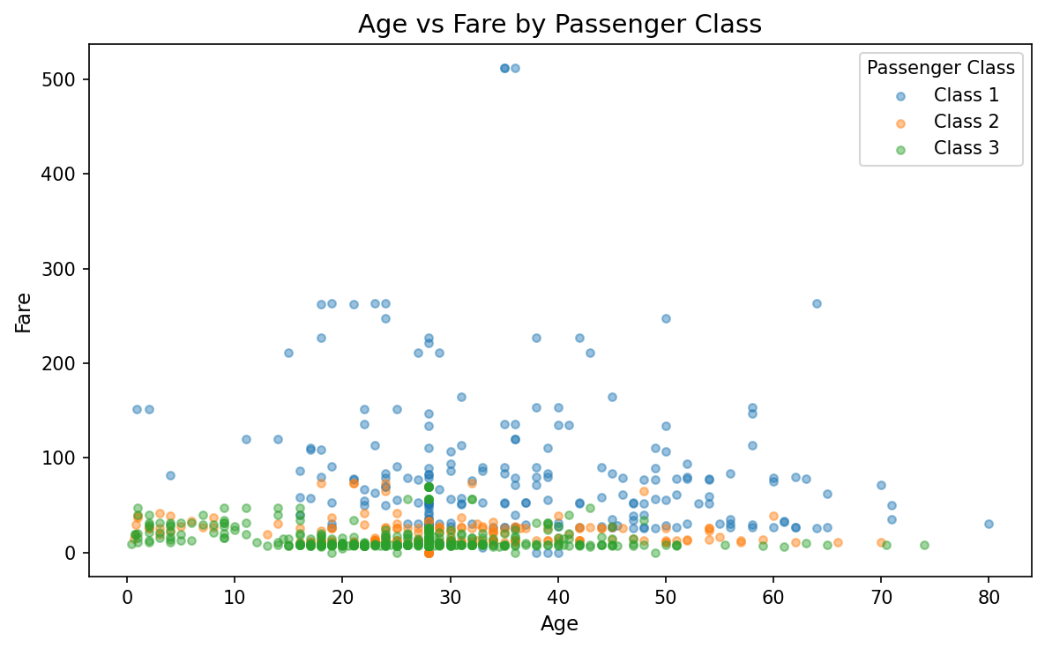
Age and Fare Relationship: The scatter plot is useful for checking whether age and fare move together and for identifying unusual combinations or weak patterns.
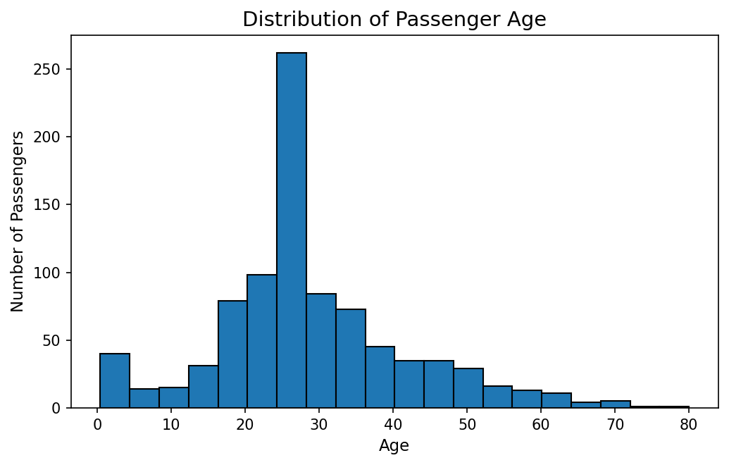
Age Distribution: The histogram shows the shape and spread of passenger ages and supports the need to check normality rather than assuming a normal distribution.
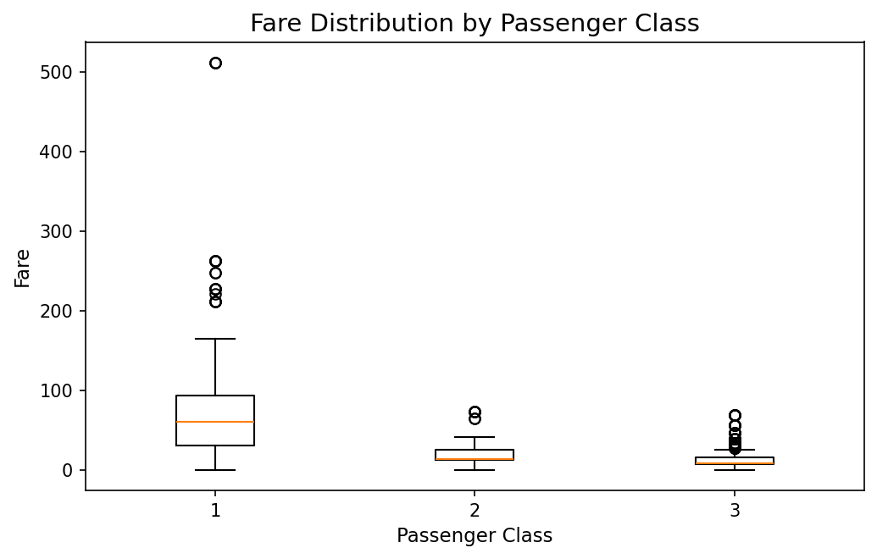
Fare by Passenger Class: The boxplot compares fare distributions across passenger classes and helps reveal differences in central tendency and variability.
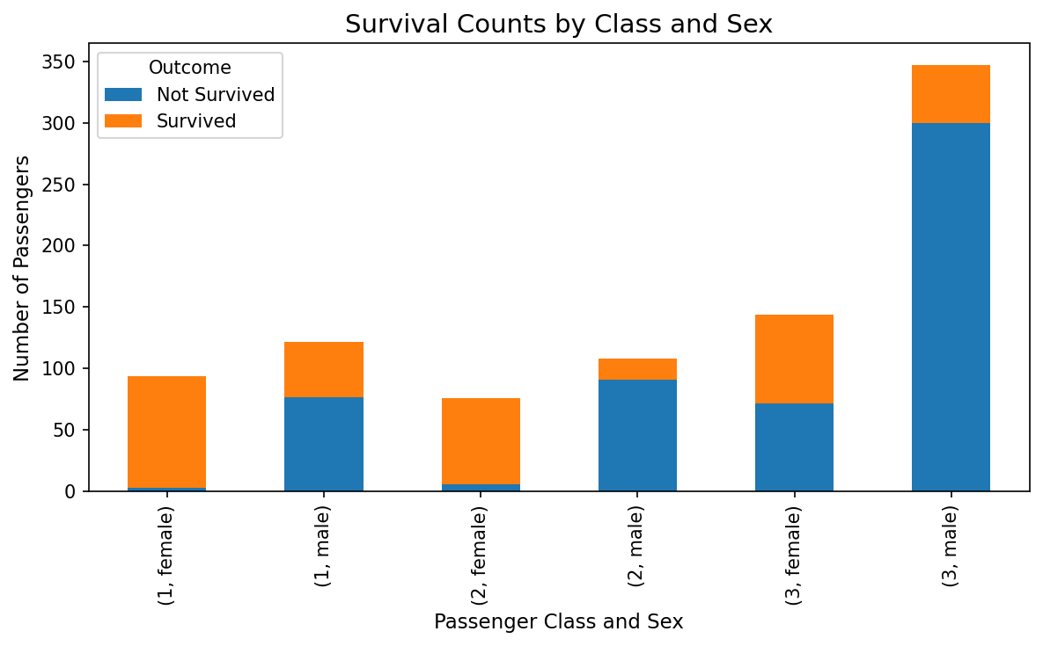
Survival by Class and Sex: This grouped comparison combines two categorical dimensions and helps communicate how survival outcomes vary across passenger groups.

7. Statistical Analysis
The project used hypothesis testing to move from visual patterns to quantitative evidence. A chi-square test examined the association between sex and survival. A Welch two-sample t-test compared average age between survivors and non-survivors. The Shapiro-Wilk test was used to examine age normality, while Pearson and Spearman correlations examined the association between age and fare.
The results support the conclusion that sex and survival are statistically associated in this dataset, and the mean age differs between survivors and non-survivors. The correlation analysis indicates that age and fare have only a limited association. Statistical significance is interpreted as evidence of association within the analyzed sample, not as proof of causation.

8. Predictive Modeling
Logistic regression was selected because survival is a binary outcome. The model uses passenger class, sex, age, family counts, fare, and embarkation port as predictors. Numerical preprocessing includes imputation, centering and scaling, while categorical predictors are encoded. Stratified 5-fold cross-validation was used to evaluate generalization while maintaining a similar class distribution across folds.
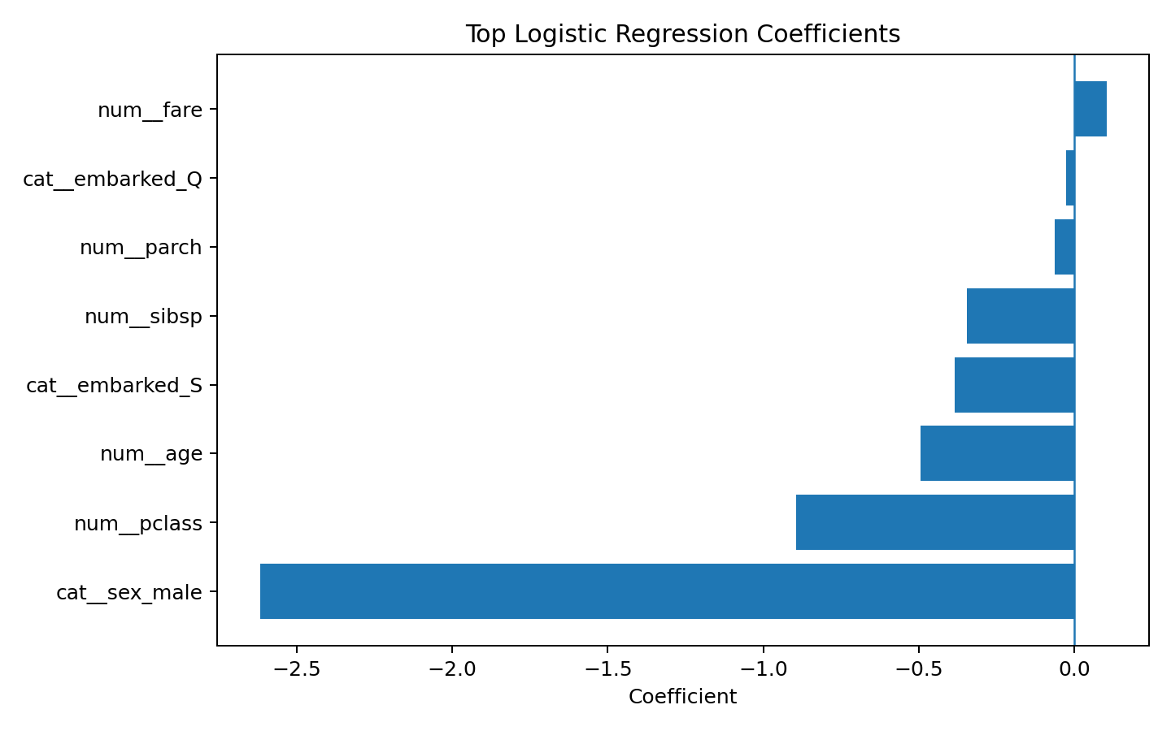
The coefficient plot provides an interpretable view of which predictors have the strongest positive or negative association with the modeled survival log-odds. Coefficients should be interpreted as conditional associations rather than causal effects.

9. Model Performance
Metric | 5-Fold CV Result
Accuracy | 0.792
Precision | 0.740
Recall | 0.708
F1 Score | 0.723
ROC-AUC | 0.851
The logistic regression achieved accuracy of 0.792 and ROC-AUC of 0.851. Precision, recall and F1 provide additional information about classification errors. Using several metrics is important because accuracy alone can hide differences between false-positive and false-negative errors.
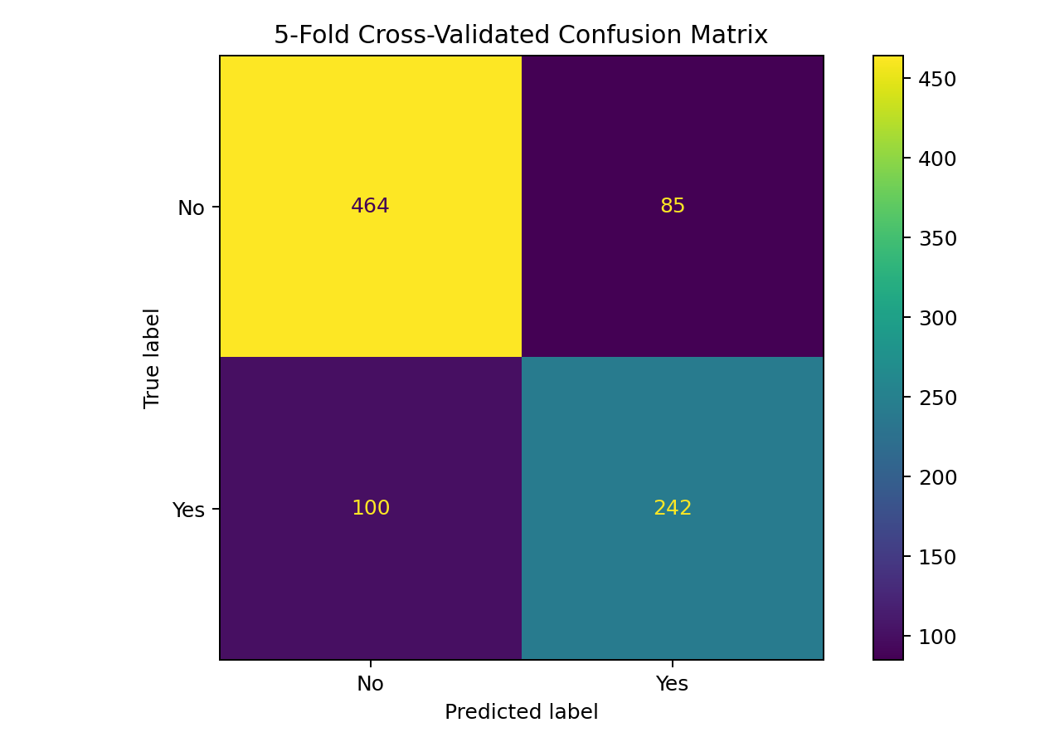
The confusion matrix shows the counts of correct and incorrect predictions for each class.
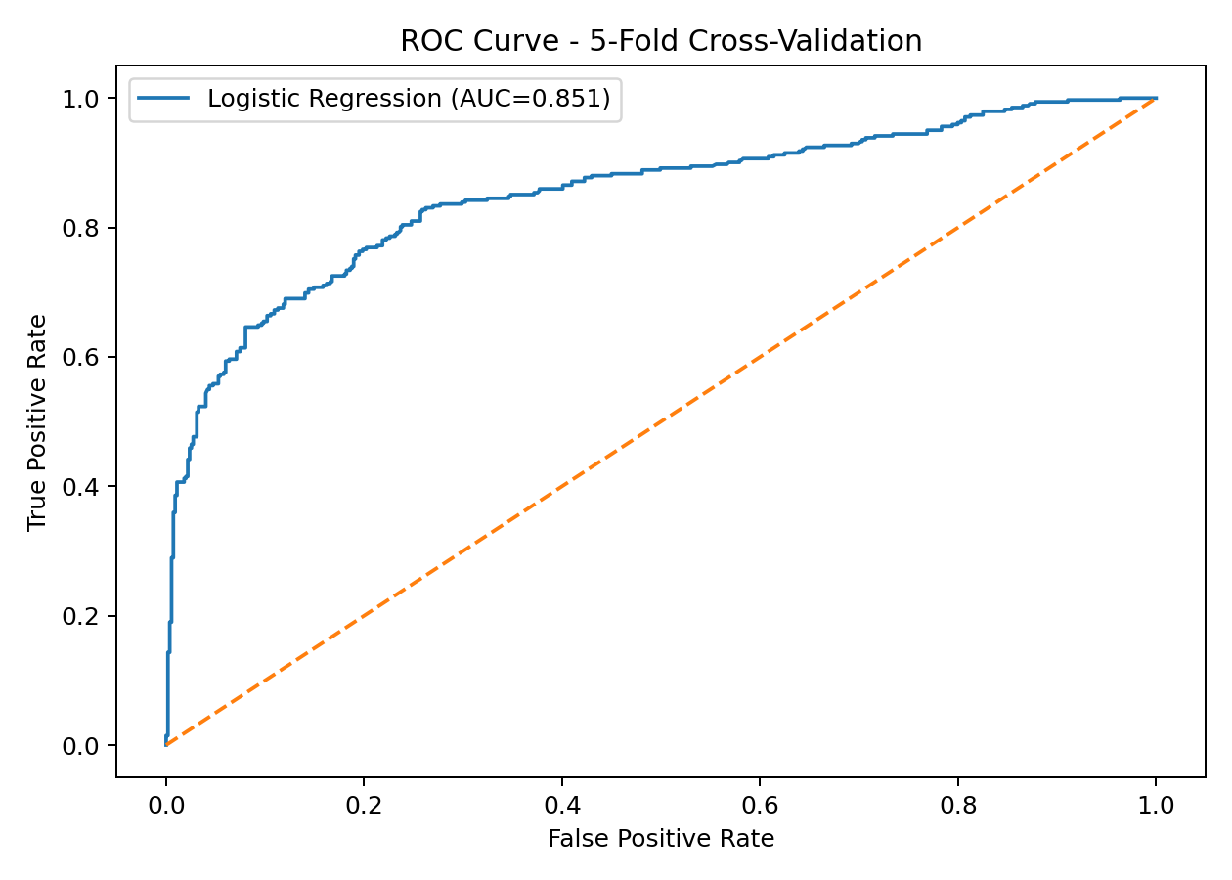
The ROC curve summarizes discrimination across thresholds. The reported AUC indicates the model's ability to rank likely survivors above non-survivors.

10. Key Integrated Findings
- Data quality is a critical first step: missing values and variable types must be handled before reliable modeling.
- Visual analysis can reveal group differences that can then be tested statistically.
- Sex and passenger characteristics show meaningful associations with survival in this historical dataset.
- Logistic regression provides an interpretable baseline and demonstrates that multiple passenger characteristics can jointly support survival prediction.
- Cross-validation gives a more robust performance estimate than relying on a single arbitrary train/test split.
- No single metric is sufficient; accuracy, precision, recall, F1 and ROC-AUC should be considered together.

11. Business and Practical Implications
Although the Titanic dataset is historical and should not be used to make modern operational decisions, it provides a useful demonstration of how organizations can move from raw data to evidence-based analysis. In a real business setting, the same workflow could be applied to customer churn, quality inspection, equipment failure, fraud detection, or demand prediction. Data cleaning would establish reliable inputs, visualization would support communication with stakeholders, statistical testing would quantify relationships, and predictive models would support forward-looking decisions. Importantly, model outputs should be interpreted within the business context and validated against current data.

12. Challenges Encountered
- Handling missing values without unnecessarily discarding observations.
- Selecting visualizations that communicate insights clearly to non-technical audiences.
- Checking statistical assumptions before interpreting test results.
- Preventing preprocessing leakage during model validation.
- Balancing model performance with interpretability.
- Maintaining reproducibility across multiple weeks of analysis.

13. Lessons Learned
The project demonstrates that effective data analysis is iterative. Cleaning decisions influence visualization, visualization informs statistical questions, and statistical findings provide context for predictive modeling. Another key lesson is that model performance should be evaluated using multiple metrics and validation procedures rather than a single accuracy number. Finally, clear documentation is essential because a technically correct analysis has limited value if its assumptions, methods and conclusions cannot be understood by its audience.

14. Limitations
- The Titanic dataset is historical and relatively small.
- The dataset contains variables that may not capture all factors influencing survival.
- Logistic regression may not capture nonlinear relationships or complex interactions.
- Statistical association does not establish causation.
- Cross-validation performance on this dataset should not be interpreted as a guarantee of performance on a different population.

15. Future Directions
- Engineer additional variables such as family size, passenger title and fare per person.
- Compare logistic regression with random forest, gradient boosting and other classification methods.
- Use repeated or nested cross-validation for more robust model selection.
- Evaluate probability calibration and optimize the classification threshold according to the cost of errors.
- Create an interactive R Shiny dashboard for non-technical stakeholders.
- Apply the complete workflow to a current business dataset to assess real-world impact.

16. Conclusion
This final report integrates the four-week project into a complete data-analysis pipeline. The work progressed from data cleaning and preprocessing to visualization, statistical inference, and predictive modeling. The analysis demonstrates how each stage contributes a different form of evidence: cleaning improves reliability, visualizations communicate patterns, statistical tests quantify associations, and predictive modeling evaluates the ability of selected variables to classify outcomes. The logistic regression model achieved a cross-validated ROC-AUC of 0.851 and accuracy of 0.792, providing an interpretable baseline. The project also highlights the importance of validation, transparent assumptions, clear communication, and acknowledging limitations. The resulting workflow is reproducible and can be adapted to more complex real-world datasets and predictive tasks.

17. Reproducibility and Project Files
The GitHub-ready project contains the final Word report, Titanic dataset, integrated R script, supporting scripts from Weeks 1–3, visual outputs, model metrics, diagnostic charts, workflow screenshots and README documentation. The integrated R script provides a single entry point for reproducing the major analysis stages.

