**Phase 4 (Development Part 2**)

**Dataset :** [**https://www.kaggle.com/datasets/ksabishek/product-sales-data**](https://www.kaggle.com/datasets/ksabishek/product-sales-data)

**1.Continue building the analysis by creating visualizations using IBM Cognos and generating actionable insights.**

**2.Use IBM Cognos to design interactive dashboards and reports that display insights such as top-selling products, sales trends, and customer preferences.**

**3.Derive insights from the visualizations, such as identifying products with the highest sales, peak sales periods, and customer preferences for specific products.**

***Highest Sales:***

+Bar Chart

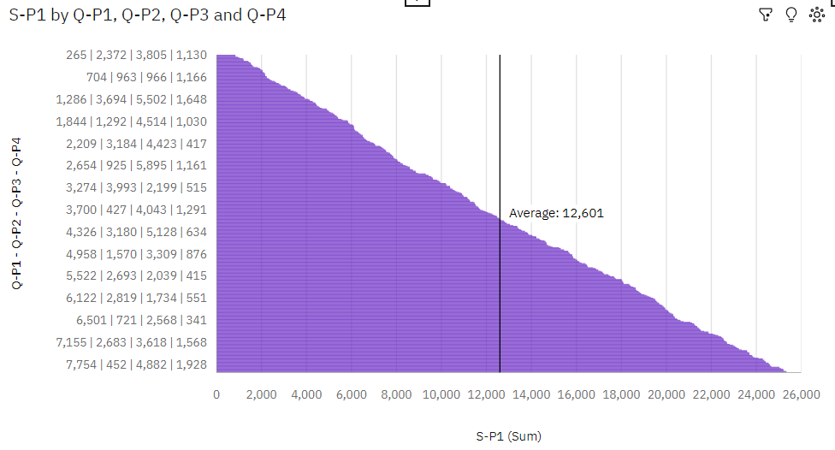

**Insights:**

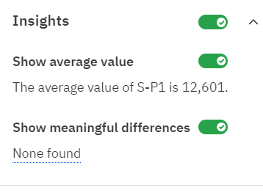

* Q-P4 1142 has the highest total S-P1 due to Q-P1 7759.
* Q-P1 6404 has the highest Total S-P4 but is ranked #3 in Total S-P1.
* Q-P3 579 has the highest Total S-P4 but is ranked #2 in Total S-P1.
* Q-P1 6404 has the highest Total S-P4 but is ranked #3 in Total S-P1.
* Q-P3 579 has the highest Total S-P4 but is ranked #2 in Total S-P1.
* Q-P2 3267 has the highest Total S-P1 but is ranked #2 in Total S-P4.
* Q-P3 1834 has the highest Total S-P1 but is ranked #2 in Total S-P4.
* Q-P1 7681 has the highest Total S-P1 but is ranked #38 in Total S-P4.
* Q-P2 1574 has the highest Total S-P4 but is ranked #8 in Total S-P1.
* Q-P4 1851 has the highest Total S-P4 but is ranked #9 in Total S-P1.
* 7681 S-P1 at nearly 49 thousand is 73% higher than the S-P4 of over 13 thousand.
* 3267 S-P1 at almost 54 thousand is 46% higher than the S-P4 of over 29 thousand.
* 1834 S-P1 at over 48 thousand is 41% higher than the S-P4 of over 28 thousand.
* 1142 S-P1 at over 59 thousand is 59% higher than the S-P4 of over 24 thousand.
* S-P1 and S-P4 diverged the most when Q-P1 is 7681, and when S-P1 was over 35 thousand higher than the S-P4.
* S-P1 and S-P4 diverged the most when Q-P2 is 1241, and when S-P1 was over 32 thousand higher than the S-P4.
* S-P1 and S-P4 diverged the most when Q-P3 is 1226, and when S-P1 was almost 24 thousand higher than the S-P4.
* S-P1 and S-P4 diverged the most when Q-P4 is 551, and when S-P1 was over 45 thousand higher than the S-P4.
* Q-P1 7681 has the highest S-P1 at nearly 49 thousand, out of which Q-P4 742 contributed the most at over 24 thousand.
* 1165 has a S-P1 of over 25 thousand for Q-P1 7994.
* S-P1 ranges from 840, when Q-P1 - Q-P2 - Q-P3 - Q-P4 is 265|2372|3805|1130, to over 25 thousand, when Q-P1 - Q-P2 - Q-P3 - Q-P4 is 7994|3128|1262|1165.
* For S-P1, the most significant values of Q-P1 - Q-P2 - Q-P3 - Q-P4 are 7994|3128|1262|1165, 7982|401|1226|251, 7951|2658|5246|1989, 7950|495|1195|908, and 7948|560|387|1850, whose respective S-P1 values add up to over 126 thousand, or 2.2 % of the total.

***Peak Sale Periods****:*

+Line

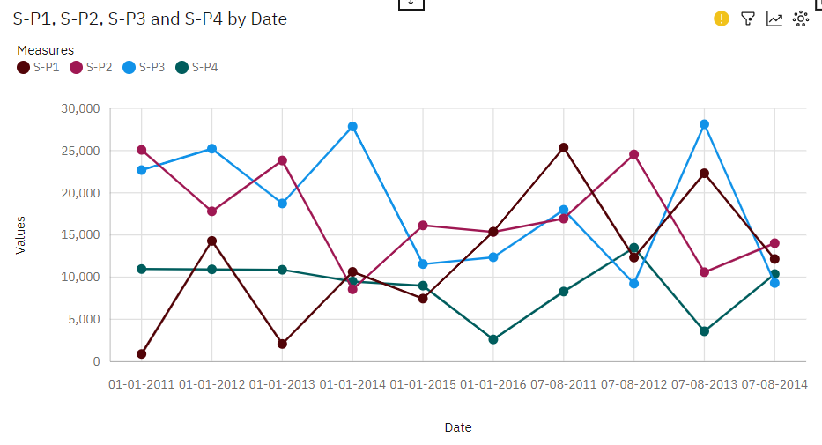

**Insights:**

* S-P1 ranges from 890.8, when Date is 01-01-2011, to over 25 thousand, when Date is 07-08-2011.
* S-P2 ranges from over 8500, when Date is 01-01-2014, to over 25 thousand, when Date is 01-01-2011.
* S-P3 ranges from over nine thousand, when Date is 07-08-2012, to over 28 thousand, when Date is 07-08-2013.
* S-P4 ranges from over 2500, when Date is 01-01-2016, to over 13 thousand, when Date is 07-08-2012.
* The total number of results for S-P1, across all dates, is 10.
* The total number of results for S-P2, across all dates, is 10.
* The total number of results for S-P3, across all dates, is 10.
* The total number of results for S-P4, across all dates, is 10
* Across all dates, the average of S-P1 is over twelve thousand.
* Across all dates, the average of S-P2 is over seventeen thousand.
* Across all dates, the average of S-P3 is over eighteen thousand.
* Over all dates, the average of S-P4 is nearly nine thousand.

***Customer Perferences :***

+Stacked bar chart

* A stacked bar chart representing customer preferences that can help us to visualize how different product units are preferred by customers. Here's an explanation of what it might look like:
* **X-Axis**: The X-axis of the stacked bar chart represents different time periods or categories. For example, it could represent dates or specific time intervals.
* **Y-Axis**: The Y-axis represents the total revenue or the number of units sold. It shows the quantitative value being measured.
* **Stacked Bars**: The chart consists of stacked bars, each representing a specific time period (e.g., date) on the X-axis. Each bar is divided into segments, with each segment representing a different product unit (unit1, unit2, unit3, unit4)**.**
* **Color-Coding**: Each segment within a stacked bar is color-coded to differentiate the product units. Customers' preferences for specific units are visualized by the distribution of colors within each bar.

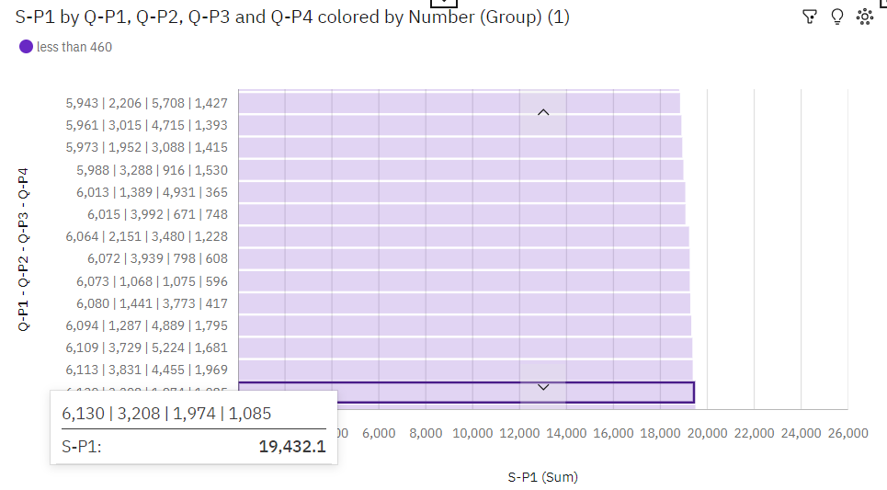

**Insights:**

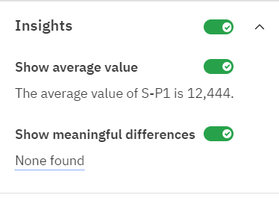

* Q-P4 1168 has the highest total S-P1 due to Q-P1 7024.
* 7910 S-P1 at over 50 thousand is 76% higher than the S-P4 of nearly 12 thousand.
* 1773 S-P1 at over 49 thousand is 56% higher than the S-P4 of almost 22 thousand.
* 671 S-P1 at nearly 44 thousand is 76% higher than the S-P4 of nearly 11 thousand.
* 1168 S-P1 at over 47 thousand is 47% higher than the S-P4 of almost 25 thousand.
* S-P1 and S-P4 diverged the most when Q-P1 is 7826, and when S-P1 was almost 43 thousand higher than the S-P4.
* S-P1 and S-P4 diverged the most when Q-P2 is 1773, and when S-P1 was almost 28 thousand higher than the S-P4.
* S-P1 and S-P4 diverged the most when Q-P3 is 671, and when S-P1 was over 33 thousand higher than the S-P4.
* S-P1 and S-P4 diverged the most when Q-P4 is 395, and when S-P1 was over 38 thousand higher than the S-P4.
* Q-P3 671 has the highest Total S-P1 but is ranked #152 in Total S-P4.
* Q-P4 1682 has the highest Total S-P4 but is ranked #121 in Total S-P1.
* Q-P1 2898 has the highest Total S-P4 but is ranked #119 in Total S-P1.
* Q-P1 7910 has the highest Total S-P1 but is ranked #83 in Total S-P4.
* Q-P4 1168 has the highest Total S-P1 but is ranked #10 in Total S-P4.
* Q-P2 3855 has the highest Total S-P4 but is ranked #7 in Total S-P1.
* Q-P2 1773 has the highest Total S-P1 but is ranked #6 in Total S-P4.
* Q-P1 7910 has the highest S-P1 at over 50 thousand, out of which Q-P4 306 contributed the most at over 25 thousand.
* Q-P3 3646 has the highest Total S-P4 but is ranked #4 in Total S-P1.
* 1163 has a S-P1 of over 25 thousand for Q-P1 7996.
* Across all values of Q-P1 - Q-P2 - Q-P3 - Q-P4, the sum of S-P1 is over 5.7 million.
* S-P1 ranges from 890.8, when Q-P1 - Q-P2 - Q-P3 - Q-P4 is 281|3956|4186|1537, to over 25 thousand, when Q-P1 - Q-P2 - Q-P3 - Q-P4 is 7996|2672|3317|1163.