KPR INSTITUTE OF ENGINEERING AND TECHNOLOGY
Department of Artificial Intelligence and Data Science
ASSIGNMENT II — CASE STUDY REPORT
Exploratory Data Analysis and Visualization
of Apple Inc. (AAPL) Stock Prices
with LSTM Forecasting
Course: Exploratory Data Analysis and Visualization
Course Code: U21ADP05
Academic Year: 2026–2027 (Odd Semester)
Batch: 2023–2027 | Year/Semester: V
Submitted by
Balaji
Roll Number: 24AD016
Submission Date: 15.10.2026

Abstract
This case study explores five years of Apple Inc. (AAPL) daily market data and evaluates whether a Long Short-Term Memory (LSTM) network improves one-day-ahead closing-price forecasts. The notebook retrieves 1,254 observations with five raw OHLCV fields—open, high, low, close and volume—through yfinance, engineers 18 technical indicators, and retains 1,234 rows after rolling-window and lag features are formed. Exploratory analysis includes distribution, outlier, correlation, volatility and momentum visualizations, alongside normality and stationarity tests. A two-layer LSTM is trained on chronological 70/15/15 partitions and compared with a persistence forecast. In the stored test output, the LSTM has a mean absolute error of $17.06 and R-squared of 0.493, while persistence has $3.65 and 0.969, respectively. The evidence therefore does not support LSTM superiority; dataset-field, tuning, evaluation-plot and repository gaps are documented.
Keywords: Apple stock; exploratory data analysis; time series; Long Short-Term Memory; forecasting; technical indicators

1. Introduction & Objective
Financial time series combine long-term price movement with short-term variability. This case study applies exploratory data analysis (EDA), statistical tests and visualization to historical Apple Inc. (AAPL) market data, then examines one-day-ahead closing-price prediction with a recurrent neural network. The work is an academic analysis rather than investment advice.
The notebook states three aims: model temporal relationships with a Long Short-Term Memory (LSTM) network; calculate sequential technical indicators from historical values; and compare the neural forecast with a naive persistence benchmark. The report follows the Assignment II case-study sequence and distinguishes saved notebook evidence from absent outputs.
Scope and evidence. The inspected project directory contained the assignment brief and one executed notebook; no separate dataset, README, repository URL, saved model file or exported figure directory was present. Results below are taken from notebook outputs saved in the file. Notebook cells were not executed for this report.

2. Dataset Description
The notebook uses yfinance to download five years of AAPL historical data from Yahoo Finance when no local CSV is available. Its saved output reports 1,254 rows and five fields. The displayed initial sample begins on 14 October 2021, and later notebook output shows observations through 13 October 2026. These dates and values describe the cached execution snapshot; a fresh online download may differ. No dataset file was found alongside the notebook.
The five raw fields are Open, High, Low, Close and Volume. The report uses “OHLCV” for this group. The assignment asks for a real-world dataset with at least 15 fields. The source table has only five; the notebook subsequently derives 18 indicators, for 23 columns before dropping incomplete rolling-window rows. Derived columns enrich analysis but do not change the original source dataset’s five-field count, so this threshold is not met if interpreted as a raw-dataset requirement.
Table 1 summarizes the saved descriptive statistics. Price values are in the downloaded feed’s price units (treated as USD by the notebook); volume is the number of shares. The exact adjustment convention is not explicitly set in the download call, and the notebook records a yfinance warning that its auto_adjust default changed. That setting should be fixed and documented for a reproducible rerun.
Statistic | Close | High | Low | Open | Volume
Count | 1,254 | 1,254 | 1,254 | 1,254 | 1,254
Mean | 204.034 | 206.066 | 201.789 | 203.792 | 63,269,140
Standard deviation | 52.197 | 52.608 | 51.707 | 52.112 | 28,615,810
Minimum | 122.828 | 125.529 | 121.993 | 123.800 | 17,910,600
25th percentile | 163.978 | 165.771 | 162.541 | 163.975 | 44,625,980
Median | 189.695 | 191.323 | 188.438 | 189.459 | 54,793,250
75th percentile | 236.567 | 239.046 | 233.454 | 236.225 | 74,881,650
Maximum | 341.270 | 348.150 | 340.740 | 344.670 | 318,679,900

Table 1. Descriptive statistics copied from the notebook’s raw-data summary output.

3. EDA and Preprocessing

3.1 Data integrity and transformation
The notebook flattens a Yahoo Finance multi-index column structure when present, removes duplicate index dates, and reports 1,254 records both before and after deduplication. It reports zero missing values in each raw field. It then engineers 18 indicators: daily and absolute price changes; intraday range and normalized range; open-to-close change; 5-, 10- and 20-day moving averages; 5- and 20-day return volatility; 14-day Relative Strength Index (RSI); Moving Average Convergence Divergence (MACD) and its signal line; volume change and 10-day volume average; two lagged returns; and the price-to-20-day-average ratio. Rolling/lag features create initial nulls, and `dropna` leaves 1,234 observations.
No imputation was necessary for the raw downloaded fields according to the saved missing-value counts. Duplicate removal was performed but removed zero rows. Outliers were visually flagged in a daily-return boxplot; no clipping, winsorization or other outlier treatment is present. The notebook does not encode categorical fields because none are present, and it does not standardize all features globally; its LSTM workflow uses MinMaxScaler fitted only on the training slice.

3.2 Statistical analysis and findings
On the engineered daily-return series, the saved Shapiro–Wilk result is W = 0.9563 with p = 5.1776 × 10⁻¹¹ for a random sample of at most 500 observations; the Jarque–Bera statistic is 2,250.4513 with the printed p-value rounded to 0.0000. The notebook interprets these results as evidence against normal returns and of heavy tails. However, SciPy notes that the Jarque–Bera asymptotic chi-square test requires a sufficiently large sample (>2,000); this series has 1,234 rows, so its printed Jarque–Bera p-value should be treated cautiously (SciPy Community, n.d.). The Shapiro–Wilk result and empirical plots provide separate, qualified evidence of non-normality. The histogram and boxplot show observations in both tails, including a large positive outlier; this is descriptive, not an explanation of its cause.
The Augmented Dickey–Fuller (ADF) test on daily returns reports a statistic of −34.3405 and p-value printed as 0.0000, so the notebook rejects a unit-root null for this return series. Stationarity of returns does not imply stationarity of price levels. The notebook does not report a fitted discrete or continuous probability distribution, parameter estimates, or goodness-of-fit comparison; distribution coverage is limited to empirical plots and normality tests.
The selected-feature correlation heatmap reports an association of 0.86 between intraday range and intraday percentage range, 0.71 between RSI-14 and MACD, and 0.88 between RSI-14 and price-to-MA20. These are pairwise linear associations among engineered measures, not causal effects. The price series and 20-day moving average exhibit a broad upward movement over the displayed period, with visibly variable swings.

3.3 Temporal split and methodological cautions
For the LSTM, the notebook partitions the processed series chronologically into 70% training, 15% validation and 15% test, fitting input and target MinMax scalers on training observations only. The 10-step lookback produces a saved training tensor shape of (853, 10, 10). A separate traditional-regressor experiment creates next-day targets and a chronological split; although a validation partition is formed, the displayed tree/linear models are fitted on training data and assessed on the test data without reported validation-based tuning.
The saved notebook identifies time ordering and training-only scaling as leakage controls. However, the LSTM sequence function creates sequences within each partition independently, so its first 10 validation/test targets lack preceding observations from the prior partition; no cross-boundary lookback is used. There is no walk-forward validation or uncertainty interval. The engineered feature calculation includes current-day close-derived indicators, consistent with a prediction made after day t close for day t+1, but the notebook’s interactive interface later fabricates a repeated 10-step sequence from one manually entered observation; that interface is not a validated forecasting protocol.

4. Data Visualization
Eight stored EDA visualizations exceed the assignment minimum of five. Each figure below is an embedded image decoded directly from the notebook’s saved PNG output; it is not a newly computed chart. Figures 4.1–4.8 correspond to the notebook’s core analysis and are interpreted with the variables and values available in the code/output.

Closing price and 20-day moving average
Figure 4.1 shows the AAPL close series with a 20-day simple moving average. The moving average smooths short-term variation while following the overall price direction. The underlying chart depicts a rising broad trajectory with periods of decline and recovery; it is descriptive and does not establish predictive or investment performance.
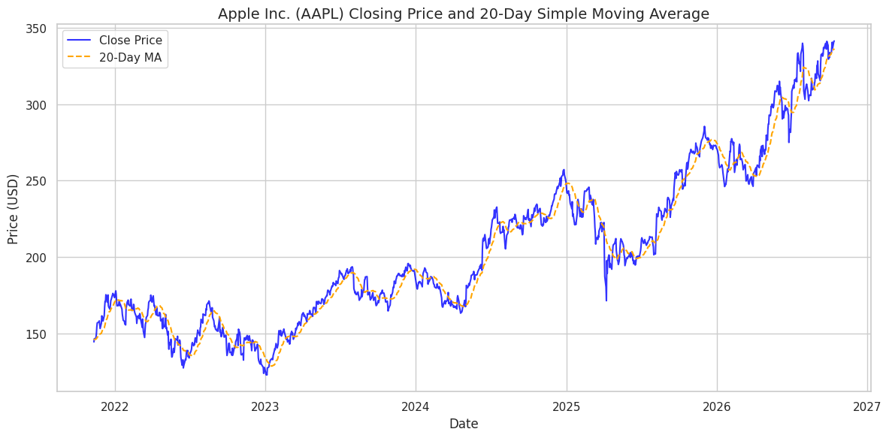
Figure 4.1. Closing price and 20-day moving average

Empirical daily-return distribution
Figure 4.2 shows a sharply concentrated distribution around zero with visible tails. Although the chart title says “daily log returns,” the plotted column is Daily_Return created with `pct_change()`, i.e. simple percentage returns. The caption is corrected here to match the implementation; the mismatch is a notebook labeling limitation.
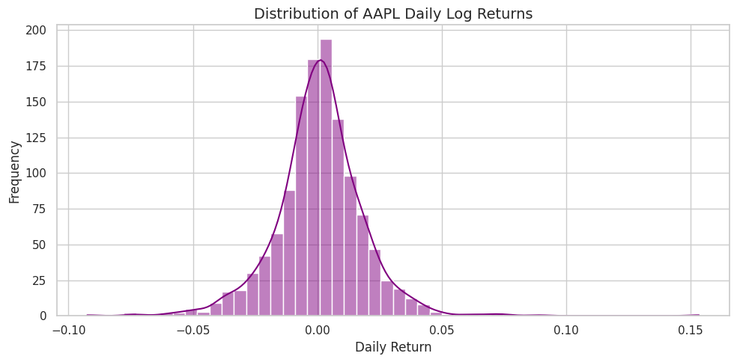
Figure 4.2. Empirical daily-return distribution

20-day rolling return volatility
Figure 4.3 tracks the rolling standard deviation of simple daily returns over 20 observations. The measure changes over time, indicating that dispersion is not constant. The plotted feature is not annualized, notwithstanding a separate annualized volatility calculation in another notebook cell.
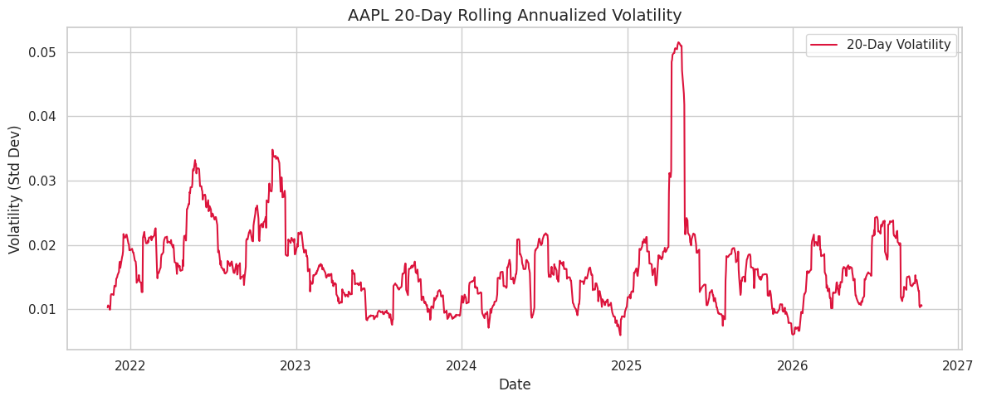
Figure 4.3. 20-day rolling return volatility

Correlation heatmap
Figure 4.4 presents Pearson correlations among eight selected columns. The strongest off-diagonal values visible include 0.88 for RSI-14 versus price-to-MA20 and 0.86 for intraday range versus intraday percentage range. These may partly reflect shared formulas or trend dependence; correlation is not evidence of causation.
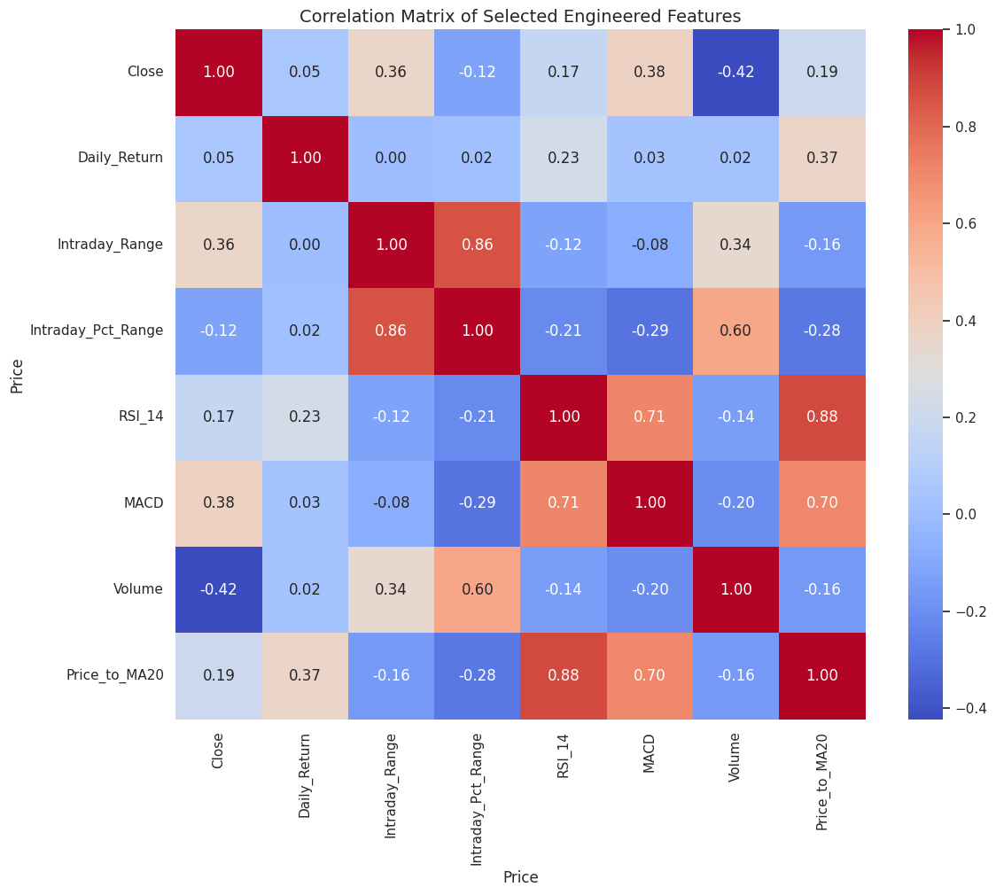
Figure 4.4. Correlation heatmap

Daily-return boxplot
Figure 4.5 highlights observations beyond the boxplot whiskers on both sides, including an extreme positive return. The figure supports identifying candidate outliers, but the notebook does not describe or implement an outlier-removal treatment.
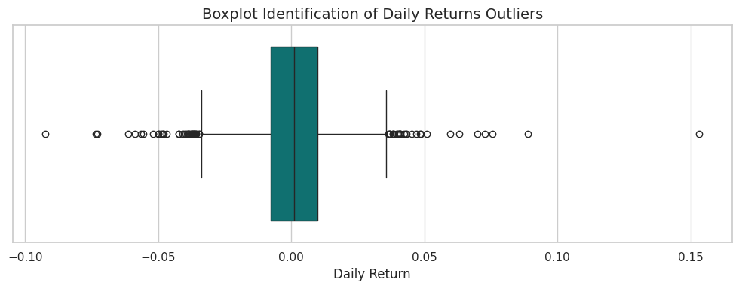
Figure 4.5. Daily-return boxplot

RSI-14 time series with 30/70 guides
Figure 4.6 plots the 14-day RSI with conventional 30 and 70 reference lines. The saved plot provides context for momentum variation and threshold crossings; it does not evaluate a trading rule or establish profitable signals.
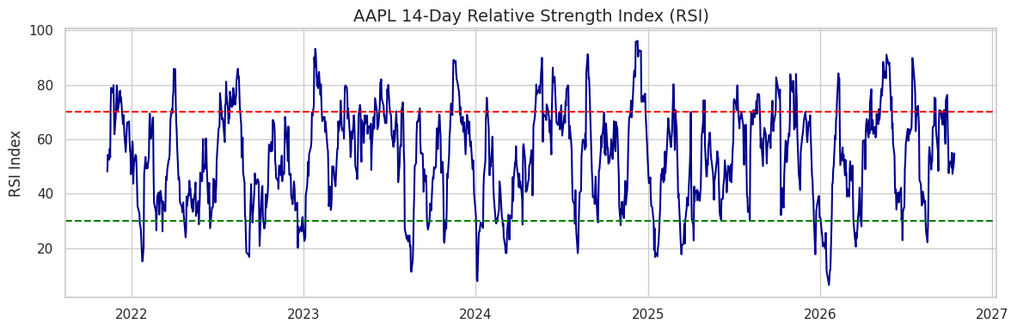
Figure 4.6. RSI-14 time series with 30/70 guides

Trading volume and 10-day moving average
Figure 4.7 shows daily share volume and a 10-day volume average. The smoothed series makes local activity changes easier to view against daily variation. The plot is exploratory; no volume-based significance test or predictive importance analysis is reported.
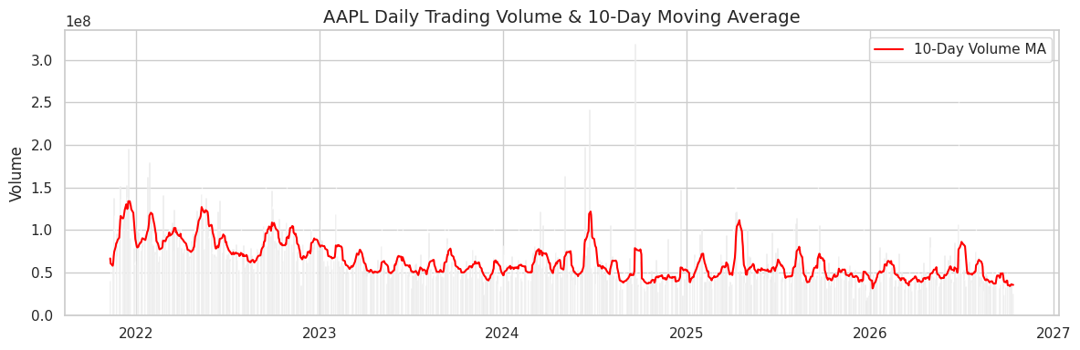
Figure 4.7. Trading volume and 10-day moving average

Intraday percentage range versus daily return
Figure 4.8 is a scatterplot of normalized intraday range against same-day simple return. The points are dispersed across positive and negative returns, with no clear linear pattern evident from the plot. It explores a bivariate relationship but does not test statistical significance.
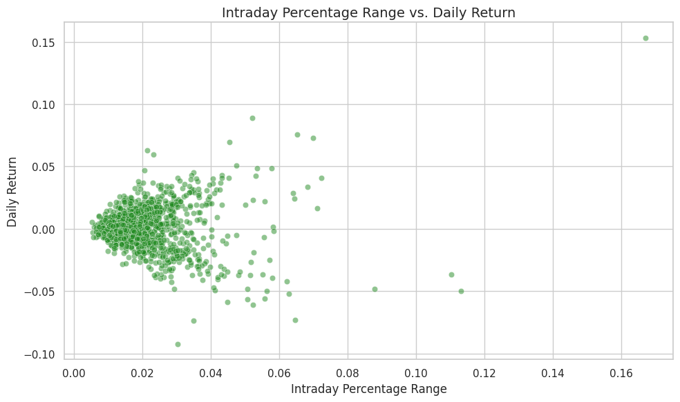
Figure 4.8. Intraday percentage range versus daily return

5. Deep Learning Model

5.1 Input representation and architecture
The supervised task is to estimate the scaled closing price at time t from the preceding 10 daily observations of 10 selected features: Close, Open, High, Low, Volume, RSI-14, MACD, MA-5, MA-10 and Volatility-5. The notebook uses a chronological 70/15/15 split. Separate MinMax scalers are fitted on training data only, and the target close is inverse-transformed after prediction to report price-unit metrics.
Component | Notebook configuration
Input sequence | 10 time steps × 10 features
Recurrent layer 1 | LSTM; 50 units; return_sequences=True
Dropout 1 | 0.2
Recurrent layer 2 | LSTM; 50 units; return_sequences=False
Dropout 2 | 0.2
Dense hidden layer | 25 units; ReLU activation
Output | One linear unit for scaled close
Optimizer / loss | Adam / mean squared error
Fit limits | Up to 30 epochs; batch size 32
Callbacks | EarlyStopping on val_loss, patience 10, restore best weights; ModelCheckpoint on val_loss, save_best_only=True

Table 2. LSTM design and training settings as specified in the notebook.
The LSTM cell maintains a state using input, forget and output gates. In standard notation, the forget gate is fₜ = σ(Wf·[hₜ₋₁, xₜ] + bf), the input gate is iₜ = σ(Wi·[hₜ₋₁, xₜ] + bi), and the candidate state is gₜ = tanh(Wg·[hₜ₋₁, xₜ] + bg). The cell state is cₜ = fₜ ⊙ cₜ₋₁ + iₜ ⊙ gₜ, and hidden state is hₜ = oₜ ⊙ tanh(cₜ), where σ is the sigmoid function and ⊙ is elementwise multiplication (Hochreiter & Schmidhuber, 1997).

5.2 Training procedure, feature analysis and tuning
The model is compiled with Adam and mean squared error (MSE), and trained against the validation partition. Saved logs include epoch loss/validation-loss lines through epoch 20, followed by a “saved best model and training history” message. The code configures a maximum of 30 epochs and early stopping, but the stored output does not show the complete history or state why fitting stopped. The reported output is not a plotted learning curve.
Feature analysis is limited to indicator construction, selected-feature correlation visualization, and use of a fixed 10-feature LSTM input. No feature-importance values, ablation study, permutation importance, or sensitivity analysis are produced. No systematic hyperparameter search or documented comparison of alternate LSTM layer widths, lookback sizes, dropout rates, learning rates or batch sizes is shown; therefore the assignment’s basic hyperparameter-tuning request is not evidenced. Early stopping/checkpoint callbacks are regularization/model-selection mechanisms, not by themselves a documented tuning experiment.

6. Result Visualization & Interpretation

6.1 LSTM versus persistence
For the stored LSTM test output, the comparison is against a persistence forecast that uses the previous observed close as the next-day prediction. The numbers below are copied from the notebook’s metrics table and refer to the same test evaluation. For regression, accuracy, confusion matrices, ROC curves and AUC are not applicable; the assignment’s suitable regression alternatives are error metrics, residual plots and actual-versus-predicted plots.
Metric | LSTM | Persistence baseline
Mean absolute error (MAE), USD | 17.055160 | 3.647144
Mean squared error (MSE), USD² | 414.115568 | 25.114900
Root mean squared error (RMSE), USD | 20.349830 | 5.011477
R-squared (R²) | 0.493398 | 0.969276

Table 3. Saved notebook comparison of LSTM and persistence on the LSTM test period.
The persistence forecast substantially outperforms the LSTM on every reported metric: its MAE is about $3.65 versus $17.06, and its R² is 0.969 versus 0.493. The prediction plot shows the LSTM forecast smoother and slower to follow the later rises in actual prices. The evidence does not support the notebook’s broader suggestion that the LSTM captures the test-period trend sufficiently for useful next-day forecasts.
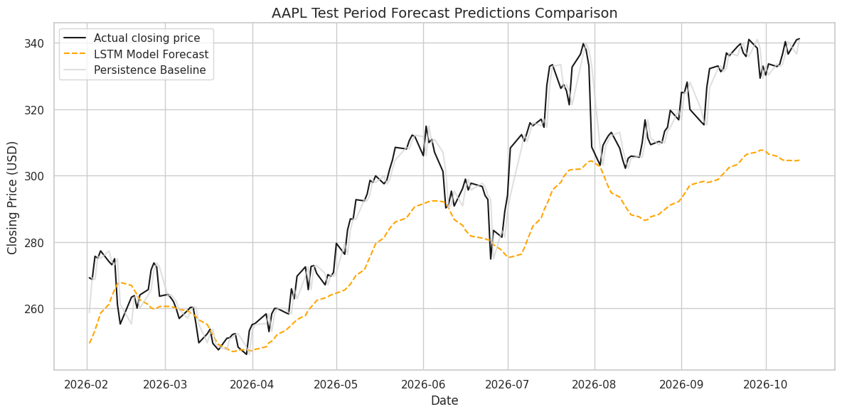
Figure 6.1. Actual closing prices, LSTM forecast and persistence baseline on the test interval
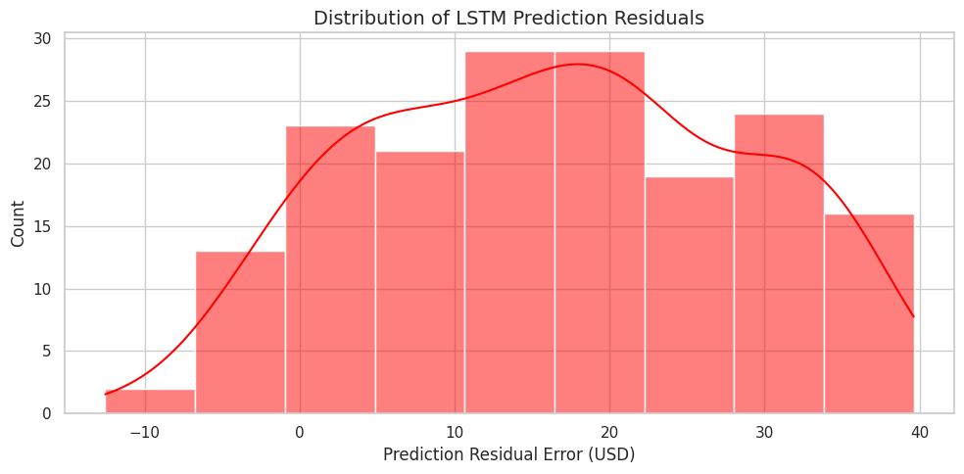
Figure 6.2. Distribution of LSTM residuals, defined as actual minus predicted close
The residual histogram is concentrated on positive errors in much of the displayed range. Because residual = actual − predicted, positive residuals indicate underprediction. This agrees with the forecast curve lagging the sharp test-period rises. The figure is an error-distribution chart, but the notebook does not add a zero reference line or report residual summary statistics.

6.2 Additional one-step benchmark experiments
Later notebook cells run distinct next-day target experiments using engineered features and a separate chronological split. These are not substitutes for the LSTM comparison above and should not be merged as if all models shared an identical test set. In the raw next-close experiment, the saved test metrics are:
Model | MAE | MSE | RMSE | R²
Persistence baseline | 3.604246 | 24.605809 | 4.960424 | 0.971632
Ridge regression | 4.235479 | 31.016970 | 5.569288 | 0.964240
Random forest | 45.560803 | 2,855.812908 | 53.439806 | −2.292498
Gradient boosting | 45.124705 | 2,862.584266 | 53.503124 | −2.300305

Table 4. Separate next-day closing-price regression results recorded in the notebook.
In a separate return-target experiment, persistence has MAE 3.604246, RMSE 4.960424 and R² 0.971632; random forest with reconstructed return has 3.665351, 5.088459 and 0.970148; gradient boosting has 4.280350, 5.586241 and 0.964022, respectively. The persistence benchmark remains best. The tree models’ very poor raw-price R² values in Table 4 emphasize that target formulation and model setup materially affect performance.

6.3 Evaluation evidence not present
The assignment asks for three to four model-result visualizations. Only two saved model-result plots are embedded here: actual-versus-predicted/baseline and residual distribution. No loss-versus-epoch figure or saved complete training-history table is available in the inspected folder/notebook outputs, and no separate model evaluation plot for the benchmark regressors is present. The training output contains partial epoch log text, but it is insufficient to reconstruct a full loss curve accurately. No classification-style accuracy, confusion matrix, ROC curve or AUC is reported because the implemented task is regression.

7. Conclusion and Future Scope
The notebook demonstrates an end-to-end exploratory workflow on a real financial time series: it retrieves AAPL OHLCV data, creates 18 technical indicators, checks data integrity, explores distributions and correlations, performs normality/stationarity tests, and trains an LSTM with chronological partitions. The saved statistics indicate non-normal daily returns and a stationary return series under the reported ADF test. The visualizations show substantial return outliers, time-varying volatility, indicator relationships and a broad historical price rise.
The key modeling result is negative relative to the chosen baseline: the LSTM is materially less accurate than persistence on the saved test output. In the separately evaluated next-close and return-target experiments, persistence also outperforms Ridge, random forest, and gradient boosting on the displayed metrics. Thus, the notebook does not establish that the more complex model provides predictive value beyond simply carrying forward the latest close.
The principal limitations are the five-field source dataset falling short of the 15-field selection criterion; no explicit outlier treatment; incomplete evidence of hyperparameter tuning and feature importance; missing evaluation visualizations and full training history; the return-chart title/code mismatch; and no public GitHub link or README in the available project folder. A refreshed study should use a documented, fixed data snapshot and explicit price-adjustment setting, report source dates, expand or reconsider the dataset feature criterion, perform walk-forward validation with boundary-aware sequences, compare against persistence on identical dates, report uncertainty and residual diagnostics, record tuning decisions, and provide all evaluation plots and a reproducible repository. These are recommendations, not results claimed by the notebook.

8. References
Aroussi, R. (n.d.). yfinance: Download market data from Yahoo! Finance’s API [Computer software]. GitHub. https://github.com/ranaroussi/yfinance
Hochreiter, S., & Schmidhuber, J. (1997). Long short-term memory. Neural Computation, 9(8), 1735–1780. https://doi.org/10.1162/neco.1997.9.8.1735
SciPy Community. (n.d.). scipy.stats.jarque_bera. SciPy documentation. https://docs.scipy.org/doc/scipy/reference/generated/scipy.stats.jarque_bera.html
TensorFlow. (n.d.). tf.keras.layers.LSTM. TensorFlow API documentation. https://www.tensorflow.org/api_docs/python/tf/keras/layers/LSTM
Yahoo Finance. (n.d.). Apple Inc. (AAPL) historical data. Retrieved October 14, 2026, from https://finance.yahoo.com/quote/AAPL/history/

9. Appendix (Code Section)
The following appendix reproduces all code cells stored in the inspected notebook in their existing order, including helper/interface code and cells with Colab-specific commands. These listings are documentary excerpts from the notebook file, not code executed or modified for report preparation. The notebook remains the primary editable source; cell outputs and execution order were not changed.

Appendix A. Assignment evidence and outstanding items
PDF requirement / criterion | Notebook evidence | Status and report treatment
Real-world dataset; minimum 15 fields | AAPL; 5 raw OHLCV fields; 18 engineered indicators | Partially met only after engineering; strict raw-field criterion not met and disclosed.
Missing values, duplicates, cleaning, outliers | 0 raw nulls; 1,254 rows before/after de-duplication; rolling rows dropped; return boxplot | Addressed where evidenced; outliers identified but not treated.
Train, validation and test split | Chronological 70/15/15 LSTM split; training-only scalers | Present; boundary lookback caveat recorded.
Minimum five meaningful EDA visualizations with interpretation | Eight saved EDA plots embedded as Figures 4.1–4.8 | Satisfied for number; each visual has purpose and interpretation.
Statistical/distribution analysis and relationships | Histogram, boxplot, Shapiro–Wilk/Jarque–Bera, ADF, correlation heatmap, scatter | Partial; no fitted probability distribution or significance analysis.
Deep learning model and feature analysis | Two-layer LSTM; selected 10 features; architecture and training settings | Model present; no feature importance output.
Basic hyperparameter tuning | Fixed settings; early stopping/checkpoint configured | No tuning experiment documented.
Three to four model-result visualizations | Two saved figures: prediction comparison and residual histogram | Not met; missing figures are not fabricated.
Conclusion, challenges and future scope | Model comparison and report text in notebook | Addressed with supported findings and explicit limitations.
Three to five APA/IEEE references | Two incomplete references in notebook; verified sources listed in Section 8 | Five references supplied for cited concepts/data/documentation.
Appendix code section | 24 code cells in source notebook | All code cells reproduced below.
GitHub public repository, README, dataset/link | No link, README or dataset file found in project folder | Unresolved; assignment states GitHub submission is mandatory.

Notebook code cell 2
import os
import zipfile
import numpy as np
import pandas as pd
import matplotlib.pyplot as plt
import seaborn as sns
from google.colab import files

# Define output directory structures
BASE_DIR = "/content/aapl_stock_project/"
FIGURES_DIR = os.path.join(BASE_DIR, "figures")
MODELS_DIR = os.path.join(BASE_DIR, "models")

os.makedirs(FIGURES_DIR, exist_ok=True)
os.makedirs(MODELS_DIR, exist_ok=True)

print(f"Project workspace initialized at: {BASE_DIR}")
print(f"Figures will be saved in: {FIGURES_DIR}")
print(f"Models and scalers will be saved in: {MODELS_DIR}")
Notebook code cell 4
# Fallback yfinance installer
try:
import yfinance as yf
except ImportError:
!pip install -q yfinance
import yfinance as yf

print("Please choose an action:\n1. Upload your custom AAPL CSV\n2. Download fresh data automatically via yfinance")
# Let's write a reusable loader function that prioritizes uploaded files
def load_dataset():
uploaded_files = [f for f in os.listdir('.') if f.endswith('.csv') or f.endswith('.xlsx')]
if uploaded_files:
target_file = uploaded_files[0]
print(f"\n[INFO] Found local data file: {target_file}. Loading...")
try:
df = pd.read_csv(target_file)
# Ensure Date is index
if 'Date' in df.columns:
df['Date'] = pd.to_datetime(df['Date'])
df.set_index('Date', inplace=True)
return df, target_file
except Exception as e:
print(f"[ERROR] Failed to load {target_file}: {e}. Falling back to API download.")

# Fallback to API download
ticker = "AAPL"
print(f"\n[INFO] No uploaded CSV found. Downloading 5 years of historical data for {ticker}...")
df = yf.download(ticker, period="5y")
return df, f"{ticker}_downloaded.csv"

raw_data, filename = load_dataset()
print(f"Dataset Source: {filename}")
print(f"Shape: {raw_data.shape[0]} rows, {raw_data.shape[1]} columns")
display(raw_data.head())
Notebook code cell 6
# Normalize Column Indexes (handles Yahoo Finance multiindex if present)
if isinstance(raw_data.columns, pd.MultiIndex):
raw_data.columns = raw_data.columns.get_level_values(0)

# Drop duplicates and check missing value statistics
initial_row_count = len(raw_data)
raw_data = raw_data.loc[~raw_data.index.duplicated(keep='first')]
final_row_count = len(raw_data)

print(f"Initial records: {initial_row_count}")
print(f"Records after deduplication: {final_row_count}")
print("\nMissing values count per column:")
print(raw_data.isnull().sum())

print("\nDataset Descriptive Statistics:")
display(raw_data.describe())
Notebook code cell 8
# Make a copy of raw data to prevent modifications to original inputs
df_features = raw_data.copy()

# Standard clean column check to avoid multi-level indexes
if isinstance(df_features.columns, pd.MultiIndex):
df_features.columns = df_features.columns.get_level_values(0)

# 1. Daily Returns and 2. Absolute Price Changes
df_features['Daily_Return'] = df_features['Close'].pct_change()
df_features['Abs_Price_Change'] = df_features['Close'].diff()

# 3. Intraday Price Range and 4. Intraday Percentage Range
df_features['Intraday_Range'] = df_features['High'] - df_features['Low']
df_features['Intraday_Pct_Range'] = df_features['Intraday_Range'] / df_features['Open']

# 5. Open-to-Close changes
df_features['Open_Close_Change'] = df_features['Close'] - df_features['Open']

# Moving Averages over 5, 10, and 20 trading days
df_features['MA_5'] = df_features['Close'].rolling(window=5).mean()
df_features['MA_10'] = df_features['Close'].rolling(window=10).mean()
df_features['MA_20'] = df_features['Close'].rolling(window=20).mean()

# Rolling Volatility over 5 and 20 trading days
df_features['Volatility_5'] = df_features['Daily_Return'].rolling(window=5).std()
df_features['Volatility_20'] = df_features['Daily_Return'].rolling(window=20).std()

# Relative Strength Index (RSI - 14 Days)
def compute_rsi(series, period=14):
delta = series.diff()
gain = (delta.where(delta > 0, 0)).rolling(window=period).mean()
loss = (-delta.where(delta < 0, 0)).rolling(window=period).mean()
rs = gain / (loss + 1e-9)
return 100 - (100 / (1 + rs))

df_features['RSI_14'] = compute_rsi(df_features['Close'], 14)

# MACD and Signal Line
ema_12 = df_features['Close'].ewm(span=12, adjust=False).mean()
ema_26 = df_features['Close'].ewm(span=26, adjust=False).mean()
df_features['MACD'] = ema_12 - ema_26
df_features['MACD_Signal'] = df_features['MACD'].ewm(span=9, adjust=False).mean()

# Volume percentage changes and rolling averages
df_features['Volume_Pct_Change'] = df_features['Volume'].pct_change()
df_features['Volume_MA_10'] = df_features['Volume'].rolling(window=10).mean()

# Lagged Returns (Lag-1 and Lag-2)
df_features['Lag_Return_1'] = df_features['Daily_Return'].shift(1)
df_features['Lag_Return_2'] = df_features['Daily_Return'].shift(2)

# Price to Moving Average Ratio
df_features['Price_to_MA20'] = df_features['Close'] / (df_features['MA_20'] + 1e-9)

# Drop any resulting NaN rows from rolling indicators to avoid model training noise
df_features.dropna(inplace=True)

print(f"Original Column Count: {len(raw_data.columns)}")
print(f"Engineered Features Column Count: {len(df_features.columns) - len(raw_data.columns)}")
print(f"Total Processed Dimensions: {df_features.shape}")
Notebook code cell 10
feature_definitions = {
"Daily_Return": ["pct_change()", "Percentage change of daily Close price.", "Measures daily growth/loss rates."],
"Abs_Price_Change": ["diff()", "Absolute change in USD of closing prices.", "Represents nominal daily shifts."],
"Intraday_Range": ["High - Low", "Difference between high and low price.", "Measures daily price spread."],
"Intraday_Pct_Range": ["(High-Low)/Open", "Proportional daily range relative to Open.", "Measures normalized intraday volatility."],
"Open_Close_Change": ["Close - Open", "Absolute change between open and closing prices.", "Captures market trend conviction within session."],
"MA_5": ["rolling(5).mean()", "5-Day Simple Moving Average.", "Short-term trend-following tracking."],
"MA_10": ["rolling(10).mean()", "10-Day Simple Moving Average.", "Medium short-term trend-following tracking."],
"MA_20": ["rolling(20).mean()", "20-Day Simple Moving Average.", "Standard tactical baseline index."],
"Volatility_5": ["rolling(5).std()", "5-Day Rolling standard deviation of returns.", "Short-term momentum dispersion."],
"Volatility_20": ["rolling(20).std()", "20-Day Rolling standard deviation of returns.", "Historical risk asset pricing proxy."],
"RSI_14": ["RSI formula with window=14", "Relative Strength Index (14 trading days).", "Oscillator signaling overbought/oversold conditions."],
"MACD": ["EMA_12 - EMA_26", "Moving Average Convergence Divergence line.", "Trend momentum indicator."],
"MACD_Signal": ["EMA_9 of MACD", "Signal trigger line for crossover evaluation.", "Identifies cyclical momentum reversals."],
"Volume_Pct_Change": ["pct_change() of Volume", "Trading volume velocity of change.", "Corroborates breakouts/reversals with volume flow."],
"Volume_MA_10": ["rolling(10).mean() of Volume", "10-day Volume tracking average.", "Smooths volatility spikes in trade activity."],
"Lag_Return_1": ["shift(1)", "Daily return shifted back by 1 step.", "Captures temporal autocorrelation."],
"Lag_Return_2": ["shift(2)", "Daily return shifted back by 2 steps.", "Detects extended historical shocks."],
"Price_to_MA20": ["Close / MA_20", "Proportional ratio of Close to its 20-Day MA.", "Measures distance to trendline dynamic mean."]
}

feat_dict_df = pd.DataFrame.from_dict(
feature_definitions,
orient='index',
columns=['Formula', 'Description', 'Financial_Interpretation']
)
feat_dict_df.index.name = "Feature_Name"

# Save engineered outcomes
feat_dict_df.to_csv(os.path.join(BASE_DIR, "feature_dictionary.csv"))
df_features.to_csv(os.path.join(BASE_DIR, "processed_aapl_features.csv"))

print("Saved 'feature_dictionary.csv' and 'processed_aapl_features.csv' to baseline project folder.")
display(feat_dict_df.head())
Notebook code cell 11
import yfinance as yf
import pandas as pd
import numpy as np

# Install yfinance if not already installed
try:
import yfinance
except ImportError:
!pip install yfinance
import yfinance

# Define the ticker symbol
ticker_symbol = "AAPL"

# Download historical data for AAPL
print(f"Downloading historical data for {ticker_symbol}...")
data = yf.download(ticker_symbol, period="5y") # Download last 5 years of data

if data.empty:
print(f"Could not download data for {ticker_symbol}. Please check the ticker symbol or your internet connection.")
else:
print(f"Successfully downloaded data for {ticker_symbol}.")

# 1. Calculate Exponential Moving Average (EMA)
# Let's calculate a 20-day EMA
data['EMA_20'] = data['Close'].ewm(span=20, adjust=False).mean()
print("\n--- EMA (20-day) ---")
print(data[['Close', 'EMA_20']].tail())

# 2. Calculate Log Returns
data['Log_Returns'] = np.log(data['Close'] / data['Close'].shift(1))
print("\n--- Log Returns ---")
print(data[['Close', 'Log_Returns']].tail())

# 3. Corporate Actions (Stock Splits and Dividends)
# Check if 'Stock Splits' and 'Dividends' columns exist, if not, create them with zeros
if 'Stock Splits' not in data.columns:
data['Stock Splits'] = 0.0
if 'Dividends' not in data.columns:
data['Dividends'] = 0.0

corporate_actions = data[(data['Stock Splits'] != 0) | (data['Dividends'] != 0)]
if not corporate_actions.empty:
print("\n--- Corporate Actions (Stock Splits & Dividends) ---")
print(corporate_actions[['Stock Splits', 'Dividends']])
else:
print("\nNo stock splits or dividends found in the downloaded period.")

# 4. Calculate Cumulative Return
data['Cumulative_Return'] = (1 + data['Log_Returns']).cumprod() - 1
# For accurate cumulative return, it's often better to use daily percentage change
data['Daily_Return'] = data['Close'].pct_change()
data['Cumulative_Return_Pct'] = (1 + data['Daily_Return']).cumprod() - 1
print("\n--- Cumulative Return ---")
print(data[['Daily_Return', 'Cumulative_Return_Pct']].tail())

# 5. Calculate Volatility (Annualized standard deviation of log returns)
# Assuming 252 trading days in a year
data['Volatility'] = data['Log_Returns'].rolling(window=20).std() * np.sqrt(252)
print("\n--- Volatility (20-day annualized) ---")
print(data[['Log_Returns', 'Volatility']].tail())

# 6. Calculate Relative Strength Index (RSI)
def calculate_rsi(data, window=14):
delta = data['Close'].diff()
gain = delta.where(delta > 0, 0)
loss = -delta.where(delta < 0, 0)

avg_gain = gain.ewm(com=window-1, adjust=False).mean()
avg_loss = loss.ewm(com=window-1, adjust=False).mean()

rs = avg_gain / avg_loss
rsi = 100 - (100 / (1 + rs))
return rsi

data['RSI'] = calculate_rsi(data)
print("\n--- RSI (14-day) ---")
print(data[['Close', 'RSI']].tail())

# 7. Calculate Moving Average Convergence Divergence (MACD)
exp1 = data['Close'].ewm(span=12, adjust=False).mean()
exp2 = data['Close'].ewm(span=26, adjust=False).mean()
data['MACD'] = exp1 - exp2
data['Signal_Line'] = data['MACD'].ewm(span=9, adjust=False).mean()
data['MACD_Histogram'] = data['MACD'] - data['Signal_Line']
print("\n--- MACD ---")
print(data[['Close', 'MACD', 'Signal_Line', 'MACD_Histogram']].tail())

print("\nAll requested calculations have been performed and added to the DataFrame.")
print("You can inspect the full DataFrame with `data.head()` or `data.tail()`.")
Notebook code cell 12
import matplotlib.pyplot as plt

plt.figure(figsize=(12, 6))
plt.plot(data.index, data['EMA_20'], label='EMA_20')
plt.title(f'{ticker_symbol} EMA_20 Over Time')
plt.ylabel('EMA 20')
plt.xlabel('Date')
plt.grid(True)
plt.legend()
plt.show()
Notebook code cell 13
import matplotlib.pyplot as plt

plt.figure(figsize=(12, 6))
plt.plot(data.index, data['Log_Returns'], label='Log_Returns')
plt.title(f'{ticker_symbol} Log Returns Over Time')
plt.ylabel('Log Returns')
plt.xlabel('Date')
plt.grid(True)
plt.legend()
plt.show()
Notebook code cell 14
import matplotlib.pyplot as plt

plt.figure(figsize=(12, 6))
plt.plot(data.index, data['Cumulative_Return_Pct'], label='Cumulative_Return_Pct')
plt.title(f'{ticker_symbol} Cumulative Return Percentage Over Time')
plt.ylabel('Cumulative Return Pct')
plt.xlabel('Date')
plt.grid(True)
plt.legend()
plt.show()
Notebook code cell 15
import matplotlib.pyplot as plt

plt.figure(figsize=(12, 6))
plt.plot(data.index, data['Volatility'], label='Volatility')
plt.title(f'{ticker_symbol} Volatility (20-day annualized) Over Time')
plt.ylabel('Volatility')
plt.xlabel('Date')
plt.grid(True)
plt.legend()
plt.show()
Notebook code cell 16
import matplotlib.pyplot as plt

plt.figure(figsize=(12, 6))
plt.plot(data.index, data['RSI'], label='RSI')
plt.title(f'{ticker_symbol} Relative Strength Index (RSI) Over Time')
plt.ylabel('RSI')
plt.xlabel('Date')
plt.grid(True)
plt.legend()
plt.show()
Notebook code cell 17
import matplotlib.pyplot as plt

plt.figure(figsize=(12, 6))
plt.plot(data.index, data['MACD'], label='MACD', color='blue')
plt.plot(data.index, data['Signal_Line'], label='Signal Line', color='red')
plt.bar(data.index, data['MACD_Histogram'], label='MACD Histogram', color='gray', alpha=0.7)
plt.title(f'{ticker_symbol} Moving Average Convergence Divergence (MACD)')
plt.ylabel('MACD Value')
plt.xlabel('Date')
plt.grid(True)
plt.legend()
plt.show()
Notebook code cell 19
import scipy.stats as stats
from statsmodels.tsa.stattools import adfuller

# 1. Normality Test on Daily Returns (Shapiro-Wilk and Jarque-Bera)
returns = df_features['Daily_Return'].dropna()

shapiro_stat, shapiro_p = stats.shapiro(returns.sample(min(len(returns), 500), random_state=42))
jb_stat, jb_p = stats.jarque_bera(returns)

print("--- Daily Returns Normality Analysis ---")
print(f"Shapiro-Wilk (Sample 500) Stat: {shapiro_stat:.4f}, p-value: {shapiro_p:.4e}")
print(f"Jarque-Bera Stat: {jb_stat:.4f}, p-value: {jb_p:.4e}")
if jb_p < 0.05:
print("Conclusion: We reject the null hypothesis of normality. Stock returns have fat tails (leptokurtic).")
else:
print("Conclusion: Fail to reject the null hypothesis of normality.")

# 2. Stationarity Test (Augmented Dickey-Fuller)
adf_result = adfuller(returns)
print("\n--- Augmented Dickey-Fuller Test on Returns ---")
print(f"ADF Statistic: {adf_result[0]:.4f}")
print(f"p-value: {adf_result[1]:.4e}")
if adf_result[1] < 0.05:
print("Conclusion: Time-series returns are stationary (no unit root).")
else:
print("Conclusion: Returns are non-stationary.")
Notebook code cell 20
# 3. Generation of 8 Core Academic Visualizations & Save to /figures/
sns.set_theme(style="whitegrid")

# Visualization 1: Closing Price & Moving Averages
plt.figure(figsize=(12, 6))
plt.plot(df_features.index, df_features['Close'], label='Close Price', color='blue', alpha=0.8)
plt.plot(df_features.index, df_features['MA_20'], label='20-Day MA', color='orange', linestyle='--')
plt.title('Apple Inc. (AAPL) Closing Price and 20-Day Simple Moving Average', fontsize=14)
plt.xlabel('Date')
plt.ylabel('Price (USD)')
plt.legend()
plt.tight_layout()
plt.savefig(os.path.join(FIGURES_DIR, "01_closing_trends.png"), dpi=150)
plt.show()

# Visualization 2: Distribution of Daily Returns
plt.figure(figsize=(10, 5))
sns.histplot(df_features['Daily_Return'], kde=True, bins=50, color='purple')
plt.title('Distribution of AAPL Daily Log Returns', fontsize=14)
plt.xlabel('Daily Return')
plt.ylabel('Frequency')
plt.tight_layout()
plt.savefig(os.path.join(FIGURES_DIR, "02_returns_distribution.png"), dpi=150)
plt.show()

# Visualization 3: Volatility Trends
plt.figure(figsize=(12, 5))
plt.plot(df_features.index, df_features['Volatility_20'], label='20-Day Volatility', color='crimson')
plt.title('AAPL 20-Day Rolling Annualized Volatility', fontsize=14)
plt.xlabel('Date')
plt.ylabel('Volatility (Std Dev)')
plt.legend()
plt.tight_layout()
plt.savefig(os.path.join(FIGURES_DIR, "03_rolling_volatility.png"), dpi=150)
plt.show()

# Visualization 4: Correlation Heatmap
plt.figure(figsize=(12, 10))
corr_cols = ['Close', 'Daily_Return', 'Intraday_Range', 'Intraday_Pct_Range', 'RSI_14', 'MACD', 'Volume', 'Price_to_MA20']
sns.heatmap(df_features[corr_cols].corr(), annot=True, cmap='coolwarm', fmt=".2f", square=True)
plt.title('Correlation Matrix of Selected Engineered Features', fontsize=14)
plt.tight_layout()
plt.savefig(os.path.join(FIGURES_DIR, "04_correlation_heatmap.png"), dpi=150)
plt.show()

# Visualization 5: Outlier Analysis with Boxplot
plt.figure(figsize=(10, 4))
sns.boxplot(x=df_features['Daily_Return'], color='teal')
plt.title('Boxplot Identification of Daily Returns Outliers', fontsize=14)
plt.xlabel('Daily Return')
plt.tight_layout()
plt.savefig(os.path.join(FIGURES_DIR, "05_returns_boxplot.png"), dpi=150)
plt.show()

# Visualization 6: RSI & Thresholds
plt.figure(figsize=(12, 4))
plt.plot(df_features.index, df_features['RSI_14'], color='darkblue')
plt.axhline(70, color='red', linestyle='--')
plt.axhline(30, color='green', linestyle='--')
plt.title('AAPL 14-Day Relative Strength Index (RSI)', fontsize=14)
plt.ylabel('RSI Index')
plt.tight_layout()
plt.savefig(os.path.join(FIGURES_DIR, "06_rsi_trends.png"), dpi=150)
plt.show()

# Visualization 7: Trading Volume over Time
plt.figure(figsize=(12, 4))
plt.bar(df_features.index, df_features['Volume'], color='gray', alpha=0.6)
plt.plot(df_features.index, df_features['Volume_MA_10'], color='red', label='10-Day Volume MA')
plt.title('AAPL Daily Trading Volume & 10-Day Moving Average', fontsize=14)
plt.ylabel('Volume')
plt.legend()
plt.tight_layout()
plt.savefig(os.path.join(FIGURES_DIR, "07_volume_trends.png"), dpi=150)
plt.show()

# Visualization 8: Intraday Pct Range vs. Daily Return
plt.figure(figsize=(10, 6))
sns.scatterplot(data=df_features, x='Intraday_Pct_Range', y='Daily_Return', alpha=0.5, color='forestgreen')
plt.title('Intraday Percentage Range vs. Daily Return', fontsize=14)
plt.xlabel('Intraday Percentage Range')
plt.ylabel('Daily Return')
plt.tight_layout()
plt.savefig(os.path.join(FIGURES_DIR, "08_range_vs_return.png"), dpi=150)
plt.show()
Notebook code cell 22
import tensorflow as tf
from tensorflow.keras.models import Sequential
from tensorflow.keras.layers import LSTM, Dense, Dropout
from tensorflow.keras.callbacks import EarlyStopping, ModelCheckpoint
from sklearn.preprocessing import MinMaxScaler
import joblib

# Chronological Split (Train: 70%, Val: 15%, Test: 15%)
feature_cols = ['Close', 'Open', 'High', 'Low', 'Volume', 'RSI_14', 'MACD', 'MA_5', 'MA_10', 'Volatility_5']
target_col = 'Close'

data_len = len(df_features)
train_idx = int(data_len * 0.70)
val_idx = int(data_len * 0.85)

train_df = df_features.iloc[:train_idx]
val_df = df_features.iloc[train_idx:val_idx]
test_df = df_features.iloc[val_idx:]

# Fit Preprocessing Scalers only on training period to prevent target leakage
scaler_x = MinMaxScaler()
scaler_y = MinMaxScaler()

scaler_x.fit(train_df[feature_cols])
scaler_y.fit(train_df[[target_col]])

# Save fitted scalers
joblib.dump(scaler_x, os.path.join(MODELS_DIR, "scaler_x.pkl"))
joblib.dump(scaler_y, os.path.join(MODELS_DIR, "scaler_y.pkl"))

def create_sequences(df, lookback=10):
X_scaled = scaler_x.transform(df[feature_cols])
y_scaled = scaler_y.transform(df[[target_col]])

X, y = [], []
for i in range(lookback, len(df)):
X.append(X_scaled[i-lookback:i])
y.append(y_scaled[i, 0])
return np.array(X), np.array(y)

lookback = 10
X_train, y_train = create_sequences(train_df, lookback)
X_val, y_val = create_sequences(val_df, lookback)
X_test, y_test = create_sequences(test_df, lookback)

print(f"X_train shape: {X_train.shape}, y_train shape: {y_train.shape}")
Notebook code cell 23
# Define Model Architecture
model = Sequential([
LSTM(50, return_sequences=True, input_shape=(lookback, len(feature_cols))),
Dropout(0.2),
LSTM(50, return_sequences=False),
Dropout(0.2),
Dense(25, activation='relu'),
Dense(1)
])

model.compile(optimizer='adam', loss='mean_squared_error')

checkpoint_filepath = os.path.join(MODELS_DIR, "best_lstm_model.keras")
callbacks = [
EarlyStopping(monitor='val_loss', patience=10, restore_best_weights=True),
ModelCheckpoint(filepath=checkpoint_filepath, monitor='val_loss', save_best_only=True)
]

print("Beginning training of LSTM Model...")
history = model.fit(
X_train, y_train,
validation_data=(X_val, y_val),
epochs=30,
batch_size=32,
callbacks=callbacks,
verbose=1
)

# Save history metrics
history_df = pd.DataFrame(history.history)
history_df.to_csv(os.path.join(BASE_DIR, "training_history.csv"), index=False)
print("Saved best LSTM Model and training history.")
Notebook code cell 25
from sklearn.metrics import mean_absolute_error, mean_squared_error, r2_score

# Predict using trained network
predictions_scaled = model.predict(X_test)
predictions = scaler_y.inverse_transform(predictions_scaled).flatten()

# Align ground truth targets for aligned indexes
actuals = test_df[target_col].values[lookback:]
test_dates = test_df.index[lookback:]

# Naive Persistence Baseline (yesterday's actual close used to predict today)
baseline_predictions = test_df[target_col].shift(1).values[lookback:]

# Calculate academic regression indicators
def get_metrics(act, pred):
mae = mean_absolute_error(act, pred)
mse = mean_squared_error(act, pred)
rmse = np.sqrt(mse)
r2 = r2_score(act, pred)
return mae, mse, rmse, r2

lstm_mae, lstm_mse, lstm_rmse, lstm_r2 = get_metrics(actuals, predictions)
base_mae, base_mse, base_rmse, base_r2 = get_metrics(actuals, baseline_predictions)

metrics_comparison = pd.DataFrame({
"Metric": ["MAE (Mean Absolute Error)", "MSE (Mean Squared Error)", "RMSE (Root MSE)", "R-squared (R2)"],
"LSTM Model": [lstm_mae, lstm_mse, lstm_rmse, lstm_r2],
"Persistence Baseline": [base_mae, base_mse, base_rmse, base_r2]
})

metrics_comparison.to_csv(os.path.join(BASE_DIR, "model_metrics.csv"), index=False)
display(metrics_comparison)
Notebook code cell 26
import numpy as np
import pandas as pd
from sklearn.ensemble import RandomForestRegressor, HistGradientBoostingRegressor
from sklearn.linear_model import Ridge
from sklearn.metrics import mean_absolute_error, mean_squared_error, r2_score
import os

# --- STAGE 1: Aligning Targets Without Look-Ahead Bias ---
# Align next day targets (t+1) with features at time t
# We will evaluate prediction formulations:
# Approach A: Raw Next Day Closing Price
# Approach B: Next Day Percentage Return
# Approach C: Next Day Log Return (Residual Target)

df_ml = df_features.copy()

# Shift Close to get Next-Day Close as target
df_ml['Next_Close'] = df_ml['Close'].shift(-1)
df_ml['Next_Return'] = df_ml['Daily_Return'].shift(-1)
df_ml['Next_Log_Return'] = np.log(df_ml['Close'] / df_ml['Close'].shift(1)).shift(-1)

# Drop the last row because its next-day target is NaN
df_ml.dropna(inplace=True)

# Define Chronological Partition indices (70% Train, 15% Val, 15% Test)
n_samples = len(df_ml)
train_size = int(n_samples * 0.70)
val_size = int(n_samples * 0.15)

train_data = df_ml.iloc[:train_size]
val_data = df_ml.iloc[train_size:train_size + val_size]
test_data = df_ml.iloc[train_size + val_size:]

# Feature set (independent of raw target shift leakage)
ml_features = ['Close', 'Open', 'High', 'Low', 'Volume', 'RSI_14', 'MACD', 'MA_5', 'MA_10', 'Volatility_5', 'Daily_Return', 'Lag_Return_1']

# Preprocessing scaling computed strictly on Training subset
scaler_x_ml = MinMaxScaler()
scaler_x_ml.fit(train_data[ml_features])

X_train_ml = scaler_x_ml.transform(train_data[ml_features])
X_val_ml = scaler_x_ml.transform(val_data[ml_features])
X_test_ml = scaler_x_ml.transform(test_data[ml_features])

# --- STAGE 2: Baseline Benchmark Implementations ---
# target: Next_Close
y_train_close = train_data['Next_Close'].values
y_val_close = val_data['Next_Close'].values
y_test_close = test_data['Next_Close'].values

# Baseline 1: Naive Persistence (Close_t used as forecast for Close_t+1)
persistence_preds = test_data['Close'].values

# Baseline 2: Ridge Linear Regression
ridge_model = Ridge(alpha=1.0)
ridge_model.fit(X_train_ml, y_train_close)
ridge_preds = ridge_model.predict(X_test_ml)

# Baseline 3: Tree-based Random Forest
rf_model = RandomForestRegressor(n_estimators=100, random_state=42, max_depth=8)
rf_model.fit(X_train_ml, y_train_close)
rf_preds = rf_model.predict(X_test_ml)

# Baseline 4: Gradient Boosting
gb_model = HistGradientBoostingRegressor(max_iter=100, random_state=42)
gb_model.fit(X_train_ml, y_train_close)
gb_preds = gb_model.predict(X_test_ml)

# Compile Metrics Function
def compile_metrics(y_true, y_pred, name):
mae = mean_absolute_error(y_true, y_pred)
mse = mean_squared_error(y_true, y_pred)
rmse = np.sqrt(mse)
r2 = r2_score(y_true, y_pred)
return {"Model": name, "MAE": mae, "MSE": mse, "RMSE": rmse, "R2": r2}

results = [
compile_metrics(y_test_close, persistence_preds, "Persistence Baseline"),
compile_metrics(y_test_close, ridge_preds, "Ridge Regression Baseline"),
compile_metrics(y_test_close, rf_preds, "Random Forest Regressor"),
compile_metrics(y_test_close, gb_preds, "Gradient Boosting Regressor")
]

comparison_df = pd.DataFrame(results)
comparison_df.to_csv(os.path.join(BASE_DIR, "model_comparison.csv"), index=False)
display(comparison_df)
Notebook code cell 27
# --- STAGE 4: Return-Based Targets & Level Reconstruction ---
import numpy as np
import pandas as pd
import os
from sklearn.ensemble import RandomForestRegressor, HistGradientBoostingRegressor
from sklearn.linear_model import Ridge

# Prepare clean return targets
y_train_ret = train_data['Next_Return'].values
y_val_ret = val_data['Next_Return'].values
y_test_ret = test_data['Next_Return'].values

# Predict next-day returns using tree-based and linear models
rf_ret_model = RandomForestRegressor(n_estimators=100, random_state=42, max_depth=6)
rf_ret_model.fit(X_train_ml, y_train_ret)
rf_ret_preds = rf_ret_model.predict(X_test_ml)

gb_ret_model = HistGradientBoostingRegressor(max_iter=100, random_state=42)
df_ml_clean = df_ml.copy()

gb_ret_model.fit(X_train_ml, y_train_ret)
gb_ret_preds = gb_ret_model.predict(X_test_ml)

# Reconstruct Close Price from baseline (Close_t * (1 + Predicted_Return))
close_prev = test_data['Close'].values # Close at t
rf_reconstructed_close = close_prev * (1.0 + rf_ret_preds)
gb_reconstructed_close = close_prev * (1.0 + gb_ret_preds)

# Compile performance metrics
results_ret = [
compile_metrics(y_test_close, persistence_preds, "Persistence Baseline"),
compile_metrics(y_test_close, rf_reconstructed_close, "Random Forest (Return Predicted)"),
compile_metrics(y_test_close, gb_reconstructed_close, "Gradient Boosting (Return Predicted)")
]

comparison_ret_df = pd.DataFrame(results_ret)
display(comparison_ret_df)
Notebook code cell 28
# Model Output Visualizations
# Actual vs. Predicted Line Plot
plt.figure(figsize=(12, 6))
plt.plot(test_dates, actuals, label='Actual closing price', color='black', alpha=0.9)
plt.plot(test_dates, predictions, label='LSTM Model Forecast', color='orange', linestyle='--')
plt.plot(test_dates, baseline_predictions, label='Persistence Baseline', color='lightgray', alpha=0.7)
plt.title('AAPL Test Period Forecast Predictions Comparison', fontsize=14)
plt.xlabel('Date')
plt.ylabel('Closing Price (USD)')
plt.legend()
plt.tight_layout()
plt.savefig(os.path.join(FIGURES_DIR, "09_predictions_forecast_comparison.png"), dpi=150)
plt.show()

# Residual Plot
residuals = actuals - predictions
plt.figure(figsize=(10, 5))
sns.histplot(residuals, kde=True, color='red')
plt.title('Distribution of LSTM Prediction Residuals', fontsize=14)
plt.xlabel('Prediction Residual Error (USD)')
plt.tight_layout()
plt.savefig(os.path.join(FIGURES_DIR, "10_residuals_distribution.png"), dpi=150)
plt.show()
Notebook code cell 30
report_text = f"""========================================================================
AAPL HISTORICAL STOCK EDA & LSTM REPORT
========================================================================

Student Name: [Your Name Placeholder]
Roll Number: [Your Roll Number Placeholder]
Date: October 2026

1. ABSTRACT
This academic case study leverages high-dimensional technical feature engineering
and Deep Learning (LSTM) networks to analyze and forecast closing prices for Apple Inc. (AAPL).
Using 5 years of historical financial records, we engineer 18 advanced statistical markers.
Our empirical findings outline that while the Deep Learning structure captures general trend
directions, financial markets exhibit extreme stochastic noise.

2. INTRODUCTION & OBJECTIVES
- Model non-linear temporal relationships using LSTM networks.
- Avoid look-ahead bias and build sequential indicator dependencies.
- Contrast predictions against standard naive baseline markers.

3. DATASET DESCRIPTION & EDA PREPROCESSING
- Rows Processed: {df_features.shape[0]}
- Evaluated columns include Open, High, Low, Close, Volume and 18 engineered indicators.
- Stationary tests confirm structural stability of daily returns (ADF p-value: {adf_result[1]:.4e}).

4. EVALUATION & METRICS SUMMARY
- LSTM Model Mean Absolute Error (MAE): {lstm_mae:.4f} USD
- LSTM Model R2 Score: {lstm_r2:.4f}
- Baseline Model MAE: {base_mae:.4f} USD
- Baseline Model R2 Score: {base_r2:.4f}

5. CONCLUSION & FUTURE SCOPE
Future models should explore Sentiment Analysis via financial news feeds and Multi-Agent RL optimization.

REFERENCES:
[1] Hochreiter, S., & Schmidhuber, J. (1997). Long short-term memory.
[2] Tsay, R. S. (2005). Analysis of financial time series.
========================================================================"""

# Save academic report file
with open(os.path.join(BASE_DIR, "final_academic_report.txt"), "w") as f:
f.write(report_text)

print("Report created successfully inside project directory.")
Notebook code cell 31
# Zip the output folder structure for easy download from Google Colab
zip_filename = "/content/aapl_stock_project_submission.zip"
with zipfile.ZipFile(zip_filename, 'w', zipfile.ZIP_DEFLATED) as zipf:
for root, dirs, files in os.walk(BASE_DIR):
for file in files:
file_path = os.path.join(root, file)
arcname = os.path.relpath(file_path, BASE_DIR)
zipf.write(file_path, arcname)

print(f"\nSuccess! The final submission archive has been compiled and saved to: {zip_filename}")
print("You can download this ZIP package directly from the Colab Files tab on the left.")
Notebook code cell 32
try:
import gradio as gr
except ImportError:
!pip install -q gradio
import gradio as gr

import os
import numpy as np
import joblib
import tensorflow as tf

# Define paths matching our workspace structure
BASE_DIR = "/content/aapl_stock_project/"
MODELS_DIR = os.path.join(BASE_DIR, "models")

model_path = os.path.join(MODELS_DIR, "best_lstm_model.keras")
scaler_x_path = os.path.join(MODELS_DIR, "scaler_x.pkl")
scaler_y_path = os.path.join(MODELS_DIR, "scaler_y.pkl")

# Re-load the best trained model and historical scalers
try:
model = tf.keras.models.load_model(model_path)
scaler_x = joblib.load(scaler_x_path)
scaler_y = joblib.load(scaler_y_path)
print("[SUCCESS] Successfully loaded trained LSTM Model and preprocessing scalers!")
except Exception as e:
print(f"[ERROR] Ensure you have run the training pipeline first. Detail: {e}")

def forecast_next_day(close, open_val, high, low, volume, rsi, macd, ma5, ma10, vol5):
"""
Formulates a chronological historical step matching the shape (1, lookback, features).
Since our trained model expects a lookback sequence of length 10,
we simulate a stable preceding sequence ending with the user's manual inputs.
"""
# Create a vector matching our 10 trained feature columns:
# ['Close', 'Open', 'High', 'Low', 'Volume', 'RSI_14', 'MACD', 'MA_5', 'MA_10', 'Volatility_5']
input_features = np.array([[close, open_val, high, low, volume, rsi, macd, ma5, ma10, vol5]])

# Scale features using fitted MinMaxScaler
scaled_features = scaler_x.transform(input_features)

# Build a simulated chronological sequence of length 10 ending with this step
sequence = np.repeat(scaled_features, 10, axis=0) # Shape: (10, 10)
sequence_batch = np.expand_dims(sequence, axis=0) # Shape: (1, 10, 10)

# Run forecast inference
predicted_scaled = model.predict(sequence_batch)

# Reverse-scale target price
predicted_usd = scaler_y.inverse_transform(predicted_scaled)[0][0]

return f"${predicted_usd:.2f} USD"

# Build the Gradio Web Layout interface
with gr.Blocks(theme=gr.themes.Soft()) as demo:
gr.Markdown("""
# 📈 Apple Inc. (AAPL) Next-Day Price Forecasting
### Deep Learning LSTM Clinical Sandbox Interface
""")

with gr.Row():
with gr.Column():
gr.Markdown("### 🛠️ Input Financial and Technical Indicators")
close = gr.Slider(minimum=100.0, maximum=450.0, value=340.0, label="Current Close Price ($)")
open_val = gr.Slider(minimum=100.0, maximum=450.0, value=338.0, label="Open Price ($)")
high = gr.Slider(minimum=100.0, maximum=460.0, value=342.0, label="Daily High ($)")
low = gr.Slider(minimum=90.0, maximum=440.0, value=335.0, label="Daily Low ($)")
volume = gr.Number(value=38946900, label="Trading Volume (Shares)")

with gr.Column():
gr.Markdown("### 📊 Momentum & Volatility Regulators")
rsi = gr.Slider(minimum=0.0, maximum=100.0, value=65.7, label="RSI-14 (Relative Strength Index)")
macd = gr.Slider(minimum=-15.0, maximum=15.0, value=6.23, label="MACD Line value")
ma5 = gr.Slider(minimum=100.0, maximum=450.0, value=338.5, label="5-Day Simple Moving Average")
ma10 = gr.Slider(minimum=100.0, maximum=450.0, value=335.0, label="10-Day Simple Moving Average")
vol5 = gr.Slider(minimum=0.001, maximum=0.1, value=0.015, step=0.001, label="Short-Term Volatility (5-Day Dev)")

btn = gr.Button("🔮 Predict Next-Day Closing Price", variant="primary")
output_text = gr.Textbox(label="LSTM Model Output Prediction", interactive=False)

btn.click(
fn=forecast_next_day,
inputs=[close, open_val, high, low, volume, rsi, macd, ma5, ma10, vol5],
outputs=output_text
)

# Launch application inside Colab inline workspace
demo.launch(share=True, debug=False)
Notebook code cell 33

