📌 Part 1 – Question Bank

10-Mark Questions
- Explain the Decision Tree Classifier in detail, covering its structural terminologies and the algorithmic steps for tree generation.
- Discuss the Naïve Bayes Method, including its mathematical foundation, underlying theorem, and its associated advantages and disadvantages.
- Describe the various metrics used to assess the quality of a classifier, explaining how they are calculated and their significance.
- Explain the concept of Rule-Based Classifiers, detailing their structure, properties, and the mechanisms for resolving rule conflicts.

5-Mark Questions
- Distinguish between Classification and Regression models with appropriate examples.
- Explain the two-step process of classification: Training and Testing.
- Discuss the three popular techniques for Attribute Selection Measures (ASM) in decision trees.
- Describe the concept of Information Theory and its application in calculating Information Gain.
- Summarize the primary advantages and disadvantages of using a Decision Tree Classifier.
- Detail the guidelines regarding the size and quality of a training dataset for effective classification.
- Explain the properties of Mutually Exclusive and Exhaustive rules in rule-based systems.
- List and briefly describe five business or medical applications of classification techniques.

2-Mark Questions
- Define Binary and Multiclass classification.
- What is the difference between Posteriori and Priori classification?
- Define the 'Root Node' in a decision tree.
- What is 'Pruning' in the context of decision tree construction?
- Define 'Entropy' as used in data mining.
- What is a 'Confusion Matrix'?
- Define 'Precision' in classification metrics.
- What is a 'Rule Antecedent'?
- Define 'Recall' and its mathematical formula.
- What is an 'Output Attribute' or 'Dependent Attribute'?

📌 Part 2 – Complete Answer Bank
EXAM POV NOTES (Q&A FORMAT)
10-Mark Questions
1. Explain the Decision Tree Classifier in detail, covering its structural terminologies and the algorithmic steps for tree generation.
A Decision Tree is a supervised learning technique that creates a flowchart-like structure to solve classification and regression problems by asking a series of questions.
- Root Node Terminology: The root node is the starting point of the tree and represents the entire dataset. It is eventually divided into two or more homogeneous sets based on attribute conditions.
- Leaf Node Terminology: Leaf nodes are the final output nodes where the classification result is presented. Once a leaf node is reached, the tree cannot be segregated any further.
- Splitting Process: Splitting is the functional process of dividing a decision node into sub-nodes. This division is done according to specific conditions identified in the input attributes.
- Pruning Mechanism: Pruning is the strategic process of removing unwanted branches from the tree structure. It is used to simplify the model and improve its general performance on new data.
- Branch or Sub-Tree: A branch or sub-tree represents a subsection of the entire tree formed after a split. These branches define the paths leading to different potential outcomes.
- Parent and Child Nodes: The node from which others originate is the parent node, while the resulting nodes are child nodes. This hierarchy maintains the logical flow of decisions within the tree.
- Algorithm Step 1 (Initialization): The tree generation begins with a root node, often called S, containing the complete dataset. This initial set includes all available training records and their attributes.
- Algorithm Step 2 (Attribute Selection): The algorithm uses Attribute Selection Measures (ASM) to find the best attribute in the dataset. Measures like Information Gain or Gini Index determine the most effective split.
- Algorithm Step 3 (Dataset Division): The dataset S is then divided into smaller subsets based on the possible values of the selected attribute. Each subset corresponds to a specific condition met by the data.
- Algorithm Step 4-5 (Recursive Generation): Decision tree nodes are generated recursively for each subset created in the previous steps. This process continues until nodes can no longer be classified, resulting in final leaf nodes.

2. Discuss the Naïve Bayes Method, including its mathematical foundation, underlying theorem, and its associated advantages and disadvantages.
The Naïve Bayes method is a classification technique based on the Bayes theorem, primarily used for determining conditional probabilities in data analysis.
- Bayes Theorem Foundation: This method is rooted in the mathematical formula provided by Thomas Bayes in the mid-18th century. It provides a way to calculate the probability of a hypothesis based on prior knowledge.
- Conditional Probability Concept: Naïve Bayes calculates the likelihood of an outcome occurring based on the occurrence of a previous outcome. This is mathematically expressed as P(A|B), the probability of A given B.
- Predictive Hypothesis: When predicting a class for a record X, the algorithm calculates the conditional probability P(Ci|X) for each possible class. The record is then assigned to the class that yields the highest probability.
- Independence Assumption: The classifier is "naïve" because it assumes that all features are independent of each other. While this simplifies calculations, it may not always reflect the complex relationships in real-world data.
- Advantage of Efficiency: One primary advantage is that the method is computationally efficient and very easy to implement. It can process high-dimensional data much faster than many other complex algorithms.
- Advantage with Limited Data: Naïve Bayes is known to perform well even with limited training data. It can provide reliable classifications without requiring massive datasets to learn parameters.
- Advantage in Categorical Features: The method is highly effective when dealing with categorical input features. This makes it a popular choice for text-based tasks like spam filtering or sentiment analysis.
- Disadvantage of Correlation: A major disadvantage is the influence of irrelevant attributes on the final prediction. If features are highly correlated, the independence assumption is violated, potentially reducing accuracy.
- Zero Probability Issue: The algorithm may assign zero probability to events or categories not seen during the training phase. This leads to poor generalisation and requires smoothing techniques to resolve.
- Application Versatility: Despite its simplicity, it is widely applied in medical diagnosis, credit scoring, and weather prediction. Its ability to provide probabilistic results is valuable for risk assessment in these fields.

3. Describe the various metrics used to assess the quality of a classifier, explaining how they are calculated and their significance.
Performance metrics are essential tools used to evaluate how accurately a classifier predicts class labels for a given set of test data.
- True Positive (TP): A True Positive occurs when the model correctly predicts the positive class for a record. It signifies a successful identification of the target event or condition.
- True Negative (TN): A True Negative is when the model correctly predicts the negative class. This metric shows the model's ability to correctly identify non-target or negative instances.
- False Positive (FP): Also known as a Type I error, this happens when the model incorrectly predicts the positive class. It represents cases where the model flags an event that did not actually occur.
- False Negative (FN): A False Negative is a Type II error where the model incorrectly predicts the negative class. In critical fields like medicine, this is dangerous as it means a condition was missed.
- Accuracy Metric: Accuracy is the most common metric, calculated as (TP + TN) / (TP + FP + TN + FN). While widely used, it is not always a clear indicator of performance, especially in imbalanced datasets.
- Precision Calculation: Precision measures the frequency of correct positive predictions, calculated as TP / (TP + FP). It is significant when the cost of a false alarm (False Positive) is high.
- Recall Calculation: Recall, or sensitivity, measures the percentage of actual positives found, calculated as TP / (TP + FN). It is vital in situations where missing a positive case is the primary concern.
- F-Measure (F1-Score): The F-measure is the harmonic mean of precision and recall, balancing both metrics. It is calculated as 2 * (precision * recall) / (precision + recall) and serves as a balanced accuracy test.
- Confusion Matrix: A confusion matrix is a correlation table between actual labels and predicted labels. It provides a visual representation of all four outcomes (TP, TN, FP, FN) for detailed error analysis.
- Quality Assessment Summary: Together, these metrics allow developers to assess the overall quality of a classifier. They help in fine-tuning the model to meet the specific accuracy requirements of its application.

4. Explain the concept of Rule-Based Classifiers, detailing their structure, properties, and the mechanisms for resolving rule conflicts.
A rule-based classifier uses a collection of "if... then..." rules to categorise records into discrete classes based on attribute tests.
- Rule Antecedent Structure: The left-hand side of a rule is the antecedent or precondition. It contains a conjunction of attribute-value tests that a record must satisfy to trigger the rule.
- Rule Consequent Structure: The right-hand side is the rule consequent, which specifies the predicted class. If the antecedent conditions are met, the model assigns the record to this class.
- Coverage Property: Coverage refers to the percentage of records that satisfy the antecedent conditions of a particular rule. It measures how broadly applicable a rule is across the dataset.
- Accuracy Property: Accuracy is the ratio of correctly classified records to the total number of records covered by the rule. It determines the reliability of a rule's specific prediction.
- Mutually Exclusive Rules: A rule set is mutually exclusive if no two rules are triggered by the same record. This ensures that every record is assigned to at most one class without contradiction.
- Exhaustive Rules: A rule set has exhaustive coverage if there is a rule for every combination of attribute values. This property guarantees that every possible record in the dataset is covered by at least one rule.
- Linear Decision Boundaries: Rule-based classifiers create linear decision boundaries, though they can become complex. Because many rules can be triggered, the overall model can be more descriptive than a simple tree.
- Conflict Resolution Mechanism: Conflicts occur when a record triggers rules that predict contradictory classes, such as "reptile" vs "amphibian". In such cases, the system must have a resolution strategy to pick the final class.
- Reliability for Uncovered Records: When no rules are applicable to a record, the classifier needs a default mechanism to ensure a prediction. This is necessary to maintain a reliable and robust classification system.
- Triggering Logic: When a test record is presented, the system checks which antecedents match the record's features. The record is then classified according to the consequent of the matching rule.

5-Mark Questions

5. Distinguish between Classification and Regression models with appropriate examples.
Classification and regression are the two primary forms of data analysis used for predictive modeling in machine learning.
Feature | Classification Model | Regression Model
Prediction Type | Predicts discrete values or classes. | Predicts a continuous numeric value.
Primary Goal | Used for the categorisation of objects into fixed classes. | Used for forecasting numerical trends and amounts.
Cricket Example | Predicts if a team will win or lose. | Predicts the number of runs scored in a match.
Business Example | Predicts if a customer will buy a product (Yes/No). | Predicts how much money a customer will spend.
Student Example | Predicts if a student will pass or fail. | Predicts the salary package a student will receive.

6. Explain the two-step process of classification: Training and Testing.
Classification is structured as a sequential two-step process that first builds a model and then validates its accuracy.
- Step 1 (Training Phase): In the training phase, a classifier is built using a labeled dataset known as training data. The system analyses existing database tuples to understand patterns.
- Rule Learning: By analyzing this data, the system learns and creates specific rules or mathematical functions for prediction. This is where the model "gains knowledge" from historical facts.
- Step 2 (Testing Phase): In the testing phase, the generated rules are applied to unknown instances, known as test data. This evaluates how the model handles new information.
- Predictive Validation: During testing, the system makes predictions about the output attributes of the test records. These predictions are then compared to the actual known labels of the test set.
- Accuracy Calculation: The final goal of this step is to calculate the predictive accuracy of the classifier. This determines if the model is ready for real-world deployment or needs further training.

7. Discuss the three popular techniques for Attribute Selection Measures (ASM) in decision trees.
ASM techniques are used to select the best attribute for the root node and sub-nodes to create an efficient decision tree.
- Information Gain: This technique specifies the amount of information gained by knowing the value of an attribute. The attribute with the highest gain is always selected for the split.
- Entropy: Entropy is a metric used to measure the impurity or randomness in a given attribute. It helps determine how mixed the classes are within a specific subset of data.
- Gini Index: This is a measure of impurity used specifically in the CART algorithm to create binary splits. It evaluates the likelihood of a record being incorrectly labeled.
- Attribute Preference: When using the Gini Index, an attribute with a low index value is preferred over one with a high index. This ensures the resulting splits are as "pure" as possible.
- Mathematical Selection: By applying these formulas, the algorithm mathematically identifies the most informative features. This reduces the number of levels required in the final tree.

8. Describe the concept of Information Theory and its application in calculating Information Gain.
The Decision Tree algorithm operates on the principles of Information Theory, which links information to the level of uncertainty in an event.
- Uncertainty and Information: Information theory posits that information is directly related to uncertainty. If an outcome is certain, there is no new information; if it is uncertain, information is present.
- Probability Correlation: Information is defined as -pi log pi, where pi is the probability of an event. Since probability is less than 1, negating the log results in a positive information value.
- Entropy Definition: In this context, entropy represents the average amount of information provided by a source of data. It is the sum of information across all possible outcomes of an event.
- Gain Calculation: Information Gain is calculated as the Entropy before the split minus the Entropy after the split. This measures the reduction in uncertainty achieved by splitting on an attribute.
- Goodness Measure: Essentially, Information Gain measures the 'goodness' of an input attribute for predicting the target class. Higher gain indicates a more useful attribute for classification.

9. Summarize the primary advantages and disadvantages of using a Decision Tree Classifier.
Decision trees are popular due to their visual and intuitive nature, but they come with specific trade-offs regarding stability and complexity.
- Advantage of Clarity: Decision trees are highly visual and easy to understand, making it easy for users to follow the decision-making process.
- Advantage of Versatility: They are versatile enough to handle both classification and regression tasks. They also manage complex, non-linear relationships in data effectively.
- Disadvantage of Overfitting: A major drawback is overfitting, where a tree becomes too complex and memorises training noise instead of learning general rules.
- Disadvantage of Instability: Trees can be highly unstable, meaning a small change in the training data can lead to a completely different tree structure.
- Disadvantage of Feature Bias: The algorithm may focus too much on certain features, especially those with many different values, giving them disproportionate importance.

10. Detail the guidelines regarding the size and quality of a training dataset for effective classification.
The performance of any machine learning model is critically dependent on the quality and size of the input training data.
- Sample-Attribute Balance: There must be a logical balance between the number of training samples and the number of independent attributes provided.
- Small Dataset Correlation: If the number of input attributes is small, the required number of training samples is also likely to be small.
- Large Dataset Correlation: Conversely, when there are many input attributes, a relatively large number of training samples is necessary for accuracy.
- Quality Dependency: The overall quality and reliability of the classifier depend entirely on the quality of the training data. Poor data results in poor predictions.
- Labeled Accuracy: For supervised learning, it is vital that the training data is correctly labeled with actual answers to facilitate proper learning.

11. Explain the properties of Mutually Exclusive and Exhaustive rules in rule-based systems.
These properties are used to ensure that a rule-based classifier can provide a definitive and singular prediction for any given record.
- Mutually Exclusive Definition: A rule set is mutually exclusive if no two rules are triggered by the same record. This prevents the system from making conflicting class predictions.
- Single Prediction Property: This property ensures that every record in the dataset is covered by at most one rule in the set. It maintains clarity in the output.
- Exhaustive Coverage Definition: A rule set has exhaustive coverage if there is a rule for every possible combination of attribute values. This ensures no record is left unclassified.
- Complete Coverage Property: This ensures that every record is covered by at least one rule, making the system robust against diverse data inputs.
- System Reliability: Together, these properties ensure the classifier can make a reliable prediction even for complex or edge-case test records.

12. List and briefly describe five business or medical applications of classification techniques.
Classification techniques are applied across various industries to automate decision-making and predict outcomes based on historical patterns.
- Medical Diagnosis: Classifiers are used to predict diseases like cancer based on a patient's symptoms and medical history.
- Loan Approval: Banks use these models to decide whether to approve or reject a loan by identifying risky vs. safe customers.
- Spam Email Detection: Email services apply classification to filter incoming messages as spam or non-spam based on content features.
- Customer Purchase Prediction: Marketing teams use historical data to predict if a customer will buy a product, such as a laptop or a dress.
- Fraud Detection: Financial institutions implement classification to detect fraudulent transactions in banking or insurance activities.

2-Mark Questions

13. Define Binary and Multiclass classification.
Classification problems are categorised based on the number of possible outcomes for the target attribute.
- Binary Classification: In this type, the target attribute has exactly two possible values, such as "Yes/No" or "Spam/Not Spam".
- Multiclass Classification: In this type, the target attribute can have more than two values, such as classifying music types or cancer stages.

14. What is the difference between Posteriori and Priori classification?
These terms refer to how the classification goal is derived, either from observed facts or self-evident propositions.
- Posteriori Classification: This is a supervised approach where the target classes are known and training data is already labeled with actual answers.
- Priori Classification: This is an unsupervised approach where target classes are not known, and techniques like clustering are used to divide unlabeled data.

15. Define the 'Root Node' in a decision tree.
The root node is the topmost element in a decision tree structure and serves as the foundation for the model.
- Starting Point: It is the node from which the entire decision tree starts and represents the complete dataset.
- Initial Split: It is eventually divided into two or more homogeneous sets based on the most informative attribute found using ASM.

16. What is 'Pruning' in the context of decision tree construction?
Pruning is a critical post-processing step used to refine and simplify a generated decision tree.
- Branch Removal: It is the process of removing unwanted or redundant branches from the tree to prevent the model from becoming too complex.
- Overfitting Prevention: Its primary purpose is to stop the model from overfitting the training data, ensuring it remains general enough for new data.

17. Define 'Entropy' as used in data mining.
Entropy is a mathematical metric used to evaluate the quality of data before and after a split.
- Impurity Measure: It is a metric used to measure the impurity or randomness in a given attribute or dataset.
- Uncertainty Calculation: It characterizes the average amount of information or uncertainty provided by a source of data based on probability.

18. What is a 'Confusion Matrix'?
A confusion matrix is a visual evaluation tool used to summarize the performance of a classification model.
- Correlation Table: It represents the correlation between actual class labels and the labels predicted by the model.
- Detailed Metrics: It allows users to see the exact counts of True Positives, True Negatives, False Positives, and False Negatives.

19. Define 'Precision' in classification metrics.
Precision is a performance metric that focuses on the accuracy of positive predictions made by the model.
- Frequency of Correctness: It identifies how often the model was correct when it predicted the positive class for a record.
- Mathematical Formula: It is calculated as the number of True Positives divided by the sum of True Positives and False Positives.

20. What is a 'Rule Antecedent'?
A rule antecedent is a fundamental component of the "if... then..." structure used in rule-based classifiers.
- Precondition Part: It is the left-hand side of a rule and contains a conjunction of attribute tests that must be satisfied.
- Conjunct Structure: Each specific attribute-value pair within the antecedent is known as a conjunct, which triggers the rule when met.

21. Define 'Recall' and its mathematical formula.
Recall, also known as sensitivity, measures the model's ability to find all relevant instances in a dataset.
- Percentage Found: It refers to the percentage of actual positive instances that the model was able to correctly identify.
- Mathematical Formula: It is calculated as True Positive divided by the sum of True Positives and False Negatives.

22. What is an 'Output Attribute' or 'Dependent Attribute'?
These terms refer to the target variable that a classification model is designed to predict.
- Predicted Result: An output attribute is the class attribute that represents the final prediction based on all other features.
- Dependent Relationship: It is called a dependent attribute because its value depends on the values of the independent input attributes.

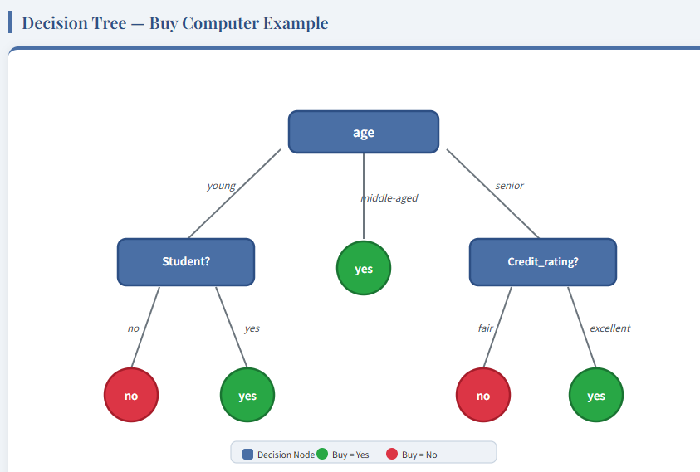

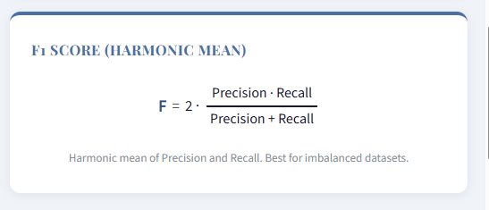
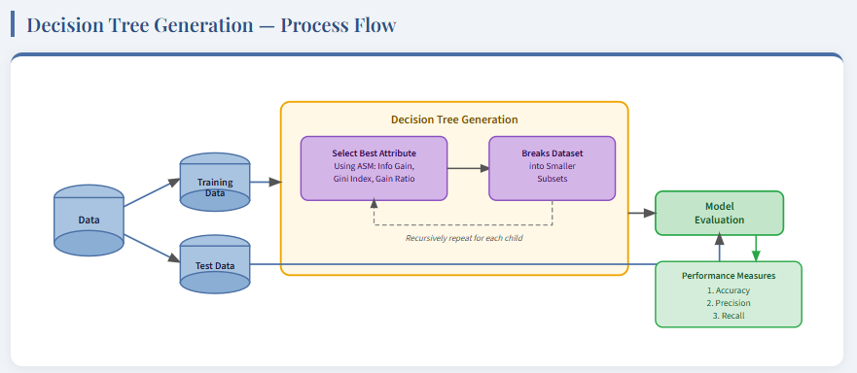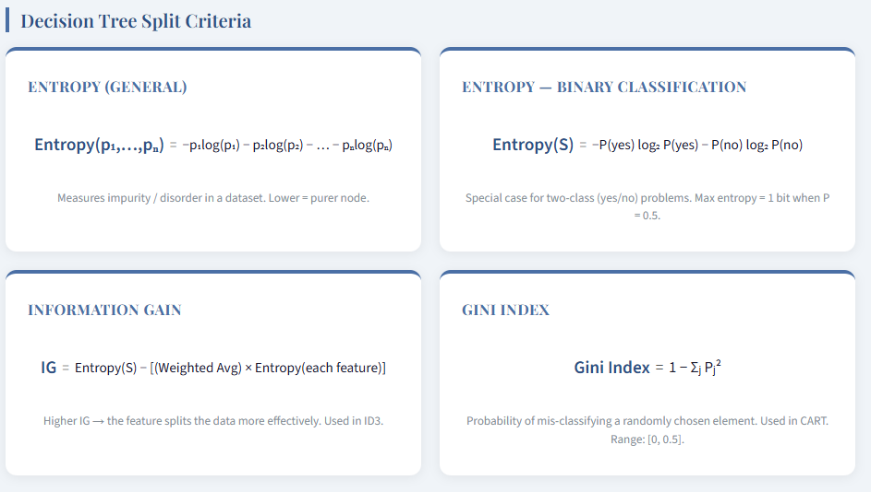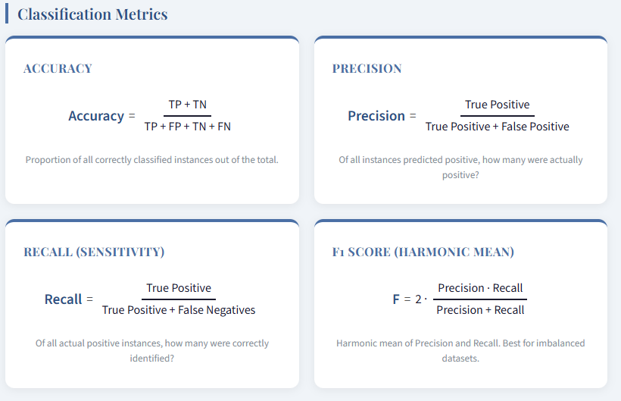
ALL NUMARICALS ARE BASED ON THESE FORMULAS

