Part 1: Key Formats & Simple Definations (JUST SEE IT)
What is a memorandum?
A memorandum, or memo, is a document shared with a group of people to disperse information on a task, project, event, or other. The purpose of a memo is to bring immediate attention to that information in a quick and brief manner.

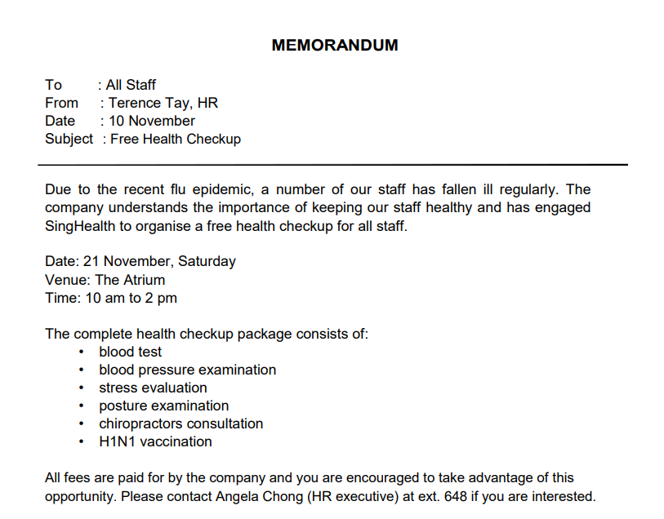
Communities can use memos to tell people within it about public safety guidelines, promote various events, raise awareness on subjects that affect their lives. Businesses can use memos to relay information involving newly updated policy, changes in procedure, or persuade employees to take an action, such as attend an upcoming meeting, convention, or a celebration for organizational milestones.

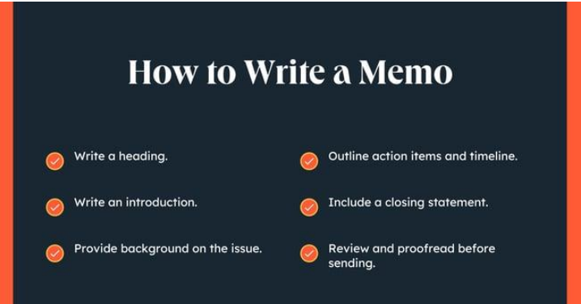

What is a AIDA?

The AIDA model is a proven formula for persuasive writing in advertising that guides your audience through four essential stages to encourage a purchase. Each step is designed to achieve a specific persuasive effect.

1. Attention:
Grab your audience's awareness immediately.
Your message must first gain the target audience's attention. To create attention-grabbing consider what your customer cares about, including their background, challenges, and motivations.
- Do:
  - Use direct, actionable language.
  - Invoke emotion with powerful wording.
  - Ask questions to encourage engagement.
  - Customize the message to prove it's relevant to them.
- Don't:
  - Use vague or clickbait words like "important" or "free!!".
  - Rely on all caps.
  - Use fake compliments or clichés like "Do you have a moment?".

2. Interest: Keep them engaged.
Once you have their attention, you must arouse their interest in the product. Show them you understand their needs by personalizing the message and proposing a solution to a problem they can relate to.

3. Desire: Make them want your offer.
Turn their interest into desire by highlighting the unique, audience-focused benefits of your product. Explain how it will make their life better or easier and showcase testimonials or case studies to build credibility.

4. Action: Tell them what to do next.
Encourage your audience to take a specific action, such as making a purchase or investigating further. Your call to action (CTA) should be clear, direct, and outline the exact next steps you want them to take. Avoid vague sign-offs like "Let me know what you think".

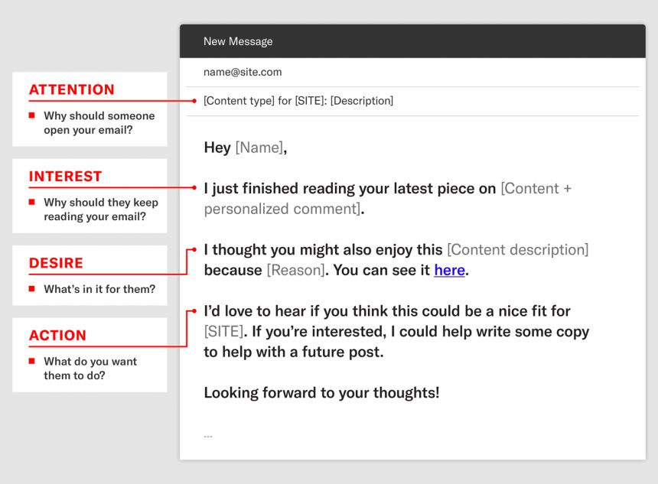

What is Personal Branding for Engineers?
Personal branding is how you present your unique combination of Technical skills, Problem-solving abilities, and Professional identity to potential employers. It's about creating a consistent, memorable impression that differentiates you from other engineering candidates.
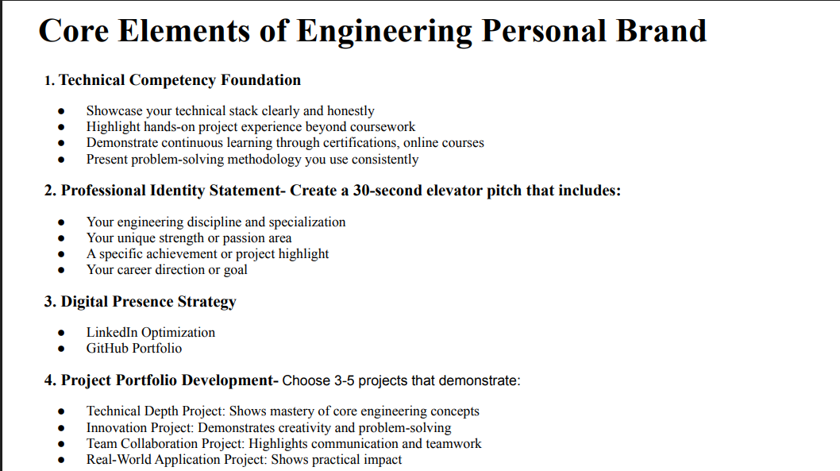

What is a Email?
An email is a digital message sent between people using electronic devices. A well-written email is clear, concise, and has a subject line that effectively summarizes its content.
Key points for writing an effective email are:
- Draft a clear, simple subject line.
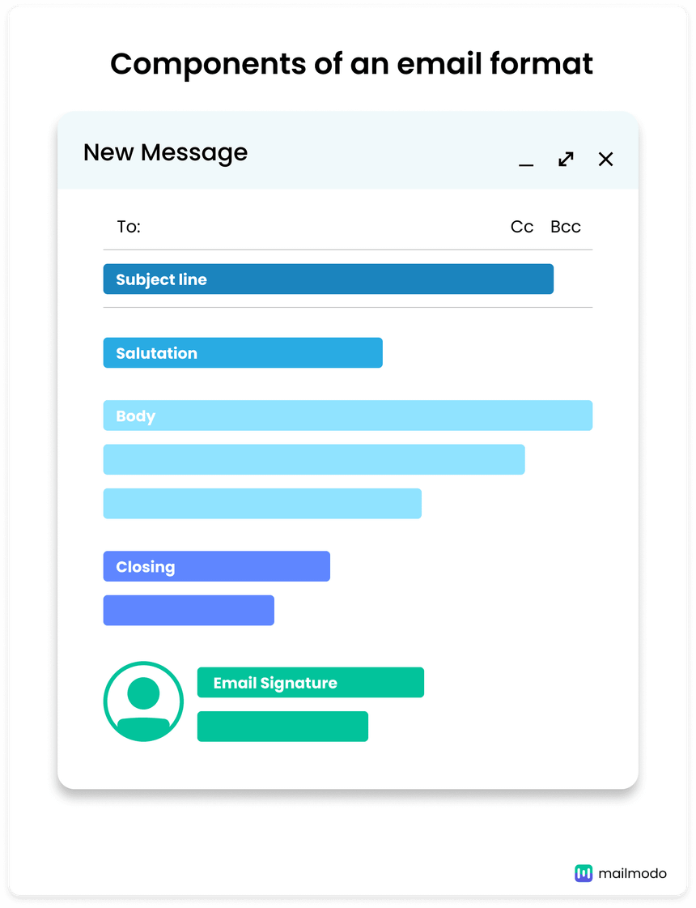
- Keep messages clear and brief.
- Address recipients formally and be polite.
- Structure the message clearly.
- Check the tone of your message before sending.
- Include a professional closing and a call to action
at the end.
- Always proofread your email before sending it.

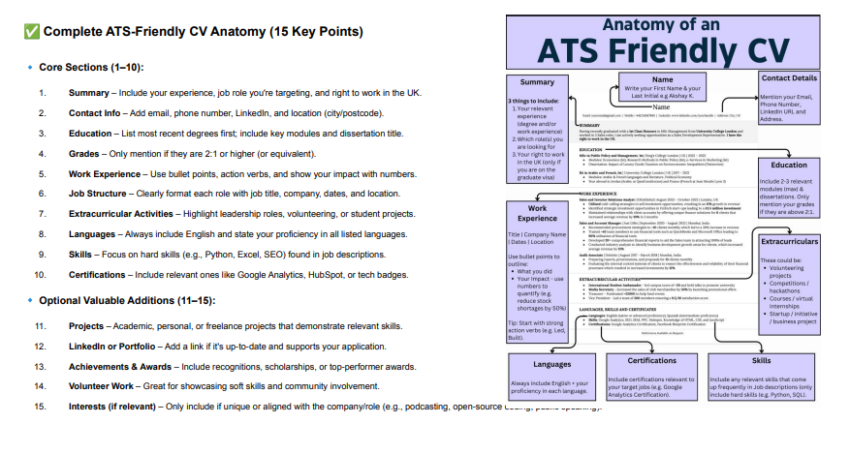

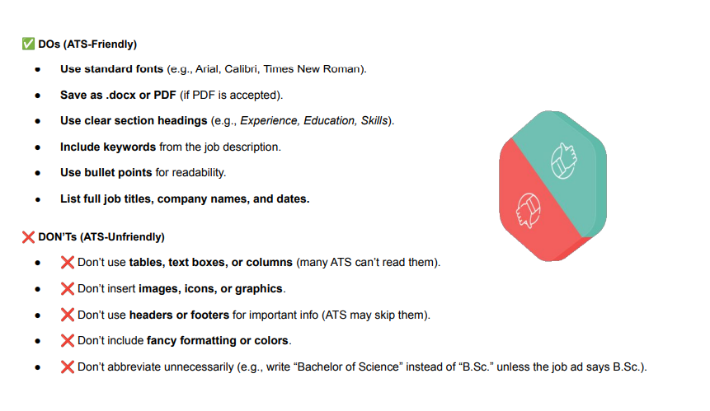

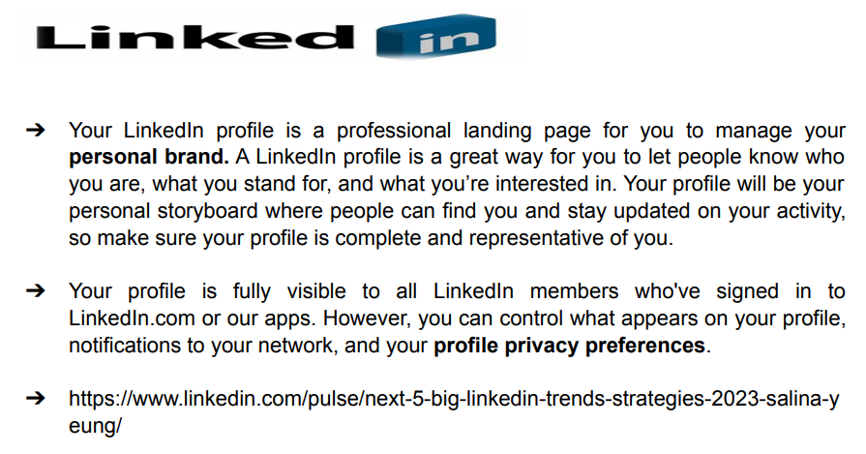

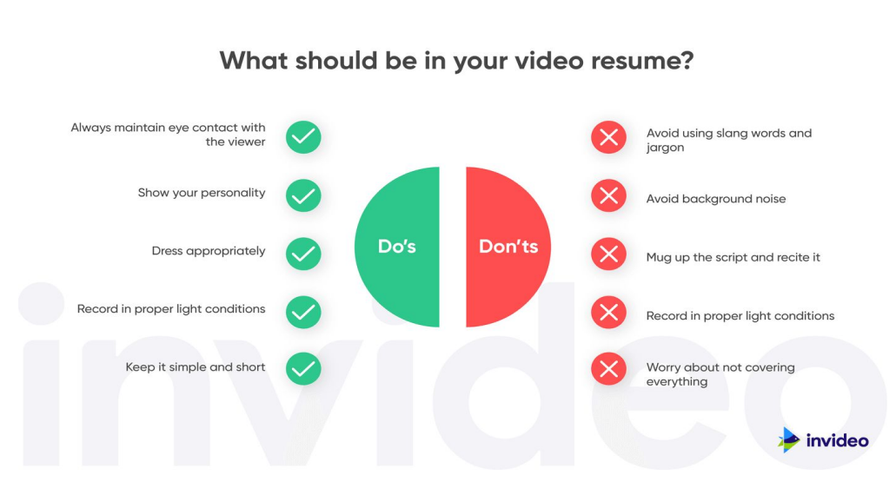

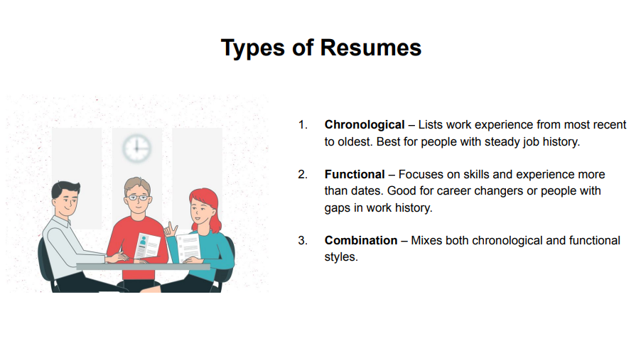

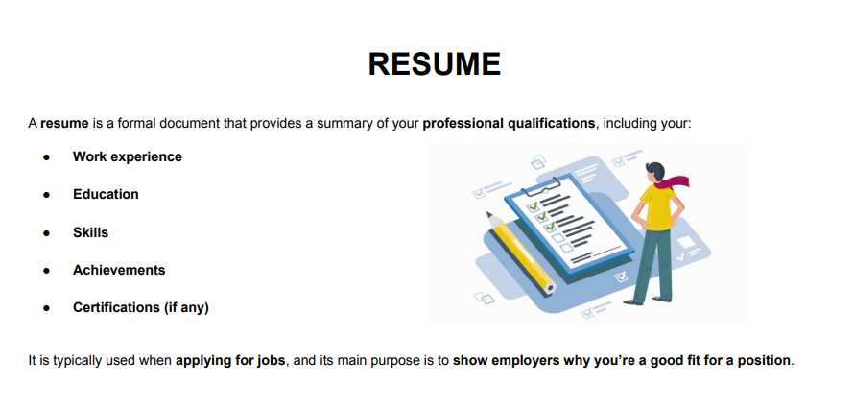

5 Key Frequently Asked Questions
- "Tell me about yourself."
Why it’s asked: To assess your communication skills and see if your background aligns with the role. Key Tip: Keep it concise (1–2 mins), relevant, and career-focused.
- "What are your strengths and weaknesses?"
Why it’s asked: To gauge self-awareness and how you handle challenges.
Key Tip: Turn weaknesses into growth opportunities.
- "Explain a technical project you worked on."
Why it’s asked: To test hands-on experience and technical depth.
Key Tip: Use the STAR method (Situation, Task, Action, Result).
- "Why should we hire you?"
Why it’s asked: To see if you understand the role and can sell yourself.
Key Tip: Match your answer to the job description.
- "Where do you see yourself in 5 years?"
Why it’s asked: To check career goals and long-term fit. Key Tip: Show ambition but align it with the company’s vision.

Part 2: Exam Q&A Section (READ IT)
Q1 What is the primary purpose of a memorandum?
A memorandum (memo) is a document shared with a group of people to disperse information on a task, project, or event. Its primary purpose is to bring immediate attention to that information in a quick and brief manner.

Q2 Identify two contexts where businesses use memos.
Businesses use memos to relay information involving newly updated policy or changes in procedure. They also use memos to persuade employees to take an action, such as attending an upcoming meeting or celebration.

Q3 Outline the essential components of a memo's heading section.
The essential components of a memo's heading include the recipient, the sender, the date, and the subject line. The 'TO' field specifies who the memo is for, whether an individual or a department. The 'FROM' field indicates the sender, and the 'DATE' specifies when the memo was written. The 'SUBJECT' line should be short, attention-grabbing, and give readers a general idea of what the memo is about.

Q4 Describe the initial two content sections following the heading in a professional memo. Following the heading, a professional memo starts with an introduction that summarises its purpose in two to three sentences. This brief intro gets straight to the point and acts as a powerful tool for creating clarity. The next section provides background on the issue, explaining the reasoning behind the memo. This could involve changes in the budget or a new rollout of procedures, providing justification for any implemented changes.

Q5 Explain the comprehensive process of writing a professional memo, detailing each structural component and its intended content.
Writing a professional memo involves several key steps and structural components designed for clarity and impact. Firstly, include a clear heading with 'TO', 'FROM', 'DATE', and a concise 'SUBJECT' line to immediately inform readers about the memo's context. Secondly, write a brief introduction (two to three sentences) that summarises the memo's purpose, getting straight to the point. Thirdly, provide background on the issue, explaining the reasoning behind the memo, such as policy changes or new procedures, which justifies the information being shared. Fourthly, outline action items and a timeline (if applicable), clearly stating what needs to be done, expected changes, deadlines, and when changes go into effect. This section can be omitted if no action is required. Finally, include a closing statement to reinforce the message and provide contact information for any questions. It is crucial to review and proofread the document before sending to avoid confusion.
Email Etiquette

Q6 What is a critical characteristic of a well-written email's subject line?
A critical characteristic of a well-written email's subject line is that it should provide essential information, allowing the recipient to understand the email's content without having to open it. A blank subject line is often ignored or rejected as spam.

NOTES / MINDMAP/ VIDEO MADE BY ABDUL HAMEED (SHIDO)
Q7 Explain the importance of a clear and concise subject line in professional emails.
A clear and concise subject line is crucial in professional emails because it acts as a primary indicator of the email's content and urgency. It allows the recipient to quickly grasp the email's purpose without opening it, saving time and aiding in message prioritisation. Conversely, a blank or vague subject line is more likely to be ignored or filtered as spam, meaning important information might not reach the intended recipient. Therefore, choosing the right words to articulate the email's topic in the subject line is fundamental for effective communication.

Q8 Discuss the strategic role of subject lines in professional email communication and outline best practices for their creation.
The subject line plays a strategic and pivotal role in professional email communication as it is often the first, and sometimes only, impression a recipient has of an email. Its primary function is to provide essential information upfront, allowing the recipient to understand the email's content and importance without needing to open it. This efficiency is critical in today's busy professional environment, where recipients often triage emails based solely on the subject. A well-crafted subject line directly influences open rates and engagement, ensuring that important messages are not overlooked. Best practices for creating effective subject lines include being direct and actionable, clearly stating what the email is about using appropriate words. It should be concise to ensure readability, especially on mobile devices. Avoiding vague or "clickbaity" language is advised, as is refraining from excessive punctuation or all caps, which can make an email appear unprofessional or like spam. Ultimately, the subject line should be a miniature summary, accurately reflecting the email's purpose and encouraging the recipient to open it based on its relevance.

Q9 What is a resume, and what is its main purpose?
A resume is a formal document that provides a summary of an individual's professional qualifications, including their work experience, education, skills, and achievements. Its main purpose is to show employers why the candidate is a good fit for a position when applying for jobs.

Q10 What are two "don'ts" for creating an ATS-Unfriendly resume?
Two "don'ts" for creating an ATS-Unfriendly resume include using tables, text boxes, or columns, as many ATS cannot read them. Another is to avoid inserting images, icons, or graphics, as these can also be problematic for ATS.

Q11 List and briefly describe the three main types of resumes.
The three main types of resumes are chronological, functional, and combination. A chronological resume lists work experience from most recent to oldest, making it ideal for individuals with a steady career path. A functional resume focuses on skills and experience more than dates, which is beneficial for career changers or those with gaps in their work history. A combination resume offers a flexible mix of both chronological and functional styles, allowing candidates to highlight both skills and a steady career progression.

Q12 Identify five core sections that should be included in an ATS-Friendly CV anatomy. Five core sections for an ATS-Friendly CV include the Summary, outlining experience and target job role. Contact Info should provide email, phone, LinkedIn, and location. Education lists degrees (most recent first), key modules, and dissertation titles. Work Experience uses bullet points, action verbs, and quantifiable impact. Finally, Skills should focus on hard skills relevant to job descriptions, like Python or Excel.

Q13 Explain how to create an , detailing both crucial elements to include and formatting aspects to avoid to ensure successful screening by applicant tracking systems.
Creating an ATS-Friendly resume is crucial for getting past the initial screening by Applicant Tracking Systems (ATS), which are machine gatekeepers. To achieve this, several elements must be included and certain formatting avoided. Do use standard fonts like Arial or Calibri and clear section headings such as "Experience" and "Education". It is vital to include keywords directly from the job description to match the ATS's search criteria. Use bullet points for readability and list full job titles, company names, and dates. Core sections should include a summary of your experience and target role, contact info, education (most recent first), grades (if 2:1 or higher), work experience (using action verbs and numbers), extracurricular activities, languages, and hard skills aligned with job descriptions. Optional valuable additions like projects, LinkedIn links, achievements, and volunteer work can further enhance the resume. Conversely, don't use tables, text boxes, or columns, as many ATS cannot read them. Avoid inserting images, icons, or graphics, and do not place crucial information in headers or footers, as ATS may skip them entirely. Fancy formatting, colours, or unnecessary abbreviations should also be avoided to ensure the resume is machine-readable.

Q14 How does personal branding for engineers differentiate them from other candidates? Personal branding for engineers differentiates them by presenting their unique combination of technical skills, problem-solving abilities, and professional identity. It helps create a consistent, memorable impression that makes them stand out from other engineering candidates.

Q16 Outline the core elements that constitute an effective engineering personal brand.
An effective engineering personal brand comprises three core elements. First, Technical Competency Foundation requires showcasing technical skills clearly, highlighting hands-on project experience, and demonstrating continuous learning through certifications. Second, a Professional Identity Statement involves creating a 30-second elevator pitch that includes their engineering discipline, unique strengths, a specific achievement, and career goals. Third, a strong Digital Presence Strategy is essential, primarily through LinkedIn optimization and a GitHub

Q17 Discuss the significance of a LinkedIn profile for students in managing their professional brand and creating opportunities. What key elements should be showcased on a strong LinkedIn profile?
- A LinkedIn profile is a professional landing page for students to effectively manage their personal brand, which is crucial for career development. It allows students to let people know who they are, what they stand for, and what their interests are, serving as a personal storyboard for their professional journey. For students, building a LinkedIn profile helps them manage their professional brand, create opportunities for themselves, build their network, track professional milestones, take skill assessments, get endorsed, and request recommendations.
- To create a strong LinkedIn profile, key elements should be showcased:
- A crisp professional identity statement acting as a 30-second elevator pitch. This should include their engineering discipline, unique strength, a specific achievement, and career direction.
- A super clear showcase of technical skills.
- A portfolio with three to five key projects that demonstrate technical depth, innovation, and teamwork.
- Education and any relevant certifications or online courses to demonstrate continuous learning.
- Work experience (including internships or part-time roles) and volunteer work to highlight soft skills and community involvement.
- Achievements and awards that demonstrate recognition or top performance.

Q18, What does the AIDA acronym represent in the context of persuasive writing?
The AIDA acronym represents Attention, Interest, Desire, and Action. It is a tried and proven persuasive writing technique used by advertising professionals.

Q19 Why is the AIDA formula considered a "hierarchy-of-effects model"?
The AIDA formula is considered a "hierarchy-of-effects model" because, in terms of persuasion, each element within the formula is designed to produce a desired effect. Consumers are expected to move through each stage sequentially, interacting with a product or service until they convert into a customer.

Q20 Briefly explain each stage of the AIDA formula and its objective.
The AIDA formula comprises four stages, each with a specific objective.
- Attention: The goal is to catch the audience's attention and create initial awareness. This involves using a powerful hook or headline.
- Interest: Once attention is gained, the objective is to arouse or evoke their interest in the promoted product by connecting with the reader. Personalization and showing an understanding of their problems can maintain engagement.
- Desire: This stage aims to stimulate the audience's desire to purchase the value proposition by explaining what they will gain. Highlighting benefits and demonstrating expertise helps turn interest into genuine desire.
- Action: The final objective is to encourage the target audience to take a specific action, such as further investigation or a physical purchase. This requires a clear and concise call to action.

Q21 Describe how marketers can effectively use the AIDA model in practice, providing specific strategies for each stage to achieve maximum persuasive impact.
Marketers can effectively use the AIDA model as a four-step journey to guide their audience towards a desired action, achieving maximum persuasive impact.
- Attention: To grab attention, marketers must open their content with a powerful hook. This is crucial for headlines and subject lines, often competing with many others. Strategies include using direct and actionable language, invoking emotion with powerful copy, asking questions to encourage a response, and customising to prove relevancy. Avoiding vague words, all caps, fake authenticity, or clichés is advised.
- Interest: Once attention is secured, the challenge is to inspire interest and keep the audience engaged. Personalization is a great way to connect, showing an understanding of their problems. Marketers should demonstrate a deep understanding of their audience, propose solutions to relatable problems, and speak their language using industry terms. Avoid lengthy, irrelevant copy or focusing solely on one's own benefits.
- Desire: With interest established, the next step is to generate desire for the offer. This is achieved by backing up the pitch with concrete benefits for the audience, explaining how it will make their life easier or better. Strategies include highlighting uniqueness, presenting audience-focused benefits, and demonstrating expertise or credibility with examples, case studies, or testimonials. The offer should not be buried or sound overly promotional.
- Action: Finally, marketers must round out their content with a clear and concise call to action (CTA). This involves being direct about the next steps, such as filling out a form or responding to an email, and avoiding vague language or multiple options. Reducing friction for the audience by providing value-adds, like data results or links to relevant resources, can increase the odds of them taking action. For instance, subtle CTAs embedded in content and larger CTA buttons at the bottom of articles make it easy for readers to shop or explore options.

