SOFTWARE QUALITY ASSURANCE (23CSE701)
Comprehensive Exam-Oriented Question Bank

Part 1 – Question Paper Creation
Section A: 10-Mark Questions (Long Answer Type)
- What is Software Quality Assurance (SQA)? Explain its key objectives, scope across the Software Development Life Cycle (SDLC), and demonstrate its practical application using a Banking Software Example.
- Detail the Human Components of SQA. Explain the distinct roles, responsibilities, and contributions of Top Management, Project Managers, the SQA Unit, Testers/Reviewers, Developers, Customers/Users, and External Bodies.
- Define Software Quality Management (SQM). Elaborate on its three primary components—Quality Planning, Quality Assurance, and Quality Control—and explain how continuous improvement is achieved using the Plan-Do-Check-Act (PDCA) cycle.
- What is Software Configuration Management (SCM)? Discuss its primary objectives, key activities (Identification, Control, Status Accounting, Audits), version control tools, and its role in supporting SQA.

Section B: 5-Mark Questions (Medium Answer Type)
- Compare and contrast Software Quality Assurance (QA) and Software Quality Control (QC) across key engineering dimensions.
- Explain the purpose, structure, typical components, and additional requirements of an SQA Plan.
- Discuss the Economics of Quality by detailing the four major categories of quality costs and explaining how SQA balances them.
- Explain how SQA activities are integrated across each phase of the Software Development Life Cycle (SDLC).
- Describe the role, authority, and main activities of an Independent SQA Unit within a software development organization.
- Outline the Configuration Control Process in SCM, explaining the five step-by-step procedures involved in handling change requests.
- Explain the critical trade-offs and considerations required to balance SQA thoroughness with operational practicality.
- Discuss the significance of International Standards and Models (ISO 9001 and CMMI) in establishing software quality frameworks.

Section C: 2-Mark Questions (Short Answer Type)
- Define Software Quality Assurance (SQA) and state its primary process goal.
- What is an SQA Plan and what is its primary purpose?
- Differentiate between Internal Failure Costs and External Failure Costs.
- Why is documentation referred to as the backbone of SQA?
- What is the primary role of Top Management in enforcing software quality?
- Explain how developers act as first-level guardians of software quality.
- What is Quality Planning within Software Quality Management?
- Define Software Configuration Management (SCM).
- What is Configuration Identification in SCM, and what items are identified?
- List four key features provided by modern Version Control Systems (VCS).

Part 2 – Model Answer Key
Section A: 10-Mark Questions

Question 1: What is Software Quality Assurance (SQA)? Explain its key objectives, scope across the Software Development Life Cycle (SDLC), and demonstrate its practical application using a Banking Software Example.

Introduction: Software Quality Assurance (SQA) is defined as a systematic set of organizational activities designed to ensure that software processes and final products conform strictly to specified requirements, industry standards, and established procedures. It represents a proactive, process-oriented engineering methodology focused on preventing defect occurrence throughout development rather than merely detecting bugs after build completion.
1. Process-Oriented Prevention Focus:
- Defect Prevention Foundation: SQA focuses on establishing robust rules, guidelines, and structural workflows across development phases to stop defects before they enter the software.
- Systematic Process Oversight: By continuously evaluating development workflows and adherence to protocols, SQA minimizes error entry during initial code creation.
- Long-Term Quality Culture: It builds an organizational culture where quality enforcement is treated as an active, ongoing process rather than a final gatekeeping check.
2. Customer Satisfaction:
- Fulfilling End-User Expectations: SQA ensures that the software product completely satisfies user requirements regarding functionality, operational usability, and overall performance.
- Building System Reliability: Consistently verifying features against real-world user workflows establishes long-term user confidence and product trust.
- Validating Operational Fit: SQA guarantees that delivered software is strictly fit for its intended operational purpose in live business environments.
3. Standards Compliance:
- Adherence to International Norms: SQA verifies that all development processes align with established international standards such as ISO 9001, ISO 25010, and CMMI frameworks.
- Organizational Rule Verification: It confirms that project teams consistently follow internal organizational procedures, coding conventions, and architectural guidelines.
- Regulatory Governance: Compliance checks protect organizations from legal or operational liabilities by ensuring mandatory security and industry benchmarks are met.
4. Continuous Process Improvement:
- Ongoing Practice Refinement: SQA drives systematic evaluations of development techniques to identify procedural bottlenecks and recurrent defect causes.
- Feedback Loop Implementation: Process audits generate actionable feedback that updates engineering guidelines and refines future development methodologies.
- Sustained Organizational Growth: Using iterative learning cycles keeps the organizational quality management system aligned with dynamic industry shifts.
5. Cost Minimization:
- Minimizing Rework Expenses: SQA significantly lowers the total cost of software quality by identifying defects early, preventing expensive post-release rework.
- Reducing Failure Liabilities: Investing in structured prevention avoids catastrophically expensive external failure costs that damage corporate reputation.
- Optimizing Quality Investments: It balances preventive quality measures against appraisal expenses to achieve an optimal cost-to-quality ratio.
6. Complete SDLC Coverage:
- End-to-End Life Cycle Ingestion: SQA activities span every phase of the Software Development Life Cycle, including requirements, design, coding, testing, release, and maintenance.
- Early Defect Elimination: Reviewing deliverables at each phase catches defects closest to their point of origin, drastically reducing correction overhead.
- Maintenance Stage Safeguards: SQA ensures that subsequent software updates, patches, and feature additions do not degrade existing system stability.
7. Comprehensive Process Involvement:
- Defining Standard Workflows: SQA defines standard organizational processes, review guidelines, and formal execution frameworks.
- Conducting Audits and Checkpoints: Independent verification checkpoints, peer reviews, and process audits are performed systematically across teams.
- Managing Feedback Channels: Systematic metrics collection establishes structured loops that continuously feed operational data back into process planning.
8. Banking Example – Critical Security and Integrity Review:
- Domain Requirement Scrutiny: In a banking application, SQA mandates rigorous requirements reviews covering transaction accuracy, multi-factor authentication, and data encryption.
- Preventing Data Corruption: Reviewing database access workflows early ensures strict compliance with ACID properties and financial privacy regulations.
- Verifying Operational Resilience: SQA establishes strict verification rules to guarantee system availability under high transaction loads.
9. Banking Example – Review and Audit Checkpoints:
- Formal Inspection Gateways: Peer code reviews and static analysis checks are required for all financial calculation modules prior to integration.
- Process Compliance Audits: Independent auditors verify that banking developers follow secure coding practices and change authorization rules.
- Regression Testing Oversight: SQA mandates standardized regression test execution to verify that patch deployments do not introduce security flaws.
10. Banking Example – Risk Mitigation and Post-Release Safety:
- Preventing Operational Failures: Catching transaction logic defects early eliminates post-release system crashes that could cause financial loss.
- Preserving Customer Trust: Thorough pre-release verification protects the institution against catastrophic public failures and loss of market credibility.
- Regulatory Reporting Integrity: Systematic audit logging ensures that the software satisfies mandatory regulatory compliance inspections.

Question 2: Detail the Human Components of SQA. Explain the distinct roles, responsibilities, and contributions of Top Management, Project Managers, the SQA Unit, Testers/Reviewers, Developers, Customers/Users, and External Bodies.

Introduction: While technical procedures, automated tools, and standardized methodologies are essential, the success of any SQA system ultimately depends on the human components involved. Human actors serve as the primary driving force behind planning, executing, monitoring, and sustaining software quality practices across an organization.
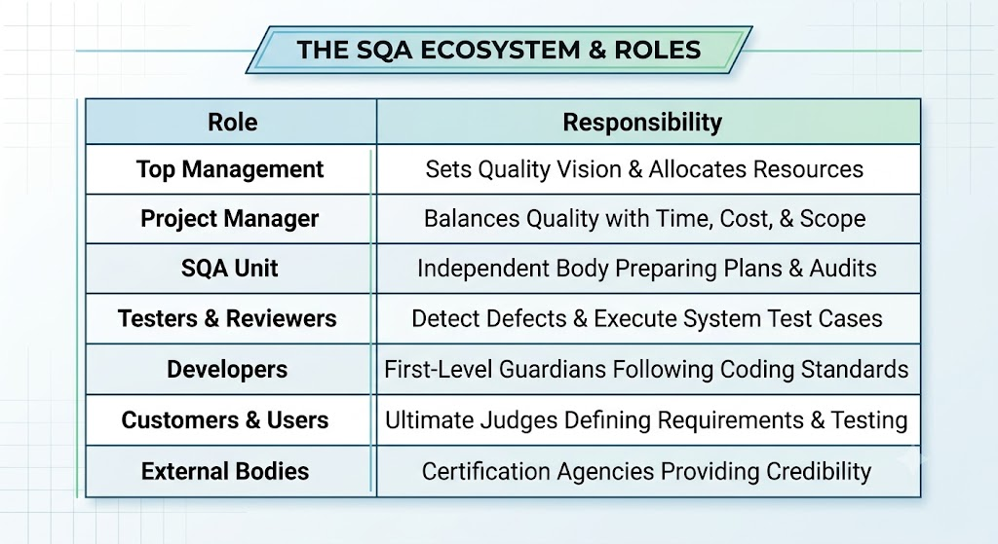
1. Human Centricity in Quality Systems:
- People as Quality Drivers: SQA relies on human leadership, discipline, and collaboration to translate theoretical quality frameworks into daily engineering practices.
- Cultivating Quality Culture: Establishing an organization-wide mindset where quality is everyone's responsibility requires active human engagement.
- Cross-Functional Collaboration: Seamless interaction among distinct organizational roles ensures quality goals are understood and enforced collectively.
2. Top Management – Vision and Policy Setting:
- Defining Quality Objectives: Top management establishes the organization's overarching quality policies, strategic targets, and performance benchmarks.
- Resource Allocation: Executive leadership secures necessary funding, staffing, technical infrastructure, and training tools for SQA initiatives.
- Leading by Example: Visible leadership commitment motivates the entire workforce and ensures quality initiatives are prioritized over short-term cutbacks.
3. Project Manager – Balancing Constraints and Quality:
- Translating Organizational Policies: Project managers convert general corporate quality guidelines into actionable, project-specific engineering practices.
- Managing Project Constraints: They balance mandatory quality assurance activities against strict project constraints including schedule, budget, and scope.
- Facilitating Team Alignment: Project managers coordinate smooth communication between development teams, testing groups, and independent quality units.
4. SQA Unit – Independent Quality Authority:
- Organizational Independence: The SQA unit operates as an independent body separate from development and testing teams, ensuring objective quality evaluation.
- Plan Preparation and Enforcement: They formally document SQA plans, establish verification checkpoints, and enforce adherence to process standards.
- Executive Metrics Reporting: SQA units perform independent compliance audits and report unbiased quality metrics directly to senior management.
5. Testers and Reviewers – Defect Detectives:
- Backbone of Defect Detection: Testers design, execute, and document comprehensive test cases to validate software behavior against user specifications.
- Multi-Level Test Execution: They execute unit, integration, system, and regression test suites to surface functional bugs before deployment.
- Peer Reviews and Inspections: Reviewers conduct formal code inspections and structural reviews to identify logical flaws and architectural violations.
6. Developers – Creators and First-Level Guardians:
- Adhering to Coding Standards: Developers serve as primary quality guardians by strictly following organizational guidelines to produce clean, maintainable code.
- Executing Self-Reviews: They perform static checks and initial self-reviews to eliminate obvious logical bugs prior to code submission.
- Defect Rectification and Technical Documentation: Developers collaborate with testers to fix identified bugs and create thorough technical docs for future maintenance.
7. Customers and End Users – Ultimate Judges:
- Requirement Definition: Customers provide the fundamental operational requirements and acceptance criteria that define product quality targets.
- User Acceptance Testing (UAT): End users evaluate software prototypes and pre-release builds to verify that operational needs are fully satisfied.
- Usability and Real-World Feedback: User feedback during evaluations guides usability refinements and validates overall system fit.
8. External Bodies – Accreditation and Validation:
- ISO Certification Auditors: External auditors assess organizational processes against international standards like ISO 9001 to issue formal quality accreditations.
- CMMI Process Appraisers: External appraisers evaluate process maturity levels and provide structured recommendations for organizational capability growth.
- Specialized Quality Consultants: External experts supply objective perspectives, specialized knowledge, and third-party validation that enhances client trust.
9. Collaborative Responsibility Synergy:
- Shared Ownership Model: SQA succeeds only when quality is recognized as a shared responsibility spanning executive, development, and user tiers.
- Cross-Role Feedback Loops: Insights generated by testers, developers, and users continuously inform project managers and SQA units for process tuning.
- Eliminating Silo Drag: Active cooperation breaks down communication barriers between building, verifying, and managing roles.
10. Strategic Value of the Human Factor:
- Strengthening Institutional Credibility: Independent audits and user-centric validation combine to build market reputation and customer trust.
- Preventing Process Breakdown: Committed human leadership ensures quality procedures remain active even under severe delivery deadlines.
- Sustaining Long-Term Quality Culture: Continuous human skill development through training creates an evolving, resilient software engineering environment.

Question 3: Define Software Quality Management (SQM). Elaborate on its three primary components—Quality Planning, Quality Assurance, and Quality Control—and explain how continuous improvement is achieved using the Plan-Do-Check-Act (PDCA) cycle.

Introduction: Software Quality Management (SQM) is a comprehensive, systematic approach in software engineering that ensures products and development processes meet predefined quality standards and satisfy customer expectations. SQM extends far beyond simple defect detection by establishing organizational policies, defining quality objectives, allocating responsibilities, and continuously improving development life cycles.
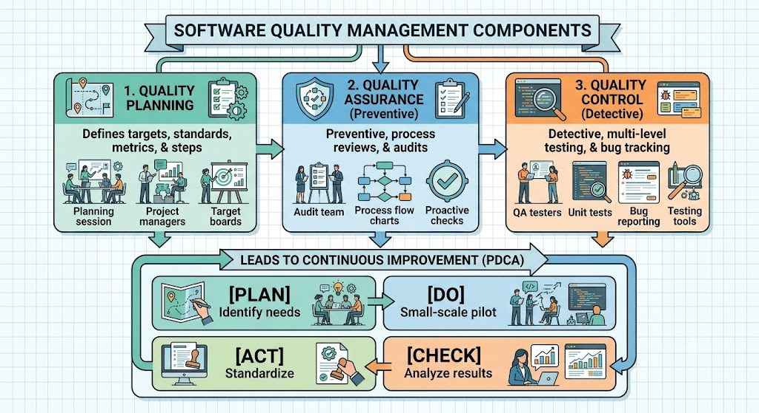
1. Core Philosophy and Objectives of SQM:
- Fit for Operational Purpose: SQM ensures delivered software operates as intended in its live environment, meeting user needs seamlessly.
- Conformance to Requirements: It guarantees strict compliance with specified functional and non-functional engineering requirements.
- Cultural Quality Integration: SQM embeds quality objectives into organizational culture with active support from executive leadership.
2. Component 1 – Quality Planning Definition:
- Upfront Baseline Setting: Quality Planning embeds quality considerations into projects from start, establishing clear goals aligned with business targets.
- Standard and Metric Selection: It selects applicable international engineering standards (e.g., ISO, IEEE) and defines quantitative metrics like defect density.
- Resource and Process Allocation: Planning identifies necessary life cycle processes, defines review schedules, and allocates required resources.
3. Component 2 – Quality Assurance (QA) Focus:
- Preventive Process Confidence: QA focuses on preventing defects by providing systematic confidence that development processes adhere to rules.
- Process Reviews and Audits: It evaluates workflows through structured process reviews and independent audits to verify standards adherence.
- Establishing Standard Workflows: QA establishes development conventions, architectural guidelines, and quality checklists across project teams.
4. Component 3 – Quality Control (QC) Focus:
- Detective Product Verification: QC represents an operational, detective discipline focused on discovering defects within the built software product.
- Multi-Level Software Testing: It executes unit, integration, system, and user acceptance test suites to evaluate software functionality.
- Inspections and Defect Tracking: QC utilizes static analysis, code inspections, and defect tracking systems to manage bug resolution.
5. Grounding in Standards and Maturity Models:
- ISO 9001 Integration: SQM utilizes ISO 9001 frameworks to maintain consistent quality management procedures across projects.
- CMMI Maturity Benchmarking: It adopts Capability Maturity Model Integration (CMMI) across five maturity levels to guide structured process refinement.
- Benchmark Credibility: Adopting established standards enhances market credibility and validates process maturity to external clients.
6. Continuous Improvement – The PDCA Cycle Framework:
- Iterative Learning Model: SQM drives ongoing quality improvement using the iterative Plan-Do-Check-Act (PDCA) framework.
- Data-Driven Problem Identification: The cycle utilizes defect logs, audit findings, and customer feedback to isolate operational weaknesses.
- Systemic Root Cause Analysis: PDCA targets underlying process gaps rather than symptoms, ensuring lasting process enhancements.
7. PDCA Stage 1 – Plan:
- Isolating Improvement Gaps: Teams evaluate historical defect data and performance metrics to identify procedural weaknesses.
- Formulating Action Plans: Detailed corrective strategies, updated guidelines, and new process targets are created to address gaps.
- Establishing Evaluation Metrics: Expected outcome metrics are defined to measure the success of proposed modifications.
8. PDCA Stage 2 – Do:
- Small-Scale Implementation: Planned process modifications are deployed on a pilot basis or within select project modules.
- Controlled Environment Testing: Implementing changes on a limited scale minimizes operational risk while gathering real-world execution data.
- Executing Updated Guidelines: Development teams follow modified coding standards or review workflows during trial runs.
9. PDCA Stage 3 – Check:
- Measuring Performance Outcomes: Quality teams collect and measure post-implementation metrics against baselined expectations.
- Analyzing Effectiveness: Data from defect tracking and process reviews is analyzed to verify if changes yielded actual quality gains.
- Identifying Process Deviations: Any unexpected side effects or procedural bottlenecks encountered during pilot execution are documented.
10. PDCA Stage 4 – Act:
- Standardizing Successful Changes: Proven process enhancements are formally integrated into standard organizational operating procedures.
- Re-Initiating Improvement Loops: If pilot results are unsatisfactory, the team adjusts parameters and re-executes the PDCA cycle.
- Sustaining Quality Evolution: Continuous PDCA cycles prevent quality stagnation and keep organizational practices aligned with industry needs.

Question 4: What is Software Configuration Management (SCM)? Discuss its primary objectives, key activities (Identification, Control, Status Accounting, Audits), version control tools, and its role in supporting SQA.

Introduction: Software Configuration Management (SCM) is a specialized discipline within Software Quality Assurance that focuses on controlling, tracking, and managing changes made to software artifacts throughout the development life cycle. SCM establishes technical baselines and controlled workflows to preserve software integrity and prevent uncontrolled modifications from corrupting the codebase.

1. Primary Objective 1 – Maintaining Artifact Integrity:
- Ensuring Artifact Consistency: SCM guarantees consistency across source code, design specifications, test scripts, and documentation at every stage.
- Preventing Unauthorized Changes: It ensures that only fully authorized, tested, and approved modifications are incorporated into released software.
- Baselining System State: Establishing stable baselines allows development teams to maintain known, reliable product configurations.
2. Primary Objective 2 – Tracking and Collaboration:
- Comprehensive Modification History: SCM tracks every code addition, modification, or deletion, recording who made changes and why.
- Facilitating Parallel Development: It enables multiple developers to work on concurrent feature branches without overwriting each other's work.
- Version Traceability: SCM provides end-to-end traceability, linking specific code modifications directly to formal change requests and defects.
3. Key Activity 1 – Configuration Identification:
- Defining Configuration Items (CIs): SCM identifies specific software artifacts that require formal version control and tracking.
- Comprehensive Scope of Items: Controlled CIs include source code files, design documents, test scripts, test data, user manuals, and build/deployment scripts.
- Unique Identification Scheme: Each identified item receives a unique identifier and version number for tracking throughout its lifecycle.
4. Key Activity 2 – Configuration Control Overview:
- Managing Change Workflows: Configuration Control establishes formal procedures for submitting, evaluating, approving, and implementing software changes.
- Preventing Uncontrolled Drift: Requiring formal evaluations stops unauthorized changes that could compromise system stability.
- Governance Board Oversight: Change evaluation is governed by a formal body, ensuring alignment with project targets.
5. Five Steps of Configuration Control:
- Step 1 – Change Request Submission: Stakeholders submit formal modification requests detailing requested functional or technical changes.
- Step 2 – Impact Analysis: Technical teams evaluate potential impacts on other modules, system performance, schedule, and cost.
- Step 3 – CCB Approval Process: The Change Control Board (CCB) reviews impact reports and formally approves or rejects requests.
- Step 4 – Controlled Implementation: Approved changes are coded and modified within an isolated development environment.
- Step 5 – Verification and Merging: Changes are thoroughly tested and verified before being merged into the main production codebase.
6. Key Activity 3 – Configuration Status Accounting:
- Recording Modification Status: Status Accounting logs and reports the status of all configuration items and pending change requests.
- Providing Real-Time Traceability: It supplies reports detailing which version of an item is currently active, what changes occurred, and who authorized them.
- Supporting Management Visibility: Clear status accounting gives project managers full visibility into software configuration history.

7. Key Activity 4 – Configuration Audits:
- Independent Verification Reviews: Independent auditors conduct configuration audits to verify that items conform strictly to specs.
- Functional and Physical Audits: Audits confirm that all approved change requests were correctly implemented and verified through testing.
- Ensuring Baseline Compliance: Auditing guarantees that delivered builds match documented configuration baselines.
8. Modern SCM Tools and Techniques:
- Version Control Systems (VCS): SCM relies on VCS tools such as Git, Subversion (SVN), CVS, and Mercurial for distributed code control.
- Branching and Merging Capabilities: Modern VCS tools support dynamic feature branching and automated merging, simplifying parallel development.
- Automated Traceability Features: VCS platforms maintain complete commit logs, enabling automated artifact traceability and version rollbacks.
9. Direct Role of SCM in Supporting SQA:
- Defect Prevention Support: Controlling change workflows minimizes defects caused by conflicting or uncontrolled code edits.
- Regression Testing Facilitation: SCM enables testers to instantly recreate exact historical software builds to perform accurate regression testing.
- Historical Audit Records: Maintaining complete revision logs provides verifiable historical evidence for formal SQA quality audits.
10. Organizational Benefits and Impact:
- Streamlining Productivity: SCM automates build and change workflows, improving developer efficiency.
- Eliminating Integration Bottlenecks: Systematic merging mechanisms reduce integration conflicts during final software assembly.
- Building Customer Confidence: Reliable configuration management guarantees stable releases, enhancing client trust and market reputation.

Section B: 5-Mark Questions

Question 5: Compare and contrast Software Quality Assurance (QA) and Software Quality Control (QC) across key engineering dimensions.

Introduction: In software engineering, Software Quality Assurance (QA) and Software Quality Control (QC) represent two complementary but fundamentally distinct disciplines within Quality Management. While QA focuses on preventive process management across the life cycle, QC centers on detective product verification to identify defects in actual software deliverables.

Dimension / Attribute | Software Quality Assurance (QA) | Software Quality Control (QC)
Operational Nature | Proactive, preventive process discipline. | Reactive, detective product discipline.
Core Orientation | Process-oriented; focuses on defect prevention. | Product-oriented; focuses on defect identification.
Primary Goal | Define rules and workflows to stop bug entry. | Identify and fix bugs in built software artifacts.
Life Cycle Timing | Executed continuously across all SDLC phases. | Executed during and after software build completion.
Key Activities | Process reviews, audits, standards definition. | Unit/system testing, code inspections, bug tracking.
1. Proactive vs. Reactive Approach:
- QA Proactive Stance: QA establishes preventive rules, development workflows, and standard operating procedures to eliminate defects before coding begins.
- QC Reactive Stance: QC acts reactively by inspecting built modules and running test suites to catch existing bugs in code artifacts.
2. Process Focus vs. Product Focus:
- QA Process Orientation: QA focuses on the development process itself, assessing whether guidelines, standards, and review checkpoints are followed.
- QC Product Orientation: QC focuses on the software product deliverable, verifying functional correctness against specified requirements.
3. Execution Timing Across SDLC:
- QA Continuous Life Cycle Presence: QA activities occur throughout all SDLC stages, including requirements analysis, design, coding, release, and maintenance.
- QC Build-Phase Execution: QC techniques operate primarily during coding, testing, and deployment phases when concrete artifacts exist.
4. Specific Operational Techniques:
- QA Techniques: QA utilizes process audits, peer review frameworks, quality planning, and organizational standards adherence checks.
- QC Techniques: QC employs unit, integration, system, and acceptance testing alongside static code analysis and formal defect tracking.
5. Responsibility Allocation:
- QA Shared Responsibility: Managed independently by the SQA unit while requiring participation across top management, PMs, and developers.
- QC Specialized Verification: Executed primarily by dedicated testers, code reviewers, and automated testing tools.

Question 6: Explain the purpose, structure, typical components, and additional requirements of an SQA Plan.
Introduction: An SQA Plan is a formal document that outlines the quality assurance activities, required resources, execution schedules, and team responsibilities for a software project. It serves as a foundational roadmap that integrates quality practices directly into project management workflows.
1. Purpose and Strategic Value:
- Formal Project Roadmap: Provides a structured roadmap for ensuring quality across all project lifecycle stages.
- Methodology Standard: Defines how standards, tools, metrics, and review checkpoints will be practically applied.
- Project Management Integration: Integrates quality assurance goals seamlessly with overall project schedule and constraint management.
2. Core Structural Components (1 to 3):
- Project Introduction: Summarizes project scope, background, and specific operational purpose.
- Objectives and Scope: Defines specific quality targets, boundary conditions, and acceptance benchmarks.
- SQA Organization: Outlines team hierarchy, individual roles, responsibilities, and authority levels.
3. Core Structural Components (4 to 6):
- Applicable Standards: Specifies mandatory ISO, IEEE, or internal organizational coding conventions.
- Metrics and Measurement: Defines quantitative metrics (e.g., defect density, test coverage) used to gauge quality.
- Reviews and Audits: Establishes formal inspection schedules and process compliance audit gatekeeper checkpoints.
4. Additional Supporting Components:
- Training Requirements: Identifies technical skill gaps and schedules necessary training for development and quality staff.
- SCM Interface Integration: Outlines interaction guidelines with Software Configuration Management for change control.
- Tools and Hardware Resources: Specifies automated testing software, static analyzers, and hardware environments needed.
5. Practical Implementation Example (E-Commerce):
- Mandatory Code Reviews: In an e-commerce website project, the SQA plan requires mandatory peer reviews for all source code modifications.
- Critical Functionality Testing: Mandates rigorous pre-release testing for core modules like login, product search, payment gateways, and order processing.

Question 7: Discuss the Economics of Quality by detailing the four major categories of quality costs and explaining how SQA balances them.
Introduction: The Economics of Quality in software engineering examines the financial relationship between investments in defect prevention and the costs resulting from software failures. SQA seeks to optimize quality expenses by balancing prevention and appraisal investments to minimize overall failure costs.
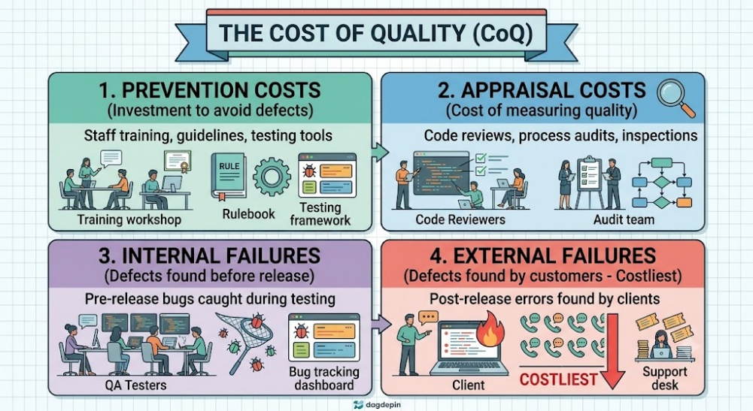
1. Prevention Costs:
- Front-End Quality Investments: Expenses incurred to prevent defects from being introduced into the software in the first place.
- Key Cost Drivers: Includes staff training programs, formulating coding guidelines, process planning, and acquiring automated testing tools.
- Long-Term Impact: Upfront prevention spending drastically cuts downstream rework and defect correction expenses.
2. Appraisal Costs:
- Verification Expenses: Costs associated with inspecting, auditing, and evaluating software artifacts to ensure standards compliance.
- Key Cost Drivers: Encompasses conducting peer reviews, formal design inspections, process compliance audits, and testing activities.
- Ensuring Quality Confidence: Appraisal activities confirm whether prevention measures were executed successfully.
3. Internal Failure Costs:
- Pre-Release Rectification Expenses: Costs resulting from defects detected within the organization prior to product deployment.
- Key Cost Drivers: Includes developer rework, bug fixing time, re-testing efforts, and internal defect tracking overhead.
- Manageable Failure Exposure: While costly, internal failures are caught before damaging end-user operations.
4. External Failure Costs:
- Post-Deployment Error Expenses: Costs incurred when software defects are discovered by customers after commercial release.
- Key Cost Drivers: Involves emergency patching, customer support overhead, legal liabilities, contractual penalties, and public relations repair.
- Most Damage to Reputation: External failures represent the most expensive quality cost and severely damage market credibility.
5. SQA Cost Balancing Strategy:
- Shift-Left Investment Strategy: SQA shifts focus to early prevention and appraisal to eliminate defects close to their origin.
- Minimizing Total Quality Cost: Upfront investments in prevention reduce catastrophic external failures, achieving an optimal overall quality expenditure.

Question 8: Explain how SQA activities are integrated across each phase of the Software Development Life Cycle (SDLC).
Introduction: SQA is not an isolated stage executed at project end; it is an active discipline embedded throughout every phase of the Software Development Life Cycle (SDLC). Catching defects close to their point of origin minimizes rework expenses and ensures continuous quality alignment.
──────────────────────────────────────────────────────────────────────
SQA ACROSS THE SDLC
──────────────────────────────────────────────────────────────────────
REQUIREMENTS ──► Requirement reviews eliminate ambiguity early
DESIGN ──► Design inspections ensure architecture soundness
CODING ──► Code reviews catch logical errors early
TESTING ──► Validates functionality against specs
MAINTENANCE ──► Ensures updates do not introduce regression

1. Requirements Phase Integration:
- Ambiguity Elimination Reviews: SQA conducts rigorous requirement reviews to identify incomplete, ambiguous, or contradictory specifications.
- Preventing Error Cascading: Catching requirement flaws early prevents misinterpretations from propagating into architecture and code.
- Establishing Baseline Testability: Verifies that requirements are documented clearly enough to formulate measurable test cases.
2. Design Phase Integration:
- Architectural Soundness Inspections: Design inspections evaluate system architecture, data models, and component interfaces.
- Compliance Checks: Ensures system designs align with organizational architectural guidelines and secure design patterns.
- Early Structural Validation: Validates that structural designs satisfy non-functional performance and scalability requirements.
3. Coding Phase Integration:
- Peer Code Reviews: Developers and reviewers conduct structured code inspections to surface logical errors and coding standard violations.
- Static Code Analysis: Automated tools run static checks to identify security vulnerabilities and maintainability bottlenecks.
- Self-Review Enforcement: Mandates developer self-reviews before submitting code increments to main branches.
4. Testing Phase Integration:
- Functional and System Validation: Executes unit, integration, system, and user acceptance testing suites to validate software against specs.
- Defect Tracking Management: QC teams log, analyze, and monitor identified defects through formal resolution workflows.
- Ensuring Test Coverage: SQA verifies that executed test cases thoroughly cover all functional business scenarios.
5. Maintenance Phase Integration:
- Update Quality Assurance: Applies structured SQA controls to bug patches, performance enhancements, and new feature updates.
- Preventing Regression Defects: Mandates regression testing and change control evaluations to ensure existing stability remains intact.

Question 9: Describe the role, authority, and main activities of an Independent SQA Unit within a software development organization.
Introduction: The SQA Unit is a specialized organizational body dedicated to planning, monitoring, enforcing, and reporting on software quality activities across projects. Unlike developers or testers who are directly involved in building the product, the SQA unit operates as an independent authority.
1. Independent Organizational Authority:
- Separation of Concerns: Operating independently from development teams prevents conflicts of interest between meeting delivery deadlines and maintaining quality.
- Strengthening Verification Credibility: Independence ensures unbiased, objective evaluations of software processes and products.
- Direct Management Reporting: Reports quality compliance findings and metrics directly to executive leadership, ensuring high visibility.
2. Main Activity 1 – Preparing SQA Plans:
- Documenting Project Quality Frameworks: Formulates project-specific SQA plans outlining quality targets, schedules, and team responsibilities.
- Defining Verification Gateways: Establishes formal review milestones, inspection criteria, and audit schedules.
- Selecting Standards and Tools: Mandates applicable ISO/IEEE standards and selects testing metrics for project evaluation.
3. Main Activity 2 – Conducting Independent Audits:
- Process Compliance Verification: Conducts systematic compliance audits to verify that teams adhere to established SDLC guidelines.
- Auditing SCM and Testing Workflows: Inspects configuration control logs, code review records, and test execution histories.
- Identifying Improvement Opportunities: Uses audit findings to isolate process weaknesses and suggest corrective adjustments.
4. Main Activity 3 – Quality Status Reporting:
- Objective Metrics Collection: Tracks quantitative quality metrics such as defect density, test execution progress, and open bug counts.
- Management Dashboard Delivery: Prepares unbiased quality status reports to inform leadership of compliance risks.
- Escalating Unresolved Quality Risks: Formally escalates process violations or unresolved high-severity defects to executive managers.
5. Value Delivery to the Organization:
- Fostering Process Discipline: Continuous oversight enforces organizational process compliance across engineering teams.
- Validating Market Readiness: Ensures software released to clients genuinely satisfies documented quality benchmarks.

Question 10: Outline the Configuration Control Process in SCM, explaining the five step-by-step procedures involved in handling change requests.
Introduction: Configuration Control is a core activity within Software Configuration Management (SCM) that establishes a formal, controlled process for requesting, evaluating, approving, and implementing changes to software items. This process prevents unauthorized or conflicting modifications from compromising codebase integrity.
────────────────────────────────────────────────────────────────────────
CONFIGURATION CONTROL PROCESS FLOW
────────────────────────────────────────────────────────────────────────
1. Change Request ──► Submitted formally by developer/user
2. Impact Analysis ──► Team evaluates cost, time, & technical drift
3. CCB Approval ──► Change Control Board authorizes request
4. Implementation ──► Coded in isolated controlled space
5. Verificatio ──► Tested & merged into main baseline
────────────────────────────────────────────────────────────────────────
1. Step 1 – Formal Change Request Submission:
- Initiation of Change: A developer, user, or project stakeholder formally submits a Change Request (CR) document.
- Documenting Modification Details: The CR details the proposed modification, rationale, affected configuration items, and urgency.
- Unique Request Logging: SCM logs the request with a unique tracking identifier for complete auditability.
2. Step 2 – Comprehensive Impact Analysis:
- Technical Evaluation: Engineering teams evaluate potential technical impacts on other system components and architectural stability.
- Constraint Assessment: Assesses the change's impact on project schedules, resource requirements, and total budget.
- Risk Identification: Isolates security or operational regression risks introduced by the modification.
3. Step 3 – Change Control Board (CCB) Approval:
- Formal Governance Review: The Change Control Board—comprising PMs, SQA leads, developers, and client reps—reviews impact reports.
- Decision Authorization: The CCB formally approves, rejects, or postpones the change request based on project priorities.
- Updating Status Accounts: The authorization decision is recorded in configuration status accounting records.
4. Step 4 – Controlled Change Implementation:
- Work Execution in Isolation: Developers modify code or documentation within a controlled, isolated workspace.
- Branching Version Control: Uses VCS branching mechanisms to isolate changes from the stable production codebase.
- Maintaining Revision Traceability: Every line change is linked directly to the approved CR ID in commit logs.
5. Step 5 – Testing, Verification, and Merging:
- Independent Verification: Quality control teams run unit, integration, and regression test suites on modified items.
- Baselining Approved Code: Once verified, the modified code is formally merged into the main production branch.
- Updating Configuration Baselines: SCM updates item version numbers and establishes a new stable configuration baseline.

Question 11: Explain the critical trade-offs and considerations required to balance SQA thoroughness with operational practicality.
Introduction: Effective SQA implementation requires finding a pragmatic balance between rigorous quality thoroughness and operational feasibility. Organizations must carefully evaluate key project considerations to ensure quality controls add real value without paralyzing development agility.
1. Trade-Off 1 – Resource Investment vs. Expected Quality Gains:
- Evaluating Financial Returns: Organizations must weigh financial, human, and time investments against anticipated product quality improvements.
- Avoiding Over-Engineering: Excessive quality activities on non-critical software components can produce diminishing returns.
- Targeting High-Risk Modules: Allocating heavy SQA resources to mission-critical modules (e.g., banking payments) yields optimal value.
2. Trade-Off 2 – Standardization vs. Project-Specific Needs:
- Rigid Rules vs. Flexibility: Balancing organizational standardization against custom, fast-paced project requirements.
- Tailoring Quality Plans: Adapting standard SQA templates to match specific project scales, technologies, and risk profiles.
- Maintaining Core Compliance: Ensuring that tailoring project practices does not violate mandatory international quality standards.
3. Trade-Off 3 – Documentation Depth vs. Team Agility:
- Comprehensive Docs vs. Speed: Weighing exhaustive documentation depth against team delivery speed and agility.
- Lean Documentation Frameworks: Maintaining clear, essential quality logs without burdening developers with bureaucratic paperwork.
- Ensuring Audit Traceability: Retaining sufficient documentation to satisfy formal compliance audits and future maintenance.
4. Trade-Off 4 – Prevention Costs vs. Potential Failure Costs:
- Optimizing Quality Spending: Evaluating upfront spending on prevention against potential financial losses from post-release defects.
- Risk-Based Quality Allocation: Investing heavily in defect prevention where post-release failures cause severe safety or financial loss.
- Acceptable Risk Thresholds: Defining acceptable defect risk levels for low-priority, non-critical features.
5. Practical Continuous Alignment:
- Dynamic Quality Evolution: Continuously adjusting SQA rigor through iterative learning to keep workflows lean and relevant.
- Fostering Practical Culture: Cultivating a workplace habit where quality enforcement is integrated smoothly into daily development routines.

Question 12: Discuss the significance of International Standards and Models (ISO 9001 and CMMI) in establishing software quality frameworks.
Introduction: International quality standards and capability models provide structured, proven frameworks that assist organizations in establishing repeatable, reliable software development practices. Adopting recognized standards like ISO 9001 and CMMI enhances organizational credibility and provides clear benchmarks for process maturity.
1. Strategic Significance and Key Benefits:
- Repeatable Process Assurance: Standards provide structured frameworks that guarantee consistent, measurable engineering approaches across projects.
- Strengthening Client Confidence: Accredited compliance with international standards enhances customer trust and market reputation.
- Competitive Market Advantage: Certified quality compliance serves as a decisive differentiator in winning corporate contracts.
2. ISO 9001 Framework Overview:
- Quality Management Standard: ISO 9001 represents an international standard specifying requirements for an organization-wide Quality Management System (QMS).
- Process-Oriented Guidelines: Focuses on establishing process consistency, executive leadership commitment, and customer satisfaction.
- Audit Compliance Verification: Requires periodic independent audits by external ISO auditors to maintain formal certification.
3. CMMI Model Overview and Maturity Levels:
- Capability Process Improvement: Capability Maturity Model Integration (CMMI) provides a continuous process improvement framework for software engineering.
- Five Progressive Maturity Levels: Structures organizational growth across five defined maturity levels—Initial, Managed, Defined, Quantitatively Managed, and Optimizing.
- Benchmarking Organizational Growth: Supplies quantitative benchmarks to evaluate process maturity and engineering capability.
4. Providing Implementation Frameworks:
- Structured Execution Templates: Standards offer guidelines for quality planning, risk evaluation, metrics collection, and review workflows.
- Guiding Continuous Refinement: Frameworks integrate continuous improvement principles (e.g., PDCA) to drive long-term process evolution.

5. External Validation and Trust:
- Independent Appraisals: Accredited third-party appraisers evaluate organizational adherence to CMMI or ISO frameworks.
- Validating Process Discipline: External accreditation confirms that organizational software development practices meet global engineering benchmarks.

Section C: 2-Mark Questions
Question 13: Define Software Quality Assurance (SQA) and state its primary process goal.
Introduction: Software Quality Assurance (SQA) is a systematic set of activities ensuring software processes and products conform strictly to requirements, standards, and procedures.
- Process Orientation: SQA represents a proactive, process-oriented engineering discipline applied across all SDLC stages.
- Core Process Goal: Its primary goal is the prevention of software defects during development, rather than merely detecting bugs after code creation.

Question 14: What is an SQA Plan and what is its primary purpose?
Introduction: An SQA Plan is a formal document outlining quality assurance activities, required resources, schedules, and team responsibilities for a software project.
- Strategic Quality Roadmap: Its primary purpose is providing a clear roadmap for executing quality activities across all development stages.
- Operational Integration: It defines how standards, review checkpoints, and metrics will be applied while integrating QA with project management.

Question 15: Differentiate between Internal Failure Costs and External Failure Costs.
Introduction: Internal and external failure costs represent the two primary failure categories within the Economics of Quality framework.
- Internal Failure Costs: Expenses arising from software defects detected and corrected within the organization prior to product deployment (e.g., bug fixing, re-testing).
- External Failure Costs: Expenses incurred when defects are discovered by customers post-release, resulting in emergency patching, legal claims, and reputational damage.

Question 16: Why is documentation referred to as the backbone of SQA?
Introduction: Clear technical and process documentation provides the structural foundation required for consistent software quality management.
- Task Consistency and Repeatability: Documentation ensures that development, review, and testing tasks are performed consistently across teams.
- Auditability and Traceability: It provides verifiable historical records for configuration accounting, defect tracking, and independent quality audits.

Question 17: What is the primary role of Top Management in enforcing software quality?
Introduction: Top management provides the essential executive leadership, vision, and resource commitment required for successful SQA implementation.
- Vision and Policy Formulation: They establish organizational quality vision, define official quality policies, and set measurable quality goals.
- Resource Allocation: Leadership secures necessary funding, staffing, and tools while leading by example to prioritize quality over short-term cuts.

Question 18: Explain how developers act as first-level guardians of software quality.
Introduction: Although developers primarily construct software, they serve as the first-level guardians of quality during daily coding.
- Standards Adherence and Self-Reviews: They strictly follow organizational coding guidelines and execute initial self-reviews to catch obvious errors before code submission.
- Rectification and Technical Documentation: Developers maintain clean technical documentation and collaborate with testers to fix identified defects promptly.

Question 19: What is Quality Planning within Software Quality Management?
Introduction: Quality Planning is the foundational SQM component that embeds quality considerations into a project from its initiation.
- Defining Targets and Standards: It involves setting measurable quality targets, selecting applicable engineering standards, and defining quantitative metrics.
- Resource and Process Mapping: Planning identifies required life cycle workflows, schedules review checkpoints, and allocates necessary resources.

Question 20: Define Software Configuration Management (SCM).
Introduction: Software Configuration Management (SCM) is a specialized discipline within SQA focused on controlling, tracking, and managing changes to software artifacts.
- Preserving Artifact Integrity: SCM maintains system consistency across code, designs, and docs throughout development.
- Controlled Modification Workflows: It ensures that only authorized, tested modifications are merged into baseline software releases.

Question 21: What is Configuration Identification in SCM, and what items are identified?
Introduction: Configuration Identification is the SCM activity that defines and labels software artifacts requiring formal version control.
- Labeling and Tracking: It assigns unique identifiers and version numbers to configuration items to track their evolution.
- Controlled Software Artifacts: Controlled items include source code files, design specifications, test scripts, test data, user manuals, and build scripts.

Question 22: List four key features provided by modern Version Control Systems (VCS).
Introduction: Version Control Systems (e.g., Git, SVN) provide automated technical mechanisms to support Software Configuration Management workflows.
- History and Version Tracking: Maintains full historical commit logs, allowing developers to track code evolution and perform rollbacks.
- Branching, Merging, and Traceability: Supports dynamic feature branching for parallel development, automated code merging, and end-to-end commit traceability.

