PART 1: STANDALONE QUESTION PAPER
SECTION A: Long Answer Questions (10 Marks Each)
Q1. Explain the traditional hierarchical management structure in software development organizations. Detail the key responsibilities, strategic scope, and operational functions across top, middle, and lower management levels.
Q2. Detail the organizational framework of Software Quality Assurance (SQA). Categorize all SQA participants, distinguishing between dedicated and part-time SQA roles and their respective organizational responsibilities.
Q3. Explain the Key Process Area (KPA) of Defect Prevention at CMM Maturity Level 5 (Optimizing). Describe its core four-step cycle, objectives, and the five key practices outlined by Paulk et al. for institutionalizing defect prevention.
Q4. Compare the managerial structures and SQA role distributions across small, medium, and large-sized software development organizations. Detail how organizational size, type, and operational scope influence middle management layers and quality oversight.
Q5. Discuss the practical implementation of Defect Causal Analysis (DCA) and continuous process improvement in software engineering. Detail its alignment with ISO 9000-3 and ISO/IEC 12207 CAPA frameworks, incorporating real-world software engineering examples.

SECTION B: Medium Answer Questions (5 Marks Each).
Q6. Describe the foundational three-level managerial model used in small to medium-sized tech enterprises and explain its core functional roles.
Q7. Explain the three foundational pillars required for an effective Software Quality Assurance (SQA) system in a tech enterprise.
Q8. Elaborate on the specific managerial roles involved in driving SQA, ranging from executive leadership to software testing team leaders.
Q9. Describe the composition, responsibilities, and key bodies constituting SQA Professionals and Practitioners in a software organization.
Q10. Compare Full-Time SQA Roles versus Part-Time SQA Involvement in software engineering organizations across key operational parameters.
Q11. Explain the core objectives and continuous four-step improvement cycle of Defect Prevention under CMM Level 5 (Optimizing).
Q12. Analyze the organizational and economic benefits of implementing a systematic Defect Prevention program as defined by CMM.

SECTION C: Short Answer Questions (2 Marks Each)
Q13. Define Top Management within the traditional software development hierarchy.
Q14. Define the role of Department Managers in software engineering organizations.
Q15. What are Project Section Managers and Team Leaders in lower management?
Q16. Define Dedicated SQA Roles vs. Extended SQA Involvement.
Q17. State the main responsibility of Software Testers in the SQA framework.
Q18. What is Defect Causal Analysis (DCA)?
Q19. Define Organizational Learning in the context of CMM Defect Prevention
Q20. What is the role of Management Involvement in CMM Level 5 Defect Prevention?
Q21. Differentiate between Corrective Action and Preventive Action (CAPA).
Q22. Give a real-world example of how Defect Causal Analysis resolves integration issues.

PART 2 – DETAILED EXAM-READY ANSWERS
SECTION A: 10-MARK QUESTIONS (EXACTLY 10 POINTS PER ANSWER)

Q1. Explain the traditional hierarchical management structure in software development organizations. Detail the key responsibilities, strategic scope, and operational functions across all three levels of management.
Software development organizations typically operate within a traditional hierarchical management structure comprising three distinct management levels. This organizational framework establishes clear lines of authority, defines departmental responsibilities, and facilitates efficient project execution from long-term strategic vision down to day-to-day software development operations.
- Apex Leadership (Top Management):
Definition/Concept: The highest managerial tier comprising C-suite executives and General Managers responsible for strategic alignment.
Explanation: Top Management resides at the pinnacle of the organizational hierarchy and is primarily charged with defining the overall corporate vision, strategic direction, and executive decision-making processes. They establish organizational policies, allocate financial resources, and align software business goals with overall market positioning. Furthermore, top executives provide policy support and leadership necessary to institutionalize quality across all software projects.
- Departmental Operational Leadership (Middle Management):
Definition/Concept: The intermediate administrative layer overseeing functional departments such as Development, Maintenance, and Testing.
Explanation: Department Managers act as the operational bridge between executive strategy and project execution. They are responsible for ensuring functional excellence within their assigned departments, managing resource distribution, and supervising department-level performance. This level monitors long-term project deliverables and maintains adherence to organizational software quality standards.
- Frontline Project & Task Governance (Lower Management):
Definition/Concept: The operational management level consisting of Project Managers, Section Managers, and Team Leaders.
Explanation: Lower management directly oversees individual development projects, specific project phases, and maintenance services. Project Managers handle overall project execution, schedule tracking, and team coordination to guarantee timely release schedules. Project Section Managers and Team Leaders provide hands-on guidance, assign individual tasks, and support developers on a daily basis.
- Strategic Vision and Executive Alignment:
Definition/Concept: The corporate governance function that aligns technical operations with strategic business objectives.
Explanation: Top Management drives strategic vision across the entire organization, ensuring that technical capabilities support broader business expansion. They evaluate macro-level risks, approve organizational quality frameworks, and establish long-term software development roadmaps. Without this executive alignment, software departments risk operational fragmentation and misaligned project priorities.
- Functional Department Oversight:
Definition/Concept: Operational administration focused on maintaining specialized technical capabilities in software engineering.
Explanation: Middle managers oversee specialized units including Software Development, Software Maintenance, and Software Testing departments. They are responsible for workforce planning, skill development, technology adoption, and process compliance within their domain. By monitoring department-specific metrics, they ensure that software engineering practices meet organizational standards.
- Project Execution and Schedule Control:
Definition/Concept: Tactical management aimed at completing software deliverables within predefined time, budget, and quality parameters.
Explanation: Project Managers plan iterations, monitor milestone achievements, and manage resource allocation across active software modules. They continuously track project performance, mitigate technical risks, and coordinate cross-functional teams. Their primary goal is to ensure project execution aligns with client specifications and delivery timelines.
- Team Guidance and Task Allocation:
Definition/Concept: Supervised leadership at the micro-level focused on developer productivity and code-level quality.
Explanation: Team Leaders guide software developers through daily sprint tasks, technical problem-solving, and peer code reviews. They manage task distribution based on individual developer capabilities and project workload. By providing immediate support, team leaders ensure smooth task execution and maintain morale within development units.
- Structural Adaptation to Organizational Size:
Definition/Concept: The flexibility of managerial hierarchies to adjust based on enterprise scale and workforce count.
Explanation: Larger software organizations implement expanded middle management layers containing specialized division managers and functional leads. Conversely, small to medium-sized tech enterprises adopt a streamlined three-level model to maximize communication efficiency. This structural adaptability ensures that managerial overhead remains proportional to organizational complexity.
- Adaptation to Organizational Business Models:
Definition/Concept: Variations in managerial hierarchy dictated by whether an organization is product-centric, service-oriented, or consulting-focused.
Explanation: Product-based software firms structure middle management around continuous product evolution and feature release cycles. Service-oriented and consulting firms align management around client project portfolios, SLA compliance, and billable resource management. Management composition directly reflects these unique operational landscapes.
- Chain of Command and Clear Lines of Authority:
Definition/Concept: Formal communication and reporting channels that establish accountability from executives to technical teams.
Explanation: The hierarchical framework enforces clear lines of authority and reporting across strategic, operational, and tactical levels. Responsibilities are explicitly assigned, preventing operational ambiguity and overlapping duties. This structured accountability ensures efficient decision-making and seamless escalation of technical issues.

Q2. Detail the organizational framework of Software Quality Assurance (SQA). Categorize all SQA participants, distinguishing between dedicated and part-time SQA roles and their respective organizational responsibilities.
The Software Quality Assurance (SQA) organizational framework establishes the structure of human resources required to achieve software excellence. A successful SQA system relies on collective contribution across the organization, requiring adherence to quality guidelines and professional task execution from both dedicated quality personnel and general engineering staff.

- Foundational Principle of Collective Contribution:
Definition/Concept: The organizational philosophy asserting that software quality is the shared responsibility of all employees.
Explanation: A successful SQA system cannot operate in isolation; it requires the active participation of almost every employee in the enterprise. Employees contribute by maintaining strict compliance with established SQA procedures and executing development tasks with professional expertise. This collective involvement ensures that quality assurance permeates every lifecycle phase.
- Procedure Compliance and Standards Adherence:
Definition/Concept: Systematic enforcement of organizational SQA guidelines, checklists, and process standards.
Explanation: Quality assurance requires mandatory adherence to documented SQA guidelines across development teams. Compliance ensures consistency in software engineering practices, minimizing variations in code quality and documentation. Regular compliance checks prevent unauthorized shortcuts that introduce defects into release candidate builds.
- Professional Execution of Technical Tasks:
Definition/Concept: The requirement for high technical expertise and diligence in performing software development activities.
Explanation: SQA frameworks mandate that technical tasks—such as coding, architecture design, and maintenance—are performed with professional competence. Developers must apply industry best practices, participate in peer reviews, and construct maintainable code modules. Professional execution reduces baseline defect injection during original software synthesis.
- Categorization into Primary Participant Groups:
Definition/Concept: The division of quality participants into Managers, Testers, and SQA Professionals & Interested Practitioners.
Explanation: To ensure organized governance, participants in the SQA framework are structured into three distinct functional categories. Managers oversee quality processes and resource allocation, Testers focus on defect identification, and SQA Professionals manage continuous process improvement. This division provides comprehensive quality coverage across administrative and technical domains.
- Managerial Cadre in SQA Governance:
Definition/Concept: Management personnel responsible for driving, resourcing, and monitoring SQA initiatives.
Explanation: The managerial group includes top management executives (specifically executive SQA leads), development and maintenance department managers, and software testing department managers. It also encompasses project managers, development team leaders, and testing team leaders. These leaders establish quality policies, enforce process compliance, and allocate necessary budget resources.
- Frontline Defect Identification (Software Testers):
Definition/Concept: Technical specialists dedicated to evaluating software functionality and locating system defects.
Explanation: Testers represent the operational frontline of software quality verification. Operating primarily as members of dedicated software testing teams, they execute test cases, run automated test suites, and perform regression testing. Their primary goal is to identify software defects, verify fixes, and ensure final builds meet client requirements.
- Specialized SQA Professionals and Practitioners:
Definition/Concept: Specialists and organizational volunteers who maintain, audit, and enhance the SQA system.
Explanation: This category includes SQA unit team members, SQA trustees, SQA committee members, and SQA forum participants. These individuals manage quality audits, facilitate process improvement workshops, and champion quality initiatives across departments. They serve as domain experts in quality standards and metrics.
- Fully Dedicated (Full-Time) SQA Roles:
Definition/Concept: Personnel whose primary, full-time job responsibility is focused entirely on SQA tasks.
Explanation: Full-time dedication is restricted to specific organizational roles: members of the dedicated SQA unit, SQA managers, and employees of the software testing department. These professionals do not write production code; instead, they focus exclusively on quality audits, process reviews, testing execution, and defect analysis.
- Extended (Part-Time) SQA Involvement:
Definition/Concept: Operational employees who engage in SQA activities as an extension of their primary development roles.
Explanation: Software developers, systems analysts, maintenance engineers, and SQA committee/forum volunteers participate in SQA on a part-time basis. While their core duty is software construction or maintenance, they contribute to quality by conducting code walkthroughs, serving on SQA committees, and adhering to SQA guidelines.
- Organizational Integration of Full-Time and Part-Time SQA:
Definition/Concept: The structural alignment between dedicated quality specialists and extended engineering staff.
Explanation: The SQA framework achieves equilibrium by combining full-time quality oversight with broad part-time engineering engagement. Dedicated SQA unit members define standards and conduct independent audits, while part-time software personnel enforce quality during daily coding. This integration ensures high quality without disconnecting quality assurance from software development realities.

Q3. Explain the Key Process Area (KPA) of Defect Prevention at CMM Maturity Level 5. Describe its core cycle, objectives, and the key practices outlined by Paulk et al. for institutionalizing defect prevention.
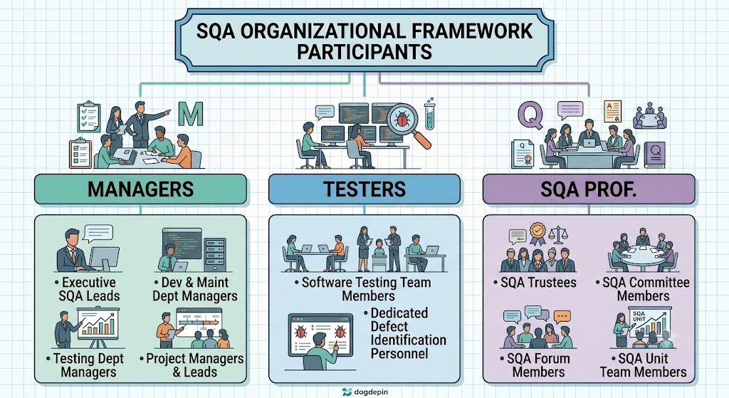
Under the Capability Maturity Model (CMM), Defect Prevention is identified as a Level 5 (Optimizing) Key Process Area (KPA). The fundamental objective of Level 5 Defect Prevention is to shift quality management from reactive defect detection to proactive defect elimination by identifying root causes and systematically modifying organizational processes.
- CMM Level 5 Optimization Context:
Definition/Concept: The highest CMM maturity level, focusing on continuous process enhancement through quantitative mechanisms.
Explanation: At Level 5 (Optimizing), an organization possesses stable, quantitatively managed processes. Defect Prevention serves as a core KPA at this level, aiming to systematically prevent defects from occurring in future development lifecycles. It transitions the organization away from relying solely on downstream testing toward upstream process perfection.
- The Four-Stage Defect Prevention Cycle:
Definition/Concept: The continuous loop encompassing Defect Detection, Cause Analysis, Fix Implementation, and Proactive Prevention.
Explanation: The KPA operates on a closed-loop cycle: initial defects are detected during reviews or testing, after which engineering teams analyze their root causes. Once root causes are determined, immediate fixes are implemented for the current project, followed by proactive process changes to eliminate defect recurrence across future projects.
- Objective 1 – Root Cause Identification:
Definition/Concept: The systematic investigation into underlying systemic flaws that allow defects to be introduced.
Explanation: Rather than merely treating defect symptoms, the primary objective of defect prevention is to uncover why a defect occurred. Teams evaluate underlying factors such as ambiguous documentation, inadequate tooling, or training gaps. Identifying root causes enables targeted corrective and preventive actions.
- Objective 2 – Incorporation of Lessons Learned:
Definition/Concept: Capturing project insights and embedding them into institutional software engineering guidelines.
Explanation: Defect prevention ensures that technical insights gained from past errors are formally recorded and integrated into organizational processes. Lessons learned are transformed into revised checklists, improved design standards, and updated coding guidelines. This prevents recurring mistakes when new project teams encounter similar development challenges.
- Objective 3 – Proactive Process Improvement:
Definition/Concept: Modifying organizational workflows to systematically eliminate practices that introduce defects.
Explanation: The ultimate objective is to continuously refine software processes so that defect-inducing conditions are permanently removed. Process modifications focus on high-risk development phases, improving design clarity and verification rigor. This continuous refinement drives quantitative improvement in software reliability.
- Key Practice 1 – Defect Causal Analysis (DCA):
Definition/Concept: Formalized periodic meetings where teams apply analytical techniques to uncover root causes of recurring bugs.
Explanation: As defined by Paulk et al., DCA involves conducting root cause analysis sessions periodically throughout the software lifecycle. Teams utilize analytical tools like the "5 Whys" and "Fishbone (Ishikawa) Diagrams" to trace defect origins back to process weaknesses. DCA provides the empirical foundation for preventive actions.
- Key Practice 2 – Action Proposals and Follow-Up:
Definition/Concept: Formulating actionable recommendations and tracking their execution across software projects.
Explanation: Following DCA sessions, engineering teams draft specific action proposals outlining procedural changes, tool upgrades, or training modules. These proposals are assigned to owners, tracked through action items, and formally reviewed to ensure implementation in future software projects. Tracking guarantees that analysis translates into tangible improvements.
- Key Practice 3 – Preventive Action and Process Change:
Definition/Concept: Updating standard process assets, documentation, and operational checklists.
Explanation: When DCA reveals that defects stem from flawed organizational processes, standard operational assets are modified. Checklists, architecture templates, interface requirements, and development guidelines are updated enterprise-wide. These process enhancements prevent similar errors across all ongoing and future projects.
- Key Practice 4 – Organizational Learning via Central Repositories:
Definition/Concept: Maintaining a centralized database to store best practices, causal analysis reports, and process metrics.
Explanation: To support enterprise-wide knowledge sharing, Paulk et al. emphasize storing DCA findings and preventive actions in an accessible central database. Development teams consult this organizational memory during initial project planning to avoid historical pitfalls. Centralized learning accelerates process maturity across distributed engineering units.
- Key Practice 5 – Management Involvement and Support:
Definition/Concept: Active executive support providing necessary funding, policy mandates, and resources for quality programs.
Explanation: Management involvement is critical for institutionalizing defect prevention across an enterprise. Leadership provides necessary financial resources, allocates time for causal analysis meetings, and establishes supportive corporate policies. Executive commitment ensures that defect prevention is treated as an essential engineering process rather than an optional overhead activity.

Q4. Compare the managerial structures and SQA role distributions across small, medium, and large-sized software development organizations. Detail how organizational size, type, and operational scope influence managerial layers and quality oversight.
Software development organizations adapt their managerial structures and SQA frameworks based on operational scale, enterprise size, and business focus. While small to medium-sized tech enterprises utilize streamlined models to maintain agility, large organizations implement multi-layered managerial structures with specialized roles to handle complex software portfolios.
Comparative Analysis Matrix:
Dimension / Parameter | Small-Sized Tech Enterprise | Medium-Sized Tech Enterprise | Large-Sized Software Enterprise
Managerial Hierarchy | Streamlined 3-Level Model (Top, Dept, Project/Team Leads). | Standard 3-Level Model with specialized department heads. | Multi-layered hierarchy with Division Managers and Functional Leads.
Middle Management Depth | Minimal; Department Managers often handle multiple functions. | Moderate; Distinct heads for Dev, Maintenance, and Testing. | Extensive; Multiple layers of specialized division and department managers.
SQA Dedicated Units | Rarely present; SQA tasks performed by general developers/leads. | Small SQA Unit or dedicated committee guiding testing teams. | Fully dedicated SQA Unit working alongside specialized testing departments.
Tester Allocation | Developers perform peer testing; limited dedicated testers. | Dedicated testing team led by a testing team leader. | Large, independent software testing departments with specialized leads.
Part-Time SQA Reliance | Extremely high reliance on part-time SQA involvement. | Balanced mix of part-time practitioners and full-time leads. | Structured balance; clear boundary between full-time SQA and part-time staff.
Process Formality | Informal compliance; direct executive oversight. | Standardized SQA procedures and committee reviews. | Highly formal, metric-driven compliance with SQA units and forums.

- Foundational Three-Level Model in Small Enterprises:
Definition/Concept: A compact managerial structure consisting of Top Management, Department Managers, and Project Leads.
Explanation: Small software firms utilize a streamlined three-level structure to minimize administrative overhead and maximize communication speed. Top management directly interacts with project leads, while department managers oversee combined functions like development and testing. This flat hierarchy allows rapid adaptation to changing project requirements.
- Expanded Middle Management in Large Enterprises:
Definition/Concept: Multi-tiered administrative structures containing Division Managers, Department Heads, and Functional Leads.
Explanation: As software organizations grow, middle management expands to control operational complexity. Large enterprises insert division managers above functional departments to oversee related product lines. Functional leads are appointed to manage specialized technical domains, creating clear operational focus across large engineering teams.
- Influence of Organizational Type on Management Structure:
Definition/Concept: Structural adjustments driven by an organization's business model (product-centric, service-oriented, or consulting).
Explanation: Product-centric organizations align management around continuous product roadmaps and release engineering. Service-oriented and consulting firms structure management around client account boundaries, project SLA compliance, and billable resource management. Management composition directly reflects these unique operational focus areas.
- Evolution of Dedicated SQA Units:
Definition/Concept: The formal establishment of independent organizational units dedicated exclusively to quality assurance.
Explanation: Small enterprises seldom maintain dedicated SQA units due to budget constraints, relying instead on project leads to enforce quality. Medium firms often establish small quality committees, whereas large enterprises maintain fully funded, independent SQA units. These dedicated units manage enterprise audits, quality metrics, and process compliance.
- Distribution and Specialization of Testing Resources:
Definition/Concept: The structural organization of software testing personnel across different enterprise scales.
Explanation: In small organizations, developers handle peer testing alongside coding duties. Medium enterprises deploy dedicated testing teams led by testing team leaders. Large software firms operate independent software testing departments headed by testing department managers, ensuring objective defect detection.
- Reliance on Extended (Part-Time) SQA Roles:
Definition/Concept: The degree to which an enterprise depends on non-dedicated staff to execute quality assurance tasks.
Explanation: Small tech firms rely almost entirely on extended SQA involvement, where developers perform reviews and testing part-time. As organizations mature, part-time involvement shifts toward formalized roles such as SQA trustees, SQA committee members, and SQA forum participants. These practitioners support full-time SQA units across departments.
- Scalability of Managerial Authority and Lines of Governance:
Definition/Concept: Establishing clear lines of authority proportional to organizational workforce scale.
Explanation: Hierarchical lines of authority must scale alongside workforce growth to prevent operational ambiguity. In large enterprises, clear delegation protocols prevent top executives from becoming bottlenecks in daily operations. Defined reporting structures ensure accountability from C-suite executives down to individual dev teams.
- Resource Allocation for Quality Programs:
Definition/Concept: The financial and operational investment assigned to process improvement initiatives.
Explanation: Large enterprises dedicate substantial resources to formal process improvement programs, such as CMM Level 5 Defect Prevention. They fund central databases, causal analysis workshops, and automated testing tools. Small enterprises focus available resources on core feature delivery, adopting lightweight quality checks.
- Formalization of SQA Committees and Quality Forums:
Definition/Concept: Establishing cross-departmental bodies to champion quality standards and knowledge sharing.
Explanation: Medium and large software organizations establish SQA committees and forums to bridge functional silos. These bodies gather representatives from development, testing, and maintenance to discuss systemic defects and propose process updates. They facilitate enterprise-wide adoption of best practices.
- Operational Agility versus Process Rigor Trade-off:
Definition/Concept: Balancing rapid delivery capabilities against formal quality verification processes.
Explanation: Small enterprises achieve high operational agility through streamlined managerial structures but risk inconsistent process rigor. Large enterprises achieve high process rigor and predictable software quality through formal SQA units and multi-layered management, but may experience reduced operational agility. Structuring SQA requires balancing speed with rigor.

Q5. Discuss the practical implementation of Defect Causal Analysis (DCA) and process improvement in software engineering. Detail its alignment with ISO 9000-3 and ISO/IEC 12207 CAPA frameworks, incorporating real-world software engineering examples.
Defect Causal Analysis (DCA) is a core analytical methodology utilized in software engineering to investigate defect origins and drive continuous process improvement. Systematically implementing DCA aligns CMM Level 5 Defect Prevention with international quality standards—specifically ISO 9000-3 and ISO/IEC 12207—which emphasize Corrective and Preventive Action (CAPA) frameworks.

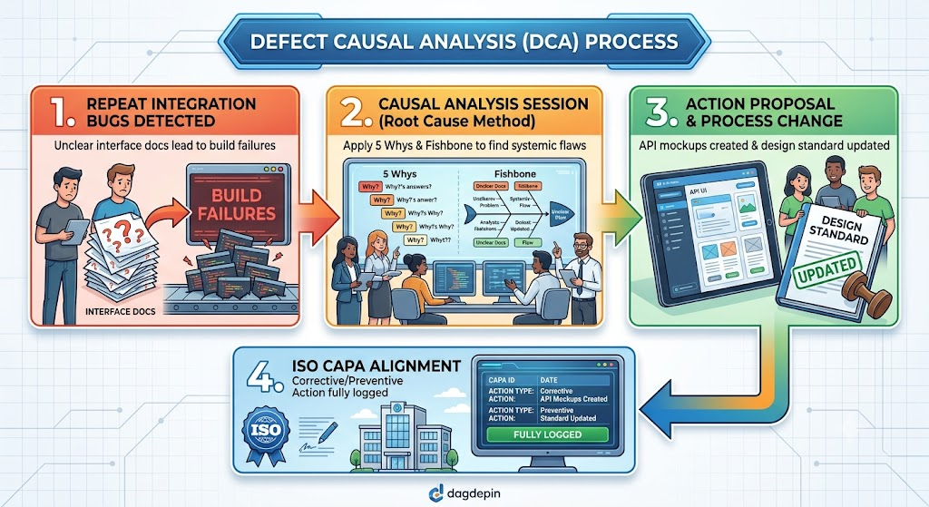

- Defect Causal Analysis (DCA) Fundamental Methodology:
Definition/Concept: A structured analytical process performed periodically to identify the primary root causes of software defects.
Explanation: DCA moves beyond surface-level bug fixing by asking why a defect was injected into the codebase. Teams hold periodic DCA meetings to evaluate defect logs collected during reviews and testing phases. By isolating common failure patterns, DCA provides data-driven targets for process improvement.
- Analytical Techniques in DCA (5 Whys and Fishbone Diagrams):
Definition/Concept: Core root-cause analysis tools used to trace technical symptoms back to process deficiencies.
Explanation: Engineering teams utilize the "5 Whys" method to iteratively question the sequence of events leading to a software bug. They also employ Fishbone (Ishikawa) diagrams to categorize potential contributing factors across process, tools, environment, and documentation. These structured tools prevent superficial conclusions during post-mortem reviews.
- Formulation of Action Proposals:
Definition/Concept: Developing specific, actionable engineering tasks to correct identified process deficiencies.
Explanation: Once root causes are isolated, team members generate formal action proposals. These proposals define technical remedies, such as creating new design templates, introducing static analysis tools, or conducting targeted team training. Assigning clear ownership ensures that proposals move toward active implementation.
- Tracking and Institutionalizing Process Changes:
Definition/Concept: Systematic monitoring of action implementation to ensure long-term integration into development lifecycles.
Explanation: Proposed preventive actions are logged in project tracking systems and systematically monitored by project managers and SQA units. Once verified, these changes are integrated into standard process assets, operational checklists, and guidelines. Tracking prevents action items from being abandoned during active release cycles.
- Real-World Case Study – Integration Bug Scenario:
Definition/Concept: A practical industry example demonstrating defect causal analysis in an active software project.
Explanation: In a real-world scenario, a software engineering team repeatedly encountered integration bugs during build assembly. Downstream testing revealed that component modules failed to communicate correctly, causing build failures and deployment delays. This recurring issue required systematic DCA investigation.
- Root Cause Discovery in Module Interface Documentation:
Definition/Concept: Identifying ambiguous technical specifications as the primary driver of integration failures.
Explanation: Through DCA, the engineering team discovered that integration defects did not stem from developer coding errors, but from unclear module interface documentation. Separate development teams interpreted API parameters differently due to vague specifications. DCA successfully pinpointed the exact upstream process failure.
- Implementation of API Mockups and Documentation Standards:
Definition/Concept: Concrete process changes designed to eliminate interface ambiguity during component development.
Explanation: To prevent future interface mismatches, the team updated documentation standards and introduced mandatory API mockups during design phases. Interface specifications were required to be validated with mock services prior to coding. This targeted process change eliminated the root cause of integration bugs.
- Alignment with ISO 9000-3 Quality Management Standard:
Definition/Concept: Harmonizing CMM defect prevention practices with ISO software guidelines for quality management.
Explanation: ISO 9000-3 mandates that software suppliers establish documented procedures for corrective and preventive actions. CMM Level 5 Defect Prevention directly satisfies ISO 9000-3 requirements by converting DCA findings into institutionalized process improvements. This alignment ensures international standard compliance.
- Alignment with ISO/IEC 12207 Software Lifecycle Processes:
Definition/Concept: Mapping causal analysis activities to the Corrective and Preventive Action (CAPA) processes of ISO/IEC 12207.
Explanation: ISO/IEC 12207 highlights CAPA as a core supporting lifecycle process necessary for maintaining system integrity. Defect Causal Analysis in CMM is functionally equivalent to systematic CAPA in ISO-based SQA systems. Both frameworks require documenting defects, analyzing causes, executing fixes, and preventing recurrence.
- Quantitative and Cultural Benefits of Integrated CAPA:
Definition/Concept: The long-term economic and behavioral advantages realized through disciplined defect prevention.
Explanation: Integrating DCA and ISO CAPA frameworks reduces rework costs by catching defects early in the lifecycle. It enables quantitative process improvement through measurable reductions in defect density over time. Culturally, it fosters an organizational environment focused on learning, quality ownership, and continuous process perfection.

SECTION B: 5-MARK QUESTIONS
Q6. Describe the Foundational Three-Level Managerial Model used in small to medium-sized tech enterprises and explain its core functional roles.
For small to medium-sized software development organizations, a streamlined three-level managerial structure is commonly adopted. This model prioritizes operational clarity, efficiency, and direct communication across management tiers.
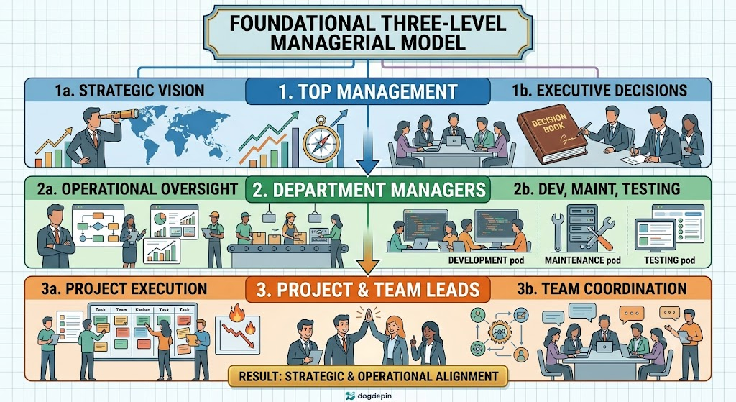
The executive apex comprising General Managers and C-suite executives driving strategic alignment.
Explanation: Top Management defines executive decision-making, establishes corporate growth roadmaps, and drives overall organizational direction. They ensure that software engineering activities align with executive business goals and market strategies.
- Functional Oversight (Department Managers Tier):
Definition/Concept: Intermediate management providing operational oversight across specialized technical departments.
Explanation: Department Managers head functional units including Software Development, Software Maintenance, and Software Testing departments. They ensure functional excellence, manage department-level resources, and maintain operational quality standards.
- Operational Execution (Project Managers & Team Leaders Tier):
Definition/Concept: Frontline project leadership managing development execution and technical teams.
Explanation: Project Managers directly manage software development projects and maintenance services to guarantee timely delivery schedules. Team Leaders provide day-to-day guidance, assign development tasks, and coordinate team members.
- Clarity and Administrative Efficiency:
Definition/Concept: The operational advantage of maintaining a flat, streamlined managerial hierarchy.
Explanation: By limiting management to three streamlined levels, small to medium tech firms minimize bureaucratic delay and communication barriers. Roles and responsibilities remain clear, enabling rapid technical decision-making and project execution.
- Balanced Task and Governance Distribution:
Definition/Concept: Division of responsibilities across strategy, department management, and task execution.
Explanation: The three-level model balances governance across strategic direction (Top Management), departmental capability building (Department Managers), and project delivery (Project Leads). This distribution ensures end-to-end operational coverage.

Q7. Explain the three foundational pillars required for an effective Software Quality Assurance (SQA) system in a tech enterprise.
A successful Software Quality Assurance (SQA) system relies on a solid operational foundation. Rather than depending solely on tools, an effective SQA system requires three core pillars involving organizational human resources and procedural discipline.

- Collective Contribution Across Staff:
Definition/Concept: Broad employee involvement where software quality is treated as a universal responsibility.
Explanation: A viable SQA system requires active contributions from nearly all employees in the enterprise. Quality cannot be sustained by dedicated auditors alone; it demands that developers, analysts, and managers take personal ownership of software quality.
- Strict SQA Procedure Compliance:
Definition/Concept: Mandatory adherence to established organizational quality guidelines and standards.
Explanation: Engineering teams must maintain diligent compliance with documented SQA procedures, checklists, and workflows. Adherence guarantees consistency across software modules and prevents unauthorized process deviations.
- Professional Execution of Technical Tasks:
Definition/Concept: Performing software engineering tasks with high technical expertise and diligence.
Explanation: Technical tasks—such as architectural design, coding, documentation, and maintenance—must be executed with professional competence. Technical diligence reduces baseline defect injection during original software synthesis.
- Integration of Quality with Engineering Workflows:
Definition/Concept: Embedding quality assurance checkpoints directly into daily software development cycles.
Explanation: SQA foundations require that quality checks are integrated into daily coding, peer reviews, and build verification routines. This integration prevents quality from becoming an isolated, post-development inspection phase.
- Organizational Quality Culture Maintenance:
Definition/Concept: Cultivating an environment that values continuous learning, excellence, and compliance.
Explanation: Together, collective contribution, procedure compliance, and professional execution foster a healthy culture of quality. This environment supports quantitative process improvement and long-term software reliability.

Q8. Elaborate on the specific managerial roles involved in driving SQA, ranging from executive leadership to software testing team leaders.
Managers play a critical role in driving software quality across an enterprise. SQA governance spans multiple leadership tiers, requiring active quality management from top executives down to technical team leaders
- Top Management Executives (SQA Lead):
Definition/Concept: Executive leadership providing top-level oversight and resource funding for SQA programs.
Explanation: Top management executives—particularly designated executive SQA leads—drive high-level quality strategy and governance. They establish corporate quality policies, allocate budgets, and ensure strategic alignment across projects.
- Development and Maintenance Department Managers:
Definition/Concept: Departmental heads responsible for quality compliance within core software engineering units.
Explanation: These managers ensure that software development and maintenance operations adhere to organizational SQA standards. They oversee functional excellence, resource allocation, and technical skill development within their departments.
- Software Testing Department Managers:
Definition/Concept: Departmental leadership directing independent software verification operations.
Explanation: Testing department managers oversee testing infrastructure, resource deployment, and test execution strategies across project portfolios. They ensure that defect detection processes operate independently and effectively.
- Project Managers and Development Team Leaders:
Definition/Concept: Tactical leaders enforcing SQA compliance within active project release cycles.
Explanation: Project managers integrate SQA milestones into project schedules, while development team leaders conduct code reviews and mentor developers. They ensure daily development tasks adhere to quality guidelines.
- Leaders of Software Testing Teams:
Definition/Concept: Operational leads supervising frontline software testing execution and defect tracking.
Explanation: Testing team leaders directly supervise testing team members during test case execution and defect logging. They validate defect reports, manage testing schedules, and report software quality metrics to department management.

Q9. Describe the composition, responsibilities, and key bodies constituting SQA Professionals and Practitioners in a software organization.
Beyond line managers and software testers, the SQA organizational framework relies on specialized SQA Professionals and Interested Practitioners. These individuals provide quality expertise, manage audit processes, and champion continuous process improvement.
- SQA Unit Team Members (Full-Time Specialists):
Definition/Concept: Dedicated quality specialists who form the enterprise SQA unit.
Explanation: SQA unit team members work full-time on quality assurance, conducting quality audits, defining process standards, and tracking quality metrics. They remain independent of development teams to ensure objective evaluation.
- SQA Trustees:
Definition/Concept: Designated organizational guardians responsible for maintaining SQA compliance within specific departments.
Explanation: SQA trustees act as departmental quality champions who monitor local compliance with SQA guidelines. They assist project teams in applying quality standards and serve as liaisons to the central SQA unit.
- SQA Committee Members:
Definition/Concept: Cross-functional representatives appointed to formal organizational quality committees.
Explanation: SQA committee members meet regularly to evaluate organizational process performance, review audit findings, and update quality frameworks. They bridge communication gaps between management and technical engineering staff.
- SQA Forum Members:
Definition/Concept: Practitioners participating in organizational forums dedicated to sharing quality knowledge.
Explanation: SQA forum members participate in open discussions regarding technical quality challenges, tools, and best practices. These forums encourage interested practitioners to contribute to organizational quality improvement.
- Synergy Between Dedicated and Practitioner Roles:
Definition/Concept: Collaborative interaction between full-time SQA unit staff and part-time engineering volunteers.
Explanation: The combination of dedicated SQA unit staff and volunteer practitioners ensures that quality policies remain technically practical. This collaborative structure promotes widespread adoption of process standards across all engineering teams.

Q10. Compare Full-Time SQA Roles versus Part-Time SQA Involvement in software engineering organizations across key operational parameters.
Participation in the SQA framework is divided between fully dedicated personnel and employees participating part-time. Understanding the distinction between full-time and part-time SQA involvement is essential for effective resource allocation and organizational design.
Comparative Analysis Matrix:
Parameter / Dimension | Full-Time SQA Roles | Part-Time SQA Involvement
Dedicated Roles | SQA Unit Members, SQA Managers, Software Testing Department Employees. | Developers, Systems Analysts, SQA Trustees, Committee/Forum Members.
Primary Task Focus | Exclusively SQA audits, testing execution, process definition, and metrics tracking. | Software development, coding, architecture, and maintenance tasks.
Independence Level | High independence from project development schedules and deliverables. | Embedded within project teams; balances delivery deadlines with quality checks.
Operational Scope | Enterprise-wide quality auditing and standard maintenance. | Project-specific code reviews, unit testing, and guideline adherence.
Resource Allocation | Dedicated overhead cost center allocation. | Direct billable/project labor cost allocation.
- Scope of Dedicated Personnel:
Definition/Concept: Role assignment restricted to specific quality assurance personnel.
Explanation: Full-time SQA involvement is limited to SQA unit team members, SQA managers, and software testing department personnel. These individuals focus exclusively on quality verification without competing software development responsibilities.
- Scope of Extended Participation:
Definition/Concept: Part-time engagement where quality tasks are performed alongside core operational duties.
Explanation: Software developers, maintenance engineers, and SQA committee/forum volunteers participate in SQA on a part-time basis. They contribute to quality through peer code walkthroughs, committee meetings, and standard adherence.
- Independence and Objectivity Differences:
Definition/Concept: Varying degrees of separation from project milestone pressures.
Explanation: Full-time SQA specialists maintain high independence, allowing them to evaluate builds objectively without pressure from development deadlines. Part-time practitioners provide immediate, hands-on quality checks within active development workflows.
- Resource and Cost Allocation Structure:
Definition/Concept: Financial budgeting mechanisms for full-time quality units versus part-time engineering staff.
Explanation: Full-time SQA personnel are budgeted as dedicated overhead cost centers focused on process infrastructure. Part-time SQA activities are funded directly through project development budgets as integrated engineering tasks.
- Organizational Balance for Overall Quality Coverage:
Definition/Concept: The structural combination of independent auditing and developer quality ownership.
Explanation: An effective SQA framework requires both full-time auditing and part-time developer participation. Full-time staff maintain quality standards, while part-time staff enforce those standards during initial code generation.

Q11. Explain the core objectives and continuous improvement cycle of Defect Prevention under CMM Level 5 (Optimizing).
Defect Prevention is a Key Process Area (KPA) at CMM Level 5 (Optimizing) designed to achieve continuous process improvement. It aims to shift quality management from downstream defect catching to upstream defect elimination.
- The Proactive Prevention Goal:
Definition/Concept: Systematically eliminating defect-inducing conditions to prevent bug creation in future work.
Explanation: The primary goal of Level 5 Defect Prevention is to proactively identify root causes of defects and modify operational processes so similar errors cannot recur in future projects.
- The Continuous Four-Step Cycle:
Definition/Concept: The operational loop linking Detection, Cause Analysis, Fix Implementation, and Proactive Prevention.
Explanation: The process follows a four-step cycle: engineering teams Detect Defects during verification, Analyze Causes using root cause analysis, Implement Fixes for immediate builds, and Prevent Proactively via process modification.
- Objective 1 – Root Cause Identification:
Definition/Concept: Investigating systemic operational flaws rather than superficial code symptoms.
Explanation: Defect prevention systematically uncovers why a defect was injected, analyzing factors such as vague requirement documentation, insufficient tooling, or skill gaps.
- Objective 2 – Incorporating Lessons Learned:
Definition/Concept: Formally embedding past project insights into organizational engineering guidelines.
Explanation: Technical insights gained from causal analysis are recorded and integrated into process assets, operational checklists, and standard design templates. This prevents recurring mistakes across project teams.
- Objective 3 – Proactive Process Improvement:
Definition/Concept: Continuously updating software workflows to eliminate defect-inducing engineering practices.
Explanation: By systematically updating processes based on causal data, the enterprise achieves measurable enhancements in product quality, process predictability, and engineering efficiency.

Q12. Analyze the organizational and economic benefits of implementing a systematic Defect Prevention program as defined by CMM.
Implementing a systematic CMM Level 5 Defect Prevention program yields substantial economic and operational advantages for software organizations. It transforms quality management from a cost overhead into a strategic driver of engineering efficiency.
- Reduced Rework Costs:
Definition/Concept: Significant reduction in project expenditure caused by fixing downstream defects.
Explanation: Fixing defects during early requirements or design phases is far less expensive than correcting bugs during late integration or post-release maintenance. Preventing defects upstream dramatically reduces rework costs.
- Improved Product Quality:
Definition/Concept: Enhancing final software reliability, stability, and customer satisfaction.
Explanation: Systematically eliminating defect causes ensures consistent product quality across development teams. The resulting software exhibits higher stability, fewer operational field failures, and better user satisfaction.
- Quantitative Process Improvement:
Definition/Concept: Achieving measurable, data-driven enhancements in software process capabilities.
Explanation: Defect prevention provides quantitative metrics tracking defect injection rates and causal patterns. Managers use these metrics to measure process maturity and verify the impact of engineering modifications.
- Establishment of a Culture of Quality:
Definition/Concept: Fostering an organizational environment dedicated to continuous learning and excellence.
Explanation: Defect prevention shifts company culture from fire-fighting and bug-hunting to proactive quality ownership. It establishes a continuous learning environment where developers collaborate to improve engineering processes.
- Alignment with International Standards (CAPA):
Definition/Concept: Achieving seamless compliance with global standards such as ISO 9000-3 and ISO/IEC 12207.
Explanation: A systematic defect prevention program satisfies ISO requirements for Corrective and Preventive Action (CAPA). This standard compliance enhances organizational credibility and competitive positioning in global markets.

SECTION C: 2-MARK QUESTIONS
Q13. Define Top Management within the traditional software development hierarchy.
Top Management sits at the highest executive tier of a software development organization.
- Executive Scope & Vision: Top Management consists of General Managers and C-suite executives who define the strategic vision, executive decisions, and corporate direction.
- Policy & Resource Governance: They establish organizational quality policies, allocate budgets, and provide leadership support to institutionalize software quality.

Q14. Define the role of Department Managers in software engineering organizations.
Department Managers represent middle management overseeing functional engineering divisions.
- Operational Oversight: They manage specific functional departments such as Software Development, Maintenance, and Testing to ensure functional excellence.
- Resource & Standard Management: Department managers allocate technical resources, supervise departmental workflows, and enforce compliance with SQA standards.

Q15. What are Project Section Managers and Team Leaders in lower management?
Project Section Managers and Team Leaders constitute frontline management directing day-to-day project operations.
- Component Oversight: Section Managers oversee specific components, modules, or phases of large software engineering projects.
- Team Guidance & Execution: Team Leaders directly guide development teams, assign daily tasks, and coordinate effort to ensure timely delivery.

Q16. Define Dedicated SQA Roles vs. Extended SQA Involvement.
SQA frameworks divide personnel based on whether quality assurance is their primary full-time job.
- Dedicated SQA Roles: Refers to full-time specialists—such as SQA unit members and software testing staff—whose sole responsibility is quality assurance.
- Extended SQA Involvement: Refers to general software personnel—such as developers and analysts—who engage in SQA tasks part-time alongside coding duties.

Q17. State the main responsibility of Software Testers in the SQA framework.
Software Testers represent the operational frontline of software quality verification.
- Defect Identification: Operating as members of software testing teams, their primary responsibility is executing tests to identify software defects.
- Verification & Quality Reporting: They run test suites, verify bug fixes, and report software stability metrics to project management.

Q18. What is Defect Causal Analysis (DCA)?
DCA is a structured root-cause analysis methodology performed periodically in CMM Level 5.
- Root Cause Investigation: DCA systematically investigates software defects to discover underlying systemic causes using methods like the 5 Whys and Fishbone diagrams.
- Preventive Action Formulation: It formulates actionable recommendations to modify software processes and prevent bug recurrence in future projects.

Q19. Define Organizational Learning in the context of CMM Defect Prevention.
Organizational Learning captures project insights to enhance enterprise-wide technical knowledge.
- Central Repository Maintenance: It involves storing DCA reports, action proposals, and best practices in an accessible central database.
- Knowledge Sharing: Development teams across the enterprise reuse stored insights to avoid repeating historical software engineering errors.

Q20. What is the role of Management Involvement in CMM Level 5 Defect Prevention?
Management Involvement provides executive support required to sustain defect prevention.
- Resource Provision: Leadership allocates funding, time, and staffing necessary to conduct DCA sessions and execute action proposals.
- Institutionalization & Policy: Management mandates policy compliance, ensuring defect prevention is embedded into standard corporate practices.

Q21. Differentiate between Corrective Action and Preventive Action (CAPA).
CAPA represents a fundamental quality concept highlighted in ISO 9000-3 and ISO/IEC 12207.
Dimension | Corrective Action | Preventive Action
Primary Focus | Eliminates the cause of an existing defect detected in current software builds. | Modifies standard processes to prevent potential future defects across projects.
Execution Timing | Performed reactively after a bug is logged during testing or reviews. | Performed proactively based on causal analysis and historical trends.

Q22. Give a real-world example of how Defect Causal Analysis resolves integration issues.
Real-world DCA implementation resolves recurring integration build failures caused by process ambiguity.
- Issue & Cause Identification: A team experiencing repeated module integration bugs conducted DCA and discovered the root cause was unclear API documentation.
- Process Remedy: The team updated documentation standards and introduced mandatory API mockups, successfully eliminating interface integration failures.

