Software Quality Program and Assurance Planning
Exam-Oriented Question Bank & Complete Answer Key

PART 1: QUESTION PAPER OVERVIEW

Section A: 2-Mark Questions (Short Answer)
1. Define a Software Quality Program (SQP) and state its primary objective.
2. Explain the concept of building quality in versus inspecting quality out in software engineering.
3. What is a Software Quality Assurance Plan (SQAP)?
4. State the core purpose of SQA Planning in software development.
5. Define Verification and Validation (V&V) within the scope of SQA planning.
6. Differentiate briefly between a Process Audit and a Product Audit.
7. Distinguish between Quality Objectives and Quality Policies.
8. Define Supplier Quality Assurance and its importance.
9. Identify the key international standards that guide Software Quality Programs.
10. List four major challenges organizations encounter when implementing an SQP.

Section B: 5-Mark Questions (Medium Answer)
11. Explain the core components that constitute a Software Quality Program framework.
12. Discuss the primary benefits of implementing a Software Quality Program in an organization.
13. Explain how SQA Planning supports risk management and defect prevention.
14. Compare Process Audits and Product Audits in detail using a comparison table and structured points.
15. Discuss the roles of Management Commitment and SQA Team Formation in establishing an SQP.
16. Describe the scope of SQA Planning across the Software Development Life Cycle (SDLC).
17. Analyze the organizational challenges in implementing an SQP and the strategies to overcome them.

Section C: 10-Mark Questions (Long Answer)
18. Explain in detail the six structured steps required to establish a Software Quality Program in an organization.
19. Describe the overview, structure, key functions, and essential components of a Software Quality Assurance Plan (SQAP).
20. Examine the comprehensive scope and key elements covered under SQA Planning across the SDLC.
21. Perform a comprehensive comparative analysis of Software Quality Assurance (SQA) vs. Quality Control (QC) and Process Audits vs. Product Audits.
22. Discuss how Software Quality Program implementation drives product reliability, cost reduction, compliance, and continuous process improvement.

PART 2: COMPLETE ANSWER KEY

SECTION A: 2-MARK QUESTIONS & ANSWERS

Q1. Define a Software Quality Program (SQP) and state its primary objective.
A Software Quality Program (SQP) is a formalised system integrated into the SDLC to govern quality practices.
- Formal Framework: A well-defined framework that builds QA processes, policies and procedures directly into the SDLC, so deliverables meet customer requirements and organisational standards.
- Primary Objective: To establish consistent, repeatable quality practices across all projects, giving better reliability, maintainability and customer satisfaction.
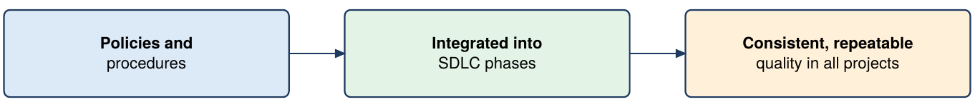
Fig 1: Software Quality Program in brief

Q2. Explain the concept of building quality in versus inspecting quality out in software engineering.
Quality cannot be added to a finished system by end-stage testing alone; it has to be engineered in from the start.
- Defect Prevention Focus: Quality is built in, not inspected in, so an SQP concentrates on proactive defect prevention in early phases rather than reactive detection at the end.
- Continuous Feedback: It relies on continuous process evaluation and measurement through the SDLC, aligned with standards such as ISO 9001 and CMMI, to stop flaws early.
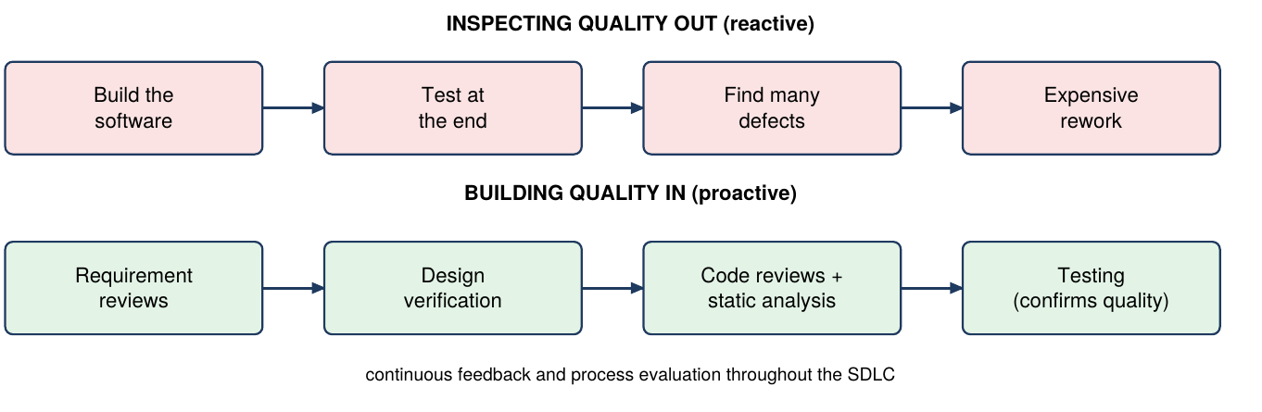
Fig 2: Inspecting quality out vs building quality in

Q3. What is a Software Quality Assurance Plan (SQAP)?
A Software Quality Assurance Plan (SQAP) is the formal operational document that says how QA will be carried out on a project.
- Operational Document: Written at project start, it specifies quality goals, procedures, tools, resources and team responsibilities.
- Quality Checkpoints: It defines explicit checkpoints such as requirement reviews, design verifications, test coverage goals and release criteria.
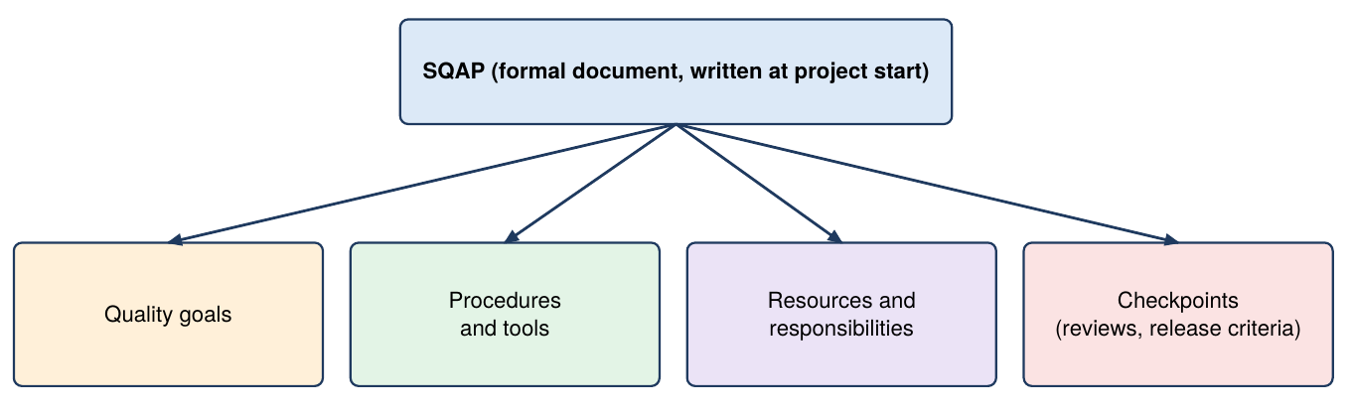
Fig 3: Contents of an SQAP

Q4. State the core purpose of SQA Planning in software development.
SQA planning is the baseline blueprint that governs quality assurance activities during development.
- Defect Prevention and Compliance: Prevents defects, mitigates project risks and ensures adherence to organisational and international standards, so flaws are caught before project failure.
- Standardisation and Communication: Standardises processes across the organisation, optimises QA resource allocation and streamlines communication between teams.
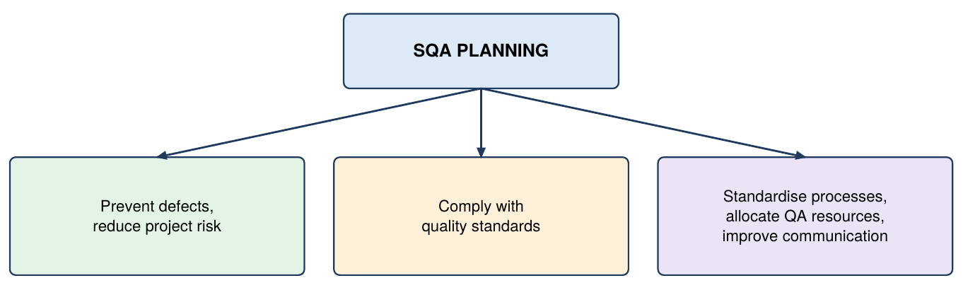
Fig 4: Purposes of SQA planning

Q5. Define Verification and Validation (V&V) within the scope of SQA planning.
Verification and Validation (V&V) are two essential QA processes defined in SQA planning.
- Verification: Evaluates intermediate work products to confirm the software is built correctly against phase requirements, checking design documents, code standards and specifications.
- Validation: Assesses the final system to confirm it meets user expectations and business needs, i.e., the right product for the operating environment.
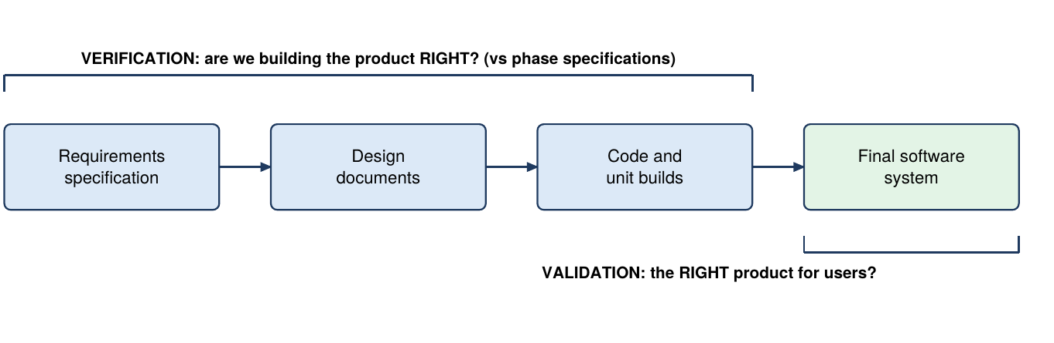
Fig 5: Verification vs validation across the SDLC

Q6. Differentiate briefly between a Process Audit and a Product Audit.
Audits are quality control activities in the SQA plan that check compliance.
- Process Audit: Checks whether development, testing and management teams strictly follow established procedures and quality processes.
- Product Audit: Checks specific intermediate or final deliverables against defined functional, structural and quality requirements.
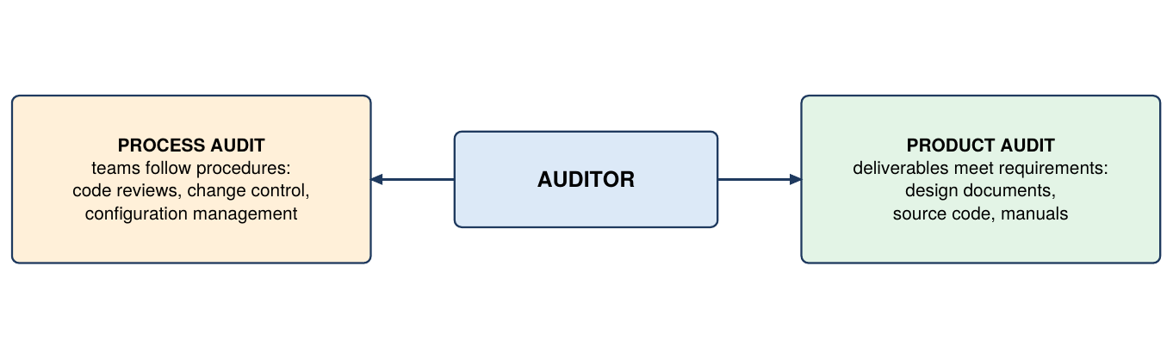
Fig 6: Process audit vs product audit

Q7. Distinguish between Quality Objectives and Quality Policies.
Quality policies and quality objectives are core components of the SQP framework.
- Quality Policies: High-level corporate guidelines stating the organisation's direction, commitment and strategic intent on quality.
- Quality Objectives: Specific, measurable, achievable targets that align deliverables with business goals and customer requirements.
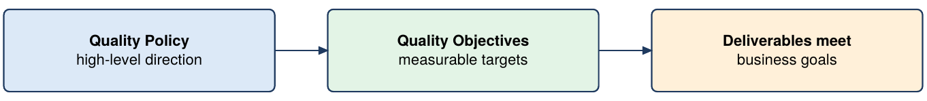
Fig 7: From policy to objectives

Q8. Define Supplier Quality Assurance and its importance.
Supplier Quality Assurance is an essential element within the scope of SQA planning.
- Definition: Processes to evaluate, monitor and manage the quality of third-party components, libraries or outsourced development services.
- Importance: Makes sure external deliverables meet quality benchmarks before integration, preventing third-party vulnerabilities and defects.
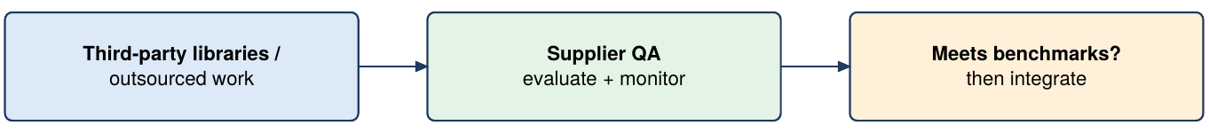
Fig 8: Supplier quality assurance flow

Q9. Identify the key international standards that guide Software Quality Programs
International standards give recognised frameworks and benchmarks for structuring Software Quality Programs.
- IEEE 730: A standard specifying requirements for preparing and carrying out Software Quality Assurance Plans.
- ISO 9001 and CMMI: ISO 9001 sets global criteria for quality management systems; CMMI (Capability Maturity Model Integration) gives process improvement models for organisational maturity.
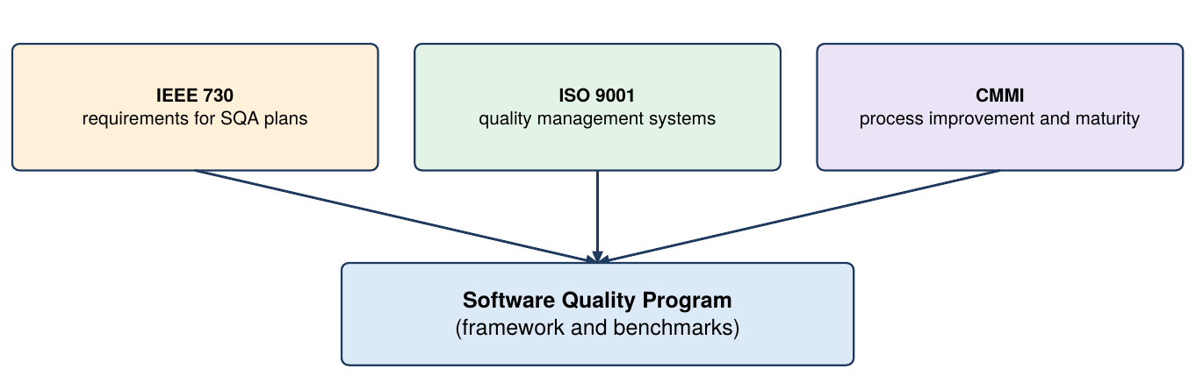
Fig 9: Standards guiding an SQP

Q10. List four major challenges organizations encounter when implementing an SQP.
Implementing an SQP means organisational change, which brings obstacles.
- Management and Training Deficits: Lack of active management support and inadequate training for personnel hinder adoption.
- Cultural Resistance and Documentation: Staff resistance to process change and insufficient documentation standards block smooth implementation.
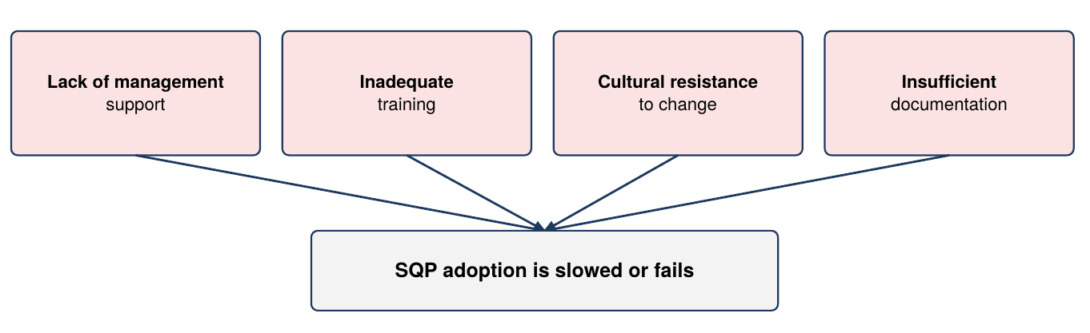
Fig 10: Four major SQP implementation challenges

SECTION B: 5-MARK QUESTIONS & ANSWERS

Q11. Explain the core components that constitute a Software Quality Program framework.
Definition & Overview
A Software Quality Program (SQP) builds essential management principles into the SDLC to define how quality is planned, achieved, maintained and verified across projects.
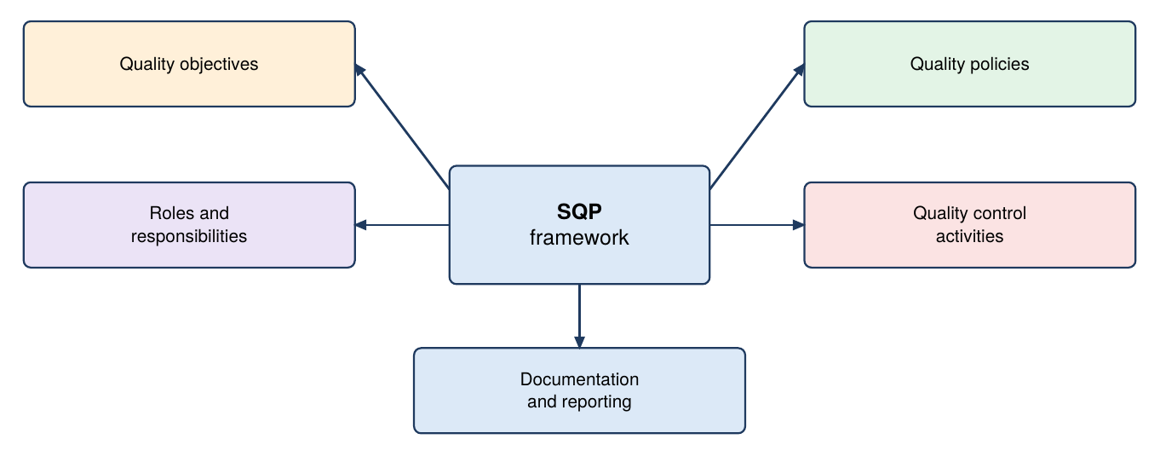
Fig 11: Core components of an SQP framework
- Quality Objectives: Clear, measurable goals aligning deliverables with customer expectations and business targets, e.g., reducing defect density or improving test coverage.
- Quality Policies: High-level guidelines stating the organisation's intent and direction on quality; the governing principles for all development and QC activities.
- Roles and Responsibilities: Assigning clear accountability for planning, executing and monitoring QA tasks removes ambiguity among developers, project managers and quality engineers.
- Quality Control Activities: Formal technical reviews, peer code inspections, system testing and compliance audits, embedded in the workflow to find and remove defects early.
- Documentation and Reporting: Comprehensive records give traceability, accountability and legal compliance; quality reports support auditing, defect tracking and data-driven decisions.

Q12. Discuss the primary benefits of implementing a Software Quality Program in an organization.
Definition & Overview
A structured SQP gives technical and business advantages and turns quality management into a strategic asset.
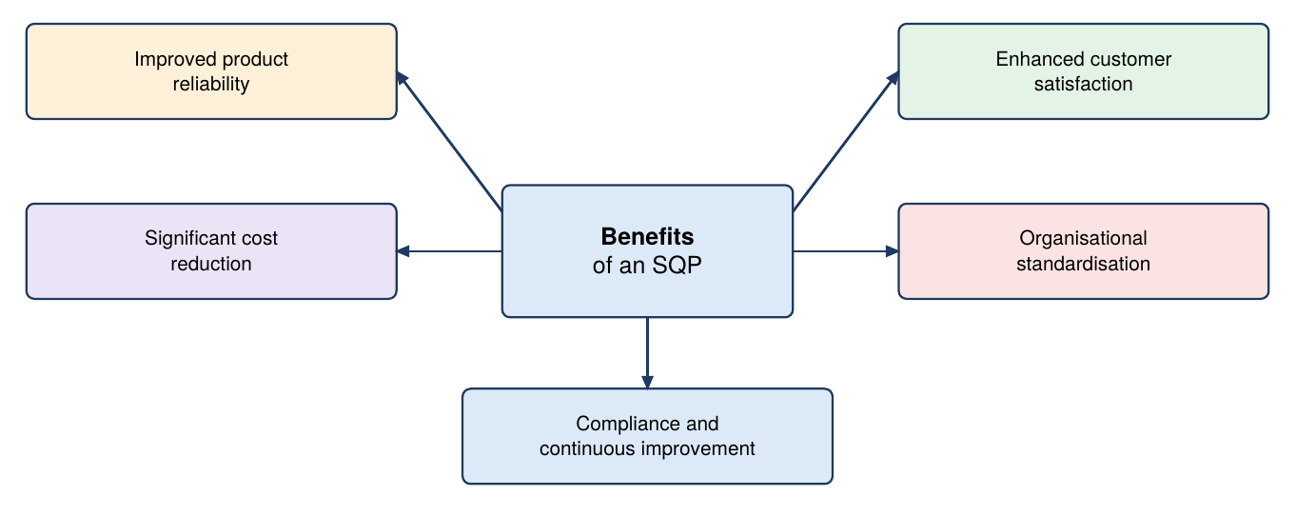
Fig 12: Benefits of implementing an SQP
- Improved Product Reliability: Continuous monitoring, inspections and systematic testing give stable software, fewer operational failures and greater user confidence.
- Enhanced Customer Satisfaction: Consistently meeting functional and technical requirements builds trust and reputation, supporting retention and growth.
- Significant Cost Reduction: Preventing defects early avoids expensive rework in final testing or maintenance, lowering lifecycle cost.
- Organisational Standardisation: Uniform practices across projects remove reliance on individual habits and give predictable outcomes.
- Compliance and Continuous Improvement: Following ISO 9001, IEEE 730 and CMMI ensures compliance and market acceptance, and feedback loops improve future iterations.

Q13. Explain how SQA Planning supports risk management and defect prevention.
Definition & Overview
SQA planning moves software engineering from reactive debugging to proactive risk mitigation and defect prevention across the SDLC.
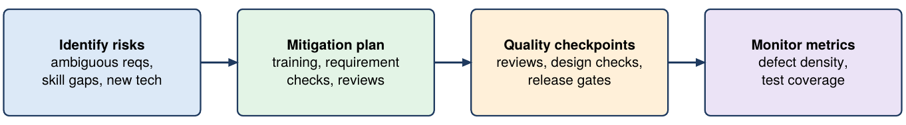
Fig 13: How SQA planning manages risk
- Early Threat Identification: Flags risks to quality early, such as ambiguous requirements, skill gaps and unproven technology, before they become critical failures.
- Risk Mitigation Strategies: Defines concrete actions: targeted training, requirements verification and incremental technical reviews.
- Embedded Quality Checkpoints: Mandatory requirement reviews, design verifications and release gates make sure work products meet standards before the next phase.
- Minimising Downstream Rework: QA in requirements and design stops defects spreading into code, avoiding costly late rework.
- Data-Driven Monitoring: Metrics such as defect density, test coverage and review trends show process health and trigger corrective action when quality drifts.

Q14. Compare Process Audits and Product Audits in detail using a comparison table and structured points.
Definition & Overview
Process Audits and Product Audits are complementary evaluations in the SQA scope that verify adherence to development standards.
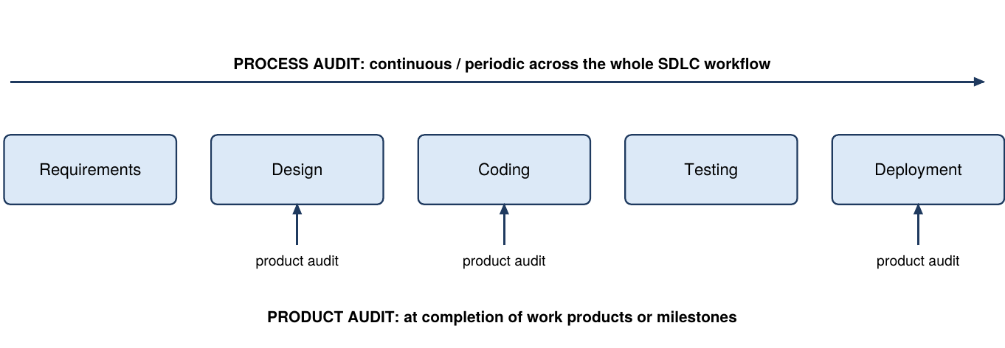
Fig 14: Timing of process audits and product audits across the SDLC
Attribute | Process Audit | Product Audit
Primary Focus | Development and testing processes, for standards compliance. | Intermediate and final software deliverables.
Objective | Team adherence to defined procedures and methodologies. | Product compliance with functional and structural requirements.
Timing | Continuously or periodically across the SDLC workflow. | On completion of specific work products or milestones.
Key Output | Non-conformance reports and process improvement recommendations. | Defect logs, review reports and release verification certificates.

- Workflow vs Deliverables: A process audit checks how software is being created; a product audit checks what has been created.
- Procedural Compliance: Process audits confirm teams correctly carry out code reviews, change control and configuration management.
- Deliverable Verification: Product audits check artefacts such as design documents, source code and user manuals against specifications.
- Prevention vs Detection: Process audits drive long-term defect prevention by improving workflows; product audits detect defects in a specific release.
- Complementary Assurance: Together they ensure both procedural discipline and product quality.

Q15. Discuss the roles of Management Commitment and SQA Team Formation in establishing an SQP.
Definition & Overview
An effective SQP needs strong leadership plus a dedicated QA structure.
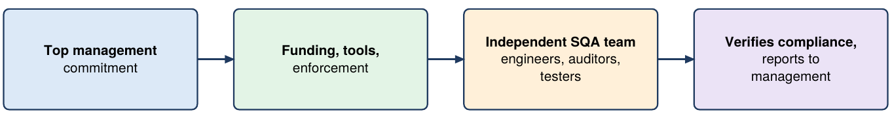
Fig 15: Management commitment and SQA team roles
- Top Management Leadership: Commitment is the foundation: without executive backing, funding, tools and enforcement across teams are impossible.
- Strategic Quality Alignment: Leadership must make software quality a strategic business goal and communicate it at all levels to build buy-in.
- Specialist SQA Team Formation: A team of SQA engineers, quality auditors, testing professionals and process specialists, working independently, monitors quality standards.
- Process Verification Responsibilities: The team's main duty is to verify that all development activities follow the established standards and procedures.
- Enforcing Accountability: It acts as an objective evaluation body reporting to management, giving unbiased oversight across development groups.

Q16. Describe the scope of SQA Planning across the Software Development Life Cycle (SDLC).
Definition & Overview
The scope of SQA planning defines the boundaries and quality activities covering every phase of the SDLC.
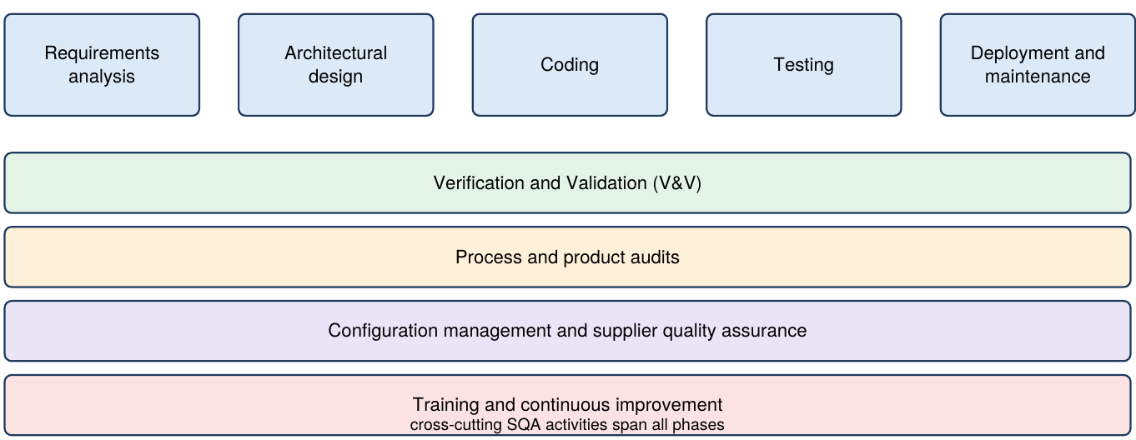
Fig 16: SQA planning scope across SDLC phases
- Comprehensive SDLC Coverage: Spans requirements analysis, architectural design, coding, testing, deployment and maintenance; quality management is active throughout.
- Verification and Validation: Verification confirms work products meet phase specifications; validation confirms the final software satisfies user requirements.
- Audits and Evaluation: Formal process and product audits check that workflows and products comply with organisational policies and specifications.
- Configuration and Supplier Management: Configuration management controls versions, updates and documents; supplier quality assurance governs third-party components.
- Training and Continuous Improvement: Ongoing staff training and process evaluation keep teams applying modern quality tools and methods.

Q17. Analyze the organizational challenges in implementing an SQP and the strategies to overcome them. ]
Definition & Overview
Introducing an SQP often meets organisational and cultural hurdles that need proactive management strategies.
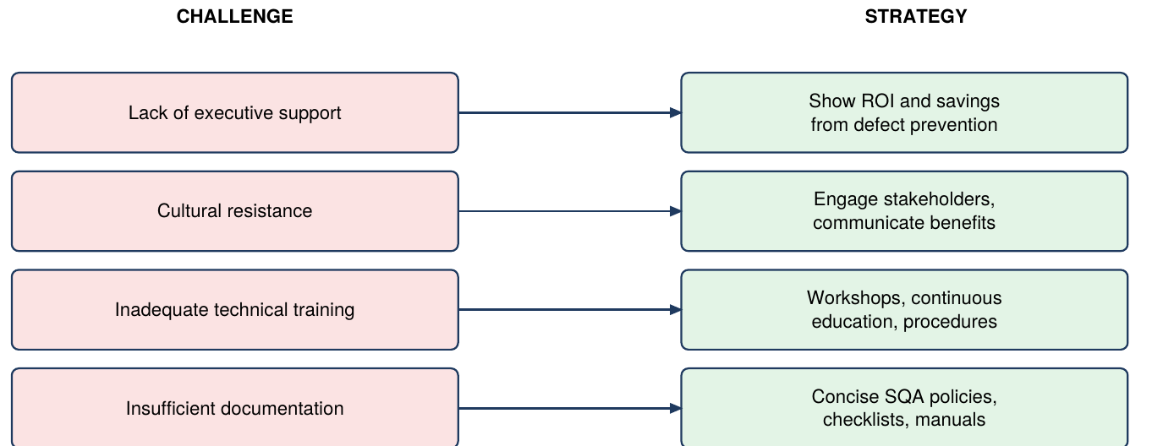
Fig 17: SQP implementation challenges and strategies
- Lack of Executive Support: Weak backing means poor funding and enforcement. Strategy: show management the ROI and cost savings from defect prevention.
- Cultural Resistance: Staff see documentation rules and audits as overhead. Strategy: build a quality culture through stakeholder engagement and clear communication of benefits.
- Inadequate Technical Training: Teams lack knowledge of QA tools, audit standards and inspection techniques. Strategy: continuous education, workshops and procedural documentation.
- Insufficient Documentation: Missing or poor guidelines cause inconsistent execution. Strategy: concise standardised SQA policies, checklists and manuals.
- Feedback-Driven Mitigation: Adoption succeeds when management keeps gathering feedback and metrics to refine processes collaboratively.

SECTION C: 10-MARK QUESTIONS & ANSWERS

Q18. Explain in detail the six structured steps required to establish a Software Quality Program in an organization.
Definition & Overview
Establishing a Software Quality Program needs a structured, multi-stage framework so that quality assurance is built into the organisation's development processes.
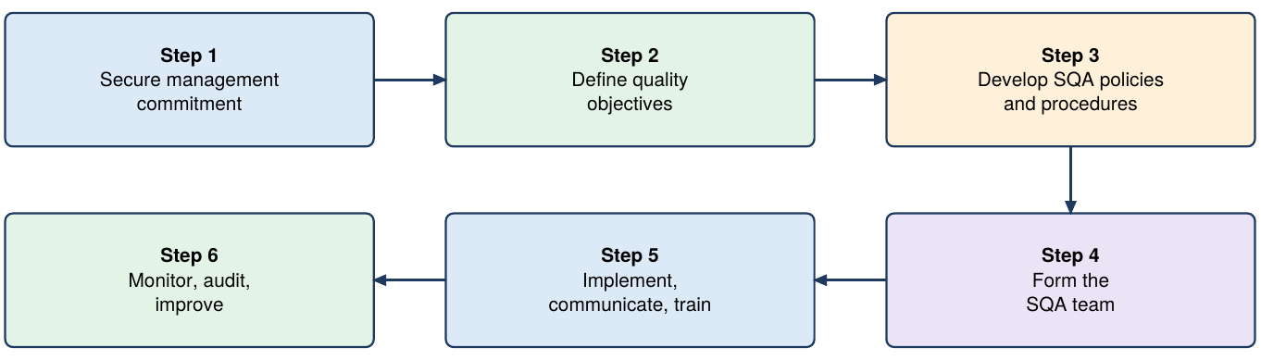
Fig 18: Six steps to establish a Software Quality Program
- Step 1: Secure Top Management Commitment: Executives define quality as a strategic objective and provide the financial, technical and human resources to sustain quality initiatives across projects.
- Step 2: Define Clear Quality Objectives: Set measurable, realistic targets aligned with business strategy, e.g., lower post-release defect density, higher automated test coverage, a target CMMI level.
- Step 3: Develop SQA Policies and Procedures: Policies state governing principles; procedures give step-by-step instructions for configuration management, peer reviews, defect classification and document control.
- Step 4: Form the Specialised SQA Team: SQA engineers, process specialists, auditors and testers, independent of project pressure, monitor and verify process compliance.
- Step 5: Implement, Communicate and Train: Roll the SQP out through communication channels, technical workshops, training and user-friendly guidelines so staff know their quality duties.
- Step 6: Monitor, Audit and Improve: Routine internal audits, review meetings and performance evaluations confirm quality processes stay active in every team.
- Quantitative Metrics Collection: Track defect discovery rates, review coverage and customer satisfaction to measure process effectiveness.
- Feedback Loops: Metrics and audit findings feed management reviews so procedures are refined continuously.
- Continuous Improvement: Root-cause analysis of flaws drives ongoing enhancements so the framework adapts to new technologies and requirements.
- Long-Term Culture Building: Sustained execution creates a culture in which quality is everyone's professional responsibility.

Q19. Describe the overview, structure, key functions, and essential components of a Software Quality Assurance Plan (SQAP). [10 Marks]
Definition & Overview
A Software Quality Assurance Plan (SQAP) is the formal operational blueprint prepared at project inception to define how QA activities are structured, managed and executed throughout the SDLC.
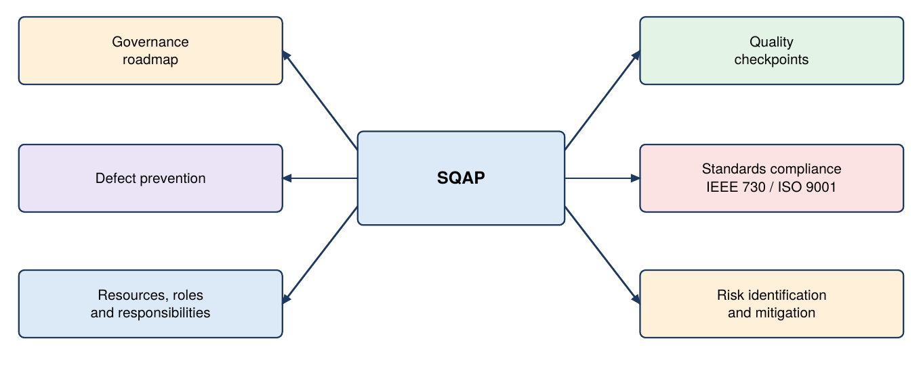
Fig 19: Structure of a Software Quality Assurance Plan
- Definition and Timing: A formal project document written during initial planning and refined across the SDLC; it turns general quality policies into project-specific operations.
- Core Functions: Gives a clear roadmap for quality execution, sets objective evaluation criteria and ensures traceability across deliverables.
- Operational Roadmap: Details timelines, review schedules and verification milestones for all QA actions.
- Role and Responsibility Transparency: Assigns quality tasks to project managers, developers, testers and SQA auditors, removing ambiguity.
- Quality Checkpoints: Mandatory gates: requirement specification reviews, design verification, test coverage targets and final deployment criteria.
- Standards Compliance Framework: Specifies how recognised standards (IEEE 730, ISO 9001, CMMI) will be met.
- Defect Prevention and Risk Reduction: Proactive inspection routines detect problems early, cutting project failure risk and rework cost.
- Tooling and Resource Allocation: Identifies tools, test environments, static analysers and specialist personnel needed for verification.
- Tracking, Auditing and Reporting: Defines logging of quality metrics, internal audits and formal quality reports for executives.
- Foundation of the Quality Program: The SQAP is the operational base of the SQP, keeping quality consistent, measurable and verifiable.

Q20. Examine the comprehensive scope and key elements covered under SQA Planning across the SDLC
Definition & Overview
The scope of SQA planning is the total domain of quality management, making sure quality work covers every development phase and external interface.
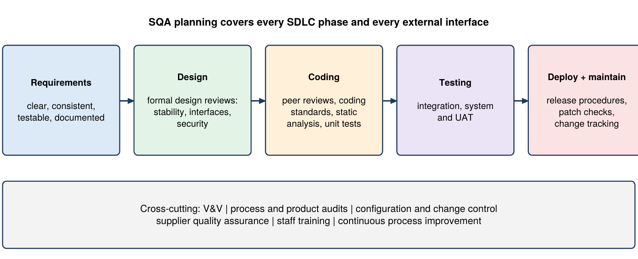
Fig 20: SQA activities in each SDLC phase plus cross-cutting elements
- Full SDLC Coverage: Quality management applies from feasibility and requirements engineering through to maintenance.
- Requirements Analysis: Checks that user requirements are clear, consistent, testable and completely documented.
- Architectural and Detailed Design: Formal design reviews confirm architecture stability, module interfaces and system security.
- Code Construction: Quality is managed by peer code reviews, coding standards, static code analysis and unit testing.
- Testing and Validation: Governs integration, system and user acceptance testing (UAT) for functional correctness and reliability.
- Deployment and Maintenance: Covers release procedures, post-deployment reviews, patch verification and change tracking.
- Verification and Validation: Verification ensures the software is built correctly; validation ensures the correct product is built for users.
- Process and Product Auditing: Process audits check process compliance; product audits check artefact quality.
- Configuration and Supplier Control: Configuration control manages versions; supplier quality assurance governs third-party modules.
- Training and Process Improvement: Ongoing staff skill upgrades and feedback-driven improvements across future cycles.

Q21. Perform a comprehensive comparative analysis of Software Quality Assurance (SQA) vs. Quality Control (QC) and Process Audits vs. Product Audits.
Definition & Overview
Software Quality Assurance (SQA) and Quality Control (QC), together with Process Audits and Product Audits, are the core managerial and operational pillars of a Software Quality Program.
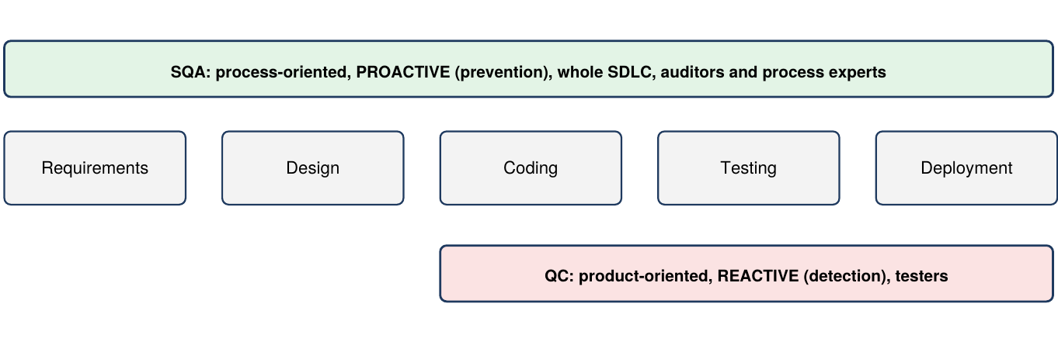
Fig 21: SQA and QC across the SDLC

Part 1: SQA vs Quality Control (QC)
Dimension | Software Quality Assurance (SQA) | Quality Control (QC)
Philosophy | Proactive: defect prevention. | Reactive: defect detection.
Scope | Development processes and methodologies. | Specific products and software builds.
Timing | Continuously across the whole SDLC. | During or after software construction.
Key Activities | Standards, process auditing, training, tool selection. | Unit and system testing, code inspections, reviews.
Responsibility | SQA engineers, auditors, process experts. | Developers, testers, QA analysts.

Part 2: Process Audits vs Product Audits
Fig 22: Process audit vs product audit
Dimension | Process Audit | Product Audit
Target | Procedural compliance of development teams. | Quality and correctness of software artefacts.
Core Goal | Adherence to organisational SQA standards. | Compliance with functional requirements.
Method | Reviewing workflows, logs and project plans. | Code inspections, document reviews, artefact testing.
Outcome | Improvement proposals and non-conformance logs. | Defect reports, bug logs and release approvals.
Long-Term Value | Organisational maturity and process consistency. | Technical stability of the current release.

Structured Comparative Points
- Prevention vs Detection: SQA builds defect-prevention frameworks; QC tests to detect existing bugs.
- Process vs Product Centricity: SQA defines standard methodologies; QC evaluates the resulting code and documents.
- Systemic vs Specific Execution: SQA governs organisation-wide quality policy; QC applies technical tests to specific builds.
- Workflow vs Artefact Verification: Process audits check workflow compliance (e.g., code reviews done properly); product audits inspect the artefact.
- Procedure vs Requirement Adherence: Process audits confirm procedural discipline; product audits confirm features meet customer requirements.
- Timing of Intervention: SQA operates continuously from planning; QC testing happens during execution and verification.
- Operational Ownership: SQA is driven by independent quality auditors; QC involves developers and test engineers.
- Organisational Impact: SQA and process audits improve project predictability; QC and product audits guarantee individual release stability.
- Standards Alignment: SQA aligns practices with ISO 9001, CMMI and IEEE 730; QC verifies the product against the test criteria set in the plan.
- Synergy: Together SQA and QC give complete quality governance, coupling process management with technical product verification.

Q22. Discuss how Software Quality Program implementation drives product reliability, cost reduction, compliance, and continuous process improvement.
Definition & Overview
Implementing an SQP turns quality management into a strategic capability that delivers reliable products, efficiency, regulatory compliance and business performance.
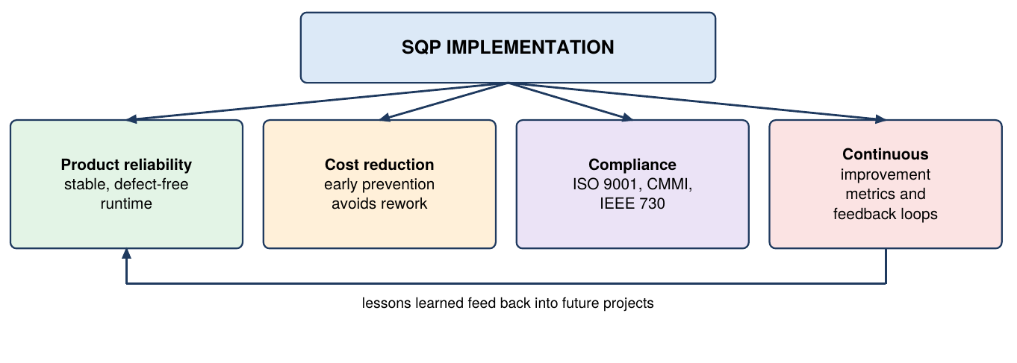
Fig 23: Strategic impact of SQP implementation
- Product Reliability: Defect-prevention activities in every SDLC phase stop architectural and coding errors, and continuous verification keeps performance stable after deployment.
- Customer Satisfaction: Consistently meeting functional specifications builds trust, client retention, brand value and competitiveness.
- Lifecycle Cost Reduction: A defect caught in requirements or design costs far less than one fixed in system testing or maintenance, so prevention cuts rework.
- Process Standardisation: Uniform policies, audit routines and coding guidelines remove dependence on individual capability and give consistent outcomes.
- Regulatory Compliance: Following ISO 9001, CMMI and IEEE 730 gives compliance and international market acceptance.
- Risk Mitigation: SQA planning identifies threats such as unclear requirements or skill gaps and carries out explicit mitigation plans.
- Resource Optimisation: The SQAP defines roles, tools and resources, improving communication and preventing waste.
- Data-Driven Monitoring: Metrics such as defect density, review coverage and test pass rates give management visibility of process health.
- Continuous Feedback: Internal audits and post-project reviews capture lessons that improve later projects.
- Quality Culture: Sustained SQP execution builds a culture where every stakeholder prioritises software quality.

