Software Quality Assurance and Process Standardization

Exam-Oriented Question Bank & Complete Answer Key

PART 1: QUESTION BANK OVERVIEW

Section A – 10-Mark Questions (Q1 – Q5)
Q1. Explain the Capability Maturity Model (CMM) framework in detail. Discuss all five maturity levels, their defining characteristics, and key process focus areas as established by the Software Engineering Institute (SEI).
Q2. Describe the ISO 9000 Quality System Standards family. Explain its core principles, essential ISO 9001 requirements, and evaluate both its strategic benefits and practical limitations in software engineering.
Q3. Elaborate on SEI CMM Level 5 (Optimizing) in detail. Discuss its defining characteristics, core key practices (Defect Prevention, Technology Change Management, Process Change Management), and organizational benefits.
Q4. Provide a comprehensive comparative analysis between ISO 9000 quality system standards and the SEI Capability Maturity Model (CMM). Discuss their structural differences, focus areas, and explain how both frameworks can be integrated for enhanced quality governance.
Q5. Detail the evolving role of Software Quality Assurance (SQA) across the five CMM process maturity levels. Explain core SQA objectives and describe how SQA integrates ISO 9000 compliance with CMM process capability.

Section B – 5-Mark Questions (Q6 – Q13)
Q6. Explain software standards, state their fundamental purpose, and describe the four primary types of software standards utilized in software engineering.
Q7. Discuss the ISO 9000 family of standards. List and explain the specific role of each main standard included within this family.
Q8. Explain the eight core Quality Management Principles governing the ISO 9000 series and discuss their relevance to software engineering.
Q9. Classify and compare Product Standards, Process Standards, Practice Standards, and Organizational Standards. Provide concrete software engineering examples for each category.
Q10. Describe the core Key Practices of SEI CMM Level 5 (Optimizing), focusing specifically on Defect Prevention, Technology Change Management, and Process Change Management.
Q11. Explain the primary objectives of Software Quality Assurance (SQA) and describe how SQA activities evolve from CMM Level 1 (Initial) to CMM Level 3 (Defined).
Q12. Analyze the strategic operational benefits and key practical limitations of implementing ISO 9000 Quality System Standards in software engineering organizations.
Q13. Explain how ISO 9000 and SEI CMM complement each other and describe the integrated benefits achieved when a software organization adopts both frameworks simultaneously.

Section C – 2-Mark Questions (Q14 – Q22)
Q14. Define a software standard and state its primary purpose in software engineering.
Q15. What is ISO 9000? State its main objective in quality management.
Q16. Define Capability Maturity Model (CMM) and identify the organization responsible for its development.
Q17. What is CMM Level 1 (Initial)? Mention its key operational characteristics.
Q18. What is CMM Level 2 (Repeatable)? State its core focus area.
Q19. Define CMM Level 4 (Managed) and name the key metrics collected at this maturity level.
Q20. What are Product Standards? Provide two concrete examples in software development.
Q21. What are Process Standards? Provide two concrete examples in software engineering.
Q22. State two fundamental differences between ISO 9000 and the SEI Capability Maturity Model (CMM).

PART 2: COMPLETE ANSWER KEY

Section A – 10-Mark Answers (Q1 – Q5)
Q1 Explain the Capability Maturity Model (CMM) framework in detail. Discuss all five maturity levels, their defining characteristics, and key process focus areas as established by the Software Engineering Institute (SEI).
The Capability Maturity Model (CMM), developed by the Software Engineering Institute (SEI), is an authoritative process improvement framework designed to evaluate and enhance the maturity of an organization's software development processes. CMM establishes a structured five-level evolutionary path that guides software organizations from chaotic, ad-hoc development practices toward predictable, quantitative, and continuously optimizing engineering discipline.
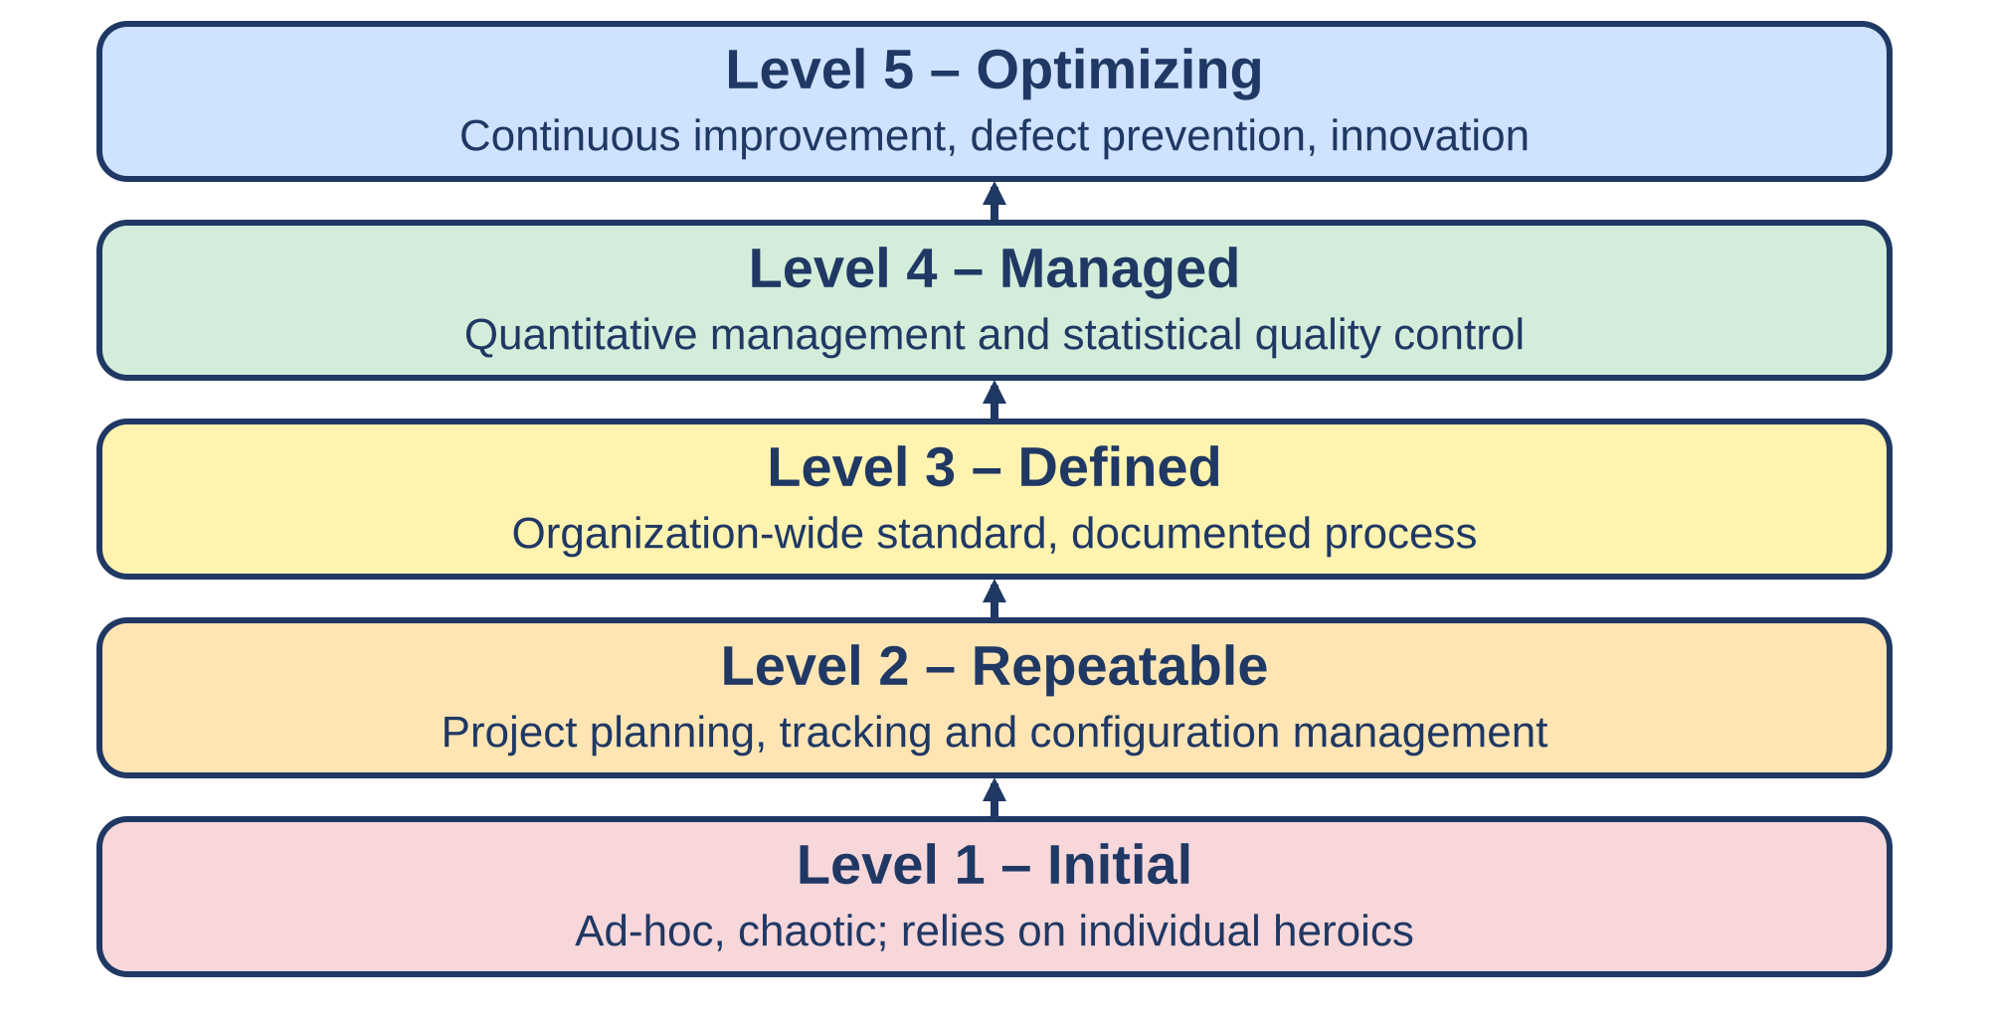
Fig 1: SEI CMM five maturity levels (Initial to Optimizing)
- Software Engineering Institute (SEI) Origin & Framework Purpose: CMM was formulated by SEI to provide software engineering organizations with a structured methodology to assess process maturity and identify key process areas needing improvement. The overarching objective of the model is to help organizations transition away from unstructured, high-risk development environments toward predictable, repeatable, and measurable software processes.
- Level 1 – Initial (Chaotic & Unstructured Baseline): At Level 1, the software development environment is characterized as ad-hoc, chaotic, and largely unstructured. Development success relies almost entirely on individual heroics, personal skills, and effort rather than organizational processes, leading to highly unpredictable product quality, cost overruns, and schedule slippages.
- Level 1 Operational Dynamics & Process Gaps: Software organizations operating at Level 1 lack formal project tracking, standardization, and quality control mechanisms. When crisis situations arise during development, projects regularly abandon planned procedures, fixing issues reactively without documented procedures or formal software quality assurance oversight.
- Level 2 – Repeatable (Basic Project Governance): Level 2 establishes basic project management control and discipline across individual software projects. Organizations implement formal project planning, cost tracking, schedule monitoring, and requirements management, enabling historical project successes to be repeated for similar applications.
- Level 2 Oversight & Configuration Discipline: At Level 2, formal project oversight and configuration management procedures are instituted to manage software baselines and change requests. Software quality assurance processes emerge at this stage to ensure project team compliance with established baseline management plans and project tracking schedules.
- Level 3 – Defined (Organization-Wide Process Standardization): Level 3 establishes organization-wide standard software engineering and management processes. Software development procedures are formally documented, integrated into a standard organizational process asset library, and tailored appropriately to satisfy specific project context requirements.
- Level 3 Engineering Training & SQA Deployment: At Level 3, the organization provides comprehensive software engineering training programs to ensure personnel possess the competencies required to execute standardized processes. Organization-wide SQA policies are deployed to systematically verify process adherence and standardized documentation enforcement.
- Level 4 – Managed (Quantitative Process Control): Level 4 introduces quantitative management and statistical quality control across software processes. Detailed process performance and product quality metrics are systematically collected, analyzed, and stored in an organizational measurement database to establish quantitative process baselines.
- Level 4 Predictability & Statistical Control: Organizations at Level 4 evaluate project performance using statistical quality control techniques to control process variation. SQA practices shift toward quantitative analysis, tracking defect densities, module reliability, development productivity, and schedule variation against statistical norms.
- Level 5 – Optimizing (Continuous Process Evolution): Level 5 represents the highest maturity level, where the entire organization is focused on continuous process improvement and innovation. The organization systematically identifies process weaknesses, evaluates novel technologies, and performs defect root cause analysis to prevent defect recurrence and continuously refine efficiency.

Q2 Describe the ISO 9000 Quality System Standards family. Explain its core principles, essential ISO 9001 requirements, and evaluate both its strategic benefits and practical limitations in software engineering.
ISO 9000 is an internationally recognized family of Quality Management System (QMS) standards developed by the International Organization for Standardization (ISO). Applicable across diverse operational sectors, including software engineering, ISO 9000 establishes a generic framework designed to ensure customer satisfaction, continuous process improvement, and rigorous process documentation.
- International Organization for Standardization (ISO) Scope: ISO 9000 defines generic quality management system standards applicable to software development and broader industrial domains. The standard provides a structured organizational framework ensuring that processes, products, and customer-facing services consistently meet defined quality specifications and regulatory expectations.
- ISO 9000 Fundamentals & Vocabulary Standard: ISO 9000 serves as the foundational document establishing essential quality management concepts, terminology, and principles. It provides a common language for quality practitioners, ensuring clear communication between clients, development teams, and external quality auditing authorities.
- ISO 9001 Quality Management System Requirements: ISO 9001 represents the primary certification standard within the family, setting out explicit criteria for a compliant QMS. Organizations undergo rigorous external third-party audits against ISO 9001 requirements to demonstrate their capability to consistently deliver compliant software products.
- ISO 9004 Performance Guidelines & ISO 19011 Auditing: ISO 9004 provides comprehensive guidelines for extending QMS performance beyond basic compliance toward long-term organizational success. Concurrently, ISO 19011 outlines mandatory practices for planning, conducting, and managing internal and external quality management system audits.
- Customer Focus & Leadership Principles: The ISO 9000 framework relies heavily on customer focus to align software requirements with client expectations. Leadership commitment ensures that executive management establishes clear quality goals, provides necessary operational resources, and maintains an environment conducive to full staff involvement.
- Process & System Approach to Management: ISO 9000 emphasizes managing software development activities as interconnected, documented processes. Treating development tasks as an integrated system improves operational efficiency, establishes clear process inputs and outputs, and enhances organizational predictability across projects.
- Factual Decision Making & Continual Improvement: Quality management decisions under ISO 9000 rely strictly on factual data analysis and documented audit records rather than subjective intuition. Continual process improvement and mutually beneficial supplier relationships ensure sustained organizational growth and external software vendor quality control.
- Core ISO 9001 Mandatory Documentation & Audit Requirements: ISO 9001 requires organizations to maintain a documented quality policy, explicit operational procedures, and thorough development records. The standard enforces clear assignment of roles and responsibilities alongside mandatory periodic management reviews and auditing cycles.
- Strategic Operational Benefits of ISO Implementation: Adopting ISO 9000 enhances customer confidence, improves management visibility, and establishes standardized workflows across software projects. It ensures repeatable development procedures, enhances documentation traceability, and provides a universally recognized baseline for auditing.
- Practical Limitations & Implementation Challenges: ISO 9000 implementation introduces significant documentation overhead and administrative maintenance costs. Additionally, because ISO 9000 is generic across all manufacturing and service industries, it lacks specific technical guidance tailored to unique software engineering activities such as testing or coding techniques.

Q3 Elaborate on SEI CMM Level 5 (Optimizing) in detail. Discuss its defining characteristics, core key practices (Defect Prevention, Technology Change Management, Process Change Management), and organizational benefits.
CMM Level 5 (Optimizing) represents the pinnacle of organizational process maturity within the Software Engineering Institute's framework. At Level 5, an organization moves beyond quantitative process control toward proactive, continuous process evolution, leveraging statistical defect analysis, rapid technology evaluation, and structured process change management to achieve software engineering excellence.
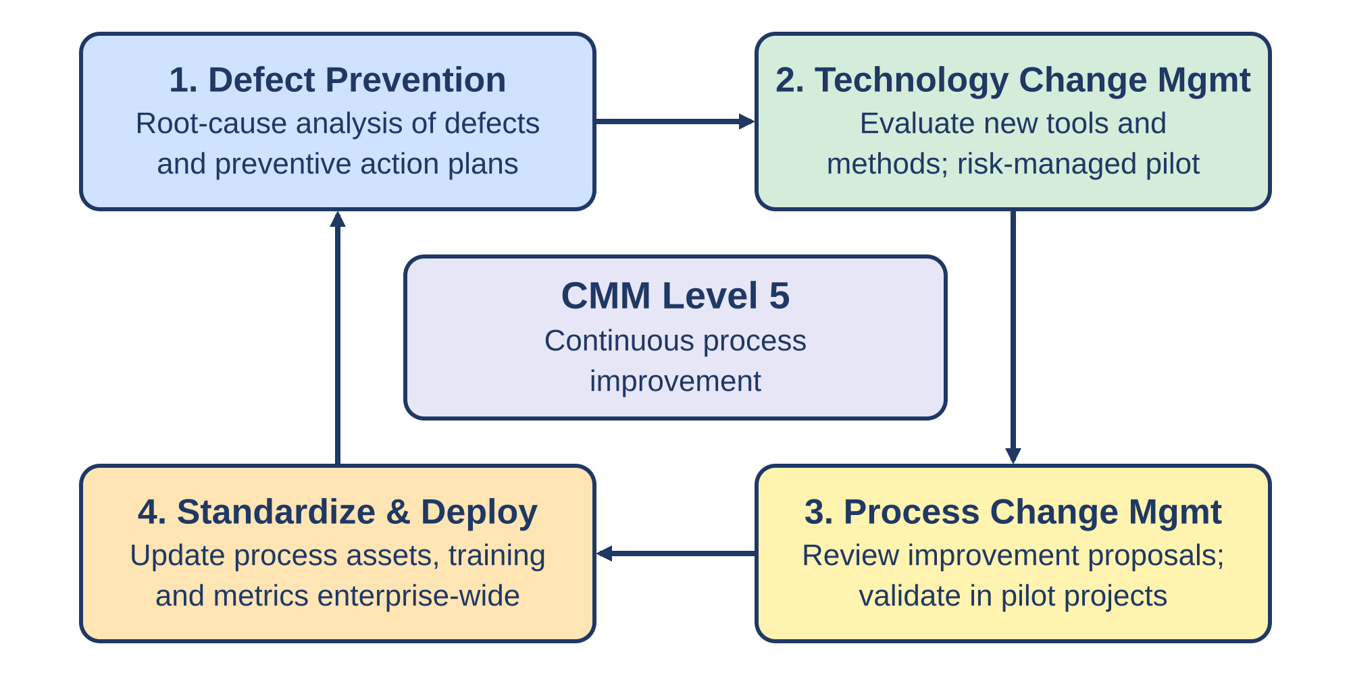
Fig 2: CMM Level 5 continuous improvement cycle
- Continuous Process Evolution Focus: CMM Level 5 organizations concentrate entirely on continuous process improvement and process innovation. Rather than merely reacting to quality deviations or maintaining statistical stability, Level 5 organizations proactively identify systemic process weaknesses and systematically optimize engineering workflows.
- Systematic Cause-and-Effect Problem Analysis: At Level 5, process deviations and software defects are analyzed systematically using advanced root cause analysis techniques. Organizations inspect development data to identify underlying process flaws, ensuring that corrective measures address systemic causes rather than isolated symptoms.
- Rapid Organizational Process Deployment: Level 5 organizations maintain flexible process infrastructures designed for rapid deployment of refined methodologies. Once process improvements or novel tools pass empirical pilot testing, they are swiftly standardized and deployed across all enterprise development teams.
- Defect Prevention Practice – Root Cause Identification: Defect Prevention is a core Key Practice Area at Level 5 dedicated to identifying the primary origins of software defects during early lifecycle phases. Project teams analyze past defect patterns to pinpoint technical, procedural, or environmental causes responsible for errors.
- Defect Prevention Practice – Preventive Action Implementation: Following root cause identification, Defect Prevention practices formulate targeted corrective and preventive action plans. Development protocols, coding guidelines, and inspection checklists are updated immediately to prevent similar defect classes from recurring in future projects.
- Technology Change Management – Tool & Method Evaluation: Technology Change Management involves the continuous identification, selection, and evaluation of innovative software engineering tools, automation frameworks, and methodologies. Organizations systematically screen emerging technologies to determine their potential for enhancing productivity and software quality.
- Technology Change Management – Risk-Managed Tool Adoption: Level 5 organizations manage the operational risks associated with integrating novel software technologies. New tools undergo controlled pilot evaluation within test environments to quantify efficiency gains and risk exposure prior to enterprise-wide adoption.
- Process Change Management – Proposal Screening & Pilot Testing: Process Change Management provides a formal mechanism for proposing, reviewing, and testing software process modifications. Process improvement proposals submitted by engineering staff are rigorously evaluated and empirically validated in controlled pilot projects.
- Process Change Management – Enterprise Standardization: Successful process change proposals validated through pilot implementations are formally integrated into the organization's standard software process assets. Training modules and quality metrics are updated synchronously to ensure uniform adoption across all business units.
- Organizational Benefits of CMM Level 5 Maturity: Achieving CMM Level 5 yields highly predictable development costs, delivery schedules, and product quality levels. Organizations experience maximized operational efficiency, reduced rework, superior defect prevention capability, and enhanced long-term customer trust.

Q4 Provide a comprehensive comparative analysis between ISO 9000 quality system standards and the SEI Capability Maturity Model (CMM). Discuss their structural differences, focus areas, and explain how both frameworks can be integrated for enhanced quality governance.
Software organizations frequently evaluate ISO 9000 Quality System Standards and the SEI Capability Maturity Model (CMM) to establish software quality governance. While ISO 9000 provides a broad, audit-based Quality Management System (QMS) framework applicable to diverse industries, CMM delivers a specialized, staged evolutionary roadmap specifically designed for software process improvement.
Feature Dimension | ISO 9000 Standard Family | SEI Capability Maturity Model (CMM)
Developing Authority | International Organization for Standardization (ISO) | Software Engineering Institute (SEI) / Carnegie Mellon
Primary Domain Focus | General Quality Management System (QMS) across industries | Software process maturity and engineering capability
Applicability Scope | Broad applicability to manufacturing, service, and software sectors | Specialized primary focus on software development organizations
Certification Mechanics | External third-party compliance audit leading to certification | Internal/external formal appraisal evaluating maturity level
Core Emphasis | Process compliance, documentation, and customer satisfaction | Staged software process maturity and continuous capability growth
Structural Architecture | Single compliance baseline (ISO 9001 QMS criteria) | Five-level staged maturity hierarchy (Levels 1 to 5)
Improvement Model | Audit-driven conformance and general continuous improvement | Stepwise, quantitative process maturity evolution roadmap
Software Specificity | Generic quality management principles requiring software tailoring | Tailored specifically to software development lifecycle practices

- Developing Authorities & Domain Focus: ISO 9000 was created by the International Organization for Standardization as a generic quality system suitable for all industries. Conversely, CMM was engineered specifically by SEI to target the unique complexities, operational risks, and process maturity challenges of software development.
- Certification Mechanics vs. Appraisal Assessment: ISO 9000 relies on external third-party registration audits to grant ISO 9001 compliance certification. CMM utilizes formal appraisal methodologies to evaluate an enterprise, assigning a specific maturity level based on demonstrated process capability across key process areas.
- Compliance Emphasis vs. Progressive Maturity Evolution: ISO 9000 emphasizes establishing a documented quality system and verifying compliance against documented procedures. In contrast, CMM focuses on progressive software process evolution, offering a structured path to move from chaotic processes toward quantitative statistical control.
- Single Baseline Hierarchy vs. Staged Level Architecture: ISO 9001 operates on a single pass/fail certification baseline, evaluating whether an organization satisfies QMS criteria. CMM provides a five-level staged framework (Initial, Repeatable, Defined, Managed, Optimizing), establishing clear evolutionary milestones for process growth.
- Generic Quality Framework vs. Domain-Specific Guidance: ISO 9000 provides overarching quality principles that require software development teams to translate generic rules into software practices. CMM provides domain-specific practices tailored directly to software engineering, such as configuration management, software inspections, and quantitative defect tracking.
- Documentation-Oriented Auditing vs. Process Capability Measurement: ISO 9000 auditing focuses heavily on verifying process documentation, record traceability, and operational compliance. CMM appraisals evaluate process capability, quantitative process baselines, statistical defect control, and root-cause defect prevention effectiveness.
- Complementary Framework Synergy & Coexistence: Despite structural differences, ISO 9000 and CMM are highly complementary. Software organizations can implement ISO 9001 to establish a certified, customer-facing QMS baseline while simultaneously adopting CMM to drive internal software engineering process improvement.
- Role of ISO 9000 as the QMS Foundation: ISO 9001 provides the overarching managerial structure, establishing quality policies, document control procedures, leadership responsibilities, and management review cycles. This creates a solid administrative foundation upon which software-specific technical practices can flourish.
- Role of CMM as the Engineering Improvement Roadmap: CMM fills the technical execution gap of ISO 9000 by offering step-by-step guidance for software engineering maturity. CMM key process areas define how software configuration management, project tracking, quantitative metrics, and defect prevention should be executed.
- Integrated Benefits of Dual Implementation: Combining ISO 9000 and CMM delivers comprehensive quality governance. Organizations achieve enhanced customer confidence through ISO certification while securing predictable project schedules, reduced defect rates, robust metric collection, and continuous engineering optimization via CMM maturity practices.

Q5 Detail the evolving role of Software Quality Assurance (SQA) across the five CMM process maturity levels. Explain core SQA objectives and describe how SQA integrates ISO 9000 compliance with CMM process capability.
Software Quality Assurance (SQA) is a planned and systematic pattern of actions necessary to provide adequate confidence that software products and development processes conform to established technical requirements and quality standards. As an organization progresses through the five SEI CMM maturity levels, the operational role of SQA shifts dramatically from reactive issue resolution to quantitative metric analysis and continuous defect prevention.
- Demonstrating Quality Confidence Objective: The primary objective of SQA is to provide executive management and external clients with verified evidence that software development activities adhere to established standards. SQA conducts independent process reviews and product audits to demonstrate confidence in software quality.
- Early Defect Prevention Objective: SQA aims to detect and prevent software defects during early lifecycle phases rather than relying solely on late-stage software testing. By reviewing requirement specifications, design documents, and project plans, SQA minimizes costly rework and downstream defect propagation.
- Productivity & Professionalism Improvement Objective: SQA establishes standardized engineering procedures, automated verification tools, and audit frameworks that eliminate process friction. This structured environment enhances developer productivity, ensures maintainable codebases, and instills professional quality discipline across project teams.
- SQA Dynamics at CMM Level 1 (Initial Stage): At Level 1, no formal, independent SQA structure exists within the organization. Quality control relies on individual developer effort, and software defects or process non-conformances are addressed reactively when critical system failures occur during operational usage.
- SQA Deployment at CMM Level 2 (Repeatable Stage): At Level 2, formal SQA roles are established to verify basic project-level governance. SQA personnel audit project planning adherence, track baseline compliance, review requirements management, and enforce software configuration management discipline across individual projects.
- SQA Governance at CMM Level 3 (Defined Stage): At Level 3, SQA operates under organization-wide policies and standardized procedures. SQA audits project teams to ensure proper process tailoring from the standard organizational process library, enforces documentation standards, and oversees formal peer reviews and design inspections.
- Quantitative SQA Analysis at CMM Level 4 (Managed Stage): At Level 4, SQA shifts from qualitative compliance checks to quantitative process evaluation. SQA utilizes statistical process control techniques to analyze defect densities, module complexity metrics, testing coverage, process productivity, and schedule variance.
- Optimization & Root Cause SQA at CMM Level 5 (Optimizing Stage): At Level 5, SQA becomes a catalyst for continuous process innovation and defect prevention. SQA leads defect root cause analysis sessions, evaluates emerging software verification technologies, and identifies systematic process refinement patterns across enterprise projects.
- SQA Support for ISO 9000 Compliance Integration: SQA bridges organizational execution with ISO 9000 standards by maintaining quality manuals, enforcing mandatory documentation standards, managing audit records, and ensuring that development procedures satisfy ISO 9001 Quality Management System requirements.
- Integrated SQA Governance Benefits across Frameworks: When SQA aligns ISO 9000 compliance with CMM process capability, the organization achieves unified quality governance. SQA ensures robust defect prevention, reliable schedule estimation, rigorous process measurement, and heightened client satisfaction backed by audit-ready quality evidence.

Section B – 5-Mark Answers (Q6 – Q13)
Q6 Explain software standards, state their fundamental purpose, and describe the four primary types of software standards utilized in software engineering.
Software standards are documented sets of rules, guidelines, definitions, or technical characteristics established to ensure that software development processes, products, and services meet defined quality expectations. They provide a unified framework that governs engineering practices across projects.
- Fundamental Purpose of Software Standards: Software standards serve to unify engineering practices, improve technical communication among developers and stakeholders, increase development productivity, reduce long-term maintenance costs, and establish measurable, repeatable software engineering processes across an enterprise.
- Product Standards Definition & Focus: Product standards define the required characteristics, structural rules, and quality attributes of the final software artifacts. They ensure that deliverables maintain uniform formats, readable code architecture, and consistent user interfaces across all modules.
- Product Standards Examples in Engineering: Practical examples of product standards include mandatory programming style and code documentation guidelines, database naming conventions, user interface (GUI) design standards, and system architectural blueprint specifications.
- Process Standards Definition & Examples: Process standards define mandatory workflows, procedures, and methodologies that engineering teams must follow during software development. Key examples include formal software testing procedures, software configuration management workflows, requirement change control processes, and code review protocols.
- Practice & Organizational Standards Scope: Practice standards represent industry-wide best practices adopted by software organizations to ensure high-quality output. Organizational standards constitute company-wide operational policies, quality manuals, and administrative guidelines applied uniformly across all enterprise software projects.

Q7 Discuss the ISO 9000 family of standards. List and explain the specific role of each main standard included within this family.
The ISO 9000 family consists of an integrated set of international quality management standards published by the International Organization for Standardization (ISO). Together, these standards assist organizations in establishing, maintaining, auditing, and continually improving effective Quality Management Systems (QMS).
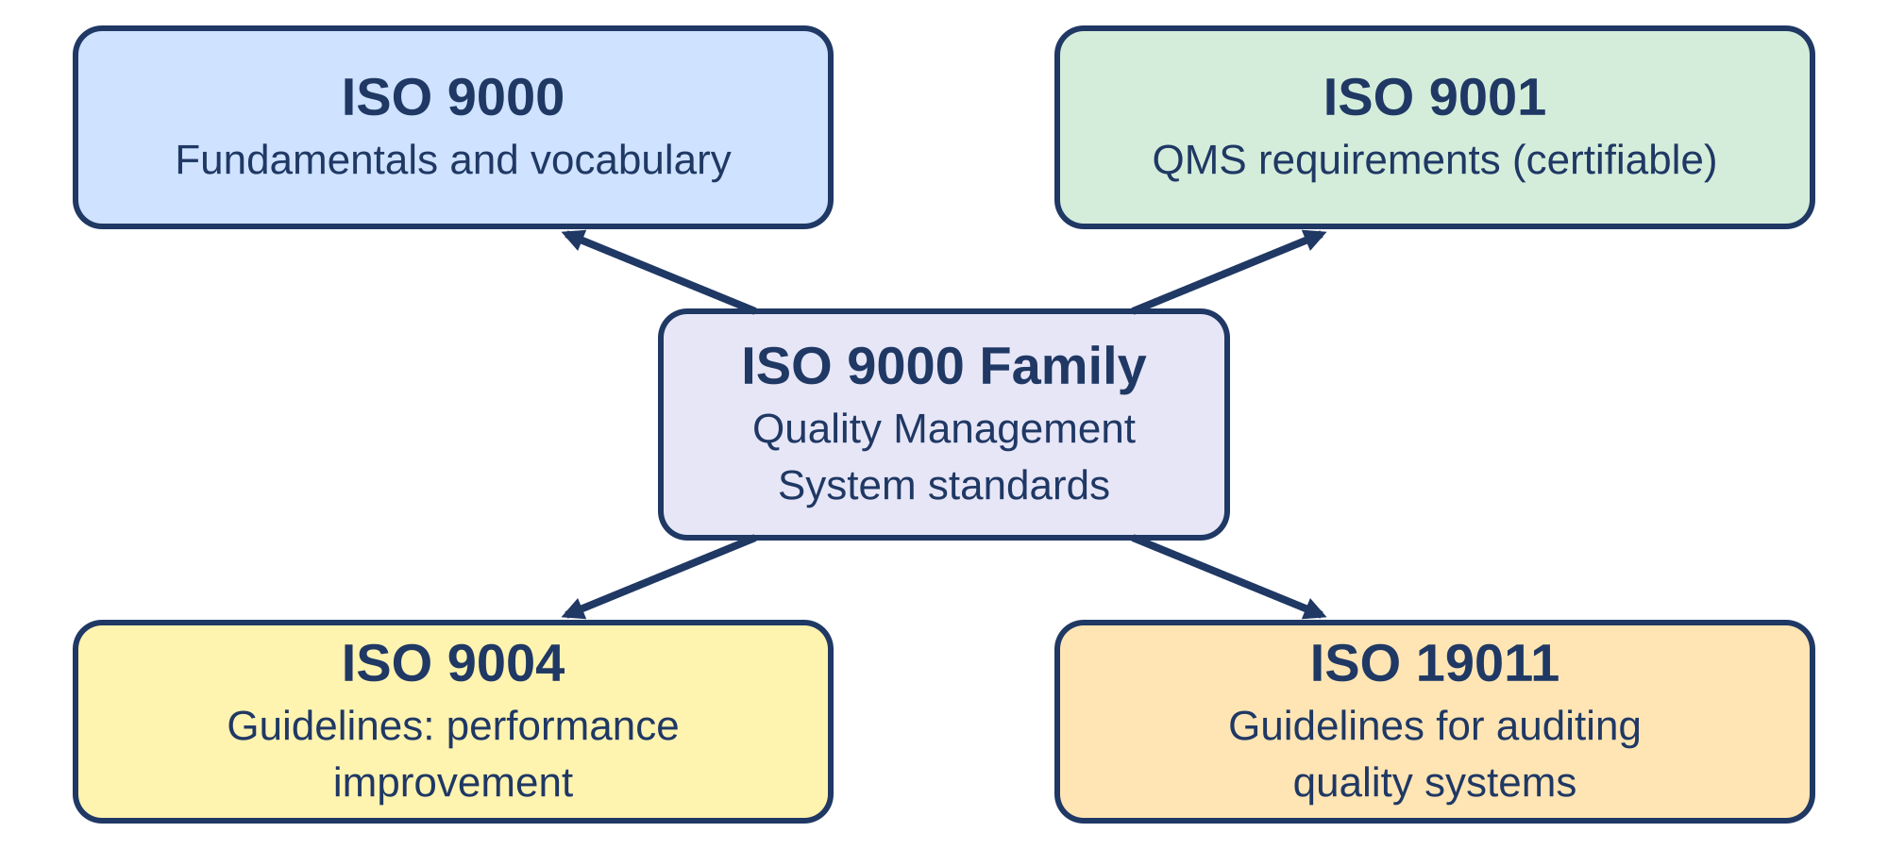
Fig 3: The ISO 9000 family of standards
- ISO 9000 – Quality Management Fundamentals & Vocabulary: ISO 9000 defines the basic concepts, core principles, and specialized terminology of quality management systems. It establishes a universally recognized vocabulary that ensures unambiguous communication between software clients, development teams, and external auditors.
- ISO 9001 – Requirements for Quality Management Systems: ISO 9001 specifies the mandatory requirements for a compliant QMS and serves as the sole standard in the family against which organizations can be formally audited and certified by external registration bodies.
- ISO 9001 Software QMS Scope: Within software engineering, ISO 9001 mandates documented quality policies, defined software lifecycle procedures, systematic record-keeping, formal role assignments, and structured management review processes to ensure consistent software quality delivery.
- ISO 9004 – Guidelines for Performance Improvement: ISO 9004 provides executive guidance for extending an established QMS beyond basic ISO 9001 compliance. It focuses on broader performance improvement, organizational sustainability, efficiency gains, and long-term stakeholder satisfaction.
- ISO 19011 – Guidelines for Quality Systems Auditing: ISO 19011 outlines professional guidelines for planning, conducting, and managing QMS audits. It provides auditor qualification criteria, audit execution protocols, and reporting standards applicable to internal quality reviews and external compliance audits.

Q8 Explain the eight core Quality Management Principles governing the ISO 9000 series and discuss their relevance to software engineering.
The ISO 9000 Quality Management System standards are built upon eight foundational quality management principles. Derived from global industry best practices, these principles guide organizations toward sustained performance enhancement, customer satisfaction, and operational excellence in software engineering.
- Customer Focus & Leadership Principles: Customer Focus emphasizes understanding user requirements and exceeding customer expectations throughout software delivery. Leadership mandates that executive management establish unified organizational direction, clear quality goals, and an environment supporting staff engagement.
- Involvement of People & Process Approach: Involvement of People ensures that personnel at all levels are fully empowered and engaged in quality initiatives. The Process Approach manages software development as structured, interconnected processes to achieve efficient and predictable outcomes.
- System Approach to Management Principle: The System Approach to Management involves identifying, understanding, and managing a network of interrelated software development processes as an integrated system, enhancing organizational effectiveness and development cohesion.
- Continual Improvement & Factual Decision Making: Continual Improvement establishes an ongoing organizational objective to refine software engineering practices. Factual Decision Making requires that project management decisions be based on objective metric analysis and documented operational evidence.
- Mutually Beneficial Supplier Relationships: This principle recognizes that software organizations and their external suppliers or component vendors are interdependent. Establishing collaborative supplier relationships enhances quality control and value creation across third-party software components.

Q9 Classify and compare Product Standards, Process Standards, Practice Standards, and Organizational Standards. Provide concrete software engineering examples for each category.
Software standards are categorized into four distinct functional classes to govern various facets of the software engineering lifecycle. Understanding the boundaries and operational focus of each standard type ensures balanced quality management across software products and organizational workflows.
Standard Category | Core Definition & Focus Area | Primary Engineering Objective | Practical Software Example
Product Standards | Defines structural and behavioral attributes of final deliverables | Ensures visual, code, and architectural uniformity | GUI design guides, Code documentation rules
Process Standards | Specifies mandatory procedures for conducting development work | Guarantees repeatable, disciplined operational workflows | Testing execution protocols, SCM workflows
Practice Standards | Enforces industry-wide proven methodologies and best practices | Aligns organizational work with global technical standards | Agile framework guidelines, IEEE code reviews
Organizational Standards | Enterprise-wide policies and guidelines applicable company-wide | Standardizes administrative and quality governance | Corporate QMS manuals, Data security policies

- Product Standards Characteristics & Purpose: Product standards directly constrain the structural formatting, architectural style, and documentation of software deliverables. They guarantee that software artifacts maintain uniform readability, consistency, and maintainability across development teams.
- Process Standards Operational Role: Process standards prescribe the exact step-by-step procedures engineers must execute during software development. They eliminate haphazard practices by defining standardized testing sequences, baseline management controls, and defect tracking procedures.
- Practice Standards Scope: Practice standards capture broader industry-proven methodologies adopted by an enterprise to maintain technical competitiveness. Examples include adopting IEEE software engineering practices, clean code conventions, and secure coding standards.
- Organizational Standards Scope: Organizational standards constitute high-level policy frameworks formulated by corporate executive leadership. They govern enterprise-wide administrative protocols, quality policy manuals, human resource training compliance, and cross-project governance.
- Interrelationship Among Standard Types: These four standard categories operate cohesively within an enterprise. Organizational standards establish high-level quality mandates, process standards enforce procedural compliance, practice standards define technical execution, and product standards verify final artifact compliance.

Q10. Describe the core Key Practices of SEI CMM Level 5 (Optimizing), focusing specifically on Defect Prevention, Technology Change Management, and Process Change Management.
At CMM Level 5 (Optimizing), continuous process improvement is operationalized through three specialized Key Practice Areas (KPAs). These KPAs provide structured methodologies for root cause defect elimination, risk-managed technology adoption, and enterprise-wide process modernization.
- Defect Prevention – Root Cause Analysis Practice: Defect Prevention systematically identifies the primary origins of software defects encountered in current and past projects. Engineering teams analyze defect trends using root cause analysis techniques to uncover procedural, technical, or training deficiencies.
- Defect Prevention – Action Plan Implementation: Once root causes are pinpointed, Defect Prevention teams formulate concrete preventive action plans. Development standards, peer review checklists, and automated static analysis rules are updated immediately to prevent recurring defect patterns across active projects.
- Technology Change Management – Screening & Evaluation: Technology Change Management continuously monitors, evaluates, and selects innovative software engineering technologies, tools, and methodologies. The practice assesses new tools for their ability to improve product quality and developer productivity.
- Technology Change Management – Controlled Pilot Deployment: To mitigate integration risks, newly selected software tools undergo controlled pilot evaluation in isolated test project environments. Operational risks and quantitative productivity impacts are analyzed before full enterprise rollout.
- Process Change Management – Proposal Review & Standardization: Process Change Management handles internal proposals for software process refinement submitted by engineering staff. Proposals undergo pilot validation; successful process changes are standardized and integrated into the organizational process asset library.

Q11 Explain the primary objectives of Software Quality Assurance (SQA) and describe how SQA activities evolve from CMM Level 1 (Initial) to CMM Level 3 (Defined).
Software Quality Assurance (SQA) provides executive management with independent visibility into software processes and product quality. SQA activities evolve dynamically alongside organizational process maturity, expanding from ad-hoc intervention to enterprise-wide quality governance.
- Core SQA Objectives: SQA aims to demonstrate internal and external confidence in software quality, prevent software defects during early lifecycle stages, enhance engineering productivity and professional discipline, and support continuous process improvement initiatives.
- SQA State at CMM Level 1 (Initial): At CMM Level 1, organizations lack a formal SQA infrastructure. Software quality verification is unstructured and reactive, relying on individual developers who fix defects post-hoc without standardized audit procedures.
- SQA Evolution at CMM Level 2 (Repeatable): At Level 2, formal SQA roles are established at the project level. SQA monitors baseline control, verifies compliance with documented project plans, audits software configuration management procedures, and ensures project-level tracking discipline.
- SQA Standardization at CMM Level 3 (Defined): At Level 3, SQA transitions to an organization-wide governance function. SQA enforces standard organizational policies, verifies project process tailoring compliance, audits formal software design inspections, and maintains centralized quality records.
- Summary of Level 1 to Level 3 Progression: The progression from Level 1 to Level 3 reflects a shift from total absence of SQA governance (Level 1) to basic project-level compliance tracking (Level 2), culminating in standardized, enterprise-wide SQA policy enforcement and audit coverage (Level 3).

Q12 Analyze the strategic operational benefits and key practical limitations of implementing ISO 9000 Quality System Standards in software engineering organizations.
Implementing ISO 9000 Quality System Standards offers software organizations a globally recognized framework for quality management. However, achieving and sustaining ISO certification requires balancing major operational benefits against notable administrative and financial constraints.
- Enhanced Customer Satisfaction Benefit: ISO 9000 implementation aligns software engineering activities with customer requirements, establishing documented feedback mechanisms that improve client communication, product reliability, and overall customer satisfaction.
- Improved Process Control & Visibility Benefit: ISO 9001 mandates documented operational procedures and formal management review cycles. This provides executive leadership with clear operational visibility, standardized workflows, and repeatable processes across development teams.
- Documentation & Traceability Benefit: ISO 9000 enforces systematic record-keeping and traceability across software requirements, design specifications, and audit logs, ensuring audit-ready documentation and simplified maintainability.
- Administrative Documentation Overhead Limitation: A significant drawback of ISO 9000 is the heavy administrative documentation burden it imposes on engineering teams, which can sometimes divert time away from core software development activities.
- Generic Scope & Certification Cost Limitation: ISO 9000 provides broad quality principles that are not software-specific, omitting targeted technical guidance for activities like code refactoring or testing. Furthermore, acquiring and maintaining third-party ISO certification involves substantial financial costs.

Q13 Explain how ISO 9000 and SEI CMM complement each other and describe the integrated benefits achieved when a software organization adopts both frameworks simultaneously.
While ISO 9000 focuses on broad Quality Management System compliance and SEI CMM targets detailed software process maturity, the two frameworks are complementary. Software organizations frequently integrate both standards to construct a robust quality governance framework.
- Complementary Operational Synergies: ISO 9000 provides the macro-level managerial structure, establishing quality policies, leadership responsibilities, and external audit readiness. CMM supplies the micro-level software engineering roadmap, detailing technical execution across specific process areas.
- Dual-Framework Integration Mechanism: Software organizations utilize ISO 9001 to satisfy customer QMS certification demands while leveraging CMM practices to guide internal software engineering process improvements across evolutionary maturity levels.
- Enhanced Defect Prevention & Productivity Benefit: Combining ISO 9000 documentation discipline with CMM quantitative metrics accelerates defect prevention and boosts developer productivity through standardized, highly efficient workflows.
- Predictable Schedule & Cost Estimation Benefit: Integrated implementation leverages CMM metric tracking and ISO process control to establish reliable historical data baselines, resulting in accurate cost, effort, and schedule predictions for new software projects.
- Strengthened Customer Trust & Market Standing: Possessing external ISO 9001 QMS certification combined with an appraised high CMM maturity level provides clients with compelling evidence of organizational capability, establishing a strong competitive market advantage.

Section C – 2-Mark Answers (Q14 – Q22)
Q14 Define a software standard and state its primary purpose in software engineering.
Software standards form the foundation of disciplined software engineering by replacing subjective development practices with documented, measurable quality controls.
- Definition of Software Standard: A software standard is a documented set of rules, guidelines, procedures, or technical characteristics established to ensure that software development processes, engineering products, and operational services consistently meet specified quality expectations.
- Primary Purpose in Software Engineering: The fundamental purpose of software standards is to ensure technical consistency, increase development productivity, lower long-term maintenance costs, enable process repeatability, and provide a common baseline for software quality auditing.

Q15 What is ISO 9000? State its main objective in quality management.
ISO 9000 provides a universally accepted framework for establishing and maintaining effective organizational Quality Management Systems across industries.
- Concept of ISO 9000: ISO 9000 is an internationally recognized family of Quality Management System (QMS) standards developed by the International Organization for Standardization (ISO) to govern quality assurance and management practices.
- Main Objective in Quality Management: Its primary objective is to ensure consistent customer satisfaction, establish controlled and documented operational processes, and drive continuous organizational process improvement across enterprise operations.

Q16 Define Capability Maturity Model (CMM) and identify the organization responsible for its development.
CMM serves as a benchmark model for measuring software process capability and guiding organizational process maturity growth.
- Definition of CMM: The Capability Maturity Model (CMM) is a staged process improvement framework designed to evaluate and elevate an organization's software development process maturity from unstructured practices to disciplined engineering capability.
- Developing Organization: CMM was developed by the Software Engineering Institute (SEI) at Carnegie Mellon University to assist software organizations in refining their development capabilities.

Q17 What is CMM Level 1 (Initial)? Mention its key operational characteristics.
CMM Level 1 represents the baseline state of process maturity characterized by unstructured execution and high project risk.
- Definition of Level 1 Initial: CMM Level 1 (Initial) is the starting maturity level where software development processes are ad-hoc, unstructured, and poorly defined, offering little to no formal process control.
- Key Operational Characteristics: Key characteristics include extreme dependency on individual employee skills, lack of formal project management tracking, unpredictable product quality, and frequent cost and schedule overruns.

Q18 What is CMM Level 2 (Repeatable)? State its core focus area.
CMM Level 2 introduces basic management discipline, ensuring that successful project execution procedures can be repeated for similar applications.
- Definition of Level 2 Repeatable: CMM Level 2 (Repeatable) is the maturity level where basic project management discipline is established to track project cost, schedule, functionality, and software requirements.
- Core Focus Area: The core focus of Level 2 is project-level management control, establishing formal project planning, tracking, baseline configuration management, and baseline requirement control.

Q19 Define CMM Level 4 (Managed) and name the key metrics collected at this maturity level.
CMM Level 4 introduces quantitative management, enabling organizations to control software processes using statistical quality methods.
- Definition of Level 4 Managed: CMM Level 4 (Managed) is the maturity level where software processes and product quality are quantitatively measured, controlled, and managed using statistical metrics.
- Key Metrics Collected: Key quantitative metrics collected include defect density rates, module code complexity, software testing coverage, developer productivity, and schedule/cost variance indicators.

Q20 What are Product Standards? Provide two concrete examples in software development.
Product standards define mandatory attributes for software deliverables, ensuring structural and visual uniformity across final artifacts.
- Concept of Product Standards: Product standards are technical specifications that define the required characteristics, formatting rules, and structural attributes of the final software product deliverables.
- Concrete Software Examples: Two practical software examples are mandatory source code documentation guidelines (coding standards) and Graphical User Interface (GUI) layout design standards.

Q21 What are Process Standards? Provide two concrete examples in software engineering.
Process standards define how software development activities must be executed, ensuring procedural discipline across the project lifecycle.
- Concept of Process Standards: Process standards define mandatory workflows, step-by-step procedures, and operational methodologies that software development teams must execute during the engineering lifecycle.
- Concrete Software Examples: Two practical software examples are formal software testing execution standards and software configuration change management procedures.

Q22 State two fundamental differences between ISO 9000 and the SEI Capability Maturity Model (CMM).
ISO 9000 and CMM differ fundamentally in their operational scope, evaluation mechanics, and structural architectural design.
Aspect | ISO 9000 | SEI CMM
Domain scope & focus | Generic quality management standard applicable across all industries | Specialized model tailored specifically to software engineering process maturity
Structure & evaluation | Single pass/fail certification baseline, evaluated via third-party registration audits | Five-level staged maturity hierarchy, evaluated through organizational capability appraisals

- (Domain Scope & Focus): ISO 9000 is a generic quality management standard applicable across all industries, whereas CMM is a specialized model tailored specifically to software engineering process maturity.
- (Structural Architecture & Evaluation): ISO 9000 operates on a single pass/fail certification baseline evaluated via third-party registration audits, whereas CMM features a five-level staged maturity hierarchy evaluated through organizational capability appraisals.

