IoT Technical Design Constraints and Hardware Architecture
Exam-Oriented Question Bank & Complete Answer Key
PART 1: QUESTION BANK
10-Mark Questions (Long Answer)
- Explain in detail the major technical design constraints governing IoT hardware devices and discuss the engineering design strategies used to mitigate them.
- Detail the multi-layered architecture of Smart City IoT systems and examine the primary network design constraints encountered during city-wide deployment.
- Compare structured data representation formats used in IoT ecosystems and explain the visualization methods and purpose-built tools required for operational intelligence.
- Analyze the operational interaction models (H2D, D2D, D2C, C2D) and remote control protocol mechanisms employed in modern IoT ecosystems.
- Examine the end-to-end design, working mechanism, and practical benefits of Industrial IoT (IIoT) monitoring systems and Smart City infrastructure applications.
5-Mark Questions (Medium Answer)
- Describe the core hardware components of an IoT system along with their primary functions and standard examples.
- Detail five key power optimization strategies implemented in resource-constrained IoT nodes.
- Compare the major wireless communication protocols used in IoT across range, data rate, power consumption, and application domains.
- Explain the core objectives and comparative characteristics of JSON, XML, CBOR, and Protocol Buffers in IoT data exchange.
- Explain the remote access mechanisms for Raspberry Pi using SSH and VNC, along with critical security practices.
- Discuss the architectural features, protocols, and benefits of Commercial Building Automation systems.
- Detail the layered security requirements and technical defensive techniques used to safeguard Smart City IoT deployments.
- Outline the five strategic phases required to implement an effective IoT strategy for smarter cities.
2-Mark Questions (Short Answer)
- Define Sensors and Actuators in the context of IoT hardware.
- Differentiate between Star Topology and Mesh Topology in IoT networks.
- Explain the concept and significance of Edge Computing in constrained node deployment.
- Contrast Human-to-Device (H2D) interaction with Device-to-Device (D2D) interaction.
- Name and describe two purpose-built open-source tools for IoT data visualization.
- What is Concise Binary Object Representation (CBOR) and why is it preferred for constrained networks?
- Define IP Rating enclosures and wide temperature range design in physical constraint mitigation.
- Explain the role of an MQTT Broker in facilitating remote device control.
- State two primary operational benefits of deploying a Smart Waste Management System.

PART 2: ANSWER KEY
10-MARK QUESTIONS & ANSWERS
Q1. Explain in detail the major technical design constraints governing IoT hardware devices and discuss the engineering design strategies used to mitigate them. [10 Marks]
Definition & Overview
IoT devices sense, process and transmit data over wireless and wired networks, but real deployments are limited by power, memory, computation, communication range, environment, cost, security and scale. Each constraint shapes the hardware architecture and has a matching engineering strategy.
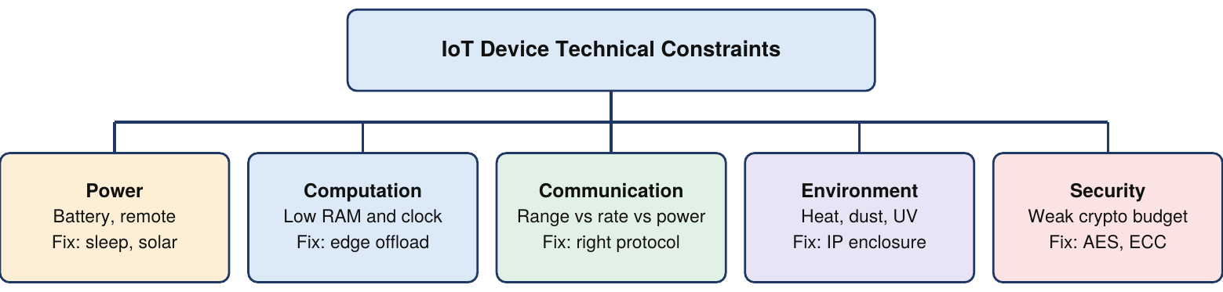
Fig 1: Major IoT design constraints and their mitigation strategies
- Power Constraints: Nodes are battery-powered and often remote, and radio transmission is the biggest drain. Use low-power MCUs (ARM Cortex-M, ATmega328), deep-sleep modes and energy harvesting (solar, piezoelectric, wind).
- Processing and RAM Limits: Typical MCUs have a few KB of RAM and clocks of tens of MHz, so heavy AI/ML cannot run locally. Use edge computing, send only summaries to the cloud, and keep firmware and data structures minimal.
- Range and Coverage: BLE reaches 10-50 m, ZigBee 10-100 m, LoRa up to 15 km. Longer range means lower throughput and higher latency, so choose the radio by geography and packet frequency.
- Data Rate and Bandwidth: Sensors send tiny periodic payloads (e.g. 2-3 bytes), so Wi-Fi is wasteful. Use compact binary packets and batch data before transmission.
- Environmental Weatherability: Devices face temperature swings, humidity, dust, vibration and UV. Use ruggedized PCBs with conformal coating and IP65/IP68 enclosures rated for -40 to +85 deg C.
- Unit Cost: Thousands of nodes make per-unit cost critical. Choose cheap SoCs (e.g. ESP8266 instead of a Raspberry Pi for basic sensing) and reuse modular designs.
- Security Limits: Constrained nodes cannot afford heavy cryptography yet face interception and spoofing. Use lightweight AES-128 or ECC, secure boot and certificate-based authentication.
- Reliability and Maintenance: Nodes must run for years unattended. Use self-diagnostics, redundant paths, automatic retransmission and OTA firmware updates.
- Interference and Congestion: Unlicensed ISM bands are crowded, causing packet loss and retry energy waste. Use frequency hopping, dynamic channel switching and mesh routing.
- Scalability: Central models hit bandwidth and connection limits as nodes grow. Use hierarchical topologies with local gateways and multi-hop mesh to spread load.

Q2. Detail the multi-layered architecture of Smart City IoT systems and examine the primary network design constraints encountered during city-wide deployment. [10 Marks]
Definition & Overview
A Smart City connects urban infrastructure, services and citizens through IoT for sustainable resource management. The architecture is split into five hierarchical layers, from physical sensors up to citizen-facing portals, and city-wide deployment must balance bandwidth, latency, interference and security.
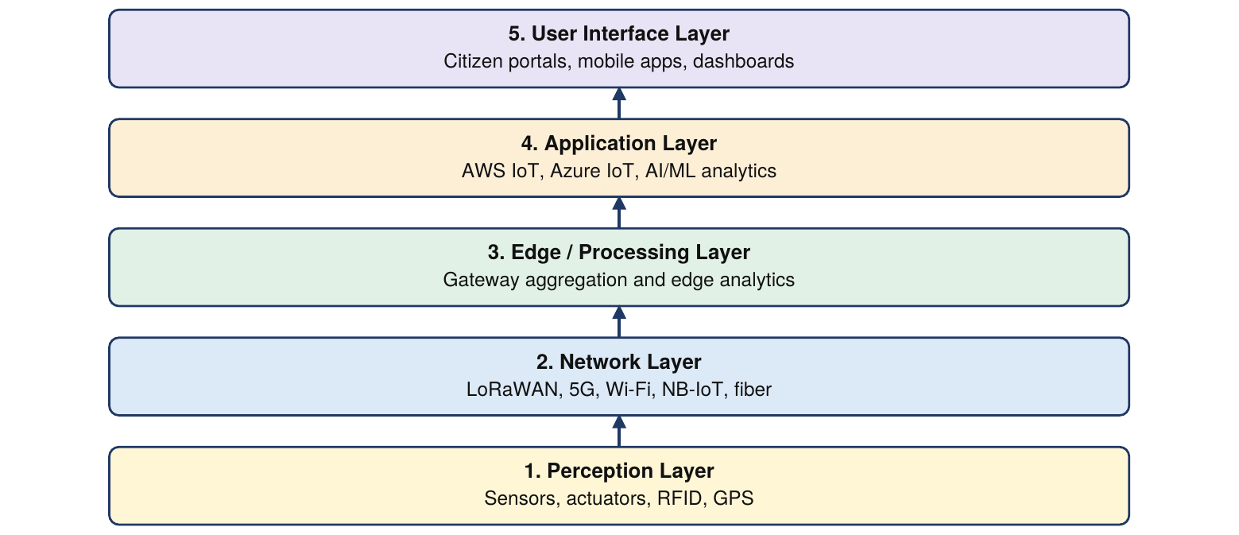
Fig 2: Five-layer Smart City IoT architecture
- Perception Layer: Physical foundation: environmental sensors, cameras, water meters, RFID and GPS collect temperature, air quality, traffic and bin-fill data. Actuators act on commands, e.g. adjust streetlights or open water valves.
- Network Layer: Carries raw data to cloud hubs over Wi-Fi, ZigBee, LoRaWAN, 4G/5G and NB-IoT. IoT gateways collect telemetry from local sensor clusters and bridge it to backbone IP networks.
- Edge / Processing Layer: Sits between access networks and the cloud to filter streams, aggregate readings and run low-latency decisions, cutting WAN bandwidth and delay.
- Application Layer: Cloud platforms (AWS IoT Hub, Azure IoT, IBM Watson) store time-series data and run AI/ML analytics, e.g. predictive maintenance for municipal transit.
- User Interface Layer: Dashboards, mobile apps and public notices: citizens see transit arrivals and report potholes; operators monitor energy grids in real time.
- Bandwidth Constraint: Hundreds of thousands of nodes choke the spectrum. Compress payloads with CBOR or Protobuf and let edge nodes send data only on significant threshold changes.
- Latency Constraint: Traffic safety and emergency routing need instant response. Process time-critical data at local edge gateways and use priority QoS for emergency alerts.
- RF Interference: Overlapping Wi-Fi, Bluetooth and ZigBee degrade signal-to-noise ratio. Use frequency hopping spread spectrum and multi-path mesh topologies.
- Scalability: New districts overload central servers. Use hierarchical sub-networks under field gateways, plus open, vendor-neutral standards for new hardware.
- Network Security: Risks include eavesdropping, packet injection and DDoS. Enforce TLS/DTLS on all channels and verify every edge device with PKI digital certificates.

Q3. Compare structured data representation formats used in IoT ecosystems and explain the visualization methods and purpose-built tools required for operational intelligence. [10 Marks]
Definition & Overview
Sensor data is continuous and heterogeneous, so it is encoded into structured payloads for transmission and storage. Stored time-series data is then turned into dashboards that support real-time monitoring and decisions.
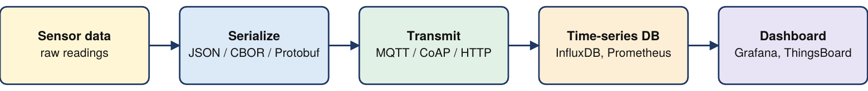
Fig 3: From sensor data to operational dashboards
- Representation Objectives: Minimize payload size to save radio power and bandwidth, while keeping machine readability, cross-vendor semantic interoperability and exact parsing.
- JSON and XML (text): JSON is a light key-value format common in MQTT/HTTP but adds string overhead. XML gives strict structure and metadata for enterprise systems but is verbose and memory-hungry.
- CBOR, MessagePack, Protobuf (binary): Binary formats raise data density and parsing speed. CBOR suits CoAP, MessagePack is faster than JSON, Protobuf uses typed schemas for high-throughput cloud streaming.
- Semantic Representation: RDF and OWL encode meaning, so "Temperature" from a weather station and "RoomTemp" from an HVAC unit are recognised as the same concept across vendors.
- Purpose of Visualization: Dashboards let administrators watch live metrics, track trends and spot anomalies; colour-coded gauges and alerts trigger preventive maintenance.
- Visualization Methods: Line charts for trends (battery voltage, soil moisture), heat maps for spatial data (air pollution, traffic), gauges for instant values, geospatial maps for GPS-tracked assets.
- Open-Source Platforms: Grafana suits time-series databases (InfluxDB, Prometheus). ThingsBoard offers dashboards, alert rule engines and device telemetry tracking end to end.
- Enterprise and Flow Tools: Kibana (Elastic Stack) for log telemetry, Google Data Studio and Power BI for corporate reporting, Node-RED Dashboard for lightweight drag-and-drop edge dashboards.
- Challenges: Render high-velocity streams without browser lag, stay responsive on mobile and desktop, and enforce role-based privacy and access control.

Format | Encoding | Characteristics | Typical IoT use
JSON | Text | Lightweight, human-readable, easy parsing | Web APIs, MQTT/HTTP payloads
XML | Text | Verbose, schema validation, rich metadata | Enterprise IT, legacy integration
CBOR | Binary | Extremely compact, low power | CoAP constrained messaging
MessagePack | Binary | Faster and smaller than JSON | Edge data serialization
Protobuf | Binary | Schema-driven, efficient, language-neutral | High-volume cloud exchange

Q4. Analyze the operational interaction models (H2D, D2D, D2C, C2D) and remote control protocol mechanisms employed in modern IoT ecosystems. [10 Marks]
Definition & Overview
IoT needs two-way communication: telemetry flows up and control commands flow down. Interactions fall into four models, and remote control over public networks uses standard application-layer protocols with strong security.
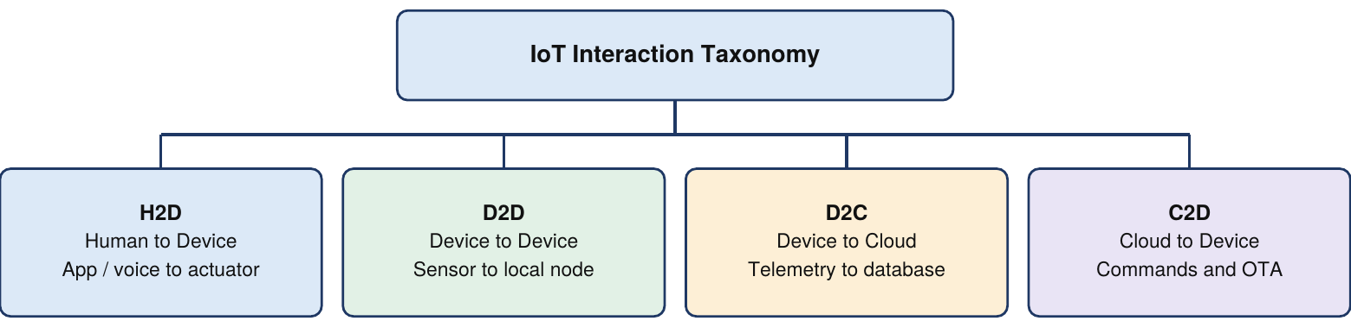
Fig 4: H2D, D2D, D2C and C2D interaction models
- H2D (Human-to-Device): Users inspect state and command hardware via mobile apps, web dashboards or voice assistants such as Alexa, e.g. toggling lights or setting a thermostat. Uses REST over HTTP, WebSockets or MQTT topics.
- D2D (Device-to-Device): Autonomous cooperation without humans over short-range links, e.g. a motion detector turning ON a room light. Uses ZigBee, Z-Wave, Thread, Bluetooth Mesh and CoAP.
- D2C (Device-to-Cloud): Upward flow of periodic telemetry to cloud endpoints over IP, feeding databases, time-series storage and analytics.
- C2D (Cloud-to-Device): Downward control: the cloud analyses D2C data and commands nodes, e.g. soil data triggers a start command to a water pump. Also used for OTA firmware patches.
- Remote Control Architecture: Operators control equipment globally through a cloud server or MQTT broker that sits between the mobile client and the device. The device validates the authentication token, then actuates.
- HTTP/HTTPS REST: Request-response with POST/PUT to update device state. Universally supported, but headers add overhead for constrained chips; HTTPS adds TLS protection.
- MQTT: Lightweight publish-subscribe through a central broker using topic strings. Commands reach devices instantly with minimal header overhead, ideal for smart homes.
- CoAP: IETF protocol giving a RESTful model over UDP instead of TCP, with tiny headers and low RAM use. Preferred for industrial automation control.
- WebSockets: Persistent full-duplex connection with low latency, replacing HTTP polling. Used for live teleoperation such as robotic arms and camera feeds.
- Security: Multi-factor authentication and API token validation, TLS/SSL encryption, ACLs limiting command privileges, and audit logging of all remote commands.

Q5. Examine the end-to-end design, working mechanism, and practical benefits of Industrial IoT (IIoT) monitoring systems and Smart City infrastructure applications. [10 Marks]
Definition & Overview
Industrial IoT (IIoT) uses sensing, edge computing and cloud analytics to improve machinery health, productivity and worker safety, while Smart City applications optimise municipal services such as traffic and solid-waste collection.
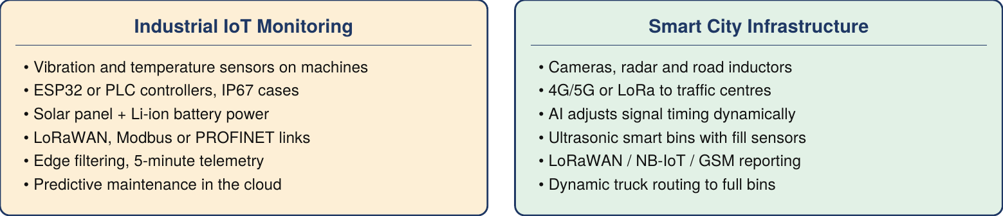
Fig 5: IIoT monitoring versus Smart City infrastructure applications
- IIoT Hardware: Vibration sensors, surface temperature transducers and motor relays connect to ESP32 or PLC controllers in rugged IP67 enclosures that resist oil, dust and heat. LoRaWAN or fieldbuses (Modbus, PROFINET) cover long factory distances.
- Edge Processing and Solar Power: Remote nodes use solar panels with Li-ion batteries. The ESP32 records high-frequency vibration locally, computes averaged statistics and transmits every 5 minutes, saving bandwidth and battery.
- Predictive Maintenance: Vibration and thermal sensors detect micro-wear in motor bearings early. Cloud analytics predict failure timelines and alert teams to schedule repairs, avoiding unplanned downtime.
- Safety and Asset Management: Gas sensors and thermal cameras detect leaks or overheating and trigger automatic shutoffs. RFID and GPS gateways track materials across the factory, reducing worker exposure to hazards.
- IIoT Benefits: Lower maintenance cost, longer equipment life, and real-time dashboards to track throughput, cut energy use and remove bottlenecks.
- Smart Traffic Mechanism: Cameras, radar and inductors capture volume, speed and lane density, sent over 4G/5G or LoRa to a control centre where AI adjusts signal timing to relieve congestion.
- Traffic Services: Navigation apps get live congestion, accident alerts and detours; ambulances and fire engines get green-wave priority. Singapore, Bangalore and Delhi use AI video traffic monitoring.
- Smart Waste Sensing: Ultrasonic or infrared sensors measure bin fill depth, and temperature sensors give early fire warnings. LoRaWAN, NB-IoT or GSM modules report fill percentage to server dashboards.
- Route Optimization: Routing algorithms send trucks only to bins at capacity, cutting trips, fuel, fleet wear and labour cost. Pune and Barcelona have deployed such systems.
- Urban Impact: Less idling lowers emissions and travel time, water and waste systems use resources efficiently, and integrated dashboards enable data-driven, sustainable governance.

5-MARK QUESTIONS & ANSWERS
Q6. Describe the core hardware components of an IoT system along with their primary functions and standard examples. [5 Marks]
Definition & Overview
IoT hardware is the physical foundation of a connected system, providing sensing, computation, communication, power, storage and actuation. It is organised into six functional building blocks.
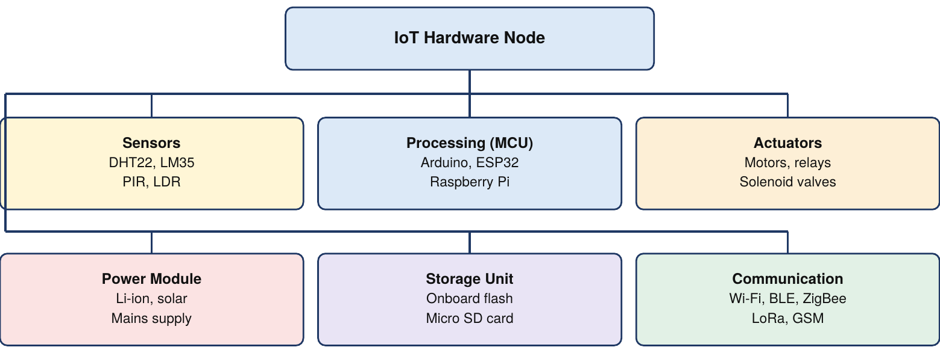
Fig 6: Six core hardware blocks of an IoT node
- Sensing Unit: Measures temperature, pressure, humidity, light and motion and converts them to electrical signals. Examples: DHT22, LM35, PIR motion detector, LDR.
- Actuation Unit: Converts control signals into motion or state changes. Examples: DC motors, servo motors, relays, solenoid water valves.
- Microprocessing Unit: The brain of the node: runs firmware, processes readings, manages storage and coordinates networking. Examples: Arduino and ESP32 (MCUs), Raspberry Pi (single-board computer).
- Communication Module: Exchanges data between nodes, gateways and cloud, matched to range and power needs. Examples: Wi-Fi, BLE, ZigBee, LoRa and GSM/cellular modems.
- Power and Storage: Rechargeable Li-ion batteries, solar panels or mains supply the energy. Onboard flash or micro SD cards hold logs, configuration and firmware.

Q7. Detail five key power optimization strategies implemented in resource-constrained IoT nodes. [5 Marks]
Definition & Overview
Most IoT nodes run on limited battery in remote places, so energy conservation determines lifespan. Wireless transmission is the most energy-hungry operation, which makes both hardware and software optimisation essential.
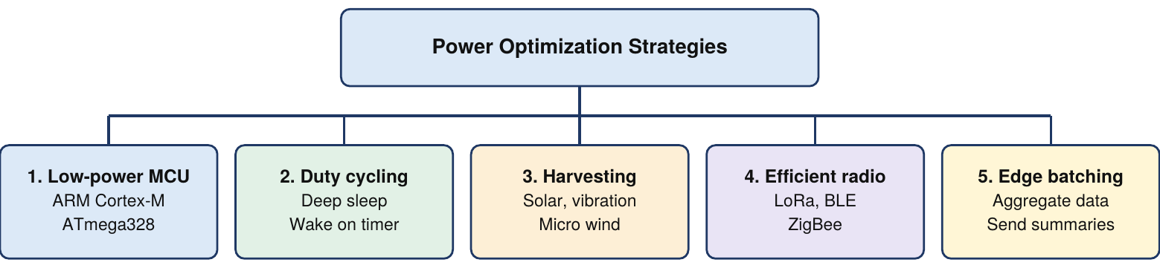
Fig 7: Five power optimization strategies for IoT nodes
- Ultra-Low-Power Microcontrollers: Chips such as ARM Cortex-M or ATmega328 draw little current and finish computations quickly before returning to low-power states.
- Sleep-Mode Duty Cycling: The node sleeps while idle, with radios and peripherals off, dropping current to microamperes. A timer or interrupt wakes it to sample, transmit and sleep again.
- Ambient Energy Harvesting: Small solar panels, piezoelectric generators or micro wind turbines charge Li-ion batteries or supercapacitors to extend life beyond battery capacity.
- Energy-Efficient Radios: Use BLE, ZigBee or LoRa instead of Wi-Fi or cellular; short packet bursts and efficient sleep modes preserve battery.
- Edge Aggregation and Batching: Sending many small packets costs more radio power than one batched payload. The node stores readings, computes averages and transmits a summary every few minutes.

Q8. Compare the major wireless communication protocols used in IoT across range, data rate, power consumption, and application domains. [5 Marks]
Definition & Overview
Wireless protocols form the transport backbone of IoT, linking nodes to gateways and the cloud. Choosing one means balancing coverage range, data throughput, operating power and hardware cost.
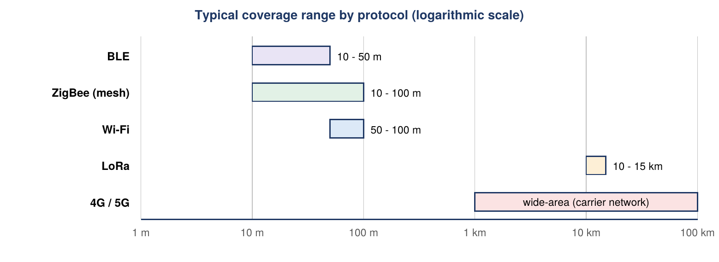
Fig 8: Coverage range of common IoT wireless protocols (log scale)
- Wi-Fi (IEEE 802.11): High speed up to about 100 m, but high power draw. Best for mains-powered indoor use such as smart home hubs and cameras.
- Bluetooth Low Energy: Short range (10-50 m), low power, medium throughput. Ideal for wearable medical sensors and fitness trackers.
- ZigBee: 10-100 m with self-healing mesh topology, very low power and medium throughput. Popular in building automation and smart lighting.
- LoRa / LoRaWAN: LPWAN with coverage up to 15 km, low data rate and minimal power. Suits battery-powered agriculture and remote industrial monitoring.

Protocol | Range | Throughput | Power | Typical application
Wi-Fi | 50 - 100 m | High | High | Smart home cameras, mains-powered
BLE | 10 - 50 m | Medium | Low | Wearables, personal health monitors
ZigBee | 10 - 100 m (mesh) | Medium | Very low | Building automation
LoRa | 10 - 15 km | Low | Very low | Smart agriculture, remote sensing
4G / 5G | Wide-area | Very high | High | Smart cities, autonomous vehicles

Q9. Explain the core objectives and comparative characteristics of JSON, XML, CBOR, and Protocol Buffers in IoT data exchange. [5 Marks]
Definition & Overview
Data representation defines how sensor readings are formatted and serialized for transmission. The right format balances payload size, parsing speed, human readability and interoperability.
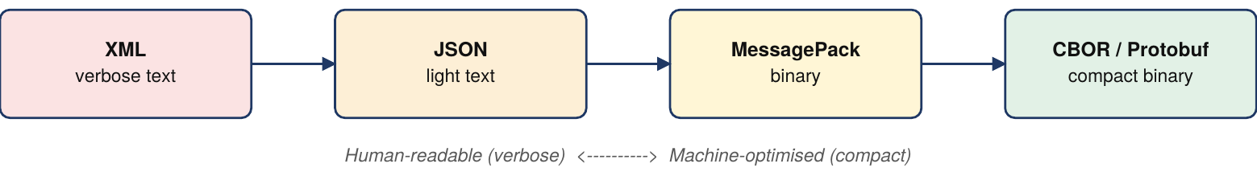
Fig 9: Data format spectrum from verbose to compact
- Core Objective: Minimize payload size to cut radio energy and bandwidth cost, while keeping exact parsing, machine readability and semantic metadata for cross-vendor interoperability.
- JSON: Lightweight text key-value format used for web APIs and MQTT payloads. Easy to read and parse in any language, but repeated string keys make it larger than binary formats.
- XML: Tag-based text format with strong metadata and schema validation, common in legacy enterprise systems. Verbose, so it wastes memory and bandwidth.
- CBOR: Binary serialization designed for constrained microcontrollers; models JSON structure in compact binary form and is optimised for CoAP networks.
- Protocol Buffers: Google binary format with strongly typed schemas; removes key-string overhead and gives fast, efficient cloud data streaming.

Q10. Explain the remote access mechanisms for Raspberry Pi using SSH and VNC, along with critical security practices. [5 Marks]
Definition & Overview
Raspberry Pi boards are often deployed headless in field locations such as weather stations and plants. They are managed remotely with SSH, VNC or cloud tools, secured against unauthorised access.
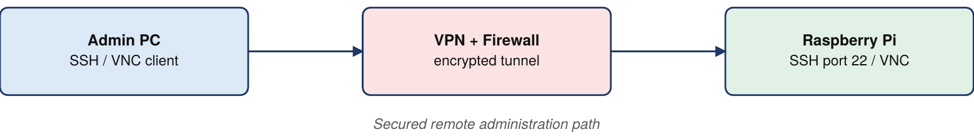
Fig 10: Secure remote access path to a Raspberry Pi
- SSH (Secure Shell): Encrypted command-line access over port 22 to run commands, edit scripts and update the system, with no monitor, keyboard or mouse attached.
- VNC: Full graphical remote desktop of the Pi. Enable it with sudo raspi-config, Interface Options, then toggle VNC.
- Cloud and Third-Party Tools: Behind firewalls or NAT, direct SSH/VNC is hard. Use BalenaCloud or Dataplicity for browser-based fleet management, or AnyDesk / TeamViewer Host for desktop access.
- Credential Hardening: Disable the default pi account after setup, use strong unique passwords and SSH key-pair authentication to block brute-force attacks.
- Network Perimeter Controls: Keep access points behind firewalls, use VPN tunnels for administration, disable root SSH login and change default ports.

Q11. Discuss the architectural features, protocols, and benefits of Commercial Building Automation systems. [5 Marks]
Definition & Overview
Commercial building automation uses IoT to integrate HVAC, lighting, security and energy metering across offices, hospitals and schools, optimising energy use, occupant comfort and facility operations.
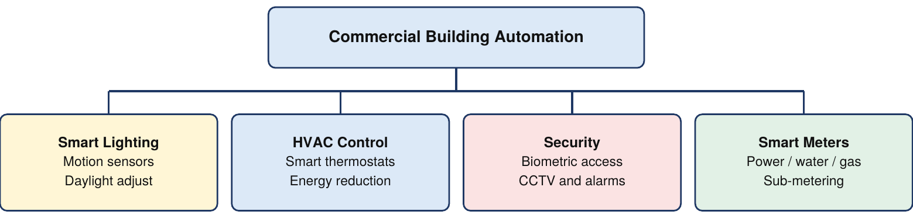
Fig 11: Subsystems of a commercial smart building
- Smart Lighting: Motion sensors switch lights off in empty rooms and daylight sensors dim fixtures, lowering electricity use and extending fixture life.
- HVAC Optimization: Smart thermostats and sensors adjust temperature by occupancy and time of day, cutting building energy consumption by 30% to 40%.
- Security and Access: CCTV, biometric readers and fire alarms feed one security system; dashboards alert staff instantly to intrusions or smoke.
- Smart Metering and Asset Tracking: Meters track electricity, water and gas in real time to expose waste; sensors on elevators and pumps support predictive maintenance.
- Protocols and Benefits: BACnet, KNX, ZigBee and Z-Wave link nodes to central software. Benefits: energy savings up to 40%, better comfort and simpler safety management.

Q12. Detail the layered security requirements and technical defensive techniques used to safeguard Smart City IoT deployments. [5 Marks]
Definition & Overview
Smart Cities control critical infrastructure such as power grids, water and transport, so they need multi-layered defences against cyber attacks, data theft and service disruption.

Fig 12: Layered Smart City security architecture
- Authentication and Access Control: Unique API tokens, cryptographic certificates and passwords verify users, gateways and nodes; role-based ACLs limit who can issue critical commands.
- Confidentiality and Encryption: Encrypt data in transit and at rest with TLS/SSL and AES-128 or AES-256 to protect citizen location data and control messages.
- Integrity and Tamper Prevention: Nodes apply hashes and digital signatures to packets; cloud brokers verify them and drop corrupted or spoofed messages.
- Availability and Redundancy: Redundant backbones, automatic failover and resilient mesh routing keep data flowing when a gateway fails.
- Advanced Controls: PKI manages certificates, blockchain ledgers keep tamper-proof admin records, and AI anomaly detection spots and isolates intrusions in real time.

Q13. Outline the five strategic phases required to implement an effective IoT strategy for smarter cities. [5 Marks]
Definition & Overview
City-wide IoT must be planned in phases so investments address real municipal problems and scale smoothly while keeping interoperability, privacy and public trust.
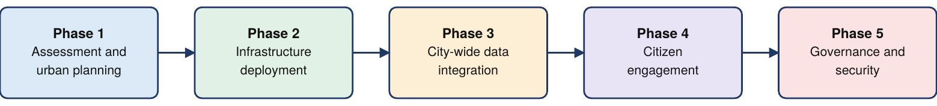
Fig 13: Five strategic phases of a Smart City IoT strategy
- Phase 1: Assessment and Urban Planning: Identify priority problems (congestion, waste collection, water loss), set goals, assess budget and technical needs.
- Phase 2: Infrastructure Deployment: Install sensors, smart bin sensors, edge gateways and actuators, and build LoRaWAN towers, 5G small cells and fiber backbones.
- Phase 3: Data Integration: A central cloud platform breaks silos between transport, water, energy and safety, using data fusion, time-series analytics and ML for insights.
- Phase 4: Citizen Engagement: Mobile apps and portals show transit arrivals, traffic and air quality, and let residents report hazards or leaks.
- Phase 5: Governance, Policy and Maintenance: Set data privacy rules and open standards, and schedule repairs, OTA updates and cyber-security audits.

2-MARK QUESTIONS & ANSWERS
Q14. Define Sensors and Actuators in the context of IoT hardware. [2 Marks]
Definition & Overview
Sensors and actuators are the physical interfaces between digital IoT systems and the real world.
Fig 14: Sensor, controller and actuator chain
- Sensors: Devices that detect physical parameters and convert them to electrical signals, e.g. LM35 temperature, DHT22 humidity, PIR motion.
- Actuators: Devices that take control signals from the microcontroller and perform physical action, e.g. DC motors, servo controllers, solenoid valves.

Q15. Differentiate between Star Topology and Mesh Topology in IoT networks. [2 Marks]
Definition & Overview
Topology defines how nodes, gateways and links are arranged to carry data in an IoT network.
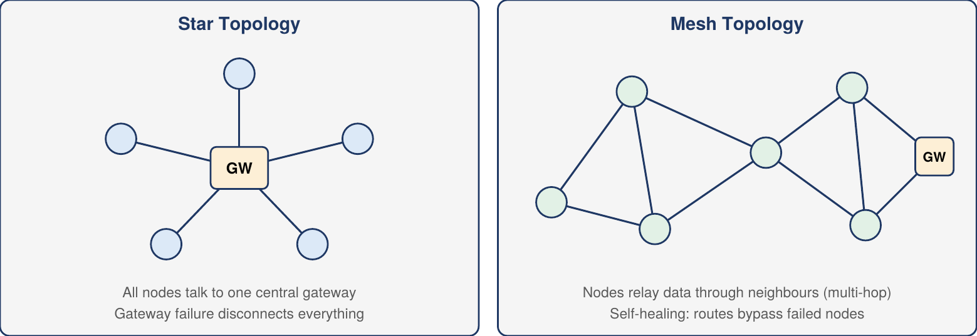
Fig 15: Star topology versus mesh topology
- Star Topology: Every node connects directly to one central gateway; if the gateway fails, the whole network disconnects.
- Mesh Topology: Nodes relay data through neighbours over multiple hops; routing is self-healing and bypasses failed nodes, so it is highly resilient.

Q16. Explain the concept and significance of Edge Computing in constrained node deployment. [2 Marks]
Definition & Overview
Edge computing processes data locally on the device or a nearby gateway instead of sending all raw telemetry to the cloud.
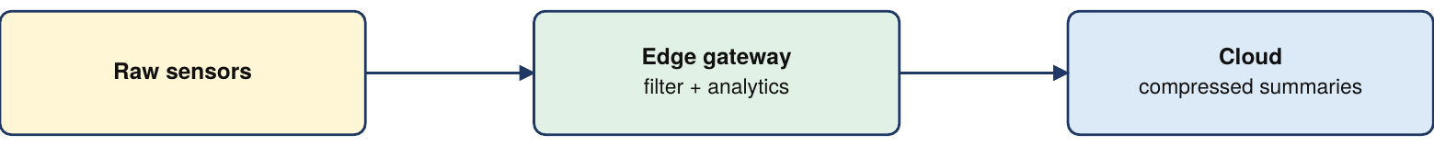
Fig 16: Edge computing between sensors and cloud
- Concept: Filtering, aggregation and threshold analysis happen near the source, e.g. an ESP8266 logs readings every minute but sends only 10-minute averages.
- Significance: Cuts bandwidth use and latency and extends battery life by reducing radio uptime.

Q17. Contrast Human-to-Device (H2D) interaction with Device-to-Device (D2D) interaction. [2 Marks]
Definition & Overview
Interaction models describe how commands and telemetry are exchanged between people, devices and automation software.
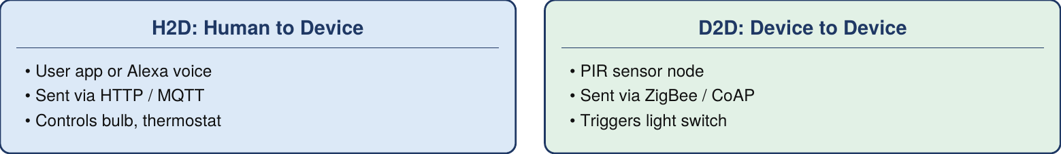
Fig 17: H2D versus D2D interaction
- H2D: Direct user control through smartphone apps, dashboards or voice assistants, using REST APIs or MQTT, e.g. turning on a smart bulb remotely.
- D2D: Fully autonomous exchange with no human involvement over local ZigBee or Z-Wave mesh, e.g. a PIR sensor switching on a room light.

Q18. Name and describe two purpose-built open-source tools for IoT data visualization. [2 Marks]
Definition & Overview
Open-source visualization tools ingest time-series sensor streams and render operational dashboards.
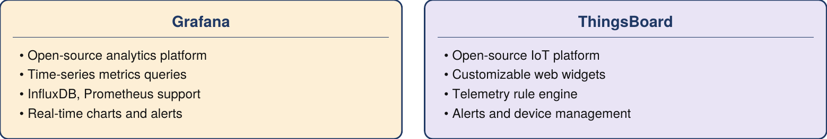
Fig 18: Grafana versus ThingsBoard
- Grafana: Queries and displays time-series metrics; integrates with InfluxDB and Prometheus for real-time sensor charts and alert dashboards.
- ThingsBoard: IoT data management platform with custom widgets, built-in rule engine, real-time alerts and remote device management.

Q19. What is Concise Binary Object Representation (CBOR) and why is it preferred for constrained networks? [2 Marks]
Definition & Overview
CBOR is a binary serialization format defined by the IETF for resource-constrained IoT systems.
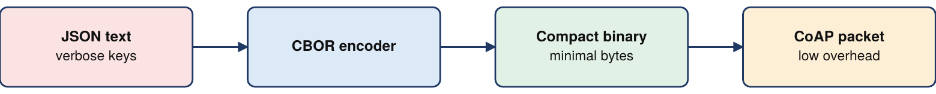
Fig 19: JSON to CBOR serialization for CoAP
- Definition: Encodes JSON-like structures into compact binary, removing repeated key strings and whitespace.
- Why Preferred: Small payloads lower memory and radio overhead on low-power microcontrollers, making it the natural payload format for CoAP.

Q20. Define IP Rating enclosures and wide temperature range design in physical constraint mitigation. [2 Marks]
Definition & Overview
Physical design strategies protect circuits when IoT hardware is deployed in harsh outdoor or industrial environments.
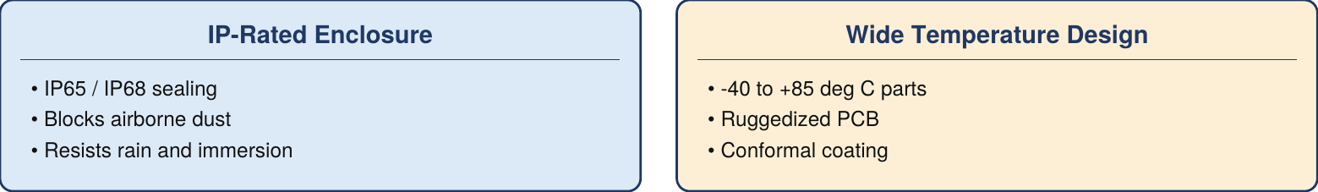
Fig 20: Physical weatherability controls
- IP-Rated Enclosures: Ingress Protection ratings classify sealing against dust and water; IP65 or IP68 keep electronics safe from heavy dust, rain and immersion.
- Wide Temperature Engineering: Industrial-grade components rated about -40 to +85 deg C, with ruggedized PCBs and conformal coatings against thermal stress, humidity and corrosion.

Q21. Explain the role of an MQTT Broker in facilitating remote device control. [2 Marks]
Definition & Overview
An MQTT broker is the central messaging hub that manages publish-subscribe communication between control apps and deployed devices.
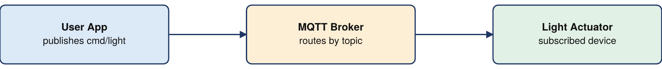
Fig 21: Command delivery through an MQTT broker
- Message Routing: Receives control payloads from applications and immediately forwards them to devices subscribed to the matching topic.
- Decoupling and Management: Sender and receiver need no direct IP link. The broker keeps low-overhead persistent connections, handles authentication and delivers commands in real time.

Q22. State two primary operational benefits of deploying a Smart Waste Management System. [2 Marks]
Definition & Overview
Smart waste systems combine ultrasonic sensor bins, LPWAN networks and cloud analytics to optimise municipal waste collection.
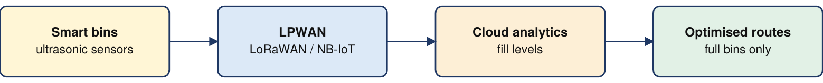
Fig 22: Smart waste management data flow
- Logistics and Cost Reduction: Trucks are dispatched only to full bins, removing unnecessary trips and cutting fuel cost, emissions and maintenance.
- Hygiene and Overspill Prevention: Fill monitoring alerts crews before bins overflow, and built-in temperature sensors warn of fires inside bins.

