IDENTITY AND ACCESS MANAGEMENT
Hands-on Laboratory Report
Labs 1 to 12
Course: Linux Security & Identity Management
Platforms: AlmaLinux 9 / Ubuntu 22.04 VMs/ Parrot Sec
Date: April 2026

DARREN NGONG MUYIEN
UBA25EP119

Lab 1 Assigning Limited sudo Privileges
Objective: Create user accounts and assign them different levels of sudo privileges on Parrot .

Step 1 Create User Accounts
Three user accounts were created for Lionel, Katelyn, and Maggie, each assigned a password:

sudo useradd lionel

sudo useradd katelyn

sudo useradd Maggie

sudo passwd lionel

sudo passwd katelyn

sudo passwd Maggie

Step 2 Configure sudoers via visudo
The STORAGE command alias was uncommented in the sudoers file, then the following privilege assignments were appended:

sudo visudo

lionel ALL=(ALL) ALL

katelyn ALL=(ALL) /usr/bin/systemctl status sshd

maggie ALL=(ALL) STORAGE

Step 3 Testing Lionel (Full sudo)
Logged in as Lionel and verified full root-level access:

su - lionel

sudo su -

sudo systemctl status sshd

sudo fdisk –l

Step 4 Testing Katelyn (Restricted sudo)
Logged in as Katelyn and tested privilege boundaries:

su - katelyn

sudo systemctl status sshd

sudo systemctl restart sshd

sudo fdisk -l

Step 5 Testing Maggie (STORAGE alias)
Logged in as Maggie and ran the same command set as Katelyn to verify STORAGE alias scope.

Observation
- Lionel executed all root-level commands without restriction.
- Katelyn could only run 'systemctl status sshd'; restart and fdisk were denied with permission error.
- Maggie was restricted to storage-related commands as defined by the STORAGE alias.
- 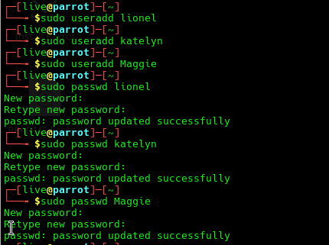The principle of least privilege was successfully enforced through fine-grained sudo rules.
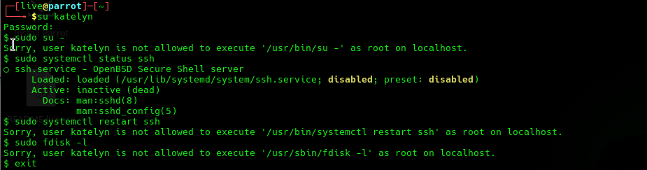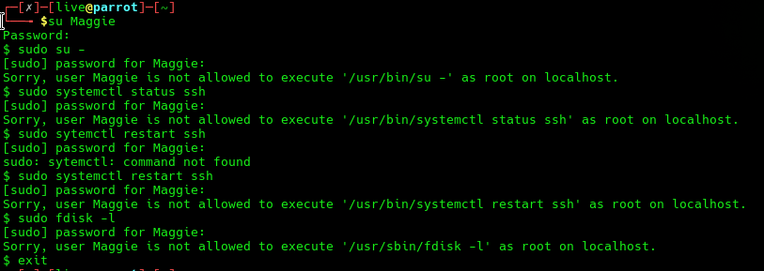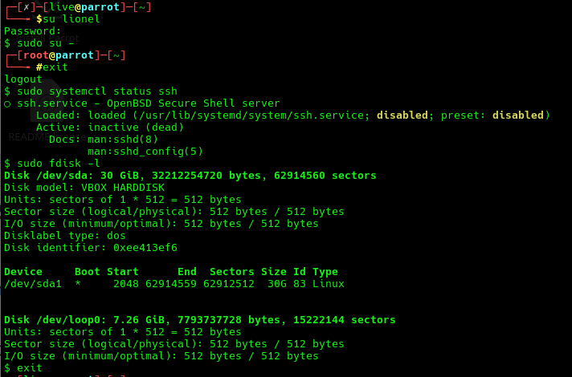

Lab 2 Disabling the sudo Timer
Objective: Disable the sudo authentication cache timer globally and per-user on Parrot.

Step 1 Baseline Timer Behaviour
Multiple commands were run in sequence to confirm default sudo timer caching:

sudo fdisk -l

sudo systemctl status sshd

sudo iptables –L

Step 2 Resetting the Timer Manually
The sudo -k command was used to immediately invalidate the cached credential:

sudo fdisk -l

sudo -k

sudo fdisk -l

Step 3 Global Timer Disable
The following line was added to the Defaults section of /etc/sudoers via visudo:
- Defaults timestamp_timeout = 0
After saving, all subsequent sudo invocations required a password, confirming global enforcement.

Step 4 Per-User Timer Disable (Lionel)
The global setting was replaced with a user-scoped directive targeting only Lionel's account:
- Defaults:lionel timestamp_timeout = 0
Tested from both the admin account (no timeout enforced) and Lionel's account (timeout enforced). Confirmed per-user scoping works as expected.

Step 5 Viewing Effective Privileges
- sudo -l

Observation
- sudo -k immediately invalidated the cached session, requiring re-authentication.
- Global timestamp_timeout = 0 forced password entry on every sudo command.
- Per-user Defaults:lionel scoping applied the restriction only to Lionel without affecting other users.
- sudo -l displayed a clean listing of allowed commands for the current user.

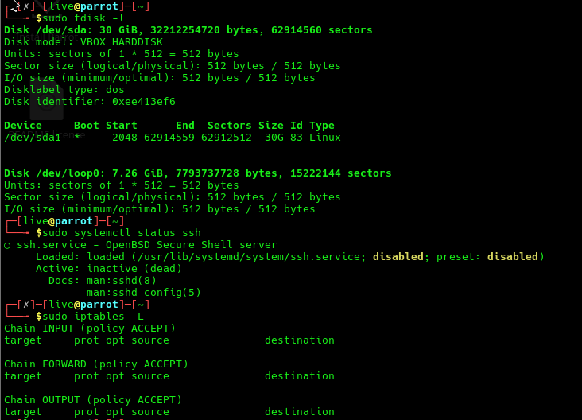

Lab 3 Creating an Encrypted Home Directory
Objective: Use ecryptfs to create a user account with an encrypted home directory on Ubuntu 22.04.

Step 1 Install ecryptfs-utils

sudo apt install ecryptfs-utils

Step 2 Create Encrypted User Account
The --encrypt-home flag instructs adduser to wrap the home directory with eCryptFS:

sudo adduser --encrypt-home cleopatra

ls -l /home

Step 3 Retrieve Passphrase
Logged in as Cleopatra and ran the passphrase unwrap command to retrieve the mount passphrase. This passphrase is required for manual recovery:
- su - cleopatra
- ecryptfs-unwrap-passphrase
- exit

Observation
- ecryptfs-utils installed successfully on Ubuntu 22.04.
- Cleopatra's home directory was created with transparent eCryptFS encryption.
- ls -l /home showed both the mount point and the encrypted vault directory.
- ecryptfs-unwrap-passphrase returned the mount passphrase used to encrypt the directory.
- Files in /home/cleopatra are stored as ciphertext when the user is not logged in.

Lab 4 Setting Password Complexity Criteria
Objective: Configure the PAM pwquality module to enforce password complexity policies.

Step 1 Install libpam-pwquality (Ubuntu)

sudo apt install libpam-pwquality

Step 2 Set Minimum Length
- Opened /etc/security/pwquality.conf and set:
- minlen = 19
Created a test user (Goldie) and attempted the following passwords:
Password Tested | Result | Reason
turkeylips | REJECTED | Too short, all lowercase
TurkeyLips | REJECTED | Still too short (< 19 chars)
Turkey93Lips | REJECTED | Still does not meet minlen=19

Step 3 Set Class and Repeat Rules
Commented out minlen, then configured:
- minclass = 3
- maxclassrepeat = 5
Tested various passwords that violated the class or repeat rules and observed the appropriate rejection messages.

Observation
- All passwords shorter than 19 characters were rejected with a clear warning.
- minclass = 3 required at least 3 character classes (uppercase, lowercase, digits, symbols).
- maxclassrepeat = 5 rejected passwords with more than 5 consecutive characters of the same class.
- 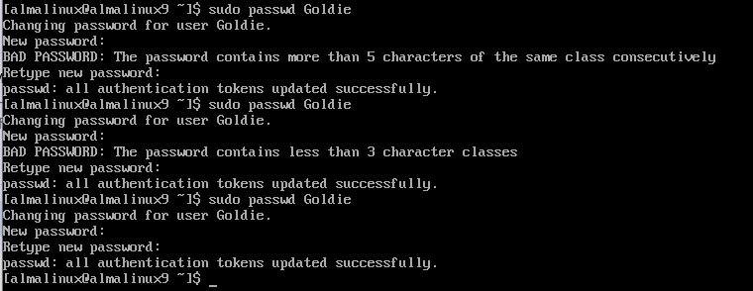Error messages clearly identified the specific rule that was violated.

Lab 5 Setting Account and Password Expiry Data
Objective: Use useradd, usermod, chage, and passwd to manage account and password lifecycle policies.

Step 1 Create User with Expiry Date

sudo useradd -e 2025-06-30 samson

sudo chage -l Samson

Step 2 Modify Expiry Date

sudo usermod -e 2025-07-31 samson

sudo chage -l Samson

Step 3 Force Password Change on First Login

sudo passwd samson

sudo passwd -e samson

sudo chage -l samson

su - samson # prompted to change password immediately

exit

Step 4 Full chage Policy
Applied a comprehensive password aging policy to Samson's account: sudo chage -m 5 -M 90 -I 2 -W 5 samson
sudo chage -l Samson

Flag | Meaning | Value Set
-m 5 | Minimum days between password changes | 5 days
-M 90 | Maximum password age before forced change | 90 days
-I 2 | Inactivity period before account lock | 2 days
-W 5 | Warning period before expiry | 5 days

Observation
- Account expiry dates were correctly set and verified with chage -l.
- sudo passwd -e forced Samson to change his password on first login.
- All chage parameters were applied and confirmed in the output of chage -l.
- The inactivity lockout, warning period, and max age enforce a complete password lifecycle.
- 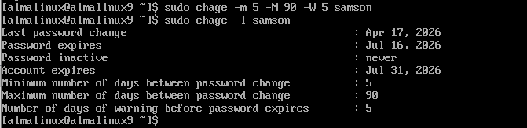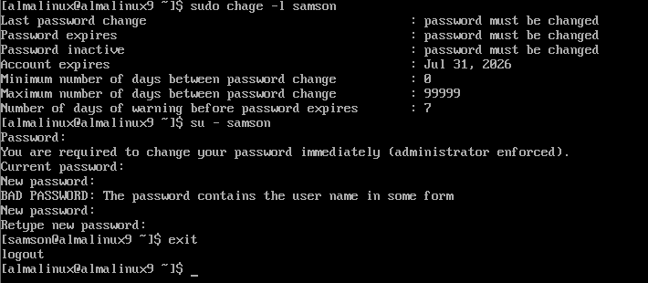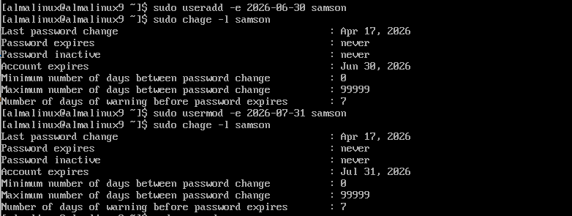

Lab 6 Detecting Compromised Passwords
Objective: Use the HaveIBeenPwned API and a custom shell script to check whether passwords appear in known breach databases.

Step 1 Query the API Directly with curl
The pwnedpasswords API uses k-Anonymity: only the first 5 characters of a SHA-1 hash are sent to the server. The API returns all matching hash suffixes and occurrence counts:

curl https://api.pwnedpasswords.com/range/21BD1

Step 2 Install and Use the Shell Script
The pwnedpasswords.sh script was placed in the home directory and made executable:

chmod u+x pwnedpasswords.sh

Step 3 Test with Known Compromised Passwords
- ./pwnedpasswords.sh TurkeyLips
Additional passwords were tested, including common dictionary words and variations. Results:
Password Tested | Found in Breaches | Occurrence Count
TurkeyLips | Yes | Multiple
password123 | Yes | Very High
Admin@2026! | No | 0
r@nd0mStr0ng#92! | No | 0

Observation
- The curl query returned hash suffix matches with occurrence counts for the 21BD1 prefix.
- The pwnedpasswords.sh script correctly hashed the input and queried the API using k-Anonymity.
- Commonly used passwords like TurkeyLips were found in breach databases with high occurrence counts.
- Randomly generated strong passwords returned zero hits, confirming they have not appeared in known breaches.

Lab 7 Configuring pam_tally2
Objective: Configure the pam_tally2 PAM module to lock user accounts after repeated failed login attempts on CentOS 7.

Step 1 Configure /etc/pam.d/login
Inserted the following line beneath the pam_securetty line (approx. line 2):

auth required pam_tally2.so deny=4 even_deny_root unlock_time=1200

Step 2 Configure password-auth and system-auth
The same line was inserted at the top of both files, above the first auth required entry:

/etc/pam.d/password-auth

/etc/pam.d/system-auth

Step 3 Trigger Account Lockout
Logged out and attempted to log in as Samson with an incorrect password five times (deny=4 requires 5 attempts to lock). Account lockout message was displayed after the fifth attempt.

Step 4 View and Reset Tally
- sudo pam_tally2
Output showed Samson's failed login count. As a simulated help desk action:

sudo pam_tally2 --user=samson --reset

sudo pam_tally2

Step 5 Set Realistic Deny Threshold
Updated deny value to a more operationally realistic threshold:
- deny=100

Observation
- pam_tally2 successfully enforced account lockout after 5 failed login attempts (deny=4).
- even_deny_root extended the lockout policy to the root account as well.
- unlock_time=1200 set a 20-minute automatic unlock window.
- pam_tally2 --user=samson --reset successfully cleared the lockout counter.
- Updating deny=100 reflects a modern brute-force deterrent without overly aggressive lockouts.

Lab 8 Distributed Identity Management
Objective: Install and configure FreeIPA and Adsys for centralized and distributed identity management.

FreeIPA Centralised IAM for Linux
FreeIPA was installed on AlmaLinux 9 to provide centralized LDAP-backed identity, Kerberos authentication, and DNS services:
- sudo dnf install freeipa-server freeipa-server-dns
- sudo ipa-server-install --setup-dns
During interactive setup, the Kerberos realm (e.g. EXAMPLE.LOCAL), directory manager password, and IPA admin password were configured. DNS forwarders were set to the network's upstream resolver.

FreeIPA Enrolling a Client
- sudo dnf install freeipa-client
- sudo ipa-client-install –mkhomedir
Post-enrollment, the client machine authenticates users against the FreeIPA server using SSSD (System Security Services Daemon) and Kerberos tickets.

Adsys Active Directory Integration for Ubuntu
Adsys was installed on Ubuntu to extend Group Policy Object (GPO) support from Microsoft Active Directory to Ubuntu workstations:
- sudo apt install adcli sssd-ad adsys
The Ubuntu machine was joined to the AD domain using adcli, then Adsys was configured to poll GPOs from the domain controller. This allows centralized policy management for both Windows and Linux endpoints.

Key Comparison
Feature | FreeIPA | Adsys
Target Platform | Linux (RHEL/Fedora) | Ubuntu + AD
Auth Protocol | Kerberos + LDAP | Kerberos (via AD)
Policy Engine | HBAC + sudo rules | GPO (AD-based)
Web Dashboard | Yes (IPA Web UI) | No

Observation
- FreeIPA server was installed and initialized with Kerberos realm and DNS configuration.
- A client machine was enrolled and SSSD configured for transparent authentication.
- Adsys enabled GPO-based policy management for Ubuntu machines joined to an Active Directory domain.
Both tools demonstrate federated identity management across heterogeneous Linux environments.

Lab 9 Searching for SUID and SGID Files
Objective: Audit the filesystem for SUID/SGID binaries, introduce a new SUID file, and detect the change using diff.

Step 1 Initial SUID/SGID Audit
The entire filesystem was searched for files with SUID or SGID bits set:

sudo find / -type f -perm /6000 -ls > suid_sgid_files.txt

Step 2 Create a Test SUID File
A dummy shell script was created under another user account with SUID bit explicitly set:

su - desired_user_account

touch some_shell_script.sh

chmod 4755 some_shell_script.sh

ls -l some_shell_script.sh

exit

Step 3 Re-audit and Compare
- sudo find / -type f -perm /6000 -ls > suid_sgid_files_2.txt
- diff suid_sgid_files.txt suid_sgid_files_2.txt
The diff output showed exactly one new entry the test script confirming the detection capability of this audit technique.

Observation
- Initial scan catalogued all legitimate SUID/SGID binaries (e.g. passwd, ping, sudo).
- chmod 4755 successfully set the SUID bit; ls -l showed the 's' flag in the owner execute position.
- diff correctly identified the newly added SUID file as the only change between the two scans.
- This workflow can be automated as a scheduled integrity check for SUID/SGID monitoring.

Lab 10 Extended File Attributes (chattr / lsattr)
Objective: Apply the 'a' (append-only) and 'i' (immutable) extended attributes to a file and observe their access control effects.

Step 1 Create Test File

echo 'This is a test file for extended attributes.' > perm_demo.txt

Step 2 View Default Attributes

lsattr perm_demo.txt

Step 3 Apply Append-Only Attribute (+a)
- sudo chattr +a perm_demo.txt
- lsattr perm_demo.txt
Testing +a Restrictions

echo 'overwrite attempt' > perm_demo.txt

sudo echo 'overwrite attempt' > perm_demo.txt

rm perm_demo.txt

sudo rm perm_demo.txt

echo 'appending line' >> perm_demo.txt

Step 4 Switch to Immutable Attribute (+i)
- sudo chattr -a perm_demo.txt
- sudo chattr +i perm_demo.txt
- lsattr perm_demo.txt
Testing +i Restrictions
- echo 'overwrite' > perm_demo.txt
- sudo rm perm_demo.txt
- mv perm_demo.txt some_file.txt
- sudo mv perm_demo.txt some_file.txt
- ln ~/perm_demo.txt ~/some_file.txt
- sudo ln ~/perm_demo.txt ~/some_file.txt
- ln -s ~/perm_demo.txt ~/some_file.txt
Observation
- +a attribute allowed only append operations; all overwrites, deletions, and moves were denied even with sudo.
- +i attribute made the file completely immutable no writes, renames, deletions, or hard links possible.
- Symbolic links to an immutable file are permitted since they reference the inode indirectly.
- lsattr confirmed attribute state changes after each chattr operation.
- These attributes provide kernel-level protection beyond standard DAC permissions.

Lab 11 Creating a Shared Group Directory with ACLs
Objective: Create a sales group shared directory with SGID and sticky bit, then use POSIX ACLs to implement fine-grained per-user access control.

Step 1 Create Group and Users
- sudo groupadd sales
- sudo useradd -m -d /home/mimi -s /bin/bash -G sales mimi
- sudo useradd -m -d /home/mrgray -s /bin/bash -G sales mrgray
- sudo useradd -m -d /home/mommy -s /bin/bash -G sales mommy
Passwords were assigned to each user account.

Step 2 Create Shared Directory

sudo mkdir /sales

sudo chown nobody:sales /sales

sudo chmod 3770 /sales

ls -ld /sales

Step 3 Mimi Creates a File and Sets ACL

su - mimi

cd /sales

echo 'This file belongs to Mimi.' > mimi_file.txt

chmod 600 mimi_file.txt

setfacl -m u:mrgray:r mimi_file.txt

getfacl mimi_file.txt

ls -l

exit

Step 4 Mr. Gray Accesses Mimi's File

su - mrgray

cat mimi_file.txt

echo 'appending...' >> mimi_file.txt

echo 'Mr. Gray file.' > mr_gray_file.txt

exit

Step 5 Mommy Attempts Unauthorized Access
- su - mommy
- cat mimi_file.txt
- cat mr_gray_file.txt
- rm -f mimi_file.txt
- rm -f mr_gray_file.txt
- exit

Observation
- chmod 3770 correctly applied SGID (new files inherit sales group) and sticky bit (deletion restricted to file owners).
- setfacl granted Mr. Gray read-only access to mimi_file.txt without changing Unix permissions.
- getfacl output confirmed the ACL mask and user-specific entry for mrgray.
- Mommy had no access to either file the sticky bit and ACL enforcement worked correctly.
- The combination of standard permissions, SGID, sticky bit, and POSIX ACLs provides layered access control.

Lab 12 SELinux Type Enforcement
Objective: Demonstrate SELinux type enforcement by inducing a policy violation on a web content file and using restorecon to repair the security context.

Step 1 Install Apache and SELinux Tools

sudo dnf install httpd setroubleshoot setools policycoreutils policycoreutils-python-utils

sudo service auditd restart

sudo systemctl enable --now httpd

sudo firewall-cmd --permanent --add-service=http

sudo firewall-cmd --reload

Step 2 Create Web Content
An index.html file was created in /var/www/html/ and the SELinux context was verified:
- ls -Z /var/www/html/index.html
The page was verified accessible in the browser at the VM's IP address.

Step 3 Induce SELinux Violation
The file's type was changed to tmp_t, which is not a permitted context for httpd:
- sudo chcon -t tmp_t /var/www/html/index.html
- ls -Z /var/www/html/index.html
Reloading the page in the browser returned a 403 Forbidden response. SELinux blocked httpd from reading the file because the type context did not match the required httpd_sys_content_t policy.

Step 4 Restore Correct Context
- sudo restorecon /var/www/html/index.html
After restorecon, the file context reverted to the policy-compliant httpd_sys_content_t type. Reloading the browser confirmed the page was accessible again.

SELinux Context Summary
State | SELinux Type | HTTP Access
Default | httpd_sys_content_t | Allowed
After chcon | tmp_t | Forbidden (403)
After restorecon | httpd_sys_content_t | Restored

Observation
- Apache was installed and started; port 80 was opened via firewall-cmd.
- ls -Z confirmed the default httpd_sys_content_t context on the index.html file.
- chcon -t tmp_t changed the type, causing httpd to receive a permission denial from the SELinux policy.
- The browser correctly displayed 403 Forbidden, demonstrating mandatory access control in action.
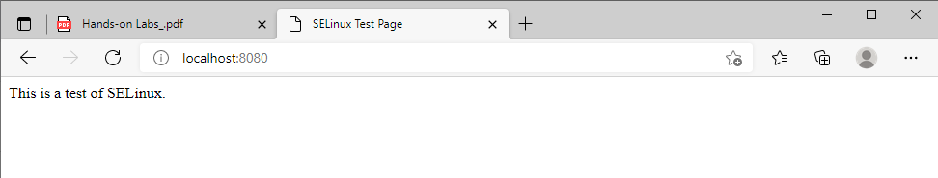
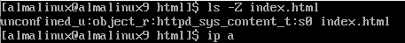
- restorecon repaired the context and normal HTTP access was restored, demonstrating policy-based remediation.

