//ROLL NO: 11255
//NAME: Vinit Sanjay Sadanshiv
//FY12

// Parking Slot Management System

//PROBLEM STATEMENT: To develop a Parking Slot Management System using C language that allocates parking slots to vehicles, tracks occupied and vacant slots, manages vehicle entry and exit, and calculates parking charges efficiently through a menu-driven program.
CODE:
#include <stdio.h>

#define MAX 10
#define RATE 20
// RATE is the parking charge per hour

struct Parking {
int vehicleNo;
int entryTime;
int isOccupied;
};

struct Parking slot[MAX];

//in this Program i have use seprate functions for being cleared about every one of it

// Function to initialize parking slots
void initialize() {
for (int i = 0; i < MAX; i++) {
slot[i].isOccupied = 0;
}
}

// Function to park a vehicle
void parkVehicle() {
int vehicleNo, time;

for (int i = 0; i < MAX; i++) {
if (slot[i].isOccupied == 0) {
printf("Enter vehicle number: ");
scanf("%d", &vehicleNo);
printf("Enter entry time (in hours): ");
scanf("%d", &time);

slot[i].vehicleNo = vehicleNo;
slot[i].entryTime = time;
slot[i].isOccupied = 1;

printf("Vehicle parked at slot %d\n", i + 1);
return;
}
}
printf("Parking full! No slots available.\n");
}

// Function to remove a vehicle
void removeVehicle() {
int vehicleNo, exitTime;
float bill;

printf("Enter vehicle number: ");
scanf("%d", &vehicleNo);

for (int i = 0; i < MAX; i++) {
if (slot[i].isOccupied == 1 && slot[i].vehicleNo == vehicleNo) {
printf("Enter exit time (in hours): ");
scanf("%d", &exitTime);

bill = (exitTime - slot[i].entryTime) * RATE;
if (bill < 0) bill = RATE;

printf("Vehicle removed from slot %d\n", i + 1);
printf("Parking Charge = Rs %.2f\n", bill);

slot[i].isOccupied = 0;
return;
}
}
printf("Vehicle not found!\n");
}

// Function to display parking status
void displayStatus() {
printf("\n--- Parking Status ---\n");
for (int i = 0; i < MAX; i++) {
if (slot[i].isOccupied)
printf("Slot %d : Vehicle No %d\n", i + 1, slot[i].vehicleNo);
else
printf("Slot %d : Empty\n", i + 1);
}
}

int main() {
int choice;
initialize();

while (1) {
printf("\n===== Parking Slot Management System =====\n");
printf("1. Park Vehicle\n");
printf("2. Remove Vehicle\n");
printf("3. Display Parking Status\n");
printf("4. Exit\n");
printf("Enter your choice: ");
scanf("%d", &choice);

switch (choice) {
case 1:
parkVehicle();
break;
case 2:
removeVehicle();
break;
case 3:
displayStatus();
break;
case 4:
printf("Thank you!\n");
return 0; // Clean exit without stdlib.h
default:
printf("Invalid choice!\n");
}
}
}

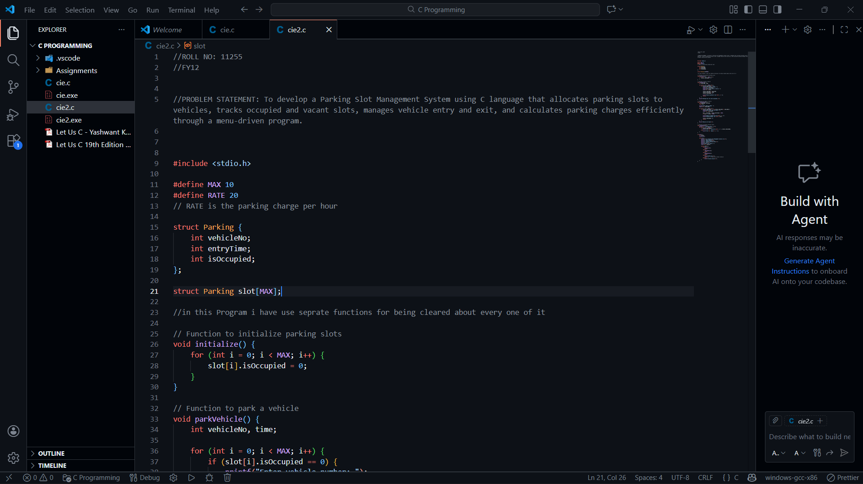

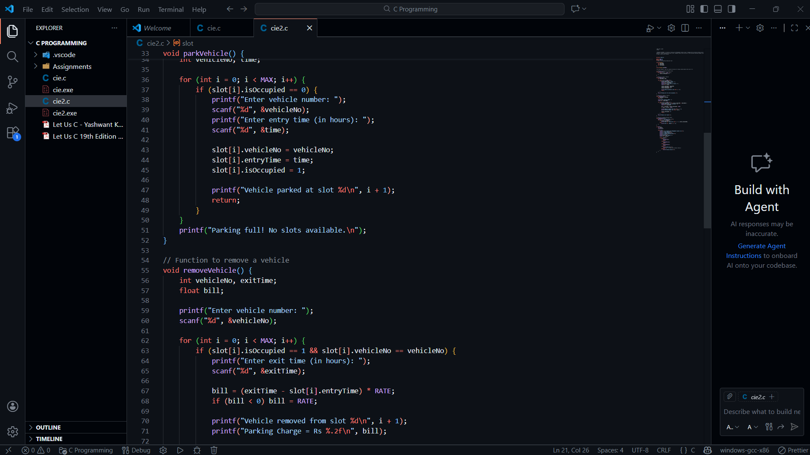

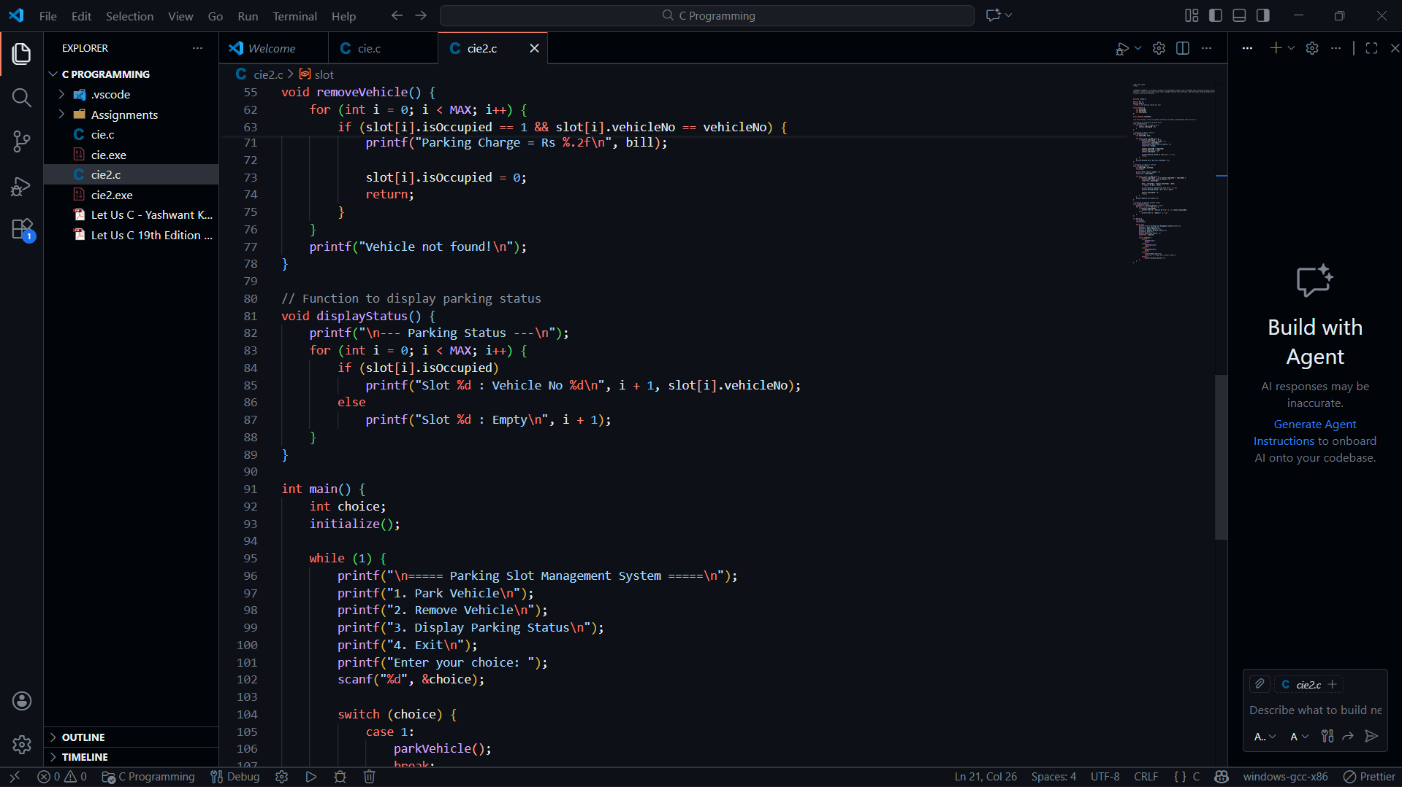

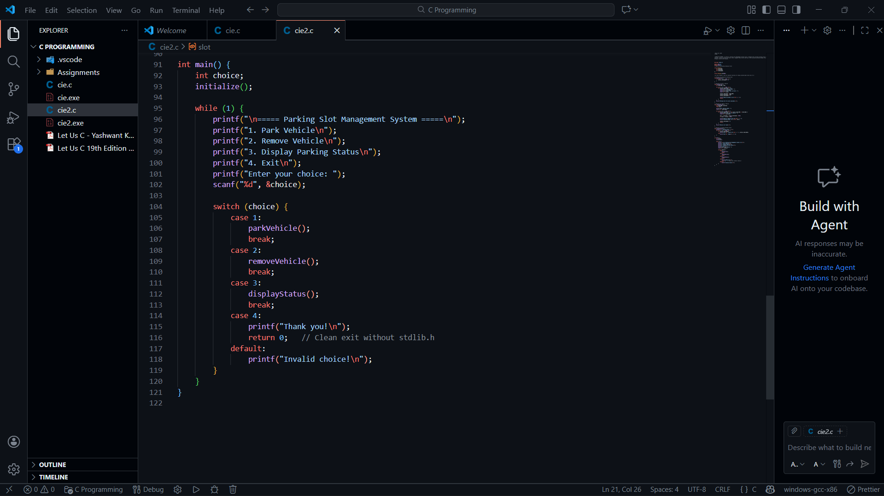

OUTPUT :
CASE 1: Entry of Vehicle:
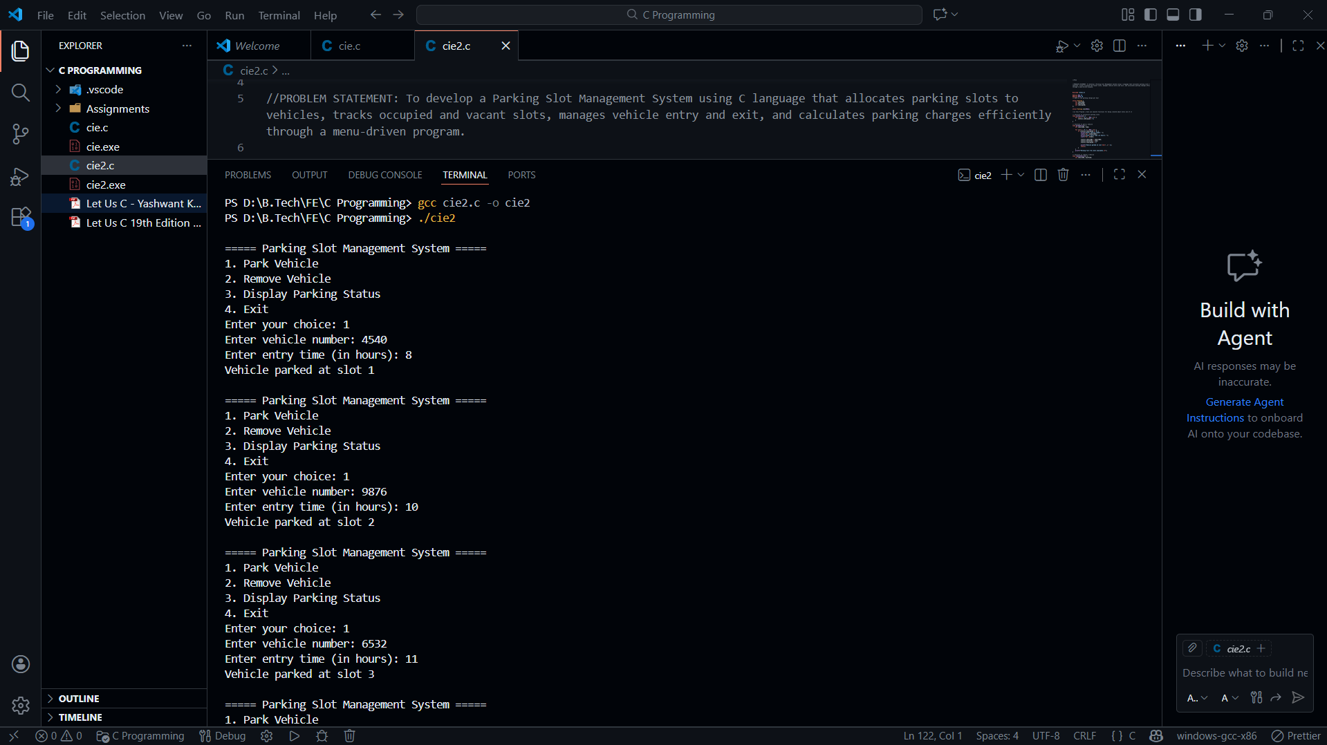
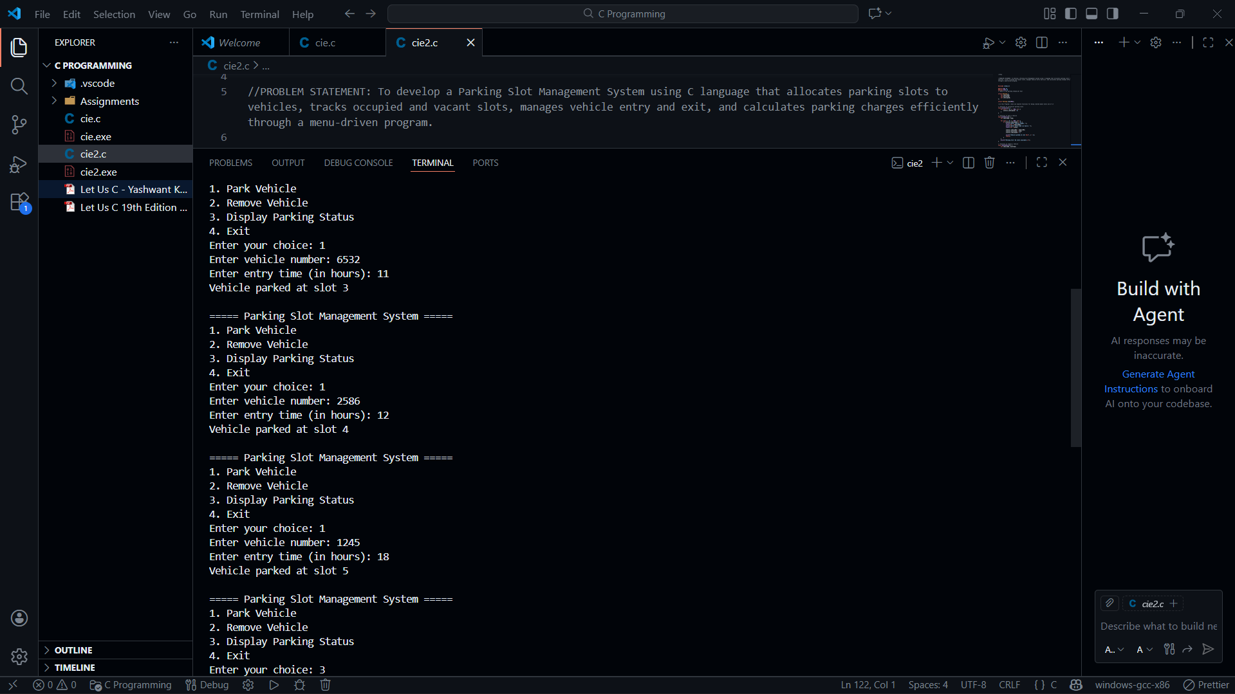

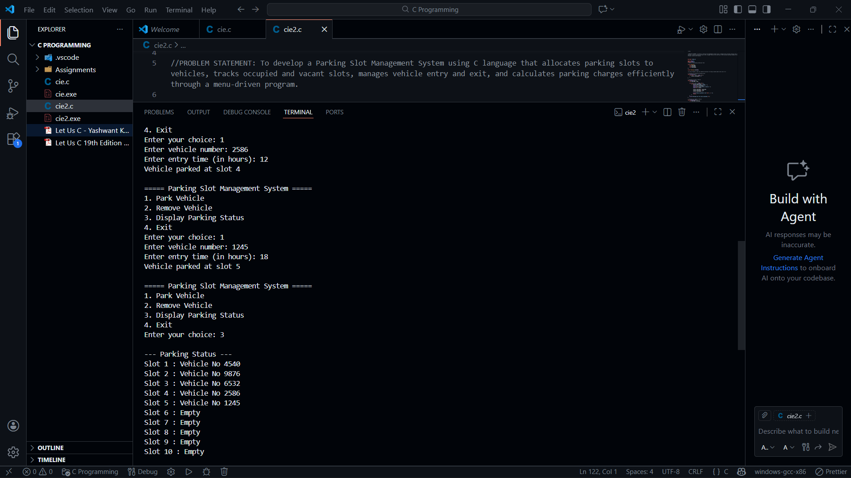

CASE 2.1 : Removing Vehicle
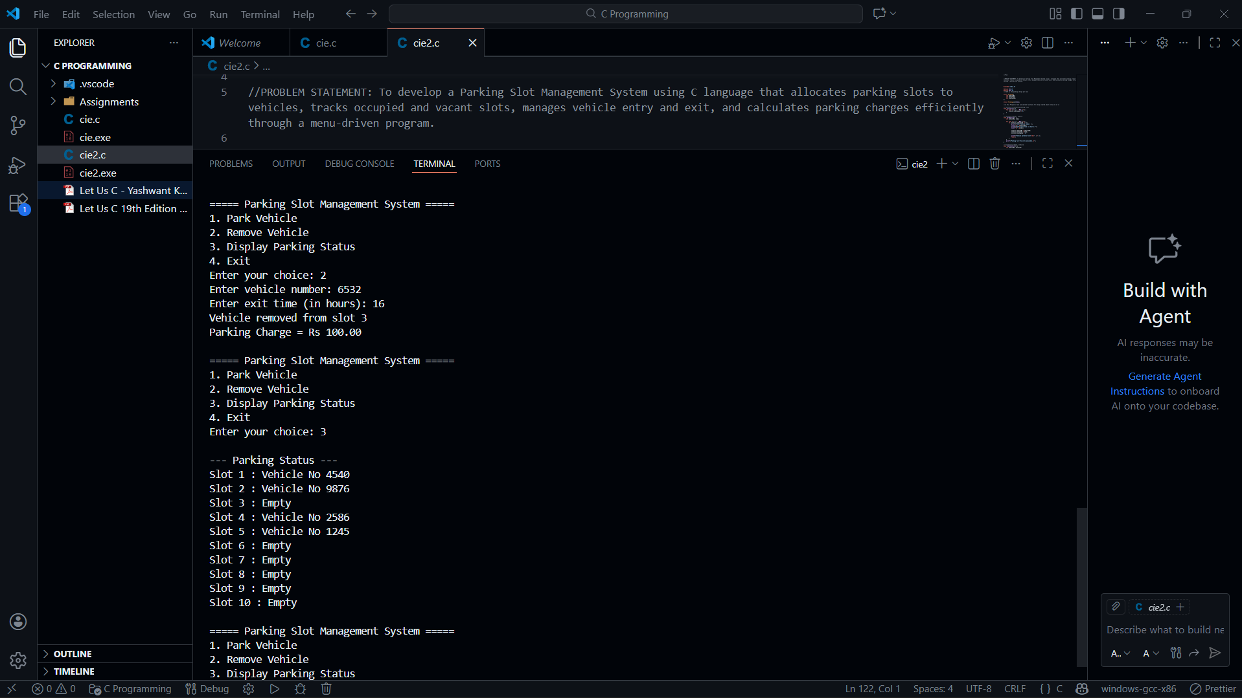

Case 2.2 : If we enter the wrong Vehicle No:
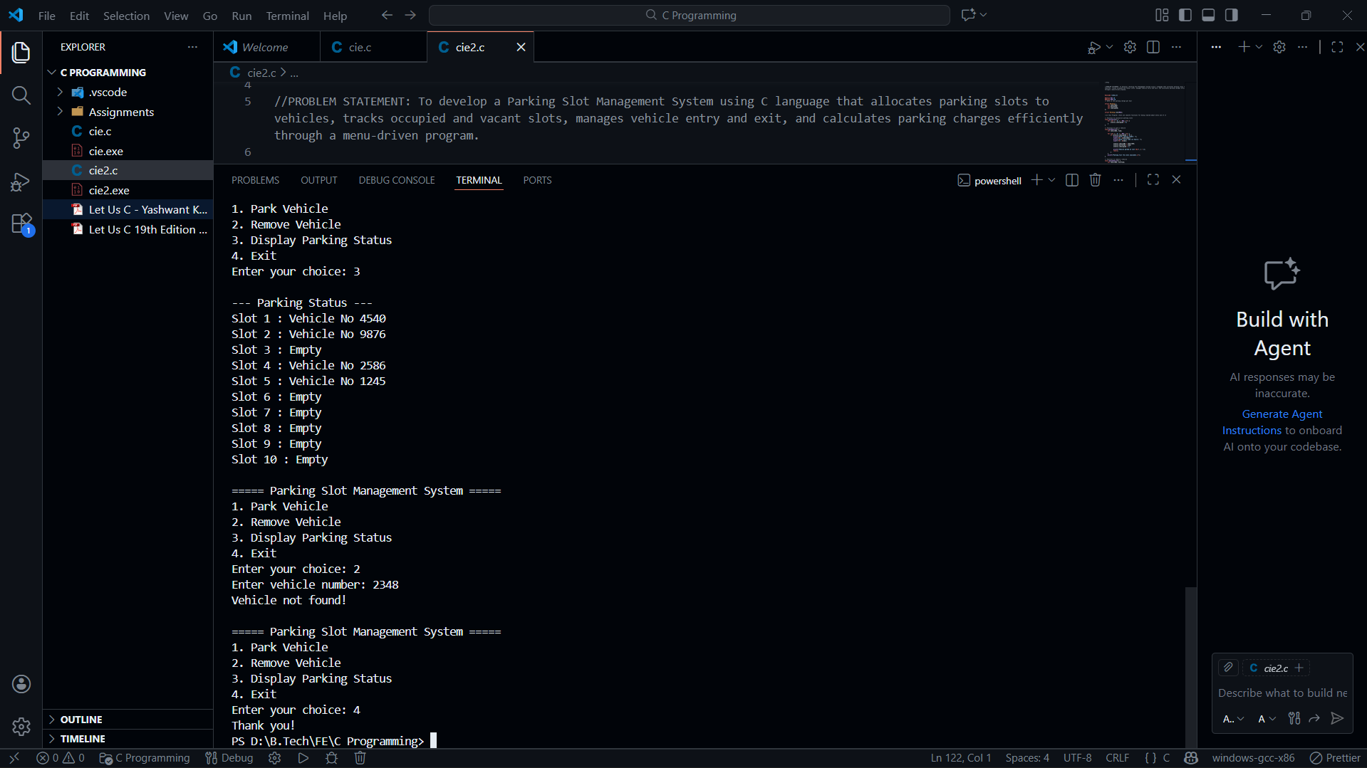

Code link :
https://github.com/official-vnt/CPPS_assignment-/blob/main/cie2.c

