# HTML

# This is prepared by YOUR NAME and ID

|  |  |
| --- | --- |
| This is prepared by YOUR NAME and ID | |
| Name | Id |
|  |  |

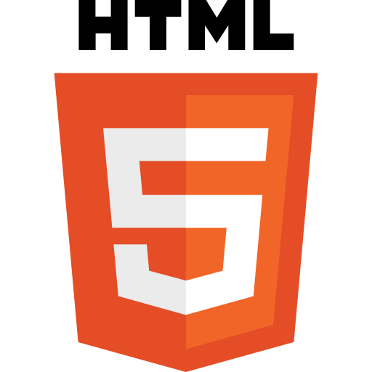

A paragraph always starts on a new line, and is usually a block of text.

HTML Paragraphs

The HTML <p> element defines a paragraph.

A paragraph always starts on a new line, and browsers automatically add some white space (a margin) before and after a paragraph.

<p>This is a paragraph.</p>  
<p>This is another paragraph.</p>

HTML Display

You cannot be sure how HTML will be displayed.

Large or small screens, and resized windows will create different results.

With HTML, you cannot change the display by adding extra spaces or extra lines in your HTML code.

The browser will automatically remove any extra spaces and lines when the page is displayed:

Code

<p>  
This paragraph  
contains a lot of lines  
in the source code,  
but the browser  
ignores it.  
</p>  
  
<p>  
This paragraph  
contains         a lot of spaces  
in the source         code,  
but the        browser  
ignores it.  
</p>