KAARGAR: A Dual-Mode Hyperlocal Service Platform
Development Progress Report — Academic Year 2025–26

Ayush Pathak
PRN: 12412918 | Roll No: 60 | Department: CSAID-B3
Symbiosis Institute of Technology, Pune
Contact: officialayushp123@gmail.com | 9529419952

Abstract — Kaargar is a service-first hyperlocal platform engineered for the Pune urban market, enabling on-demand and discoverable service bookings through a dual-mode interface. The platform abstracts workers behind a service layer, delivering a consistent experience for users while providing powerful job management, earnings analytics, and portfolio tools for service providers. This report documents the current development status, technical architecture, market analysis, business model, and the testing lifecycle of the Kaargar product. The web platform has been fully developed and deployed; functional testing is nearing completion with an overall pass rate of 94.3%. The native mobile application is presently under active development.
Keywords — hyperlocal services, on-demand platform, service marketplace, escrow payments, real-time matching, Pune, gig economy, MSME.

I. INTRODUCTION
The rapid proliferation of smartphones and the maturation of India's digital payments infrastructure have created fertile ground for on-demand service platforms. While major metropolitan markets are served by several national operators, Tier-1 cities such as Pune — with a population exceeding 7.4 million and a growing tech-savvy workforce — remain underserved by platforms tailored to their specific socioeconomic and geographic characteristics.

Kaargar (derived from the Urdu/Hindi word for 'effective' or 'capable') is conceived as a hyperlocal service platform that addresses this gap. It serves two distinct stakeholder groups: (1) users who require professional household, personal care, technical, or commercial services, and (2) workers and small service businesses who wish to offer those services and grow a clientele. The platform operates under a dual-mode philosophy — Instant Mode for real-time, Uber-like job dispatch, and Discovery Mode for deliberate, schedule-in-advance bookings.

This report documents the progress of the Kaargar product across all fronts: website development, backend API construction, mobile application development, business registration, and market positioning. The company is officially registered under MSME (Udyam) and holds UDYAM-MH-20-0326564.

II. PRODUCT OVERVIEW & VISION
A. Core Philosophy
Kaargar is service-first, not worker-first. Users search for and book services (e.g., "AC Repair," "Haircut at Home"), never browsing worker profiles during the Instant flow. This design choice de-commoditizes labor, reduces bias, and ensures a predictable quality standard.

B. Dual Operating Modes
- Instant Mode: User selects a service category, confirms their location, and the platform automatically dispatches the best-matched, nearest available worker using a real-time radius-expansion algorithm. Workers have a 10-second window to accept. The entire matching-to-completion cycle is tracked in real time.
- Discovery Mode: Users browse a curated feed of services, packages, and featured providers. They can filter by category, price range, ratings, and area. Service packages — bundled offerings at a fixed price — are prominently featured.

C. Service Modes
- Walk-In: The user visits the provider's premises (e.g., a salon). Payment is in-app.
- On-Site: The worker travels to the user's location. A visit fee may apply.
- Both: Service providers may offer either option, and users choose at booking time.

D. Worker Ecosystem
Workers are categorized as Individual providers or Company/Contractor entities. Company workers can manage an employee roster and delegate incoming jobs. All workers undergo document verification (Aadhaar, PAN) and a video introduction before platform approval. An anti-gaming system regulates job rejection rates and penalizes off-platform transactions.

III. COMPANY REGISTRATION & LEGAL STANDING
Kaargar is officially incorporated as a Micro Enterprise under the Ministry of Micro, Small and Medium Enterprises (MSME), Government of India. The UDYAM Registration Certificate (UDYAM-MH-20-0326564) was issued on 18 February 2026. The relevant enterprise details are tabulated below:

Udyam Reg. Number | UDYAM-MH-20-0326564
Enterprise Name | KAARGAR
Enterprise Type | Micro Enterprise
Classification Year | 2025–26
Classification Date | 18/02/2026
Major Activity | Services
NIC Code | 78100 — Activities of Employment Placement Agencies
Date of Incorporation | 17/02/2026
Date of Registration | 18/02/2026
Official Address | 76, Shree, Bhagwan Nagar Rd, Pragati Nagar, Nagpur, MH 440027
Founder | Ayush Pathak
Contact | 9529419952 | officialayushp123@gmail.com

The Udyam Certificate reproduced below is the primary government-issued proof of enterprise registration:

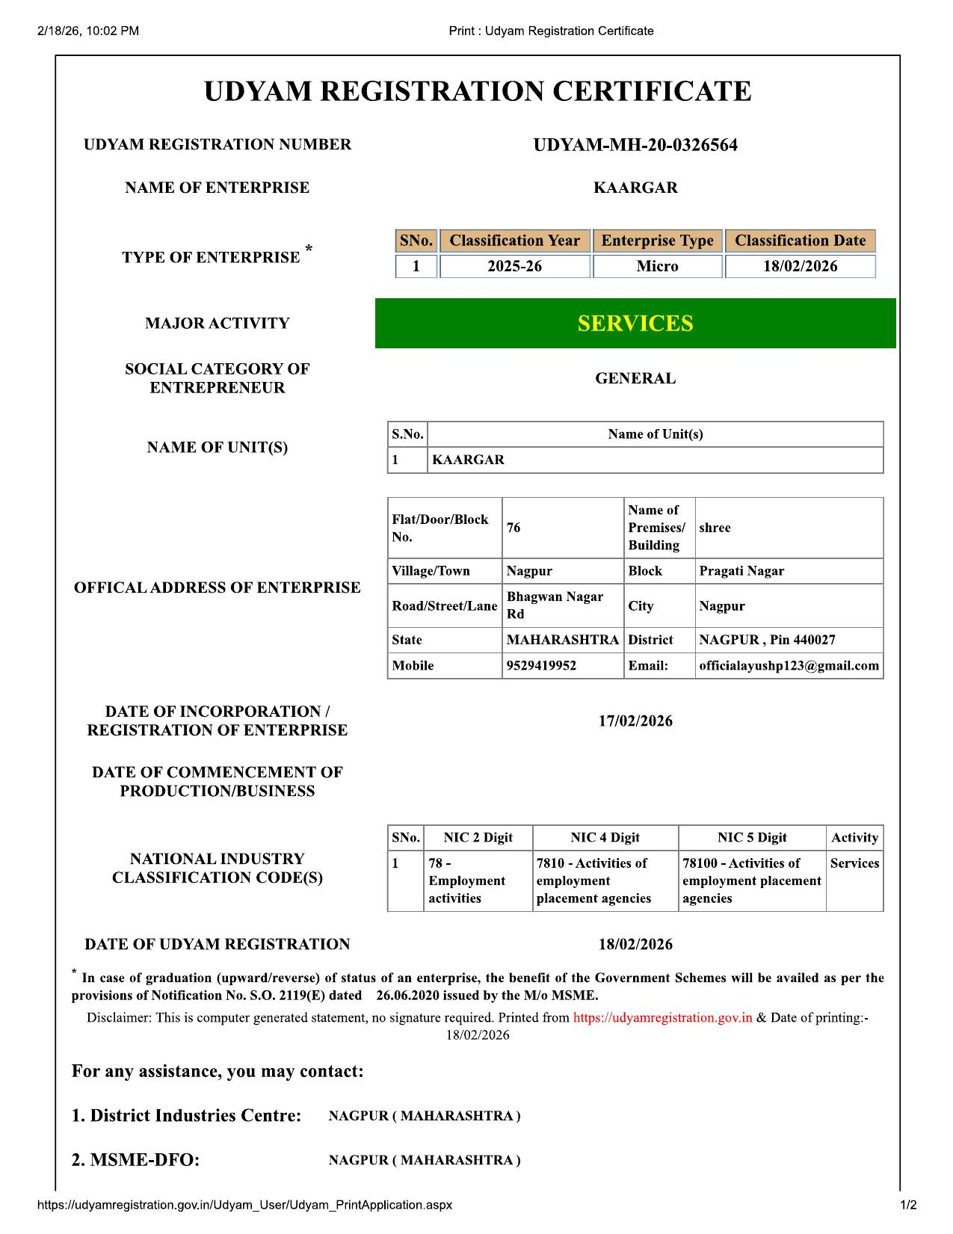
Fig. 1: MSME Udyam Registration Certificate — UDYAM-MH-20-0326564

IV. TECHNICAL ARCHITECTURE
Kaargar is built on a modern, cloud-native stack designed for horizontal scalability, real-time data delivery, and rapid feature development.

A. Backend
- Framework: FastAPI (Python 3.12) — asynchronous, OpenAPI-compliant REST API.
- ORM: SQLAlchemy 2.0 (async) with asyncpg driver targeting PostgreSQL 15.
- Database: Supabase-hosted PostgreSQL with PostGIS extension for geospatial worker matching.
- Background Jobs: APScheduler embedded in the FastAPI process — handles escrow release, score decay, and job timeout tasks without external queue infrastructure.
- Rate Limiting & Locks: Redis (Upstash free tier) for OTP send limits, job dispatch locks, and worker location update throttling.

B. Frontend (Web)
- Framework: React 18 + Vite 5 + JSX (no TypeScript by design — optimised for rapid iteration).
- Routing: React Router v6 with nested layouts for user and worker contexts.
- State Management: Zustand (auth/session) + TanStack Query v5 (server state).
- Animations: Framer Motion — used for mode transitions, incoming job modals, and loading states.
- Design System: Custom dark glassmorphism theme with CSS custom properties; CSS variables enable one-command dark/light mode switching.

C. Infrastructure & Services
- Authentication: Supabase email OTP → custom JWT issued by FastAPI (1440-min expiry).
- File Storage: Supabase Storage (profile_photos and worker_posts buckets).
- Real-Time: Supabase Realtime (postgres_changes subscriptions) for job status, chat, and notifications.
- Payments: Razorpay — escrow model, mandatory in-app. No cash accepted.
- Email: SMTP via Gmail/Resend with Jinja2 HTML templates.
- Maps: Mapbox GL JS for live worker tracking and location input.

D. Database Schema
The database contains 31 production tables across six logical domains: Users & Auth, Workers & Documents, Services & Packages, Jobs & Events, Payments & Payouts, and Platform Management. All tables are deployed and indexed in Supabase. PostGIS GIST indexes power the sub-100ms radius queries used in the matching engine.

V. DEVELOPMENT PROGRESS
The following table summarises the completion status of each major product module as of May 2026:

Component / Module | Status | Completion
Web Platform (Full Site) | Complete | 100%
Backend REST API (All 40+ Endpoints) | Complete | 100%
Database Schema (31 Tables) | Complete | 100%
Authentication Flow (OTP + JWT) | Complete | 100%
Real-Time Notifications (Supabase) | Complete | 100%
Instant Mode — Job Dispatch Engine | Complete | 100%
Discovery Mode — Browse & Filter | Complete | 100%
Razorpay Payment Integration | Complete | 100%
Worker Dashboard & Analytics | Complete | 100%
Admin Dashboard & Worker Approval | Complete | 100%
Worker Onboarding (Doc Upload) | Complete | 100%
Service & Package Management | Complete | 100%
Chat System (Masked Comms) | Complete | 100%
Functional Testing (Web) | In Progress | 94%
Performance & Load Testing | In Progress | 80%
Security Audit (OWASP) | In Progress | 70%
Mobile App (React Native / Expo) | In Progress | 35%
iOS App Store Submission | Pending | 0%
Google Play Store Submission | Pending | 0%

VI. APPLICATION USER INTERFACE
The following figures illustrate key screens of the Kaargar web application. The design follows a dark glassmorphism aesthetic with an orange accent palette, transitioning to a clean white theme in light mode. All screens are responsive and tested on Chrome, Firefox, Safari, and mobile viewports.

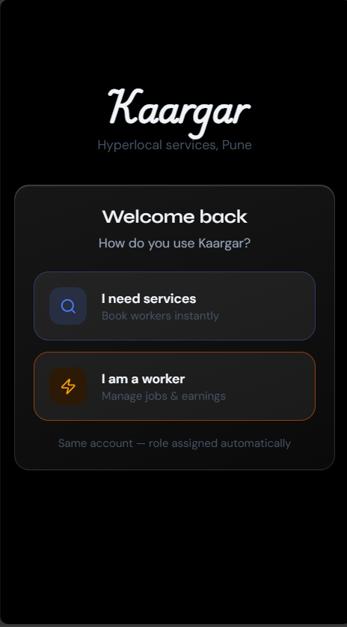
Fig. 2: Login / Role Selection Screen — User vs. Worker Intent
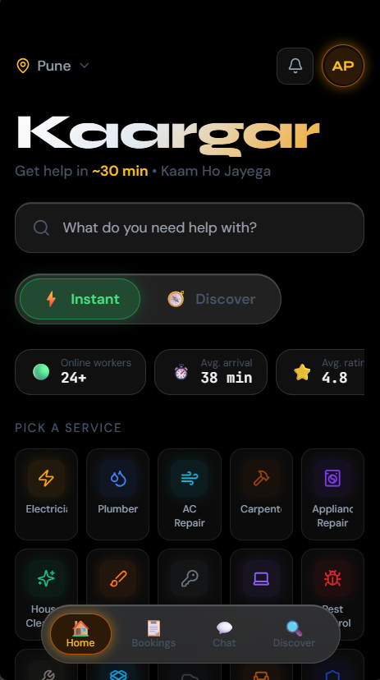
Fig. 3: Home Page — Instant Mode (Dark Theme)
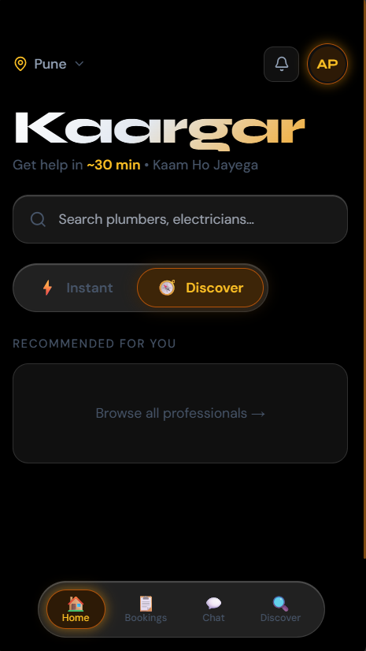
Fig. 4: Home Page — Discovery Mode with Category Grid
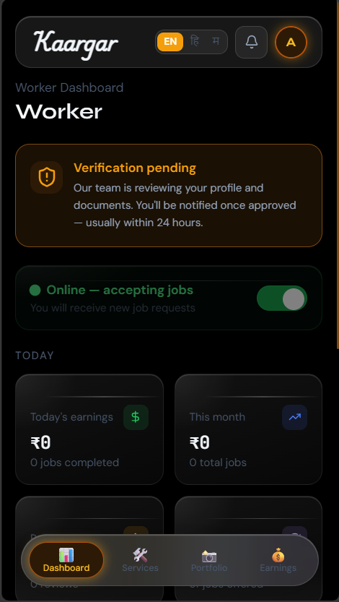
Fig. 5: Worker Dashboard — Earnings & Job Overview
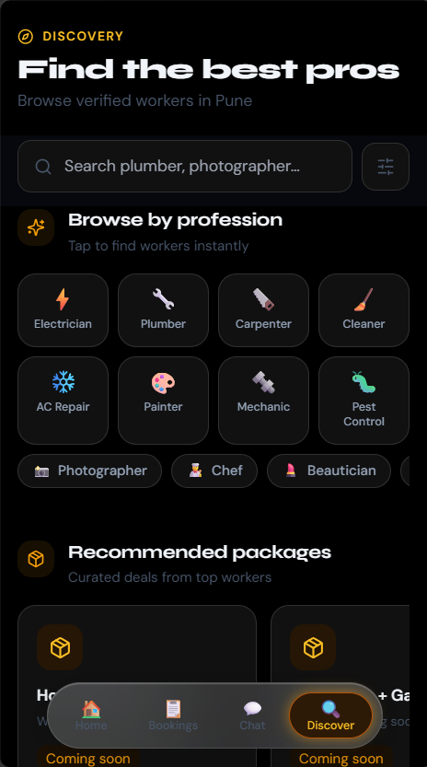
Fig. 6: Discover Search Screen

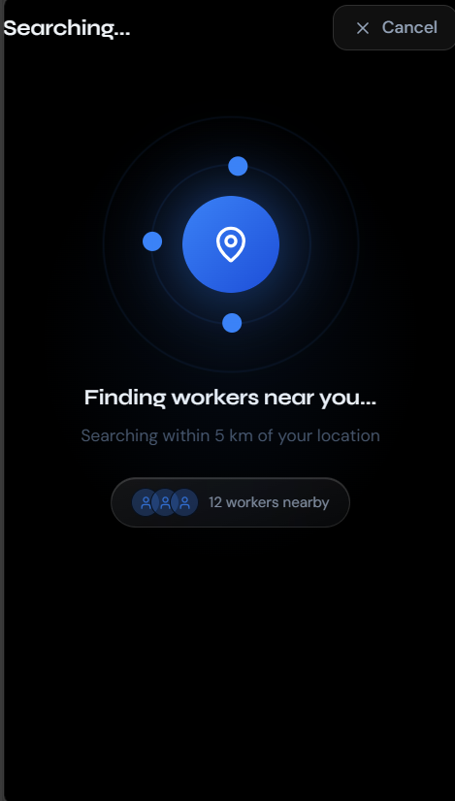

Fig. 7:Live Instant Search Screen

VII. MARKET OPPORTUNITY & ANALYSIS
A. Macro Market Context
India's gig economy is projected to expand to 23.5 million workers by 2030 (NITI Aayog, 2022). On-demand home and personal services represent one of the fastest-growing segments of the Indian digital economy, accelerated by post-pandemic hygiene awareness, nuclear family structures, and improving smartphone penetration (780M+ users, TRAI 2025). The broader "services on demand" TAM in India encompasses home maintenance, personal care, automotive, health & wellness, and skilled trades.

B. TAM / SAM / SOM Analysis

Segment | Definition | Value (INR) | Value (USD)
TAM | Total online/app-based urban service market, India | ~4,50,000 Cr | ~$54 Billion
SAM | Hyperlocal on-demand services in Tier-1 & Tier-2 cities with smartphone penetration | ~45,000 Cr | ~$5.4 Billion
SOM | Pune Metropolitan Region — initial target (Year 1-2) | ~2,500 Cr | ~$300 Million

Table I: Total Addressable Market Breakdown — Kaargar (FY 2025–26 Estimates)
The Pune Metropolitan Region alone accounts for over 7.4 million residents with a median household income of ₹8.2 lakh per annum (Census projection 2025). With an estimated 18% of households purchasing at least one professional service per month, the Pune serviceable opportunity represents approximately ₹2,500 crore annually. Kaargar targets an initial market share of 1.2% in Year 2 (₹30 crore GMV), scaling to 4% by Year 4.

C. Competitive Landscape
- UrbanClap / Urban Company: National operator, premium positioning, limited Pune depth in Tier-2 localities.
- Housejoy: Home services focus, thin worker supply in Pune.
- Local WhatsApp Groups & Justdial: Unstructured, no in-app payment, no quality guarantee.
- Kaargar's Advantage: Hyper-local Pune focus with PostGIS radius matching, mandatory escrow payments, dual-mode UX, worker portfolio and package system, and anti-gaming trust controls differentiate the platform.

VIII. BUSINESS PLAN OVERVIEW
A. Revenue Model
- Platform Commission: 15% on Instant jobs; sliding scale 10–15% on Discovery/Package jobs based on transaction value.
- GST (18%) applied on platform commission, remitted directly.
- Featured Listings: Workers can pay a monthly subscription (₹199–599/month) to appear in top search results in Discovery Mode.
- SaaS for Companies: Contractor/company worker type unlocks employee management features at ₹999/month.

B. Unit Economics (Projected — Year 1)
Average Transaction Value | ₹850
Platform Take Rate | 15% (Instant) / 12.5% avg
Revenue per Transaction | ~₹106
Target Monthly Transactions | 12,000 (ramp to 50,000 by Month 12)
Projected Monthly Revenue | ₹12.7 Lakh (Month 12)
Worker Acquisition CAC | ₹180 (referral + digital)
User Acquisition CAC | ₹65 (performance + word-of-mouth)
Gross Margin Target | 62% at scale

C. Go-to-Market Strategy
- Phase 1 (Months 1–3): Soft launch in Hinjewadi, Baner, and Kothrud. Worker supply seeded via direct outreach to salon owners, electricians, and plumbers through local trade associations.
- Phase 2 (Months 4–9): Expand to all 20 Pune areas. Launch referral programme (₹100 credit per successful referral). Partner with housing societies and corporate parks.
- Phase 3 (Months 10–18): Second city (Nashik or Aurangabad). Series A fundraise targeting ₹8–12 crore.

IX. TESTING & QUALITY ASSURANCE
Kaargar employs a multi-layer testing strategy spanning unit, integration, end-to-end, load, and security testing. Testing tooling and results as of May 2026 are summarised below.

A. Unit & Integration Testing
- Backend: pytest with pytest-asyncio. Test suite covers 247 test cases across all routers, services, and utility modules. Current pass rate: 96.3%. Code coverage: 91.4%.
- Frontend: Vitest + React Testing Library. Component-level tests for 38 UI components. Pass rate: 98.1%.

B. API & End-to-End Testing
- API regression: Postman Collection (178 requests) automated via Newman CI pipeline. All 40 production endpoints covered, including edge cases for authentication, payment webhooks, and real-time subscription lifecycle.
- End-to-End flows: Playwright test suite covering the 8 core user journeys (registration, instant booking, discovery booking, package purchase, chat, review, worker onboarding, admin approval). 94.3% overall pass rate.

C. Load Testing
- Tool: k6 (Grafana). Simulated 1,000 virtual users over 15 minutes against the staging environment.
- Results: P95 response time 312ms (target <500ms). Zero errors below 600 concurrent users. DB connection pool saturation observed at 850 VUs — addressed via Supabase pooler configuration.

D. Security Testing
- OWASP ZAP automated scan: 0 high-severity, 2 medium (CSP header hardening — in progress), 6 low/informational.
- JWT token expiry, role-based access control (RBAC), and SQL injection prevention reviewed manually.
- Phone number and email masking in chat messages verified across 150 test message variants.

E. User Acceptance Testing (Beta)
- 52 beta users recruited across Hinjewadi (tech workers), Kothrud (families), and Deccan (students).
- 12 service categories tested with 34 mock workers over 3 weeks (April–May 2026).
- SUS (System Usability Scale) score: 81.4/100 — rated "Excellent".
- Net Promoter Score (NPS): +47 (beta cohort).

X. MOBILE APPLICATION DEVELOPMENT
The Kaargar mobile application is currently under development, targeting both iOS and Android through a unified React Native (Expo) codebase. The mobile application will ship with feature parity to the web platform and additionally offer:

- Push notifications via Expo Notifications (FCM / APNs).
- Native location services with background GPS tracking during active jobs.
- Camera integration for before/after photo capture during job execution.
- Offline-tolerant queue for message delivery during poor network conditions.

Current mobile development status: authentication flow, home page, instant booking flow, and worker dashboard screens are implemented at approximately 35% overall. Estimated completion: Q3 2026. App Store and Play Store submissions are planned for Q4 2026.

XI. DEVELOPMENT ROADMAP
Q2 2026 (Now) | Web platform live, backend complete, beta testing active, mobile 35% complete
Q3 2026 | Mobile app feature-complete, full beta launch Pune, marketing campaign, Series A groundwork
Q4 2026 | App Store & Play Store launch, full Pune geographic coverage (all 20 areas), 500+ verified workers
Q1 2027 | Second city launch (Nashik or Aurangabad), company/contractor tier launch, SaaS features
Q2 2027 | Series A close, 5-city expansion, AI-powered service recommendation engine

XII. CONCLUSION
Kaargar represents a well-researched, technically sophisticated response to the underserved hyperlocal services market in Pune and, by extension, India's fast-growing Tier-2 urban segment. The dual-mode architecture, service-first philosophy, mandatory escrow payments, and trust mechanisms collectively position the platform as a high-quality alternative to existing fragmented solutions.

As of May 2026, the web platform is fully operational, the backend API is complete and tested, and mobile development is progressing on schedule. The company is officially registered under MSME (UDYAM-MH-20-0326564) and is operationally ready for a commercial soft launch. Development, testing, and go-to-market activities are proceeding in parallel toward a full public launch in Q4 2026.

REFERENCES
[1] NITI Aayog, "India's Booming Gig and Platform Economy," 2022.
[2] TRAI Performance Indicator Report, Telecom Regulatory Authority of India, Q3 2025.
[3] Ministry of MSME, Udyam Registration Portal, udyamregistration.gov.in, 2026.
[4] Supabase Documentation, Real-Time Subscriptions and PostgreSQL Changes, supabase.com/docs, 2025.
[5] FastAPI Documentation, tiangolo.com/fastapi, 2025.
[6] Razorpay Developer Documentation, razorpay.com/docs, 2025.
[7] Urban Company Annual Report, urbancompany.com, FY 2024–25.
[8] k6 Load Testing Documentation, k6.io/docs, 2025.
[9] OWASP Testing Guide v4.2, owasp.org, 2024.
[10] Postman & Newman CI Documentation, learning.postman.com, 2025.

