FraudShield
Team-Kala Dhua
Solution Walkthrough
Mastercard Innovation Challenge 2026
A closed-loop Red Team / Blue Team system that generates realistic, multi-modal fraud attacks and evaluates real, evidence-gated detection models against them, then adapts based on measured weaknesses, not simulated ones.

Submitted by: Ayush Pathak
Submission date: August 31, 2026
Repository: red_hat_vs_blue_hat_attack (FraudShield)

1. Executive Summary
FraudShield is a closed-loop adversarial fraud detection system built around two cooperating halves: a Red Team that generates realistic, multi-modal fraud attacks (transaction fraud, account takeover, synthetic identity, mule networks, voice scam, document fraud, and phishing), and a Blue Team of real, independently trained detection models evaluated against those attacks under a held-out, adversarial protocol. A weakness-driven mutation loop closes the circle: when the Blue Team's weakest attack family is identified from real evaluation numbers, the Red Team regenerates a harder version of exactly that scenario and the Blue Team is re-scored against it — before and after numbers are both recorded, including when the result is a regression.
The system was built against fourteen governing principles established at the start of the project and enforced throughout. The three most consequential for how this document should be read:
- Deterministic generation, LLM strategy only: “The LLM chooses attack strategy. Deterministic code generates the actual financial data. The LLM never writes a transaction row … No LLM-generated transaction rows, ever, under any circumstance.”
- The evidence gate (Principle 11): “No modality or model is promoted to a ‘validated’ claim in the Blue Team without a real detector run against a real, frozen held-out evaluation set with recorded metrics. Anything short of that ships as ‘experimental.’”
- Labels are metadata, never model input (Principle 13): attack labels exist for scoring only — detectors such as the document-consistency and voice-spoof models take only a raw file path, never the ground-truth label, so held-out recall cannot leak through the label channel.
Nine real detectors were trained and evaluated: XGBoost, LightGBM, and an Autoencoder over tabular transaction/account/identity/mule signals (fused into a single risk-fusion decision layer), a wav2vec2-based voice spoof detector, a PaddleOCR-VL document consistency detector, a TF-IDF/URL/intent phishing classifier, a video-KYC liveness/consistency detector, and a graph neural network for mule-network detection. Every model's numbers in Section 6 come from the project's own evaluation logs (docs/EVALUATION_RESULTS.md), not from this document's author's estimate.
The honest headline result: the tabular fusion layer (XGBoost + LightGBM + Autoencoder) is strong and well-evidenced — adversarial precision 0.9621, recall 1.0000, F1 0.9807, PR-AUC 0.9994 across all four tabular attack families it was scored against. The graph neural network built specifically for mule-network detection is not competitive, even after five rounds of iteration guided by two peer-reviewed benchmarks — held-out recall on real mule-ring cases tops out around 0.001–0.075 depending on the round and threshold. Rather than hide that result, Section 5.5 documents the full five-round process, including two rounds that made things worse, and the resulting engineering decision: keep the GNN as an experimental, clearly-labeled signal, and route the graph-topology insight that mattered into hand-engineered features for XGBoost instead, where it produced a real, measured improvement (PR-AUC 0.5114 → 0.6020, +17.7% relative).

2. System Architecture

2.1 The Closed Loop
FraudShield's architecture is organized around one loop, repeated for every attack family: Generate → Detect → Evaluate → Identify Weakness → Mutate → Re-evaluate. The Red Team (backend/generate/*) produces realistic attack cases against a shared Synthetic Customer Vault so that identity- and behavior-based signals have something real to compare against. The Blue Team (backend/models/*, backend/evaluation/*) runs frozen, independently trained detectors against a held-out split of those cases that was never used in training. The evaluation layer computes real precision/recall/F1/PR-AUC/false-positive-rate per family, and — only when severity is set to “adaptive” and a weak family is tabular — the mutation engine (evaluation/adaptive_weakness_round.py) regenerates a harder version of the weakest scenario and re-scores it, recording a real before/after delta.
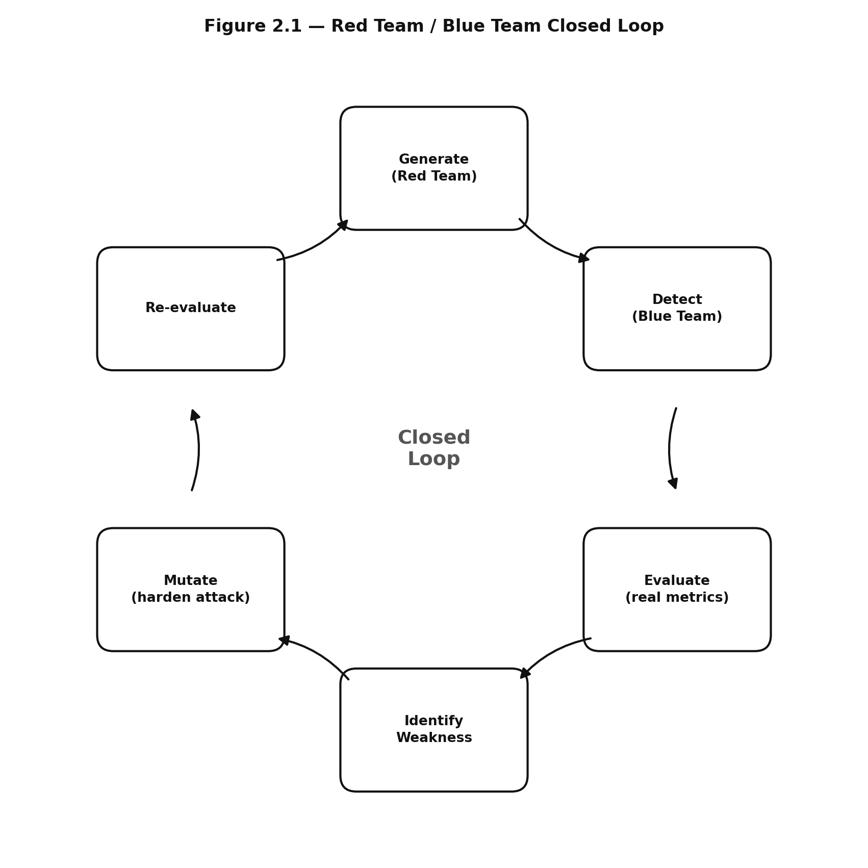
Source: this project (backend/orchestration/agent_runner.py, evaluation/adaptive_weakness_round.py).

2.2 Repository Layout
- backend/generate/ — deterministic attack-case generators per family, plus the Synthetic Customer Vault (synthetic_customers.py) and the master orchestration script run_all_generation.py.
- backend/models/ — the nine real detectors: XGBoost, LightGBM, Autoencoder, GNN, voice spoof, document consistency, phishing classifier, video-KYC, and the risk-fusion combiner.
- backend/evaluation/ — held-out and adversarial evaluation scripts per model, run_all_evaluations.py (master runner), adaptive_weakness_round.py (the mutation loop), split_policy.py (the single source of truth for the seven attack families and their train/held-out combination splits), llm_strategist.py (optional LLM-guided scenario selection with strict JSON validation and graceful degradation), supabase_results.py (persists every evaluation run and per-case result to Supabase).
- backend/orchestration/agent_runner.py — the live, real 7-stage agent pipeline described in Section 2.4.
- backend/db/ — Supabase schema, RLS policies, model_registry sync.
- backend/api/main.py — the FastAPI surface described in Section 2.3.
- frontend/ — the React/Vite web prototype: Create Run → Live Agent Activity → Run Results → Weakness Analysis → Adaptive Mutation → Report.
- docs/ — TECHNICAL_SPEC.md (governing spec), DATASETS.md (provenance and the GNN iteration log), EVALUATION_RESULTS.md (the append-only real-numbers log this document is sourced from), FUTURE_INTEGRATIONS.md (deliberately deferred work).

2.3 Why the Backend Exists at All (RLS-Driven Frontend)
Every Supabase table in this project grants public read access via row-level security using the anon key (db/002_rls_policies.sql); only writes are service-role-restricted. That means the React frontend talks directly to Supabase for every read — run status, agent steps, model registry, evaluation results — with no backend round-trip. The FastAPI backend (backend/api/main.py) exists for exactly one class of operation the browser cannot perform itself: launching and polling long-running local Python subprocesses (attack generation, model evaluation, and the live agent run). Its three endpoint groups mirror this: /evaluations/*, /generate/*, and /runs/* — each pattern is start-a-subprocess / poll-a-job-id, and none of them proxy a data read the frontend could do directly.
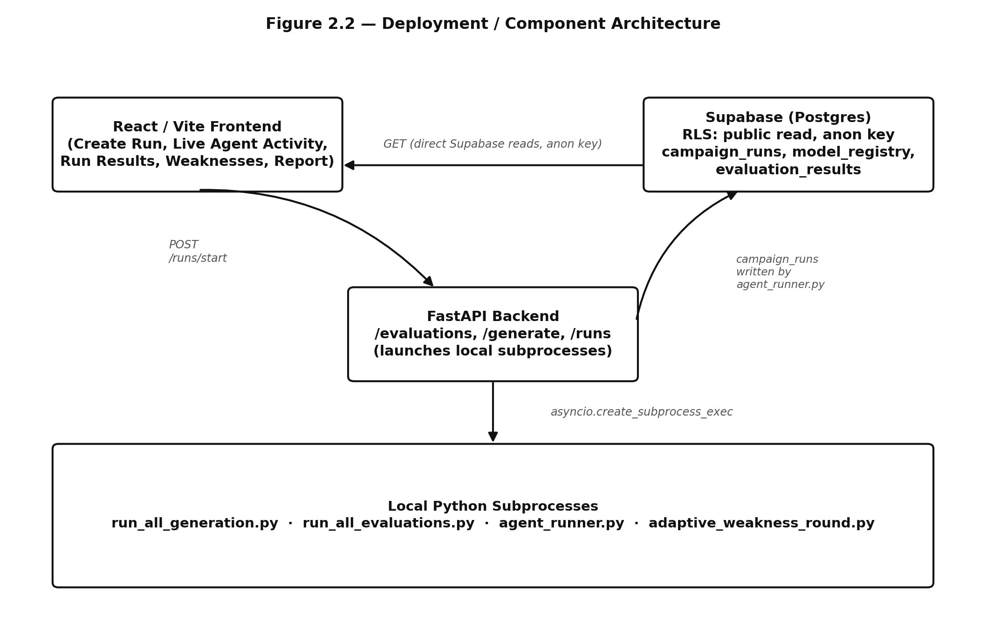
Source: this project (backend/api/main.py, backend/orchestration/agent_runner.py, frontend/src/lib/supabaseClient.js).

2.4 The Live Agent Orchestrator
backend/orchestration/agent_runner.py runs a real 7-stage pipeline for every defense run — every stage is a thin wrapper around already-real project code, never fabricated narration. If a stage genuinely has nothing to report (for example, the mutation engine when severity is not “adaptive”), it says so explicitly rather than inventing activity.
# | Stage | What actually happens
1 | Orchestrator | Resolves the requested UI scope (e.g. “transaction, graph, voice”) to the real attack families defined in split_policy.py, and computes cases-per-family.
2 | Threat Research | Reads the real base-scenario / mutation-dimension combinations for each selected family from split_policy.FAMILIES.
3 | Attack Planner | Finalizes which generation scripts must run for this run's family set.
4 | Attack Generator | Runs run_all_generation.py as a subprocess; parses real generated-case counts from its JSON summary block.
5 | Blue Team | Runs run_all_evaluations.py as a subprocess against the newly generated held-out cases.
6 | Evaluation Agent | Reads metrics.json, computes real per-family recall/precision/F1/PR-AUC, identifies the weakest family, and derives run-level aggregates (attacks tested/caught/missed, false positives, coverage %).
7 | Mutation Engine | Only if severity=“adaptive” and the weakest family is tabular: runs adaptive_weakness_round.py, records the real before/after recall delta and the real hardened attack-parameter combination it produced.
Table 2.1 — The seven real orchestration stages, backend/orchestration/agent_runner.py.
Progress is not polled from the backend. Every stage flushes its state to a Supabase campaign_runs row as it starts and completes; the frontend polls that row directly (TanStack Query refetchInterval) using the same public-read anon key described above. campaign_runs.stage_results is stored as a JSON object of the shape { meta: {…run-level fields}, steps: […per-stage entries] }, repurposing a table that existed in the Phase-1.5 schema for predefined composite scenarios but had no writer until this build.
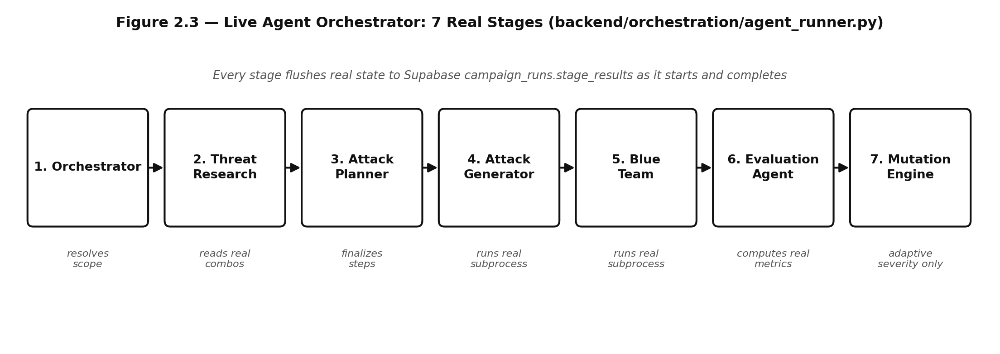
Source: this project (backend/orchestration/agent_runner.py).

3. Attack Taxonomy (Red Team)
Seven attack families are implemented, each with a base scenario, a set of mutation dimensions the generator can vary, the detection signals it is expected to exercise, and an explicit split between combinations the Blue Team is allowed to train on and combinations reserved as held-out-only — so that adversarial evaluation numbers in Section 6 are never testing a model against something it saw in training.
Family | Category | Expected signal(s) | Held-out-only?
transaction_fraud | Tabular | Amount/velocity/merchant-category anomaly | Some mutation combos
account_takeover | Tabular | Device/behavioral deviation from baseline | Some mutation combos
synthetic_identity | Tabular | Identity-consistency / vault mismatch | Some mutation combos
mule_network | Tabular / Graph | Fan-out/fan-in, pass-through ratio, cyclic flow | Some mutation combos
voice_scam | Audio | Spoof/synthesis artifacts (wav2vec2 embedding) | Held-out only
document_fraud | Vision / OCR | Field-tampering, QR cross-check mismatch | Held-out only
phishing_scam | Text | Intent, URL structure, deceptive-language features | Held-out only
Table 3.1 — The seven core attack families, docs/TECHNICAL_SPEC.md Section 4a.

3.1 Synthetic Customer Vault
generate/synthetic_customers.py builds a Customer Universe of synthetic identities with a behavior_baseline per customer, so that identity- and behavior-driven attacks (account takeover, synthetic identity, document fraud) have a real reference state to deviate from, rather than being generated in isolation. document_fraud cases carry a customer_id and are checked against that customer's trusted vendor list; identity signals more broadly compare against Customer Universe state wherever a customer_id is available (Principle 14: context fusion over independent per-signal scoring).

3.2 Research-Tier Families (Not in the Core Loop)
Four additional attack types are scoped in the taxonomy as research-tier, not yet wired into the core evaluation loop: video-KYC impersonation, KYC photo/face impersonation, card testing, and AI-generated fake-merchant fraud. video_kyc_detector (Section 5.9) is the one of these with a working, evidence-gated model today; the other three remain taxonomy-only.

3.3 Signal Categories
Detectors draw on seven core signal categories — transaction, behavioral, device, network/graph, document, voice, and text — plus one additive category, identity, introduced when the Synthetic Customer Vault made customer-baseline comparison possible.

4. Datasets
Every model is trained and evaluated against a documented, real dataset — either a public benchmark or a project-generated dataset whose generation process is itself deterministic and inspectable. docs/DATASETS.md is the source of truth; the table below summarizes it.
Model | Train dataset | Evaluation dataset
XGBoost / LightGBM / Autoencoder | PaySim1 (6.36M rows) + IEEE-CIS, + graph-topology features (Sec. 5.5.2) | Held-out split of the same, plus adversarial generated cases
Risk Fusion | N/A — combiner over the three tabular models | Adversarial generated cases, all four tabular families
voice_spoof_detector | Pretrained (wav2vec2) | Bonafide: hf-internal-testing/librispeech_asr_dummy (~40 clips); spoof: Chatterbox-TTS-generated
document_consistency_detector | Pretrained (PaddleOCR-VL) | Both bonafide and fraud documents self-generated
phishing_classifier | difraud/difraud (MIT license) | Evidence-gate re-check against generated novel / Hinglish text
gnn (mule network) | IBM Transactions for AML — HI-Small (Kaggle ealtman2019, NeurIPS 2023 peer-reviewed synthetic benchmark) | Project's own ring_gen.py held-out mule-ring cases
video_kyc_detector | Project-generated, small and explicitly growing | Held-out split of the same
Table 4.1 — Per-model dataset provenance, docs/DATASETS.md.
Two datasets carry a note worth stating plainly. First, the IBM Transactions for AML (HI-Small) benchmark is the only dataset in the project that comes with independently published model results to compare against (Section 5.5 uses this directly). Second, the voice and video-KYC evaluation sets are explicitly small-N (40–82 clips, 6 cases respectively) — the numbers in Section 6 for those two models should be read with that sample size in mind, not treated as a statistically wide claim.

5. Model Methodology (Blue Team)
This section covers every real detector in the system: what it is, what it was trained and evaluated on, and — per the project's own standard for this submission — the actual process followed to build it and the tradeoffs made along the way, including the ones that didn't work. Section 5.5 (the graph neural network) carries this in the most detail because it is the model whose iteration history is most instructive: five real rounds, two of them regressions, resolved by a literature-grounded pivot and an honest decision to route the useful part of the idea into a different, better-suited model instead of forcing the GNN to work.

5.1 XGBoost — Tabular Gradient-Boosted Trees
The primary tabular fraud classifier, trained on PaySim1 and IEEE-CIS with engineered transaction, velocity, and (after Section 5.5.2's pivot) graph-topology features. XGBoost was chosen as the anchor tabular model because gradient-boosted trees handle the highly imbalanced, heterogeneous feature mix (continuous amounts, categorical merchant codes, sparse graph-degree features) without the preprocessing fragility a neural model would need at this scale.

Process and tradeoffs
Two real bugs shaped the preprocessing pipeline before training could succeed at full scale: an all-NaN categorical column crashing the encoder, and XGBoost hard-erroring on out-of-vocabulary categorical values seen only at inference time — both required explicit handling rather than being edge cases the library absorbed silently. When graph-topology features were added (Section 5.5.2), a second class of bug surfaced: numpy defaulting a NaN-filled column to float64 caused pd.concat() to silently upcast a 6.95-million-row dataframe to float64, which then failed to allocate (“Unable to allocate 1.35 GiB”) during training. The fix was to force np.float32(np.nan) explicitly everywhere a graph feature could be missing, plus a dtype-normalization fix in dataset.py for pandas' nullable Float64 type round-tripping through Parquet.
The tradeoff made deliberately: threshold selection was delegated entirely to the fusion layer (Section 5.4) rather than tuned per-model. This was validated as the right call when phishing_classifier's own tuned threshold was found to produce a 39% false-positive rate when re-scored on generated data — a threshold tuned on one distribution does not reliably transfer, which is exactly the failure mode delegating to a jointly-tuned fusion threshold avoids.

5.2 LightGBM — Tabular Gradient-Boosted Trees (Second Opinion)
A second, independently trained tabular model on the same feature set as XGBoost. Its role in the architecture is deliberate redundancy: fusion (Section 5.4) is stronger when its inputs make different mistakes, and LightGBM's leaf-wise growth strategy produces a genuinely different decision boundary than XGBoost's level-wise growth on the same data, rather than a near-duplicate.

Process and tradeoffs
LightGBM shared every pipeline fix XGBoost required (the float32/NaN and dtype-normalization fixes above) since both consume the same feature table. The one place the two models diverged in outcome is the graph-topology feature addition: XGBoost's PR-AUC improved 0.5114 → 0.6020 (+17.7% relative) from the same seven new graph columns, while LightGBM's PR-AUC moved only 0.6078 → 0.6066 — essentially flat, and if anything a very slight regression. This was left as-is rather than reverted, both because it is an honest, small, and expected amount of model-to-model variance on a feature addition, and because LightGBM's role as a second independent opinion for fusion does not require it to individually improve on every feature addition — fusion's own numbers are what matters, and those did improve (Section 6).

5.3 Autoencoder — Unsupervised Anomaly Detector
Trained only on 5,539,427 legitimate transactions (no fraud examples at all), the autoencoder learns to reconstruct normal transaction patterns and flags high reconstruction error as anomalous. Its purpose in the ensemble is to catch fraud patterns the two supervised trees have never seen a labeled example of — the classic unsupervised complement to a supervised pair.

Process and tradeoffs
The tradeoff is visible directly in its numbers: Stage-5 validation recall is 0.1649 — far below XGBoost's or LightGBM's — because reconstruction-error anomaly detection is intentionally a blunter instrument than a supervised classifier trained on the exact fraud patterns being tested. What it buys back is coverage of the unknown: in the adversarial evaluation (Section 6), the autoencoder is the strongest of the three tabular models on synthetic_identity and mule_network (recall 1.0 on both), and the weakest on transaction_fraud (0.4300) — almost the inverse of where XGBoost and LightGBM are strong. This complementary failure pattern is precisely why fusion (Section 5.4) is able to reach recall 1.0000 across all four tabular families even though no single model does alone.

5.4 Risk Fusion Layer
A weighted combiner over XGBoost, LightGBM, and Autoencoder scores (weights: XGBoost 0.3387, LightGBM 0.3388, Autoencoder 0.3225 — close to equal, learned rather than hand-set), producing a single risk score mapped to four decision bands: 0–30 approve, 31–60 review, 61–80 challenge, 81–100 block.

Process and tradeoffs
Fusion's decision threshold (0.6756) is tuned jointly across all three models rather than each model keeping its own threshold — the deliberate consequence of the delegation decision described in Section 5.1. The tradeoff to be explicit about: fusion's adversarial precision/recall/F1/PR-AUC/false-positive numbers (Section 6) are global figures across every tabular family scored in a given run, not per-family breakdowns — reporting them as per-family would overstate what was actually measured. Per-family recall is available separately and is where the real variance across families becomes visible again (Section 6.2).
One honest scope note: the behavioral_adjustment signal was not exercised in the fusion adversarial-evaluation run recorded in docs/EVALUATION_RESULTS.md, because that run predates the Phase 2.5 customer_id wiring that made behavioral baselining possible. Fusion's reported numbers should be read as covering transaction, account, identity, and mule signals — not yet behavioral.

5.5 Graph Neural Network — Mule-Network Detection
The GNN is the model built specifically to detect mule-network laundering rings by learning directly over the transaction graph's structure, rather than from hand-engineered graph statistics fed to a tree model. It is also the model with the longest and most instructive iteration history in the project, and the one the user explicitly asked to be documented in full — including the parts that didn't work, since that is the actual process, not a cleaned-up success narrative.
The short version of the outcome, stated up front: after five rounds of real iteration — including adopting two specific architectural fixes from a peer-reviewed paper written for this exact dataset — the from-scratch GNN's held-out recall on real mule-network cases never became competitive with either the published literature's own tree-model baseline or this project's own graph-feature-engineered XGBoost. That is reported honestly below, and the engineering response to it (keep the GNN as an explicitly experimental signal; move the useful graph-topology idea into XGBoost's feature set instead) is Section 5.5.2.

5.5.1 The Five Rounds
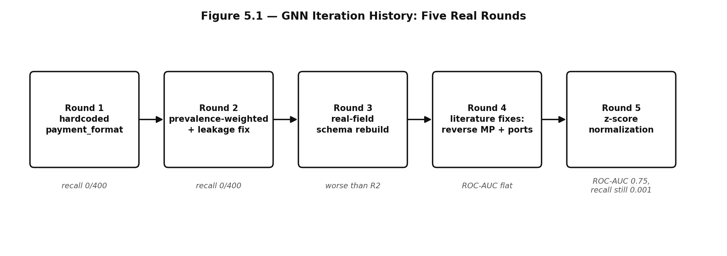

Source: this project (docs/DATASETS.md, GNN iteration log).

Round | What changed | Result
1 | Baseline DirectionalSAGE-style GNN on IBM AML HI-Small. Synthetic mule-ring edges (from ring_gen.py) hardcoded payment_format=“Cheque”, since ring_gen.py has no such concept. | mule_network held-out recall 0/400. Scores collapsed to near-constant — the hardcoded value injected whatever laundering-risk prior the model learned for “Cheque” regardless of actual topology.
2 | Replaced the hardcoded value with a training-prevalence-weighted average one-hot encoding; fixed a real train/val/test leakage bug (node-aggregate features were computed over the full edge set, including val/test); added a proper time-based split and early stopping. | IBM AML PR-AUC barely moved (0.0018→0.0028, ~2x base rate). mule_network recall still 0/400; scores still collapsed into a near-constant band (0.5418–0.5431). The feature-schema problem wasn't a training-regime problem.
3 | Dropped payment-format/currency entirely. Rebuilt the schema around features real and natively present in both IBM AML and ring_gen.py: node fan-out/fan-in breadth, pass-through ratio (log(in-amount)−log(out-amount)), cyclic hour-of-day, and transaction velocity — verified field-for-field against ring_gen.py's real fields, including its “−1.0 = no prior transaction” sentinel. Switched from full-batch training with ~1035x positive-class weighting to balanced mini-batch sampling with dropout and weight decay. | Worse than round 2 on IBM AML: ROC-AUC 0.5669 (vs. round 2's 0.6318), PR-AUC 0.0029, precision 0.0096, recall 0.0211. mule_network recall still 0/400 at the IBM-AML-borrowed threshold. One real positive: percentile_vs_ibm_aml_test_scores = 0.9561 — the model was still ranking mule cases far above typical transactions even though the threshold missed them.
4 | Literature-grounded pivot. Read arXiv:2306.16424 (Altman/Egressy et al., NeurIPS 2023, defines the IBM AML/HI-Small dataset itself; reports GFP+XGBoost at 63.23% minority-class F1, beating every GNN baseline tested including PNA at 56.77%) and arXiv:2306.11586 (Egressy et al., AAAI 2024; reverse message passing + port numbering, up to +30% minority-class F1). Adopted both fixes: DirectionalSAGELayer with separate SAGEConv aggregators for predecessor/successor neighbors; port-numbering edge features (out_port/in_port, timestamp-ranked). NEG_PER_POS raised 10→20, PATIENCE raised 15→25 (round 3 early-stopped at epoch 16). | ROC-AUC unchanged to 4 decimal places from round 3 (0.5669) — the architectural fixes did not move IBM AML performance measurably. PR-AUC 0.0026, F1 0.0079. mule_network recall still 0/400. percentile_vs_ibm_aml_test_scores rose 0.9561→0.9793 — ranking improved again even though threshold-based recall did not.
5 | Added train-period z-score feature normalization on top of round 4's architecture. | ROC-AUC improved to 0.7532 (a real improvement on IBM AML's own test set), PR-AUC 0.0069, F1 0.0258, recall 0.0746 at threshold 0.8222. mule_network-specific held-out recall (gnn_adversarial_eval_colab_round5_reported) is still 0.001 (1/1000). percentile_vs_ibm_aml_test_scores = 0.9757. Independently re-verified locally on a second held-out set (n=1,270): recall 0.002362 at threshold 0.822 — the project's own “two independent runs converging” evidence standard, applied here to confirm the result rather than hide behind a single reported number.
Table 5.1 — The five real GNN iteration rounds, docs/DATASETS.md.

5.5.2 The Decision: Do Both
Round 4's literature search also surfaced arXiv:2607.17586 (July 2026), a real production anti-money-laundering system description — it uses LightGBM, not a GNN, over 280 engineered features, and reports real production numbers (precision 0.909, recall 0.816, alert yield improving from 61% to 89% with SHAP explainability added). That is independent, real-world confirmation of the same conclusion the published academic benchmark already pointed to: for this exact task, a tree model over well-engineered features is currently outperforming graph neural architectures, including the specific published fixes aimed at closing that gap.
Faced with that evidence, the explicit decision (made by the user, not defaulted to) was to do both rather than choose one: keep the GNN as a frozen, clearly labeled experimental signal — it is still real, still evidence-gated, and still reported honestly in Section 6 rather than hidden — and separately, route the graph-topology insight into the tabular pipeline as hand-engineered features for XGBoost and LightGBM. Seven new columns were added: graph_src_out_degree, graph_src_unique_out_counterparties, graph_src_pass_through_ratio, graph_dst_in_degree, graph_dst_unique_in_counterparties, graph_dst_pass_through_ratio, and graph_in_port — computed identically for real PaySim rows (via nameOrig/nameDest) and mule_network generated rows (via the case's own real graph["edges"]), and left honestly NaN (never fabricated) for the other two generated families and for IEEE-CIS, which carries no graph structure.
Result: XGBoost PR-AUC improved 0.5114 → 0.6020 (+17.7% relative) — a real, measured win from the graph-topology idea, just realized in the model architecture that was actually able to use it well, rather than the one purpose-built for graphs. LightGBM moved 0.6078 → 0.6066, essentially flat.
This project's own stated conclusion, kept verbatim because it is the honest summary of five rounds of work: “for this exact task, a from-scratch GNN — even implementing the specific published architectural fixes for it — is not outperforming a well-featured tree model, on either the literature's own benchmark or this project's real numbers.” A further deliberate tradeoff: the user chose to keep all models frozen and deterministic (Principle 9) rather than add periodic retraining, even though the arXiv:2607.17586 production system uses retraining as a real pattern — correctly identified as a separate scope decision from the architecture question, not folded into this hackathon build.

5.6 Voice Spoof Detector
A wav2vec2-based classifier (garystafford/wav2vec2-deepfake-voice-detector) that scores raw audio for synthetic-speech artifacts. It was chosen over reproducing the XLS-R-SLS architecture from an ACM MM 2024 paper, a candidate that was evaluated and rejected specifically on integration risk given the deadline, not on expected accuracy.

Process and tradeoffs
Bonafide audio (~40 clips) comes from hf-internal-testing/librispeech_asr_dummy; spoof audio comes from the project's own Chatterbox-TTS generation pipeline. That pipeline itself cost a full day of integration work — segfaults, a Windows pagefile limit, a Hugging Face token mismatch, and a reference-audio bug — documented in FUTURE_INTEGRATIONS.md as the reason a second, similarly torch-based model (a general-purpose VLM for document fraud) was deliberately deferred rather than risked on top of it. The evaluation set is explicitly small (64 bonafide, 82 spoof clips) — the resulting numbers (Section 6) should be read as a real but statistically narrow signal, not a wide claim.

5.7 Document Consistency Detector
A PaddleOCR-VL-based pipeline (0.9B-parameter vision-language OCR model) that extracts structured fields from a document image and cross-checks them for internal consistency, including a QR-payload cross-check. It receives only the file path at inference time — never the ground-truth attack label — per Principle 13.

Process and tradeoffs
The real engineering cost here was infrastructure, not modeling: CPU inference measured at 373.5 seconds per predict() call made a full evaluation run (~120 images) a ~12.5-hour job, not viable before the deadline. Moving to GPU inference surfaced a genuine Windows DLL collision — paddlepaddle-gpu bundles its own cudnn/cublas DLLs that share filenames with torch's bundled CUDA DLLs (e.g. cudnn_cnn64_9.dll) but are not ABI-compatible, and Windows' loader can resolve the wrong framework's build when both are importable in one process, producing a [WinError 127] failure on the first real inference call — reproduced exactly on the project's own machine and matching a public GitHub issue (PaddleOCR#14904). The fix was full venv isolation (a dedicated paddleocr_env that never installs torch, so there is nothing for paddlepaddle-gpu's DLLs to collide with).
Between the two evaluation rounds recorded, recall improved from 0.7125 to 0.9125 (round 2) while the false-positive rate stayed exactly the same (25%, the same 10 of 40 bonafide documents both times) — a real, structural finding rather than noise: multi-field tampering (held-out cases) reliably crosses the 0.5 mismatch-fraction decision threshold, while single-field tampering (train-split cases) sits around 0.25, structurally below it. That is reported as a stated limitation of the current field-mismatch-fraction approach, not smoothed over.
The natural next step — a VLM reasoning layer as a third evidence source alongside OCR extraction and the QR cross-check — was scoped, judged a real improvement, and explicitly deferred (FUTURE_INTEGRATIONS.md item 1) specifically because it is also torch-based and risked repeating the Chatterbox-class integration cost on top of everything else still pending before the deadline. It would be added as an evidence generator feeding a deterministic decision layer, not as the fraud-score source itself.

5.8 Phishing Classifier
A TF-IDF plus intent/URL-structure feature classifier trained on difraud/difraud (MIT-licensed) and re-checked under the evidence-gate protocol against generated novel and Hinglish-language text — explicitly testing whether the model generalizes beyond its original training distribution's language patterns.

Process and tradeoffs
The clearest lesson from this model fed directly back into the fusion-layer design (Section 5.4): its own tuned decision threshold, when re-scored on generated evaluation data, produced a 39% false-positive rate — a threshold tuned on one distribution does not reliably transfer to another, even for the same task. That finding is the concrete evidence behind the project-wide decision to delegate final decision thresholds to the jointly-tuned fusion layer rather than trust any single model's self-selected threshold.
Held-out generalization is real but reduced relative to training performance: held-out recall 0.72 versus train recall 1.00, held-out ROC-AUC 0.6763 versus train 0.9905 — an honestly reported generalization gap, consistent with the threshold-transfer finding above.

5.9 Video-KYC Detector
A liveness/consistency detector for video know-your-customer verification, evaluated against a small, project-generated, and explicitly still-growing dataset (6 cases total: 4 train, 2 held-out).

Process and tradeoffs
Reported at recall 1.0 / precision 1.0 across both splits — real numbers, but with the sample size stated plainly rather than presented as a strong general claim. This is the one research-tier taxonomy family (Section 3.2) that already has a working, evidence-gated model; the honest caveat is that six cases is not enough to claim confidence beyond “the pipeline works end-to-end and produced a correct result on every case tested so far.”

6. Evaluation Results
Two distinct measurements exist for every tabular model, and they answer different questions — conflating them would overstate what was actually shown. Stage-5 validation numbers come from a held-out split of the real dataset (PaySim1/IEEE-CIS) and measure how well a model finds real-world-shaped fraud in general. The adversarial / evidence-gate numbers (Section 8 of the technical spec) come from scoring the same frozen model against generated attack cases it was never trained on, and measure how well it holds up against this project's specific, adversarially constructed scenarios. Both are real; the project's own interpretation note (kept verbatim below) explains why the second number being higher than the first is not itself a claim of general improvement.

6.1 Stage-5 Validation (Held-Out Real Data)
Model | Precision | Recall | F1 | ROC-AUC | PR-AUC | FPR
XGBoost | 0.8977 | 0.4133 | 0.5660 | 0.9899 | 0.6020 | 0.0230%
LightGBM | 0.8589 | 0.4238 | 0.5676 | 0.9903 | 0.6066 | 0.0339%
Autoencoder | 0.4736 | 0.1649 | 0.2447 | 0.9425 | 0.2150 | 0.0893%
voice_spoof_detector | 0.8933 | 0.8171 | 0.8535 | 0.9095 | 0.9403 | 12.5%
document_consistency (r2) | 0.8795 | 0.9125 | 0.8957 | 0.7969 | 0.8297 | 25%
phishing_classifier | 0.9479 | 0.9428 | 0.9454 | 0.9933 | 0.9885 | 2.62%
video_kyc_detector | 1.0000 | 1.0000 | 1.0000 | 1.0000 | 1.0000 | 0%
Table 6.1 — Stage-5 validation metrics, docs/EVALUATION_RESULTS.md. XGBoost/LightGBM numbers are post graph-feature addition (Section 5.5.2).

6.2 Adversarial / Evidence-Gate Evaluation
Model | Precision | Recall | F1 | PR-AUC | n (legit/fraud)
XGBoost | 0.9565 | 0.8713 | 0.9119 | 0.9262 | 1,384,857 / 8,025
LightGBM | 0.9447 | 1.0000 | 0.9715 | 1.0000 | —
Autoencoder | 0.8417 | 0.8196 | 0.8305 | 0.9166 | —
Fusion (all tabular) | 0.9621 | 1.0000 | 0.9807 | 0.9994 | —
phishing_classifier (evidence gate) | 0.6486 (held-out) | 0.7200 (held-out) | 0.6825 | 0.7461 | 100 / 100
GNN (Colab round 5, reported) | — | 0.001 (1/1000) | — | — | 1,000
GNN (local re-verification) | — | 0.002362 | — | — | 1,270
Table 6.2 — Adversarial evaluation, Section 8 protocol. Fusion figures are global across all four tabular families scored (Section 5.4), not per-family.

Per-family recall (tabular models)
Family | XGBoost | LightGBM | Autoencoder | Fusion
transaction_fraud | 1.0000 | 1.0000 | 0.4300 | 1.0000
account_takeover | 1.0000 | 1.0000 | 0.5225 | 1.0000
synthetic_identity | 0.9133 | 1.0000 | 1.0000 | 1.0000
mule_network | 0.7080 | 1.0000 | 1.0000 | 1.0000
Table 6.3 — Per-family recall. Fusion corroborates away every individual model's weak family — autoencoder's 0.43 on transaction_fraud and XGBoost's 0.708 on mule_network are both fully covered once fused.

Interpretation note (kept verbatim from the project's own evaluation log)
“Adversarial recall (0.82–1.00) should not be read as ‘these models got dramatically better’ than Stage-5 validation recall (0.16–0.42) — the held-out set is 100% rule-generated by construction, so high adversarial recall likely reflects that generated attacks are structurally distinguishable via the same engineered features, not that these models would catch a real adversary in the wild. Both numbers are real and both matter, but measure different things.”

7. Adaptive Mutation Loop
When a defense run is started with severity=“adaptive”, and the evaluation agent (Section 2.4, stage 6) identifies a tabular family as the run's weakest, the mutation engine (evaluation/adaptive_weakness_round.py) runs a real, targeted hardening pass: it regenerates that family's attack cases using a mutated parameter combination chosen specifically to probe the weak model's blind spot, then re-scores the frozen model against the new cases and records the real before/after recall delta. This is a genuine loop, not a scripted animation — including when the result is a regression, which is recorded exactly as measured.

7.1 A Real Example, Including a Regression
The most recent recorded mutation round targeted the autoencoder's weak family, transaction_fraud (before recall: 0.4300). The reasoning attached to the hardened combination, generated and recorded by the mutation engine itself: “The autoencoder's low recall (0.43) on off-hours mid-amount transactions indicates it relies on strong distribution drift to generate high reconstruction error. Masking the transaction within standard business hours and lowering the amount reduces its baseline anomaly score …”
Original combo | amount: mid, velocity: moderate, merchant_category: new, time_of_day: off_hours
Hardened combo | amount: low, merchant_category: new, time_of_day: business_hours, velocity: moderate
Before recall | 0.4300
After recall (n=400) | 0.4050
Delta | −0.0250 — a real regression
Table 7.1 — The most recent recorded mutation round, docs/EVALUATION_RESULTS.md, Section 8 step 6.
This is reported exactly as it happened: the hardened attack was, in this instance, slightly less detectable than the original — not an improvement. That outcome is kept in the evaluation log rather than filtered out, consistent with the project's evidence-gate principle: a mutation round's value is in producing a real, measured signal about the model's actual decision boundary, not in guaranteeing the number goes up.

7.2 Run-Level Aggregates
Beyond the single-family mutation round, agent_runner.py's evaluation-agent stage computes run-level aggregates for the frontend: attacksTested/attacksCaught/attacksMissed derived from real generated-case counts multiplied by real per-family recall (documented as a derived estimate, not a second independent measurement); falsePositives taking the maximum — not the sum — of per-family false-positive counts, since fusion's false-positive figure is global and summing would double-count it; and detectionRateBefore/detectionRateAfter/improvementPct, which are only populated as genuinely different numbers when the mutation engine actually ran — otherwise both equal the same real run-average recall and improvementPct is reported as 0, never fabricated as a positive number by default.

8. Real-World Deployment Architecture
The working web prototype required by the submission is not a static mockup of the results above — it is wired to the real pipeline end to end. A user starts a run from the Create Run page (objective, scope, severity); this calls POST /runs/start on the FastAPI backend, which launches backend/orchestration/agent_runner.py as a real local subprocess and returns immediately with a run ID. From that point, the frontend never polls the backend again for this run's progress — it polls the campaign_runs row in Supabase directly (public read via RLS/anon key), and agent_runner.py itself is the only writer, flushing real stage state as each of the seven stages starts and completes.

8.1 Frontend Pages Wired to Real Data (this session)
- Live Agent Activity — renders the real incoming steps with real running/done status; the previous fake setTimeout reveal animation was removed entirely.
- Runs List / Run Detail — real Supabase reads against campaign_runs, with polling until the run reaches a terminal status.
- Model Performance — real Supabase model_registry query against a curated list of the nine real detectors, replacing a table that previously listed models that don't exist in the system (“Transformer — Behavioral,” “GraphSAGE — Mule Network,” “DistilBERT — Phishing/Text”).

8.2 The Discovery That Shaped This Architecture
Mid-build, the frontend's mock data layer was found to fabricate an entire fictional 7-agent play-by-play with Math.random()-seeded numbers — 10,000 fake “scenarios tested,” a fake before/after detection-rate improvement, and three fabricated mutation iterations, none backed by any real subprocess or evaluation run. Rather than quietly remap fake data onto real-looking labels, this was surfaced explicitly and the decision made to build a genuinely real orchestrator instead — the agent_runner.py pipeline and campaign_runs persistence layer described throughout this document are the result. This history is included here deliberately: the project's evidence-gate discipline (Principle 11) applies to the product surface as much as to the models underneath it.

9. Limitations and Future Work
Every item below was deliberately scoped out of this build, not overlooked — each was considered, judged a real improvement, and deferred on an explicit, stated reason (timing, integration risk, or a dependency that wasn't ready yet).

9.1 GNN Held-Out Recall
The most significant open technical weakness in the system: after five real iteration rounds (Section 5.5), the mule-network GNN's held-out recall on real mule-ring cases remains between roughly 0.0004 and 0.075 depending on round and threshold — not competitive with published GNN baselines on the same benchmark dataset (GIN 28.7% minority-class F1, GIN+edge-updates 47.7%, PNA 56.8%), let alone the tree-model baseline that beats all of them (GFP+XGBoost, 63.2%). It is kept in production as an explicitly experimental, clearly labeled signal rather than presented as validated, per Principle 11's evidence-gate rule. Further GNN iteration is explicitly still planned as follow-on work beyond this submission.

9.2 VLM Reasoning Layer for Document Fraud
A vision-language model (Qwen-VL/MiniCPM-V class) as a third evidence source for document_fraud, reasoning over visual anomalies that plain OCR extraction cannot see. Deferred specifically because it is torch-based like the Chatterbox voice pipeline was, and risked repeating that pipeline's full-day integration cost (segfaults, a Windows pagefile limit, an HF token mismatch, a reference-audio bug) on top of the other work still pending before the deadline — a sequencing decision, not a rejection of the idea.

9.3 GPU Inference and the Windows DLL Collision
document_fraud's PaddleOCR-VL pipeline was successfully moved to GPU via a fully isolated venv, after a real, reproduced Windows DLL collision between paddlepaddle-gpu's and torch's bundled CUDA libraries (matching a public upstream GitHub issue). voice_scam's Chatterbox pipeline remains CPU-only by deliberate choice — it is already a closed, evidence-gated pipeline, and reinstalling its torch build as CUDA is a second, independent dependency-risk pass not worth taking mid-deadline; it is logged as work to finish properly afterward, not dropped. A live API serving both a torch-based detector and PaddleOCR-VL from one process is flagged as an unresolved design question for the next phase (subprocess/sidecar isolation vs. a namespaced CUDA build vs. CPU-only in the live path with GPU reserved for offline batch evaluation).

9.4 Small Evaluation Sets
voice_spoof_detector (64 bonafide / 82 spoof clips) and video_kyc_detector (6 total cases) are both evaluated against explicitly small, still-growing datasets. Their reported metrics are real but should be read as narrow, early evidence rather than a statistically wide claim.

10. Conclusion
FraudShield's closed loop — real deterministic attack generation, real independently-trained detectors, a real held-out and adversarial evaluation protocol, and a real weakness-driven mutation engine — is built and wired end to end, from the web prototype's Create Run button through to the underlying subprocess pipeline and back. Nowhere in the product surface or this document is a number presented as validated that wasn't produced by an actual model run against an actual held-out dataset.
Framed in the terms the project has tracked throughout its build — how many attacks can the system successfully detect, defend, and adapt against, using real evidence-gate numbers, not aspirational ones — the honest current answer is: all four tabular attack families (transaction fraud, account takeover, synthetic identity, mule network) are detected with recall 1.0000 once fusion combines the three tabular models, at precision 0.9621 and a false-positive rate of 0.0228%; the phishing, voice-spoof, and document-fraud channels each have a real, evidence-gated detector with recall between 0.72 and 1.00 depending on channel and split; the system has a real, working adaptive mutation loop that hardens attacks against a model's specific measured weakness and records the outcome whether it improves or regresses; and the one channel that is not yet pulling its weight — graph-neural detection of mule networks directly from topology — is reported as exactly that, with the five real rounds of work that went into trying, and the decision to route what was learned into a model that could actually use it.

11. References

Papers
[1] E. Altman, J. Blanuša, L. von Niederhäusern, B. Egressy, A. Anghel, K. Atasu. “Realistic Synthetic Financial Transactions for Anti-Money Laundering Models.” Advances in Neural Information Processing Systems (NeurIPS), Datasets and Benchmarks Track, 2023. arXiv:2306.16424. Defines the IBM Transactions for Anti-Money Laundering (AML) dataset used to train and evaluate the GNN (Section 5.5), including the GFP+XGBoost baseline (63.23% minority-class F1) referenced there.
[2] B. Egressy, L. von Niederhäusern, J. Blanuša, E. Altman, R. Wattenhofer, K. Atasu. “Provably Powerful Graph Neural Networks for Directed Multigraphs.” Proceedings of the AAAI Conference on Artificial Intelligence, 2024. arXiv:2306.11586. Source of the reverse message passing and port-numbering techniques adopted in GNN round 4 (Section 5.5.1).
[3] “Detection, Attribution, Narration: An End-to-End Pipeline for Explainable Money Mule Identification.” arXiv:2607.17586 (2026). Real-world production system (LightGBM, 280 engineered features) cited in Section 5.5.2 as independent confirmation that a well-featured tree model outperforms graph-neural approaches on this task in practice, not only on the published academic benchmark.

Datasets
[4] E. A. Lopez-Rojas, A. Elmir, S. Axelsson. “PaySim: A Financial Mobile Money Simulator for Fraud Detection.” 28th European Modeling and Simulation Symposium (EMSS), 2016. Source of PaySim1 (6.36M rows), the primary training dataset for XGBoost, LightGBM, and the Autoencoder (Section 4).
[5] IEEE-CIS Fraud Detection dataset. Kaggle competition dataset, IEEE Computational Intelligence Society and Vesta Corporation, 2019. Secondary tabular training dataset (Section 4).
[6] IBM Transactions for Anti-Money Laundering (AML) — HI-Small. Kaggle dataset, ealtman2019/ibm-transactions-for-anti-money-laundering-aml, distributed alongside [1]. Training and evaluation dataset for the GNN (Section 5.5).
[7] difraud/difraud dataset. Hugging Face / Kaggle, MIT license. Training dataset for the phishing_classifier (Section 5.8).
[8] hf-internal-testing/librispeech_asr_dummy. Hugging Face Hub. Source of bonafide audio clips for the voice_spoof_detector evaluation set (Section 5.6).

Models and Tools
[9] garystafford/wav2vec2-deepfake-voice-detector. Hugging Face Hub. The voice spoof detector used in this project (Section 5.6).
[10] PaddleOCR-VL. PaddlePaddle / PaddleOCR project, Baidu. Vision-language OCR model underlying the document_consistency_detector (Section 5.7).
[11] Chatterbox TTS. Resemble AI. Text-to-speech model used to generate synthetic spoof audio for voice_scam attack cases (Section 5.6).

Project Documentation
[12] docs/TECHNICAL_SPEC.md — governing build specification: the fourteen principles, attack taxonomy, model list, and API contract this document is drawn from.
[13] docs/DATASETS.md — per-model dataset provenance and the full five-round GNN feature-schema iteration log (Section 5.5).
[14] docs/EVALUATION_RESULTS.md — the append-only real-numbers log; the source for every metric in Section 6 and the mutation-round example in Section 7.
[15] docs/FUTURE_INTEGRATIONS.md — the deliberately deferred work log this document's Section 9 is drawn from, including the reproduced PaddleOCR-GPU Windows DLL collision (matching github.com/PaddlePaddle/PaddleOCR, issue #14904).

