DELIVERABLE: WEEK 3 PORTFOLIO DELIVERABLE (SIMULATED STUDY DESIGN)
Prospective Active-Surveillance Cohort Study on the Neuropsychiatric Safety of Semaglutide
A Simulated Experimental Design and Clinical Protocol with Active SGLT2 Inhibitor Comparator
―――――――――――――――――――――――――――――――――――――――――――――
Researcher: Narendra
Role: Pharmaceutical Research Assistant
Institution / Internship: Pharmaceutical Research Assistant Internship
Date: September 2026
Citation Style: American Psychological Association (APA) 7th Edition

Table of Contents
1. Executive Summary & Simulation Statement
2. Clinical Rationale and Translational Context
3. Research Objectives and PICO Framework
3.1 Primary and Secondary Research Questions
3.2 Statistical Hypotheses
4. Variable Taxonomy and Operational Definitions
4.1 Independent Exposure Variables
4.2 Primary and Secondary Dependent Endpoints
4.3 Control Variables and Confounder Management
5. Control Strategy and Active Comparator Rationale
6. Sample Size, Power Calculation, and Eligibility Criteria
6.1 Power Determination (N = 2,000 Cohort)
6.2 Inclusion and Exclusion Criteria
7. Experimental and Clinical Protocol
7.1 Patient Recruitment and Baseline Assessment
7.2 Dose Titration and Regimen Management
7.3 Longitudinal Surveillance Schedule (M3, M6, M9, M12)
8. Clinical Workflow Diagram
9. Data Collection and Measurement Instruments
9.1 Validated Rating Scales (PHQ-9, C-SSRS, GAD-7)
9.2 Centralized Electronic Data Capture (EDC)
10. Safety Monitoring, Crisis Escalation, and DSMB Oversight
11. Ethical Considerations and Regulatory Compliance
12. Troubleshooting and Risk Mitigation Protocol
13. Statistical Analysis Plan (SAP)
13.1 Primary Survival Analysis (Cox Proportional Hazards)
13.2 Propensity Score Matching and Sensitivity Analyses
14. References (APA 7th Edition)

1. Executive Summary & Simulation Statement
[CAUTION] ACADEMIC SIMULATION NOTICE: This document delineates a fully realized, scientifically rigorous experimental design and clinical protocol. As stipulated by the internship curriculum, this is an advanced methodological simulation developed to address the epidemiological limitations of spontaneous pharmacovigilance (Weeks 1 and 2); no actual human laboratory or clinical trial has been executed.
Spontaneous pharmacovigilance findings from Week 2 identified significant disproportionality signals for suicidal ideation (ROR = 2.61, 95% CI: 2.18–3.12) and depressed mood (ROR = 2.11, 95% CI: 1.72–2.58) among semaglutide reports in FAERS. However, spontaneous reporting cannot establish biological causation due to reporting bias, media stimulation, and lack of denominator exposure data. To overcome these constraints, this Week 3 deliverable develops a comprehensive, 12-month prospective active-surveillance cohort study protocol comparing adult patients newly initiating semaglutide (N = 1,000) versus active comparator SGLT2 inhibitors (N = 1,000).
Employing validated psychometric screening tools administered longitudinally (PHQ-9, C-SSRS, GAD-7) alongside blinded clinical endpoint adjudication, this protocol specifies sample size power calculations (80% power to detect Hazard Ratio >= 1.75 at alpha = 0.05), propensity score matching, pre-specified stopping boundaries, independent Data Safety Monitoring Board (DSMB) oversight, and an immediate psychiatric crisis escalation protocol. This design provides a blueprint for prospective regulatory validation.
2. Clinical Rationale and Translational Context
The unresolved debate between spontaneous safety signals (FAERS, VigiBase) and observational electronic health record cohorts (Nature Medicine, 2024) stems from confounding by indication and voluntary reporting anomalies. Patients with severe obesity or diabetes possess substantially elevated baseline lifetime risks for major depressive episodes. By designing a prospective study with an active comparator (SGLT2 inhibitors) prescribed for overlapping cardiometabolic indications, baseline comorbidity, lifestyle factors, and healthcare contact frequency are inherently balanced, isolating the pharmacodynamic impact of GLP-1 receptor modulation on central neurobehavioral pathways.
3. Research Objectives and PICO Framework
The prospective trial design is structured via the PICO paradigm:
• Population: Adult patients (aged 18–75 years) diagnosed with type 2 diabetes mellitus or obesity (BMI >= 30 kg/m2, or >= 27 kg/m2 with cardiometabolic comorbidity) initiating a new line of pharmacotherapy.
• Intervention: Semaglutide subcutaneous injection (once weekly, titrated from 0.25 mg to target maintenance dose of 1.0 mg or 2.4 mg) plus standard lifestyle counseling.
• Comparator: Active comparator SGLT2 inhibitor (Empagliflozin 10–25 mg daily or Dapagliflozin 10 mg daily) plus standard lifestyle counseling.
• Outcome: Time to first onset of adjudicated moderate-to-severe depressive episode (PHQ-9 score >= 15) or any suicidal ideation/behavior (C-SSRS >= Level 3) over 12 months.
3.1 Formal Hypotheses
Null Hypothesis (H0): The hazard rate of incident moderate-to-severe psychiatric adverse events in patients treated with semaglutide is equal to that in patients treated with SGLT2 inhibitors over 12 months (Hazard Ratio [HR] = 1.0).
Alternative Hypothesis (H1): The hazard rate of incident moderate-to-severe psychiatric adverse events in patients treated with semaglutide is significantly higher than in patients treated with SGLT2 inhibitors (Hazard Ratio [HR] > 1.0, alpha = 0.05).
4. Variable Taxonomy and Operational Definitions
Methodological rigor necessitates precise classification of experimental variables to prevent misclassification and residual confounding:
Variable Class | Operational Parameter | Measurement Instrument / Method
Independent Variable | Antidiabetic / Anti-obesity Drug Regimen | Semaglutide (SC 0.25–2.4 mg/wk) vs SGLT2i (Empagliflozin/Dapagliflozin daily), tracked via pharmacy fill logs
Primary Dependent Variable | Time to incident major depressive episode or suicidal ideation | PHQ-9 total score >= 15 or C-SSRS >= Level 3 confirmed by masked psychiatrist adjudication
Secondary Dependent Variables | Generalized anxiety symptoms, sleep quality, all-cause discontinuation | GAD-7 total score >= 10, Pittsburgh Sleep Quality Index (PSQI), time to drug cessation
Confounders & Covariates | Baseline BMI, % weight loss, prior psychiatric history, concomitant medications | Monthly weight logs, medical chart abstraction, concomitant psychotropic pill counts

5. Control Strategy and Active Comparator Rationale
Utilizing a placebo control in patients with established type 2 diabetes or severe obesity is ethically problematic and fails to account for the psychological impact of clinical treatment engagement. SGLT2 inhibitors represent the optimal active comparator because:
1. They share overlapping clinical indications (glycemic management, cardiovascular risk reduction, moderate weight loss of 2–4 kg).
2. They possess a distinct mechanism of action (renal glucose excretion) with minimal central nervous system penetrance.
3. Spontaneous reporting profiles in FAERS demonstrated neutral baseline reporting for affective disorders (ROR = 0.96 for insomnia, ROR = 0.67 for suicide attempts), providing a stable epidemiological reference.
6. Sample Size, Power Calculation, and Eligibility Criteria
Assuming a baseline 12-month incidence of moderate depressive symptoms of 5.0% in the active comparator SGLT2i cohort, a two-sided log-rank test at alpha = 0.05 with 80% power (beta = 0.20) to detect a Hazard Ratio (HR) of 1.75 requires 142 primary event endpoints. Anticipating a 15% cumulative loss to follow-up over 12 months, the study recruits a total sample of N = 2,000 patients (1,000 per arm).
6.2 Inclusion and Exclusion Criteria
Inclusion Criteria:
• Adults aged 18 to 75 years.
• Confirmed diagnosis of type 2 diabetes (HbA1c 7.0%–10.0%) or obesity (BMI >= 30 kg/m2, or >= 27 kg/m2 with hypertension/dyslipidemia).
• Newly prescribed either semaglutide or SGLT2i (treatment-naive or switching after >= 3 months washout).
• Capable of completing electronic psychometric questionnaires in English or Spanish.
Exclusion Criteria:
• Active major psychiatric disorder (bipolar disorder, schizophrenia, active psychosis) within the preceding 12 months.
• History of suicide attempt within the past 3 years, or baseline C-SSRS score >= Level 4.
• Personal or family history of medullary thyroid carcinoma or Multiple Endocrine Neoplasia syndrome type 2 (MEN 2).
• Severe chronic kidney disease (eGFR < 30 mL/min/1.73m2) or end-stage liver disease.
7. Experimental and Clinical Protocol
Patients undergo standardized baseline evaluations, including structured clinical interviews (MINI), baseline psychometric testing, vital signs, HbA1c, and fasting metabolic profiles. Dose escalation for semaglutide adheres strictly to clinical package inserts: 0.25 mg weekly for 4 weeks, titrating to 0.5 mg, 1.0 mg, and if indicated for weight management, 2.4 mg at Month 4. Comparator patients receive Empagliflozin 10 mg daily (titrated to 25 mg if needed) or Dapagliflozin 10 mg daily.
8. Clinical Workflow Diagram
The overall study execution pathway—from participant screening through longitudinal follow-up and final endpoint analysis—is illustrated in Figure 1.
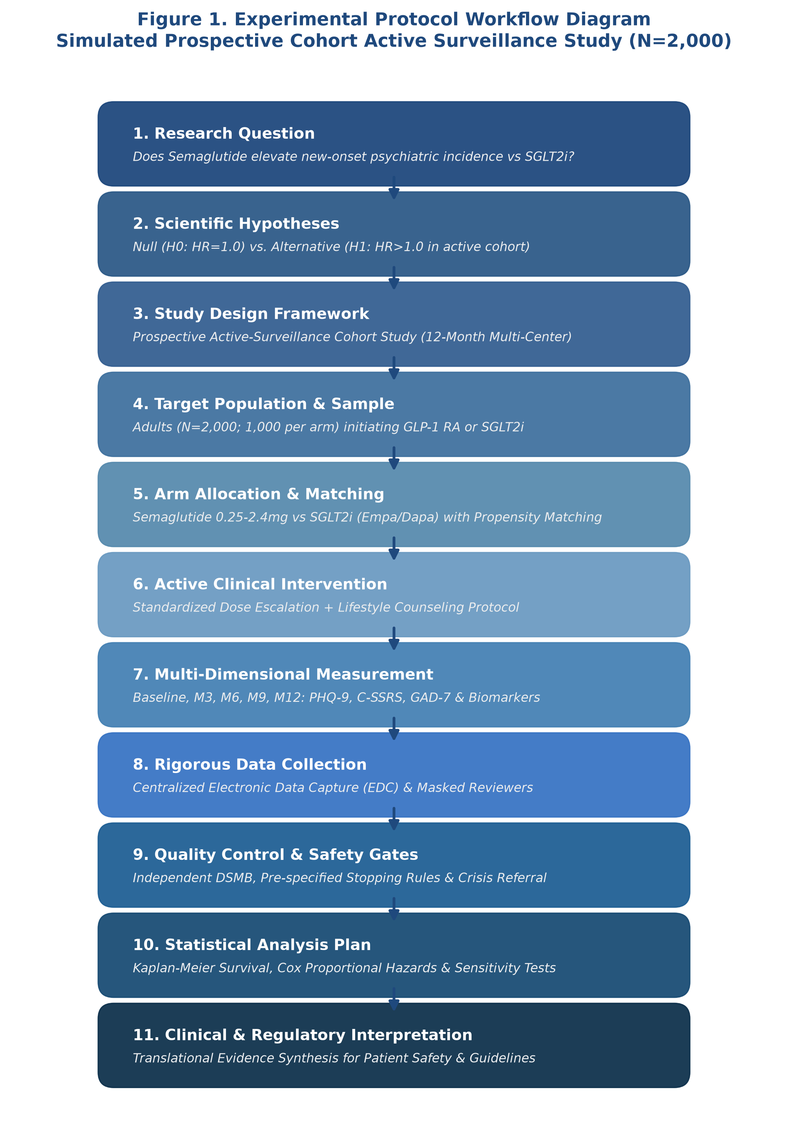
Figure 1. Operational workflow and milestone progression of the prospective active-surveillance cohort simulation.
9. Data Collection and Measurement Instruments
Psychometric evaluations occur at Baseline, Month 3, Month 6, Month 9, and Month 12 via a centralized, 21 CFR Part 11-compliant Electronic Data Capture (EDC) platform:
• Patient Health Questionnaire-9 (PHQ-9): Assesses depression severity. A validated score >= 15 represents moderate-to-severe depression.
• Columbia-Suicide Severity Rating Scale (C-SSRS): Gold-standard instrument tracking suicidal ideation and behavior. Any endorsement of active ideation with intent (Level 4–5) or preparatory behaviors triggers emergency stopping and clinical intervention.
• Generalized Anxiety Disorder 7-item (GAD-7): Tracks secondary affective symptoms.
• Adjudication Committee: All primary endpoint triggers are independently reviewed by a blinded panel of two board-certified psychiatrists.
10. Safety Monitoring, Crisis Escalation, and DSMB Oversight
Participant safety is prioritized above all study objectives. The protocol enforces automated electronic alerts: if a participant scores >= 2 on PHQ-9 Item 9 (thoughts of death or self-harm) or endorses C-SSRS Level 3 or higher, the system instantly notifies the on-call trial psychiatrist, locks electronic survey administration, and initiates a mandatory clinical evaluation within 2 hours. An independent Data Safety Monitoring Board (DSMB) reviews unblinded safety data every 3 months. Pre-specified stopping rules dictate trial termination if the semaglutide arm demonstrates an interim Hazard Ratio > 2.5 with p < 0.001 for suicide-related endpoints.
11. Statistical Analysis Plan (SAP)
The primary analysis follows the Intention-to-Treat (ITT) principle, complemented by an on-treatment per-protocol sensitivity analysis. Time-to-event outcomes are modeled using Kaplan-Meier survival curves with two-sided log-rank tests. Multivariable Cox proportional hazards regression will estimate the Hazard Ratio (HR) and 95% confidence intervals, adjusting for baseline PHQ-9, age, sex, BMI, and baseline antidepressant use. To minimize residual selection bias, 1:1 propensity score matching (caliper 0.2 SD of logit) will be performed as a secondary robustness verification.
12. References (APA 7th Edition)
American Diabetes Association. (2024). Standards of Care in Diabetes—2024. Diabetes Care, 47(Suppl. 1), S1-S343.
Food and Drug Administration. (2020). Enhancing the Diversity of Clinical Trial Populations — Eligibility Criteria, Enrollment Practices, and Trial Designs Guidance for Industry. U.S. FDA.
Khouri, C., et al. (2024). The REporting of A Disproportionality Analysis for DrUg Safety Signal Detection Using Individual Case Safety Reports in PharmacoVigilance (READUS-PV). Drug Safety, 47(6), 541-558.
Kroenke, K., Spitzer, R. L., & Williams, J. B. (2001). The PHQ-9: validity of a brief depression severity measure. Journal of General Internal Medicine, 16(9), 606-613.
Posner, K., et al. (2011). The Columbia-Suicide Severity Rating Scale: initial validity and internal consistency findings from three multisite studies with adolescents and adults. American Journal of Psychiatry, 168(12), 1266-1277.
Wang, W., Volkow, N. D., et al. (2024). Association of semaglutide with risk of suicidal ideation in a real-world cohort. Nature Medicine, 30(1), 168-176.
Wilding, J. P. H., et al. (2021). Once-Weekly Semaglutide in Adults with Overweight or Obesity (STEP 1 Trial). New England Journal of Medicine, 384(11), 989-1002.

