SafeWalk
Visual Design Specification
Web MVP · 15 Screens · For Claude Code

How to use this document:
Every screen is shown as a pixel-accurate mockup with a spec table alongside it.
The spec table defines exact colours, sizes, spacing, states, and component behaviour.
When building any page, reference both the visual mockup and the spec table — the image
shows the layout intention, the spec table shows the implementation rules.

Design direction: Soft purple (#7F77DD) + white. Calm, trustworthy, feminine.
Map-first home screen. Mobile-first layout. All touch targets minimum 48px.

1. Design System

1.1 Color palette
Use only these named tokens. Never use raw hex values in component files — always reference the Tailwind config tokens (see the Build Spec document for the tailwind.config.js).

Color | Token / Hex | When to use it
 | Purple 400  #7F77DD | Primary buttons, active nav icons, user location pin, SOS ring border, progress fills
 | Purple 600  #534AB7 | Hover/pressed states on primary buttons, active status bar during walk, heading text
 | Purple 800  #3C3489 | Text on purple backgrounds, deep active states, escalation status bar
 | Purple 50  #EEEDFE | Badge backgrounds, avatar fill, info box backgrounds, onboarding illustration tint
 | Purple 200  #AFA9EC | Inactive progress dots, ghost button borders, secondary purple UI elements
 | Dark text  #1A1A28 | Primary body text, headings, bold labels on white backgrounds
 | Gray text  #888899 | Secondary labels, timestamps, placeholders, helper text, disabled states
 | Gray BG  #F0F0F4 | Page backgrounds, stats cards, form field backgrounds on white sheets
 | Gray border  #E0E0E8 | Card outlines, input field borders, dividers, bottom sheet top edge
 | White  #FFFFFF | Bottom sheets, cards, modal surfaces, button text, pin border
 | Status green  #3B6D11 | Text in "Completed" / "All good" / "I'm okay" states
 | Status green BG  #EAF3DE | Background behind green status text and badges
 | Status amber  #854F0B | Text in check-in / escalating states, warning messages
 | Status amber BG  #FAEEDA | Check-in overlay background, escalating status bar background
 | Red SOS  #E24B4A | SOS button fill, SOS ring, 911 call button, critical danger states
 | Red text  #A32D2D | Text in danger/SOS contexts, "Delete all data", emergency status text
 | Red BG  #FCEBEB | SOS overlay tint, 911 button background, destructive action backgrounds

1.2 Typography
Web font: Inter (import from Google Fonts). Fallback: -apple-system, BlinkMacSystemFont, "Segoe UI", sans-serif.

Page title | 22px / 27px line-height / Bold / Dark text — e.g. "Walk history", "Trusted contacts"
Section header | 13–14px / 1.4 line-height / Bold / Dark text — e.g. sheet title, modal headline
Body text | 11–12px / 1.6 line-height / Regular / Dark text — descriptions, explanations
Label / caption | 9–10px / 1.4 line-height / Regular / Gray text — timestamps, helper text, secondaries
Button text | 10–12px / 1.0 / Bold / White (primary) or Purple (ghost) — all caps is never used
Input text | 11px / Regular / Dark text — placeholder in gray text, value in dark text
Badge text | 7–8px / Bold / Colour-matched — e.g. "Completed", "Primary", "Active"
Timer / numeric | 18–32px / Bold / Tabular nums / Dark or Purple — session timer, countdown

1.3 Spacing and sizing
Page horizontal padding | 16px from edge on all pages and sheets
Card internal padding | 12px all sides (smaller cards), 16px (larger info cards)
Touch target minimum | 48×48px for all interactive elements (WCAG 2.5.5)
Border radius — small | 6px — badges, small chips, toggle tracks
Border radius — medium | 10px — contact cards, history rows, input fields
Border radius — large | 16–20px — bottom sheets, modals, major cards
Border radius — pill | 50px — full pills (SOS ring uses 50%)
Border width | 0.5–1px for cards and inputs, 2px for user pin ring, 3px for SOS ring
Bottom sheet handle | 48×4px, border-radius 2px, gray-border color, centered
Nav bar height | 52px, border-top 1px gray-border, white background
Status bar height | 22px, color depends on app state (see screen specs)
Section gap | 24px between major content sections on the same sheet
Item gap in lists | 8px between contact/history rows

1.4 Shadows and elevation
Bottom sheets | box-shadow: 0 -4px 24px rgba(0,0,0,0.10) — subtle upward lift from map
Modals / overlays | box-shadow: 0 8px 40px rgba(0,0,0,0.18) — clearly floating above content
Cards on white BG | border: 1px solid #E0E0E8 — no shadow. Use border instead of shadow on white.
Cards on gray BG | No border, no shadow — the color contrast provides separation
SOS button | box-shadow: 0 0 0 3px #E24B4A, 0 4px 16px rgba(226,75,74,0.4) — danger glow
Floating map buttons | box-shadow: 0 2px 8px rgba(0,0,0,0.12) — small elevation

2. Auth Screens
Auth screens are the first thing new users see. They must feel clean, trustworthy, and get out of the way quickly. No decorative illustrations — let the typography and logo do the work.

Sign In
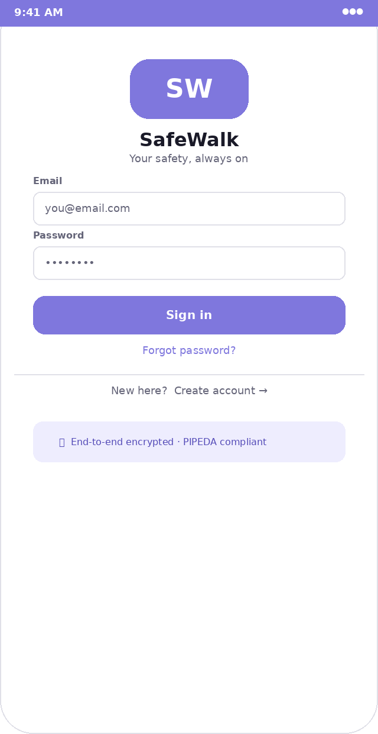  Sign in screen | Route /sign-in (public)  Status bar 22px, purple #7F77DD background, white text  Logo block 100×50px rounded rect, purple fill, "SW" white bold 22px, centered. Below: "SafeWalk" 16px bold dark, "Your safety, always on" 9px gray  Form position Logo block vertically centered in top 40% of screen  Input fields 264px wide, 28px tall, 6px radius, 1px gray-border, left-padded 10px. Label 8px bold gray above, 4px gap  Email placeholder "you@email.com" in gray text 9px  Password field type=password. Placeholder "••••••••". Add show/hide toggle icon right side  Sign in button 264×32px, purple fill, white 10px bold, 10px radius. Full width.  Forgot password 9px purple link, centered, 16px below button  Divider 1px gray-border line, 16px margin each side  Create account "New here?" gray + "Create account →" purple link, centered  Security note Purple-light bg box, 8px border-radius, lock icon + "End-to-end encrypted · PIPEDA compliant" 8px purple-dark  Error state Red border on relevant input, red 9px error text below the field. No toast on auth errors.  Implementation notes  - Use React Hook Form + Zod for validation. Validate on submit, not on every keystroke.  - Show a spinner inside the Sign in button while the Supabase call is in-flight. Disable the form.  - On "Invalid login credentials" from Supabase, show error below the password field: "Incorrect email or password."  - On "Email not confirmed", show: "Please confirm your email. Check your inbox or resend below." + resend link.

Sign Up
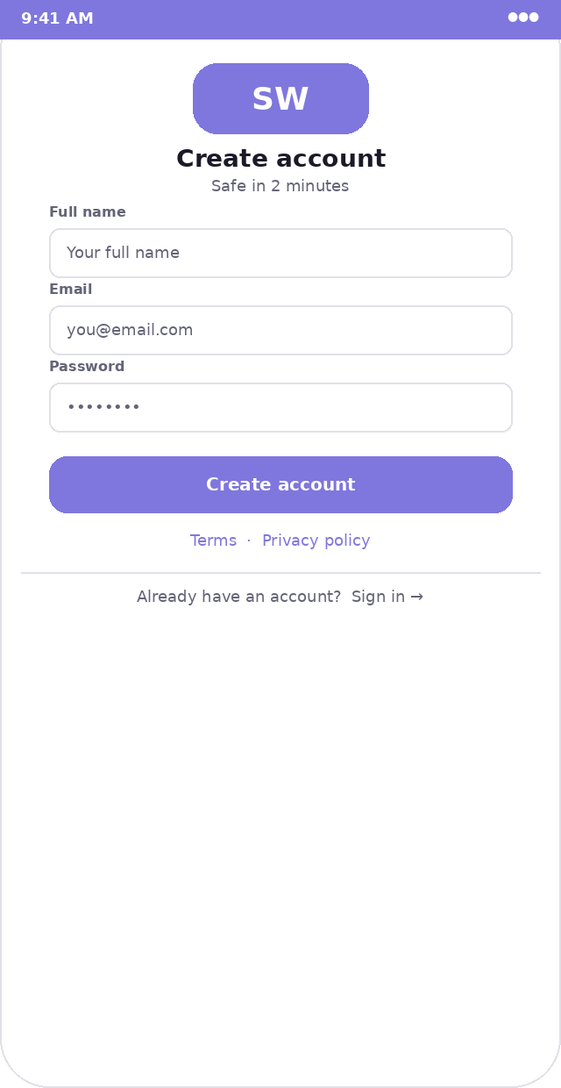  Create account screen | Route /sign-up (public)  Logo block Smaller than sign-in: 100×40px, same purple fill. "Create account" 14px bold below, "Safe in 2 minutes" 9px gray  Fields Full name → Email → Password, all 264×28px, same style as sign-in  Full name autocomplete="name". No special validation beyond required.  Password Show strength indicator below field: weak / fair / strong. Color: red / amber / green.  Create account btn Same as sign in button. Label "Create account".  Legal links "Terms · Privacy policy" in purple, 9px, centered. Links to /terms and /privacy static pages.  Sign in link "Already have an account? Sign in →" 9px gray+purple, below divider  Implementation notes  - On submit: call supabase.auth.signUp() with { email, password, options: { data: { full_name } } }  - On success: redirect to /auth/check-email — a static page, not a toast.  - If email already registered, Supabase returns error. Show: "An account with this email already exists."

Email Confirmation
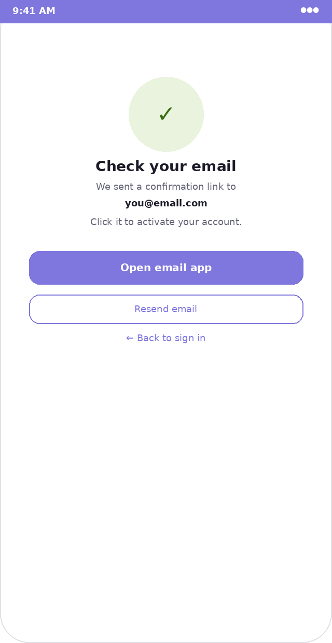  Check your email screen | Route /auth/check-email (public, static)  Icon 72px circle, green-bg fill (#EAF3DE), large green checkmark inside  Headline "Check your email" 14px bold dark, centered  Body "We sent a confirmation link to" + email in bold on next line + "Click it to activate your account."  Open email app Primary button. On mobile, links to mailto: which opens the native mail app.  Resend email Ghost button. Calls supabase.auth.resend() with the email. Disable for 60s after tap (show countdown).  Back link "← Back to sign in" purple link, 9px, centered at bottom

3. Onboarding Screens
Shown exactly once after email confirmation. Three steps. Purple-light illustration area at the top of steps 1 and 2 (to add warmth without heavy imagery). Step 3 uses an overlay modal on a blurred/dimmed background.

Onboarding — Step 1 of 3
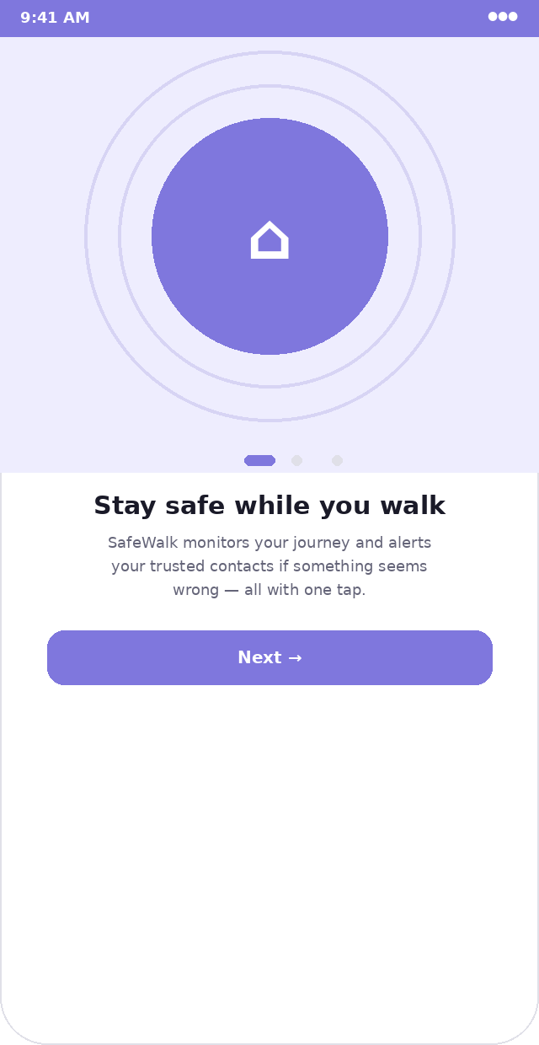  Welcome illustration screen | Route /onboarding (protected, gate: onboarding_completed = false)  Illustration area Full-width, purple-light (#EEEDFE) background, ~258px tall. Contains a 140px purple circle with home icon. Two concentric ring outlines at 180px and 220px diameter, purple at 30% opacity.  Progress indicator Below illustration: 3 dots. Active = 16×6px purple pill. Inactive = 6px circle, gray-border color.  Headline "Stay safe while you walk" 15px bold dark, 24px below illustration area  Body text Three lines, 9px gray, 1.6 line-height, centered, 24px horizontal padding  Next button 264×32px primary purple, full width, "Next →"  No skip on step 1 Step 1 has no skip option — it is purely informational.

Onboarding — Step 2 of 3
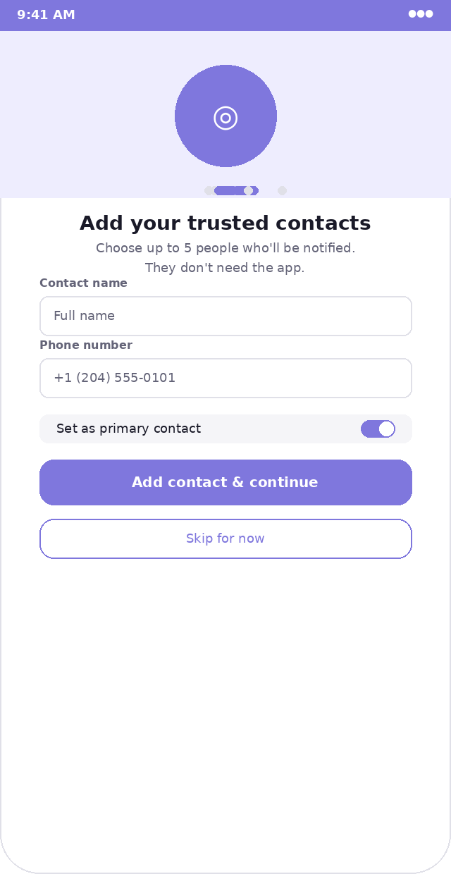  Add trusted contacts | Illustration area Shorter: ~118px. Purple-light bg, 72px purple circle with person icon.  Progress dot Middle dot is active (pill), dots 1 and 3 are inactive circles  Headline "Add your trusted contacts" 14px bold  Add contact form Inline form: name input + phone input + primary toggle. Same input style as auth screens.  Primary toggle Full-width gray-bg row, label left, iOS-style toggle right. Purple when on, gray when off.  Add & continue btn 264×32px primary purple, "Add contact & continue"  Skip btn Ghost button below, "Skip for now". Skipping is allowed — but the home screen shows a banner.  On save Write to trusted_contacts immediately. Show success toast. Advance to Step 3.

Onboarding — Step 3 of 3
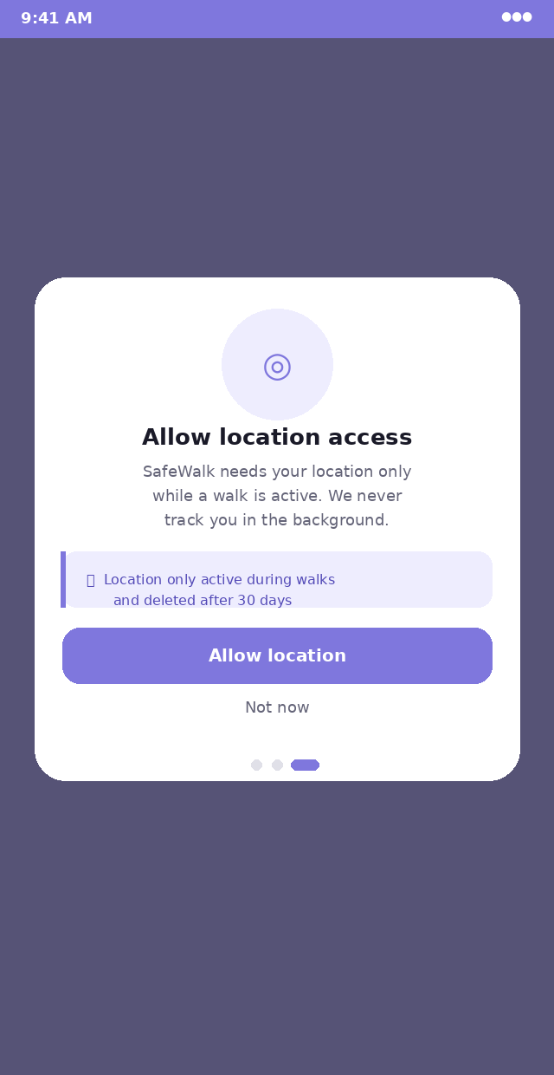  Location permission modal | Background Full screen, dark purple overlay (rgba 40,36,80,0.85) — not a pure black dimmer.  Modal card 280×290px approx, white, 18px radius, centered on screen  Icon 64px circle, purple-light bg, location/target icon in purple  Headline "Allow location access" 13px bold, centered  Body 9px gray, 3 lines, centered. Explains location is only active during walks.  Privacy info box Purple-light, left border 3px purple. "🔒 Location only active during walks and deleted after 30 days" 8px purple-dark  Allow button Purple primary, full width. On click: call navigator.geolocation.getCurrentPosition() to trigger native browser prompt.  Not now "Not now" gray link below button. Sets onboarding_completed = true anyway. Shows persistent location-needed banner on home.  Progress dots Visible below modal. Right dot active.

4. Home Screen
The home screen has two distinct visual states — idle (no walk active) and active (walk in progress). The map is always rendered and full-screen behind everything. Only the bottom sheet changes between states.

Home — Idle State
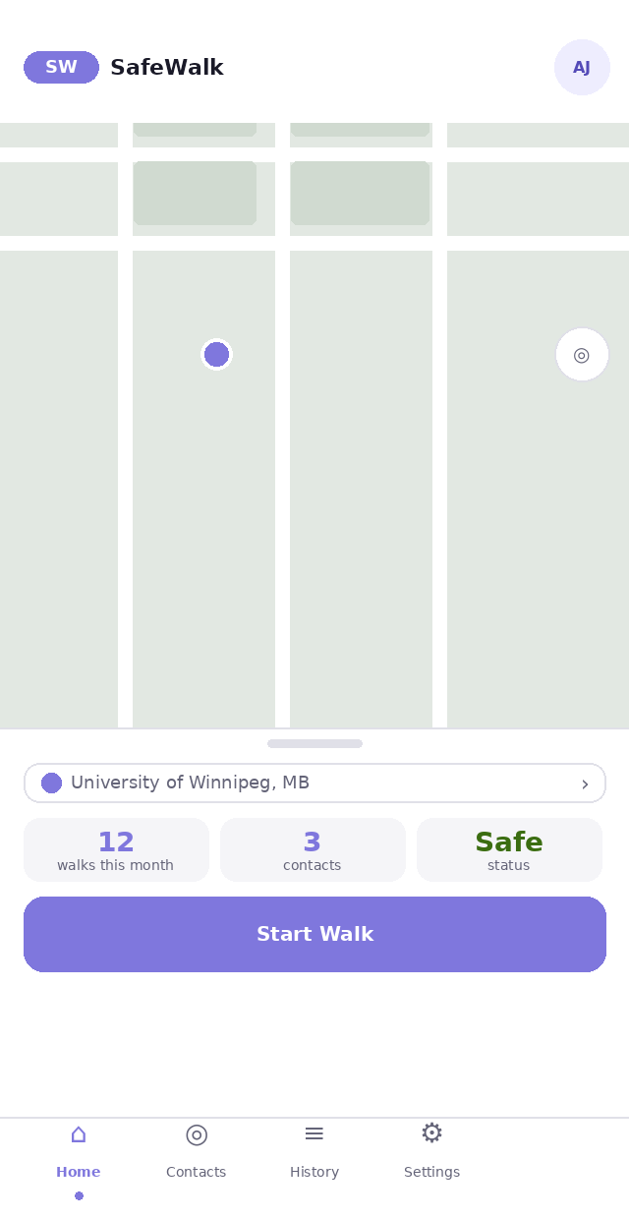  Map-first home, no active walk | Route /home (protected)  Map Mapbox GL JS, style: mapbox://styles/mapbox/streets-v12. Fills 100vw × 100vh. No zoom controls. Only geolocate button bottom-right.  Top bar NOT a fixed header. Just a gradient overlay: white to transparent, 60px tall, from top. Logo + name left, avatar circle right. Sits above the map visually.  Logo 38×16px purple rounded rect (8px radius), "SW" white 9px bold. "SafeWalk" 11px bold dark text, 6px to the right.  Avatar 28px circle, purple-light bg, user initials purple-dark 8px bold. Tap → /settings.  User pin 16px diameter circle, purple fill, 4px white border. Custom Mapbox marker, not the default blue dot.  Bottom sheet White, border-top 1px gray-border. Slides up from bottom. Resting height: 220px. No border-radius on top when fully resting — use 16px only when partially open.  Handle bar 48×4px, gray-border, 2px radius, centered, 8px from top of sheet  Location row 264×20px, white bg, 1px gray-border, 8px radius. Purple 10px dot left, address text, chevron right. Tap to open destination picker.  Stats row Three equal cards, gray-bg, 8px radius. Each: stat number 14px bold purple (or green for "Safe"), label 7px gray below.  Start Walk btn 264×38px, purple fill, white 11px bold. 10px radius. 16px from sides.  Nav bar 52px, white, border-top. 4 icons: Home (active=purple, dot below), Contacts, History, Settings. Icon 18px, label 7px below, active dot 4px circle.  Implementation notes  - Map renders on mount. Do not show a loading skeleton for the map — it loads quickly.  - If location is not yet available, center map on Winnipeg (49.8951° N, 97.1384° W) at zoom 13.  - Stats cards pull from Supabase on mount with React Query. Show skeleton loaders (gray animated pulse) while fetching.  - If user has 0 contacts, the "contacts" stat card shows "0" in amber, not purple.

Home — Active Walk State
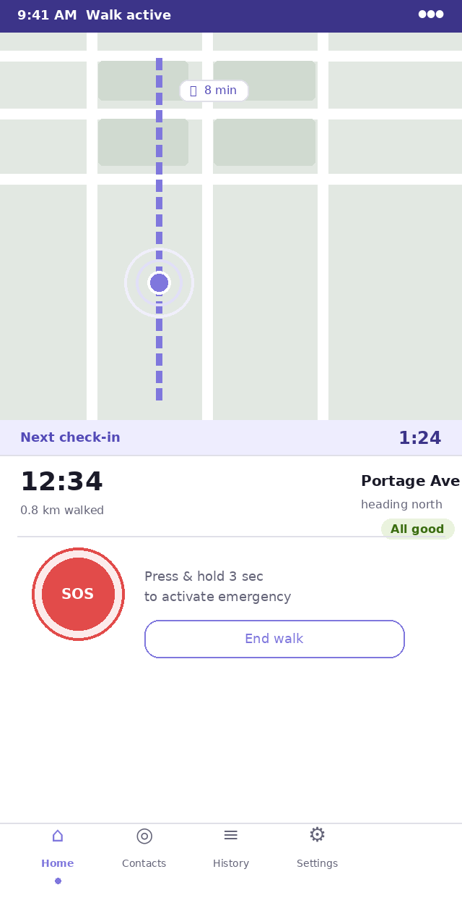  Walk in progress | Status bar Purple-deep (#3C3489) background, white text. Shows "9:41 AM Walk active" — walk status label right-aligned.  Map Same as idle but zoomed to 16. Route polyline drawn in purple (#7F77DD), 3px, dashed (dash: 8px, gap: 6px). ETA chip floats at route midpoint.  ETA chip 48×14px white pill, 6px radius, 1px gray-border. Clock icon + "X min" in purple-dark 8px. Position: absolute over map.  Pulse rings Two concentric circles around user pin: 32px and 48px diameter, purple at 60% and 30% opacity, animated via CSS keyframe (scale 1→1.3, opacity 0.6→0, 2s infinite).  Check-in bar Full width, purple-light bg, 24px tall. "Next check-in" label 9px purple-dark bold left. Countdown "MM:SS" 12px bold purple-deep right. Always visible.  Sheet height Taller than idle: ~290px. Animates up from idle height on walk start.  Session row Walk timer HH:MM:SS 18px bold dark (left), distance "X.X km walked" 8px gray below. Street name 10px bold (right), direction 8px gray below, status badge far right.  Status badge "All good" green pill when no escalation. "Escalating" amber when check-in missed. "SOS" red when SOS active.  SOS button 64px circle, red fill (#E24B4A), 3px red ring at 70px. "SOS" white 10px bold. Press-and-hold 3s. SVG progress ring animates during hold.  End walk button Ghost button, 160px wide, right of SOS. 26px tall. Tap shows confirm dialog.  Implementation notes  - The bottom sheet transition from idle to active uses CSS transform: translateY(). Duration: 300ms, ease-out.  - The check-in bar background pulses amber when countdown is below 15 seconds (CSS animation).  - Walk timer uses setInterval(1000) stored in Zustand. Persists through re-renders.  - Location pings write every 10 seconds via a separate setInterval. On network failure, queue and retry.

5. Safety Screens
These screens appear during escalation events. They are the most critical UI in the app — they must be unmissable, load instantly, and work under stress. Prioritise clarity over design here.

Check-In Overlay — Stage 1
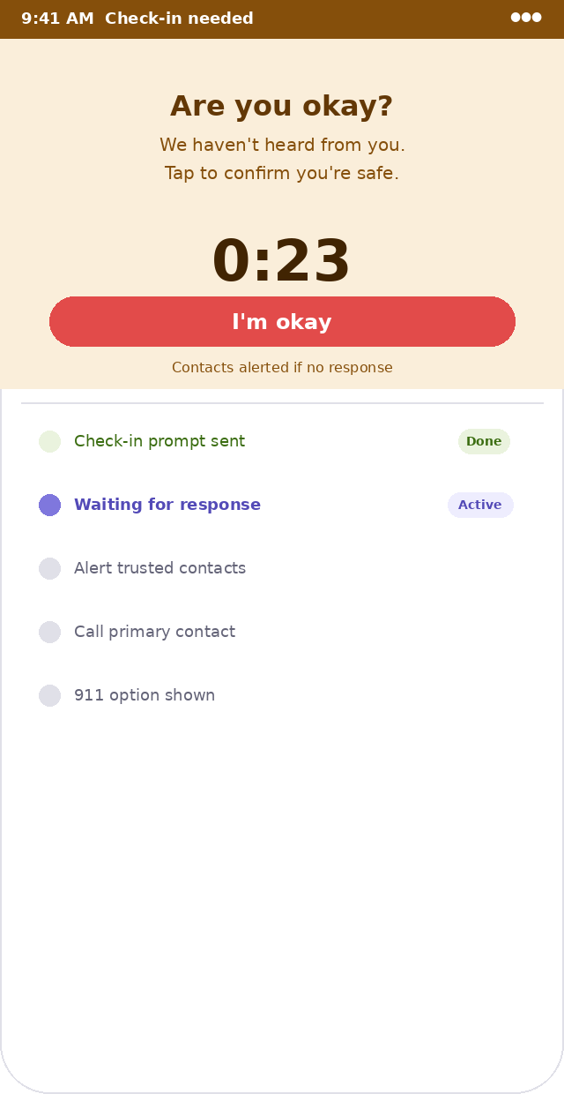  Missed check-in prompt | Trigger Check-in countdown reaches 0:00. Renders as a full-screen overlay, z-index above everything including the map.  Status bar Amber-text (#854F0B) background, white text "Check-in needed"  Overlay top section Full width, amber-bg (#FAEEDA), ~200px tall. Contains headline, body, countdown timer, and "I'm okay" button.  Countdown timer "0:30" starting, counts down. 32px bold dark amber, centered. When it hits 0, Stage 2 fires automatically.  I'm okay button 264×28px, RED background (#E24B4A) — red here, not purple, for maximum urgency. White 12px bold. Full width.  Helper text "Contacts alerted if no response" 8px amber-text, centered below button  Escalation ladder Below divider: 5 rows. Each row: 12px dot (green=done, purple=active, gray=pending) + label text. "Done" rows have a green pill right-aligned. "Active" row has purple bold text. Duration: current stage shows amber badge.  Backdrop The map is still visible behind — the amber section is NOT full opacity, it sits above the walk UI.  Cannot dismiss This overlay has NO close button. The only way to dismiss it is "I'm okay" or the walk ending.  Implementation notes  - This overlay must render above all other UI. Use a React portal to a root-level div.  - Play a subtle sound on appearance if the Audio API is available (single soft chime).  - The "I'm okay" button calls resolveEscalation() which resets the timer and closes the overlay.  - Escalation ladder rows animate in one at a time using CSS transitions as each stage fires.

SOS Active — Emergency State
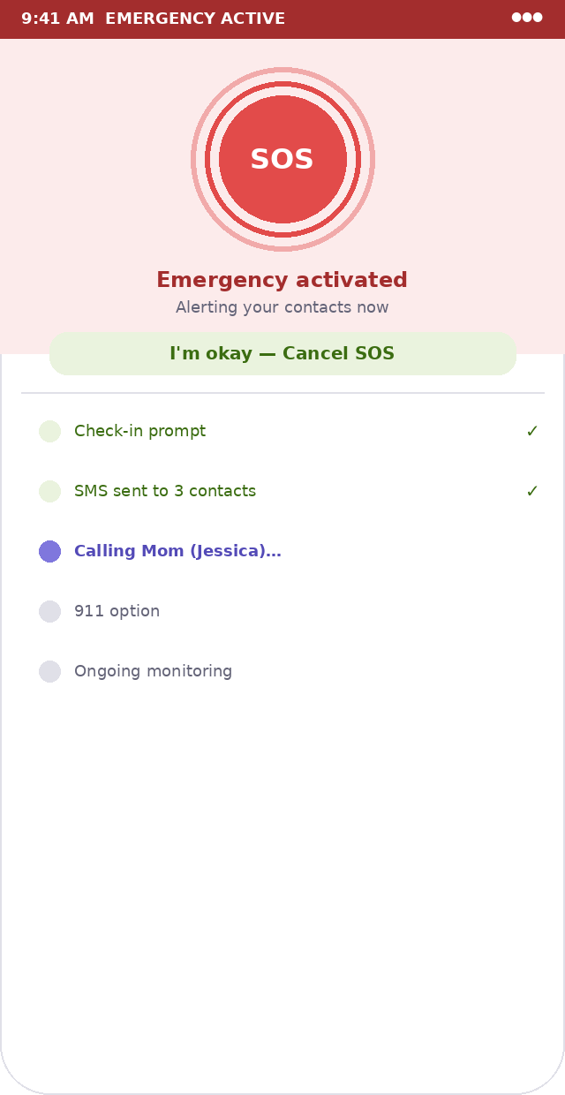  SOS triggered, escalation ladder visible | Trigger User presses SOS button for 3 full seconds. Jumps directly to Stage 2 (skips 30s Stage 1 window).  Status bar Red-text (#A32D2D) background "EMERGENCY ACTIVE"  Top section Red-bg tint (#FCEBEB), ~200px. Contains large SOS circle + messaging.  SOS circle 104px diameter total: red fill (#E24B4A) at 72px, 3px ring at 88px, 3px faint outer ring at 104px. Danger glow shadow. "SOS" white 16px bold.  Status message "Emergency activated" 12px bold red-text, "Alerting your contacts now" 9px gray  Cancel button Full-width, green-bg (#EAF3DE), green-text, "I'm okay — Cancel SOS". This is prominent — allow easy cancellation.  Escalation ladder Same as check-in overlay but Stage 1 and 2 both show "done" with checkmarks. Stage 3 shows "active" with a spinner icon.  Calling indicator Stage 3 row: "Calling Mom (Jessica)…" with animated ellipsis (CSS). Shows the contact name.  Implementation notes  - The progress ring during press-and-hold is an SVG: circle with stroke-dasharray="163" stroke-dashoffset animating from 163 to 0 over 3s.  - Haptic feedback on SOS activation: navigator.vibrate([100, 50, 100, 50, 200])  - Cannot navigate away from SOS screen during active emergency. Nav bar is still shown but tabs are disabled (grayed out, pointer-events: none).  - "I'm okay — Cancel SOS" calls cancelSOS() which resolves all open escalation_events and resets to active walk state.

6. Contacts Screen

Contacts List
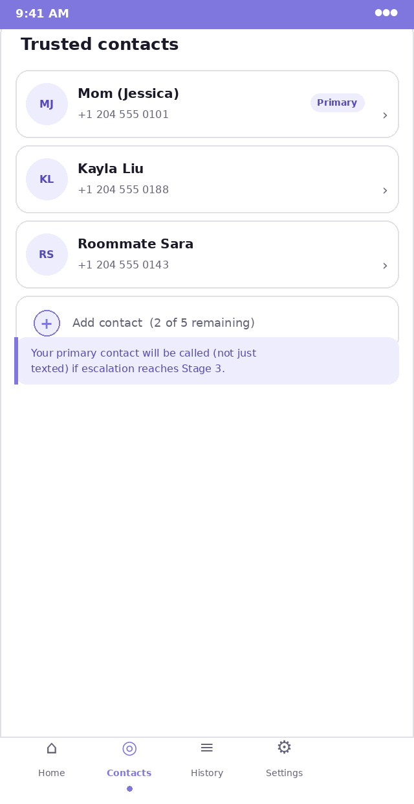  Trusted contacts page | Route /contacts (protected)  Page title "Trusted contacts" 13px bold dark, 16px from top of content area  Contact card 296×52px, white, 1px gray-border, 10px radius. 8px gap between cards.  Avatar in card 32px circle, purple-light bg, initials purple-dark 8px bold  Name 10px bold dark, 6px below top of card content area  Phone 8px gray, below name  Primary badge Purple-light bg, purple-dark text, 7px bold pill. Right-aligned in card.  Chevron 11px gray "›" right edge of card, vertically centered  Add contact row 296×42px, same card style. Left: 20px circle purple-light with "+" purple inside. Text: "Add contact (X of 5 remaining)" 9px gray.  Info box Purple-light, left border 3px purple, below the list. Explains primary contact behaviour.  Max contacts When 5 contacts exist, replace add row with: "Maximum contacts reached (5/5)" gray text, no border.  Empty state No cards: centered empty state — icon, "No trusted contacts yet", body text, "Add your first contact" primary button.  Implementation notes  - Long-press or swipe-left on a card reveals delete option (red trash icon). Tap → confirm dialog.  - Tap the card (not swipe) opens a bottom sheet with Edit form populated with existing values.  - Only one contact can be is_primary = true. Setting a new primary unsets the previous one in the same transaction.

Add Contact — Bottom Sheet
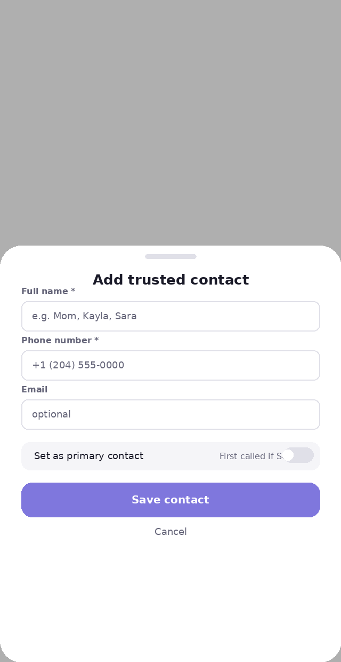  Add or edit a contact | Trigger Tapping "Add contact" row or tapping an existing card.  Backdrop Semi-transparent black overlay (rgba 0,0,0,0.5) behind the sheet.  Sheet White, 20px top radius. Slides up from bottom. Height: auto, approximately 380px.  Sheet handle 48×4px gray bar, centered, 10px from top of sheet  Title "Add trusted contact" or "Edit contact" 13px bold dark, centered, 30px from top  Name field Label "Full name *" 8px bold gray. Input 280×28px.  Phone field Label "Phone number *". Input with tel: type, format hint "+1 (204) 555-0000"  Email field Label "Email" — no asterisk, optional. Input with email type.  Primary toggle Full-width gray-bg row, 8px radius. Label left, toggle right. Helper: "First called if SOS" 8px gray between label and toggle.  Save button 280×32px primary purple "Save contact"  Cancel "Cancel" 9px gray link, centered, 12px below save button

7. Trusted Contact Web View
This is a standalone public page — no nav bar, no auth UI. It must instantly communicate what it is and where the user is. A trusted contact arrives here from an SMS link and may have no prior knowledge of SafeWalk.

Contact Web View /track/:token
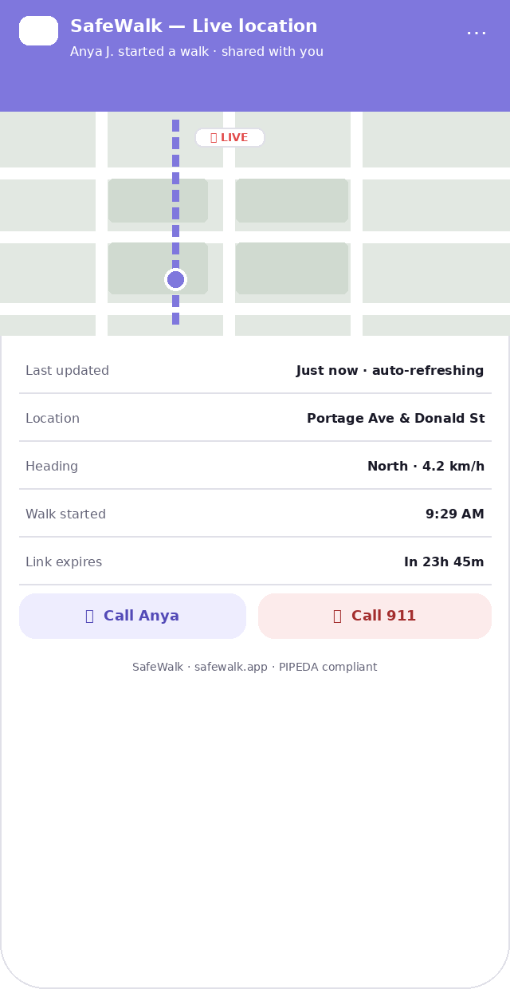  Public page, no login required | Route /track/:token (public — no auth)  Header Full-width, purple fill (#7F77DD), 70px tall. Logo (small white rect, "SW" white) + "SafeWalk — Live location" white bold 11px. Subtitle: "[Name] started a walk · shared with you" 8px white 80% opacity.  Overflow menu "⋯" icon top-right of header. Currently just shows "About SafeWalk" linking to landing page.  Map section Mapbox static map or interactive map, 40% viewport height. Centered on last known ping. User pin same style as app (purple circle, white border). Shows "🔴 LIVE" badge chip floating top-right of map.  Map auto-updates Every 15 seconds, re-fetch latest location_ping and animate pin to new position (smooth transition).  Info rows 5 rows: Last updated / Location / Heading + speed / Walk started / Link expires. Left: 8px gray label. Right: 8px bold dark value. 1px gray-border divider between rows.  "Last updated" Shows "Just now" if ping < 30s ago. "X seconds ago" or "X minutes ago" otherwise. Auto-updates every 5s without re-fetching.  "Link expires" Countdown: "In 23h 45m". Red text when under 1 hour remaining.  Call Anya button Left half, 50% width. Purple-light bg, purple-dark text. Icon + "Call [name]". Opens tel:[phone] in system dialer.  Call 911 button Right half. Red-bg, red-text. "🚨 Call 911". Opens tel:911.  Footer "SafeWalk · safewalk.app · PIPEDA compliant" 7px gray, centered  Expired state If share_expires_at < now: full page error with SafeWalk logo, "This link has expired", "Call 911" button still shown prominently.  Implementation notes  - This page is optimised for first-time visitors on mobile. Target load time < 2 seconds on 4G.  - Add Open Graph meta tags: title="[Name] shared their location", description="SafeWalk live location link", image=SafeWalk logo.  - The "Live" badge pulses with a CSS animation (opacity 1→0.4→1, 1.5s infinite) to signal real-time data.  - If location permissions are denied in the browser, the map still works — it uses server-side ping data, not the viewer's GPS.

8. History Screen

Walk History
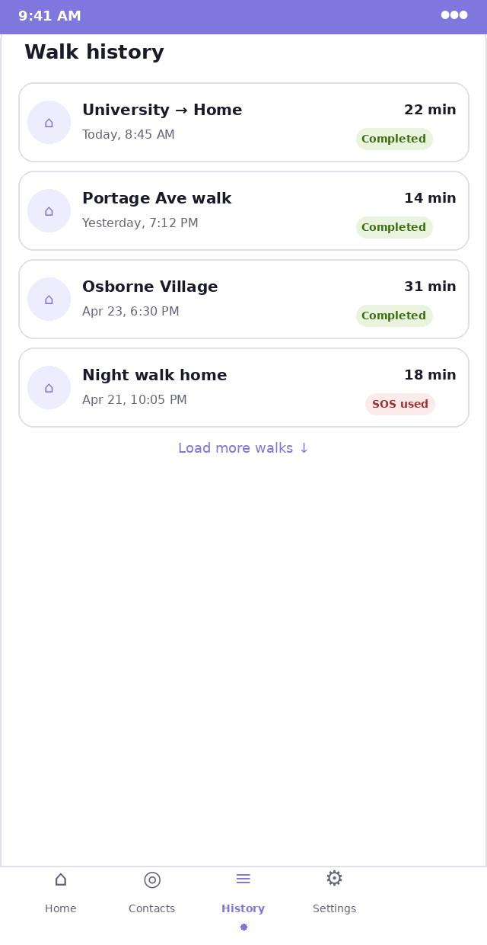  Chronological walk log | Route /history (protected)  Page title "Walk history" 13px bold dark  Walk card 296×52px, white, 1px gray-border, 10px radius. 8px gap between cards.  Left icon 28px circle, purple-light fill, home/walk icon purple inside  Destination 10px bold dark — shows typed destination or "Walk" if none set  Date 8px gray below destination — "Today, 8:45 AM" / "Yesterday, 7:12 PM" / "Apr 23, 6:30 PM"  Duration 9px bold dark, right-aligned at top of card  Status badge Right-aligned below duration. Green pill "Completed", Amber pill "Ended early", Red pill "SOS used"  Expanded card Tap expands: adds distance, starting address, and a 96×64px static Mapbox map thumbnail. Smooth height transition.  Load more "Load more walks ↓" 9px purple link, centered, 20 per page  Empty state No cards: centered layout — icon, "No walks yet", "Start your first walk", primary button linking to /home

9. Settings Screen

Settings
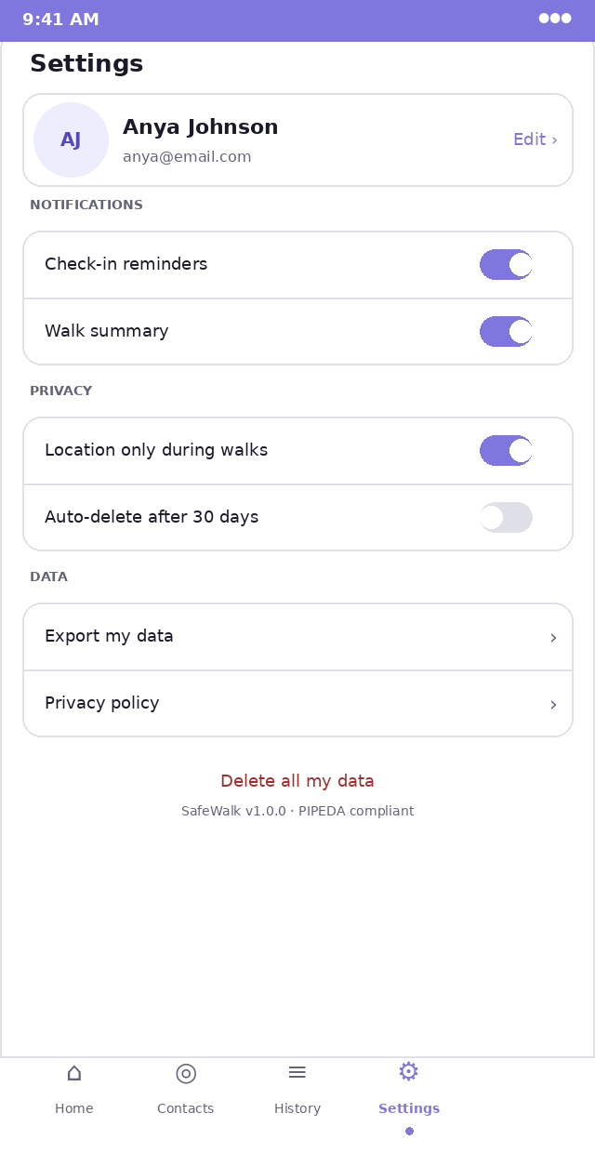  User preferences and account | Route /settings (protected)  Page title "Settings" 13px bold dark  Profile card 296×50px, white, 1px gray-border, 10px radius. Avatar 40px circle left. Name 11px bold, email 8px gray. "Edit ›" purple right.  Section headers 7px uppercase bold gray — "NOTIFICATIONS", "PRIVACY", "DATA". 14px above each section group.  Settings group White card with 1px gray-border, 10px radius. Contains multiple rows. Rows separated by 1px gray-border dividers.  Toggle row Label 9px dark left. iOS-style toggle right: 28×16px track (purple on, gray off), 12px white thumb. Smooth 200ms transition.  Arrow row Label 9px dark left. "›" gray right. Tap navigates or opens sheet.  Danger zone "Delete all my data" 9px red-text link, centered, below all groups. No card — standalone link.  Version "SafeWalk v1.0.0 · PIPEDA compliant" 7px gray, centered at very bottom  Sign out Not shown in this screen — accessible via the "⋯" menu in the profile card or a dedicated "Sign out" row at the bottom of settings.  Implementation notes  - Toggle state is saved to the profiles table on every change (debounce 500ms).  - "Export my data" generates a JSON blob and triggers a download via a hidden <a download> element.  - "Delete all my data" shows a ConfirmDialog requiring the user to type "DELETE". This is irreversible.  - The Edit profile flow opens a bottom sheet with name and phone inputs. Email change triggers re-verification.

10. States, Interactions & Animations

10.1 All interactive states
Every interactive element needs these four states styled explicitly:

Default | As shown in mockups. Purple primary button, ghost buttons with purple border.
Hover (desktop) | Primary button: purple-600 (#534AB7). Ghost button: purple-light bg. Cards: slight gray-bg. Cursor: pointer always.
Active / pressed | Primary button: scale(0.97) transform, purple-800 bg. Touch feedback: immediate, no delay.
Disabled | Opacity 0.45. Cursor: not-allowed. No pointer events. Applies during loading states.
Focus (keyboard) | 2px purple outline, 2px offset. Visible on all focusable elements. Never remove outline for keyboard users.
Loading | Button: spinner replaces text, button stays same width. List: skeleton rows (gray animated gradient). Page: full-screen SafeWalk logo + spinner.
Error | Input: red border, red 9px error text below. Card: red border, error message inside. Toast: red background, white text, dismissible.
Empty | See EmptyState component: centered icon, headline, body, optional CTA button.

10.2 Key animations
Bottom sheet open | transform: translateY(100%) → translateY(0). Duration: 300ms. Easing: cubic-bezier(0.32, 0.72, 0, 1).
Bottom sheet close | translateY(0) → translateY(100%). Duration: 250ms. Easing: ease-in.
SOS press ring | SVG stroke-dashoffset: 163 → 0 over 3000ms. Linear. Cancelled on pointerup.
User location pulse | Two rings: scale(1) → scale(1.8), opacity(0.6) → opacity(0). 2s staggered infinite loop.
Escalation row appear | Each row: opacity 0 → 1, translateX(-8px) → 0. 200ms ease-out. Staggered 100ms between rows.
Check-in bar pulse | Background: purple-light → amber-light → purple-light. Only when countdown < 15s. 1s ease infinite.
Route polyline draw | stroke-dashoffset animation on SVG path from full length to 0. 600ms on walk start.
Toast in | translateY(100%) → translateY(0). 200ms spring easing. Stacks above previous toasts.
Card expand (history) | max-height: 52px → auto. 300ms ease-out. Smooth, no layout jump.

10.3 Navigation behaviour
Bottom nav tap | Immediate navigation. No slide transition between tabs — instant switch. Active icon turns purple.
Back navigation | Browser back button works on all routes. No custom back button needed on main pages.
Deep links | /track/:token is the only deep link designed for external access (SMS). All others require auth.
Session restore | On app load: show full-screen spinner while checking Supabase session. Max 1.5s before timeout.
Auth redirect | Unauthenticated access to protected route: redirect to /sign-in with returnTo query param. After sign-in, return to original URL.
Walk state persistence | If user closes the tab during a walk: Zustand persists to localStorage. On next open: detect active session in Supabase, restore walk state.

11. Responsive Breakpoints
Build mobile-first. The mockups represent 390px viewport (iPhone 14). These are the only breakpoints needed for the web MVP:

375px (iPhone SE) | The minimum supported width. All content must be usable. Reduce horizontal padding to 12px if needed. No horizontal scrolling ever.
390px (iPhone 14) | Primary design target. All mockups are at this width.
414px (Pixel 7) | Content should scale naturally. No layout changes needed.
768px (tablet / desktop) | Show a centered 430px column for the app content. Gray-bg (#F0F0F4) fills the sides. Nav bar stays at bottom of the column, not the browser window. Map still fills the column, not the full viewport.
> 768px desktop | Same as tablet treatment. SafeWalk is a mobile-first app — desktop is a "works fine" bonus, not a primary layout to design for. No sidebar nav.

The trusted contact web view (/track/:token) is an exception — it DOES use full-width on tablet/desktop.
The map and info rows should spread to fill the viewport on larger screens for the contact web view.
On desktop, the call buttons become "Click to call" with the phone number shown alongside.

12. Component Completion Checklist
Use this checklist to verify every component is built to spec before considering the MVP complete.

UI / Button | variants: primary, ghost, danger, link. sizes: sm, md, lg. loading state: spinner. disabled state. fullWidth prop.
UI / Input | label, error, helperText. Password show/hide toggle. Error border + text. Passes all native input props.
UI / Badge / Pill | variants: success, warning, danger, info, purple. sm and md sizes. Pill shape (50px radius).
UI / Avatar | initials prop, size sm/md/lg, purple-light bg, purple-dark text.
UI / Modal | isOpen, onClose, title, children. Scroll lock. Escape key close. Focus trap.
UI / BottomSheet | Slides from bottom. Drag handle. Backdrop click to close. Focus trap.
UI / Toast | success (green), error (red), info (purple). Auto-dismiss 4s. Manual dismiss X. Stacks correctly.
UI / Spinner | sm/md/lg. Purple color. Used inside Button and full-page loading.
UI / EmptyState | icon, title, body, actionLabel, onAction. Centered. Used on all empty list pages.
UI / ConfirmDialog | Extends Modal. confirmLabel, confirmVariant, onConfirm. Used for delete and end walk.
Map / MapView | Mapbox init, user pin, route polyline, ETA chip, location button, resize observer.
Map / UserPin | Custom purple circle marker. Animated position updates.
Walk / CheckInBar | Countdown MM:SS. Pulse animation < 15s. Always visible during active walk.
Walk / SosButton | Press-and-hold 3s. SVG progress ring. Haptic feedback. Accessible via keyboard.
Walk / EscalationLadder | Five rows. done/active/pending states. Animates in per-stage.
Walk / SessionInfo | Timer, distance, street name, direction, status badge. All real-time.
Layout / NavBar | Four tabs. Active state: purple icon + dot. 52px height. Fixed bottom.
Layout / ProtectedRoute | Session check. Loading state. Redirect to /sign-in if no session.
Layout / AppShell | Wraps all protected pages. Includes NavBar. Map-first on home only.

End of SafeWalk Visual Design Specification
Read alongside SafeWalk_Web_MVP_Spec.docx for the complete build picture.

