## The Flavorful Tuscany Meetup

### Welcome letter

Dear Guest,

We are delighted to welcome you to the annual *Flavorful Tuscany Meetup*. We hope you will enjoy the program as well as your stay at the [Bilancino Hotel](https://ckeditor.com).

Please find attached the full schedule of the event.

The annual Flavorful Tuscany meetups are always a culinary discovery. You get the best of Tuscan flavors during an intense one-day stay at one of the top hotels in the region. All the sessions are led by top chefs passionate about their profession. I would recommend saving the date in your calendar for this one!

Angelina Calvino, food journalist

Please arrive at the [Bilancino Hotel](https://ckeditor.com) reception desk at least **half an hour earlier** to ensure that the registration process goes as smoothly as possible.

We look forward to welcoming you to the event.

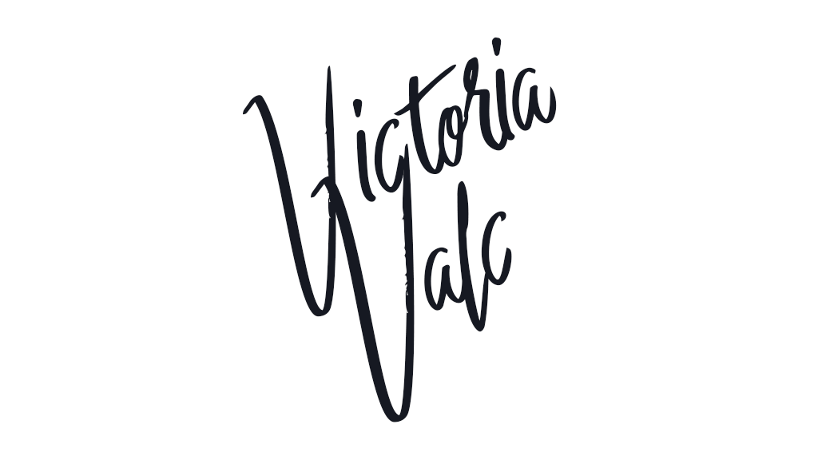

**Victoria Valc**, **Event Manager at Bilancino Hotel**

## The Flavorful Tuscany Meetup Schedule

|  |  |
| --- | --- |
| Saturday, July 14 | |
| 9:30 AM - 11:30 AM | **Americano vs. Brewed - “know your coffee”** with:   * Giulia Orlanda * Stefano Garau * Giuseppe Russo |
| 1:00 PM - 3:00 PM | **Regional delicacies of Tuscany** - live cooking 1  Incorporate the freshest ingredients  with Rita Fresco |
| 5:00 PM - 8:00 PM | **Tuscan vineyards at a glance** - wine-tasting  with Frederico Riscoli |

1 *Registration for the live cooking session is required as seats are limited.*