Final Report: Bayesian Hierarchical Prediction of Used Car Prices
0. Group Members
Jack Liu (jackliu3), Xing Sun (xingsun3), Ning Xu (ningx4), Martin Wang(hanran2)

1.Introduction
Used car prices are influenced by many observable vehicle characteristics, including mileage, model year, fuel type, transmission type, accident history, title status, and brand. Accurately predicting used car prices is useful for both buyers and sellers because it can help consumers evaluate whether a listed price is reasonable and help sellers understand how different vehicle features affect market value. However, used car prices can vary substantially across brands, even after accounting for individual vehicle characteristics. For example, luxury brands may have systematically higher baseline prices than non-luxury brands.
The goal of this project is to build and evaluate a Bayesian hierarchical prediction model for used car prices using a real-world dataset of used vehicle listings. We model the log of vehicle price as the response variable and use vehicle level predictors such as age, mileage, fuel type, transmission, accident history, and clean title status. To account for systematic differences across vehicle brands, we include brand level random intercepts in the model. This hierarchical structure allows different brands to have different baseline price levels while partially pooling information across brands.
Our main objective is prediction rather than causal inference. After fitting the Bayesian hierarchical model using Markov chain Monte Carlo methods in JAGS, we evaluate its out-of-sample predictive performance on a held-out test set. We compare its prediction accuracy with that of a standard ordinary least squares regression model using test-set RMSE and MAE on the original dollar price scale. In addition, we examine the Bayesian model’s posterior predictive intervals to assess predictive uncertainty.

2. Data and Preprocessing
The data used in this project come from the Used Car Price Prediction Dataset on Kaggle, created by Taeef Najib (Naji, 2023). The dataset contains information on used vehicle listings, including vehicle price, brand, model year, mileage, fuel type, transmission type, accident history, clean title status, and other vehicle characteristics. The original dataset contains 4,009 observations and 12 variables.
The response variable in this analysis is the listed vehicle price. Since vehicle prices are positive and strongly right skewed, we modeled the logarithm of price rather than the raw price. Mileage was also transformed using $log⁡(mileage+1)$ to reduce skewness and the influence of very high mileage observations. Vehicle age was constructed from model year using 2024, the maximum model year in the cleaned dataset, as the reference year:
${age}_{i}=2024-{model year}_{i}.$
Several preprocessing steps were performed before fitting the models. First, the price and mileage variables were converted from character strings into numeric variables by removing currency symbols, commas, and mileage units. Observations with impossible or invalid values were removed. To focus on mainstream used-car listings and reduce the influence of extreme luxury or exotic vehicles, we excluded listings with prices above $200,000 and mileage above 300,000 miles. After filtering, the cleaned dataset contained 3,928 observations.
Categorical predictors were also cleaned and simplified. Missing values in categorical variables were treated as an “Unknown” category when appropriate. The transmission variable originally contained many detailed labels, so it was simplified into broader categories: Automatic, Manual, CVT, Other, and Unknown. Rare vehicle brands were combined into an “Other” category to avoid sparse group level estimates in the hierarchical model. After this step, the final brand grouping variable contained 35 levels. The other categorical predictors included fuel type with 6 levels, transmission with 5 levels, accident history with 3 levels, and clean title status with 2 levels.
For model fitting, the cleaned data were split into training and testing sets using an 80/20 split stratified by brand group. This produced 3,143 training observations and 785 testing observations. The training set was used to fit both the Bayesian hierarchical model and the OLS regression model, while the testing set was used to evaluate out-of-sample predictive performance. Continuous predictors were standardized using the training set mean and standard deviation before model fitting. The final fixed-effect design matrix contained 14 predictor columns after encoding categorical variables as dummy variables.
Variable | Role | Type | Preprocessing
Price | Response | Continuous | Transformed to (log(Price))
Model Year | Predictor | Numeric | Converted to vehicle age
Mileage | Predictor | Continuous | Transformed to (log(mileage+1))
Brand | Grouping variable | Categorical | Rare brands combined; 35 final levels
Fuel Type | Predictor | Categorical | Missing/rare values grouped; 6 levels
Transmission | Predictor | Categorical | Collapsed into 5 broad categories
Accident History | Predictor | Categorical | 3 levels including Unknown
Clean Title | Predictor | Categorical | 2 levels

We also conduct a simple exploratory data overview after the data cleaning process. Figure 1 summarizes the cleaned sample of 3,928 listings. Panel A shows that log listing price is roughly unimodal, which supports modeling log price rather than raw dollars. Panel B shows that vehicle age is concentrated in recent model years and that log(mileage + 1) is right-skewed on the original mileage scale, consistent with the transforms in Table 1. Panel C shows uneven listing counts across the largest brand groups and a non-negligible Other category formed by pooling rare brands, motivating brand-level random intercepts with partial pooling and the brand-stratified train-test split described above.

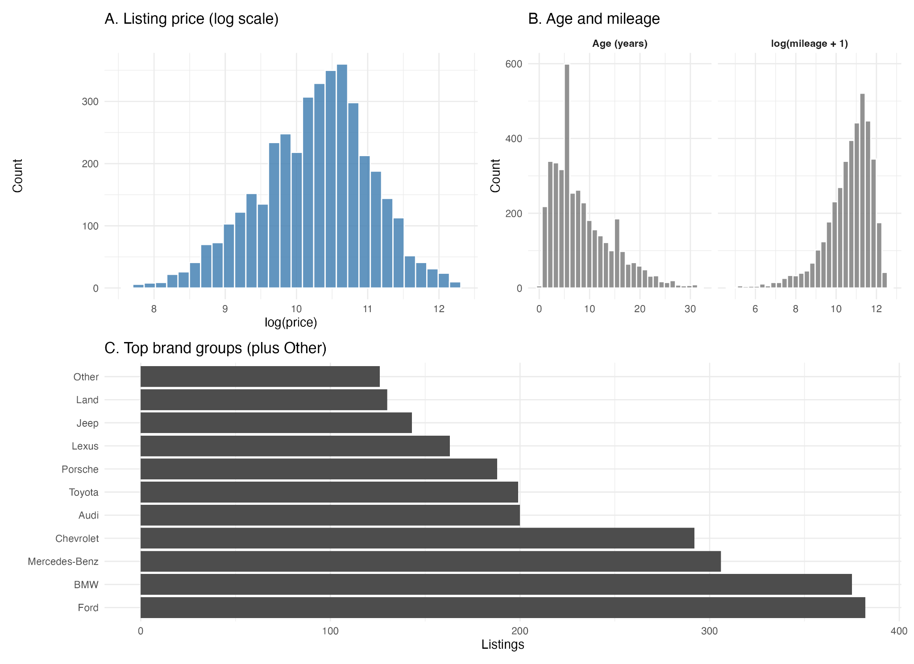

3. Bayesian Hierarchical Model
We use a Bayesian hierarchical regression model to predict used car prices. Since the original price variable is positive and right-skewed, the response variable is defined as the centered log price:
$y_{i}=loglog \left({price}_{i}\right) -{\underline{loglog \left(price\right) }}_{train}$
where $i=1,…,n$ indexes vehicles in the training set. Centering the log price helps improve computation and makes the intercept easier to model.
For each vehicle $i$, we assume
$y_{i}∣μ_{i},σ^{2}∼N(μ_{i},σ^{2}),$
where $μ_{i}$ is the expected centered log price and $σ^{2}$ is the residual variance. The linear predictor is
$μ_{i}=α_{b[i]}+x_{i}^{T}β,$
where $b[i]$ denotes the brand group of vehicles $i$, $α_{b[i]}$ is the brand-specific random intercept, $x_{i}$ is the vector of fixed effect predictors, and $β$ is the corresponding vector of regression coefficients. The fixed effect predictors include standardized vehicle age, standardized log mileage, fuel type, transmission type, accident history, and clean title status. After dummy encoding the categorical variables, the design matrix contained $p=14$ fixed-effect columns.
To account for systematic price differences across vehicle brands, we introduce a hierarchical structure through brand level random intercepts. If there are $J=35$ brand groups, then for each brand group $j=1,…,J$,
$α_{j}∣μ_{α},σ_{α}^{2}∼N(μ_{α},σ_{α}^{2}).$
Here, $μ_{α}$ represents the overall mean brand level intercept, and $σ_{α}^{2}$ measures the amount of variation in baseline log prices across brands. This structure allows different brands to have different baseline price levels while partially pooling information across brands. Brands with fewer observations are pulled toward the overall mean, which can help stabilize estimates for smaller groups.
We assign weakly informative priors to the model parameters. For the fixed effect coefficients,
$β_{k}∼N(0,2^{2}),k=1,…,p.$
For the overall brand level mean,
$μ_{α}∼N(0,5^{2}).$
For the residual standard deviation and the brand level standard deviation, we use weakly informative half normal priors:
$σ∼Half-Normal(0,2^{2}),σ_{α}∼Half-Normal(0,2^{2}).$

These priors are weakly informative because the response variable is centered log price and the continuous predictors are standardized. Therefore, values of the regression coefficients or standard deviations much larger than 2 would represent very large changes on the log price scale. The priors provide regularization while still allowing the data to determine the main posterior patterns.
We conduct a prior assessment following the prior selection. In the assessment, We refit replacing beta_k ~ N(0, 2^2) by beta_k ~ N(0, 1^2), priors on mu_alpha, sigma, and sigma_alpha unchanged (prior_sensitivity_posterior_compare.csv; prior_sensitivity_test_metrics.csv). Means for sigma and sigma_alpha shift O(10^-4); early beta_k and mu_alpha by at most ~0.01; test RMSE/MAE under one percent—inference is likelihood-driven. We retain N(0, 2^2) on beta and estimate by MCMC below.

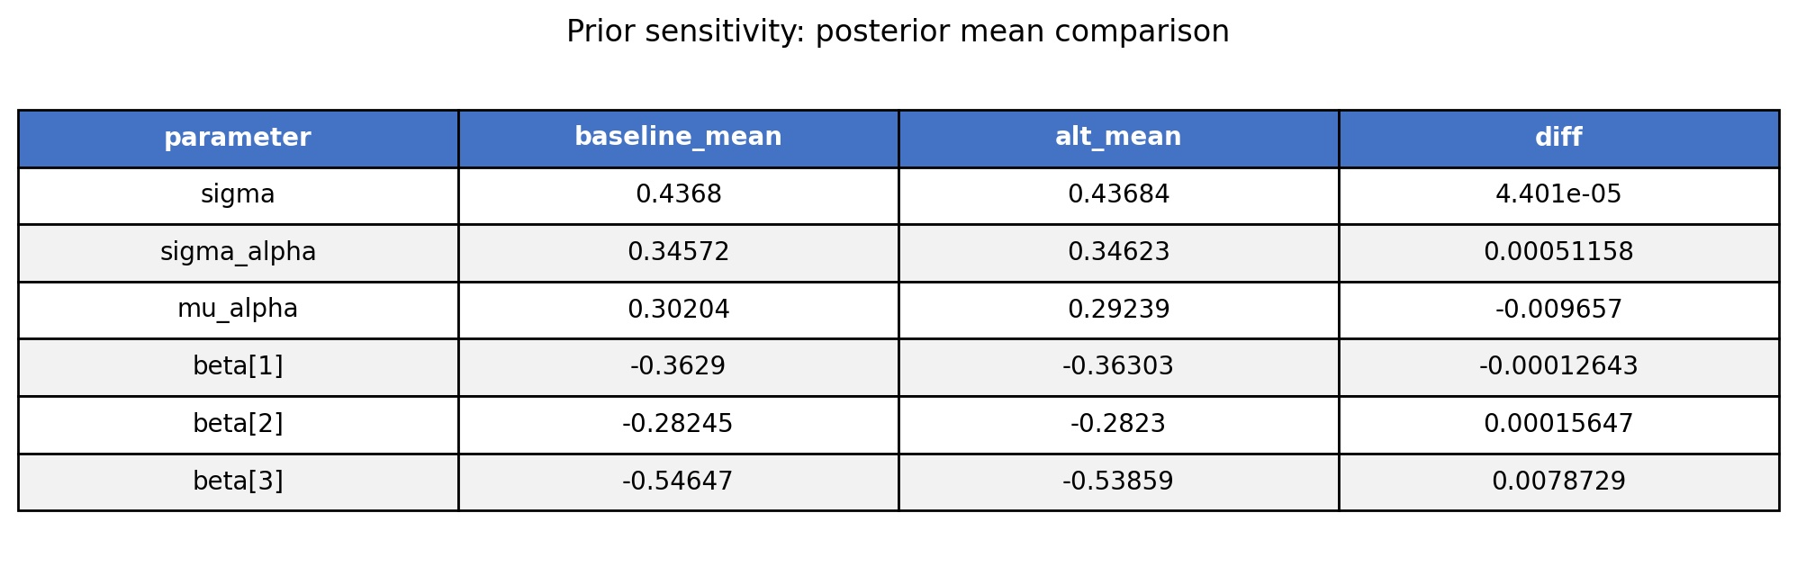
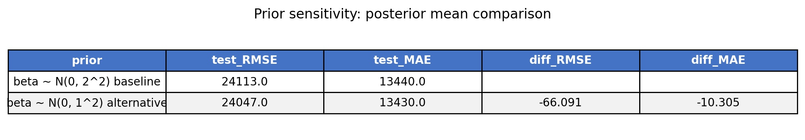

Besides test RMSE and MAE, we report DIC, WAIC, and LOO from training data only, using JAGS posterior draws rather than the test set. DIC combines mean deviance with penalty p_D; WAIC and LOO penalize complexity (lower WAIC or looic, higher elpd_loo). We compare baseline and alternative beta priors, N(0,4) versus N(0,1); methodology in Section 4, values in Section 5.

The model was estimated using Markov chain Monte Carlo methods implemented in JAGS. In JAGS, normal distributions are parameterized using precision rather than variance, so we used
$τ=\frac{1}{σ^{2}},τ_{α}=\frac{1}{σ_{α}^{2}}.$
Thus, the hierarchical model combines vehicle level predictors with brand level random effects to produce posterior predictive distributions for used car prices.

4. MCMC Computation and Diagnostics
The Bayesian hierarchical model was estimated using Markov chain Monte Carlo methods implemented in JAGS through the rjags package in R. The model was run with three parallel chains. We used 1,000 adaptation iterations, followed by 5,000 burn-in iterations. After burn-in, we drew 10,000 iterations from each chain with a thinning interval of 5, resulting in 2,000 posterior samples per chain and 6,000 posterior samples in total.
The parameters monitored in the MCMC sampling included the fixed effect regression coefficients $β$, the brand specific random intercepts $α_{j}$, the overall brand level mean $μ_{α}$, the residual standard deviation $σ$, and the brand level standard deviation $σ_{α}$. These parameters were used to summarize the posterior distribution and to generate posterior predictive distributions for the test data.
We assessed convergence using trace plots, Gelman-Rubin diagnostics, and effective sample sizes. The trace plots for the main hyperparameters and selected regression coefficients showed stable mixing across the three chains, with no obvious trends or separation between chains. The Gelman-Rubin point estimates were close to 1 for all monitored parameters, mostly between 1.00 and 1.02, suggesting no major convergence problems. Effective sample sizes were also generally adequate for posterior inference and prediction.
Monte Carlo error was assessed with coda time-series standard errors on saved baseline draws for sigma, sigma_alpha, mu_alpha, and beta[1]-beta[3] (Table/Figure: mcmc_mcse_summary). MCSE-to-posterior-SD ratios ranged from about 0.013 to 0.039, with ESS roughly 640-6,300. Sampling uncertainty in posterior means was small relative to posterior spread, so reported summaries, model comparison, and prediction used the converged chains.
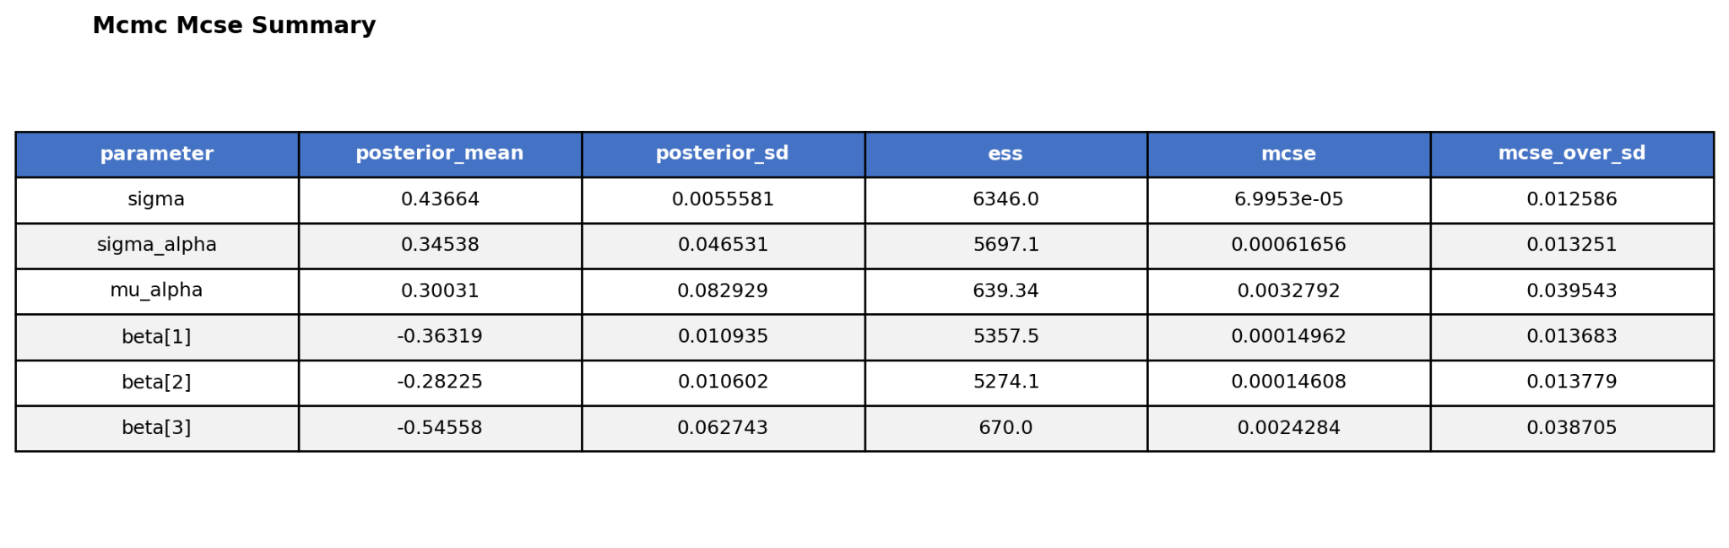

Because the chains mixed well and posterior summaries were stable, we used the same training likelihood and saved JAGS draws to summarize in-sample predictive fit with DIC, WAIC, and LOO (Section 5 tables). Details below.
Using the same training likelihood and converged JAGS draws, we summarized in-sample predictive fit with DIC from dic.samples, plus WAIC and LOO from an R-built S-by-n log-likelihood matrix of centered log price. A sensitivity refit changed only beta priors, N(0,4) versus N(0,1); scores differed negligibly, so reported posteriors and test predictions use the baseline model.
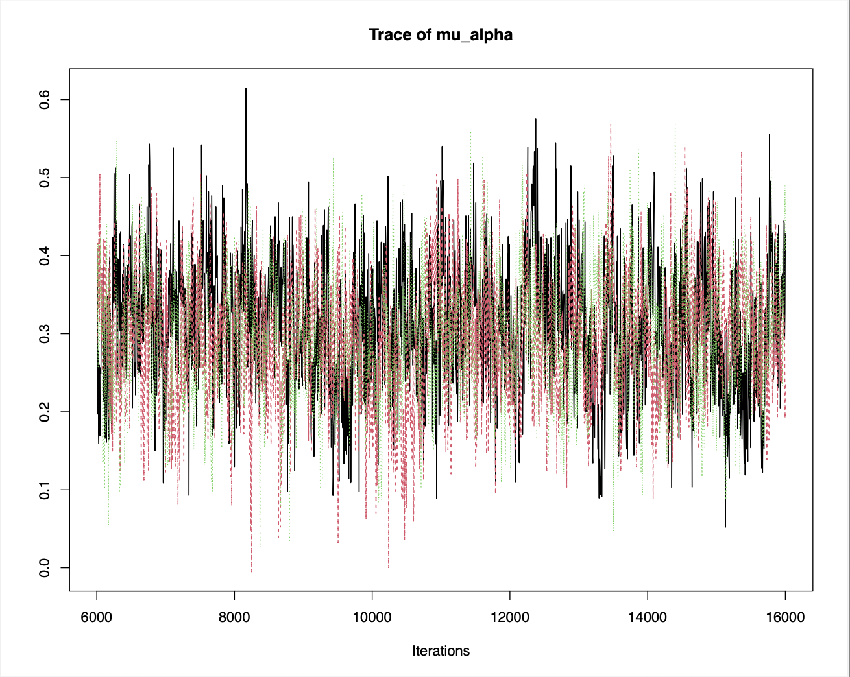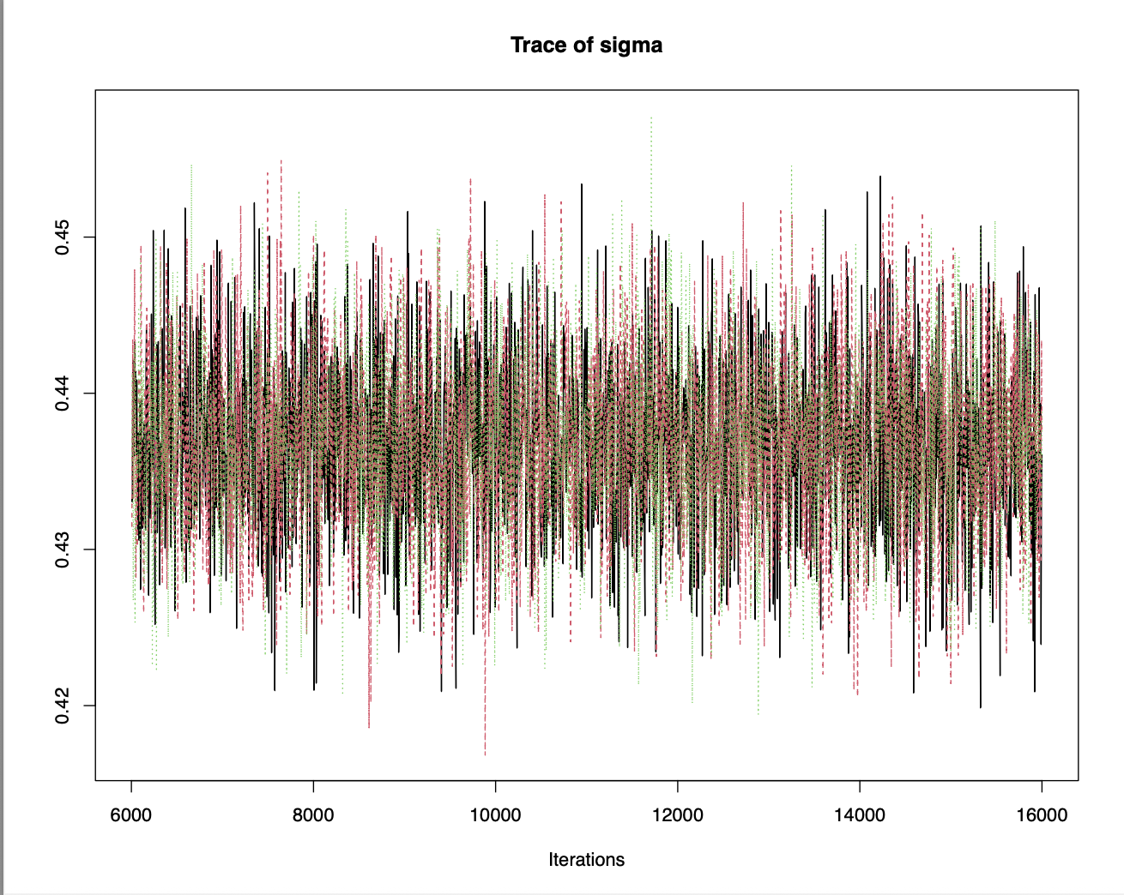
Figure 1 shows trace plots for two main parameters in the Bayesian hierarchical model: the overall brand levelmean $μ_{α}$and the residual standard deviation $σ$. The three MCMC chains appear to mix well and fluctuate around stable ranges without clear upward or downward trends. This suggests that the chains reached a stable posterior distribution. Together with the Gelman-Rubin diagnostic values close to 1, these trace plots provide evidence that the MCMC sampler converged reasonably well for the main model parameters.

5. Prediction Results and Model Comparison
After fitting the Bayesian hierarchical model, we evaluated its predictive performance on the held-out test set of 785 observations. For each test observation, posterior predictive draws were generated using the sampled model parameters. These predictions were then transformed back to the original dollar price scale. We summarized point prediction accuracy using root mean squared error (RMSE) and mean absolute error (MAE).
To evaluate whether the Bayesian hierarchical structure improved prediction, we compared it with a standard ordinary least squares (OLS) regression model. The OLS model used the same training and testing split and included the same vehicle-level predictors, along with brand indicators. Therefore, the comparison focuses on whether the Bayesian hierarchical partial-pooling structure improves out-of-sample prediction relative to an ordinary regression approach.
The prediction results are shown in Table 1.
Model | Test RMSE | Test MAE
OLS regression | 23,057.40 | 13,013.17
Bayesian hierarchical model | 24,067.64 | 13,433.21

On the original price scale, the OLS regression model achieved a slightly lower test RMSE and MAE than the Bayesian hierarchical model. Specifically, the OLS model had a test RMSE of 23,057.40 and a test MAE of 13,013.17, while the Bayesian hierarchical model had a test RMSE of 24,067.64 and a test MAE of 13,433.21. This indicates that, in this train test split, the OLS model slightly outperformed the Bayesian hierarchical model in terms of point prediction accuracy.
However, the Bayesian hierarchical model also provides predictive uncertainty through posterior predictive intervals. The 95% posterior predictive intervals had a test-set coverage of approximately 94.5%, which is close to the nominal 95% level. This suggests that although the Bayesian hierarchical model did not produce lower point prediction errors than OLS, it produced reasonably calibrated uncertainty estimates.
The actual-versus-predicted plots also show that both models perform reasonably well for low- and mid-priced vehicles, where most observations are concentrated. However, both models show larger prediction errors for high priced vehicles. This suggests that the available predictors capture much of the variation in ordinary used car prices but may not fully explain the pricing of expensive or unusual vehicles. Additional information such as trim level, detailed vehicle condition, location, and optional features could potentially improve prediction for these high price listings.
Overall, the Bayesian hierarchical model was competitive with the OLS baseline but did not clearly outperform it in point prediction accuracy. Its main advantage is that it provides posterior predictive uncertainty, while OLS gives slightly better RMSE and MAE in this test set.

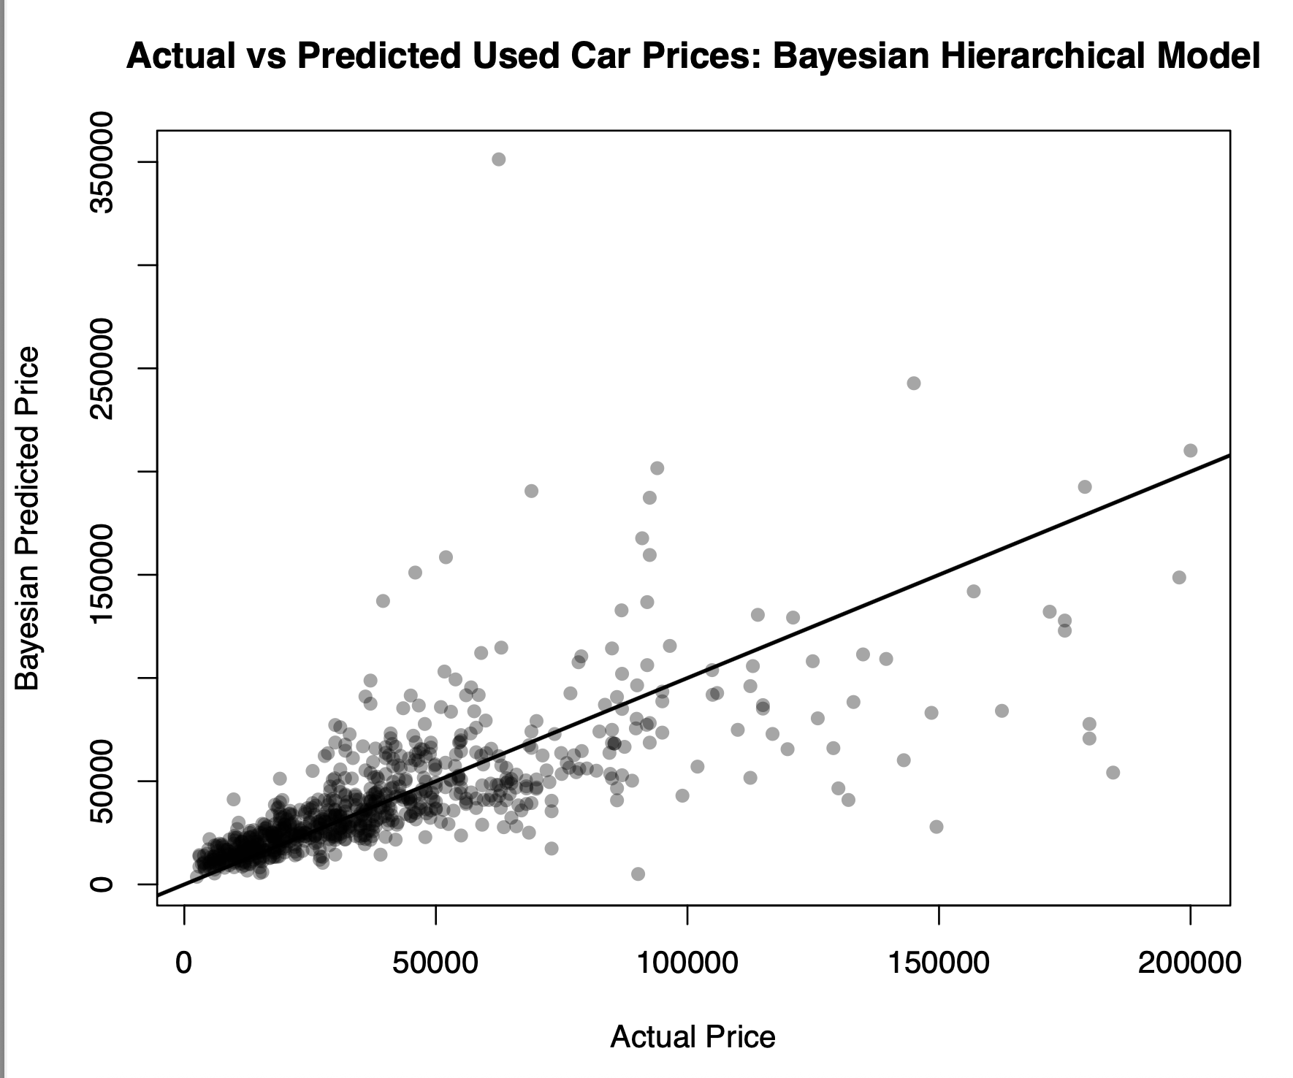

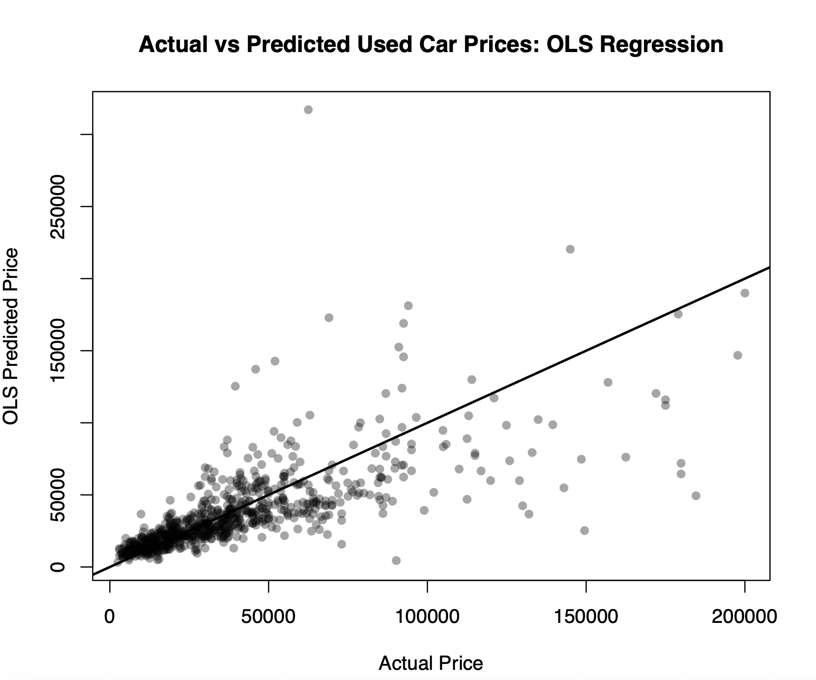
Training-only DIC (~1.1967), WAIC (~3759), and LOOIC (~3760) matched closely for baseline and alternative beta priors; loo_compare favored the tighter prior by only 0.25 elpd (SE 0.19). In-sample criteria therefore do not prefer one beta prior strongly and do not change the test-set ranking, where OLS still gave lower RMSE and MAE.

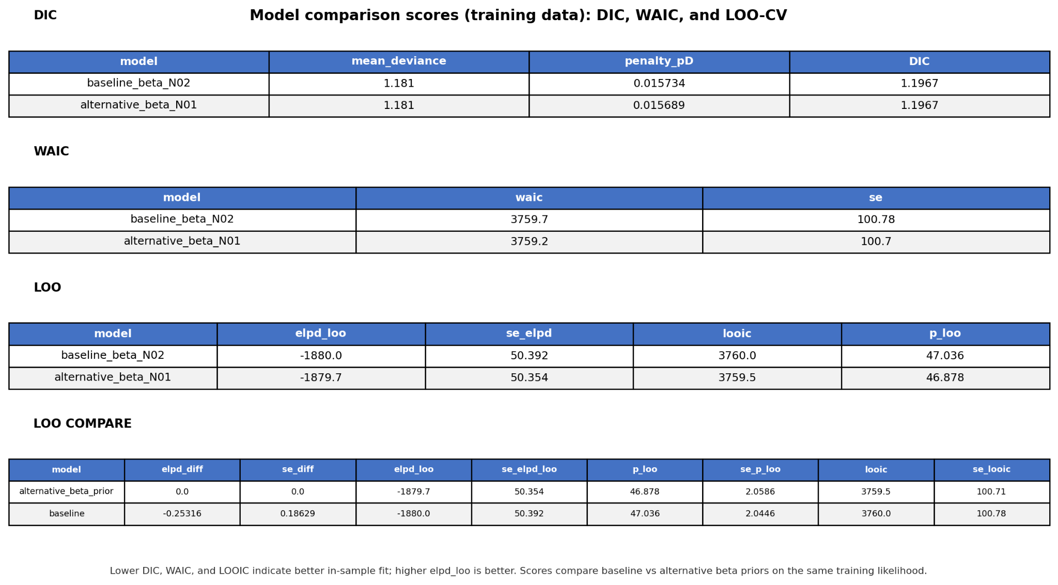

6. Discussion and Conclusion
This project used a Bayesian hierarchical regression model to predict used car prices from vehicle characteristics and brand level variation. The model included fixed effects for vehicle level predictors such as age, mileage, fuel type, transmission type, accident history, and clean title status, while allowing baseline prices to vary across brands through brand specific random intercepts. This hierarchical structure allowed partial pooling across brands, which can be useful when some brands have fewer observations than others.
In terms of point prediction accuracy on the original dollar price scale, the Bayesian hierarchical model did not outperform the OLS regression baseline. The OLS model achieved a lower test RMSE and MAE than the Bayesian hierarchical model. This suggests that, for this dataset and train test split, the ordinary regression model with brand indicators was slightly more accurate for point prediction. One possible explanation is that many major brands in the dataset had enough observations for OLS brand indicators to estimate brand level differences effectively. In such cases, the partial pooling in the Bayesian hierarchical model may not provide a clear predictive advantage over ordinary regression.
However, the Bayesian hierarchical model still provided useful information beyond point predictions. In particular, it generated posterior predictive intervals, and the 95% predictive interval coverage was approximately 94.5%, close to the nominal level. This suggests that the Bayesian model produced reasonably calibrated uncertainty estimates. Therefore, although the Bayesian hierarchical model was not better than OLS in terms of RMSE and MAE, it remained competitive and offered a meaningful advantage in uncertainty quantification.
There are several limitations to this analysis. First, the dataset contains listed prices rather than final transaction prices, so the response variable may not perfectly reflect actual market value. Second, the available variables do not include some important factors that may affect used car prices, such as vehicle condition, trim level, location, optional packages, seller type, and local market conditions. Third, very high-priced vehicles were more difficult to predict, suggesting that the model may not fully capture the pricing patterns of luxury or unusual listings. Finally, the results depend on one training-testing split, so a future analysis could use cross-validation to obtain a more stable estimate of predictive performance.
Overall, the results show that both the Bayesian hierarchical model and the OLS regression model produced reasonable predictions for used car prices. The OLS model slightly outperformed the Bayesian hierarchical model in point prediction accuracy, while the Bayesian model provided well calibrated predictive uncertainty. This suggests that Bayesian hierarchical modeling can be useful for structured prediction problems with grouped data, especially when uncertainty quantification and group level variation are important parts of the analysis.

Reference (in MLA citation format)

Naji, Taeef. Used Car Price Prediction Dataset. Kaggle, 2023, https://www.kaggle.com/datasets/taeefnajib/used-car-price-prediction-dataset.
This dataset is the core data source for our project.

Gelman, Andrew, et al. Bayesian Data Analysis. 3rd ed., CRC Press, 2013.
provided the main Bayesian inference framework for prior/posterior reasoning, hierarchical model structure, and interpretation of uncertainty..

Reich, Brian J., and Sujit K. Ghosh. Bayesian Statistical Methods. CRC Press, 2019.
(the course textbook) used ideas from the case-study style examples (including JAGS-oriented analysis) to shape our coding and diagnostic steps.

Plummer, Martyn. JAGS Version 4.3.0 User Manual. 2017.
used it while debugging model code and confirming implementation details for MCMC sampling in rjags.

Johnson, Alicia A., and Galin L. Jones. “Gibbs Sampling for a Bayesian Hierarchical General Linear Model.” Electronic Journal of Statistics, vol. 4, 2010, pp. 313-333. Project Euclid, https://doi.org/10.1214/09-EJS515. Accessed 10 May 2026.
This paper gave us a strong methodological reference for Gibbs sampling in hierarchical linear-model settings similar in structure to ours. support our use of MCMC for posterior estimation and to motivate convergence-aware interpretation of simulation-based results.

Cronin, Beau, et al. “Hierarchical Bayesian Modeling and Markov Chain Monte Carlo Sampling for Tuning-Curve Analysis.” Journal of Neurophysiology, vol. 103, no. 1, 2010, pp. 591-602, https://doi.org/10.1152/jn.00379.2009. PubMed Central, https://pmc.ncbi.nlm.nih.gov/articles/PMC2807240/. Accessed 10 May 2026.
It demonstrates hierarchical Bayesian modeling with MCMC and posterior-based uncertainty quantification. We used it as a conceptual reference for explaining why MCMC is useful when posterior distributions are complex and not analytically tractable.

Appendix A: Group Contributions
Xing Sun contributed to data preprocessing, R implementation, JAGS model fitting, MCMC diagnostics, and prediction evaluation.
Martin Wang
Ning Xu
Jack Liu contributde to data researching, project proposal design project option selection, prior assessment, compute model score comparison, monte carlo error,

Appendix B: Use of Generative AI
Generative AI tools were used to assist with drafting, editing, and clarifying explanations. All analysis, code, results, interpretations, and references were reviewed and verified by the authors. The authors take full responsibility for the final submitted work, final report copy writing

Appendix C: R and JAGS Code

https://github.com/officialjackliu/stat_431_final
https://drive.google.com/drive/folders/13OA4SSMRO6CDjSerLmlLVMKfTn7TwW7Q?usp=sharing
The complete code is hosted on GitHub for streamlined access and review, as including the full R source code within this document would compromise its organization.
For convenience, the GitHub source files are mirrored on Google Drive to allow for direct access and easier visualization.

