NearER
NGO Partnership, Community Awareness & Emergency Control Booth Framework
“Finding the right emergency care, not just the nearest hospital.”

DOCUMENT METADATA | DETAILS & SPECIFICATION
Document Title | NearER – NGO Partnership, Community Awareness & Emergency Control Booth Framework
Document Type | Institutional Partnership & Operational Implementation Proposal
Target Audience | NGO Leaders, Hospital Directors, Healthcare Authorities, Ambulance Networks & Sponsors
Platform Core Concept | Healthcare Coordination & Decision-Support System (Non-Clinical Routing Engine)
Key Shift | Shifting Emergency Dispatch from 'Nearest Hospital' to 'Nearest Suitable and Available Hospital'
Version / Date | Version 2.0 • September 2026 Release
Prepared By | NearER Global Engineering & Healthcare Social Impact Directorate

Table of Contents & Framework Overview
SECTION | FRAMEWORK MODULE | LOCATION
Section 1 | Executive Summary | Page 3
Section 2 | Problem Statement & Emergency Redirection Analysis | Page 4
Section 3 | NearER Solution & Core Operating Principles | Page 5
Section 4 | Complete Ecosystem Architecture & Flowcharts | Page 6
Section 5 | Patient Application Framework | Page 7
Section 6 | Hospital Emergency Department Portal | Page 8
Section 7 | Ambulance & Emergency Transport System | Page 9
Section 8 | Emergency Decision Engine (Step-by-Step Logic) | Page 10
Section 9 | NGO Partnership Model & Multi-Branch Roles | Page 11
Section 10 | Community Awareness & Promotion Plan | Page 12
Section 11 | NearER Control Booth Infrastructure & Setup | Page 13
Section 12 | Control Booth Incident Operations Workflow | Page 14
Section 13 | Control Booth SOP & Escalation Hierarchy | Page 15
Section 14 | Volunteer Training & Certification Framework | Page 16
Section 15 | NGO and NearER Responsibility Matrix | Page 17
Section 16 | Data Privacy, Consent & Information Security | Page 18
Section 17 | Safety, Risk Management & Fallback Protocols | Page 19
Section 18 | Pilot Implementation Plan & Timeline | Page 20
Section 19 | NGO Community Promotion & Awareness Campaigns | Page 21
Section 20 | Measurable Key Performance Indicators (KPIs) | Page 22
Section 21 | Long-Term Vision & Scalability Roadmap | Page 23
Section 22 | Expected Social Impact Assessment | Page 24
Section 23 | Official Partnership Proposal & Invitation to NGO | Page 25

Section 1 — Executive Summary
📌 CENTRAL PARADIGM SHIFT
NearER shifts emergency healthcare routing from the nearest hospital to the nearest suitable and available hospital. Its primary objective is to drastically reduce avoidable delays between an emergency occurring and appropriate medical treatment beginning.

In medical emergencies, every minute lost directly impacts patient survival and recovery. During the critical 'Golden Hour'—particularly in severe trauma, cardiac arrest, acute stroke, pediatric emergencies, and severe burns—the speed of arriving at a medical facility that is fully equipped, staffed, and immediately ready to admit the patient is the single most decisive factor in saving lives.
Across urban, suburban, and rural healthcare ecosystems globally, a systemic failure persists: patients, family members, and traditional emergency vehicles instinctively navigate to the geographically nearest hospital. However, upon arrival, victims frequently discover that the nearest facility lacks available Intensive Care Unit (ICU) beds, functional mechanical ventilators, on-duty specialized surgeons, emergency blood supplies, or immediate resuscitation capacity. This leads to catastrophic secondary and tertiary inter-hospital transfers ('hospital ping-ponging'), during which clinical deterioration accelerates and precious time expires.
NearER is an innovative, non-clinical emergency healthcare coordination and decision-support platform designed to bridge this information gap. By real-time interconnecting Patients, Emergency Transport Fleets, Hospital Control Rooms, and NGO Community Control Booths, NearER dynamically identifies, verifies, and routes patients to the most suitable available hospital.
Crucially, NearER is NOT an AI doctor. It does not provide clinical diagnoses, prescribe treatment, or replace qualified medical professionals. Instead, NearER acts as an intelligent logistics and decision-support pipeline, structuring emergency data, verifying hospital capability, calculating real-time traffic delays, and pre-alerting emergency departments prior to patient arrival.
Section 2 — Problem Statement & Emergency Redirection Analysis
The traditional emergency response ecosystem suffers from profound structural inefficiencies that cause thousands of avoidable fatalities annually. These core systemic failures include:
Information Asymmetry during Crisis
Patients and distressed relatives have zero real-time visibility into hospital capabilities, bed availability, or specialist attendance when an emergency strikes.
Manual & Fragmented Ambulance Coordination
Ambulance operators frequently rely on manual phone calls to hospital reception desks while driving, leading to delayed responses, unanswered calls, and uncoordinated drop-offs.
Dynamic & Rapidly Fluctuating Hospital Capacity
Hospital Emergency Department (ED) bed capacity, ICU availability, ventilator counts, and blood bank stocks change continuously. Static directories are useless during live emergencies.
Catastrophic Golden Hour Depletion
Patients spending 30–90 minutes traveling to an unsuitable hospital must be re-triaged, stabilized, and transferred to a secondary facility, exhausting the clinical Golden Hour.
Severe Emergency Room Overcrowding
Unannounced patient arrivals overload specific famous tertiary hospitals while neighboring equipped centers remain underutilized.
Digital Exclusion of Vulnerable Populations
Elderly citizens, low-income families, and non-digital users are excluded from modern emergency platforms without community coordination infrastructure.
Section 3 — NearER Solution & Core Principles
NearER addresses these structural failures by deploying an integrated digital-and-physical emergency coordination ecosystem. The platform establishes a seamless, verified chain of information from the moment an emergency is triggered to definitive clinical admission.
📌 HIGH-LEVEL SYSTEM FLOW
Patient / Citizen (App / NGO Booth / Web)
│
▼
NearER Emergency Cloud Platform
│
▼
Hospital Suitability & Live Resource Matching Engine
│
▼
Optimal Available Hospital (Pre-Arrival Alert & Bed Lock)
│
▼
Ambulance Coordination & Traffic Escort (Green Corridor)
│
▼
Direct Emergency Department Triage Admission

Core Operating Principles & Non-Clinical Boundaries
NearER adheres to strict institutional and healthcare ethical boundaries:
• Non-Clinical Support System: NearER never diagnoses medical conditions or prescribes pharmaceutical interventions.
• Clinical Authority Preservation: All medical decisions, triage grading, and treatment protocols remain 100% under the authority of qualified hospital physicians.
• Zero Friction Intake: Emergency reporting requires minimal steps—supporting 1-tap SOS, voice brief recording, and automatic GPS capture.
• Complementary Ecosystem: NearER complements and integrates with existing statutory emergency numbers (e.g., 108 / 112 / 911), rather than replacing them.
• Total Transparency & Data Integrity: Capacity data is verified with strict timestamp audits to prevent outdated routing.
Section 4 — Complete Ecosystem Architecture
The NearER ecosystem unites nine specialized software modules and physical operational units into a synchronized real-time emergency network.
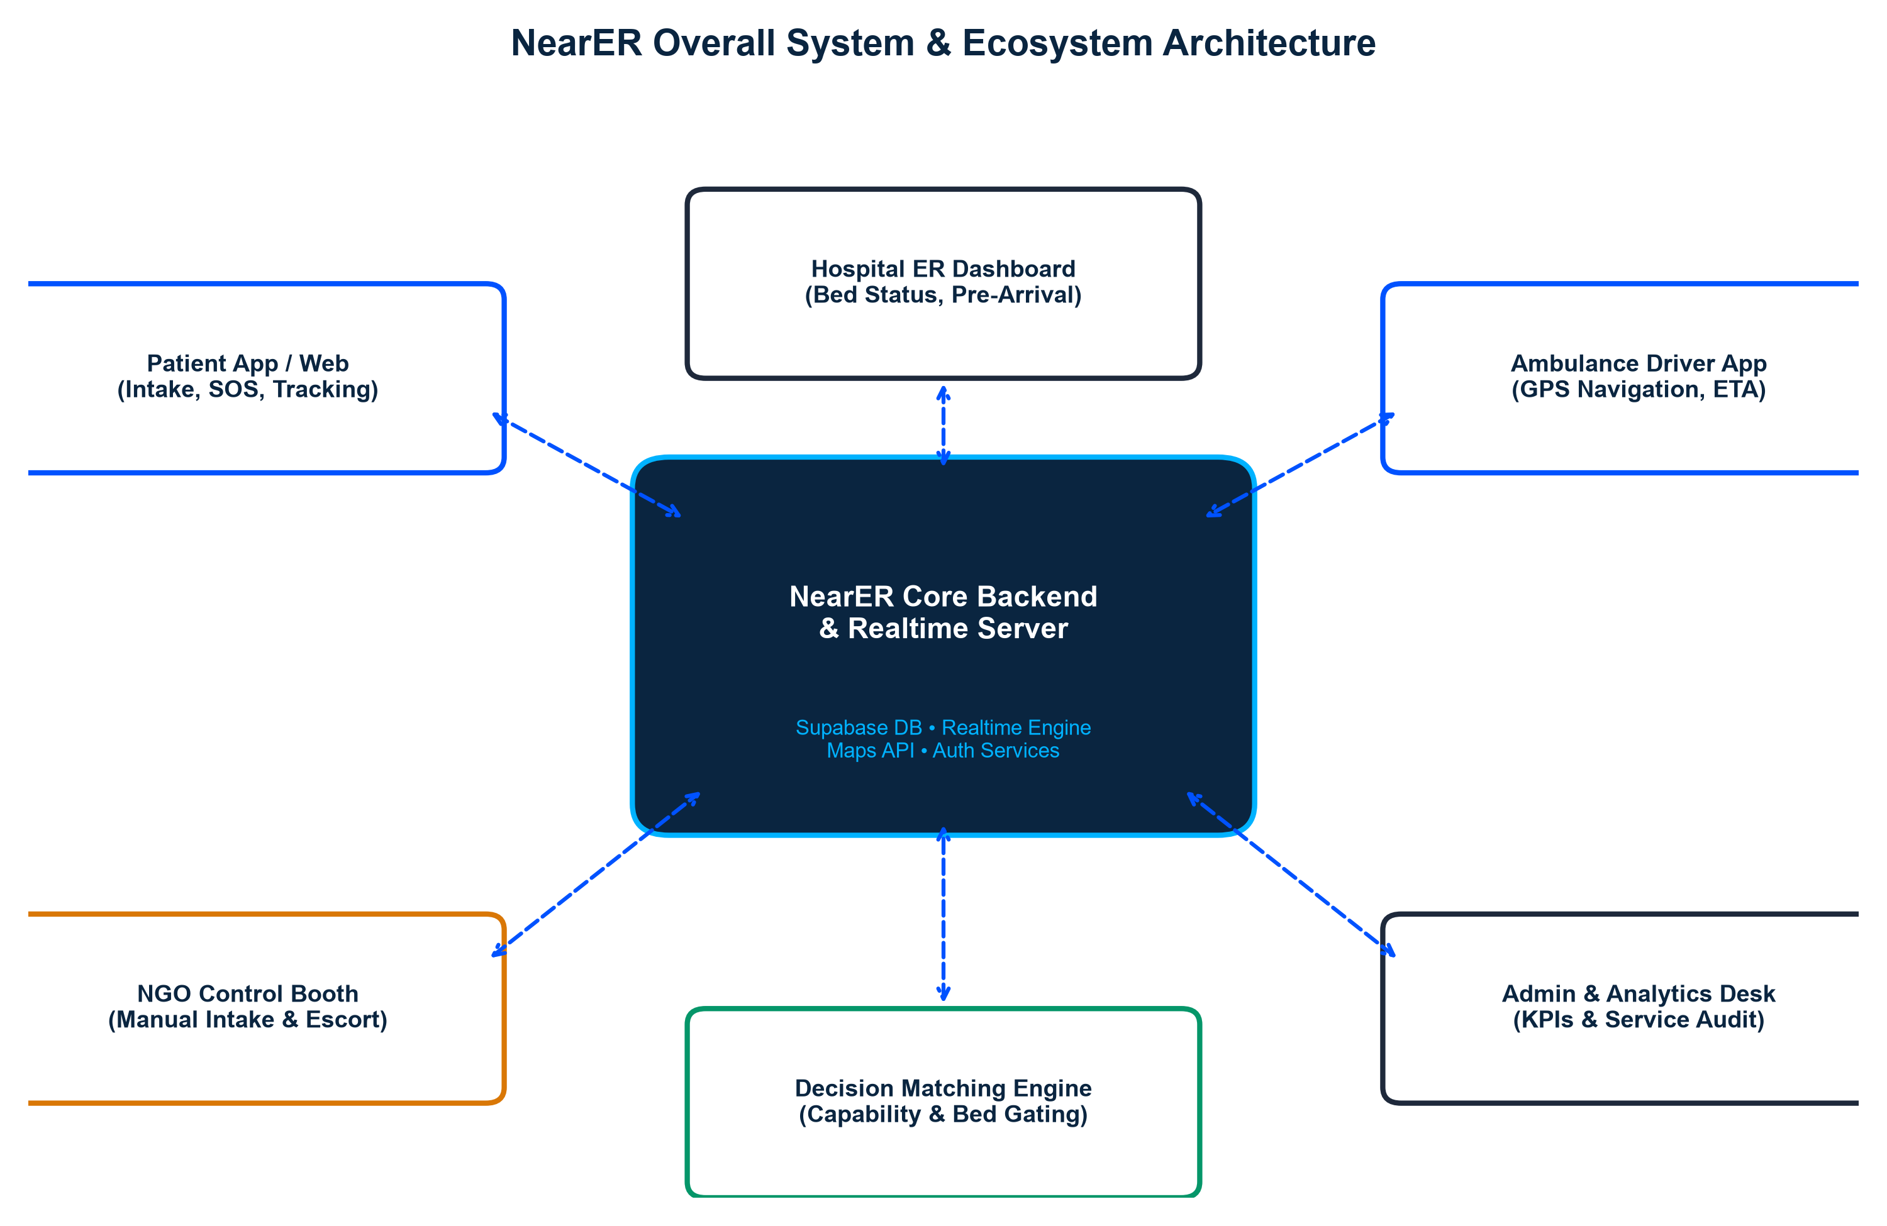
Figure: NearER Overall System & Multi-Node Architecture
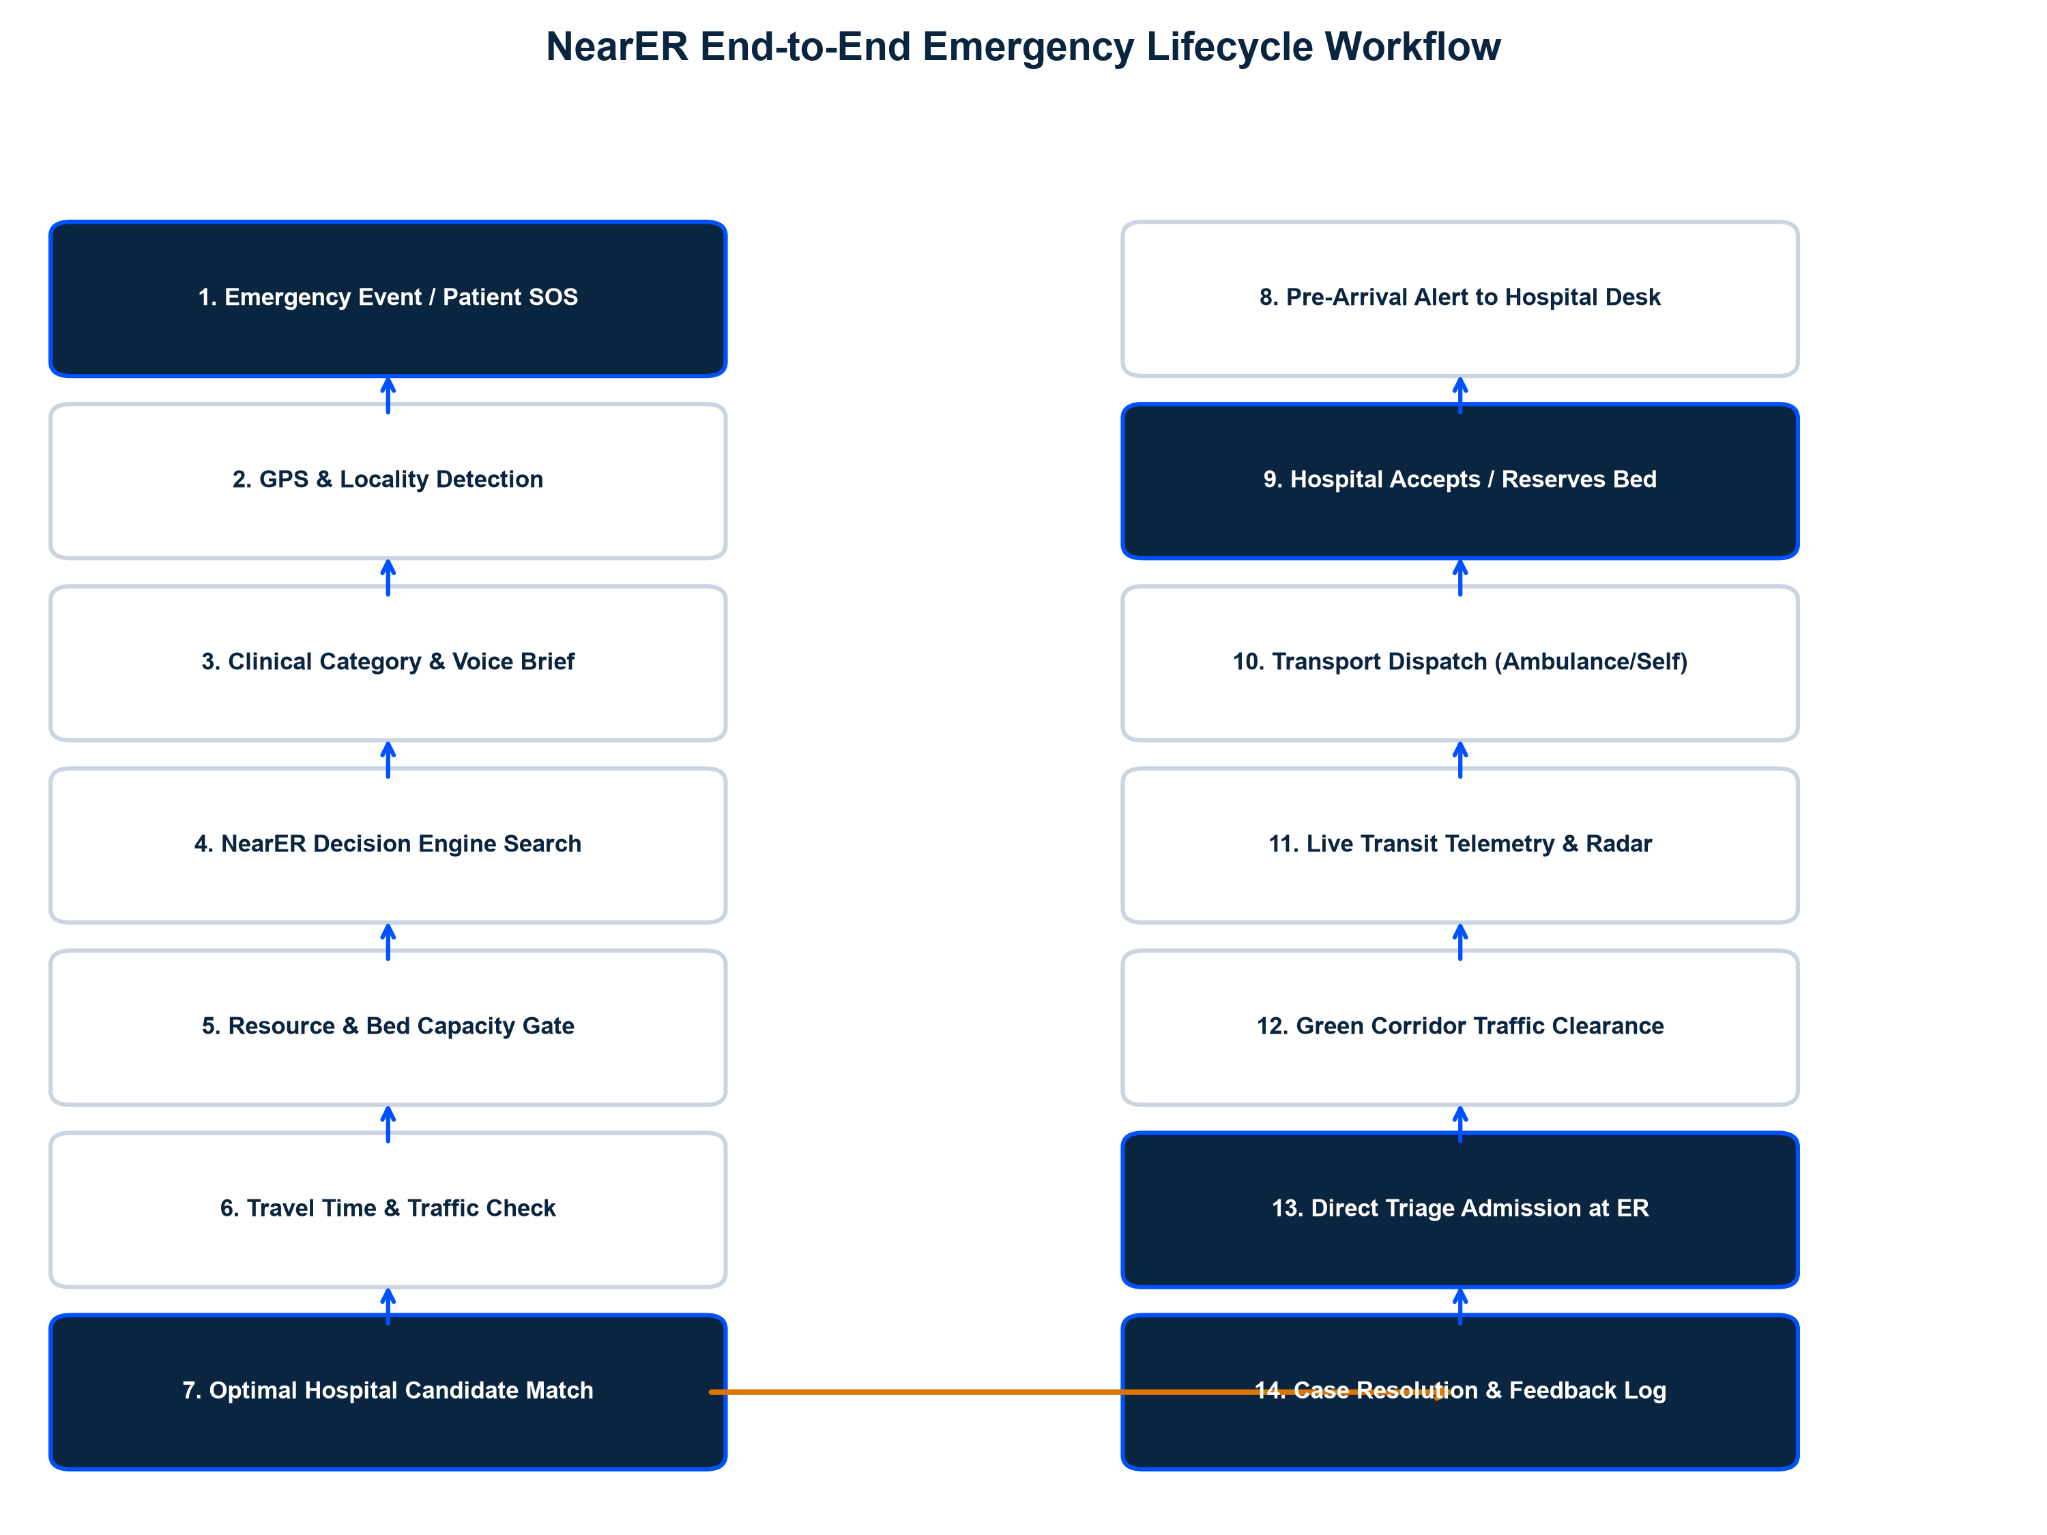
Figure: NearER End-to-End Emergency Lifecycle Workflow (14 Steps)
Detailed System Nodes
1. Patient Mobile App (Android/iOS)
Provides 1-tap SOS, voice briefing, live GPS capture, emergency category selection, and real-time transit tracking.
2. Patient Web Emergency Portal
Browser-based intake for instant access without app installation, providing locality selection and turn-by-turn routing.
3. Hospital Emergency Department Dashboard
Control room interface for ER staff to receive pre-arrival alerts, review patient audio notes, accept/decline cases, and manage live ER/ICU bed capacity.
4. Ambulance Driver Application
Provides drivers with pickup navigation, clinical condition briefs, target hospital locking, and direct ETA broadcasting.
5. NearER Backend Cloud Server
Secure Supabase/PostgreSQL backend handling authentication, data encryption, real-time WebSockets, and state persistence.
6. Decision Matching Engine
Algorithmic pipeline performing capability filtering, bed capacity gating, data freshness checks, and travel delay scoring.
7. Maps & Telemetry Routing Engine
Integrates OpenStreetMap/Google Maps telemetry for live travel time calculation and traffic corridor alerts.
8. NGO Control Booth Operator Desk
Specialized dashboard allowing trained NGO volunteers to log emergency requests for non-digital or distressed citizens.
9. Admin & Analytics Executive Suite
Provides health authorities and NGO leadership with regional emergency metrics, response times, and capacity audit logs.
Section 5 — Patient Application Framework
The patient application is engineered under the 'Zero Panic Friction' design philosophy. During extreme stress, users cannot navigate complex menus or complete lengthy forms.
Key Patient Application Capabilities
1-Tap Instant Emergency SOS
Single button press immediately broadcasts high-accuracy GPS coordinates, user mobile number, and default profile metrics to nearby hospital desks.
Automated GPS & Manual Locality Override
Uses high-accuracy device GPS with intelligent reverse-geocoding, backed by an instant 1-tap manual locality picker (e.g., 'Salt Lake, Sector V') if GPS is disabled or indoors.
Voice Brief Emergency Recorder
Allows patients or bystanders to record up to 30 seconds of audio describing the situation. Audio is encoded and transmitted to the ER triage team prior to arrival.
Conditional Transport Selector
Offers two distinct choices: (a) Emergency ALS ICU Ambulance Required (with live radar tracking and driver call) OR (b) Self-Transport (direct Google Maps navigation to ER door).
Dynamic Escalation Trigger
Self-transporting patients can tap 'NEED AMBULANCE' at any point during travel if their medical condition deteriorates, dispatching an ALS unit to their moving location.
Digital Admission Pass & QR Code
Generates a unique Case ID (e.g., 'NR-10482') and scannable QR passport containing blood group, emergency contact details, and registered medical history for instant hospital check-in.
Section 6 — Hospital Emergency Department Portal
The Hospital Portal serves as the emergency department's command center, converting surprise arrivals into pre-planned clinical admissions.
Hospital Dashboard Management Scope
RESOURCE / FEATURE | CONTROL ROOM FUNCTIONALITY | CLINICAL IMPACT
ER Resuscitation Beds | Live count toggles (+ / -) for open emergency beds | Prevents over-booking and redirects cases when full
ICU & Ventilator Capacity | Real-time tracker for Intensive Care Unit beds and vents | Ensures critical respiratory/trauma cases find open ICUs
On-Duty Specialist Shifts | Checklist for Cardiologists, Trauma Surgeons, Neurologists | Guarantees relevant specialty care is present before arrival
Blood Bank Inventory | Units available by group (O+, O-, A+, AB+, etc.) | Critical for severe hemorrhage and trauma resuscitation
Incoming Case Queue | Live cards with patient vitals, audio notes, ETA, and transport mode | Allows ER triage team to pre-assign resuscitation bays
Accept / Decline Action | Explicit confirmation buttons for incoming requests | Locks bed reservation or triggers automatic system backup match
Data Freshness Monitor | Timestamp indicator showing last capacity verification | Alerts staff if data is stale (> 30 mins unconfirmed)

Section 7 — Ambulance & Emergency Transport System
The Ambulance Driver Interface turns emergency transport fleets into connected mobile ICUs.
Driver Duty Authentication
Secure login allowing driver to toggle status: Available, En-Route Pickup, Patient Onboard, At Hospital, or Maintenance.
Automated Dispatch Alerts
Receives instant pop-up assignments containing patient GPS coordinates, age/gender, medical brief, and assigned hospital.
Turn-by-Turn Navigation
Direct integration with Google Maps and native geo-navigation for fast pickup and hospital routing.
Hospital Pre-Arrival Link
Broadcasts live vehicle telemetry to the hospital dashboard, allowing ER staff to watch the incoming vehicle's ETA countdown.
Strict Non-Clinical Boundaries
Driver interface is strictly for navigation and transport telemetry; drivers do not perform clinical triage or diagnostic input.
Section 8 — Emergency Decision Engine (Step-by-Step Logic)
The Emergency Decision Engine is the core algorithmic intelligence of NearER. It evaluates multi-dimensional spatial, clinical capability, and resource availability metrics to identify the optimal hospital.
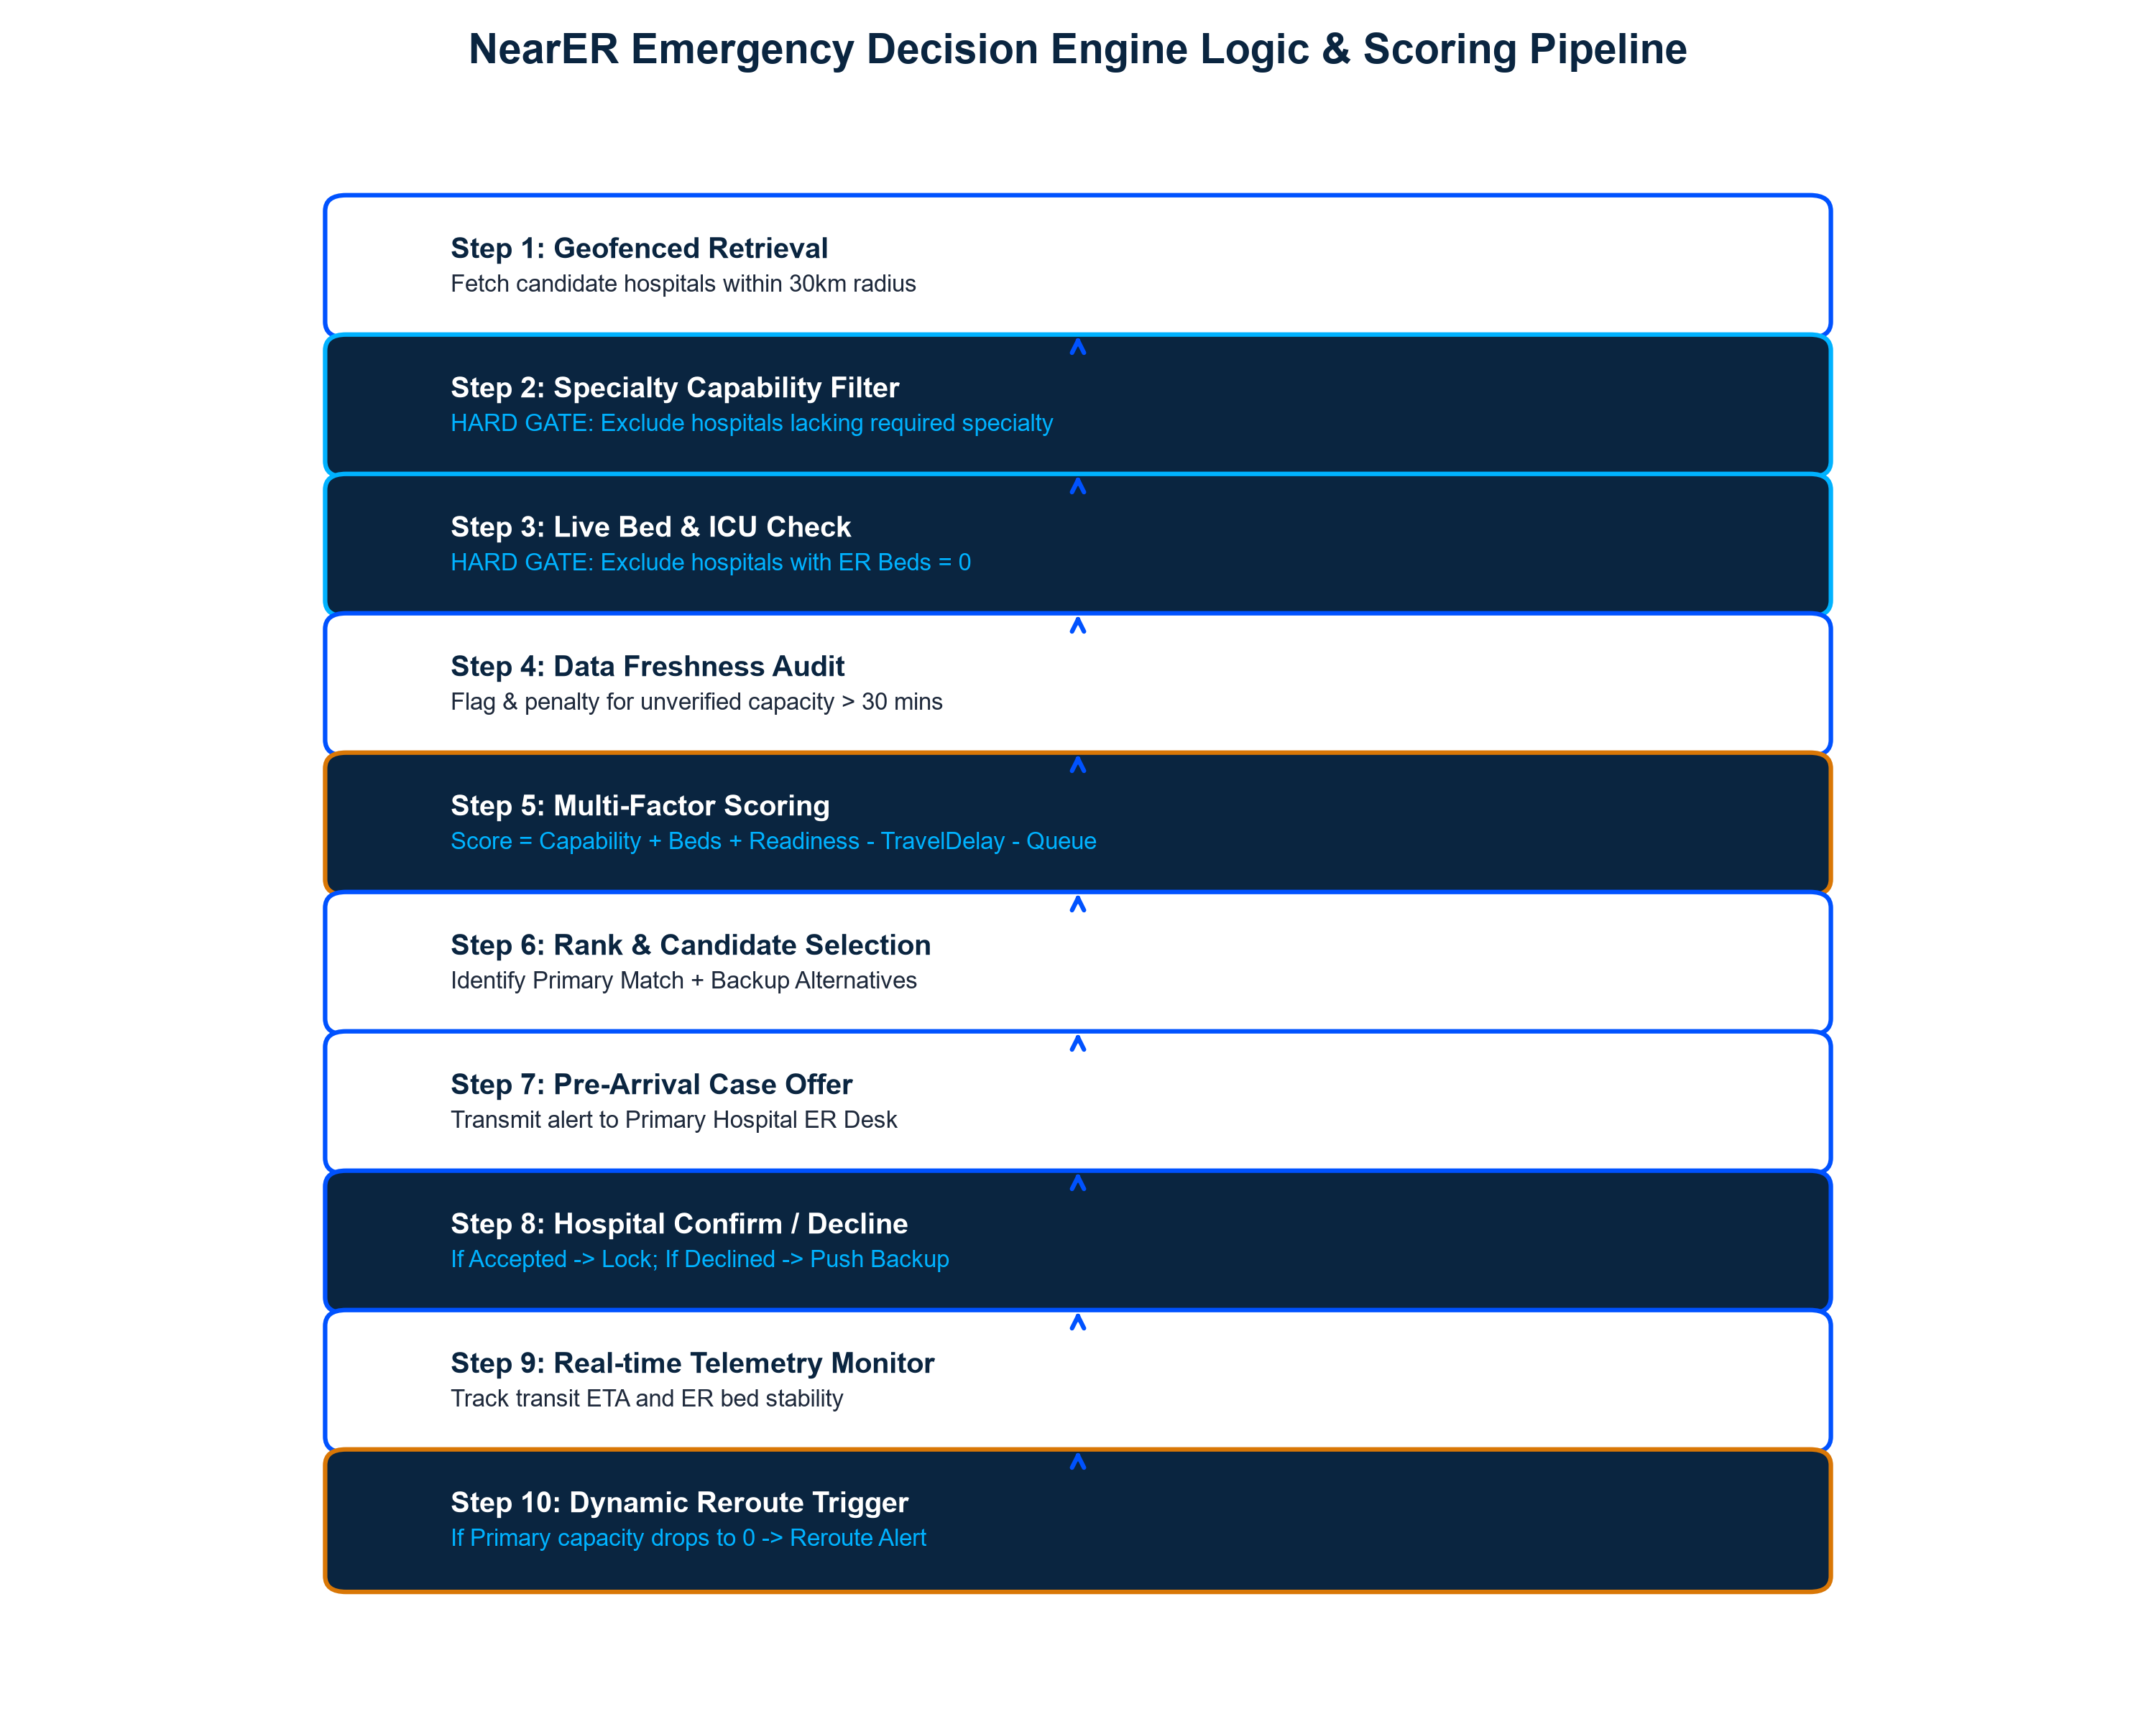
Figure: NearER Emergency Decision Engine Logic & Scoring Pipeline (Steps 1–10)
Step-by-Step Decision Logic
Step 1: Geofenced Candidate Retrieval
Queries database for verified hospitals within a 30km driving radius of the patient's GPS location.
Step 2: Specialty Capability Filter (HARD GATE)
Excludes any hospital that does not possess primary surgical/clinical capabilities required for the specific emergency category (e.g., excluding facilities without cath labs for cardiac cases).
Step 3: Live Bed & ICU Capacity Gate (HARD GATE)
Excludes any hospital where ER Available Beds <= 0. If a hospital is full, it CANNOT accept emergency cases.
Step 4: Data Freshness Audit
Applies confidence penalties if hospital capacity data has not been updated within the last 30 minutes.
Step 5: Multi-Factor Suitability Scoring
Calculates a dynamic suitability score using the scoring framework below.
Step 6: Rank & Candidate Selection
Identifies the Primary Optimal Match plus up to 3 verified backup alternatives.
Step 7: Pre-Arrival Case Transmission
Dispatches emergency notification to the Primary Hospital control desk.
Step 8: Hospital Confirmation Loop
If Primary accepts -> lock reservation. If Primary declines -> automatically push to Backup Match #1.
Step 9: Real-time Telemetry Monitoring
Continuously monitors travel ETA and destination bed status during patient transit.
Step 10: Dynamic Reroute Trigger
If Primary hospital capacity drops to 0 during transit, the engine immediately prompts a mandatory reroute alert.
📌 SUITABILITY SCORING MODEL
Hospital Suitability Score =
+ Specialty Capability Match (Weight: 40%)
+ ER & ICU Bed Availability (Weight: 30%)
+ On-Duty Specialist & Blood Readiness (Weight: 15%)
+ Data Freshness Confidence (Weight: 15%)
- Estimated Travel & Traffic Delay Penalty
- Hospital Current Triage Queue Penalty
*Disclaimer: This scoring logic is an operational routing model, not a medically validated clinical formula. Final parameter weights are refined continuously in collaboration with medical advisory boards and pilot empirical data.

Section 9 — NGO Partnership Model & Multi-Branch Roles
NGO partners are not merely promotional sponsors; they are the essential operational, community, and human delivery arm of NearER. Without NGO community integration, digital platforms fail to reach non-digital, elderly, or socio-economically disadvantaged populations.
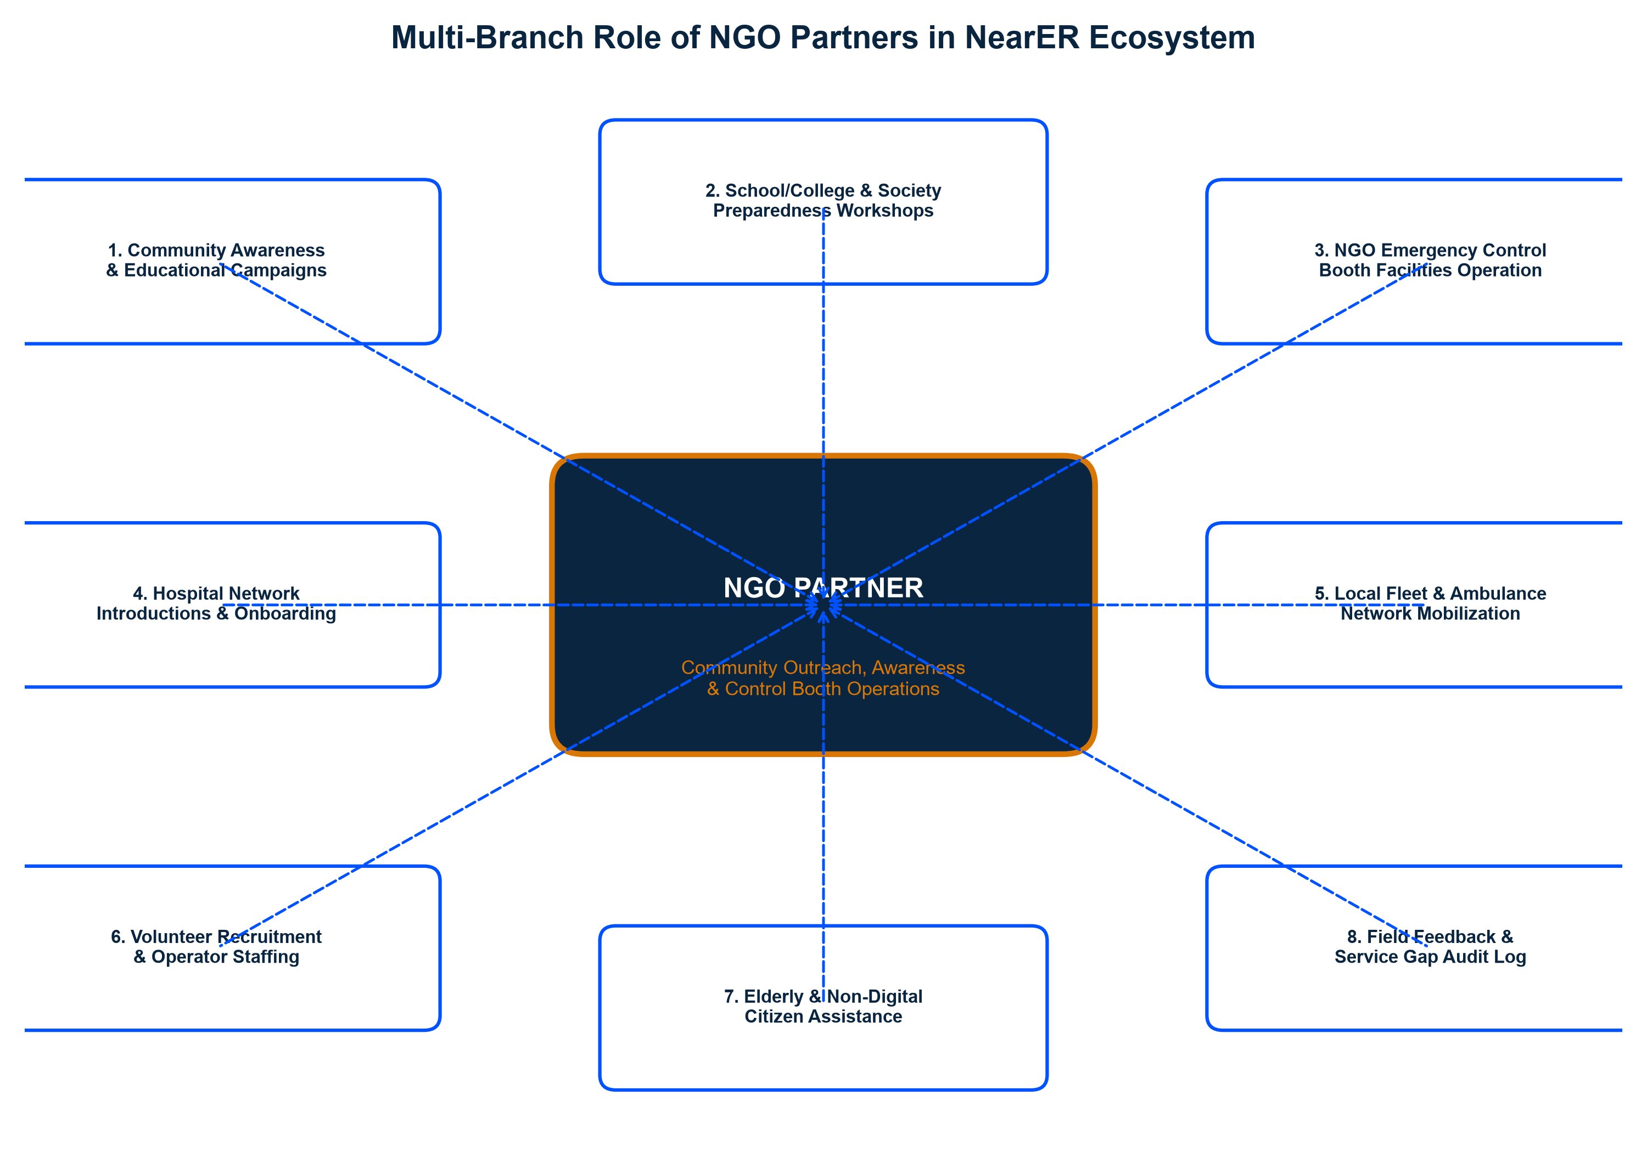
Figure: Multi-Branch Role of NGO Partners in the NearER Ecosystem
15 Core NGO Responsibilities
• 1. Community Awareness: Leading local public campaigns on emergency preparedness.
• 2. NearER Platform Promotion: Educating citizens on downloading and using the platform.
• 3. School & College Workshops: Conducting emergency response training in educational institutions.
• 4. Residential Society Drives: Partnering with housing associations to pre-register profiles.
• 5. Hospital Introductions: Facilitating meetings with local private and public hospitals.
• 6. Ambulance Fleet Onboarding: Connecting private, trust, and charity ambulance providers.
• 7. NGO Control Booth Operation: Establishing and staffing physical/virtual emergency help desks.
• 8. Volunteer Recruitment: Mobilizing dedicated community youth and health volunteers.
• 9. Volunteer Training Execution: Ensuring operators complete all 10 training modules.
• 10. Elderly Citizen Support: Assisting senior citizens with profile pre-filling and QR badges.
• 11. Non-Digital Accessibility: Providing telephone assistance for users without smartphones.
• 12. Field Data Verification: Verifying physical addresses and contact numbers of local providers.
• 13. Feedback & Audit Logging: Documenting operational gaps, delay bottlenecks, and user feedback.
• 14. Public Health Camp Integration: Setting up NearER demo booths at blood drives and health camps.
• 15. Institutional Coordination: Interfacing with local municipal health and disaster authorities.
Section 10 — Community Awareness & Promotion Plan
A technology platform is only effective if citizens know how to use it before crisis strikes. The NGO partner leads a structured 7-stage community awareness cycle.
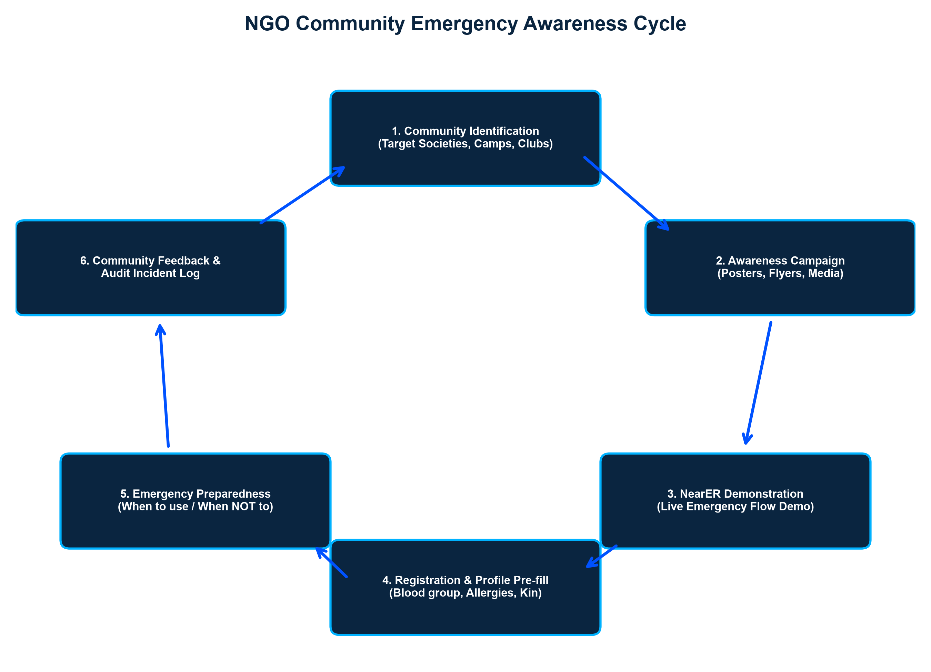
Figure: 7-Stage NGO Community Emergency Awareness Cycle
Key Educational Messages for Public Campaigns
✔ Why the nearest hospital is not always the right hospital: Educating the public on capacity and specialized care.
✔ Know Before the Emergency: Pre-registering family blood groups, allergies, and contacts in the app.
✔ How Voice Briefing Works: Demonstrating 30-second audio symptom reporting.
✔ Complementing Statutory Services: Explaining that NearER works alongside 108/112 to optimize hospital selection.
✔ Clear Boundaries: Emphasizing that NearER is an emergency logistics network, not a virtual doctor.
Section 11 — NearER Control Booth Infrastructure & Setup
To ensure universal access, NGO partners establish physical or virtual NearER Control Booths. These booths serve as assistance hubs for elderly, distressed, or digitally inexperienced citizens.
Control Booth Deployment Locations
📍 NGO Central Offices and Community Welfare Centers
📍 Public Hospitals Coordination Desks & Outpatient Waiting Halls
📍 Major Public Gatherings, Festivals, Cultural Events, and Sports Meets
📍 Target Pilot Neighborhoods and Health Awareness Camps
Standard Control Booth Equipment & Hardware Specifications
EQUIPMENT / RESOURCE | MINIMUM SPECIFICATION | OPERATIONAL PURPOSE
Workstation / Laptop | Intel i5/8GB RAM, Windows 11 / Linux | Runs NearER Control Booth Web Dashboard
Primary Internet | Fiber Broadband (Min 50 Mbps) | Real-time WebSocket streaming & database updates
Backup Internet | 4G/5G Cellular Mobile Wi-Fi Dongle | Instant failover if primary broadband drops
Telephony & Headset | Dedicated Smartphone + Noise-Canceling Headset | Receiving incoming calls & talking to hospitals/drivers
Power Backup | 1000VA UPS / Inverter (Min 2-Hour Backup) | Ensures booth stays operational during power cuts
SOP & Reference Folder | Printed Workflows, Hospital Directories & Contact Lists | Offline reference during system or network outages
Incident Logbook | Physical / Digital Incident Register | Audit trail for all handled emergency calls
First Aid & Comfort Kit | Basic First Aid Supplies & Emergency Water | Immediate assistance for walk-in distress cases

Booth Staffing Architecture & Roles
Booth Supervisor (1 Per Shift)
Senior NGO staff member overseeing operations, quality compliance, and handling complex escalations.
Volunteer Operators (1–2 Per Shift)
Trained NGO volunteers operating the NearER dashboard, taking calls, and entering patient data.
Technical Support Liaison
Dedicated NearER engineer available on-call for immediate platform troubleshooting.
Hospital & Ambulance Network Liaison
Designated contact person at participating healthcare facilities for rapid coordination.
Section 12 — Control Booth Incident Operations Workflow
Control Booth operators follow a rigorous, standardized 13-stage workflow for every emergency incident.
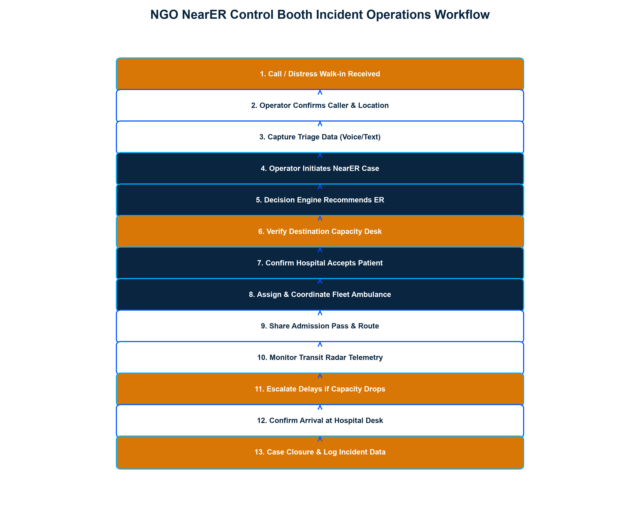
Figure: NGO NearER Control Booth Incident Operations Workflow (15 Stages)
📌 MANDATORY OPERATOR BOUNDARIES
CRITICAL SAFETY & OPERATIONAL BOUNDARIES FOR BOOTH OPERATORS:
1. DO NOT DIAGNOSE: Operators must NEVER offer clinical opinions or diagnose illnesses.
2. DO NOT PRESCRIBE: Operators must NEVER recommend pharmaceuticals or medical treatments.
3. DO NOT OVERRIDE PHYSICIANS: Clinical authority belongs 100% to hospital doctors.
4. DO NOT GUARANTEE BED AVAILABILITY: Operators report live system data, not absolute medical guarantees.
5. DO NOT DELAY STATUTORY SERVICES: Statutory emergency numbers (108/112) must be dialed immediately for critical life threats.

Section 13 — Control Booth SOP & Escalation Hierarchy
When an emergency request encounters roadblocks—such as hospital rejections, sudden bed capacity drops, or fleet delays—operators follow a strict 5-tier escalation hierarchy.
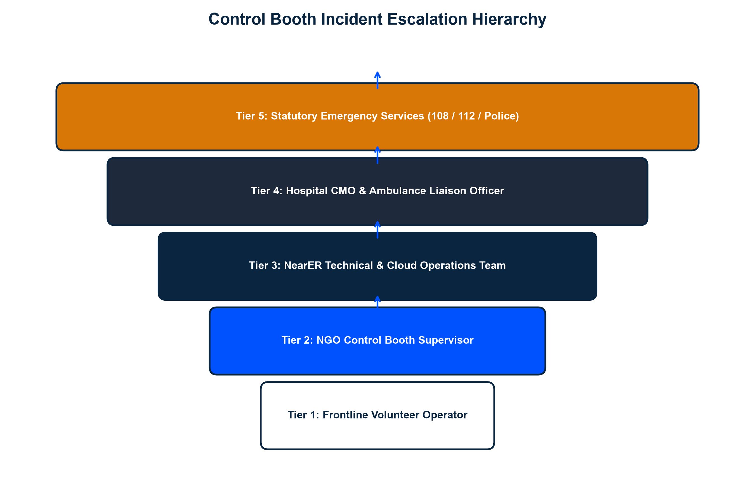
Figure: Control Booth Incident Escalation Hierarchy (Tiers 1–5)
5-Tier Escalation SOP
Tier 1: Frontline Volunteer Operator
Handles initial intake, data entry, system recommendation, and standard hospital pre-arrival notification.
Tier 2: Booth Supervisor
Escalated if Primary Hospital declines request, or if user is severely distressed and requires manual intervention.
Tier 3: NearER Technical & Operations Team
Escalated if system technical errors, app crashes, or mapping telecommunication glitches occur.
Tier 4: Hospital CMO & Ambulance Liaison
Direct institutional escalation to senior hospital medical officers when bed disputes or urgent capacity overrides occur.
Tier 5: Statutory Emergency Services (108 / 112)
Immediate escalation to government emergency services for mass casualties, crime scenes, or disaster scenarios.
Section 14 — Volunteer Training & Certification Framework
All NGO volunteer operators must complete a comprehensive 10-module training curriculum before being authorized to staff a NearER Control Booth.
10-Module Training Curriculum
Module 1: NearER Overview & Mission
Understanding the shift from nearest to nearest suitable hospital.
Module 2: Emergency Communication Etiquette
De-escalation techniques, active listening, and concise information gathering under stress.
Module 3: Patient Privacy & Data Ethics
Handling sensitive medical data, consent protocols, and confidentiality rules.
Module 4: Control Booth Dashboard Mastery
Hands-on software operation, case creation, map navigation, and logging.
Module 5: Hospital & Ambulance Coordination
Professional communication protocols when interfacing with ER desks and drivers.
Module 6: Escalation Hierarchy & SOPs
Knowing exactly when and how to escalate cases to Supervisors or 108/112.
Module 7: Handling Distressed & Hysterical Callers
Psychological first aid, staying calm, and maintaining control of the call.
Module 8: Cyber Security & Data Protection
Password safety, secure logins, auto-logout compliance, and avoiding personal device usage.
Module 9: Non-Clinical Boundaries & 'What NOT to Say'
Strict prohibition against medical advice, diagnosing, or promising outcomes.
Module 10: Simulation Exercises & Competency Audit
Live mock-emergency scenarios tested against real-time evaluation rubrics.
Section 15 — NGO and NearER Responsibility Matrix
To ensure seamless collaboration, operational responsibilities are clearly demarcated across all ecosystem partners.
ACTIVITY / DOMAIN | NearER TEAM | NGO PARTNER | HOSPITAL | AMBULANCE
Platform Software Development & Maintenance | LEAD | Support | None | None
Community Awareness & Local Campaigns | Support | LEAD | Support | Support
Control Booth Installation & Operations | Support | LEAD | None | None
Hospital Capacity Data Accuracy & Updates | Audit | None | LEAD | None
Ambulance Fleet Availability & Location | Audit | None | None | LEAD
Volunteer Recruitment & Staffing | None | LEAD | None | None
Volunteer Training & Certification | LEAD | Co-Lead | None | None
Technical Support & Cloud Hosting | LEAD | None | None | None
Hospital Onboarding & Clinical Alignment | Co-Lead | Co-Lead | LEAD | None
Clinical Decision-Making & Patient Triage | NONE | NONE | LEAD | NONE
Patient Data Privacy & Security Compliance | LEAD | Support | Support | Support
Incident Logging & Service Audit Reports | Co-Lead | Co-Lead | Support | Support

Section 16 — Data Privacy, Consent & Information Security
Patient emergency data is highly sensitive. NearER implements enterprise-grade data protection and privacy safeguards.
Minimum Necessary Data Principle
NearER collects only the data essential for emergency routing (Location, Category, Contact, Vitals/Voice Note).
Explicit User & Relative Consent
Data capture requires user authorization via app prompt or verbal phone consent logged by operators.
Role-Based Access Control (RBAC)
Hospital desks only see incoming patients; volunteers only see active booth cases; admin metrics are anonymized.
End-to-End Data Encryption
All data in transit is encrypted using TLS 1.3, and database storage is secured using AES-256 encryption.
Strict Personal Device Restrictions
Volunteer operators are strictly prohibited from recording patient details on personal phones or paper scratchpads.
Automated Session Expiry
Control Booth workstations automatically log out after 10 minutes of inactivity to prevent unauthorized access.
Section 17 — Safety, Risk Management & Fallback Protocols
A comprehensive risk management matrix identifies potential operational hazards and establishes mitigations.
RISK SCENARIO | SEVERITY | MITIGATION & FALLBACK PROTOCOL
Outdated Hospital Capacity Data | High | 30-min data freshness audit; automatic score penalty; operator manual verification call.
Mobile Network / Broadband Failure | High | Automatic 4G/5G dongle failover at booth; SMS fallback dispatch; offline directory SOP.
GPS Accuracy / Drift Errors | Medium | 3-second GPS timeout; instant 1-tap manual locality picker; landmark verification by operator.
Hospital Rejects Emergency Request | High | Engine automatically routes request to pre-calculated Backup Hospital Candidate #1.
Ambulance Fleet Unavailable | High | System immediately switches patient to Self-Transport mode with direct ER routing.
Operator Miscommunication / Error | Medium | Mandatory 10-module training certification; live booth supervisor monitoring; incident audits.
Statutory Emergency Service Conflict | Medium | NearER acts as non-clinical decision support; statutory 108/112 services are never delayed or replaced.

Section 18 — Pilot Implementation Plan & Timeline
NearER will be deployed in a controlled 6-month pilot zone to validate operational metrics before wider scaling.
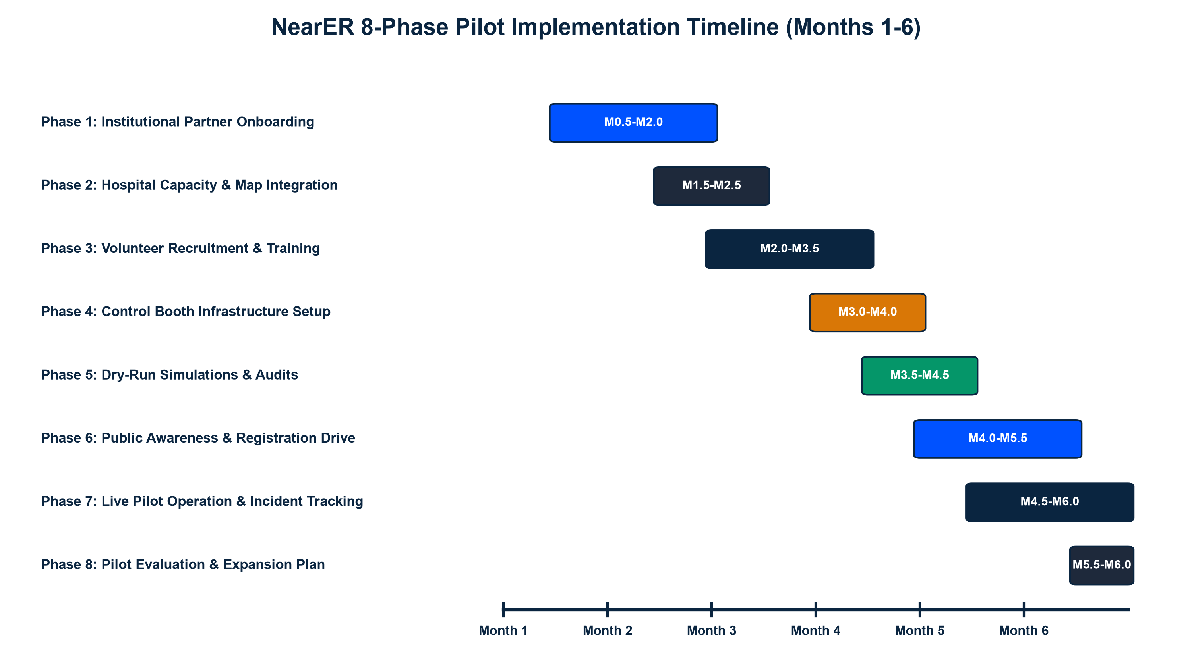
Figure: NearER 8-Phase Pilot Implementation Timeline (Months 1–6)
Baseline Target Metrics for Pilot Phase
METRIC CATEGORY | PILOT BASELINE TARGET
Participating Hospitals Onboarded | 3 to 5 Verified Tertiary & Secondary Hospitals
Emergency Ambulance Units Mapped | 5 to 10 ALS / BLS Ambulance Fleets
NGO Control Booths Established | 1 to 3 Operational Community Help Desks
Trained & Certified NGO Volunteers | 10 to 20 Operator Candidates
Community Awareness Reach | 500 to 1,000 Citizens Registered & Educated
Target Pilot Region | Designated Urban / Suburban Municipal Zone

Section 19 — NGO Community Promotion & Awareness Campaigns
The NGO partner leads creative, high-impact public awareness campaigns under responsible messaging guidelines.
Core Campaign Themes
Campaign 1: 'Know Before the Emergency'
Focuses on pre-registering family blood groups, emergency contacts, and allergies into the NearER profile.
Campaign 2: 'Right Hospital. Right Time.'
Educates citizens on why going to the nearest hospital can cause dangerous delays if beds or specialists are lacking.
Campaign 3: 'Emergency Preparedness with NearER'
Community workshops teaching youth, college students, and society leaders how to trigger SOS requests.
📌 PUBLIC MESSAGING GUIDELINES
RESPONSIBLE MESSAGING RULES:
• NEVER claim: 'NearER guarantees to save every life.'
• ALWAYS claim: 'NearER is designed to reduce avoidable emergency coordination delays.'
• ALWAYS emphasize that clinical medical treatment is delivered by qualified hospital doctors.

Section 20 — Measurable Key Performance Indicators (KPIs)
Program success is evaluated across four quantitative metric domains.
DOMAIN | KEY PERFORMANCE INDICATOR (KPI) | TARGET BENCHMARK
Community Outreach | Citizens Reached in Awareness Campaigns | >= 1,000 Citizens in Pilot Zone
User Adoption | NearER App Profiles Registered & Pre-filled | >= 500 Pre-registered Profiles
Operational Speed | Average Decision Engine Hospital Search Time | < 2.0 Seconds per Request
Hospital Responsiveness | Hospital Control Desk Acknowledgment Rate | >= 90% Case Review within 60s
Data Quality | Hospital Capacity Data Freshness Compliance | >= 85% Updated within 30 mins
Control Booth Impact | Assisted Emergency Requests Handled by Booth | 100% Logged with Zero Errors
User Satisfaction | Patient & Relatives System Satisfaction Rating | >= 85% Positive Feedback Score

Section 21 — Long-Term Vision & Scalability Roadmap
NearER is designed to scale progressively from a local municipal pilot into a state and national emergency coordination grid.
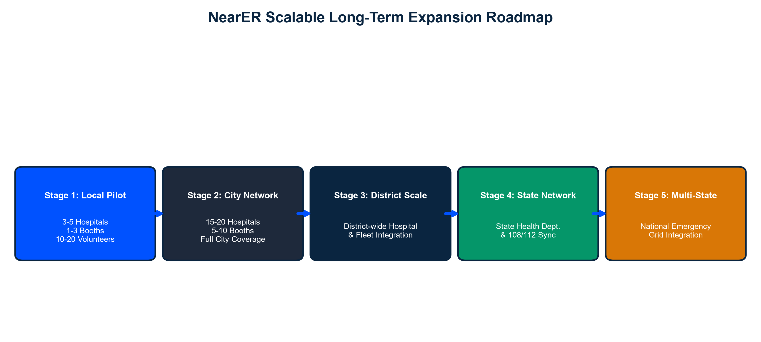
Figure: NearER Scalable Long-Term Expansion Roadmap (Stages 1–5)
*Note: Multi-state and governmental integration phases require formal regulatory, healthcare authority, and institutional approvals.
Section 22 — Expected Social Impact Assessment
NearER delivers profound social return on investment (SROI) across public health ecosystems:
Reduction in Avoidable Hospital Ping-Ponging
Prevents critical trauma and cardiac patients from being turned away at full emergency rooms.
Golden Hour Optimization
Saves an estimated 20–45 minutes in initial emergency response and hospital placement.
Democratized Health Access for Senior Citizens
NGO Control Booths ensure digitally inexperienced and elderly citizens receive equal access to emergency coordination.
Optimized Resource Utilization for Hospitals
Distributes emergency patient load evenly across municipal networks, preventing single-hospital congestion.
Section 23 — Official Partnership Proposal & Invitation to NGO
We formally invite your esteemed organization to join NearER as an official institutional partner.
📌 OFFICIAL DESIGNATION OFFER
PROPOSED NGO PARTNER DESIGNATION:
“NearER Community Outreach & Emergency Coordination Partner”

Bilateral Contributions Matrix
NearER PLATFORM CONTRIBUTIONS | NGO PARTNER CONTRIBUTIONS
Complete NearER Cloud Software & Mobile Apps | Community Volunteer Mobilization & Staffing
Control Booth Web Dashboard Access | Control Booth Physical / Office Location Space
10-Module Volunteer Training Curriculum & Materials | Local Community Awareness & School/College Drives
24/7 Technical Support & Cloud Server Maintenance | Hospital & Local Ambulance Network Introductions
Promotional Banners, Digital Graphics & Flyer Templates | Field Feedback, Audit Logging & Service Monitoring
Executive Analytics & Social Impact Audit Reports | Support for Elderly & Non-Digital Citizens

ACCEPTED & ENDORSED BY NEARER TEAM | ACCEPTED & ENDORSED BY NGO PARTNER
Signature: ___________________________  Name: NearER Project Directorate  Title: Chief Operations Officer  Date: September 23, 2026 | Signature: ___________________________  Name: _________________________________  Title: Executive Director / Secretary  Date: _________________________________

