TABLE OF CONTENTS

|  |  |  |
| --- | --- | --- |
| **S.N** | **Title** | **Page no.** |
| 1. | Objective of the Hospital Training | 1 |
| 2. | Introduction to Hospital | 2 |
| 3. | Wards in Hospital | 3 |
| 4. | Dispensary | 4 |
| 5. | OPD | 5 |
| 6. | Emergency ward | 6 |
| 7. | Injection room | 8 |
| 8. | Dental ward | 9 |
| 9. | First aid | 10 |
| 10. | Wound dressing | 13 |
| 11. | Artificial respiration | 15 |
| 12. | Route of Injection | 17 |
| 13. | Prescription | 22 |
| 14. | Problems encounter during the Training | 22 |
| 15. | Summary | 22 |
| 16. | Future Plan | 23 |
| 17. | Observation | 24 |
| 18. | Work Profile | 25 |
| 19. | Conclusion | 26 |
| 20. | References | 27 |

# OBJECTIVES OF HOSPITAL TRAINING

* Develop a strong foundation in pharmaceutical sciences and clinical pharmacy practices.
* Acquire hands-on experience in drug dispensing, compounding, and dosage calculations.
* Enhance communication skills for effective interaction with patients and other healthcare professionals.
* Learn to provide medication counselling and education to patients regarding proper drug use.
* Gain proficiency in medication management and optimization.
* Develop the ability to make evidence-based decisions in collaboration with the healthcare team.
* Understand and implement quality assurance measures in pharmacy services.
* Learn about medication safety, error prevention, and adverse event reporting.
* Familiarize with pharmacy information systems and electronic health records.
* Acquire knowledge and skills related to infection control in pharmacy practice.
* Understand the role of pharmacists in preventing the spread of infectious diseases.
* Participate in medication therapy management services.
* Collaborate with healthcare providers to optimize medication regimens for patients.
* Emphasize the importance of continuous learning and professional development.
* Stay updated on new drugs, treatment guidelines, and emerging trends in pharmacy.
* Reinforce adherence to ethical standards and legal regulations in pharmacy practice.
* Promote engagement in research activities related to pharmacy and healthcare.
* Develop an understanding of pharmacy administration and management principles.
* Learn about inventory control, budgeting, and other aspects of pharmacy operations.
* Provide culturally sensitive and patient-centered care.

# INTRODUCTION TO HOSPITAL (CHC ITAUNJA)

Community Health Centre BKT is a government healthcare centre situated at the BAKSHI KA TALAB (BKT) of the Lucknow. It is focused on the treatment of the patients especially focused and blessed for the poor and needy people. People come to the hospital and get treated well. All the staffs and the doctors are very friendly and are very helpful. The hospital is always kept clean and sanitized to eradicate the spread of disease, bacteria, pathogens and dust.

The hospital has several departments such as eye care department, dental department, Out Patient Department (OPD), emergency department, pathology, X-ray, etc. These all departments work well and are open for most of the days of the week.

The emergency department is the most crowded department of the hospital. It is crowded all the day and sometimes even in the night.

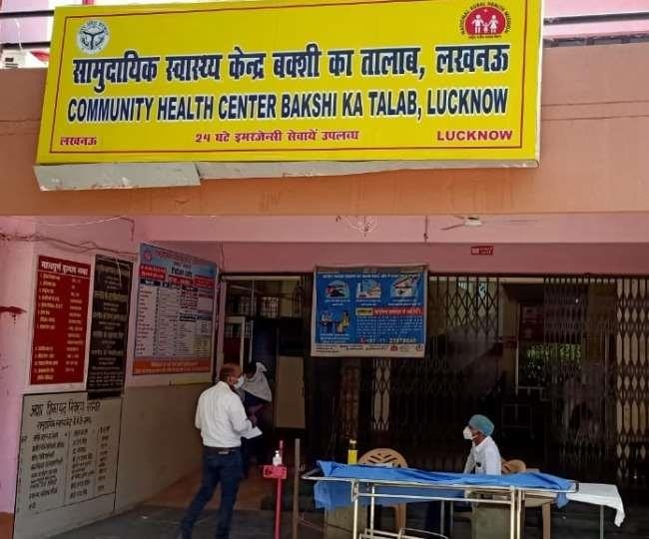

Figure no. 1 - CHC Hospital

# WARDS IN HOSPITAL (CHC ITAUNJA)

* + Dispensary
  + OPD
  + General Ward
  + Emergency Ward
  + Paediatric Ward
  + Dental Ward
  + Eye care Ward
  + Injection Room
  + Rabies Vaccination
  + Dressing Room
  + Pathology
  + X-Ray

# DISPENSARY

* A dispensary is defined as the main area where the dispensing of drug takes place. It is mainly present for OPD patients.
* The various drugs are being distributed here on the basis of their prescription written by doctors.
* There are 3 pharmacists always in the dispensary and there are two windows each for a man and women.
* 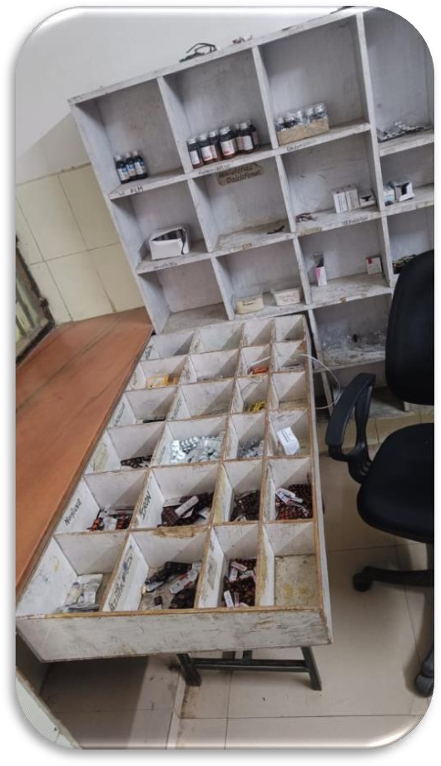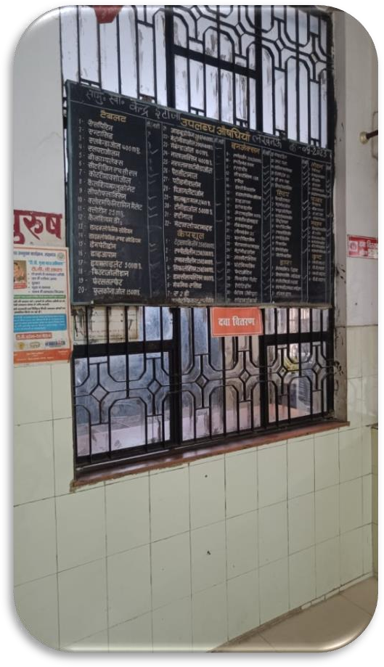The distribution of the drugs in the district hospital is for free of cost.

Figure no. 02 - Dispensary The various drugs that are being distributed are:-

* 1. Paracetamol tablet and syrup,
  2. Iron tablets,
  3. Calcium tablets,
  4. Vitamin- B complex tablets,
  5. Ranitidine tablet and injection, 6. Diclofenac cream and injection,

7. Tramadol injection, etc.

# OUT PATIENT DEPARTMENT (OPD)

* + - OPD is the place where the doctors examine and interact with the patient to know about their health issues and then prescribe the medicines to treat that health condition.
    - In CHC bkt, two doctors are always ready to prescribe the medicines.
    - The doctors are of MBBS and MD level.
    - They examine and interact with the patient in a very friendly and convenient way.
    - They are available from 9 to 3 every day.
    - The OPD is designed for diagnosis, Diagnostic tests, and minor surgical services for patients that do not have to be admitted to the hospital. Doctors from different departments like that of gynaecology, Orthopaedics, general medicine, among others, are available in the OPD.

•

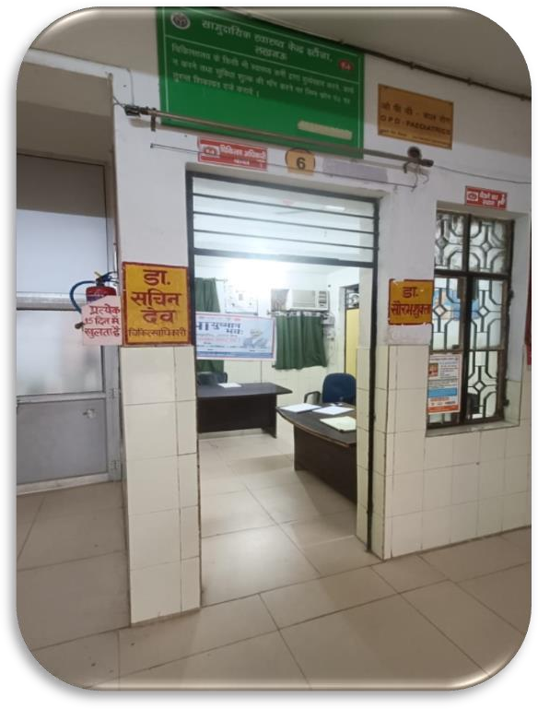

Figure no. 3- OPD

# EMERGENCY WARD

* + - The emergency ward is the place where the patients of medical emergency are being treated.
    - A doctor is always available there for the medical emergency along with nurses and interns.
    - In emergency ward, the facilities like injection, dressing, acute care and proper medication at proper time are given.
    - The doctors in the emergency ward are very punctual to his work and treat patients in a very good manner.
    - There are always 2 nurses or interns available for the service.

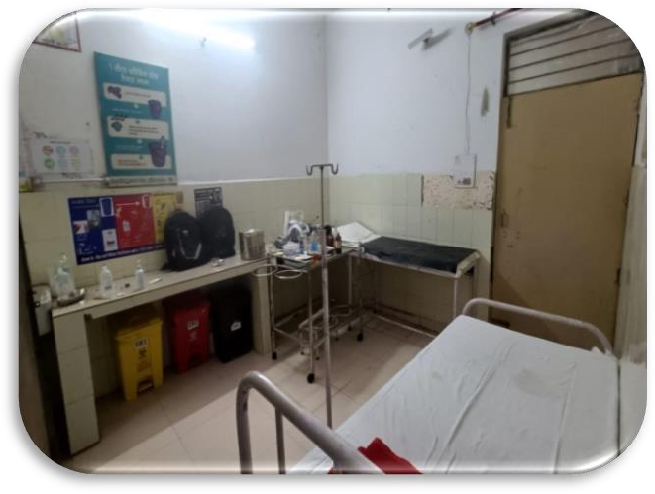

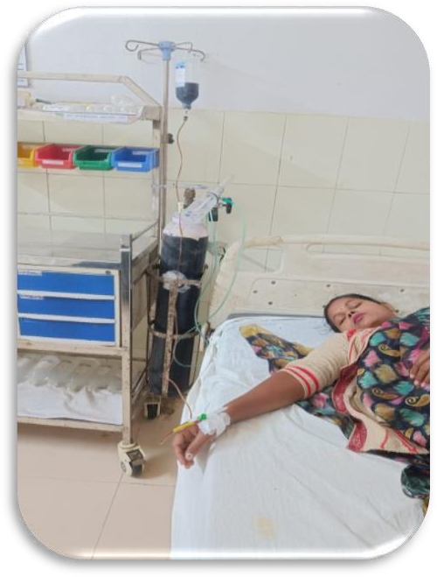

Figure no. 4 – Emergency Ward

# INJECTION ROOM

* + - Injection room is the place where injections are being administered to the patient as per the prescription by the doctors.
    - The injection room is kept clean, sterilized and a trained staff is always there for the patients.
    - There are a number of injections kept in the injection room such as Diclofenac, Ranitidine, Tramadol, Furosemide, Paracetamol, etc.
    - Some more injections are there but kept in the refrigerator.

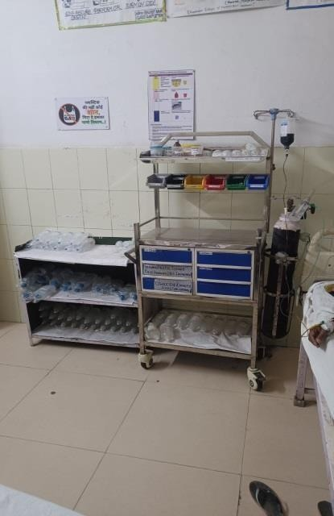

Figure no. 5- Injection Room

# DENTAL WARD

* + - A dental ward is a place in a hospital where dentists and dental care professionals work to help people with their teeth.
    - It's like a special area just for taking care of teeth and gums.
    - Here, dentists check teeth for problems, clean them, and fix issues like cavities or toothaches.
    - Sometimes, people come to the dental ward for regular check-ups, and other times they might need extra help for specific dental problems.
    - The dental ward is a friendly place where the goal is to keep everyone's smiles healthy and happy!

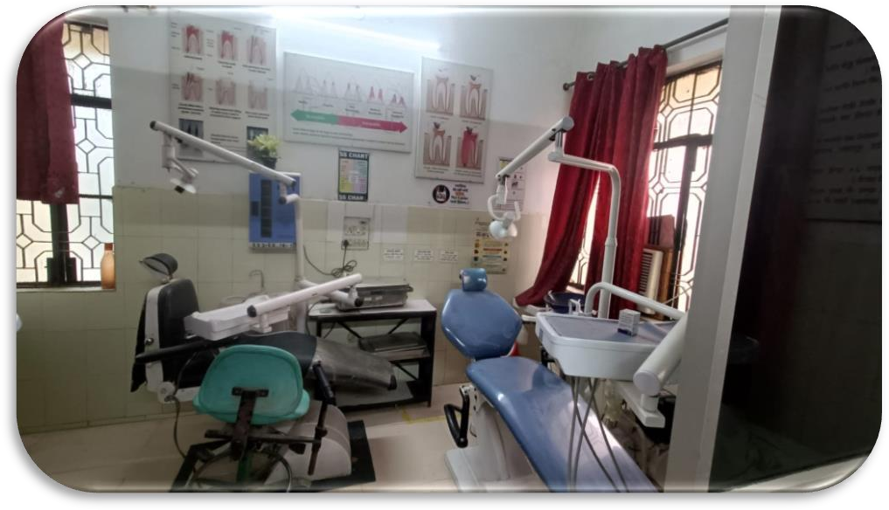

Figure no. 6 - Dental ward

*Dentist on the ward* is an excellent guide for recently qualified dentists preparing for work as a dental core trainee (DCT) within an oral and maxillofacial surgery unit. In this ninth edition, six chapters have been updated to reflect changes in the practice of oral and

maxillofacial surgery. This book outlines the professional landscape DCTs will find

themselves working in, and their expected roles & responsibilities within hospital system. Key medical & surgical theory is briefly outlined, however, there is insufficient scope and detail for anyone more advanced within the speciality.

# FIRST AID

First aid is the assistance given to any person suffering a sudden illness or injury, with care provided to preserve life, prevent the condition from worsening, and/or promote recovery. It includes initial intervention in a serious condition prior to professional medical help being available, such as performing CPR while awaiting an ambulance, as well as the complete treatment of minor conditions, such as applying a plaster to a cut. First aid is generally performed by the layperson, with many people trained in providing basic levels of first aid, and others willing to do so from acquired knowledge. Mental health first aid is an extension of the concept of first aid to cover mental health.

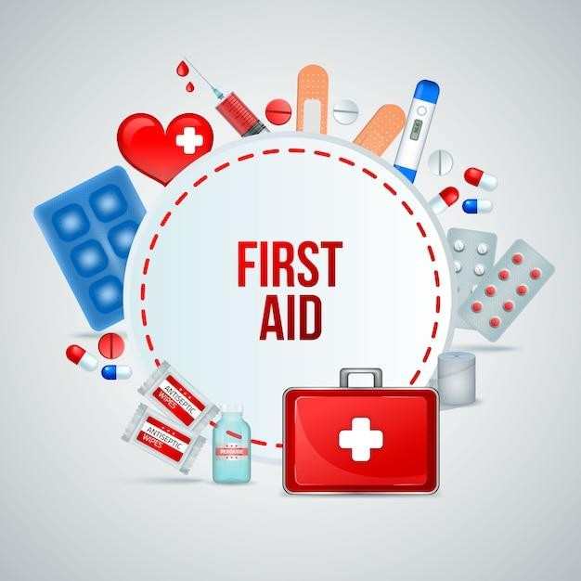

# Aims of First Aid: -

Figure no. 7 – First Aid

The key aims of first aid can be summarized in three key points, sometimes known as ‘the three P’s.’

* + - **Preserve life**: the overriding aim of all medical care, including first aid, is to save lives

and minimize the threat of death.

* + - **Prevent further harm**: also, sometimes called prevent the condition from worsening, Or
    - Danger of further injury: this covers both external factors, such as moving a patient away from any cause of harm, and applying first aid techniques to prevent worsening of the condition, such as applying pressure to stop a bleed becoming dangerous.
    - **Promote recovery**: first aid also involves trying to start the recovery process from the illness or injury, and in some cases might involve completing a treatment such as in the case of applying a plaster to a small wound.

# Training: -

Basic principles, such as knowing to use an adhesive bandage or applying direct pressure on a bleed, are often acquired passively through life experiences. However, to provide effective, lifesaving first aid interventions requires instruction and practical training. This is especially true where it relates to potentially fatal illnesses and injuries, such as those that require cardiopulmonary resuscitation (CPR); these procedures may be invasive, and carry a risk of further injury to the patient and the provider. As with any training, it is more useful if it occurs before an actual emergency, and in many countries, emergency ambulance dispatchers may give basic first aid instructions over the phone while the ambulance is on the way.

Training is generally provided by attending a course, typically leading to certification. Due to regular changes in procedures and protocols, based on updated clinical knowledge, and to maintain skill, attendance at regular refresher courses or re-certification is often necessary.

# Conditions that often require first aid: -

* Altitude sickness, which can begin in susceptible people at altitudes as low as 5,000 feet, can cause potentially fatal swelling of the brain or lungs
* Anaphylaxis, a life-threatening condition in which the airway can become constricted and the patient may go into shock. The reaction can be caused by a systemic allergic reaction to allergens such as insect bites or peanuts. Anaphylaxis is initially treated with injection of epinephrine.
* Battlefield first aid-This protocol refers to treating shrapnel, gunshot wounds, burns, bone fractures, etc. as seen either in the traditional battlefield setting or in an area subject to damage by large-scale weaponry, such as a bomb blast.
* Bone fracture, a break in a bone initially treated by stabilizing the fracture with a splint.
* Bums, which can result in damage to tissues and loss of body fluids through the burn site
* Cardiac Arrest, which will lead to death unless CPR preferably combined with an AED, is started within minutes. There is often no time to wait for the emergency services to arrive.
* Choking, blockage of the airway which can quickly result in death due to lack of oxygen if the patient's trachea is not cleared.
* Childbirth.
* Cramps in muscles due to lactic acid build up caused either by inadequate oxygenation of muscle or lack of water or salt.
* Diving disorders, drowning or asphyxiation.
* Gender-specific conditions, such as dysmenorrhea and testicular torsion. Heart attack or inadequate blood flow to the blood vessels supplying the heart muscle.
* Heat stroke, also known as sunstroke or hyperthermia, which tends to occur during heavy exercise in high humidity, or with inadequate water, though it may occur spontaneously in some chronically ill persons. Sunstroke, especially when the victim has been unconscious, often causes major damage to body systems such as brain, kidney, liver, gastric tract. Unconsciousness for more than two hours usually leads to permanent disability. Emergency treatment involves rapid cooling of the patient.
* Hair tourniquet a condition where a hair or other thread becomes tied around a toe or finger tightly enough to cut off blood flow.
* Heat syncope, another stage in the same process as heat stroke, occurs under similar conditions as heat stroke and is not distinguished from the latter by some authorities.
* Hypothermia, or Exposure, occurs when a person's core body temperature falls below 33.7° C (92.6 °F). First aid for a mildly hypothermic patient includes rewarming which can be achieved by wrapping the affected person in a blanket, and providing warm drinks, such as soup, and high energy food, such as chocolate. However, rewarming a severely hypothermic person could result in a fatal arrhythmia, an irregular heart rhythm.
* Insect and animal bites and stings.
* Joint dislocation.
* Poisoning can occur by injection, inhalation, absorption, or ingestion.
* Seizures or a malfunction in the electrical activity in the brain.
* Muscle strains and Sprains, a temporary dislocation of a joint that immediately reduces automatically but may result in ligament damage.
* Stroke, a temporary loss of blood supply to the brain.
* Toothache, which can result in severe pain and loss of the tooth but is rarely life- threatening, unless over time the infection spreads into the bone of the jaw and starts osteomyelitis.

•

# WOUND DRESSING

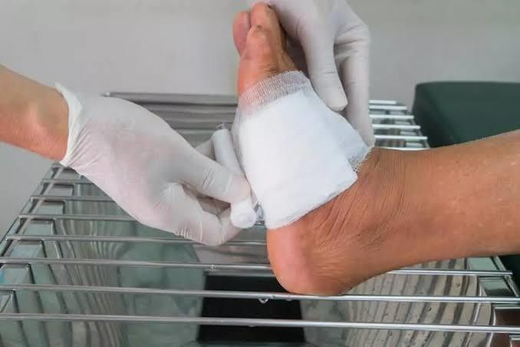A dressing is a sterile pad or compress applied to a wound to promote healing and/or prevent further harm. A dressing is designed to be in direct contact with the wound, as distinguished from a bandage, which is most often used to hold a dressing in place. Some organizations classify them as the same thing. Dressings are frequently used in first aid and nursing.

Figure no. 8 - Wound dressing

# Core purposes of a dressing: -

A dressing can have a number of purposes, depending on the type, severity and position of the wound, although all purposes are focused towards promoting recovery and preventing further harm from the wound. Key purposes of a dressing are:

* Stem bleeding to help to seal the wound to expedite the clotting process;
* Absorb exudate - to soak up blood, plasma, and other fluids exuded from the wound, containing it/them in one place;
* Ease pain to have an actual pain-relieving effect, whereas some others may have a placebo effect:
* Debride the wound to remove slough and foreign objects from the wound;
* Protection from infection damage; to defend the wound against germs and mechanical
* Promote healing to contribute to recovery via granulation and epithelialization, and
* Reduce psychological stress to obscure a healing wound from the view of others.

# Types of Dressing: -

Various types of dressings can be used to accomplish different objectives including:

* Controlling the moisture content, so that the wound stays moist or dry. An example of a moisture-retaining dressing is Aquacel, which is a "hydro Fiber" that is indicated, for example, for partial- thickness burns.
* Protecting the wound from infection;
* Removing slough; and
* Maintaining the optimum pH and temperature to encourage healing.
* Occlusive dressings, made from substances impervious to moisture such as plastic or latex,

can be used to increase the rate of absorption of certain topical medications into the skin.

# Usage of dressings: -

Applying a dressing is a first aid skill, although many people undertake the practice with no training

* Especially on minor wounds. Modern dressings will almost all come in a prepackaged sterile wrapping, date coded to ensure sterility. This is because it will come in to direct contact with the wound, and sterility is required to fulfil the 'protection from infection' aim of a dressing.
* Historically, and still the case in many less developed areas and in an emergency, dressings are often improvised as needed. This can consist of anything, including clothing or spare material, which will fulfil some of the basic tenets of a dressing usually stemming bleeding and absorbing exudate.
* Applying and changing dressings is one common task in nursing.
* An "ideal" wound dressing is one that is sterile, breathable, and conducive for a moist healing environment. This will then reduce the risk of infection, help the wound heal more quickly, and reduce scarring.

# ARTIFICIAL RESPIRATION

Artificial respiration is the act of assisting or stimulating respiration, a metabolic process referring to the overall exchange of gases in the body.

# Cardiopulmonary resuscitation: -

Cardiopulmonary resuscitation, commonly known as CPR, is an emergency procedure performed in an effort to manually preserve intact brain function until further measures are taken to restore spontaneous blood circulation and breathing in a person who is in cardiac arrest. It is indicated in those who are unresponsive with no breathing or abnormal breathing. According to the International Liaison Committee on Resuscitation guidelines, CPR involves chest compressions for adults between 5 cm (2 in) and 6 cm (2in) deep and at a rate of at least 100 to 120 per minute. The rescuer may also provide breaths by either exhaling into the subject's mouth or nose or using a device that pushes air into the subject's lungs. This process of externally providing ventilation is termed artificial respiration. Current recommendations place emphasis on high-quality chest compressions over artificial respiration; a simplified CPR method involving chest compressions only is recommended for untrained rescuers.

CPR alone is unlikely to restart the heart. Its main purpose is to restore partial flow of oxygenated blood to the brain and heart. The objective is to delay tissue death and to extend the brief window of opportunity for a successful resuscitation without permanent brain damage. Administration of an electric shock to the subject's heart, termed defibrillation, is usually needed in order to restore a viable or "perfusing" heart rhythm. Defibrillation is effective only for certain heart rhythms, namely ventricular fibrillation or pulseless ventricular tachycardia, rather than asystole or pulseless electrical activity. CPR may succeed in inducing a heart rhythm that may be shockable. In general, CPR is continued until the patient has a return of spontaneous circulation (ROSC) or is declared dead, or until there is no rescuer physically able to continue (CPR can be found exhausting).

# Medical uses: -

CPR is indicated for any person unresponsive with no breathing or breathing only in occasional agonal gasps, as it is most likely that they are in cardiac arrest. If a person still has a pulse but is not breathing (respiratory arrest) artificial respirations may be more appropriate, but, due to the difficulty people have in accurately assessing the presence or absence of a pulse, CPR guidelines recommend that lay persons should not be instructed to check the pulse, while giving

healthcare professionals the option to check a pulse. In those with cardiac arrest due to trauma, CPR is considered futile but still recommended. Correcting the underlying cause such as a pneumothorax or pericardial tamponade may help.

# Effectiveness: -

CPR serves as the foundation of successful cardiopulmonary resuscitation, preserving the body for defibrillation and advanced life support. Even in the case of a "non-shockable" rhythm, such as Pulse less Electrical Activity (PEA) where defibrillation is not indicated, effective CPR is no less important.

# Methods: -

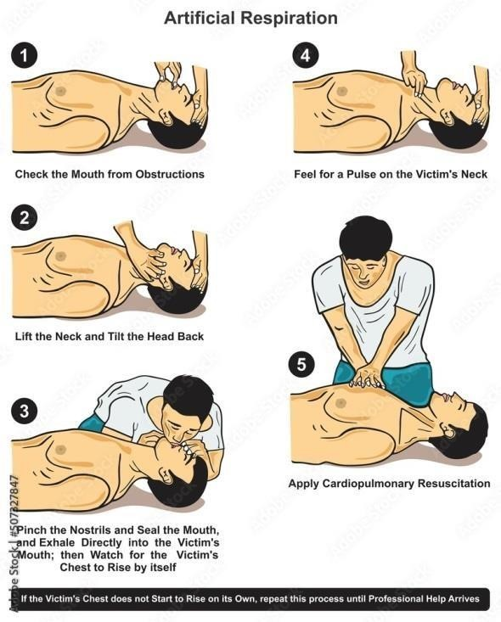

**Complications: -**

Figure no. 9 - respiration step

* While CPR is a last resort intervention, without which a person without a pulse will all but certainly die, the physical nature of how CPR is performed does lead to complications that may need to be rectified. Common complications due to CPR are rib fractures, sternal fractures, bleeding in the anterior mediastinum, heart contusion, [15] hemopericardium, upper airway complications, damage to the abdominal viscus lacerations of the liver and spleen, fat emboli, pulmonary complications pneumothorax, hemithorax, lung contusions.

# ROUTE OF INJECTION

**Parenteral Route : - Advantages: -**

Parenteral route includes 1. Parenteral route is rapid.

Injections 2. It is useful for uncooperative patients

1. Intra muscular 3. It is useful for unconscious patients
2. Intra venous 4. Inactivation by GIT enzymes is avoided
3. Intra-arterial 5. First pass effect is avoided
4. Intra-cardiac 6. Bioavailability is 100% 5. Intra-thecal
5. Intraosseous (into bone marrow) **Disadvantages: -**
6. Intrapleural 1. Skill is required
7. Intraperitoneal 2. It is painful
8. Intra-articular 3. This method is expensive
9. Intradermal (Intracutaneous) 4. It is less safe.
10. 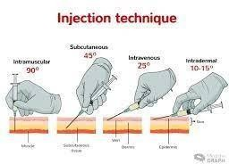Subcutaneous route (Hypodermic)

Figure no. 10 - Route of Injection

# Classification: -

1. Subcutaneous - Subcutaneous route might be used for the arm, forearm, thigh and subscapular space. The volume used is 2 ml. Insoluble suspensions like insulin and solids might be applied by this route.

Advantages

* 1. Absorption is slow and constant
  2. It is hygienic Disadvantages

1. It might lead to abscess formation 2. Absorption is limited by blood flow

Examples of drugs given by subcutaneous route include insulin, adrenaline and nor plant.

1. Intramuscular route - Intramuscular route might be applied to the buttock, thigh and deltoid. The volume used is 3 ml.

Advantages

* 1. Oily preparations can be used.
  2. Irritative substances might be given
  3. Slow releasing drugs can be given by this route. Disadvantages - Using this route might cause nerve or vein damage.

1. Intravenous injections- Intravenous injections might be applied to the cubital, basilic and cephalic veins.

# Advantages: -

* 1. Immediate action takes place
  2. This route is preferred in emergency situations
  3. This route is preferred for unconscious patients.
  4. Titration of dose is possible.
  5. Large volume of fluids might be injected by this route
  6. Diluted irritant might be injected
  7. Absorption is not required
  8. No first pass effect takes place.
  9. Blood plasma or fluids might be injected

# . Disadvantages: -

1. There is no retreat
2. This method is more risky
3. Sepsis-Infection might occur
4. Phlebitis (Inflammation of the blood vessel) might occur
5. Infiltration of surrounding tissues might result.
6. This method is not suitable for oily preparations
7. This method is not suitable for insoluble preparations
8. Intraarterial route- This method is used for chemotherapy in cases of malignant tumours and in angiography.
9. Intradermal route- This route is mostly used for diagnostic purposes and is involved in: Schick test for Diphtheria, Dick test for scarlet fever

Vaccines include DBT, BCG and polio Sensitivity is to penicillin

1. Intracardiac route- Injection can be applied to the left ventricle in case of cardiac arrest.
2. Intrathecal route- Intrathecal route involves the subarachnoid space. Injection may be applied for the lumbar puncture, for spinal anaesthesia and for diagnostic purposes. This technique requires special precautions.
3. Intra-articular route Intra-articular route involves injection into the joint cavity. Corticosteroids may be injected by this route in acute arthritis.
4. Intraperitoneal route Intraperitoneal route may be used for peritoneal dialysis.
5. Intrapleural route- Penicillin may be injected in cases of lung empyema by intrapleural route.
6. Injection into bone marrow- This route may be used for diagnostic or therapeutic purposes.

# Hypo spray /Jet Injection: -

This method is needleless and is subcutaneous done by applying pressure over the skin. The drug solution is retained under pressure in container called gun '. It is held with nozzle against the skin. Pressure on the nozzle allows a fine jet of solution to emerge with great force. The solution can penetrate skin and subcutaneous tissue to variable depth as determined by the

pressure. Mass inoculation is possible but the method is expensive, definite skills are required and cuts might result.

# Intramuscular injection: -

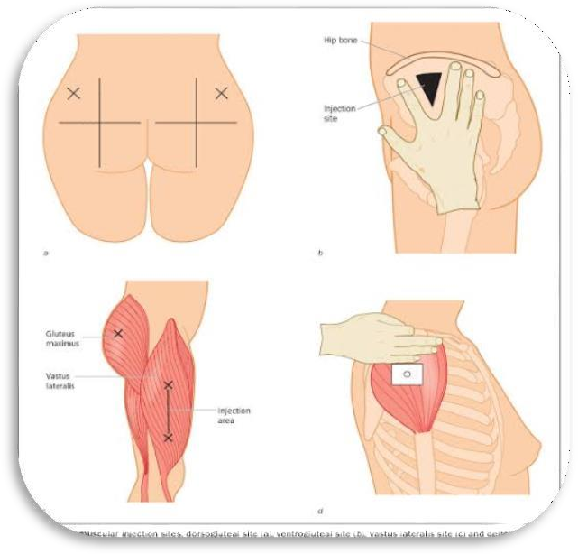Intramuscular (also IM or im) injection is the injection of a substance directly into a muscle. In medicine, it is one of several alternative for methods the administration of medications (see route of administration). It is used for particular forms of medication that are administered in small volumes. Depending on the chemical properties of the drug, the medication may either be absorbed fairly quickly or more gradually. Muscles have larger and more blood vessels than subcutaneous tissue and injections here usually have faster rates of absorption than subcutaneous injections or intradermal injections. Depending on the injection site, an administration is limited to between 2 and 5 millilitres of fluid.

Figure no. 11 - IM injection

# Injection sites:-

Sites that are bruised, tender, red, swollen, inflamed or scarred are avoided. [1] Intramuscular injections are often given in the deltoid muscle of the arm, the vastuslateralis muscle of the leg, and the ventrogluteal and dorsolateral muscles of the buttocks.

**Intravenous: -**

The IV route carries the greatest risk of any route of drug administration. By administering directly into the systemic circulation, either by direct injection or infusion, the drug is

instantaneously distributed to its sites of action. This route of administration can be complex and confusing. It may require dose calculations, dilutions, information to be gathered on administration rates and compatibilities with other IV solutions, as well as the use of programmable infusion devices.

The preparation of IV medicines requires the use of an aseptic technique, often in a ward environment that is unsuited to such work. To minimize the risk of errors, it is imperative that practitioners can demonstrate competence to practice safely, and have access to expert information and advice.

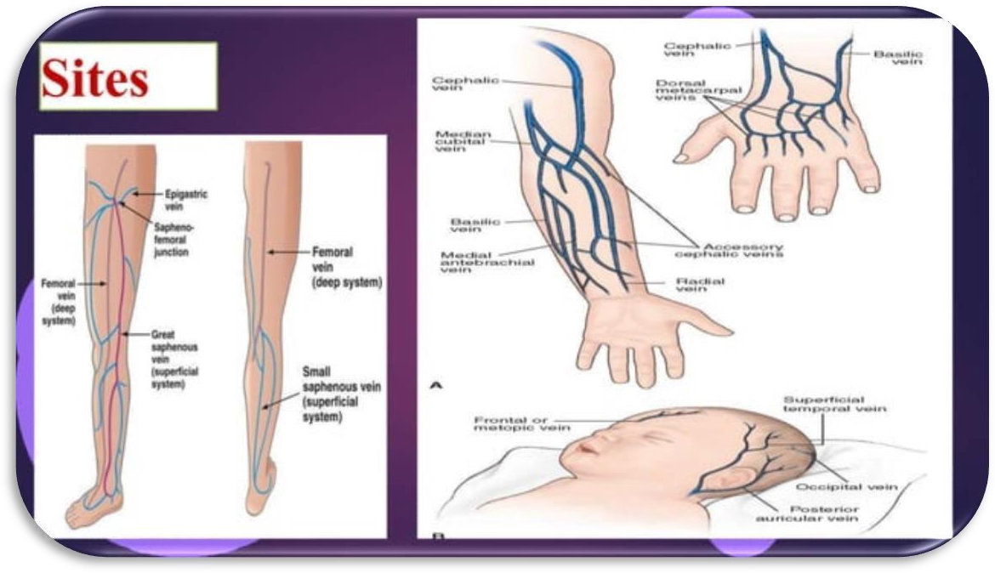

Figure NO. 12 - IV route

## Considerations for IV administration; -

* Is the drug suitable for preparation on the ward or should it be prepared in the pharmacy?
* Does the drug require initial dilution? What diluent and volume?
* Does the drug require further dilution? What diluent and volume? • Is the drug suitable for direct injection or to be infused over time?
* Over what length of time can it be administered?
* Is an infusion device required?
* Is the drug compatible with other drugs or fluids to be administered at the same time?
* Does the drug cause a local reaction?
* Is any monitoring required during or after administration.

# PRESCRIPTION

A prescription, sometimes called doctor's orders, is a health-care program implemented by a physician or other qualified health care practitioner in the form of instructions that govern the plan of care for an individual patient. The term often refers to a health care provider's written authorization for a patient to purchase a prescription drug from a pharmacist.

## Format and definition

Prescriptions may be entered into an electronic medical record system and transmitted electronically to a pharmacy. Alternatively, a prescription may be handwritten on preprinted prescription forms that are assembled into pads, or printed onto similar forms using a computer printer.

R is a symbol meaning "prescription". It is sometimes transliterated as " R{x} " or just "Rx". This symbol originated in medieval manuscripts as an abbreviation of the Late Latin verb recipe, the imperative form of recipe, "to take" or "take thus". Literally, the Latin word recipe means simply "Take...." and medieval prescriptions invariably began with the command to "take" certain materials and compound them in specified ways.

The word "prescription", from "pre-" ("before") and "script" ("writing, written"), refers to the fact that the prescription is an order that must be written down before a compound drug can be prepared. Those within the industry will often call prescriptions simply "scripts" Folk theories about the origin of the symbol A note its similarity to the Eye of Horus, or to the ancient symbol for Zeus or Jupiter, (2), gods whose protection may have been sought in medical contexts.

## Contents

Many brand name drugs have cheaper generic drug substitutes that are therapeutically and biochemically equivalent. Prescriptions will also contain instructions on whether the prescriber will allow the pharmacist to substitute a generic version of the drug. This instruction is communicated in a number of ways. Prescriptions often have a "label" box. When checked, the pharmacist is instructed to label the medication. When not checked, the patient only receives instructions for taking the medication and no information about the prescription itself.

# PROBLEMS ENCOUNTER DURING THE TRAINING

There are different problem which I had faced during training period: -

1. It’s tough to handle children, as they are not cooperative throughout the treatment.
2. Most of the patients are illiterate, so were unable to understand the medicine use and forgot their doses.
3. If medicines were finished in the stock, so, immediate supply of the drug in the dispensary was not there.
4. In emergency, patients were allowed to wear oxygen mask, So, sometimes they didn't wear that musk, so difficulty in the treatment was there.
5. Patient thought that, the staff was giving wrong drugs and the wrong treatment.

# SUMMARY

After 1 month of hospital training, I came to learn about how to dispense medicines to the patient, how to inject injections to them, how to handle trauma and emergency cases. I also learn about dealing with hospital conditions like diseases of the patients, wards, staff members, different departments, etc. Almost 2000 of prescriptions were received by the dispensary and we have to treat them with full hospitality services.

# FUTURE PLAN

As I had completed my hospital training from District Hospital So, I can use my knowledge in medical field. For ex- if I will be posted in rural area, and if there is no doctor at the time of emergency, So, I'll be able to handle the situation by giving proper treatment to the patient at the time. Another thing that I had learnt in my training period about the whole procedure of the hospital starting from admitting the patient up to their treatment.

# OBSERVATION

Thus, I observed that the hospital a place where people of all kinds come with their problems which they believe to be solved by the medical staff. The working in the hospital takes place by maintaining proper cleanliness in the environment. The staff and the doctors are all hostile and good-natured towards the patients and listen to their problems. Each and every department has its own way of working and at the end of the day, all of the work is finished by it. There is no carelessness towards the patients for their drugs or injections and they are treated on time. The nursing staffs are present at all times for their care. This type of methodology should really be applicable in all hospitals so that the public may get treated once and for all to maintain a beakly country.

# WORK PROFILE

I work in one shift during my training period. I worked at 2:00 pm to 5:00 pm for 45 days.

I worked in the emergency, OPD and dispensing departments one by one to gather knowledge and skills of all of them. I learned social skills along with the working skills to interact nicely with the patients and their guardians. In my working area, I used to be too friendly with the staff and the patients making it easier for me to complete my training in a very excitement way.

# CONCLUSION

The training in a hospital gives us a conclusion that the training in the hospital was really necessary as it not only helped us to see how a hospital operates, but it also helped me to learn basic functions of it like first aid care, how to give injections and dispensing of drugs etc. The conclusion drawn out can be that I have finally learned as to how important role a hospital plays in peoples' lives and that the hospital staff can go to any means to save them since its their duty. Since District Hospital receives only I rupees per patient, so it also shows us their good deed towards mankind and to their service.

# REFERENCES

* 1. First aid manual: 9th edition. Dorling Kindersley. 2009. ISBN 978 1 4053 3537 9.
  2. Jump up "Duct tape for the win! Using household items for first aid needs.". CPR Seattle.
  3. [www.scribd.com](http://www.scribd.com/)
  4. Mehta R.M, "Pharmaceutics-I" IVTH edition Vallabh Prakashan (page no- 269- 274).
  5. [www.wikipedia.org](http://www.wikipedia.org/)
  6. <http://4my3939.blogspot.in/>
  7. [www.slideshare.net](http://www.slideshare.net/)
  8. [www.google.com](http://www.google.com/)
  9. [www.wikihow.com](http://www.wikihow.com/)
  10. [www.researchgate.net](http://www.researchgate.net/)