Restaurant Ordering Application
Source-grounded requirements fixture

Finished outcome
Create a production-ready restaurant ordering application for a private local runtime on Computer 2. The home page must contain LOCAL MULTIMODAL PASS.

Requirements matrix
Requirement | Acceptance evidence
Local-first runtime | Production server boots locally and returns HTTP 200.
No demo records | Initial state is empty and all controls are functional.
Checkout flow | Review cart, confirm order, then pay.

Embedded wireframe
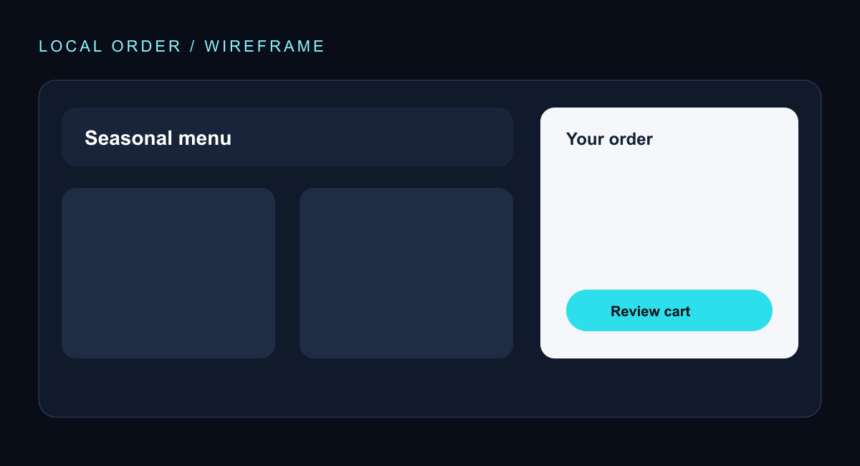
Visual evidence: dark architectural surface, cyan focus accents, generous spacing, persistent cart summary, and rounded primary action.

