SELECT *FROM Employees_52 WHERE BirthDate > DATE '1980-01-01' ORDER BY BirthDate DESC;

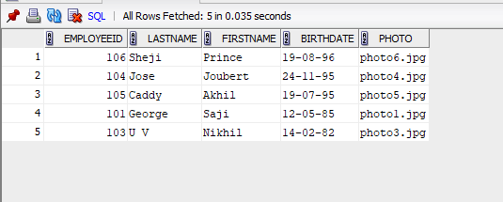

SELECT CustomerId, COUNT(OrderID) AS TotalOrders FROM Orders_53 GROUP BY CustomerID;

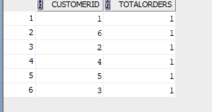

SELECT City, COUNT(CustomerID) AS Total_Customers FROM Customers_51 GROUP BY City;

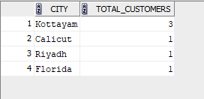

SELECT
c.CustomerID,
c.CustomerName,
COUNT(o.OrderID) AS Total_Orders
FROM Customers_51 c
JOIN Orders_53 o
ON c.CustomerID = o.CustomerID
GROUP BY c.CustomerID, c.CustomerName
HAVING COUNT(o.OrderID) > 2;



SELECT
c.CustomerID,
c.CustomerName,
COUNT(o.OrderID) AS Total_Orders
FROM Customers_51 c
JOIN Orders_53 o
ON c.CustomerID = o.CustomerID
GROUP BY c.CustomerID, c.CustomerName
HAVING COUNT(o.OrderID) > 0;

