Modelling Chromatin Restoration Post UV Damage Repair.

**David Holcman**, **Ofir Shukron**, Group of [Applied mathematics and computational Biology](http://www.biologie.ens.fr/bcsmcbs/), Ecole Normale Superierue, Paris.

[holcman.david@gmail.com](mailto:holcman.david@gmail.com), [oshukron@biologie.ens.fr](mailto:oshukron@biologie.ens.fr)

**Sophie E. Polo**, group leader [Epigenetic integrity](http://parisepigenetics.com/ei/), University of Paris Diderot,

[sophie.polo@univ-paris-diderot.fr](mailto:sophie.polo@univ-paris-diderot.fr),

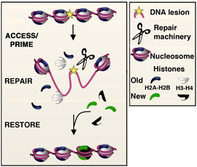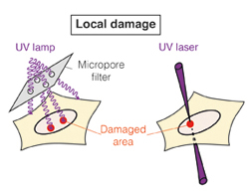

Figure 1

**Background:**

In response to local DNA damage the genomic region undergoes several structural changes, among which are histone eviction, conformational changes to allow repair mechanisms to access the damage site, reorganization of the repaired region by re-deposition of histones, and refolding of the local genetic region.

At the onset of DNA damage, histones are evicted from the site, either by being pulled out or by sliding away from the damage site by histone chaperones and DDB2. DDB2 is recruited to the site of the damage to orchestrate the repair mechanism. It is thought that DDB2 also takes part in the clearance of histones from the damage site. Histones are synthesizes and escorted to the damage site by histone chaperones to stabilize the chromatin structure

The group of Sophie Polo (Paris Diderot U) have examined the response and coordination of the genome and epigenome *in vivo* in response to an induced local UV damage. They have observed that after the induction of local UV damage 40% of the histones were evicted from the site while only 20% loss in DNA density was observed in an observation window.

Local UV damage was induced by focusing and irradiating UVC laser to specific sub-nuclear region (Figure 1). Histones where replaced by labeled histones and were tracked *in-vivo* by [SNAP tagging](http://en.wikipedia.org/wiki/SNAP-tag) methods. New histone deposition is at site of local UVC damage is visualized by immunofluorescence expressing tagged histones.

DNA density was examined after UV induction and was found to be less compact. It was found to be no overall loss of histones in the nucleus in response to UV damage

**Aim:**

In this work we aim to interpret the above finding of the group of Sophie Polo, by putting forward a computational/mathematical framework for DNA-histone dynamic complex after the induction of either single or multiple damage sites, and conclude what is the dynamical/mechanical properties that can explain these observations?

**Methods:**

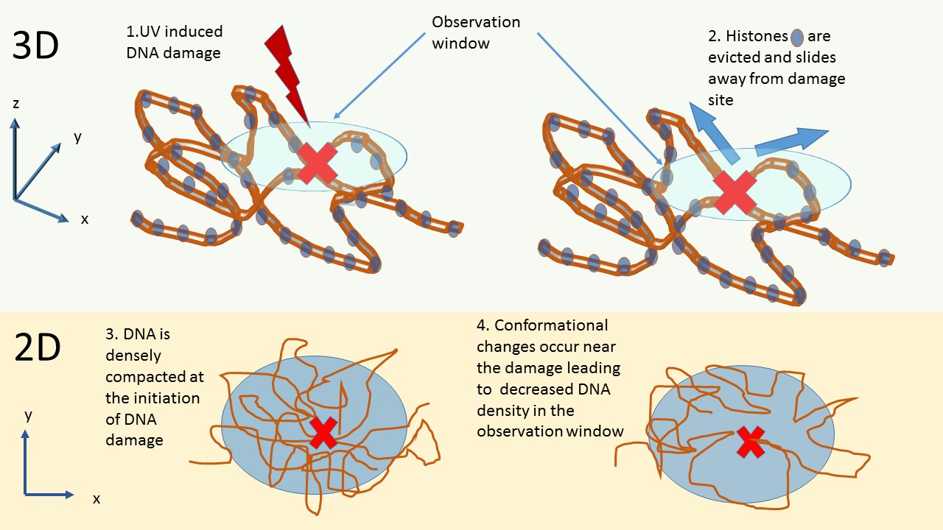

Figure 2

We will construct a 3D simulation framework to address these questions. At first step we will examine whether eviction of 40% histones can account for 20% loss in DNA density in an observation window. For this end we will specify the physical model describing the DNA-histone Complex, its dynamics, UV induced damage sites, and the construction of the simulation framework.

**Modeling the histone-DNA polymer**

We will simulate a beads on strings (Rouse) polymer chain representing the DNA-histone polymer, with beads representing histones and springs representing the DNA chain. The polymer chain will be defined according to the biological experimental data.

**UV-induced DNA damage**

Initially, we will consider the damage to be in a single position on the DNA chain. Situation where multiple damage site are distributed along the chain will be examined in later stages. We assume that damage to the DNA does not create a double stranded break such that the damaged strand is not disconnected.

**The observation window**

We will set our simulation in an open domain in which a circle of radius r will represent the observation window. The polymer is allowed to go in and out of this observation window and it forms no physical barrier to it.

**DNA density**

Density of DNA will be calculated as total length of the springs contained in the observation window divided by the area of the observation window. DNA density percentages will be relative to the initial DNA density.

**Modelling histone eviction**

This will be explored in two ways:

1. Simulate the system until 40% of the beads are out of the observation window for the first time. In which time, we calculate the density of the DNA. Since in open domain the chain will eventually exit the observation window if left to diffuse, we have to find a way to correct it such that the chain remains mostly inside the observation window
2. Take into account a static picture in which 40% of the beads are outside the observation window. Then all possible conformations for which 40% beads are outside will be tested. (I still need to resolve how exactly this will be performed. I might do it with consecutive Brownian bridges)

**Histone sliding on the DNA**

**1. A single damage site**

After UV damage we need to incorporate a force which draws the histone away from the damage site.

In the case of a single damage site, pushing the histones away from the site can be done in several ways

1. Shorten the standard deviation of the distance between beads away from the break (the actual shortening function should be defined, as first step we shorten in a linearly decreasing manner from the break site towards polymer ends, such that the springs closest to the break site undergo the most amount of shortening
2. Equivalently, changing spring constants between beads, such that the springs closest to the break site contract the most.
3. Changing the angles between springs
4. By active 1D force pushing away from the damage site (to be defined).

**2. Multiple damage sites**

In this case damage sites are distributed along the chain. Sliding away from damage sites will be defined according to the distance of each histone to the closest damage site. Histones are allowed to cross over a damage site during sliding, and thus can be trapped between damage sites. The effect of the damage on the motion of each histone should be additive, such that histone will be pushed away from regions of high density damage sites.