##### Results & Material and methods

Ofir Shukron & David Holcman

Sun Nov 29 12:42:41 2015

## 1 Result section

To estimate the nucleosome reorganization following DNA damages, we have constructed a model where redistribution can be due either to chromatin de-compaction or nucleosome sliding along the chromatin or both of them. We have used the model to assess the relative contribution of these two processes to the total signal loss from a region of interest (ROI), a quantity which is inaccessible experimentally.

The model (presented in Material and methods) follows the DNA, , and nucleosome, , fraction of signal loss from the ROI as a function of the UV dose, . We have used the measured H3.3 and DNA signal loss to calibrate parameters of nucleosome and DNA models respectively (Fig. 3A-D). Using the calibrated models we have found that the relative contribution of nucleosome sliding to the total signal loss in the ROI is monotonically decreasing from 70% to 64 % for nucleosomes and 43 to 41% for DNA loss, as the UV dose increases from 5 to 75 msec. The remaining percentages are attributed to chromatin expansion and de-compaction (see Figure 1).

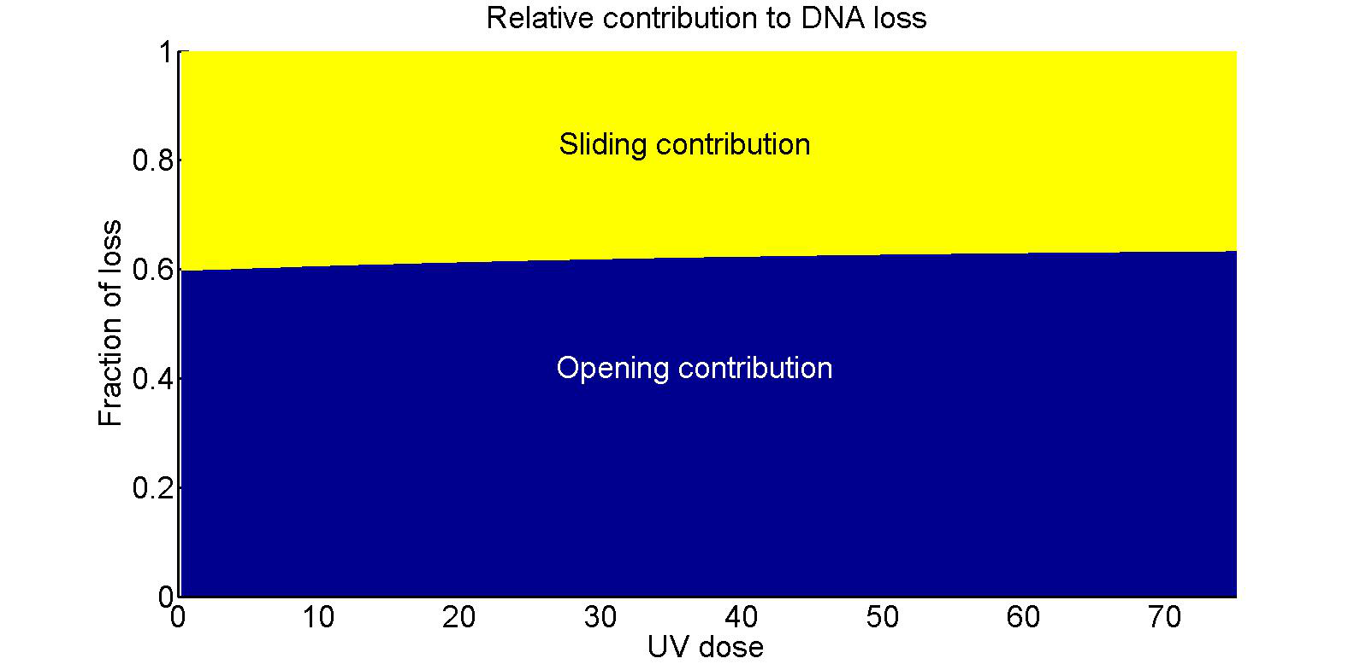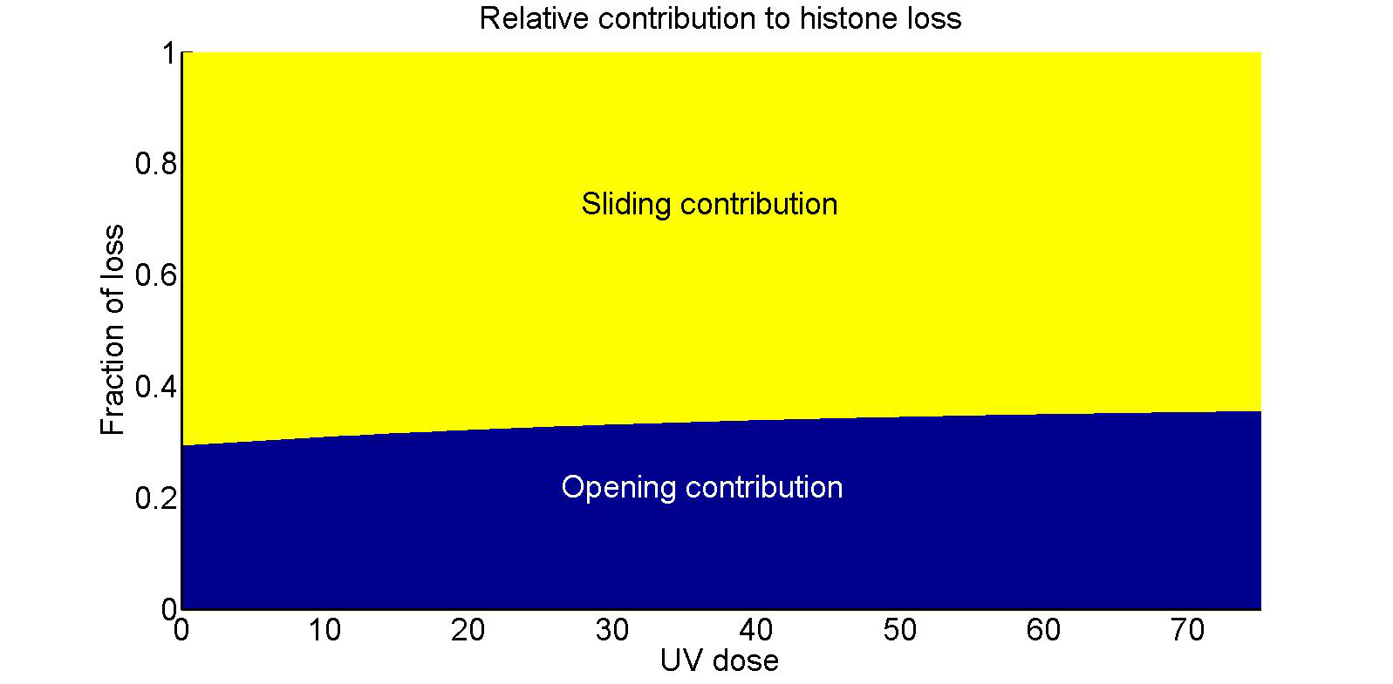

Figure 1: **Relative contribution of chromatin opening and histone sliding to DNA (left) and histone (right) loss**. Sliding contribution is monotonically decreasing with UV dose for both DNA and nucleosome signals. The increase in chromatin opening contribution is due to the increase in chromatin reorganization following high dosages of UV, which is responsible for the majority of signal loss

## 2 Material and methods: Modeling histones and DNA redistribution following UV damages

We present here a model for nucleosomes and DNA re-organization following UV damages. The cascade of events leading to tagged DNA and nuclesoms’ redistribution, results in signal extrusion from a region of interest (ROI) up to a maximal loss, measured 15 minutes post UV-C.

### 2.1 Dynamics of histones following UV damages in the region of interest

Following the experimental protocol, a 2D circular initial damage region (IDR), induced by the UV laser beam, is centered around the focal point (origin of the coordinates) with a fixed area of . Following laser induction with UV dose, , the tagged damage region expands radially outward and reaches it maximal area of  after 15 minutes. At the end of expansion, the circular region, characterized by , is defined as the ROI, which remains a fixed region for the measurement of signals at time 0 and 15 minutes. The fraction of signal loss is obtained by the ratio between measurements at the two times (see also the empirical definition in XXX).

We assume that the loss of DNA and nucleosomes signal post UV-C is due to two mechanisms: the first is chromatin expansion, and the second is nucleosomes sliding along the chromatin. In the first mechanism, recruitment and binding of repair factors to damaged DNA causes chromatin de-compaction, chromatin cross-links break, which result in an expansion of the chromatin in the IDR. Because the majority of damages are inflicted around the laser’s focal point, the accumulation of repair factors will cause pushing force to surrounding chromatin in a radial outward direction, which result in DNA and nucleosome extrusion from the ROI in equal proportions. In the second mechanism, repair factors slide nucleosomes along the chromatin to facilitate efficient repair of DNA by exposing the damaged positions. Sliding nucleosomes over damaged positions on the DNA displaces the tagged damages spatially in the general direction of the ROI boundary, which results in an expassion of the IDR and signal loss from the ROI.

Inline with the description above, we construct a model representing signal loss 15 minutes post UV-C. We do not specifically take into account the mechanism of signal loss in time and only present the steady-state equations for signal loss as a function of the UV dose.

### 2.2 Fraction of DNA and nucleosome loss

We assume an initial uniform distribution of both DNA and nucleosome in the vicinity of the IDR. In our model, we define the number of nucleosomes in the IDR as . The ROI is considered to be a 2-dimensional circular region with an area , and the circular IDR of area , with the IDR and the ROI both centered at the origin. We shall now construct a model describing the the fraction of DNA loss (resp. nucleosomes)  (resp. ) in the ROI 15 minutes post UV-C.

By construction, DNA signal loss is given by the ratio of the amount of DNA in the annulus between the IDR and the ROI to the total amount of signal in the ROI. Nucleosome signal loss is calculated as the sum of the nucleosomes that have been translocated with the DNA plus the ones that are sliding out, resulting in the following formulas

 (1)

 (2)

In order to evaluate the functions above, we will now construct models for the functions  and .

The increase of DNA damages with UV dose is thought of as governing the dynamics of both nucleosome and DNA signal loss. Therefore, we start our construction with a description of the accumulation of damages  in the IDR, and derive the function  and  from it.

### 2.3 Deriving the number of damages

We assume here that the rate of accumulating DNA damages, , with increasing UV dose in the IDR is increasing proportional to the undamaged DNA in the IDR.

 (3)

with  the rate constant, and  the maximal number of damages possible in . Using the initial condition  the solution is

 (4)

We assume no two damages can occur in the same position on the DNA, hence we can treat the quantity



as the fraction of chromatin length in the IDR which is damaged, or as the DNA damage -coverage percentage.

### 2.4 Deriving the function and

We now turn to construct a model for the number of nucleosomes  left in ROI, as a function of the UV dose. Although the exact mechanism by which nucleosomes are lost is not known, we assume here that the number of nucleosomes leaving the ROI,namely , is proportional to the rate of accumulation of DNA damages, , on nucleosomes. The nucleosmes occupy a length of the chromatin proportional to , whereas chromatin damage coverage is proportional to . Therefore, in the first-order approximation, the dynamics of  is given as by the multiplication



with  a constant describing the rate of nucleosome depletion from the ROI due to sliding. Using the initial condition , the solution is given by

 (5)

Next, we model the dynamics of the ROI area  with increasing UV dose. For this end, we consider the ROI expansion to be affected by two additive mechanisms: one is chromatin de-compaction, and the other is nucleosome sliding.

 (6)

where  is a constant. Using the initial condition , we find

 (7)

where  represents the size of the IDR even in the absence of UV induction.

We can now substitute equations 5 and 7 into the steady-state equation 1 and 2 to get the expressions

 (8)

and

 (9)

### 2.5 Parameter fit for and

We now use equations. 9 to fit the experimental data describing the fraction of nucleosome loss from the ROI 15 minutes post UV-C. Because  and  share similar parameters, only the H3.3 data will be used to fit the function  and he resulting parameters will be used in the model for . Excluding the measurement at  ms and using classical fitting procedure, we find a  using the following parameters









Plugging these values into DNA loss equation 8 and calculating the deviation, we find a value of 

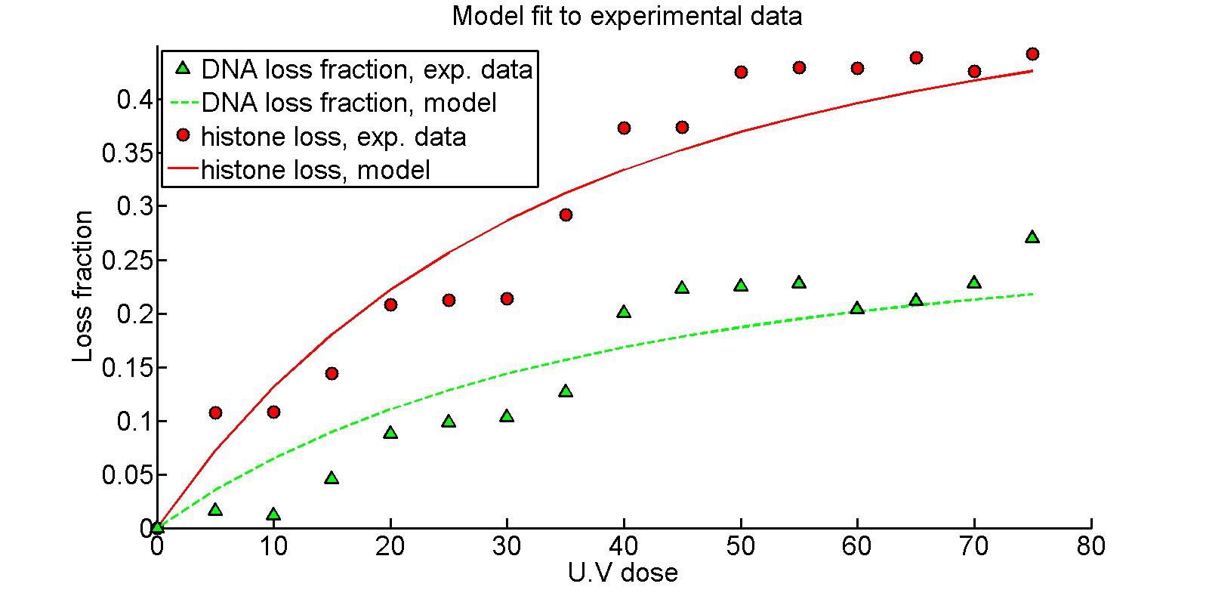

Figure 2: **Histone loss (red): experimental data (circle) versus analytical curve (continuous)**. The fit is obtained from eq. 9. The parameters found in fitting of the H3.3 loss signal are plugged into equation 8 for DNA signal loss (green dashed curve) and plotted against experimental points (green triangles).

### 2.6 Relative contribution of opening and sliding to DNA and nucleosome signal loss

Using the calibrated model in equation 8 and 9, we now calculate the relative contribution of chromatin opening and nucleosome sliding to the total loss of DNA and nucleosomes. We start by partitioning the ROI area dynamics into the two sub-mechanisms of signal loss



The effect of de-compaction on the expansion of the damage region and loss of signal is given by the second term on the right hand-side of equation 6. Zeroing-out the sliding contribution term and, we obtain an equation for the opening contribution



with the initial condition , the solution is given by

 (10)

The fraction attributed to chromatin opening out of the total DNA loss due is given by

 (11)

and the complementary function

 (12)

indicates the relative contribution of sliding to the total DNA loss.

Similarly, the relative contribution of chromatin opening to the total nucleosome loss is given by

 (13)

and for sliding

 (14)

where here we used the fact that  The result can be appreciated in Figure 1, where the sliding contribution for both DNA and nucleosome loss is a decreasing function of the UV dose.

### 2.7 Nucleosomes sliding out of the IDR

The fraction of nucleosomes sliding ot of the IDR (and eventually pushed out of the ROI) is given by the expression

 (15)

Using the parameter values in subsection 2.5 and plugging 9 and 8 into the expression above, we obtain the results in Figure 3, where the model is plotted against the experimental data ().

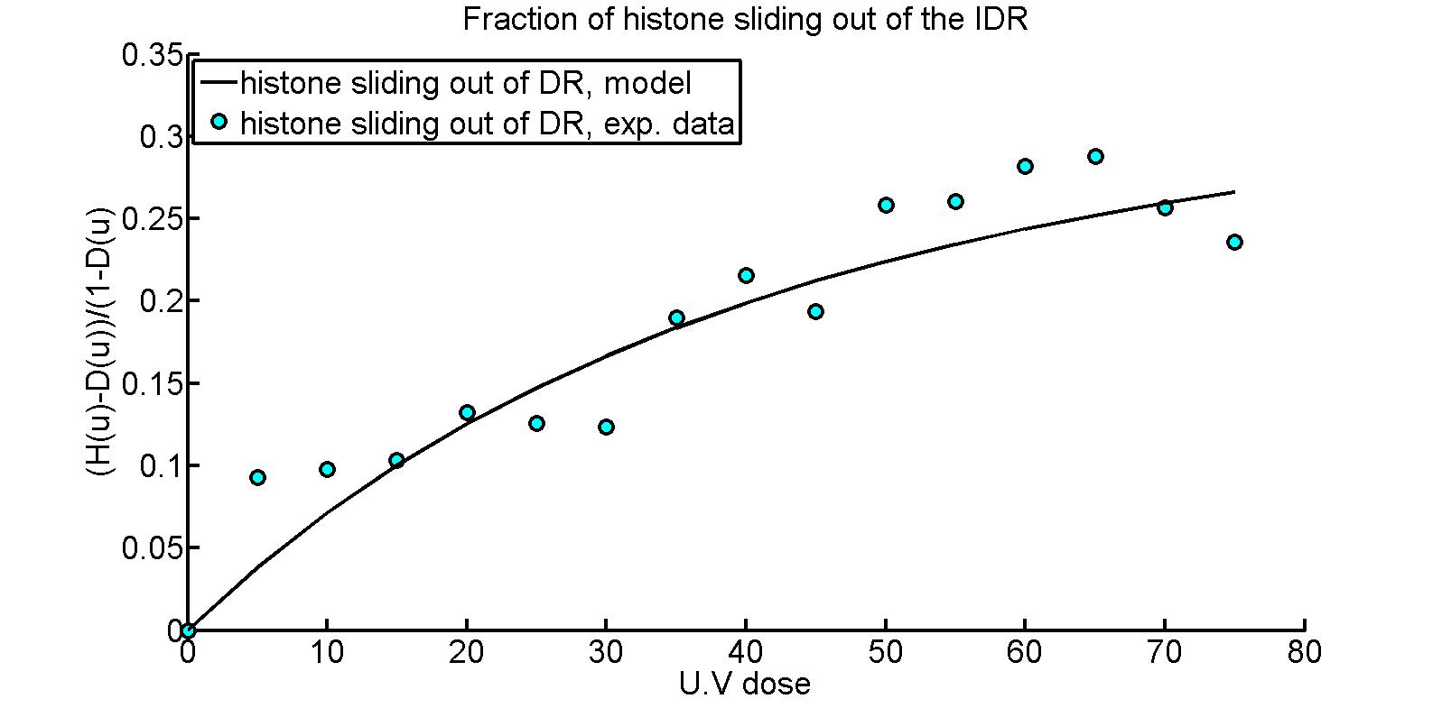

Figure 3: **Fraction of nucleosomes sliding out of the IDR. The plot against the experimental data resulted in **