Results & Material and methods

Ofir Shukron & David Holcman

12/7/2015

## 1 Result section

To estimate the nucleosome reorganization following DNA damages, we have constructed a mathematical model, where redistribution can be due either to chromatin de- compaction or nucleosome sliding along the chromatin or both of them. We have used the model to assess the relative contribution of these two processes to the total DNA and nucleosome signal loss from a region of interest (ROI), a quantity which is inaccessible experimentally.

The model (presented in Material and methods) follows the DNA, , and nucleosome, , fraction of signal loss from the ROI as a function of the UV dose, . We have used the measured H3.3 and DNA signal loss to calibrate parameters of nucleosome and DNA models respectively (Fig. 3A- D). Using the calibrated models we have found that the relative contribution of nucleosome sliding to the total signal loss in the ROI is monotonically decreasing from 75% to 70% for nucleosomes and 51% to 40% for DNA loss, as the UV dose increases from 5 to 100 msec. The remaining percentages are attributed to chromatin expansion and de-compaction (see Figure ).

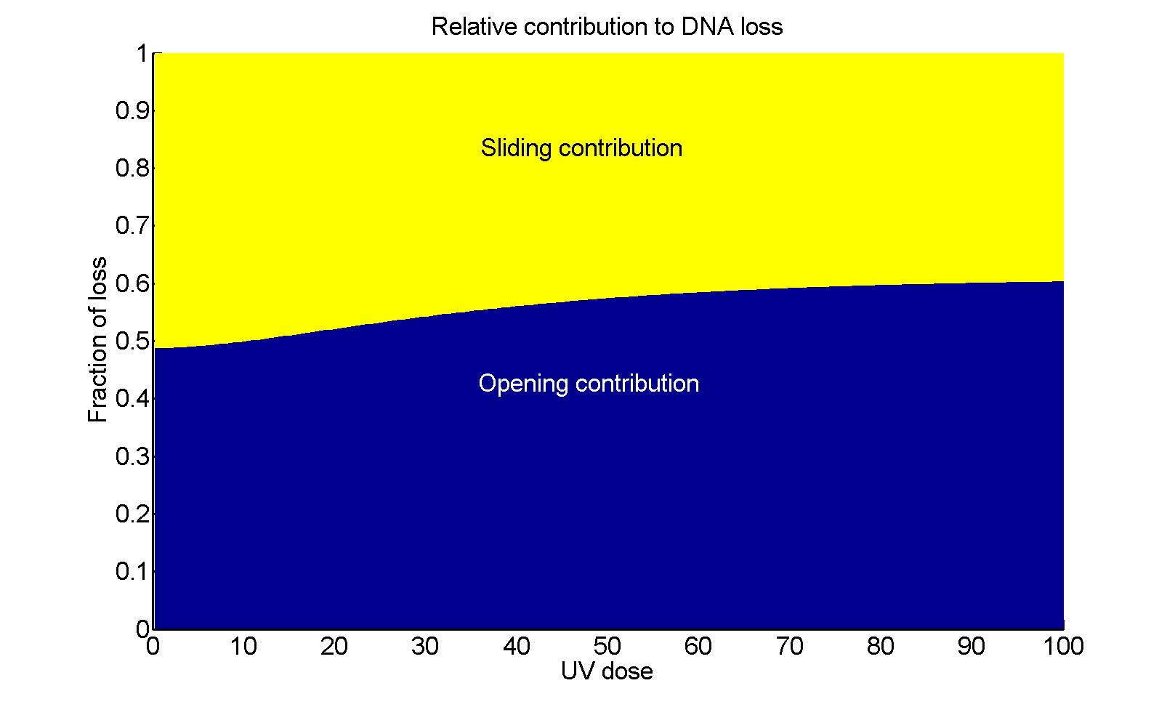 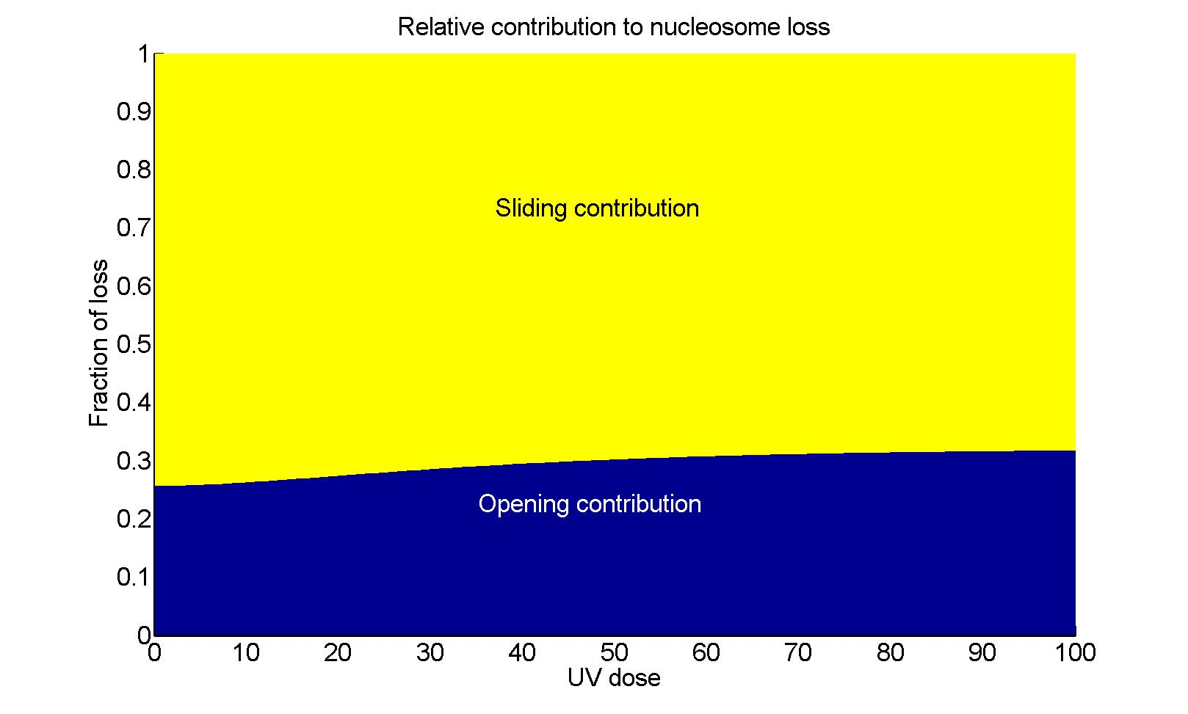

Figure 1: **Relative contribution of chromatin opening and nucleosome sliding to DNA (left) and histone (right) loss**. Sliding contribution is monotonically decreasing with UV dose for both DNA and nucleosome signals. The increase in chromatin opening contribution is due to the increase in chromatin reorganization following high dosages of UV, which is responsible for the majority of signal loss.

## 2 Material and methods: Modeling nucleosomes and DNA redistribution following UV damages

We present here a model for nucleosomes and DNA re-organization following UV damages. The cascade of events leading to tagged DNA and nucleosomes’ redistribution, results in signal extrusion from a region of interest (ROI) up to a maximal loss, measured 15 minutes post UV-C.

### 2.1 Dynamics of nucleosomes following UV damages in the region of interest

Following the experimental protocol, a two-dimensional circular initial damage region (IDR), induced by the UV laser beam, is centered around the focal point (origin of the coordinates) with a fixed area of . Following laser induction with a UV dose , the tagged damage region expands radially outward and reaches its maximal area of after 15 minutes. At the end of expansion, the circular region, characterized by , is defined as the ROI, which remains a fixed region for the measurement of signals at time 0 and 15 minutes. The fraction of signal loss is obtained by calculating the difference between measurements at the two times relative to the initial measurement (see also the empirical definition in XXX).

We assume that the loss of DNA and nucleosomes signal post UV-C is due to two mechanisms: the first is chromatin expansion, and the second is nucleosomes sliding along the chromatin. In the first mechanism, recruitment and binding of repair factors to damaged DNA causes chromatin de-compaction, chromatin cross-links break, which result in an expansion of the IDR. Because the majority of damages are inflicted around the laser’s focal point, the accumulation of repair factors will generate a pushing force on surrounding chromatin in a radial outward direction, which results in DNA and nucleosome extrusion from the ROI in equal proportions. In the second mechanism, repair factors slide nucleosomes along the chromatin to facilitate efficient repair of DNA by exposing the damaged positions. Sliding nucleosomes over damaged positions on the DNA displaces the tagged damages spatially in the general direction of the ROI boundary, which results in an expansion of the IDR and signal loss from the ROI.

In-line with the description above, we construct a model representing signal loss 15 minutes post UV-C. We do not specifically take into account the mechanism of signal loss in time and only present the steady-state equations for signal loss as a function of the UV dose.

### 2.2 Steady-state equations describing DNA and nucleosome loss

We assume an initial uniform distribution of both DNA and nucleosome in the IDR and its vicinity, such that the amount of DNA and nucleosomes in the IDR is proportional to its area. We define the number of nucleosomes leaving the IDR 15 minutes post UV-C as , with and the number of nucleosomes sliding and pushed out of the IDR, respectively. Nucleosomes pushed out of the IDR are associated with undamaged DNA, therefore we have representing this quantity. The IDR and the ROI are considered to be two-dimensional concentric circular regions, characterized by an area and respectively, with , for all values. We shall now compute the fraction of DNA loss (resp. nucleosomes) (resp. ) in the ROI 15 minutes post UV-C.

By construction, DNA signal loss is given by the ratio of the amount of DNA in the annulus between the IDR and the ROI plus the nucleosomes pushed out of the IDR to the total amount of signal in the ROI. Nucleosome signal loss is calculated as the sum of the nucleosomes that have been translocated with the DNA plus the ones that are sliding out, resulting in the following formulas

(1)

(2)

In order to evaluate the functions above, we will now construct models for the functions and . The increase of DNA damages with UV dose is thought of as governing the dynamics of both nucleosome and DNA signal loss. Therefore, we start our construction with a description of the accumulation of damages in the IDR, and derive the function and from it

### 2.3 Deriving the number of damages

We will derive the equation describing accumulation of damages on a radial cross-section of the IDR and then expand it to the whole IDR. We assume here that the rate of accumulating DNA damages along the radius of the IDR, , with increasing UV dose in the IDR is increasing proportional to the undamaged DNA in that cross-section.

with the rate constant, and the maximal number of damages possible along the radial cross-section of the IDR. Using the initial condition , the solution is

Expanding this equation to describe damages in a two-dimensional IDR, we obtain

(3)

We assume no two damages can occur in the same position on the DNA, hence we can treat the quantity

as the fraction of chromatin length in the IDR which is damaged, or as the DNA damage-coverage percentage.

### 2.4 Deriving the functions describing loss of nucleosome from the IDR and the ROI expansion

We now turn to construct a model for the total number of nucleosomes leaving the IDR and subsequently being pushed out of the ROI, as a function of the UV dose. Although the exact mechanism by which nucleosomes are lost is not known, we assume here that the number of nucleosomes leaving the ROI is composed of two contributions, one due to nucleosomes pushed out of the IDR, and the second due to nucleosome sliding to expose damaged DNA positions and facilitate efficient repair.

The nucleosomes occupy a length of the chromatin proportional to , whereas chromatin damage coverage is proportional to . Therefore, in the first-order approximation, the dynamics of is given by the multiplication

with the rate constant. Due to the accumulation of repair factors around damaged DNA, a pushing force acts on the surrounding undamaged DNA in the IDR. The rate nucleosomes are being pushed out of the IDR is considered to be proportional to the fraction of DNA damaged due to small amount of UV dose minus the fraction which slides out

The dynamics of is obtained by adding equations 6 and 7. Using the initial condition , we can solve for to have

(4)

Therefore,

(5)

(6)

with and constants describing the rate of nucleosome depletion from the ROI due to sliding and pushing respectively.

Next, we model the dynamics of the ROI area with increasing UV dose. For this end, we consider the ROI expansion to be affected by two additive mechanisms originating from the IDR: one is chromatin opening or de-compaction, and the other is nucleosome sliding. The two contributions are inherent in the equation for , therefore

where is the rate constant. Using the initial condition , we find

(7)

where represents the size of the IDR even in the absence of UV induction.

We can now substitute equations (), () and () into the steady-state equations () and () to get the expressions for and . Using the relation , we present the result in terms of

(8)

(9)

### 2.5 Parameter fit for and

We now use equations () and () to fit the experimental data. We simultaneously fit equations () and () to the H3.3 and DNA loss data, with the goal of maximizing the of both equations. Excluding the measurement at 5 msec, and using classical fitting procedure, we find

with and for DNA and nucleosome loss fit respectively.

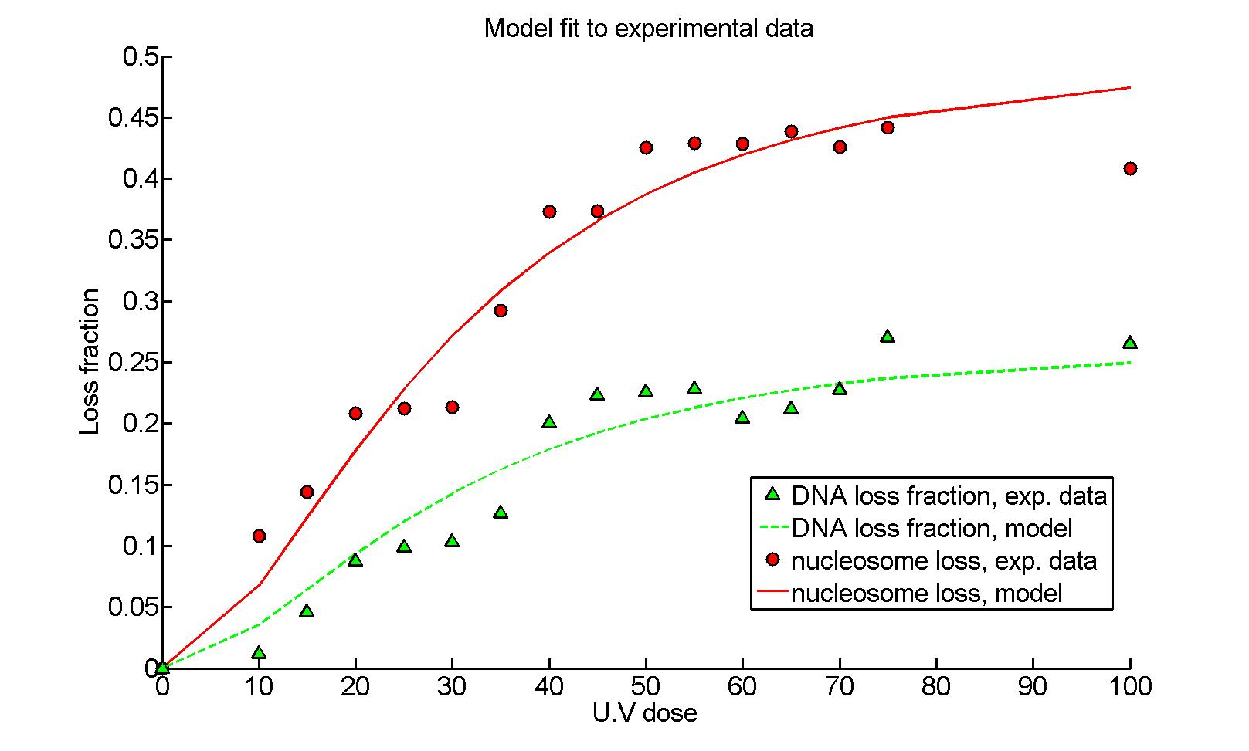

Figure 2: **Histone (red) and DNA (green) loss: experimental data for nucleosomes (circle) and DNA (triangles) versus model curves (continuous and dashed, respectively)**. Parameter values are obtained by simultaneously fitting equations() and () to the experimental data with the goal of maximizing the . The resulting curves show and for nucleosome and DNA loss, respectively.

### 2.6 Relative contribution of opening and sliding to DNA and nucleosome signal loss

Using the calibrated model in equation equations () and (), we now calculate the relative contribution of chromatin opening and nucleosome sliding to the total loss of DNA and nucleosome signals. The sliding contribution refers to all loss caused by either directly sliding nucleosome out of the IDR or as the effect nucleosome sliding has on pushing chromatin out of the IDR by operations of repair factors. Chromatin opening contribution refers to all signal loss caused by chromatin remodeling, which causes expansion of the IDR and subsequent loss of signal from the ROI.

We start by dividing the equation describing the ROI expansion into the two sub-mechanisms of signal loss

with the area attributed to chromatin opening, and to nucleosome sliding. Subtracting the sliding contribution from the ROI expansion in equation (), we arrive at

The DNA loss attributed to chromatin opening and de-compaction is thus

The fraction attributed to chromatin opening and sliding out of the total DNA loss are given respectively by

(10)

Similarly, the relative contribution of chromatin opening and nucleosome sliding to the total nucleosome loss is given respectively by

(11)

where here we have used the fact that . Graphs of equations () and () are presented in Figure .

### 2.7 Nucleosome sliding out of the IDR

The fraction of nucleosomes lost by sliding out of the total nucleosomes in the IDR (and eventually pushed out of the ROI) is found to be an increasing function of the UV dose

Substituting the parameter values in subsection and plugging () and () into the expression above, we obtain the results in Figure , where the model in equation () is plotted against the experimental data ().

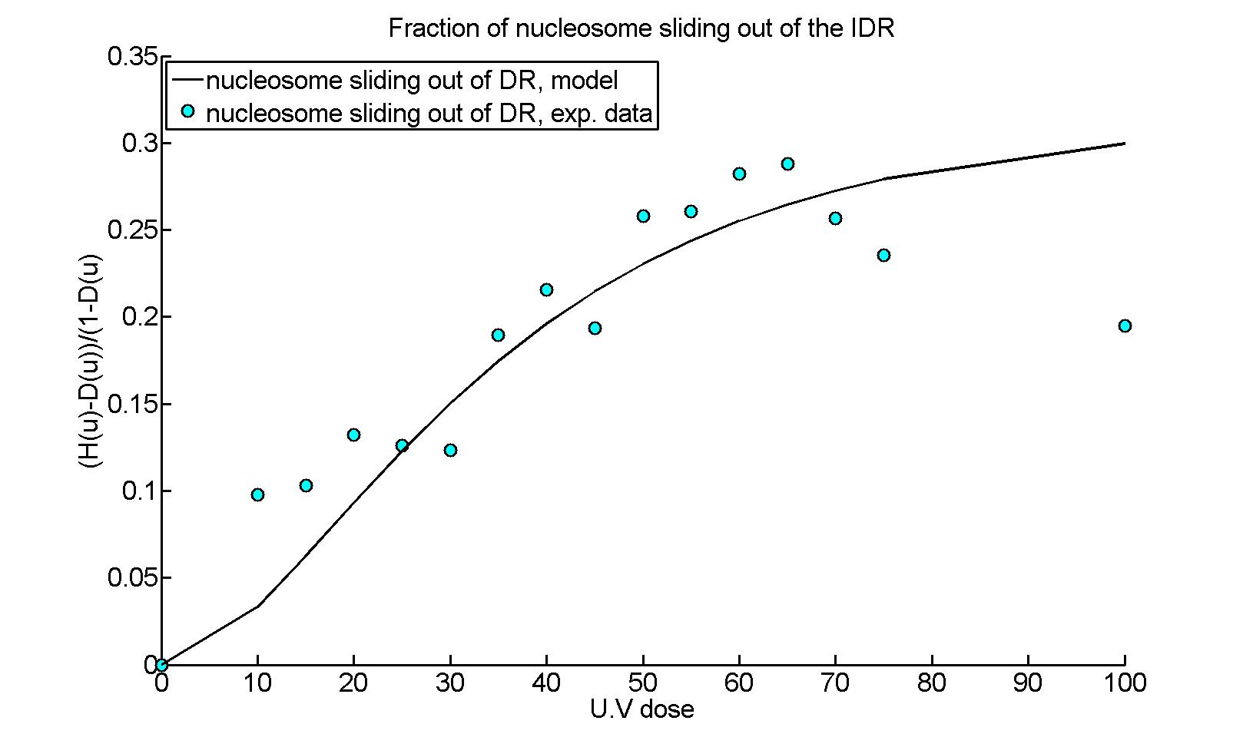

Figure 3: **Fraction of nucleosomes sliding out of the IDR. The plot against the experimental data resulted in**

The parameters values found in subsection , can further be used to estimate the fraction of nucleosome loss from the IDR attributed to sliding and chromatin opening. These contributions are given by the leading coefficients in the equations () and () for and , respectively. We have, for chromatin opening and sliding, respectively