Results & Material and methods
Ofir Shukron & David Holcman

1 Result section
To estimate the nucleosome reorganization following DNA damages, we have constructed a model where redistribution can be due either to chromatin de-compaction or nucleosome sliding along the chromatin or both of them. We have used the model to assess the relative contribution of these two processes to the total DNA and nucleosome signal loss from a region of interest (ROI), a quantity which is inaccessible experimentally.
The model (presented in Material and methods) follows the DNA, D(u), and nucleosome, H(u), fraction of signal loss from the ROI as a function of the UV dose, u. We have used the measured H3.3 and DNA signal loss to calibrate parameters of nucleosome and DNA models respectively (Fig. 3A-D). Using the calibrated models we have found that the relative contribution of nucleosome sliding to the total signal loss in the ROI is monotonically decreasing from 70% to 64 % for nucleosomes and 43 to 41% for DNA loss, as the UV dose increases from 5 to 75 msec. The remaining percentages are attributed to chromatin expansion and de-compaction (see Figure 1).
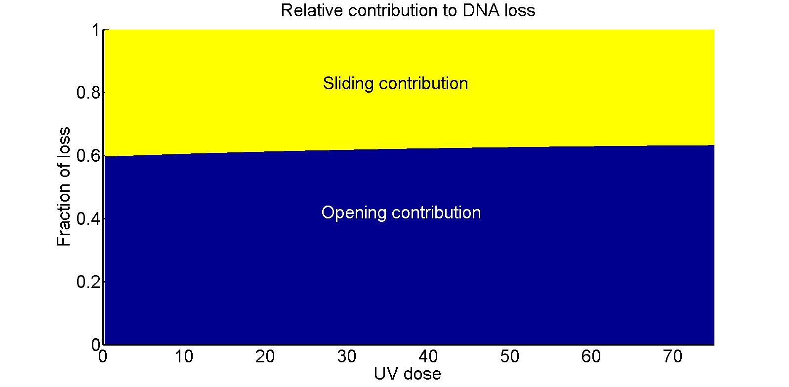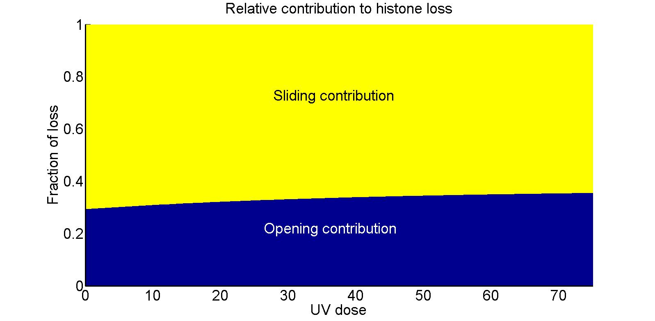
Figure 1: Relative contribution of chromatin opening and histone sliding to DNA (left) and histone (right) loss. Sliding contribution is monotonically decreasing with UV dose for both DNA and nucleosome signals. The increase in chromatin opening contribution is due to the increase in chromatin reorganization following high dosages of UV, which is responsible for the majority of signal loss

2 Material and methods: Modeling histones and DNA redistribution following UV damages
We present here a model for nucleosomes and DNA re-organization following UV damages. The cascade of events leading to tagged DNA and nuclesoms’ redistribution, results in signal extrusion from a region of interest (ROI) up to a maximal loss, measured 15 minutes post UV-C.

2.1 Dynamics of histones following UV damages in the region of interest
Following the experimental protocol, a two-dimensional circular initial damage region (IDR), induced by the UV laser beam, is centered around the focal point (origin of the coordinates) with a fixed area of . Following laser induction with a UV dose u, the tagged damage region expands radially outward and reaches its maximal area of A(u) after 15 minutes. At the end of expansion, the circular region, characterized by A(u), is defined as the ROI, which remains a fixed region for the measurement of signals at time 0 and 15 minutes. The fraction of signal loss is obtained by calculating the difference between measurements at the two times relative to the initial measurement (see also the empirical definition in XXX).
We assume that the loss of DNA and nucleosomes signal post UV-C is due to two mechanisms: the first is chromatin expansion, and the second is nucleosomes sliding along the chromatin. In the first mechanism, recruitment and binding of repair factors to damaged DNA causes chromatin de-compaction, chromatin cross-links break, which result in an expansion of the chromatin in the IDR. Because the majority of damages are inflicted around the laserâ€™s focal point, the accumulation of repair factors will cause pushing force to surrounding chromatin in a radial outward direction, which result in DNA and nucleosome extrusion from the ROI in equal proportions. In the second mechanism, repair factors slide nucleosomes along the chromatin to facilitate efficient repair of DNA by exposing the damaged positions. Sliding nucleosomes over damaged positions on the DNA displaces the tagged damages spatially in the general direction of the ROI boundary, which results in an expansion of the IDR and signal loss from the ROI.
In line with the description above, we construct a model representing signal loss 15 minutes post UV-C. We do not specifically take into account the mechanism of signal loss in time and only present the steady-state equations for signal loss as a function of the UV dose.

2.2 Steady-state equations describing DNA and nucleosome loss
We assume an initial uniform distribution of both DNA and nucleosome in the IDR and its vicinity, such that the amount of DNA and nucleosomes in the IDR is equal to the area of the IDR. We define the number of nucleosomes leaving the IDR 15 minutes post UV-C as , with and the number of nucleosomes sliding and pushed out of the IDR respectively. Nucleosomes pushed out of the IDR are associated with undamaged DNA, therefore we set to represent this quantity. The IDR and the ROI are considered to be two-dimensional concentric circular regions, characterized by the area and A(u) respectively, with , for all u values. We shall now compute the fraction of DNA loss (resp. nucleosomes) D(u) (resp. H(u)) in the ROI 15 minutes post UV-C.
By construction, DNA signal loss is given by the ratio of the amount of DNA in the annulus between the IDR and the ROI plus the nucleosomes pushed out of the IDR to the total amount of signal in the ROI. Nucleosome signal loss is calculated as the sum of the nucleosomes that have been translocated with the DNA plus the ones that are sliding out, resulting in the following formulas
(1)
(2)
In order to evaluate the functions above, we will now construct models for the functions A(u) and . The increase of DNA damages with UV dose is thought of as governing the dynamics of both nucleosome and DNA signal loss. Therefore, we start our construction with a description of the accumulation of damages T(u) in the IDR, and derive the function and A(u) from it.

2.3 Deriving the number of damages T(u)
We will derive the equation describing accumulation of damages on a radial cross-section of the IDR and then expand it to the whole IDR. We assume here that the rate of accumulating DNA damages along the radius of the IDR, , with increasing UV dose in the IDR is increasing proportional to the undamaged DNA in that cross-section.
(3)
with the rate constant, and the maximal number of damages possible along the radius. Using the initial condition the solution is
(4)
Expanding this equation to describe damages in a two-dimensional IDR, we obtain
(5)
We assume no two damages can occur in the same position on the DNA, hence we can treat the quantity

as the fraction of chromatin length in the IDR which is damaged, or as the DNA damage-coverage percentage.

2.4 Deriving the functions describing ROI expansion and loss of nucleosome from the IDR
We now turn to construct a model for the total number of nucleosomes leaving the IDR, as a function of the UV dose. Nucleosome leaving the IDR are later being pushed out of the ROI along with undamaged DNA. Although the exact mechanism by which nucleosomes are lost is not known, we assume here that the number of nucleosomes leaving the ROI is composed of two contributions, one due to nucleusomes pushed out of the IDR, and the second due to nucleosome sliding to expose damaged DNA positions and facilitate efficient repair.
The nucleosmes occupy a length of the chromatin proportional to , whereas chromatin damage coverage is proportional to T(u). Therefore, in the first-order approximation, the dynamics of is given by the multiplication
(6)
A pushing force, due to the accumulation of repair factors around damaged DNA, acts on the undamaged DNA in the IDR. We assume here that the dynamics of nucleosomes pushed out the IDR is proportional to the additional damages times the remaining DNA in the IDR after sliding.
(7)
Adding equations 6 and 7 we obtain the dynamics of . Using the initial condition , we can solve to obtain
(8)
Therefore
(9)
(10)
with and constants describing the rate of nucleosome depletion from the ROI due to sliding and pushing respectively.
Next, we model the dynamics of the ROI area A(u) with increasing UV dose. For this end, we consider the ROI expansion to be affected by two additive mechanisms originating from the IDR: one is chromatin de-compaction, and the other is nucleosome sliding. The two contributions are inherent in the equation for , therefore
(11)
where is the rate constant. Using the initial condition , we find
(12)
where represents the size of the IDR even in the absence of UV induction.
We can now substitute equations 9, 10 and 12 into the steady-state equation 1 and 2, and using the relation to get the expressions for D and H
(13)
and
(14)

2.5 Parameter fit for H(u) and D(u)
We now use equations. 14 and 13 to fit the experimental data. We simultaneously fit the H3.3 and the DNA loss data with the goal of maximizing the of both equations. Using classical fitting procedure, we find

Plugging these values into DNA loss equation 13 and calculating the deviation, we find a value of

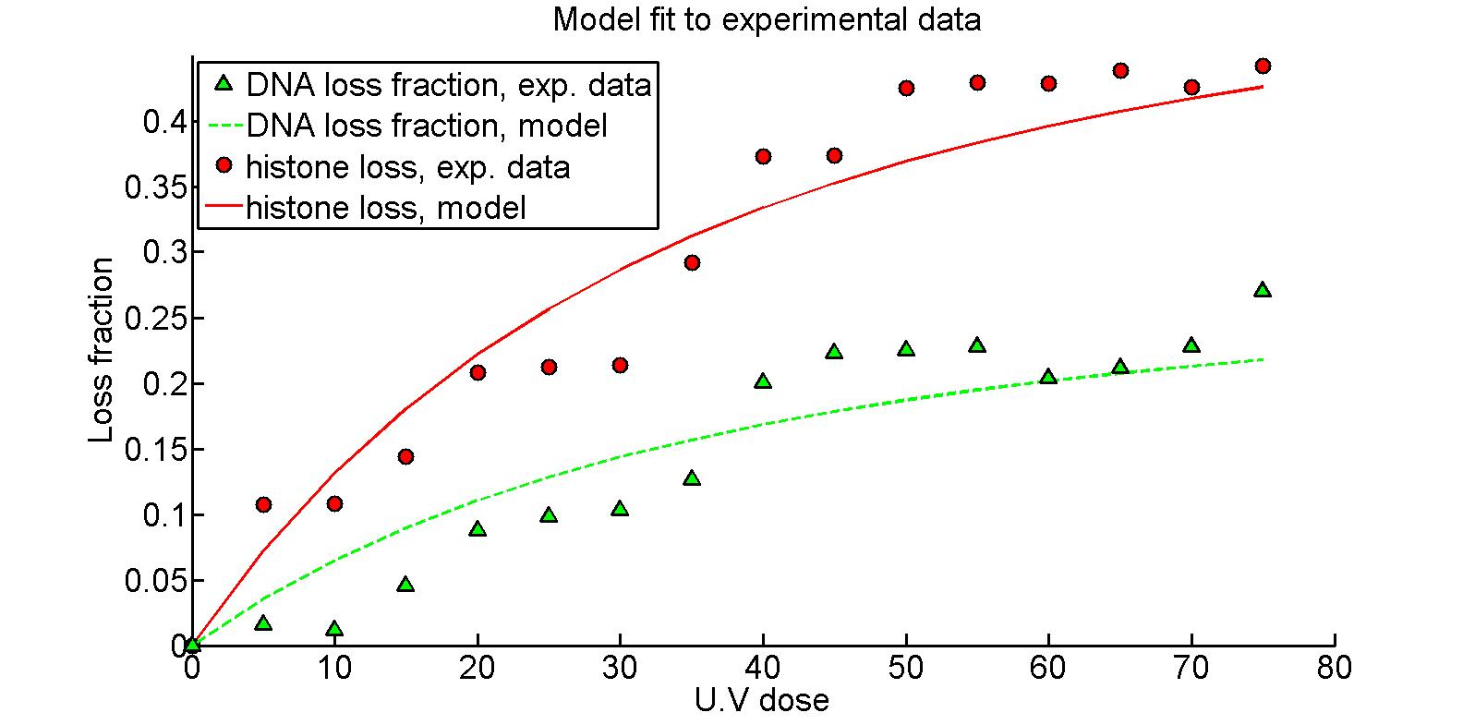
Figure 2: Histone loss (red): experimental data (circle) versus analytical curve (continuous). The fit is obtained from eq. 14. The parameters found in fitting of the H3.3 loss signal are plugged into equation 13 for DNA signal loss (green dashed curve) and plotted against experimental points (green triangles).1413

2.6 Relative contribution of opening and sliding to DNA and nucleosome signal loss
Using the calibrated model in equation 13 and 14, we now calculate the relative contribution of chromatin opening and nucleosome sliding to the total loss of DNA and nucleosomes. We start by partitioning the ROI area dynamics into the two sub-mechanisms of signal loss

The effect of de-compaction on the expansion of the damage region and loss is due to nucleosome loss due to pushing equation 10, Zeroing-out the sliding contribution in equation 12, we obtain an equation for the opening contribution

with the initial condition , the solution is given by
(15)
The fraction attributed to chromatin opening out of the total DNA loss due is given by
(16)
and the complementary function
(17)
indicates the relative contribution of sliding to the total DNA loss.
Similarly, the relative contribution of chromatin opening to the total nucleosome loss is given by
(18)
and for sliding
(19)
where here we used the fact that The result can be appreciated in Figure 1, where the sliding contribution for both DNA and nucleosome loss is a decreasing function of the UV dose.

2.7 Nucleosomes sliding out of the IDR
The fraction of nucleosomes sliding ot of the IDR (and eventually pushed out of the ROI) is given by the expression
(20)
Using the parameter values in subsection 2.5 and plugging 14 and 13 into the expression above, we obtain the results in Figure 3, where the model is plotted against the experimental data ().

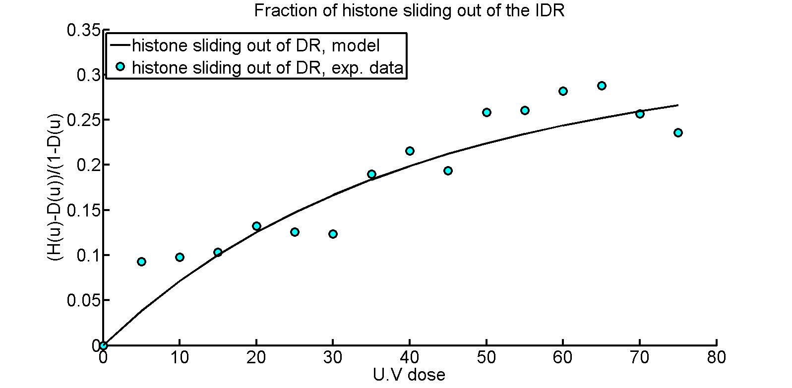
Figure 3: Fraction of nucleosomes sliding out of the IDR. The plot against the experimental data resulted in

