**Drones - Background:**

By definition, a drone is a remote-controlled pilotless aircraft or missile. In general, it is unmanned aerial vehicle with a pre-programmed path. One of the most popular consumer drone is the **quadcopter**, which is an unmanned helicopter having four rotors.

In its movement, this drone can pitch, roll and yaw. In addition, a remote control communicates to the quadcopter which allows us control the drone’s path. To be more specific, the quadcopter includes:

* Onboard accelerometer
* Gyroscope
* Microcontroller that tells each of the rotors exactly what to do. It computes the complex equations and tells the drone the exact degrees and positions it needed in its path.

In out project,…. ? the drone is controlled by computers and artificial intelligence or controlled by a remote human ? little bit of both? “piloted by human but capable of some degree of navigation on its own if necessary”.

**Jetson Nano Developer Kit** (1)**:**

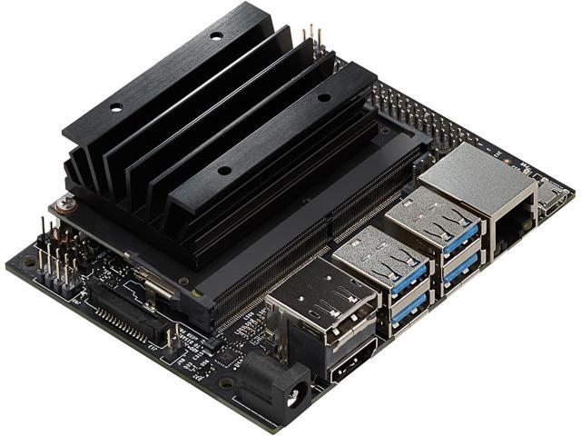

Jetson Nano is the platform for the AI functions used in the drone. This platform relates to deep learning and computer vision programs in the project. By running multiple neural networks in parallel this platform enables us focusing on image classification, speech processing and object detection at once.

Jetson Nano come with no software pre-installed and so a carrier board and a suitable software were needed. In out project Jetson Nano Developer Kit is used. This includes a Jetson module attached to a reference carrier board. This kit is small, low power and relatively cheap. Its GPU for example is 128-core Maxwell. The main reason for using this specific kit is its size. By comparing between the available carrier boards in market, the Nano dev. Kit has the smallest size which is $79mm ×100mm$.

|  |  |  |  |  |
| --- | --- | --- | --- | --- |
| carrier | Nano dev. Kit | JN30-LC | JN30-PSE | JN30-PD |
| size | $$79mm ×100mm$$ | $$80mm ×104.6mm$$ | $$80mm ×104.6mm$$ | $$80mm ×104.6mm$$ |

Table 1. comparison between the different carrier boards suitable for Jetson Nano (2).

….

This product is supported by NVIDIA software libraries such as CUDA cuDNN and TensorRT for accelerated AI applications.

**Jetson Nano Projects** (3)**:**

Here we describe examples of projects, not necessary relating to drones, which have been built for Jetson Nano.

ROS NavBot By Imesh Sachinda:

In this project a differential wheeled robot named NavBot, was built using ROS operating system to perform SLAM (simultaneous localization and mapping ). In other words, NavBot is able to map the environment in 2D with Gmapping and 3D with RTAB-Map with Microsoft Kinect v1.

Jetson Nano Detection and Tracking By Steve Macenski**:**

In this project, a constant velocity Kalman Filter was used to track and detect objects in images. In this way, different tools based on machine learning for examples, were installed and set up the Jetson Nano.

**Choice of camera:**

We consider the following points in choosing the drone’s FPV camera (לבדוק סופית).

1. **Size and Weight.**

In general, we want our drone to be as much smaller and lighter as possible. This is reflected through the choice of the camera. The size of the camera is mostly determined by the width.

Typical weight – 4 [g] – 20 [g]. Typical sizes nowadays are the following (4):

Standard (full size) – 28 [mm].

Mini – 21 [mm].

Micro – 19 [mm].

Nano – anything smaller than micro.

1. **Aspect Ratio:**

Aspect ratio is the proportion of the height and width of the image that is seen on the screen. There are two options for drone FPV camera: 16:9 and 4:3. Although the aspect ratio has very little effect on the image captured, it is important to choose the size that is matched to the display screen to avoid distortions.

1. **Sensor type:**

The two main sensor types are CCD and CMOS. Originally, CCD have lower latency. Latency refers to the delay before electrical signals transmit following the moment the light entering the lens. This happen to be a very important feature when discussing drones because the slightest delay might cause the drone to get damaged in a crash. However, nowadays CMOS latency have reduced and generally might even be lower compared to CCD. Another important quality is a good WDR (wide dynamic range) which relates to the ability to see clearly both in light and dark areas. CCD have very good WDR however not the best. The latest CMOS cameras, on the other hand, are considered to be better in this feature. In addition, images have better contrast and color is warmer and more natural in CCD compared to CMOS. But resolution in CCD is generally lower than the resolution in CMOS.

1. **Field of View (FOV):**

This term used to describe the observable view that is seen at any given moment through the lens of the camera. FOV usually measured in degrees. Human, for example, can see $120°$. On the one hand, very small FOD might cause difficulties in keeping track of the drone and its surrounding. On the other hand, as the FOV increases, the image might be disordered and distorted. $2.1 – 2.8 mm$ lens are very commonly used and lead to approximately $130°-150°$ FOV.

|  |  |  |  |  |  |  |  |
| --- | --- | --- | --- | --- | --- | --- | --- |
| title | IMX179(8M)MIPI for NANO | IMX290(2M)MIPI for NANO | Raspberry Pi [Camera v2](https://www.raspberrypi.org/products/camera-module-v2/) (IMX219 sensor) | Stereolabs [ZED](https://www.stereolabs.com/) (stereo camera) | LI-IMX219-MIPI-FF-NANO | Logitech C920 (USB webcam) | e-con Systems e-CAM30_CUNANO (3.4 MP MIPI Camera) |
| size |  |  | 25mm x 23.862 mm | 175 mm x 30 mm | 150.0 mm (L) x 25.0 mm (W) | 2.83 x 7.52 x 8.94 in |  |
| Weight |  |  | 3 g | 159 g |  | 217.7243 grams | 12 Grams (with out lens)  17.5 Grams (with lens) |
| CCD/ CMOS |  |  |  |  |  |  |  |
| Aspect Ration |  |  |  | 16:9 |  |  |  |
| FOV |  |  | H- 62.2 degrees  W - 48.8 degrees | 90° (H) x 60° (V) x 110° (D) max | 90°(H) / 145°(H) | 78 degrees | 3.4 MP - 120° (with the lens provided by e-con) |
| Dynamic range |  |  |  |  |  |  | 69.5 dB |
| PAL (25 fps) / NTSC (30 fps) | 8M15fps/1080P(30fps) | 60fps |  | 1080p HD video at 30FPS | 3280 x 2464 @ 21fps |  | 38 fps |
| Resolution | 8M(3280x2464) | 2M(1920x1080) | 3280 × 2464 pixels | 3840 x 1080 | 3280 (H) x 2464 (V) |  | 3.4 MP |
| price | $25 | $99 | $25 | 449$ | 29 $ | 55$ | 79$ |
| Depth range |  |  |  | 0.5 – 20 m |  |  |  |

# Bibliography

1. Jetson Nano Developer Kit. *nvidia. AUTONOMOUS MACHINES.* [Online] https://developer.nvidia.com/embedded/jetson-nano-developer-kit.

2. AUVIDEA. Carrier board for the NVIDIA Jetson Nano. *NVIDIA Jetson - Auvidea.* [Online] July 2019. https://auvidea.eu/download/datasheet/JN30_1.2.pdf.

3. Jetson Projects. *nvidia. autonomous machines.* [Online] https://developer.nvidia.com/embedded/community/jetson-projects.

4. HOW TO CHOOSE FPV CAMERA FOR QUADCOPTERS AND DRONES. *OscarLiang.* [Online] https://oscarliang.com/best-fpv-camera-quadcopter/.

<https://developer.nvidia.com/embedded/jetson-nano-developer-kit>

<https://auvidea.eu/product/70781/>

<https://auvidea.eu/download/datasheet/JN30_1.2.pdf>

<https://auvidea.eu/product-category/jetson/>

<https://github.com/imeshsps/ros-navbot/wiki>

<https://www.getfpv.com/learn/new-to-fpv-beginner/>

<https://www.getfpv.com/learn/new-to-fpv/all-about-multirotor-drone-fpv-camera/>

<https://oscarliang.com/best-fpv-camera-quadcopter/>