Project <2>

Name: Odalis R. Flores

Class: CMSC 140, CRN:21714

Due Date: 10/14/2019

**Test Page**

|  |  |  |  |  |  |
| --- | --- | --- | --- | --- | --- |
| **Test Case #** | **Input** | **Actual Input** | **Expected Output** | **Actual Output** | **Did the test pass?** |
| 1 | United Kingdom  Choice 1  Temp 20 | 20 | 68 | 68  United Kingdom sounds fun!! | y |
| 2 | Russia  Choice 2  Distance -8 | -8 | Error message | !!! Program does not convert negative distance!!!  Russia sounds fun!! | y |
| 3 | United states of America  Choice 2  Distance 6.8 | 6.8 | 4.08 | 4.08  United States of America sounds fun!! | y |
| 4 | USA  Choice 3  Weight -2 | -2 | Error message | !!! Program does not convert negative distance!!!  USA sounds fun!! | y |
| 5 | Brazil  Choice 3  Weight 16 | 16 | 35.2 | 35.2  Brazil sounds fun!! | y |
| 6 | El Salvador  Choice 4 | 4 | Program ended | Program ended  El Salvador sounds fun!! | y |
| 7 | China  Unknown choice number | 5 | Error message | You have entered an invalid input.  Please close the window and run the program again.  China sounds fun!! | y |

**Screenshots**

Case 1

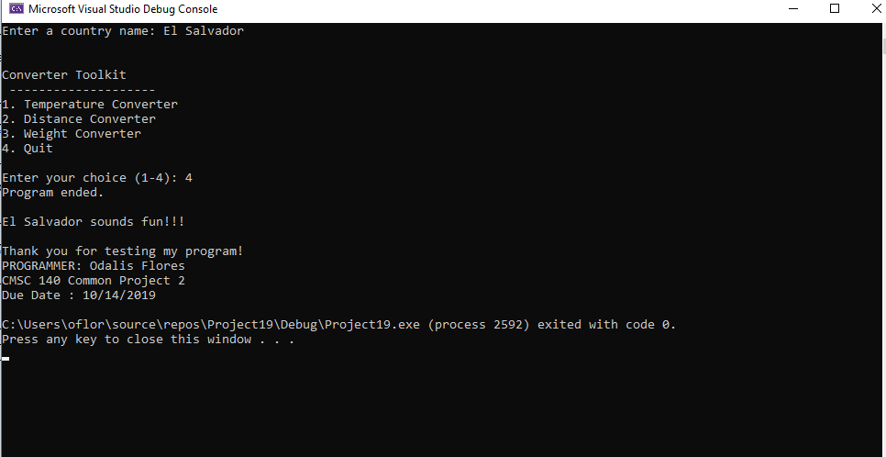

Case 2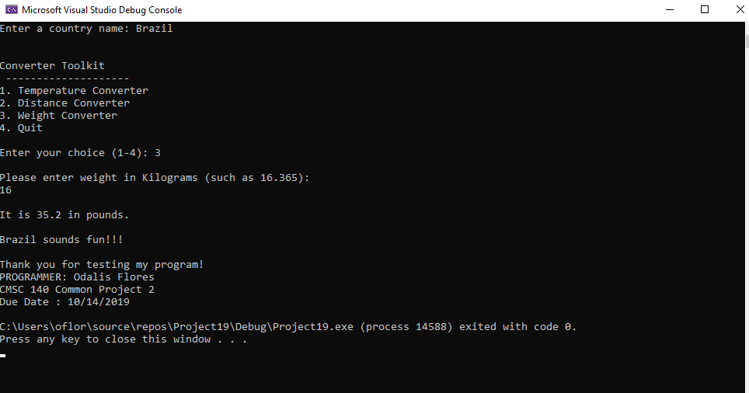

Case 3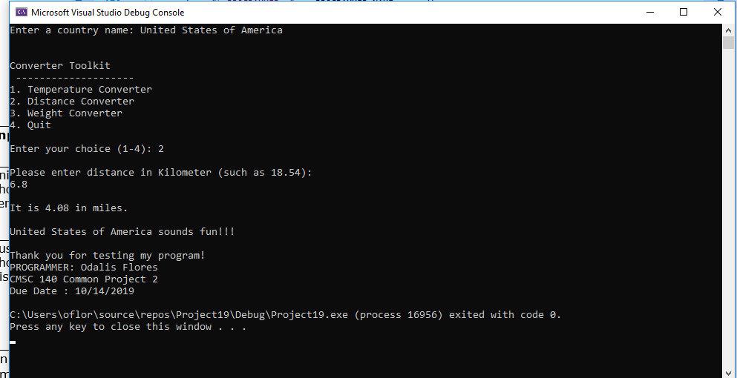

Case 4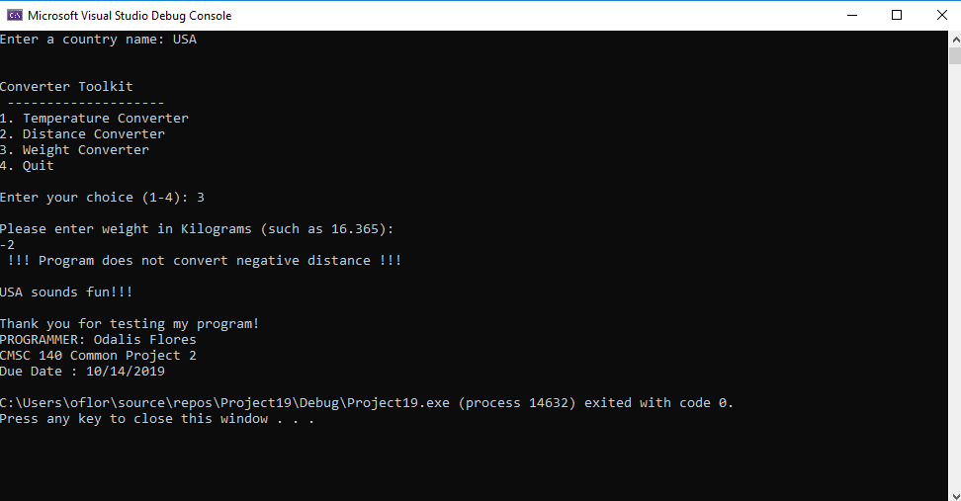

Case 5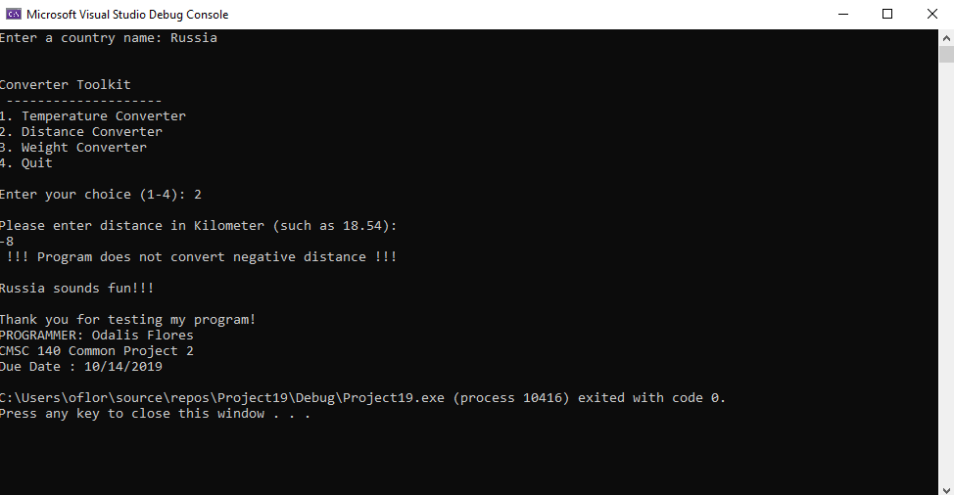

Case 6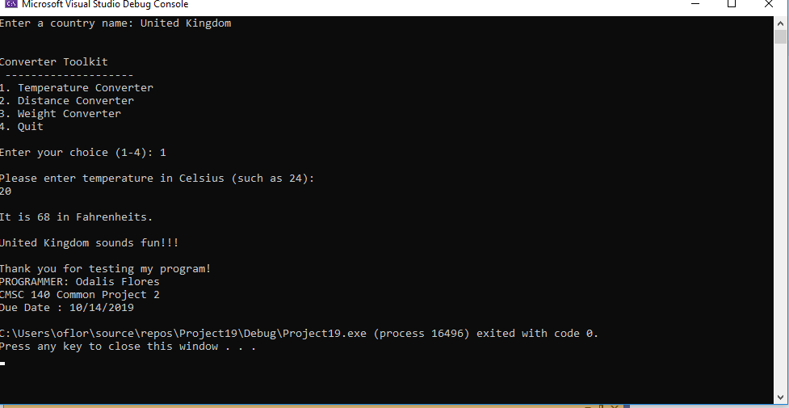

Case 7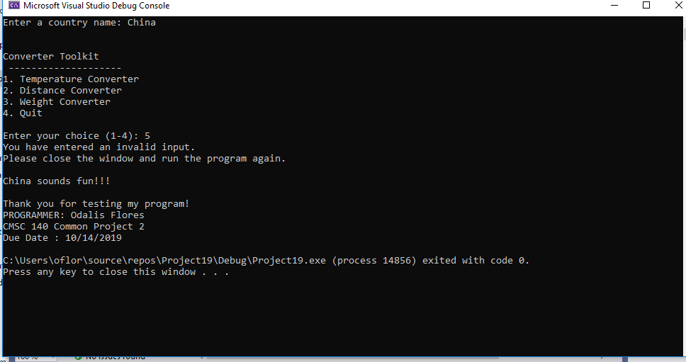

**Pseudocode Pr <2>**

1. Declare and initialize constant integer variables
   1. Temperature converter = 1
   2. Distance converter = 2
   3. Weight converter =3
   4. Quit = 4
   5. Assignment number = 2
2. Declare and initialize constant string variables
   1. Programmer name = Odalis Flores
   2. Due date = 10/14/2019
3. Declare integer variable
   1. number
4. Declare double variables
   1. fahrenheit
   2. celsius
   3. kilometer
   4. miles
   5. kilograms
   6. pounds
5. Declare string variable
   1. country name
6. Display “Enter a country name:”
7. Get country name from user
8. Display Converter tool kit Menu

**“Converter Toolkit**

**--------------------**

**1. Temperature Converter**

**2. Distance Converter**

**3. Weight Converter**

**4. Quit”**

1. Display message to user “Enter your choice (1-4):”
2. Get number from user
3. Switch statement begins, switch (number)
   1. Case temperature converter:
      1. Prompt user “Please enter temperature in Celsius (such as 24):
      2. Get Celsius from user
      3. Convert Celsius to Fahrenheit using expression Fahrenheit = (9/5)* Celsius +32
      4. Display “It is (display Fahrenheit as a whole number) in Fahrenheit”
      5. break
   2. Case distance converter:
      1. prompt user “Please enter distance in Kilometer (such as 18.54):”
      2. get kilometer from user
         1. if kilometer is greater than or equal to 0
            1. then convert kilometer to miles, using expression miles = kilometer * 0.6
            2. display “It is (miles displayed in two decimal places) in miles.
         2. Else
            1. Display “!!! Program does not convert negative distance !!!”
      3. break
   3. Case weight converter:
      1. Prompt user “Please enter weight in Kilograms (such as 16.365):”
      2. Get kilograms from user
         1. If kilogram is greater than or equal to 0
            1. Convert kilogram to pounds, using expression pounds = kilograms * 2.2
            2. Display “It is (pounds shown to one decimal place) in pounds”
         2. Else
            1. Display “!!! Program does not convert negative distance !!!”
      3. break
   4. Case quit:
      1. Display “Program ended.”
      2. Break
   5. Default:
      1. Display “You have entered an invalid number, please close the window and run the program again”
4. Display “(country name) sounds fun!!’
5. Display “Thank you for testing my program!

PROGRAMMER: (programmer name)

CMSC 140 Common Project (assignment number)

Due date: (due date)

**Flowchart**

Start

Declare variables

Temperature converter, distance converter, weight converter, quit, assignment number, programmer name, due date, number, fahrenheit, celsius, kilometer, miles, kilograms, pounds;

country name

Prompt user to enter country name

Get country name from user

Display

**Converter Toolkit**

**--------------------**

**1. Temperature Converter**

**2. Distance Converter**

**3. Weight Converter**

**4. Quit**

Prompt user to pick number 1-4 on converter toolkit

Get number 1-4 from user

A

A

Switch (number)

False

False

False

True

True

True

Convert temperature from Celsius to Fahrenheit

Fahrenheit= (9/5)* Celsius +32

Get temp**eratur**e from user

Display temperature in Fahrenheit’s as whole number

Prompt user to enter temperature in Celsius

Display cannot convert negative numbers

B

Case:

Distance converter

Display distance in miles with 2 decimal places

Convert distance from kilometers to miles

miles = kilometers*0.6

If Kilometer >=0

Get distance from user

Prompt user to enter distance in kilometers

Case:

temperature converter

False

False

False

True

True

True

True

C

default

Display weight in pounds with one decimal place

Display cannot convert negative numbers

Display invalid input

Display program ended

Case:

Quit

Convert weight in kilograms to pounds

pounds=kilogram*2.2

If Kilogram >=0

Get weight from user

Prompt user to enter weight in kilograms

B

Case:

Weight converter

C

End

Display

Thank you for testing my program!!

Programmer: programmer name

CMSC 140 Common Project, project number

Due date

Display country name sounds fun!!

**Lessons Learned**

Project 2 involved declaring variables, constant variable, using the switch statement and if else statements that was covered in chapter 4. This project also consisted of flowchart and pseudocode which is different from project one. I started working on my flowchart about 2 weeks ago. Since I started my flowchart before I was able to finish reading chapter 4, I was unaware of the switch statement. Initially I thought using if else if statement was my best option. After reading the chapter I then realized it would be much more efficient to use the switch statement. I learned that the switch statement is preferable for its simplicity and cleanliness. When I had started writing my code out with the if else if statement things looked a bit messy and confusing. Although the indentions help a lot, because I had to use nested if else statements it made the code harder to track. When I modified my code using the switch statement things became easier to follow and fix.

The only issue I ran into was getting started before being able to finish reading Chapter 4. Since I changed my code from if else if statement to the switch statement, I had to go back and edit my flowchart. The flowchart feels time consuming since I use a word document to add shapes with description and then I add arrows and if I make changes, I must make sure the flow chart and its shape are aligned. I felt that the easiest part was creating the pseudocode because I am saying what I must do for my code without having to make much attention to my diction.

I found it difficult to edit my flowchart using the switch statement. When I read Chapter 4, it showed examples of how-to flowchart if, if else, if else if statements. When it came down to the switch statement, the book did not offer a visual to represent the switch statement in a flowchart. I did use the internet to find examples of switch statements in a flowchart. Once I was able to see a visual then I could start to edit my flowchart.

I also learned that I could name a different variable to get the user input and use that variable to compare it to my switch statement cases. I knew I had to name a constant variable for the numbers in the converter tool kit. At first, I wrote that I would name the variables 1-4, soon enough I figured I am supposed to use letters to name these variables. After naming the constant variable according to converting method, I was stuck on how I would get the number from the user if the user does not know the constant variable I am using in my code. That is when I learned that I had to declare a variable, in my case I declared number, that would allow the user to enter an integer value. The integer expression in my switch statement would compare the integer value to the cases in which I would add my constant variables. I learned that the expression used in the beginning of my switch statement would compare it to the cases, if it matched the case then those statements would run otherwise the default statement would display an error message. Overall, I felt that I learned how to correctly use the if, if else, if else if, and switch statement very well. Project <2> also reminded me how to declare constant variables.