Pr<3>

Odalis Flores

CMSC 140 CRN: 21417

due date 11/04/2019

[Year]

|  |  |  |  |  |  |
| --- | --- | --- | --- | --- | --- |
| **Test Case #** | **Input** | **Actual Input** | **Expected Output** | **Actual Output** | **Did the test pass?** |
| 1 | loc: Washington  #of floors: 0 | Location: Washington  Number of floors :0  Number of floors: 6  Number of floors:1  Number of rooms:30  SR: 5  DR: 5  KR: 5  SuR: 5 | Number of floors should be between 1 and 5. Please try again!!  Number of floors should be between 1 and 5. Please try again!!  Hotel income = 1925  Total rooms=30  number of occupied rooms=20  number of unoccupied =10  occupancy rate = 66.67% | Error message number of floors should be between 1-5  Error message number of floors should be between 1-5  Hotel Income: 1925.00  Total # of rooms: 30  Total number of Occupied rooms: 20  Total # of unoccupied rooms: 10  Occupancy rate: 66.67% | Y |
| 2 | Loc: Los Angeles  # of floors 2  Number of rooms in floor 1: 33 | Loc: Los Angeles  # of floors 2  Number of rooms in floor 1: 33  Number of rooms:30  SR: 5  DR: 5  KR: 5  SuR: 5  Number of rooms in floor 2: 10  Number of rooms:30  SR: 1  DR: 1  KR: 1  SuR: 1 | Error message, floors should be between 1- 30 try again  Hotel income: 2310  Total # of rooms: 40  Total number of Occupied rooms: 24  Total # of unoccupied rooms: 16  Occupancy rate:60.00% | Number of rooms should be between 1 and 30 !!, please try again  Hotel Income: 2310.00  Total # of rooms: 40  Total number of Occupied rooms: 24  Total # of unoccupied rooms: 16  Occupancy rate:60.00% | Y |
| 3 | Loc: Rockville  # of floors:2  Number of rooms in 1: 30  SR: 10  DR: 10  KR: 10  SuR: 10 | Loc: Rockville  # of floors:2  Number of rooms in 1: 30  SR: 10  DR: 10  KR: 10  SuR: 10  number of rooms in floor # 1: 30  SR: 5  DR: 5  KR: 5  SuR: 5  number of rooms in floor # 2: 20  SR: 2  DR: 2  KR: 2  SuR: 2 | Error message number of occupied rooms exceeds number of rooms on the floor try again  Hotel Income: $1540.00  Total # of rooms: 40  Total number of Occupied rooms: 16  Total # of unoccupied rooms: 24  Occupancy rate: 40.00%  You need to improve the occupancy rate. Floor # 2 with 20 rooms has the least number of rooms. | Error message number of occupied rooms exceeds number of rooms on the floor try again  Hotel Income: $1540.00  Total # of rooms: 40  Total number of Occupied rooms: 16  Total # of unoccupied rooms: 24  Occupancy rate: 40.00%  You need to improve the occupancy rate. Floor # 2 with 20 rooms has the least number of rooms. | Y |
| 4 | Loc: Chicago  # of floors in the hotel: 5  rooms in floor # 1: 30  SR: 5  DR: 5  KR: 5  SuR: 5  rooms in floor # 2: 20  SR: 10  DR: 10  KR: 10  SuR: 2 | Loc: Chicago  # of floors in the hotel: 5  rooms in floor # 1: 30  SR: 5  DR: 5  KR: 5  SuR: 5  rooms in floor # 2: 20  SR: 10  DR: 10  KR: 10  SuR: 2 | Error message number of occupied rooms exceeds number of rooms on the floor try again  Hotel Income: $5235.00  Total # of rooms:95  Total number of Occupied rooms: 54  Total # of unoccupied rooms: 41  Occupancy rate: 56.84%  You need to improve the occupancy rate. Floor # 5 with 10 rooms has the least number of rooms. | Error message number of occupied rooms exceeds number of rooms on the floor try again  Hotel Income: $5235.00  Total # of rooms:95  Total number of Occupied rooms: 54  Total # of unoccupied rooms: 41  Occupancy rate: 56.84%  You need to improve the occupancy rate. Floor # 5 with 10 rooms has the least number of rooms. | y |

**Screenshots**

**Case 1:** 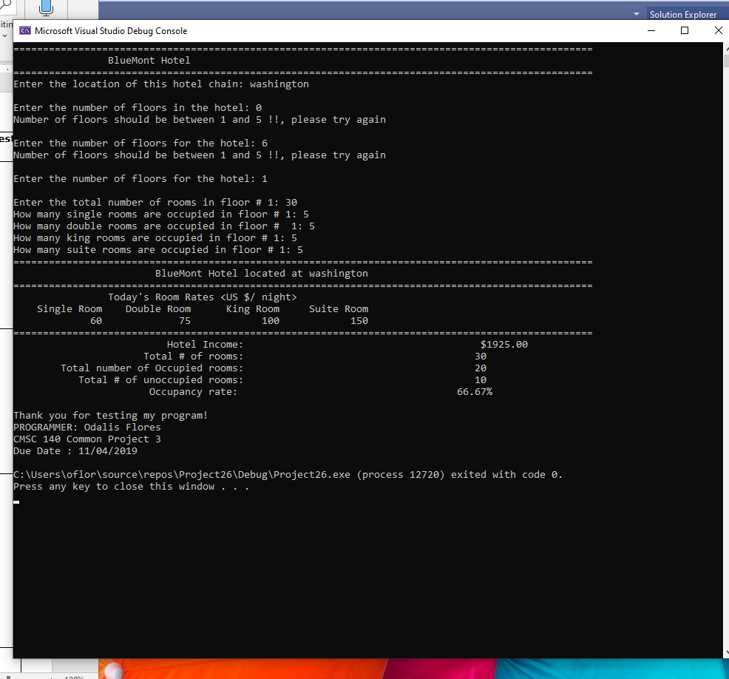

**Case 2:**

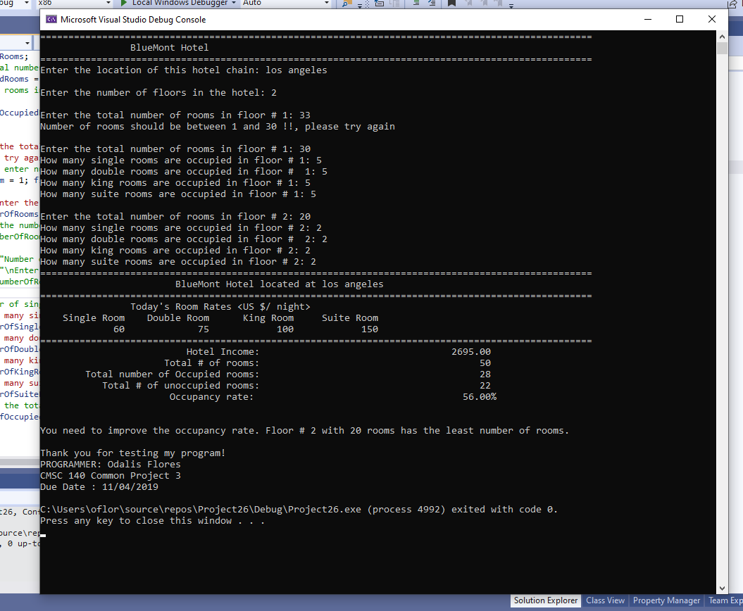

**Case 3:**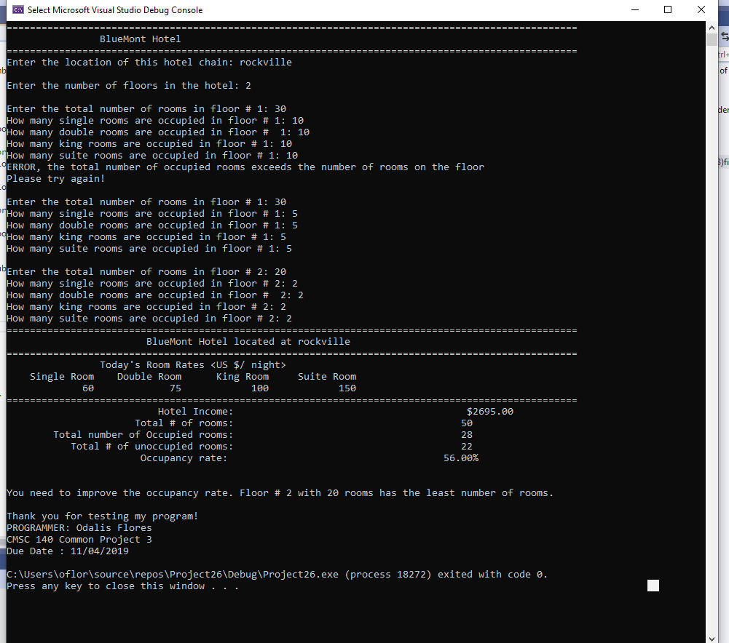

**Case 5:**

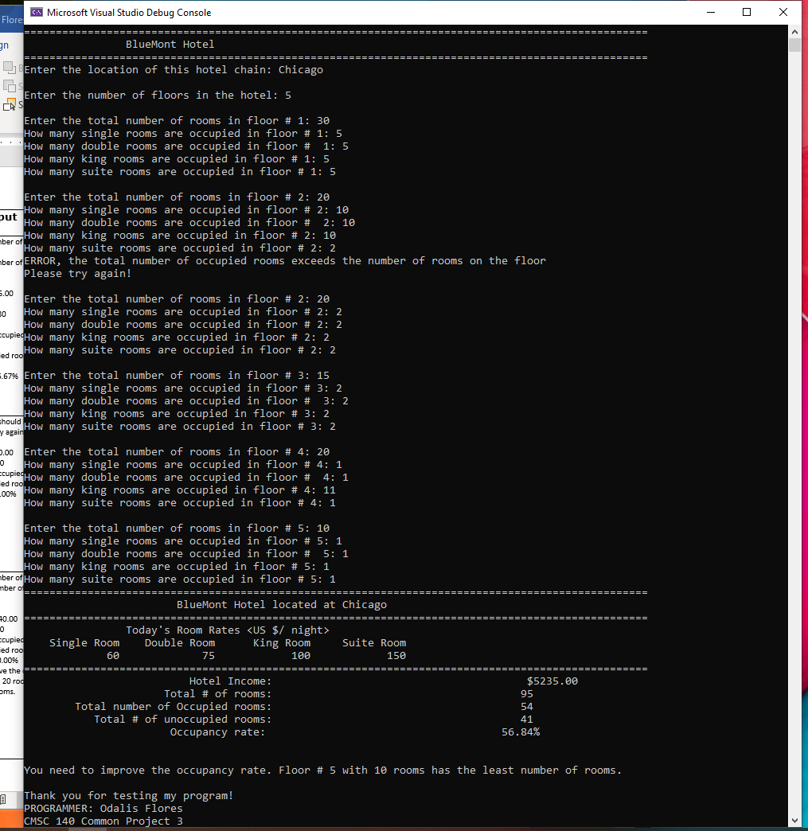

**Pseudocode Pr <3>**

1. Declare constant integers for
   1. Single room rate = 60
   2. Double room rate =75
   3. King room rate = 100
   4. Suite room rate=150
   5. Max rooms=30
   6. Min rooms=1
   7. Max floors =5
   8. Min floors=1
   9. Assignment number = 3
2. Declare const string for
   1. Programmer name = Odalis Flores
   2. Due date = 11/04/2019
3. Declare string for hotel location
4. Declare integers for number of floors, number of rooms, number of single rooms, number of double rooms, number of king rooms, number of suite rooms, total number of occupied rooms, total number of single rooms, total number of double rooms, total number of king rooms, total number of suite rooms, total number of hotel rooms, absolute number of occupied rooms, absolute sum of rooms. Lowest number of rooms, and lowest floor number
5. Declare double variable for hotel income and occupancy rate
6. Display Bluemont hotel header
7. Prompt user to enter location of hotel
8. Get location of hotel and store in variable hotel location
9. Prompt user to enter number of floors in hotel
10. Get number of hotel floors from user and store in number of floors
11. Generate loop, if number entered by user is less than 1 or greater then 5
    1. Display error message
    2. Prompt user to enter number of floors in hotel
    3. Get number of hotel floors from user and store in number of floors
    4. Repeat if loop continues to be true
12. Start for loop, for floor num that = 1, floor num is less than or equal to number of floors, increment floor num
    1. Prompt user to enter the total number of rooms in floor # floor num
    2. Get number of rooms from user
    3. Start nested wile loop, so that if number of rooms is less than min rooms or greater than max rooms
       1. Display error message
       2. Prompt user to enter the total number of rooms in floor # floor num
       3. Get number of rooms from user
       4. Repeat if loop is true
    4. Prompt user to enter single rooms occupied in floor num
    5. Get single rooms occupied in floor num
    6. Prompt user to enter double rooms occupied in floor num
    7. Get double rooms occupied in floor num
    8. Prompt user to enter king rooms occupied in floor num
    9. Get king rooms occupied in floor num
    10. Prompt user to enter suite rooms occupied in floor num
    11. Get suite rooms occupied in floor num
    12. Calculate the total number of rooms occupied in this floor and store in variable total number of rooms occupied
        1. = Single room + double room + king room + suite room
    13. While the total number of occupied rooms is greater than the number of rooms
        1. Display error message
        2. Prompt user to enter single rooms occupied in floor num
        3. Get single rooms occupied in floor num
        4. Prompt user to enter double rooms occupied in floor num
        5. Get double rooms occupied in floor num
        6. Prompt user to enter king rooms occupied in floor num
        7. Get king rooms occupied in floor num
        8. Prompt user to enter suite rooms occupied in floor num
        9. Get suite rooms occupied in floor num
        10. Calculate the total number of rooms occupied in this floor and store in variable total number of rooms occupied
        11. Repeat if while loop is true
    14. Add the sums of each room type and the number of rooms
        1. Total number of Single Rooms is the sum of number Of Single Rooms
        2. Total Number of Double Rooms is the sum of number Of Double Rooms
        3. Total Number of King Rooms is the sum number Of King Rooms
        4. Total Number of Suite Rooms is the sum number Of Suite Rooms
        5. Total Number of Hotel Rooms is the sum number Of Rooms
    15. Start if statement to find the floor with the lowest number of occupied rooms, and the number of rooms in the floor
        1. If the floor num is greater than or equal to 1
           1. The lowest floor room is assigned the total number of occupied rooms
           2. The lowest floor room is assigned the floor num
           3. Lowest number of rooms is assigned the number of rooms
        2. Else
           1. If total number of occupied rooms is less than lowest floor rooms
              1. Lowest floor room is assigned the floor num for the floor
              2. Lowest number of rooms is assigned number of rooms for that floor
    16. Get out of for loop
13. Display the menu with hotel header including the hotel location and pattern before and after
14. Display the room type with he rates for the room type with specific field width
15. Calculate/display the hotel income
    1. Cast integers to doubles to avoid type conversation
    2. = total single rooms * single rate + total double rooms * double rate + total king rooms * king rate + total suite rooms * suite rate
    3. Display hotel income with two decimal places and set the width to align with other messages displayed
16. Display the total amount of rooms in the hotel (= sum of number of rooms) and set the width to align with other messages displayed
17. Calculate/display the absolute total amount of occupied rooms in the hotel
    1. = total single rooms + total double rooms + total king rooms + total suite rooms
    2. Display the absolute total amount of occupied rooms in the hotel set the width to align with other messages displayed
18. Calculate and display the number of unoccupied rooms
    1. Subtract the total amount of rooms in the hotel and absolute total amount of occupied rooms in the hotel set the width to align with other messages displayed
19. Calculate and display the occupancy rate
    1. Cast the variables to doubles
    2. = absolute total amount of occupied rooms in the hotel / total number of hotel rooms store in occupancy rate
    3. Display occupancy rate with two decimal places and set the width to align with other messages displayed
20. If the occupancy rate is less than 60%
    1. Display message to improve occupancy rate with the floor with least amount of occupied rooms and the amount of room on that floor.
21. Display thank you message for using program with programmer name and common project number and due date