Project <4>

Common Project

Programmer: Odalis r. Flores

CMSC 140 CRN: 21714

due date: 11/18/2019

2019

|  |  |  |  |  |  |
| --- | --- | --- | --- | --- | --- |
| **Test Case #** | **Input** | **Actual Input** | **Expected Output** | **Actual Output** | **Did the test pass?** |
| 1 | Username: oflores  No. of employees:4  Employee ID’s/Days of absence:  1111 4  1112 5  1113 4  1114 3 | Username: oflores  No. of employees:4  Employee ID’s/Days of absence:  1111 4  1112 5  1113 4  1114 3 | Total: 16  Average: 4.0 | Total: 16  Average: 4.0 | Y |
| 2 | Username: oflores  No. of employees:5  Employee ID’s/Days of absence:  1234 2  2234 4  3234 6  4234 9  234 4 | Username: oflores  No. of employees:5  Employee ID’s/Days of absence:  1234 2  2234 4  3234 6  4234 9  234 4 | Total: 25  Average: 5.0 | Total: 25  Average: 5.0 | Y |
| 3 | Username: Odalis Flores  No. of employees:2  Employee ID’s/Days of absence:  0000 2  1111 -5 | Username: Odalis Flores  No. of employees:2  Employee ID’s/Days of absence:  0000 2  1111 -5 / 5 | Error message when entered -5 for absent days  Total: 7  Average: 3.5 | Error message when entered -5 for absent days  Total: 7  Average: 3.5 | Y |
| 4 | Username: John Travolta  No. of employees:0  Employee ID’s/Days of absence:  1234 5  1235 6  1236 1  1234 0 | Username: John Travolta  No. of employees:0 / 4  Employee ID’s/Days of absence:  1234 5  1235 6  1236 1  1234 0 | Error message when entered 0 for number of employees  Total: 12  Average: 3.0 | Error message when entered 0 for number of employees  Total: 12  Average: 3.0 | Y |
| 5 | Username: Lizzy McGuire  No. of employees: -1  Employee ID’s/Days of absence:  9999 1  8888 -3  7777 0  6666 -5 | Username: Lizzy McGuire  No. of employees: -1/ 4  Employee ID’s/Days of absence:  9999 1  8888 -3 / 3  7777 0  6666 -5 / 5 | Error message when entered -1 for number of employees  Error message when entered -3 for absent days  Error message when entered -5 for absent days  Total: 9  Average: 2.3 | Error message when entered -1 for number of employees  Error message when entered -3 for absent days  Error message when entered -5 for absent days  Total: 9  Average: 2.3 | Y |

**Screenshots**

Test Case 1:

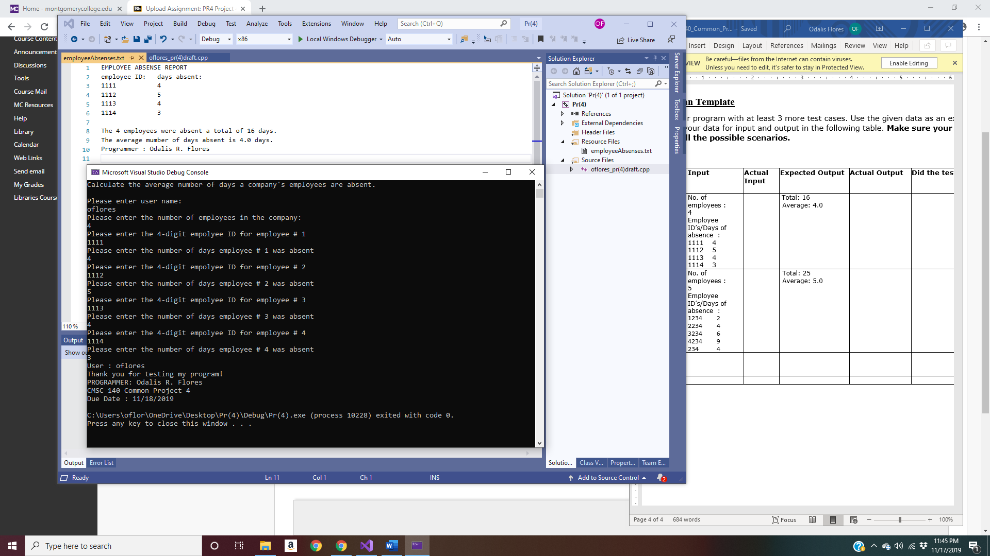

Test Case 2: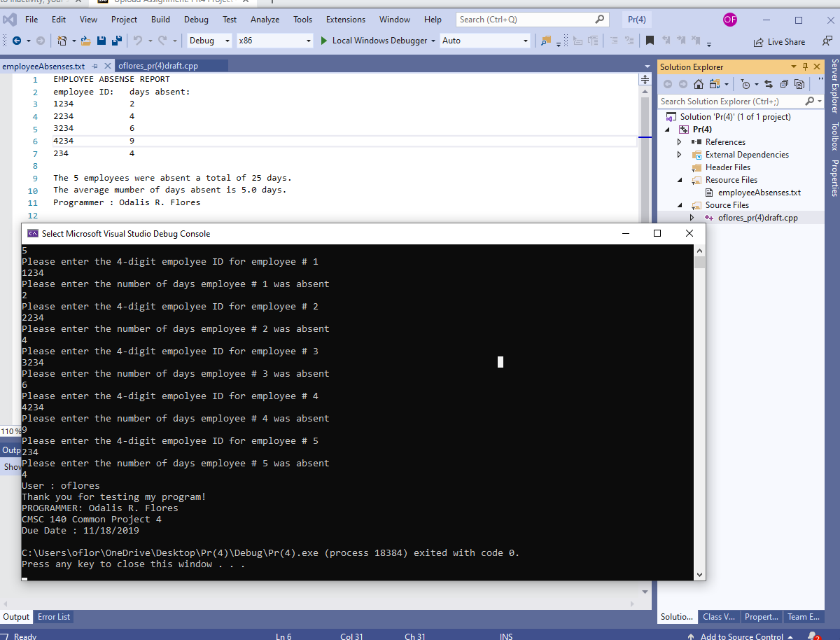

Test Case 3: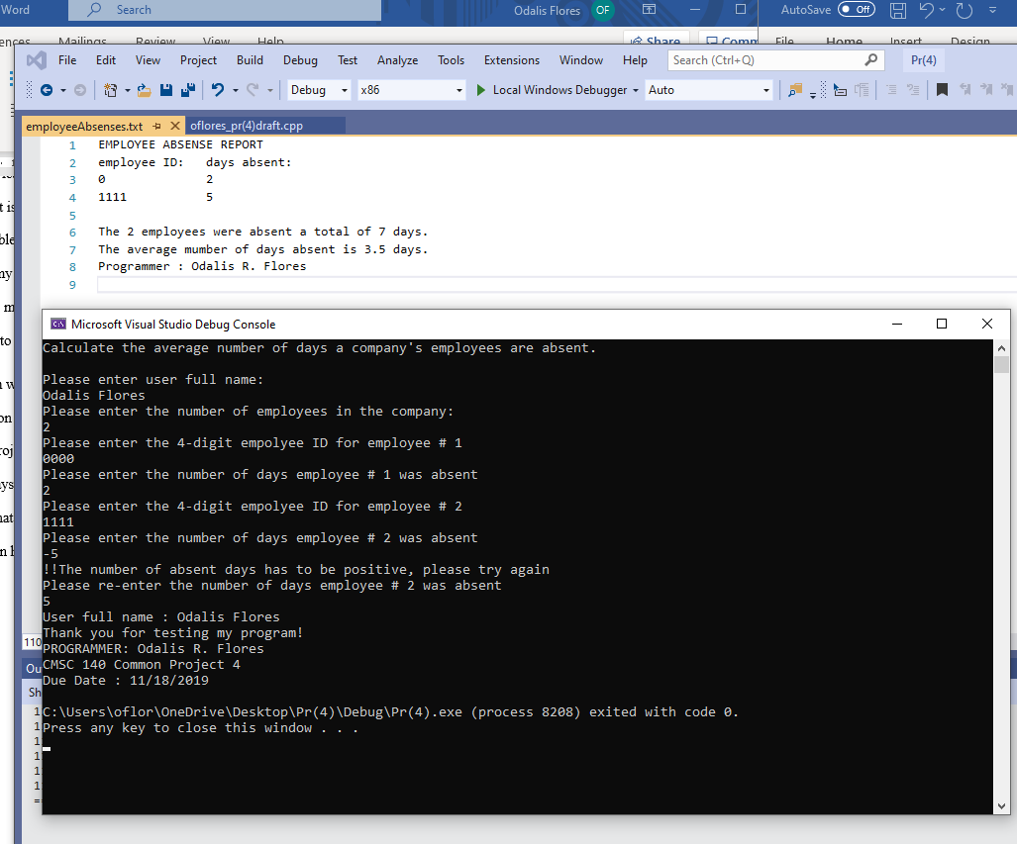

Test Case 4: 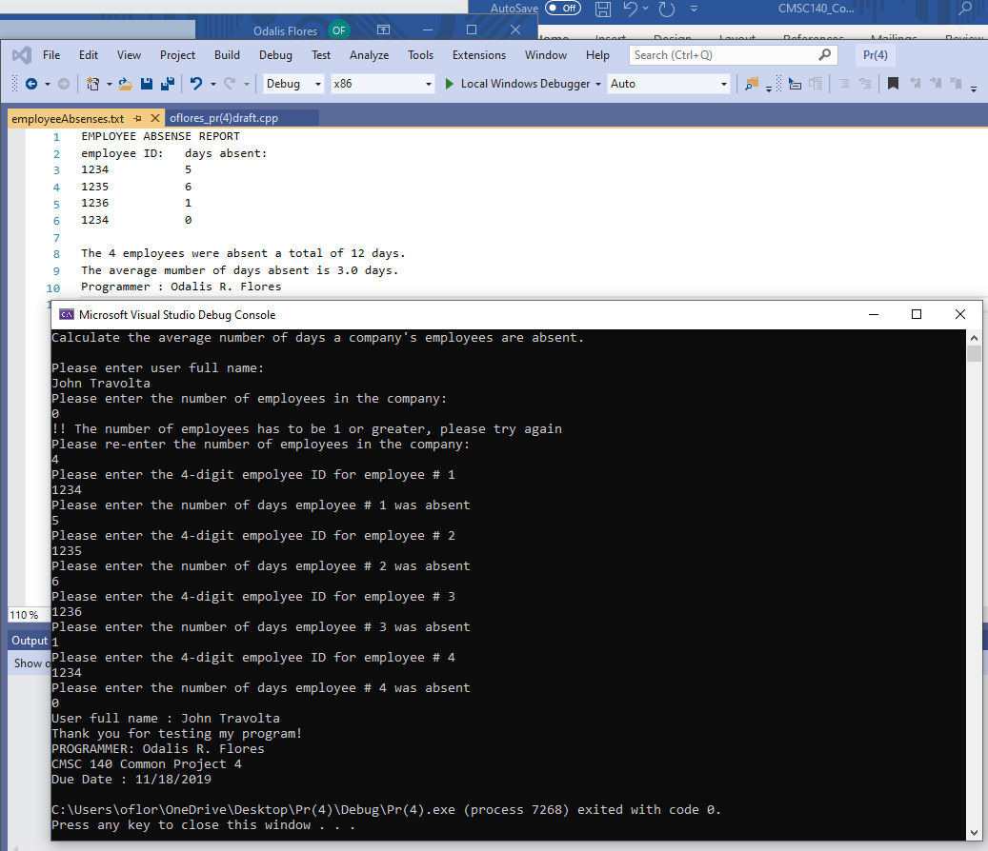

Test Case 5: 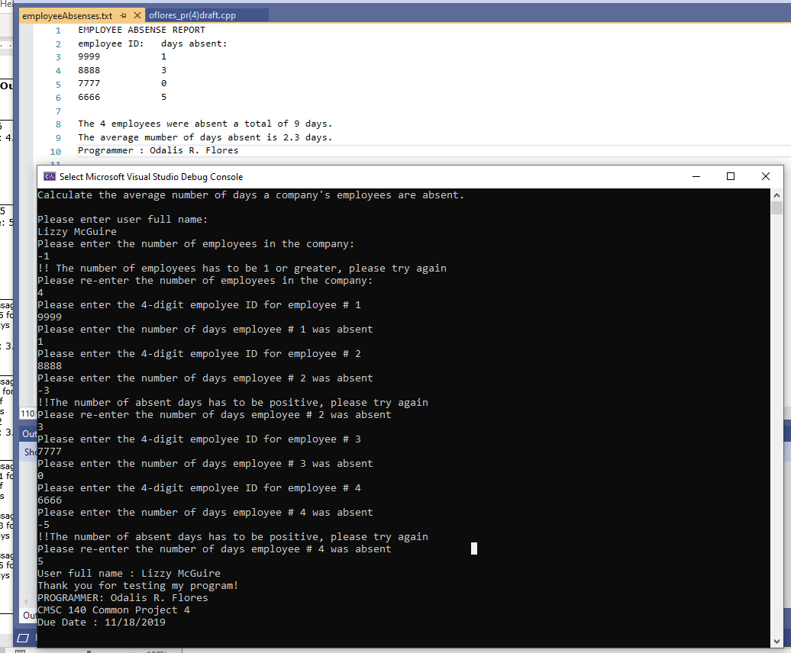

**Lessons learned**

Common project number 4 allowed me to understand the concept of using functions. I learned that it is easier to use a function because it can be used many times within a program. I find that this is useful because it makes long codes become shorter and easier to read. I felt that if we had used functions for our last common project, it could’ve saved students more time when coding.

I also learned how to properly create a text file and send information directly to it so that it display’s what is needed. In the processing requirements I found it helpful that it was mentioned to create a global variable of type ofstream. I felt that because that was mentioned I was able to use that variable anywhere in my program so when I created the function that asked for employee id and absent days I just made sense to me that I would use the global variable to display those variables in the text file. Then I was also able to use it in my main function with does the calculations.

I learned how to also use a for loop in a function and using parameters as the variable that is tested with in the function. I felt that it was easy to do since we had to use for loop in the last project. I wish we were able to do Boolean functions in this project to learn how to properly code for that type of function and see how it can be used with-in a program. There are some minor changes I would make to the project description, like on page 1 of document [CMSC140_Common_Project4_Fall2019.docx](https://bb-montgomerycollege.blackboard.com/bbcswebdav/pid-4778012-dt-content-rid-51293854_1/xid-51293854_1), the section that says project specifications input for this project, I would add that user must enter their full name. I feel that this would eliminate some confusion in the output section. Overall, I felt this a great project to learn how to use global variables and functions with return values.

**Pseudocode Pr<4>**

1. Start
2. Declare functions
   1. numOfEmployees();
   2. totDaysAbsent(int);
   3. averageAbsent(double, double);
3. declare text file ofstream fout;
4. start main function
   1. declare variables
      1. numberOfEmployees
      2. sumOfnumOfAbsentDays
      3. average;
      4. PROGRAMMER_NAME = "Odalis R. Flores";
      5. DUE_DATE= "11/18/2019";
      6. ASSIGNMENT_NUMBER = 4;
      7. userName;
   2. display program description = Calculate the average number of days a company's employees are absent
   3. prompt user to enter user ful name
   4. get user full name
   5. Open text file "EmployeeAbsent.txt"
   6. Display header "EMPLOYEE ABSENT REPORT

employee ID: days absent:"

* 1. Call for function numOfEmployees and initialize return value to variable numberOfEmployees
  2. Call for function totDaysAbsent with parameter set to numberOfEmployees and initialize return value to variable sumOfnumOfAbsentDays
  3. Call for function averageAbsent with parameter set to numberOfEmployees and sumOfnumOfAbsentDays, inialize to variable average
  4. Display “the numberOfEmployees number of employees were absent a total of sumOfnumOfAbsentDays. In text file "EmployeeAbsent.txt"
  5. Display “the average of absent days is average” in text file "EmployeeAbsent.txt"
  6. Display “Programmer: PROGRAMMER_NAME”
  7. Close text file PROGRAMMER_NAME =
  8. Display the users full name
  9. Display thank you message: include
     1. Programmer name
     2. Project number
     3. Due date

1. Define function numOfEmployees() with no parameter
   1. Declare variable x
   2. Prompt user to enter number of employees
   3. Get number and store in variable x
      1. While x is less than 1
         1. ERROR MESSAGE
         2. Prompt user to enter number of employees
         3. Get number and store in variable x
         4. Repeat as long as while expression is true
   4. Return value of variable x
2. Define function totDaysAbsent(int z) with parameter of data type integer and argument z
   1. Declare variables
      1. employeeID
      2. numOfAbsentDays
      3. sumOfnumOfAbsentDays initialize to value 0
   2. start for loop, for int = count, if count is less than or equal to z, increment count
      1. prompt user to enter 4-digit
      2. ID number for employee
      3. get employeeID
      4. display employeeID in text file "EmployeeAbsent.txt"
      5. Enter the number of absent days for employee #
      6. Get numOfAbsentDays
         1. While numOfAbsentDays is less than 0
            1. ERROR MESSAGE
            2. Enter the number of absent days for employee #
            3. Get numOfAbsentDays
            4. Repeat as long as while expression is true
      7. Display numOfAbsentDays in text file "EmployeeAbsent.txt"
      8. Add the sum of numOfAbsentDays and initialize to variable sumOfnumOfAbsentDays
      9. Return value of sumOfnumOfAbsentDays
3. Define function double averageAbsent with parameters with two arguments a, b of data type double
   1. Declare variable for averageOfAbs
   2. Calculate b divided by a and initialize value to variable averageOfAbs
   3. Return the value of variable averageOfAbs
4. End

A

averageAbsent (numOfEmployee, TotalAbsentDays)

totDaysAbsent (int numOfEmployees)

input

start

Declare ofstream fout

numOfEmployees

Return value of averageOfAbsentDays

Declare variable averageOfAbsentDays

Calculate average of value of b divided by a

display employee ID in text file

Return value of numOfEmployee

Get number of employees store in variable numOfEmployee

While numOfEmployees

< 0

Return value of sumOfNumOfAbsentDays

Calculate sum of absent days and store in variable sumOfNumOfAbsentDays += absent days

Store absent days in text file

Get absent days

Prompt user to enter number of absent days for employee

ERROR MESSAGE

While absent days is less than 0

Get absent days

Prompt user to enter number of absent days for employee

Get employee ID

Prompt user to enter 4 digit employee ID

For int num= 1, if num <= numOfEmployees is true increment num

Declare variable employeeID, numOfAbsentDays

numOfEmployees < 0

ERROR MESSAGE

Prompt user to enter number of employees

Get number of employees store in variable numOfEmployees

Prompt user to enter number of employees

Declare variable numOfEmployees

A

Display

User full name : userName

Thank you for testing my program!!

Programmer: PROGRAMMER _NAME

CMSC 140 Common Project = ASSIGNMENT_NUM

Due date DUE_DATE

Display “the numberOfEmployees were absent a total of TotalAbsentDays.

The average number of days absent is averageAbsentDays.

Programmer : PROGRAMMER_NAME”

in text file

Display project description,

Prompt user to enter user full name

Get user full name

Display header

“EMPLOYEE ABSENT REPORT

Employee ID: days absent”

in text file

numberOfEmployees = function value of numOfEmployees

TotalAbsentDays = function value of totDaysAbsent with parameter = numberOfEmployees

Declare and start text file “employeeAbsent.txt”

averageAbsentDays = function value of averageAbsent with parameter that equals arguments numOfEmployees , and sumOfNumOfAbsentDays

Close text file “EmployeeAbsent.txt”

Declare constant PROGRAMMER _NAME = Odalis R. Flores, ASSIGNMENT_NUM =4, DUE_DATE = 11/18/2019

Declare variable numberOfEmployees, userName, TotalAbsentDays, averageAbsentDays

end

output

process