Odalis Flores

Lab 10

CMSC 203

**Task#2 (x^3 - 7*x^2 + 15*x – 9)**

Function#4 will approach 0 at these points, (1,0) and (3,0) which can be seen when using 0 and 4 as extents of the function. This photo best shows when the graph approached 0.

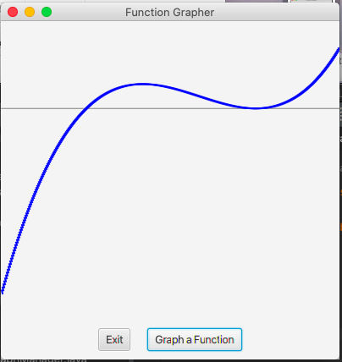

When using a larger scale, -10 to 0 the whole graph cannot be appreciated and does not show the behavior of a cubic function (left photo). When using 0 to 10 as the extents you can appreciate the graph is behaving like a cubic function but you cannot see when the graph approaches zeros clearly (right side).

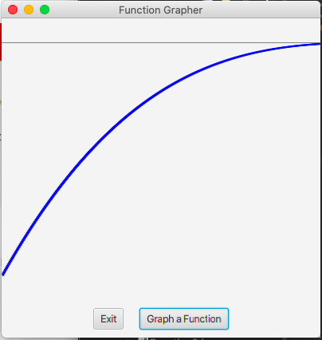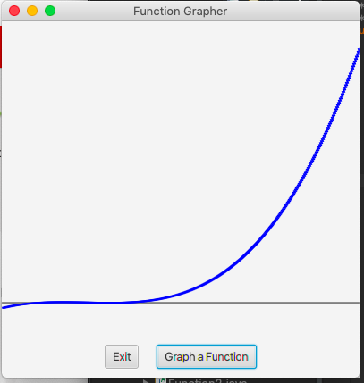

**Task #3 (sin(1/x)**

For function#5 when the extents are greater in size the graph appears to have a different trajectory as for when the extents are closer/smaller in size. When using -1 and 1 as its extents we can see the graph is oscillating as the graph approaches 0 because the limit does not exist at the point (0,0). As shown in the photo below.

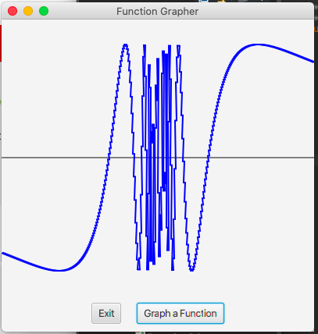

When using larger extents like -100 to 100 the graph seems to have an a horizontal and vertical asymptote where you can still conclude that the limit does not exist at 0 but you cannot appreciate the oscillation of the graph when it approaches 0.

