Week 4 Homework Submission File: Linux Systems Administration

Step 1: Ensure/Double Check Permissions on Sensitive Files

* Permissions on /etc/shadow should allow only root read and write access.
* Command to inspect permissions: **ls -l shadow**
* Command to set permissions (if needed):
* Permissions on /etc/gshadow should allow only root read and write access.
* Command to inspect permissions: **ls -l gshadow**
* Command to set permissions (if needed):
* Permissions on /etc/group should allow root read and write access, and allow everyone else read access only.
* Command to inspect permissions: **ls -l group**
* Command to set permissions (if needed):
* Permissions on /etc/passwd should allow root read and write access, and allow everyone else read access only.
* Command to inspect permissions: **ls -l passwd**
* Command to set permissions (if needed):

Step 2: Create User Accounts

* Add user accounts for sam, joe, amy, sara, and admin.
* Command to add each user account (include all five users):
* **sudo adduser sam**
* **sudo adduser joe**
* **sudo adduser amy**
* **sudo adduser sara**
* **sudo adduser admin**
* Ensure that only the admin has general sudo access.
* **sudo -l -U sam**
* **sudo -l -U joe**
* **sudo -l -U amy**
* **sudo -l -U sara**
* **sudo -l -U admin**
* Command to add admin to the sudo group: **sudo usermod -a -G sudo admin**

Step 3: Create User Group and Collaborative Folder

* Add an engineers group to the system.
* Command to add group:**sudo groupadd engineers**
* Add users sam, joe, amy, and sara to the managed group.
* Command to add users to engineers group (include all four users):
* **sudo usermod -a -G engineers sam**
* **sudo usermod -a -G engineers joe**
* **sudo usermod -a -G engineers amy**
* **sudo usermod -a -G engineers sara**
* Create a shared folder for this group at /home/engineers.
* Command to create the shared folder: **sudo mkdir /home/engineers**
* Change ownership on the new engineers' shared folder to the engineers group.
* Command to change ownership of engineer's shared folder to engineer group: **sudo chown :engineers engineers**

Step 4: Lynis Auditing

* Command to install Lynis: **sudo apt install lynis**
* Command to see documentation and instructions: **man lynis**
* Command to run an audit: **sudo lynis audit system**
* Provide a report from the Lynis output on what can be done to harden the system.
* Screenshot of report output:
* 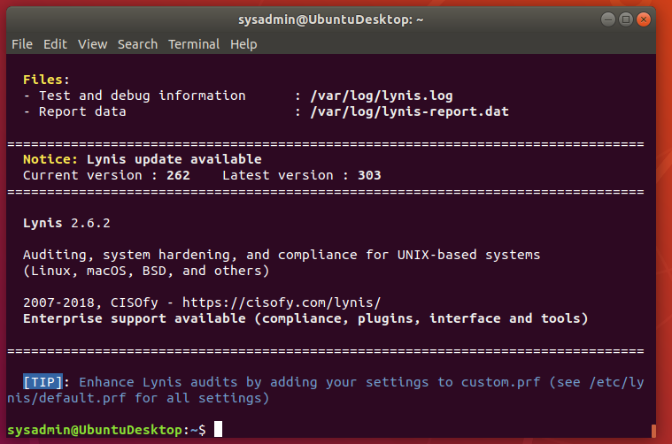

Bonus

* Command to install chkrootkit: **sudo apt install chkrootkit**
* Command to see documentation and instructions: **man chkrootkit**
* Command to run expert mode: **sudo chkrootkit -x**
* Provide a report from the chrootkit output on what can be done to harden the system.
* Screenshot of end of sample output:
* 