Task #1

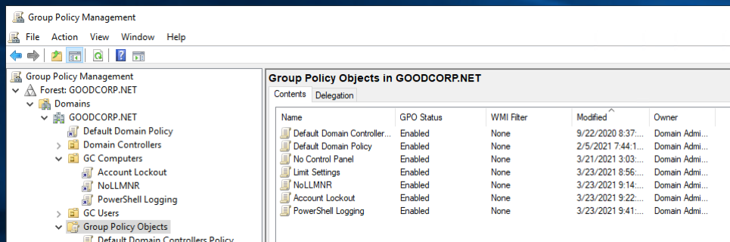

Task #2

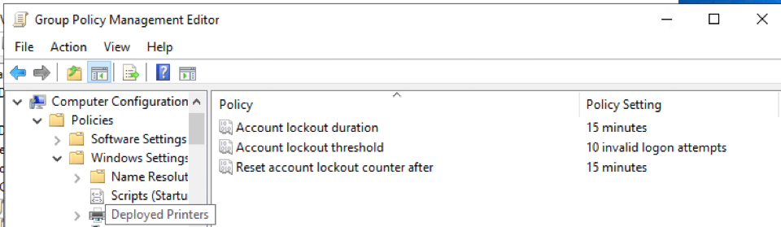

Task #3

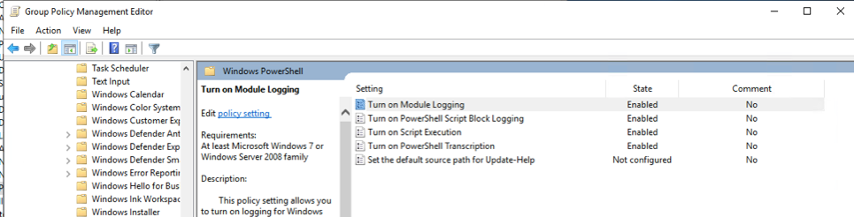

Task #4

$directory = Get-ChildItem $PSScriptRoot

foreach ($item in $directory) {

Get-Acl $item.FullName

}

Bonus Task #5

