**## Networks Fundamentals II Homework: *\*In a Network Far, Far Away!\****

**### Mission 1**

cmd: nslookup -query=mx starwars.com

The Resistance is not receiving any emails because the mail servers are not listed in the DNS server. The corrected DNS record should look like –

starwars.com mail exchanger = 1 asltx.l.google.com

starwars.com mail exchanger = 5 asltx.2.google.com

**### Mission 2**

cmd: nslookup -type=txt theforce.net

The forces emails are going to spam because the IP address from their server was not updated in the SPF document.

The corrected DNS should look like..

theforce.net text = "v=spf1 a mx mx:smtp.secureserver.net include:aspmx.googlemail.com ip4: 45.23.176.21"

**### Mission 3**

cmd: nslookup -type=cname www.theforce.net

The sub page is not redirecting because there is no reference from the sub page on the DNS record.

The corrected format should include

resistance.theforce.net canonical name = theforce.net.

**### Mission 4**

cmd: nslookup -type=ns princessleia.site

After confirming the DNS record, it shows that the backup DNS server is not listed. To fix this issue the record needs to be updated to include a reference to the wanted backup DNS server.

princessleia.site nameserver = ns25.domaincontrol.com.

princessleia.site nameserver = ns26.domaincontrol.com.

princessleia.site nameserver = ns2.galaxybackup.com.

**### Mission 5**

The shortest path does include planet N, in order to improve traffic flow the shortest path must change.

Current shortest, Batuu-D-C-E-F-J-K-N-O-R-Q-T-V-Jedha (20 hops)

Change to Batuu-D-C-E-F-J-I-L-Q-T-V-Jedha (23 hops)

**### Mission 6**

Darkside key: dictionary:linksys

IP Addresses MAC Addresses

​172.16.0.101 00:13:ce:55:98:ef

​172.16.0.1 00:0f:66:e3:e4:01

172.16.0.9 00:0b:86:c2:a4:85

**### Mission 7**

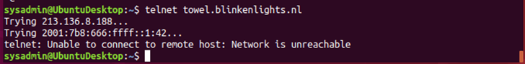

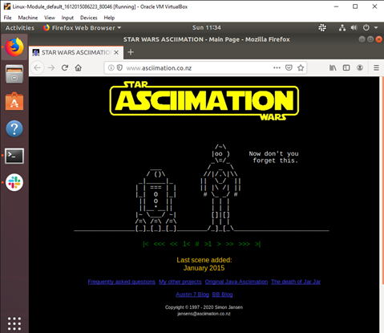

- Take a screenshot of the results.

**### Conclusion**

- Submit your results and findings from every mission.

- Congratulations, you have completed your mission and saved the Galaxy!

​