URL del Backend

utils/constants.js

Cpanel

<https://dev.to/crishanks/deploy-host-your-react-app-with-cpanel-in-under-5-minutes-4mf6>

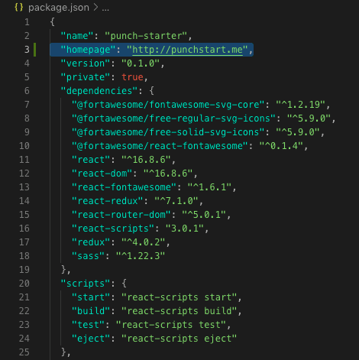

"homepage": <http://yourdomainname.whatever>

.htaccess

<IfModule mod_rewrite.c>

RewriteEngine On

RewriteBase /

RewriteRule ^index\.html$ - [L]

RewriteCond %{REQUEST_FILENAME} !-f

RewriteCond %{REQUEST_FILENAME} !-d

RewriteCond %{REQUEST_FILENAME} !-l

RewriteRule . /index.html [L]

</IfModule>

Netlify

1)"homepage": "https://gifted-boyd-4252dd.nettlify.com/",

2)**public**

**_redirect**

**---------------------------------**

**/* /index.html 200**

**---------------------------------**

3)App.js

**BrowserRouter as Router 🡪 HashRouter as Router**

**/#/**