DATA ACQUISITION,
CLEANING & PREPROCESSING
A practical Python workflow using a logistics and supply-chain dataset
INTERNSHIP TASK REPORT
Prepared by: Anant Shirke
Tools: Python • Pandas • NumPy • Matplotlib • Seaborn • Scikit-learn
DATASET: dynamic_supply_chain_logistics_dataset.csv

Contents
- 1. Executive Summary
- 2. Task Objective and Scope
- 3. Dataset and Data Collection Simulation
- 4. Tools and Reproducibility
- 5. Methodology and Implementation
- 6. Results and Visual Interpretation
- 7. Data Quality Considerations and Limitations
- 8. Reflection: Data Quality in Logistics
- 9. Conclusion
- Appendix A. Key Code Reference
- Appendix B. GitHub Publication Checklist

1. Executive Summary
This report documents a practical data-preprocessing workflow for a structured logistics dataset containing 32,065 records and 26 columns. The work was completed in Python using Pandas for data inspection and transformation, NumPy for numerical operations, Matplotlib and Seaborn for visual analysis, and Scikit-learn for Min-Max normalization. The pipeline covers CSV ingestion, data profiling, missing-value and duplicate assessment, timestamp conversion, IQR-based outlier detection, IQR capping on selected features, normalization, visualization, and export of processed files.
Key result
The dataset contained 32,065 rows and 26 columns. Initial checks found 0 missing values, 0 duplicate rows, and 0 invalid timestamps after datetime conversion. Three numerical features were flagged by the IQR scan: fuel_consumption_rate (2,536), iot_temperature (2,301), and disruption_likelihood_score (2,494). Capping reduced observations outside the original IQR fences to zero for these selected features. Numerical columns were then scaled to the 0–1 range.

The absence of missing values and duplicate rows means those cleaning operations were assessed but not applied. This is an intentional finding, not an omitted step. The report also records limitations: an IQR flag is not proof of an error, the distribution of the disruption score needs domain review, and a model-development workflow should fit a scaler on training data only.

2. Task Objective and Scope
The task objective is to demonstrate the critical data collection and preparation stages in a logistics context. The practical scope is to simulate data acquisition by reading a supplied CSV file, identify data-quality issues, apply justified cleaning and preprocessing methods, and document the process with Python code and visual evidence.
- Inspect the structure, size, columns, data types, and descriptive statistics of the supplied logistics dataset.
- Assess missing values and duplicate records, and decide whether imputation or deletion is necessary.
- Convert the timestamp field to a proper datetime data type and check for invalid conversions.
- Detect possible numerical outliers with the Interquartile Range (IQR) method and apply capping to selected columns.
- Normalize numerical features with Min-Max Scaling and verify the resulting range.
- Export the cleaned and normalized datasets and create visualizations to communicate the results.
Scope clarification
The supplied CSV was used as the reference dataset and data collection was simulated through local file ingestion. The supplied materials do not identify an original public URL, publisher, or licence. Therefore, this report does not claim that the dataset is publicly licensed. Confirm the original source and redistribution terms before publishing the raw CSV in a public GitHub repository.

3. Dataset and Data Collection Simulation

3.1 Dataset profile
The input file is a structured comma-separated values (CSV) file named dynamic_supply_chain_logistics_dataset.csv. Each row represents a logistics/supply-chain observation, while each column represents an operational, environmental, demand, risk, or delivery-related attribute.
Dataset property | Observed value
Records | 32,065
Attributes | 26
Observation period | 01 January 2021 to 29 August 2024
Numerical attributes | 24
Non-numerical attributes before conversion | 2: timestamp and risk_classification
Missing values | 0
Duplicate rows | 0
Invalid timestamps after conversion | 0

3.2 Dataset attributes
Logical group | Fields
Time and vehicle location | timestamp; vehicle_gps_latitude; vehicle_gps_longitude
Fuel, movement and delivery | fuel_consumption_rate; eta_variation_hours; delivery_time_deviation; lead_time_days
Traffic and facilities | traffic_congestion_level; warehouse_inventory_level; loading_unloading_time; handling_equipment_availability; port_congestion_level
Costs, suppliers and demand | shipping_costs; supplier_reliability_score; historical_demand
Environment and cargo | weather_condition_severity; iot_temperature; cargo_condition_status
Risk and people-related indicators | route_risk_level; customs_clearance_time; driver_behavior_score; fatigue_monitoring_score; disruption_likelihood_score; delay_probability; risk_classification; order_fulfillment_status

3.3 Simulated acquisition approach
In a production logistics system, data may arrive from transport-management systems, warehouse-management systems, vehicle GPS devices, IoT sensors, carrier feeds, supplier systems, or shipping records. For this assignment, that acquisition stage is represented by reading the supplied CSV into a Pandas DataFrame. No live API, database connection, or sensor feed was used.
data = pd.read_csv("dynamic_supply_chain_logistics_dataset.csv")
print(data.shape)
print(data.head())

This approach creates a reproducible starting point: the same input file can be loaded repeatedly and subjected to the same inspection and cleaning steps.

4. Tools and Reproducibility
Tool / library | Role in this task
Python | Programming language used to implement the preprocessing workflow.
Pandas | CSV ingestion, DataFrame inspection, missing-value checks, duplicate checks, datetime conversion, clipping, and export.
NumPy | Numerical support and selection of numerical data types.
Matplotlib | Creation and saving of figures.
Seaborn | Statistical plots such as histograms and boxplots.
Scikit-learn | MinMaxScaler to transform numerical features into the 0–1 range.
VS Code / Jupyter Notebook | Development environment used to execute and document the workflow.

4.1 Installation
pip install pandas numpy matplotlib seaborn scikit-learn jupyter

4.2 Reproducibility notes
- Keep the raw CSV unchanged. Perform transformations on a copy so the original values remain available for comparison.
- Run notebook cells in order because later stages depend on variables created in earlier stages.
- Keep the notebook, report, output files, and visualizations in a documented project folder.

5. Methodology and Implementation

5.1 Initial data exploration
Initial exploration was carried out to understand the dimensions, field names, sample records, data types, completeness, uniqueness, and numerical distributions of the dataset. These checks help identify the next cleaning steps and prevent assumptions about data quality.
Pandas operation | Purpose
data.shape | Returns the number of rows and columns.
data.columns.tolist() | Lists all field names.
data.head() | Displays the first records for a quick visual inspection.
data.dtypes / data.info() | Shows data types and non-null counts.
data.isna().sum() | Counts missing values by column.
data.duplicated().sum() | Counts fully duplicated rows.
data.describe() | Summarizes numerical columns using count, mean, standard deviation, quartiles, minimum, and maximum.

data = pd.read_csv("dynamic_supply_chain_logistics_dataset.csv")
print("Shape:", data.shape)
print(data.columns.tolist())
print(data.head())
print(data.dtypes)
data.info()
print(data.isna().sum())
print("Duplicate rows:", data.duplicated().sum())
print(data.describe())

5.2 Missing-value assessment
The missing-value check returned 0 missing cells across the 26 columns. Since no missing values were present, the pipeline did not apply mean, median, mode, or forward/backward-fill imputation. Imputing values when no gaps exist would add an unnecessary transformation and could obscure the fact that the original data was complete at this check.
missing_report = pd.DataFrame({
"Missing count": data.isna().sum(),
"Missing percentage": data.isna().mean() * 100
})
print(missing_report)
print("Total missing values:", data.isna().sum().sum())

Decision
Missing-value handling was assessed and found unnecessary for this dataset. The report records the result rather than claiming an imputation operation was performed.

5.3 Duplicate-record assessment
The duplicate check returned 0 fully duplicated rows. As a result, no duplicate rows were removed. The conditional code below is written defensively so that it removes duplicates if a future version of the dataset contains them.
duplicate_count = data.duplicated().sum()
if duplicate_count == 0:
print("No duplicate records found; removal is not required.")
else:
data = data.drop_duplicates()
print("Duplicate records removed:", duplicate_count)

Implementation correction
The original notebook contains a variable-name mismatch in the duplicate-handling branch: duplicate_Values is assigned, but duplicate_values is referenced in the elif/else branch. The branch was not executed because the duplicate count is zero. The corrected code above uses one consistent name.

5.4 Data-type conversion and timestamp validation
The timestamp field was initially imported as an object/string column. Date and time operations are more reliable when this field is represented as a datetime value. The pandas to_datetime() function was used with errors="coerce"; values that cannot be parsed become NaT, which can then be counted and reviewed. The conversion produced zero invalid timestamps in the supplied dataset.
data["timestamp"] = pd.to_datetime(
data["timestamp"], errors="coerce"
)
invalid_timestamps = data["timestamp"].isna().sum()
print("Invalid timestamps:", invalid_timestamps)

5.5 Outlier detection with the IQR method
An outlier is an observation that is unusually distant from the bulk of a feature distribution. The IQR method is a distribution-based screening technique. It uses the first quartile (Q1, 25th percentile) and third quartile (Q3, 75th percentile). The difference between them is the interquartile range.
IQR formulas
IQR = Q3 − Q1
Lower fence = Q1 − 1.5 × IQR
Upper fence = Q3 + 1.5 × IQR
A value below the lower fence or above the upper fence is flagged as a potential outlier.

The IQR method was applied to all numerical columns during assessment. Three features had observations outside their IQR fences. The counts below are based on the original values before capping.
Feature | Q1 | Q3 | Lower fence | Upper fence | Flagged
Fuel Consumption Rate | 5.0200 | 9.6699 | -1.9550 | 16.6449 | 2,536 (7.91%)
Iot Temperature | -9.9311 | 6.0240 | -33.8637 | 29.9566 | 2,301 (7.18%)
Disruption Likelihood Score | 0.6937 | 0.9987 | 0.2362 | 1.4563 | 2,494 (7.78%)

numerical_columns = data.select_dtypes(include=np.number).columns
outlier_report = {}
for column in numerical_columns:
q1 = data[column].quantile(0.25)
q3 = data[column].quantile(0.75)
iqr = q3 - q1
lower = q1 - 1.5 * iqr
upper = q3 + 1.5 * iqr
mask = (data[column] < lower) | (data[column] > upper)
outlier_report[column] = int(mask.sum())

5.6 Outlier treatment using IQR capping
The selected features were capped by replacing values below the lower fence with the lower fence and values above the upper fence with the upper fence. In Pandas, Series.clip(lower=..., upper=...) performs this operation. Unlike deleting rows, capping retains the observation count. It can reduce the impact of extreme values on some analyses, but it changes the recorded measurement and should only be used when justified.
cleaned_data = data.copy()
outlier_columns = [
"fuel_consumption_rate",
"iot_temperature",
"disruption_likelihood_score"
]
for column in outlier_columns:
q1 = cleaned_data[column].quantile(0.25)
q3 = cleaned_data[column].quantile(0.75)
iqr = q3 - q1
lower = q1 - 1.5 * iqr
upper = q3 + 1.5 * iqr
cleaned_data[column] = cleaned_data[column].clip(
lower=lower, upper=upper
)
cleaned_data.to_csv("Cleaned_logistic_dataset.csv", index=False)

5.7 Min-Max normalization
Normalization transforms numerical variables to a common scale. Min-Max Scaling maps each feature value to the range 0 to 1 by subtracting that feature minimum and dividing by its range. Scikit-learn MinMaxScaler applies this transformation independently to each selected numerical column.
Min-Max formula
x_scaled = (x − x_min) / (x_max − x_min)
For a non-constant feature, the minimum maps to 0 and the maximum maps to 1.

The pipeline selected 24 numerical columns after timestamp conversion and applied MinMaxScaler to them. The timestamp column is datetime and risk_classification is text, so neither is included in numerical scaling. Scaling changes the measurement range, not the rank ordering or overall distribution shape of a feature.
from sklearn.preprocessing import MinMaxScaler
normalized_data = cleaned_data.copy()
numerical_columns = normalized_data.select_dtypes(
include=np.number
).columns
scaler = MinMaxScaler()
normalized_data[numerical_columns] = scaler.fit_transform(
normalized_data[numerical_columns]
)
normalized_data.to_csv("normalized_logistic_Data.csv", index=False)

5.8 Final export and verification
The cleaned and normalized outputs are saved as separate CSV files so the stages remain traceable. The raw dataset should be preserved as the original input. The normalized output is intended for downstream analysis or model experimentation; it should not replace the cleaned dataset as the authoritative source of original measurement units.
print("Cleaned shape:", cleaned_data.shape)
print("Normalized shape:", normalized_data.shape)
print("Missing values:", normalized_data.isna().sum().sum())
print("Duplicate rows:", normalized_data.duplicated().sum())
print(normalized_data[numerical_columns].agg(["min", "max"]).T)

6. Results and Visual Interpretation

6.1 Summary of data-quality findings
Quality check | Observed result | Action / interpretation
Dataset dimensions | 32,065 rows × 26 columns | All records retained through preprocessing.
Missing values | 0 | No imputation required.
Duplicate rows | 0 | No duplicate deletion required.
Timestamp parsing | 0 invalid values | Conversion to datetime successful for all records.
IQR outlier scan | 3 columns flagged | Selected columns reviewed and capped.
Numerical scaling | 24 numerical columns | Min-Max transformation applied to 0–1 range.
Final dimensions | 32,065 rows × 26 columns | Same row and column count as input.

6.2 Outlier-capping comparison
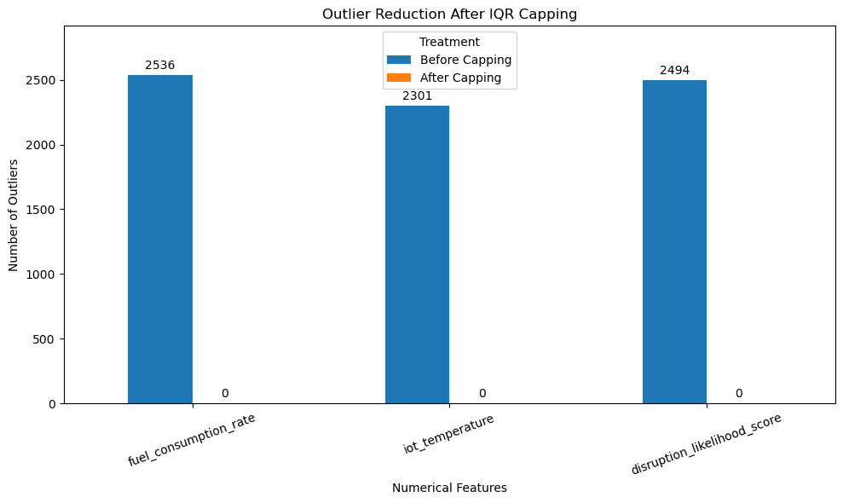
fuel_consumption_rate: 2,536 potential outliers before capping (0 lower-tail; 2,536 upper-tail) and 0 values outside the original IQR fences after capping.
iot_temperature: 2,301 potential outliers before capping (0 lower-tail; 2,301 upper-tail) and 0 values outside the original IQR fences after capping.
disruption_likelihood_score: 2,494 potential outliers before capping (2,494 lower-tail; 0 upper-tail) and 0 values outside the original IQR fences after capping.
The post-capping bars are zero-height because no values remain outside the fences used to cap the observations. This is expected, rather than a plotting defect.

6.3 Shipping-cost distribution before and after scaling
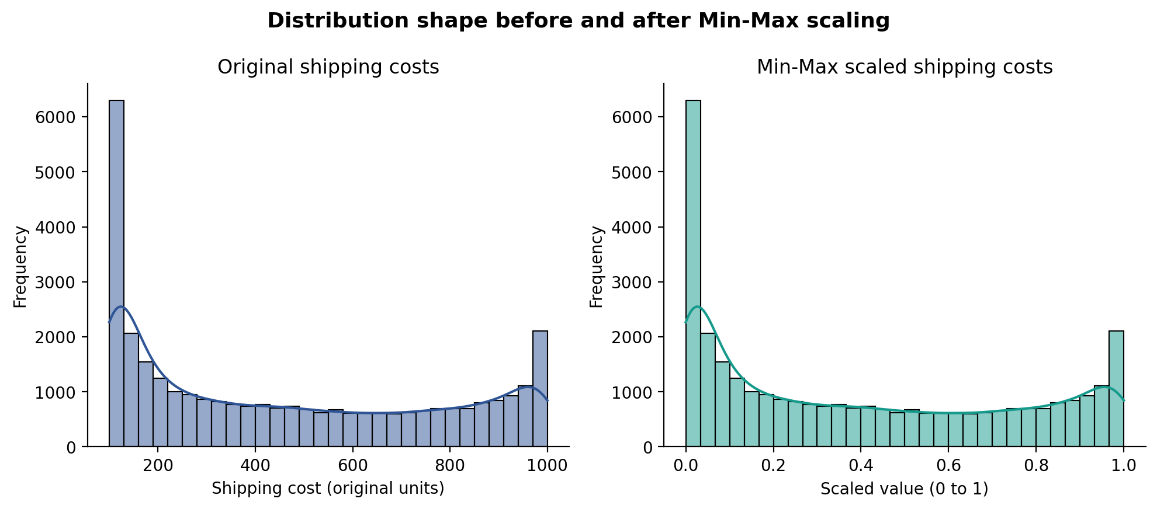
The two histograms have a similar shape because Min-Max Scaling is a linear transformation. The original shipping-cost values are shown in their input units, while the transformed values lie between 0 and 1. A similar shape is evidence that scaling changed the axis range but did not rearrange the observations.

6.4 Selected normalized features
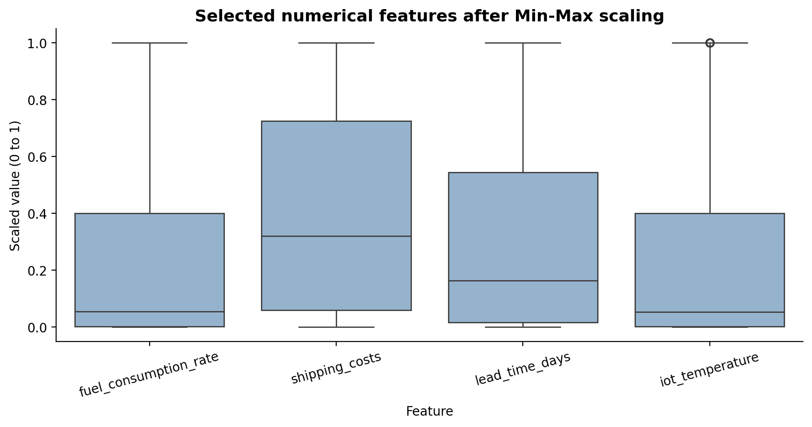
The selected boxplots show multiple numerical variables on the common 0–1 scale. This improves scale comparability for some algorithms and visual comparisons, although each feature retains its own statistical distribution.

7. Data Quality Considerations and Limitations

Outliers are not automatically errors
IQR identifies values that are far from the middle 50% of a distribution. Extreme shipping, temperature, or risk values may represent real events. Domain rules, source-system checks, and business context should be considered before changing them.

Review of disruption_likelihood_score
This feature is bounded between 0 and 1. Its IQR lower fence is approximately 0.2362, and the flagged observations are in the lower tail. Capping raises all 2,494 flagged low values to the fence. These may be legitimate low-disruption observations. For a real operational model, review this decision with the score definition or compare results with an uncapped alternative.

Normalization scope
The notebook scales all numerical columns, including coordinates, indicator scores, and numeric fields that may be targets or labels in later modeling. For a specific model, select predictors intentionally and do not scale a target or identifier by default.

Train/test leakage prevention
The demonstrated notebook fits MinMaxScaler on the complete dataset because this task is a preprocessing demonstration. For predictive modeling, split data into training and test sets first, fit the scaler only on training predictors, and use that fitted scaler to transform validation/test data.

Dataset provenance and licence
The supplied file does not establish an original public URL or licence. Before publishing the raw CSV to a public repository, confirm redistribution rights or omit the raw file and link to its authorised source.

Missingness is dataset-specific
No null values were observed in this file. That does not mean missing-value handling is unnecessary in all logistics datasets. New data batches should be checked again.

8. Reflection: Importance of Data Quality in Logistics
Logistics decisions depend on the reliability and consistency of operational data. Route planning may depend on location, traffic, and travel-time fields; warehouse planning may depend on inventory and historical demand; supplier decisions may rely on reliability measures; and delivery-risk analysis may use weather, port congestion, and disruption indicators. If these records contain missing values, duplicates, invalid timestamps, or extreme measurement errors, the resulting reports and models may be misleading.
This task demonstrated that preprocessing is not simply a matter of applying every available cleaning function. The data must first be assessed. In this dataset, missing-value imputation and duplicate removal were unnecessary because no missing cells or duplicate rows were found. Timestamp conversion was appropriate because time data should be represented in a datetime type. IQR helped identify unusual numerical observations, while capping demonstrated one possible treatment. Min-Max Scaling made numerical features comparable on a common range.
The main lesson is that a repeatable pipeline should combine statistical checks with domain knowledge. A transformation can improve numerical stability but may also remove meaningful operational signals. Documenting the reason for each step, preserving the original data, and validating assumptions are essential for trustworthy logistics analytics.

9. Conclusion
The task successfully demonstrated a Python-based preprocessing workflow on a logistics dataset of 32,065 rows and 26 columns. The CSV was loaded and explored, the data-quality profile was assessed, timestamps were converted, three features were flagged by IQR and capped, and 24 numerical columns were transformed with Min-Max Scaling. The final cleaned and normalized outputs were exported and supported by visualizations.
The initial checks showed no missing values, no duplicate rows, and no invalid timestamps; therefore, imputation and duplicate removal were not performed. The report also identifies limitations that should be considered before reusing the transformed data in an operational or machine-learning setting. The resulting workflow provides a documented starting point for exploratory data analysis and further logistics analytics.

