Trefoil Knot Mesh and SWE Simulation
This project consists of two Blender Python scripts, Create_Knot.py and Simulate_SWE.py, designed to create a trefoil knot mesh with custom attributes and simulate the shallow water equations (SWE) on the mesh.

Project Overview
- Create_Knot.py: This script generates a trefoil knot mesh with custom noise-based attributes (h, u, v) and calculates a gravity vector for each vertex.
- Simulate_SWE.py: This script simulates the shallow water equations (SWE) on the generated mesh, updating the h, u, and v attributes over time, and assigns materials to visualize these attributes.

Installation and Setup
- Blender Installation: Ensure you have Blender installed on your system. These scripts are intended to run within Blender's scripting environment. As it’s free and open-source, you can simply download Blender’s newest stable version (currently 4.2) here: https://www.blender.org/download/
- Loading the Scripts:
  - Open Blender.
  - The file is already configured in such a way that the scripts Create_Knot.py and Simulate_SWE.py can be easily accessed. You can switch between them here (see figure 1).
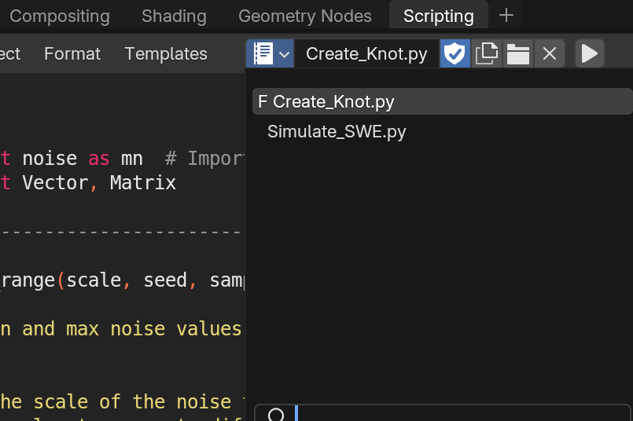Figure 1: Switch between text files
- Script Dependencies:
  - The scripts rely on Blender's built-in modules like bpy, bmesh, mathutils, and numpy. No additional installation is required.

Usage Instructions

1. Creating the Trefoil Knot Mesh
Run the Create_Knot.py script to generate a trefoil knot mesh with custom attributes. For simply hit the ‘Run script’ button or alternatively use the shortcut in Blender, which is Alt + P, given that the mouse cursor is already in the text file. The mesh will have the following attributes:
- h, u, v: Noise-based attributes with customizable scale and seed values.
- x_index, y_index: Custom indices for vertices.
- g_vector_x, g_vector_y, g_vector_z: Components of a gravity vector for each vertex
- position: Position for each vertex

2. Simulating the SWE on the Mesh
After generating the mesh, run the Simulate_SWE.py script to simulate the shallow water equations. The script updates the h, u, and v attributes over a specified number of steps.

3. Viewing Results
The simulation updates the UV maps h_map, u_map, and v_map of the mesh to visualize the h, u, and v attributes. You can render the mesh or view it in the viewport to see the simulation results.

4. Measuring Simulation Performance
The script measures and outputs the average simulation step time and overall runtime in the console. To see this and any outputs generated by the script, you can access Blender’s system console by going to Window → Toggle System Console, as shown in figure 2.
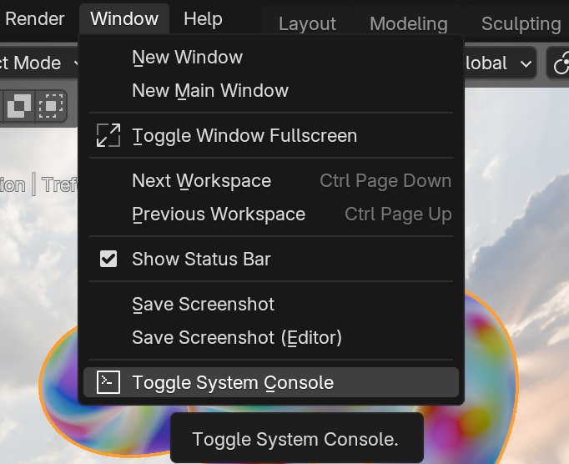Figure 2: How to toggle system console

Configuration

Customization Options
- Noise Parameters: Customize the noise scale and seeds in Create_Knot.py to change the appearance of the h, u, and v attributes.
- Simulation Parameters: Adjust the number of steps and timestep dt in Simulate_SWE.py to control the simulation duration and accuracy.

Material Assignment
You can assign different materials (h_map, u_map, v_map, huv_map) to visualize specific attributes. The material assignment is handled in the assign_material_to_object() function.

Other Navigation tips in Blender
If you wish to view the knot surface from a different angle in the viewport (top-left window in the file), you can achieve this in a number of ways:
- Drag with the middle mouse button (MMB)
- Numpad 2, 4, 6, 8: These keys allow you to rotate the view in steps. Numpad 2 and 8 rotate vertically, while Numpad 4 and 6 rotate horizontally.
- Numpad 1, 3, 7: These keys snap the view to specific angles:
Numpad 1: Front view, Numpad 3: Right view, Numpad 7: Top view

For regulating the distance to the object, you can use the scroll wheel to zoom in or out. All these tips are simply here to make exploring the visual effects of the simulation more easily. Unfortunately, adjustments in the viewport cannot be made during the simulation, as Blender is unresponsive during that time due to the computational load it’s experiencing - but you can freely make adjustments in between simulations very freely.

Hiding Objects in the Viewport
All meshes generate by Create_Knot.py are located at the world origin. Hence, when creating new meshes, they occupy the same space which can result in strange mesh intersections in the viewport. To avois this, you can simply hide (or unhide) certain objects in the viewport, such that others are completely visible (invisible). You accomplish this by clicking on the eye icon in the Outliner menu (top-right in the file) (see figure 3).

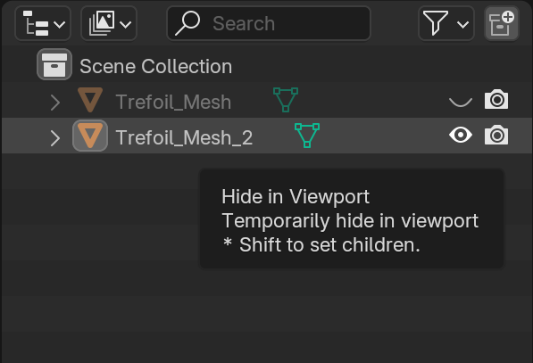Figure 3: How to hide/unhide objects in the viewport

Other remarks

The blend-file’s internal set-up should warrant no problems when running the script, as all relevant text files and materials are already included. It may happen that, when running the simulation the first time with a previously unused material, that only the end step is being shown. This is due to shaders not being compiled already, so if this happens, run the simulation a second time and you should see the evolution of any SWE variable material with no problems.

Should any problem arise anyways regarding the script or navigating in Blender’s UI, feel free to contact me (neyerp@student.ethz.ch)! :)

