**O’ZBEKISTON RESPUBLIKASI RAQAMLI TEXNOLOGIYALAR VAZIRLIGI MUHAMMAD AL-XORAZMIY NOMIDAGI**

**TOSHKENT AXBOROT TEXNOLOGIYALARI UNIVERSITETI**

Kompyuter injiniringi fakulteti

Sun’iy intellekt kafedrasi

Kompyuter ko'rish

fanidan

**4-TOPSHIRIQ**

Bajardi: 221-21guruh talabasi

Odinayev Og'abek

Tekshirdi: Xasanov Umidjon

TOSHKENT 2024

4**-topshiriq**

**Mavzu:** OpenCV va Python yordamida obyektni aniqlash algoritmini amalga oshirish.

Dastur kodi

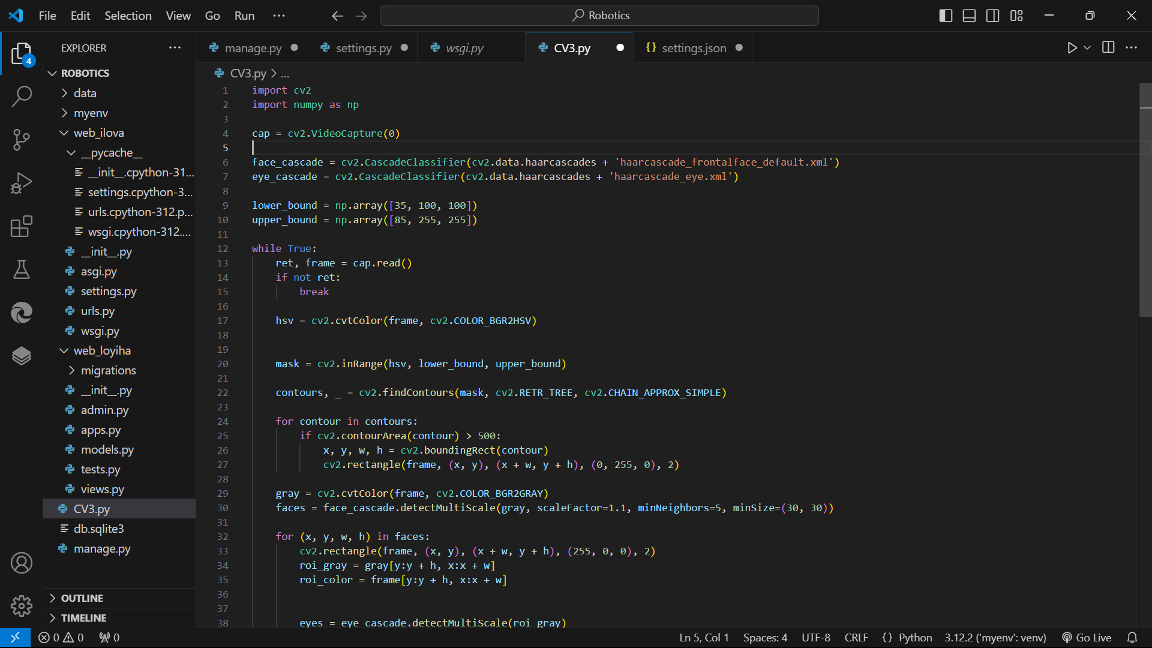

import cv2

import numpy as np

cap = cv2.VideoCapture(0)

face_cascade = cv2.CascadeClassifier(cv2.data.haarcascades + 'haarcascade_frontalface_default.xml')

eye_cascade = cv2.CascadeClassifier(cv2.data.haarcascades + 'haarcascade_eye.xml')

lower_bound = np.array([35, 100, 100])

upper_bound = np.array([85, 255, 255])

while True:

    ret, frame = cap.read()

    if not ret:

        break

    hsv = cv2.cvtColor(frame, cv2.COLOR_BGR2HSV)

    mask = cv2.inRange(hsv, lower_bound, upper_bound)

    contours, _ = cv2.findContours(mask, cv2.RETR_TREE, cv2.CHAIN_APPROX_SIMPLE)

    for contour in contours:

        if cv2.contourArea(contour) > 500:

            x, y, w, h = cv2.boundingRect(contour)

            cv2.rectangle(frame, (x, y), (x + w, y + h), (0, 255, 0), 2)

    gray = cv2.cvtColor(frame, cv2.COLOR_BGR2GRAY)

    faces = face_cascade.detectMultiScale(gray, scaleFactor=1.1, minNeighbors=5, minSize=(30, 30))

    for (x, y, w, h) in faces:

        cv2.rectangle(frame, (x, y), (x + w, y + h), (255, 0, 0), 2)

        roi_gray = gray[y:y + h, x:x + w]

        roi_color = frame[y:y + h, x:x + w]

        eyes = eye_cascade.detectMultiScale(roi_gray)

        for (ex, ey, ew, eh) in eyes:

            cv2.rectangle(roi_color, (ex, ey), (ex + ew, ey + eh), (0, 255, 255), 2)

    cv2.imshow("Original Frame", frame)

    cv2.imshow("Mask", mask)

    if cv2.waitKey(1) & 0xFF == ord('q'):

        break

cap.release()

cv2.destroyAllWindows()

Natija

