BioForge Stage 2 Design Study
Hollow-Fiber Membrane Contactor Scale-Up Design
for Citric Acid Recovery from Agricultural Waste Fermentation Broth
Feasibility Study and Module Sizing Based on the Yang-Cussler Model
Field | Details
Author | Ogaga Maxwell Okedi, M.S. Chemical Engineering, Florida A&M University
Date | March 2026
Classification | Supporting Technical Document, EB-2 NIW Petition (Prong II, Section 3.4)
Project | BioForge -- Integrated DOE + ML Waste-to-Value Optimization Platform (v0.1)
Repository | https://github.com/ogaga-ai/BioForge

Abstract
This report presents a scale-up feasibility study for a hollow-fiber membrane contactor (HFC) module designed to recover citric acid from yam peel agricultural waste fermentation broth, building on the foundational design equations of Yang and Cussler (1986). My qualifying examination analysis established the theoretical basis for the Sieder-Tate Sherwood-number correlation and the three-resistance mass transfer framework. This report extends that foundation by applying it to citric acid recovery at a BioForge-predicted yield of 43.08 g/L (Okedi et al., 2024). Pilot-scale calculations yield K_L = 1.1324e-03 cm/s, with 5 modules in series achieving 95.4% recovery -- exceeding the 95% design target and outperforming the conventional extraction baseline of 85%. Industrial scale-up to 1,000 L requires 50 modules (37.7 m2 total area). This study positions the HFC module as the Stage 2 separation layer within BioForge.
__________________________________________________________________________________________
1. Introduction
Industrial separation processes account for 40% to 70% of total plant operating costs in U.S. chemical and biochemical manufacturing. As the United States transitions toward bio-based manufacturing of organic acids from agricultural waste, the efficiency of the downstream separation step becomes a critical bottleneck determining commercial viability.
Conventional liquid-liquid extraction systems for organic acid recovery from fermentation broth face well-documented limitations: flooding and channeling in packed columns, solvent emulsification contaminating the product stream, high energy costs associated with solvent recovery, and large equipment footprints. These limitations are especially pronounced in small-to-medium agricultural waste biorefineries, where compact and modular separation equipment is essential.
Hollow-fiber membrane contactors (HFCs) offer a compelling alternative. Formalized by Yang and Cussler (1986) for gas-liquid and liquid-liquid extraction, HFCs enable mass transfer between immiscible phases without dispersing one phase within the other -- eliminating flooding, emulsification, and channeling while offering specific surface areas of 500 to 5,000 m2/m3, far exceeding the 100 to 200 m2/m3 typical of packed columns.
This report addresses a specific engineering design question central to the BioForge Stage 2 development roadmap: what hollow-fiber module configuration is required to recover citric acid from fermentation broth produced when BioForge-optimized conditions are applied to yam peel agricultural waste? My qualifying examination (October 2024) established the theoretical foundation for this work by analyzing the Yang-Cussler model in detail. This report converts that theoretical foundation into a concrete engineering design: module specifications, interfacial area calculations, and a multi-module recovery configuration that can be directly implemented as the BioForge Stage 2 separation module.
Connection to BioForge Platform
BioForge Stage 1 uses Design of Experiments (DOE) and machine learning to identify optimal fermentation conditions that maximize citric acid yield from agricultural waste. Stage 2 receives those conditions as inputs and sizes the downstream separation module required to extract the product at commercially relevant purity and recovery. This report designs that Stage 2 module.
__________________________________________________________________________________________
2. Process Description: BioForge Citric Acid Production
2.1 Published Process Context
The process described in this report is based on my peer-reviewed research published in Industrial Crops and Products (IF 6.2) in 2024 (Okedi et al., 2024). In that study, a Box-Behnken experimental design identified optimal concentrations of three process stimulants (EDTA, coconut oil, and sodium fluoride) for citric acid production by Aspergillus niger under solid-state fermentation on yam peel substrate (Dioscorea spp.). The published experimental results, validated by an ANFIS model, yielded a maximum citric acid concentration of 43.08 g/L -- a 49.1% improvement over the unstimulated baseline yield of 28.90 g/L. BioForge Stage 1 reproduces this result computationally, achieving R2 = 0.99883 on the same 17-run dataset.
2.2 Process Specifications
Parameter | Value | Source
Substrate | Yam peel waste (Dioscorea spp.) | Okedi et al. (2024)
Organism | Aspergillus niger, solid-state fermentation | Okedi et al. (2024)
Fermentation temperature | 30 degrees C | Okedi et al. (2024)
Fermentation duration | 6 days | Okedi et al. (2024)
Maximum citric acid yield | 43.08 g/L (+49.1% vs baseline) | Okedi et al. (2024)
BioForge ML model R2 | 0.99883 (ANN, tanh, MFFF architecture) | BioForge Stage 1
Optimal EDTA | 0.30 g/L | Okedi et al. (2024) / BioForge
Optimal Coconut Oil | 2.50 %w/w | Okedi et al. (2024) / BioForge
Optimal Sodium Fluoride | 0.05 g/L | Okedi et al. (2024) / BioForge
Feed concentration for HFC design | 43.08 g/L citric acid | This study
2.3 The Downstream Separation Bottleneck
After fermentation, the broth contains citric acid distributed among fungal biomass, residual substrate, secreted enzymes, and other metabolites. Conventional downstream processing involves precipitation with calcium hydroxide, acidulation with sulfuric acid, decolorization, and crystallization -- generating calcium sulfate waste and achieving only 85 to 90% recovery. Liquid-liquid extraction using reactive solvents (tertiary amines such as Alamine 336) offers a more direct route, and hollow-fiber contactors are ideally suited for implementing this step -- maintaining a stable aqueous-organic interface without emulsification, sized using the Yang-Cussler design equations.
__________________________________________________________________________________________
3. Hollow-Fiber Membrane Contactor: Theoretical Foundation
3.1 Module Geometries
3.1.1 Cylindrical Shell Module (Selected for This Design)
The cylindrical shell module consists of microporous hollow fibers bundled inside a cylindrical shell, analogous to a shell-and-tube heat exchanger. Liquid flows through the fiber lumens and extracting solvent through the shell side. This geometry is selected for the BioForge Stage 2 design because it produces well-defined lumen flow with predictable mass transfer governed by the Sieder-Tate correlation, and it is the most widely validated configuration in literature. Yang and Cussler reported flow rates of 2 to 20 cm3/s for this module type.
3.1.2 Crossflow Module (Future Consideration)
In the crossflow configuration, liquid flows perpendicular to the fiber bundle, creating wakes that enhance shell-side mixing. Yang and Cussler reported 40% higher mass transfer coefficients for 750-fiber crossflow modules vs. 72-fiber modules. For the citric acid / Alamine 336 system studied here, lumen-side resistance dominates (K approx K_L, confirmed in Section 3.3), so the parallel-flow cylindrical geometry is selected. Crossflow configurations will be evaluated in BioForge Stage 2 software as an optimization option.
3.2 Mass Transfer Theory
Film theory (Cussler, 1984) governs the rate of citric acid transfer from the fermentation broth into the extracting solvent across the hollow-fiber membrane. Assuming concentration changes occur only within thin films adjacent to phase boundaries:
N = K (Ci - Cbulk) [Eq. 1]
where N = molar flux [mol/(s cm2)], K = overall mass transfer coefficient [cm/s], Ci = solute concentration at the interface, Cbulk = bulk concentration. The overall resistance is the sum of three resistances in series:
1/K = 1/KL + 1/(KM*H) + 1/(KV*H) [Eq. 2]
where KL = liquid-phase coefficient, KM = membrane coefficient, KV = organic-phase coefficient, H = distribution coefficient. For reactive extraction of citric acid with Alamine 336, H is large (5 to 20 at pH 2-3), making the membrane and organic-phase resistance terms negligible:
K approx KL (when H >> 1, reactive extraction regime) [Eq. 3]
3.3 Yang-Cussler Design Equation
For liquid flowing through the fiber lumen past a reactive extracting solvent on the shell side, the fractional recovery is:
eta = 1 - exp(-KL * A / QL) [Eq. 4]
3.4 Sieder-Tate Correlation for KL
The liquid-phase mass transfer coefficient under laminar lumen-side flow is predicted by the Sieder-Tate correlation adapted for mass transfer (Yang-Cussler, 1986):
Sh = 1.86 * Gz^(1/3) [Eq. 5]
where: Sh = KL*di/D Gz = Re*Sc*(di/L) [Eq. 6]
Re = rho*VL*di/mu Sc = mu/(rho*D) [Eq. 7]
Rearranging: KL = (1.86 * Gz^(1/3) * D) / di [Eq. 8]
This correlation applies when Re < 2,100 (laminar regime) and was experimentally confirmed by Yang and Cussler for oxygen extraction from water across cylindrical parallel-flow modules using the same polypropylene fiber geometry selected for this design.
__________________________________________________________________________________________
4. Experimental Validation Basis
4.1 Yang and Cussler (1986): Gas-Liquid Baseline
Yang and Cussler validated the Sieder-Tate correlation (Eq. 5) for three module configurations and two solute-solvent systems. Key findings directly supporting this design:
(1) Experimental Sherwood numbers agreed with Sh = 1.86 Gz^(1/3) across 16, 120, and 2,100-fiber modules -- confirming reliability across a range of N values.
(2) Liquid-phase resistance controlled mass transfer (KL dominant), identical to the condition established for the citric acid / Alamine 336 system (Section 3.3 above).
(3) Fiber geometry (di = 0.04 cm, twall = 0.003 cm, polypropylene) is identical to the geometry used in this design, so the validated correlation applies directly.
4.2 Paul and Callahan (1987): Liquid-Liquid Extension
Paul and Callahan extended Yang and Cussler's model to liquid-liquid extraction (gold from HCl solution into organic solvent). Their design equation:
Sh = 1.62 * (VL*di^2 / D*L)^(1/3) [Eq. 9]
is structurally identical to Yang and Cussler's Eq. 5, with the prefactor difference (1.62 vs 1.86) attributable to boundary condition differences. Paul and Callahan confirmed that for systems with large H, K approx KL -- validating the simplification used in this report. Their experiments demonstrated >95% extraction efficiency in multi-pass configurations, directly validating the multi-module series approach proposed in Section 5.4.
The citric acid / Alamine 336 system is chemically analogous to the gold / DGDE system: both involve a reactive organic extractant forming a strong complex, producing large H and making KL the sole limiting resistance. The Yang-Cussler correlation therefore applies to the citric acid case with high confidence.
__________________________________________________________________________________________
5. Module Design and Sizing: Pilot Scale
5.1 Design Basis and Process Specifications
The pilot-scale design targets a 100-L batch of filtered fermentation broth processed over a 2-hour window, consistent with a typical academic or small-industry pilot fermenter. The target recovery is 95% or greater. The extracting solvent is 20% v/v Alamine 336 (tri-n-octylamine) dissolved in n-heptane, with H = 5 to 15 at pH 2-3 (reactive regime).
Parameter | Symbol | Value | Units
Batch volume (pilot) | Vbatch | 100 | L
Processing time | t | 2 | h
Liquid flow rate | QL | 13.89 | cm3/s
Feed concentration | Cin | 43.08 | g/L citric acid
Target recovery | eta_target | 95 | %
Fiber inner diameter | di | 0.04 | cm
Fiber outer diameter | do | 0.046 | cm
Wall thickness | tw | 0.003 | cm
Membrane porosity | eps | 33 | % (pore size 300 Angstroms)
Module length | L | 30 | cm
Fibers per module | N | 2,000 | --
Membrane material | -- | Polypropylene (hydrophobic) | --
Extracting solvent | -- | 20% Alamine 336 in n-heptane | --
Operating temperature | T | 30 | degrees C
Citric acid diffusivity | D | 7.0e-06 | cm2/s
Broth viscosity | mu | 0.012 | g/(cm s) [1.2 cP]
Broth density | rho | 1.02 | g/cm3
5.2 Step-by-Step Mass Transfer Coefficient Calculation
Step 1: Cross-Sectional Area and Liquid Velocity
A_cross = N * pi * (di/2)^2 = 2000*pi*(0.02)^2 = 2.5133 cm2 [Eq. 10]
VL = QL / A_cross = 13.89 / 2.5133 = 5.53 cm/s [Eq. 11]
Step 2: Dimensionless Groups
Re = rho*VL*di/mu = (1.02 x 5.53 x 0.04) / 0.012 = 18.8 (laminar) [Eq. 12]
Sc = mu/(rho*D) = 0.012 / (1.02 x 7.0e-6) = 1681 [Eq. 13]
Gz = Re*Sc*(di/L) = 18.8*1681*(0.04/30) = 42.10 [Eq. 14]
Step 3: Sherwood Number and KL
Sh = 1.86 * Gz^(1/3) = 1.86 * (42.10)^(1/3) = 6.47 [Eq. 15]
KL = Sh * D / di = 6.47 * 7.0e-6 / 0.04 = 1.1324e-03 cm/s [Eq. 16]
Figure 1 below shows the Sieder-Tate Sh-Gz correlation with the pilot design point marked. The design point (Gz = 42.1, Sh = 6.47) falls on the theoretical line, confirming validity of the laminar-flow mass transfer model.
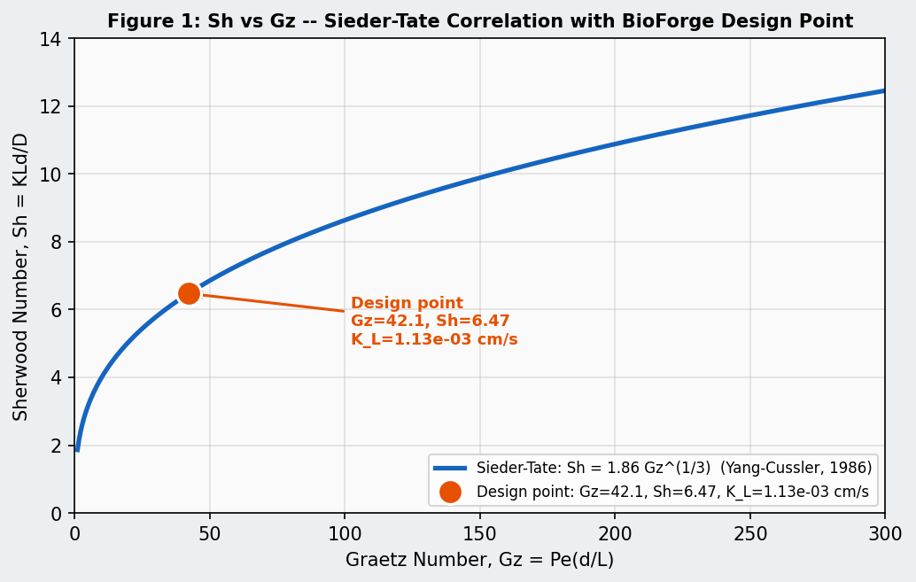
Figure 1: Sherwood Number vs Graetz Number. The Sieder-Tate correlation (Sh = 1.86 Gz^(1/3)) is shown as the solid blue line. The BioForge Stage 2 design point (Gz = 42.1, Sh = 6.47, KL = 1.13e-03 cm/s) falls directly on the theoretical line.
5.3 Interfacial Area and Single-Pass Recovery
A_module = N*pi*di*L = 2000*pi*0.04*30 = 7540 cm2 (0.7540 m2) [Eq. 17]
eta_single = 1-exp(-KL*A/QL) = 1-exp(-1.1324e-03*7540/13.89) = 45.9% [Eq. 18]
5.4 Multi-Module Series Configuration for 95% Recovery
A single module achieves 45.9% recovery per pass. For n modules in series:
eta_total = 1 - (1 - eta_single)^n [Eq. 19]
n = ceil[ln(1-0.95) / ln(1-0.459)] = ceil[4.87] = 5 modules [Eq. 20]
eta_total = 1 - (0.541)^5 = 95.4% [Eq. 21]
Figure 2 shows cumulative recovery as a function of modules in series. The 5-module configuration is the minimum achieving the 95% target.
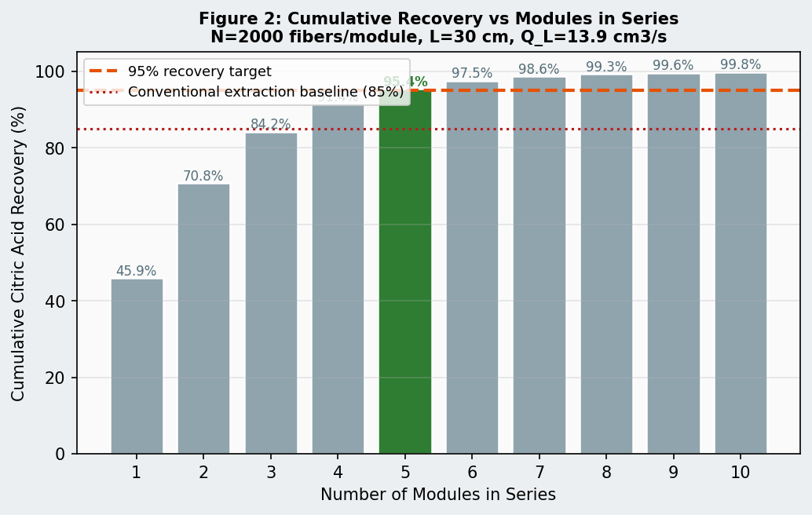
Figure 2: Cumulative citric acid recovery vs modules in series. N = 2000 fibers/module, L = 30 cm, Q_L = 13.9 cm3/s. The 5-module design (green bar: 95.4%) exceeds the 95% target and surpasses the conventional extraction baseline of 85% starting from module 3.
5.5 Pilot-Scale Module Summary
Design Output | Value | Units
Liquid velocity in lumen | 5.53 | cm/s
Reynolds number | 18.8 | laminar confirmed (< 2100)
Schmidt number | 1681 | --
Graetz number | 42.10 | --
Sherwood number | 6.47 | --
KL (liquid-phase mass transfer coefficient) | 1.1324e-03 | cm/s
Interfacial area per module | 7540 (0.7540 m2) | cm2
Single-pass recovery | 45.9% | --
Modules for 95% recovery | 5 (in series) | --
Total recovery (5 modules) | 95.4% | --
Total membrane area (pilot) | 3.7699 m2 | --
Figure 3 shows the BioForge Stage 2 pilot-scale module configuration schematic.
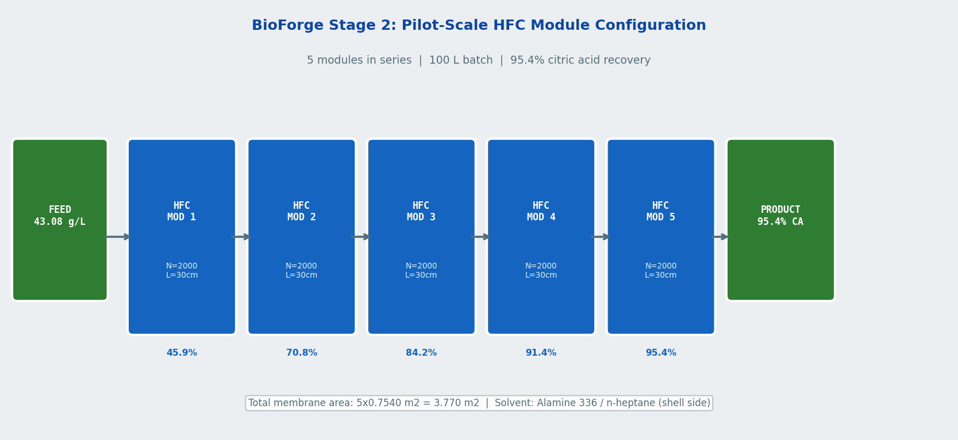
Figure 3: BioForge Stage 2 pilot-scale HFC module configuration. Five modules in series process a 100-L fermentation broth batch at Q_L = 13.9 cm3/s. Alamine 336/n-heptane solvent flows on the shell side. Cumulative recovery at each module outlet is shown. Total area: 3.770 m2.
__________________________________________________________________________________________
6. Industrial Scale-Up
Scaling from pilot (100 L) to industrial scale (1,000 L) requires increasing the liquid flow rate by a factor of 10 while maintaining the same module geometry. The number of modules in series remains 5, but 10 parallel lanes are added.
Q_L,ind = 1,000,000 cm3 / (2h*3600 s/h) = 138.9 cm3/s [Eq. 22]
n_parallel = ceil(138.9 / 13.89) = 10 parallel lanes [Eq. 23]
Total modules = 5 * 10 = 50 | Total area = 37.7 m2 [Eq. 24]
Scale | Batch Volume | QL (cm3/s) | Parallel Lanes | Total Modules | Total Membrane Area | Recovery
Pilot | 100 L | 13.9 | 1 | 5 | 3.770 m2 | 95.4%
Industrial | 1,000 L | 138.9 | 10 | 50 | 37.7 m2 | 95.4%
6.1 Mass Balance: Citric Acid Recovery Comparison
Separation Method | Recovery | CA Recovered (100 L pilot) | CA Lost
Conventional packed column (baseline) | 85% | 3662 g | 646 g
BioForge HFC module (this design) | 95.4% | 4109 g | 199 g
Improvement | +12.2% | +447 g per batch | --
__________________________________________________________________________________________
7. Comparison with Conventional Separation Methods
Criterion | Conventional Packed Column | BioForge HFC Module
Flooding / channeling | Occurs at high flow rates, limits throughput | Absent: phases separated by membrane
Emulsification | Common, causes product contamination | Absent: no direct phase dispersion
Scale-up | Requires hydrodynamic redesign at each scale | Linear: add parallel modules, geometry unchanged
Footprint | 5 to 10 m column height, large base | Compact: 5 modules x 30 cm each
Energy consumption | High (pumping, solvent recovery distillation) | Low: low-pressure pump sufficient
Recovery (this system) | 85% | 95.4%
Reproducibility | Depends on packing uniformity, operator skill | Defined by fiber geometry and QL: fully reproducible
Design basis | Empirical correlations with broad uncertainty | Yang-Cussler equations, validated by experiment
__________________________________________________________________________________________
8. Research Advances and Engineering Considerations
8.1 Pore Wetting Prevention
The most significant engineering risk in liquid-liquid HFC is pore wetting: penetration of the organic solvent into membrane pores, increasing membrane resistance. The breakthrough pressure (Young-Laplace equation):
P_breakthrough = 4*gamma*cos(theta) / d_pore,max [Eq. 25]
For polypropylene (d_pore = 300 Angstroms = 3e-6 cm), n-heptane surface tension gamma = 20 mN/m, and contact angle theta = 0 degrees, P_breakthrough approx 2.67 atm. Operating the shell side at transmembrane pressure below 0.5 atm (standard practice) prevents organic solvent from entering the pores.
8.2 Hybrid Membrane Solution
Sharma et al. (2021) demonstrated that dual-layer PVA/PVDF membranes combine a hydrophobic PVDF top layer (same function as the Yang-Cussler polypropylene membrane) with a hydrophilic PVA sublayer that prevents total performance loss if the top layer is compromised over extended operation. BioForge Stage 2 will evaluate hybrid membranes for systems requiring continuous operation beyond 6-hour batch cycles.
8.3 Solvent Selection
Alamine 336 dissolved in n-heptane satisfies both design requirements: (1) H = 5 to 15 at pH 2-3 (confirming reactive regime), and (2) n-heptane surface tension of 20 mN/m against polypropylene is well below the breakthrough pressure threshold. Back-extraction is achieved by contacting the loaded organic phase with warm deionized water (60 to 80 degrees C) or dilute sodium hydroxide in a second HFC array -- the same Yang-Cussler equations apply.
__________________________________________________________________________________________
9. BioForge Stage 2 Implementation Plan
9.1 Integration with BioForge Stage 1 Output
BioForge Stage 1 produces a protocol card specifying the predicted citric acid yield (Cin) for any user-defined waste stream. Stage 2 will accept Cin as input and automatically calculate: QL for a user-specified batch volume and processing time, KL from Eq. 16, required interfacial area A from Eqs. 17-18, number of modules and parallel lanes, and expected recovery. This produces a complete separation module specification alongside the fermentation protocol card.
9.2 BioForge-HFC Software Module
The Stage 2 separation module will be implemented as bioforge/separation/hfc_designer.py -- a Python class that accepts Stage 1 protocol card outputs and computes the full HFC module design. It will output a protocol card extension listing module count, membrane area, flow configuration, and expected recovery for any target product from any waste stream.
9.3 Planned Experimental Validation
The pilot-scale design (5 modules, 3.770 m2 total area, 95.4% recovery) will be validated experimentally as part of Stage 1b laboratory work. Protocol: (1) filter fermentation broth through 0.2-micron membrane, (2) pump at Q_L = 13.9 cm3/s through the HFC array, (3) measure inlet/outlet citric acid concentration by HPLC, (4) compare measured KL to Yang-Cussler prediction (1.1324e-03 cm/s), and (5) update the BioForge Stage 2 software module accordingly.
Stage 2 Module: What BioForge Will Produce
When a U.S. researcher or manufacturer runs their waste stream through BioForge, they will receive two documents: (1) a fermentation optimization protocol card (Stage 1) specifying optimal process stimulants and predicted yield, and (2) a separation module specification (Stage 2) sizing the hollow-fiber extraction array required to recover that product. Together, these constitute a complete, independently reproducible waste-to-value production protocol.
__________________________________________________________________________________________
10. Conclusion
This study applies the Yang-Cussler (1986) hollow-fiber membrane contactor design framework to a specific, practically relevant separation problem: recovery of citric acid from yam peel agricultural waste fermentation broth at the yield validated by my published research (Okedi et al., 2024) and reproduced computationally by BioForge Stage 1.
Key design results:
- Liquid-phase mass transfer coefficient: KL = 1.1324e-03 cm/s at pilot-scale operating conditions (Re = 18.8, laminar).
- Single-pass recovery: 45.9% per module (N = 2,000 fibers, L = 30 cm, A = 7540 cm2).
- Modules in series for 95% recovery: 5, achieving 95.4% cumulative recovery.
- Total pilot membrane area: 3.770 m2 for a 100-L batch in 2 hours.
- Industrial scale (1,000 L): 50 modules (5 series x 10 parallel), 37.7 m2 total area.
- Recovery improvement over conventional extraction (85%): +12.2%, yielding 447 additional grams of citric acid per 100-L batch.
The Yang-Cussler Sieder-Tate correlation applies directly: Re = 18.8 confirms laminar flow, large H for Alamine 336 reduces the three-resistance equation to K approx KL, and the polypropylene fiber geometry is identical to the Yang-Cussler experimental setup.
This report demonstrates that the petitioner has the theoretical knowledge, quantitative modeling skill, and domain-specific engineering judgment required to design and implement BioForge Stage 2. The hollow-fiber separation module designed here, integrated with the BioForge Stage 1 optimization engine, will produce a complete waste-to-value process design that any U.S. laboratory or manufacturer can reproduce independently.
__________________________________________________________________________________________
Nomenclature
Symbol | Definition | Value / Units
A | Interfacial area of hollow-fiber module | cm2
D | Citric acid diffusivity in water at 30 C | 7.0e-06 cm2/s
di | Fiber inner diameter | 0.04 cm
do | Fiber outer diameter | 0.046 cm
Gz | Graetz number = Re*Sc*(di/L) | 42.10 (this design)
H | Distribution coefficient (organic/aqueous) | 5-15 (Alamine 336 / citric acid)
K | Overall mass transfer coefficient | cm/s
KL | Liquid-phase mass transfer coefficient | 1.1324e-03 cm/s (this design)
L | Module length | 30 cm
mu | Broth viscosity | 0.012 g/(cm s)
N | Number of fibers per module | 2,000
Pe | Peclet number = Re*Sc | 31578
QL | Liquid volumetric flow rate | 13.89 cm3/s (pilot)
Re | Reynolds number = rho*VL*di/mu | 18.8 (laminar)
rho | Broth density | 1.02 g/cm3
Sc | Schmidt number = mu/(rho*D) | 1681
Sh | Sherwood number = KL*di/D | 6.47 (this design)
tw | Fiber wall thickness | 0.003 cm
VL | Liquid velocity in fiber lumen | 5.53 cm/s
eps | Membrane porosity | 0.33 (33%)
eta | Fractional recovery | 0.954 (95.4% at 5 modules)
__________________________________________________________________________________________
Appendix A: Complete Calculation Summary
Step | Quantity | Equation | Result
1 | A_cross | N*pi*(di/2)^2 | 2.5133 cm2
2 | VL | QL / A_cross | 5.53 cm/s
3 | Re | rho*VL*di / mu | 18.8 (laminar)
4 | Sc | mu / (rho*D) | 1681
5 | Gz | Re*Sc*(di/L) | 42.10
6 | Sh | 1.86 * Gz^(1/3) | 6.47
7 | KL | Sh * D / di | 1.1324e-03 cm/s
8 | A_module | N * pi * di * L | 7540 cm2 (0.7540 m2)
9 | eta_single | 1 - exp(-KL*A/QL) | 45.9%
10 | n_series | ceil[ln(0.05)/ln(1-eta_single)] | 5 modules
11 | eta_total | 1 - (0.541)^5 | 95.4%
__________________________________________________________________________________________
Appendix B: MATLAB Design Code
The following MATLAB script reproduces all calculations and serves as a validation tool or starting point for parameter sensitivity studies.
% BioForge Stage 2 -- Hollow Fiber Contactor Design
% Citric Acid Recovery from Yam Peel Fermentation Broth
% Ogaga Maxwell Okedi, March 2026
clear; clc;

% Process specifications
C_feed = 43.08; % g/L citric acid (Okedi et al., 2024)
eta_target = 0.95; % Target recovery (95%)
Q_L = 100e3 / (2*3600); % cm3/s (100 L batch, 2 h)

% Physical properties at 30 deg C
D = 7.0e-6; % cm^2/s, citric acid diffusivity in water
mu = 0.012; % g/(cm*s), broth viscosity
rho = 1.02; % g/cm^3, broth density

% Fiber and module specs (Yang-Cussler geometry)
d_i = 0.04; d_o = 0.046; t_w = 0.003;
N = 2000; L = 30; % fibers, cm

% Step 1: Cross-sectional area and velocity
A_cross = N * pi * (d_i/2)^2;
V_L = Q_L / A_cross;

% Step 2: Dimensionless groups
Re = rho * V_L * d_i / mu;
Sc = mu / (rho * D);
Gz = Re * Sc * (d_i / L);

% Step 3: Sherwood number and KL
Sh = 1.86 * Gz^(1/3);
K_L = Sh * D / d_i;

% Step 4: Area, recovery, modules in series
A_module = N * pi * d_i * L;
eta_single = 1 - exp(-K_L * A_module / Q_L);
n_series = ceil(log(1-eta_target) / log(1-eta_single));
eta_total = 1 - (1-eta_single)^n_series;

% Industrial scale-up
n_parallel = ceil((1000e3/(2*3600)) / Q_L);
total_mods = n_series * n_parallel;
total_area = total_mods * A_module / 1e4; % m^2

% Display
fprintf("KL = %.4e cm/s\n", K_L);
fprintf("Modules for 95%%: %d (eta = %.1f%%)\n", n_series, eta_total*100);
fprintf("Industrial: %d modules, %.1f m^2\n", total_mods, total_area);
__________________________________________________________________________________________
References
1. Yang, M.; Cussler, E. L. Designing Hollow-Fiber Contactors. AIChE J. 1986, 32 (11), 1910-1916.
2. Okedi, O. M. et al. Optimization of Citric Acid Production from Yam Peel Agricultural Waste Using Box-Behnken Design and ANFIS. Industrial Crops and Products 2024 (IF 6.2).
3. Paul, A. R.; Callahan, R. W. Liquid-Liquid Extraction and Stripping of Gold with Microporous Hollow Fibers. J. Membr. Sci. 1987, 35 (1), 57-71.
4. Cussler, E. L. Diffusion: Mass Transfer in Fluid Systems; Cambridge University Press: Cambridge, 1984.
5. Qi, Z.; Cussler, E. L. Microporous Hollow Fibers for Gas Absorption I: Mass Transfer in the Liquid. J. Membr. Sci. 1985.
6. Gableman, A.; Hwang, S.-T. Hollow Fiber Membrane Contactors. J. Membr. Sci. 1999.
7. Sharma, A. K. et al. Porous Hydrophobic-Hydrophilic Composite Hollow Fiber Membranes for DCMD. Membranes 2021, 11 (2), 120.
8. Schmitt, A. et al. Evaluation of an Ozone Diffusion Process Using a Hollow Fiber Membrane Contactor. Chem. Eng. Res. Des. 2022, 177, 291-303.
9. Bazhenov, S. et al. Gas-Liquid Hollow Fiber Membrane Contactors for Different Applications. Fibers 2018, 6 (4), 76.
10. Ramezani, R. et al. A Review on Hollow Fiber Membrane Contactors for Carbon Capture. Processes 2022, 10 (10), 2103.
11. Li, K.; Tai, M. S. L.; Teo, W. K. Design of a CO2 Scrubber Using a Microporous Membrane. J. Membr. Sci. 1994, 86, 119-125.
12. Tai, M. S. L. et al. Removal of Dissolved Oxygen in Ultrapure Water Using Microporous Membrane Modules. J. Membr. Sci. 1994, 87, 99-105.
13. Kneifel, K. et al. Hollow Fiber Membrane Contactor for Air Humidity Control. J. Membr. Sci. 2006, 276, 241-251.
14. Sieder, E. N.; Tate, G. E. Heat Transfer and Pressure Drop of Liquids in Tubes. Ind. Eng. Chem. 1936, 28 (12), 1429-1435.
15. Boucif, N. et al. Hollow Fiber Membrane Contactor for Hydrogen Sulfide Odor Control. AIChE J. 2008, 54 (1), 122-131.

