# Design Document

## Introduction

Our site will display data about airports and their relative efficiencies. We will have two main displays, or maps. The first one will display the total number of flights at each airport in our dynamic dataset, which will have scalable circles of different shades to indicate a quantity. The second one will display flight delays as a percentage of total flights, with the same corresponding scalable circles. When the user clicks on an airport-circle, we plan to have a pop up screen with more bar graphs and data.

## Tasks

* App.py
  + Separate functionalities to deal with:
    - Total Flights
    - Percent Delays
    - Extra Bar graphs
* HTML + Prettify
  + Empty svg container
  + Prettify (OG)
* App.js
  + Retrieve data from airlines.py + parse (OG)
  + Take parsed data and visualize
    - Total flights (GT)
    - Delays (MW)

## Site Map

Airlines by Total Flights

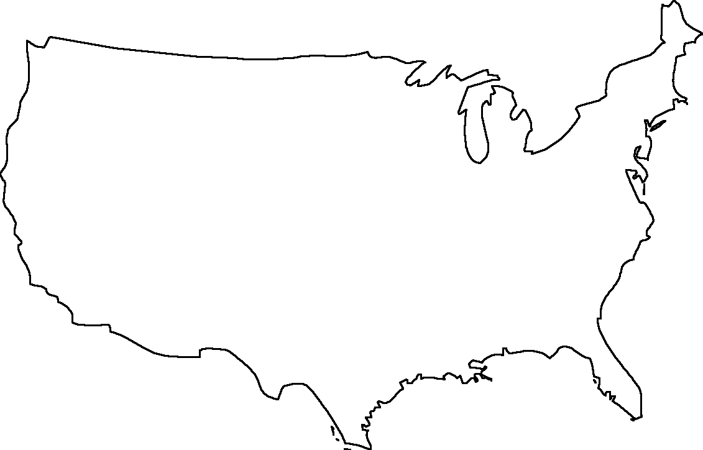

Airlines By Percent of Flights Delayed



On Click:

## Component Map