**Climapp Reimplementation of the Climate Corridor Approach**

*Comparison of results with results obtained from original code from Boris Orlowsky for the Kita Case Study.*

*August 9th, 2023*

For the development of the Caritas Climapp, the original Climate Corridor Algorithm of Borlowsky (available as R-Code) has been generalized and simplified. The objective of this analysis is to check, whether the new code leads to the same results, when the same data is used.

The original code of Orlowsky was provided for the Kita case study, based on historical climate data from CRU TS4.01 climate projections from CMIP5one, for two Maize varieties Sotubaka and TZEE-F. This data was reformatted and provided as input to the new code.

As it can be seen in the figures below. The two versions of the algorithm lead to the same Temperature corridors:

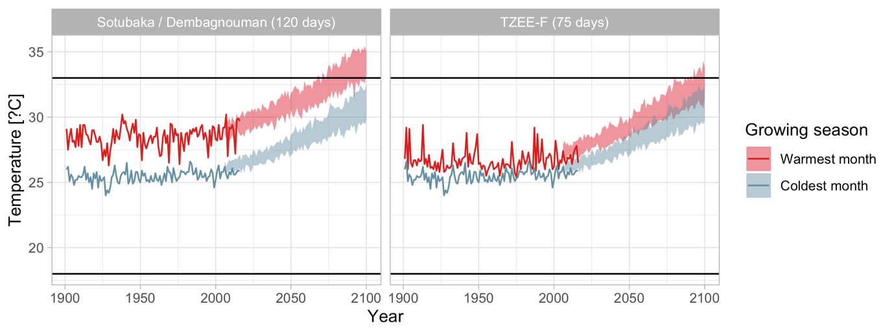

*Temperature corridors using the original code*

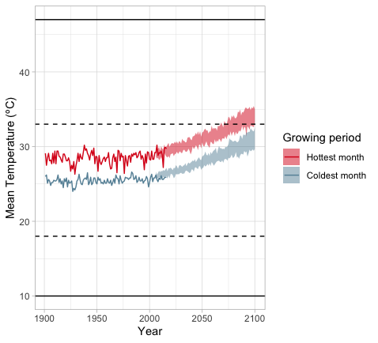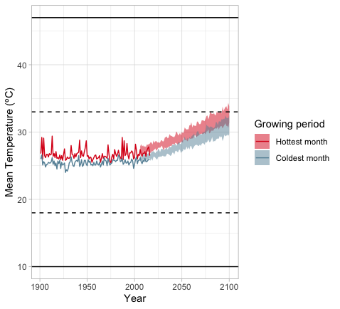

*Temperature corridors using the new code*

Also for the Precipitation Corridors, the two algorithms lead to the same result. Minor deviations are due to the fact how precipitation during the vegetation period is determined. The original code uses precipitation data in mm/month, divides this by 30 and multiplies with the duration of the growing period in days. This introduces a small error, as not all months have 30 days. The new code uses precipitation data in mm/day and thus can directly apply the duration of the growing period in days.

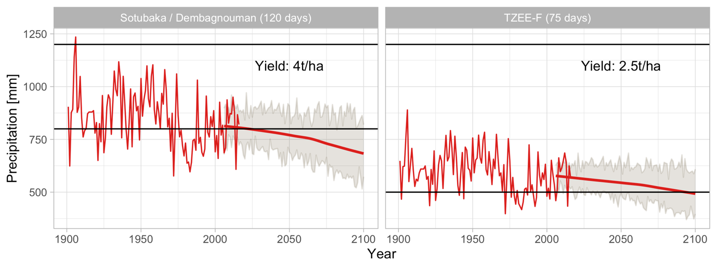

*Precipitation corridors using the original code*

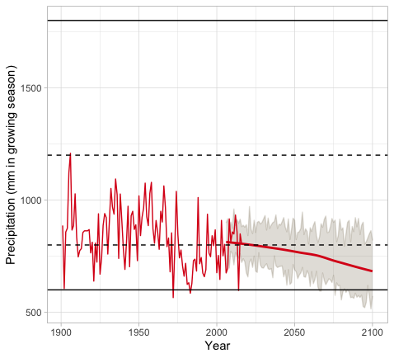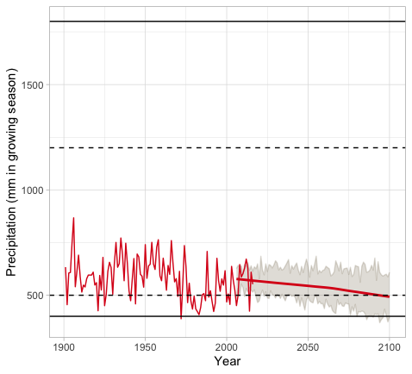

*Precipitation corridors using the new code*