**Web Storyboards**

1. **Landing page - New User:** User lands on our landing page, understands what the product is about, and is able create an account
   1. Clear explanation of what the product does
   2. Consistent logo, tagline, visual theme that complements the product
   3. Clear call-to-action in the form of a sign-up button
   4. Sign-up screen requires minimal information (email and password) before an account is created
2. **Landing page - Returning User:** User lands on our landing page, already has an account, is able to easily log in
   1. Cookie support – previously authenticated users with an unexpired cookie are automatically redirected to dashboard without needing to re-authenticate
3. **Dashboard - First login**: land on the Activities dashboard, which has some prepopulated content
   1. Learn about Zaplify activity, which has Tasks
      1. Get Connected
      2. Choose activities from the gallery
      3. Create a custom activity
      4. Create appointments and tasks in an Activity
      5. Associate contacts and locations with an Activity (or appointment, or task)
      6. …
   2. Pre-populated content
      1. Personal care
      2. Shopping
      3. …
   3. “Template” gallery

**Phone Storyboards**

1. **App Store – New User:** User searches for one of our keywords, lands on the product description page, understands what the product is about, and is able to easily install
   1. App size is small enough to download over the air
2. **First launch – Welcome and Introduction:** Welcome screen introduces the user to the product, explains why the user needs a free account and what the benefits are, and redirects to the account page
   1. Zaplify helps you organize your life by Activities.
   2. The free account allows Zaplify to store and synchronize your Activities, tasks, appointments, and contacts across all your devices
   3. The Phone application works hand-in-hand with the website, which allows the you to connect to your existing data sources (Google, Facebook), and offers a rich user interface to enter and arrange your Activities, tasks, and appointments
3. **First launch – New User:** User is required to enter account information and create a new account
4. **First launch – Existing User:** User is required to enter existing account information and connect to an existing account
5. **Dashboard – First login:** For a new account, user sees Prepopulated Activity Content (same exact content as they would see if they created a web account and didn’t change anything). For an existing account, user sees Activities that were in the account.
6. **Dashboard – App Load:** Each activity is represented by an icon (OG: and text? And color?). Activities are laid out horizontally, then vertically, much like iOS app icons.

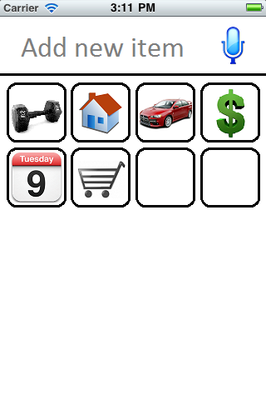

1. **Dashboard – Opening an Activity:** when tapping an activity, the row of icons below slides down and the list underneath the activity is opened.

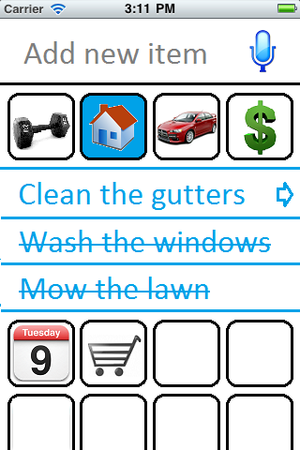

1. **Dashboard – navigating into an Activity:** when the disclosure icon next to the activity is tapped, the next level of content is rendered below, indented.

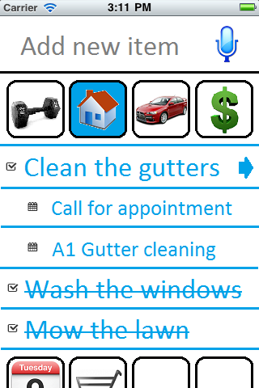

1. **Dashboard – navigating into an Item:** when an item is tapped (whether it’s an activity, a task / list, or an appointment), the Item screen is pushed onto the navigation stack. The navigation stack can only get one deep.

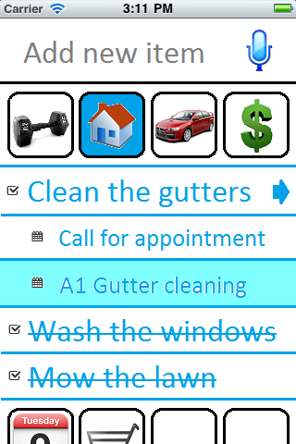 Tapping A1 Gutter cleaning 🡺 