Problem A

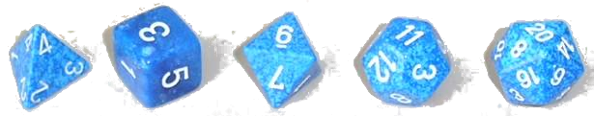

In many table-top games it is common to use different dice to simulate random events. A “*d*” or “*D*” is used to indicate a die with a specific number of faces, *d4* indicating a four-sided die, for example. If several dice of the same type are to be rolled, this is indicated by a leading number specifying the number of dice. Hence, *2d6* means the player should roll two six-sided dice and sum the result face values.

**Task**

Write a program to compute the most likely outcomes for the sum of two dice rolls. Assume each die has numbered faces starting at 1 and that each face has equal roll probability.

**Input**

The input consists of a single line with two integer numbers, N,MN,M, specifying the number of faces of the two dice.

**Constraints**

4≤N,M≤204≤N,M≤20 Number of faces.

**Output**

A line with the most likely outcome for the sum; in case of several outcomes with the same probability, they must be listed from lowest to highest value in separate lines.

|  |  |
| --- | --- |
| **Sample Input 1** | **Sample Output 1** |
| 6 6 | 7 |

|  |  |
| --- | --- |
| **Sample Input 2** | **Sample Output 2** |
| 6 4 | 5  6  7 |

|  |  |
| --- | --- |
| **Sample Input 3** | **Sample Output 3** |
| 12 20 | 13  14  15  16  17  18  19  20  21 |