Quadrant Selection

A common problem in mathematics is to determine which quadrant a given point lies in. There are four quadrants, numbered from 11 to 44, as shown in the diagram below:

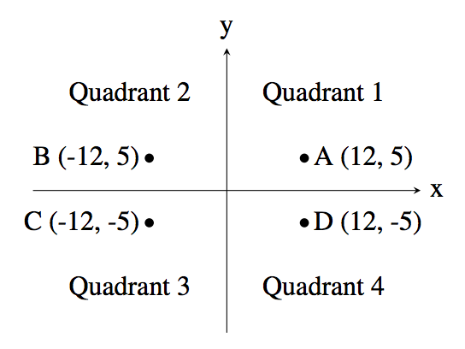

For example, the point AA, which is at coordinates (12,5)(12,5) lies in quadrant 11 since both its xx and yy values are positive, and point BB lies in quadrant 2 since its xx value is negative and its yy value is positive.

Your job is to take a point and determine the quadrant it is in. You can assume that neither of the two coordinates will be 00.

**Input**

The first line of input contains the integer xx (−1000≤x≤1000;x≠0−1000≤x≤1000;x≠0). The second line of input contains the integer yy (−1000≤y≤1000;y≠0−1000≤y≤1000;y≠0).

**Output**

Output the quadrant number (11, 22, 33 or 44) for the point (x,y)(x,y).

|  |  |
| --- | --- |
| **Sample Input 1** | **Sample Output 1** |
| 10  6 | 1 |

|  |  |
| --- | --- |
| **Sample Input 2** | **Sample Output 2** |
| 9  -13 | 4 |

const readline = require("readline");

const rl = readline.createInterface({

input: process.stdin,

output: process.stdout,

clrfDelay: Infinity

});

const lines = [];

rl.on("line", readLine => {

lines.push(readLine);

});

rl.on("close", () => {

const x = parseInt(lines[0]);

const y = parseInt(lines[1]);

if (x > 0 && y > 0) {

console.log(1);

} else if (x < 0 && y > 0) {

console.log(2);

} else if (x < 0 && y < 0) {

console.log(3);

} else {

console.log(4);

}

});