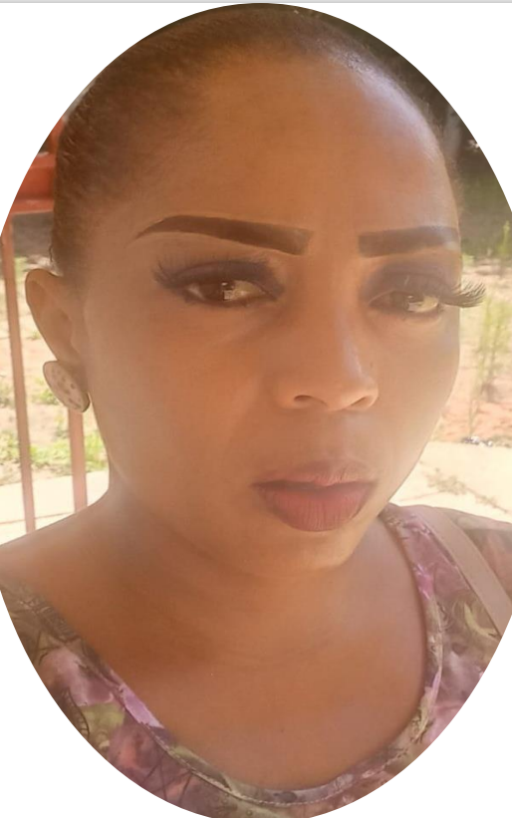

Palesa | 0730205357 | reorec20@gmail.com

# About me

My name is Palesa, I am 34 years old. I am a Somatology.

# Work Experience

**Somatology higher education** *2013-2016*Social Media and Tutor

**Blem Blem** *2016_2019*Tutor and Services

# Skills

* computer intermediate
* Marketing
* Management