CP/M™
TEX
TEXT FORMATTER
USER'S GUIDE
1978 Digital Research
Box 579, Pacific Grove California 93950
DIGITAL RESEARCH

;TEX PATCH #1: 27 JUN 78
;THIS PATCH CORRECTS AN ERROR WHICH OCCURS
;DURING ;“.NA” MODE WHERE A WORD IS
;DUPLICATED WHEN THE ;OUTPUT LINE IS EQUAL
;TO THE LINE LENGTH.
;PATCH FOLLOWS:

1D43 = PATCH EQU lD43H
0DAB = L606 EQU 0DABH
1DE5 = TLINE EQU 1DE5H
1DE6 = WLINE EQU 1DE6H
1DE8 = ELINE EQU 1DE8H
1DEA = NLINE EQU 1DEAH
0DAB ORG L606
0DAB C3431D JMP PATCH
RETPAT:
1D43 ORG PATCH
1D43 32E51D STA TLINE
1D46 3AE61D LDA WLINE
1D49 21E81D LXI H,ELINE
1D4C BE CMP M
1D4D F2AE0D JP RETPAT
1D50 3AEAlD LDA NLINE
1D53 32E61D STA WLINE
1D56 C3AE0D JMP RETPAT
1D59 END
;TEX PATCH #2, 28 JUN 78
;THIS PATCH CORRECTS AN ERROR WHICH OCCURS
;WHEN THE $F FORM FEED OPTION IS USED. IN
;PARTICULAR, THIS PATCH CAUSES A FORM FEED
;ON THE FIRST PAGE, WHICH WAS NOT
;PREVIOUSLY DONE.

1D59 = PATCH EQU 1D59H
0980 = L445 EQU 0980H
1F11 = SAV$LINELENGTH EQU 1F11H
1F0C = FORM$FEED EQU 1F0CH
0672 = PUTDEST EQU 0672H
000C = FF EQU 0CH
0980 ORG L445
0980 C3591D JMP PATCH
RETPAT:
1D59 ORG PATCH
1D59 32111F STA SAV$LINELENGTH
1D5C 3A0C1F LDA FORM$FEED
1D5F 17 RAL
1D60 0E0C MVI C,FF
1D62 DC7206 CC PUTDEST
1D65 C38309 JMP RETPAT
1D68 END

A>DDT TEX.COM
DDT VERS 1.4
NEXT PC
1D80 0100
-L0DAB
0DAB STA 1DE5
0DAE LDA 1DE8
-L0980
0980 STA 1F11
-ITEXPAT1.HEX
–R
NEXT PC
1D80 0100
-ITEXPAT2.HEX
-R
NEXT PC
1D80 0100
-L0DAB
0DAB JMP 1D43
0DAE LDA 1DE8
-L0980
0980 JMP 1D59
0983 LXI H,1F10
-L1D43,1D68
1D43 STA 1DE5
1D46 LDA 1DE6
1D49 LXI H,1DE8
1D4C CMP M
1D4D JP 0DAE
1D50 LDA 1DEA
1D53 STA 1DE6
1D56 JMP 0DAE
1D59 STA 1F11
1D5C LDA 1F0C
1D5F RAL
1D60 MVI C,0C
1D62 CC 0672
1D65 JMP 0983
1D68 LDAX D
1D69 LDAX D
-G0
A>SAVE 29 TEXP.COM
A>

COPYRIGHT
Copyright (c) 1978 by Digital Research. All rights reserved. No part of this publication may be reproduced, transmitted, transcribed, stored in a retrieval system, or translated into any language or computer language, in any form or by any means, electronic, mechanical, magnetic, optical, chemical, manual or otherwise, without the prior written permission of Digital Research, Post Office Box 579, Pacific Grove, California 93950.

TRADEMARK
The names CP/M, SID, MAC, TEX, and Digital Research are trademarks of Digital Research.

DISCLAIMER
Digital Research makes no representations or warranties with respect to the contents hereof and specifically disclaims any implied warranties of merchantability or fitness for any particular purpose. Further, Digital Research reserves the right to revise this publication and to make changes from time to time in the content hereof without obligation of Digital Research to notify any person of such revision or changes.
The "TEX User's Guide" was prepared using the TEX Text Formatter.

FORWARD
This manual is intended as a guide for users of a microcomputer system who wish to use the TEX Text Formatter program running under the CP/M Operating System. Because all users do not need to familiarize themselves with the entire contents of the Digital Research documentation for CP/M in order to use the TEX program, this manual should enable the casual user to operate the system with a minimum amount of study and training.
Most of the information in this manual is contained in more detail in the manuals, "CP/M Features and Facilities" and "ED: a Context Editor for the CP/M Disk System" which are available from Digital Research.
Although this manual does not assume a prior knowledge of CP/M on the part of the user, it does assume a familiarity with the user's particular hardware system.
The "TEX User's Guide" is divided into sections in the following manner. Section 1 gives an overview of the CP/M programming system, emphasizing those portions which are needed in the operation of TEX. The explanation of ED, the Context Editor for CP/M, is of particular importance because the TEX input source files are created with ED.
Sections 2, 3, and 4 describe the TEX program in detail. Section 2 introduces TEX to the user; this section presents various features of the program and explains how to use it. Section 3 describes each of the TEX commands in detail, includes examples, and highlights functions which warrant special attention. Section 4 describes the formatted output options which TEX allows the user to choose at run time.
The Appendices include (A) a quick reference table of TEX commands, (B) a summary of the TEX run-time parameters, (C) examples of the paging commands, and (D) a description of possible error messages.

TABLE OF CONTENTS
SECTION PAGE
1 An INTRODUCTION TO CP/M 1
1.1 A Typical Microcomputer System 1
1.2 Overview of the CP/M Operating System 3
1.3 CP/M Commands 6
1.4 The STAT Command 10
1.5 The PIP Command 11
1.6 The ED Command 13
2 AN INTRODUCTION TO TEX 25
2.1 Executing the TEX Program 26
2.2 TEX Command Format 27
2.3 Run-Time Parameters 29
3 TEX COMMANDS 31
3.1 .AD ADJUST MARGINS 32
3.2 .BP +-n BEGIN PAGE 33
3.3 .BR BREAK 34
3.4 .CE n CENTER LINES 35
3.5 .CP n CONDITIONAL PAGE 36
3.6 .DS DOUBLE SPACE 37
3.7 .HE string HEADING 38
3.8 .HM +-n HEADING MARGIN 39
3.9 .IG IGNORE 41
3.10 .IN +-n INDENT 42
3.11 .LI LITERAL 44
3.12 .LL +-n LINE LENGTH 45
3.13 .LS n LINE SPACING 47
3.14 .MB +-n MARGIN, BOTTOM 48
3.15 .MT +-n MARGIN, TOP 49
3.16 .NA NO ADJUST 50
3.17 .OP OMIT PAGE NUMBERS 51
3.18 .PA n PAGE ADVANCE 52
3.19 .PL +-n PAGE LENGTH 53
3.20 .PN +-n PAGE NUMBER 54
3.21 .PO +-n PAGE OFFSET 55
3.22 .PP n PARAGRAPH 57
3.23 .QI QUIT INDENT 58
3.24 .SP n SPACE LINES 59
3.25 .SS SINGLE SPACE 60
3.26 .TI +-n TEMPORARY INDENT 61
4 TEX RUN-TIME PARAMETERS 63
4.1 Parameters Redirecting Output 63
4.2 Printing Aids 65
Appendix A: SUMMARY OF TEX COMMANDS 69
Appendix B: SUMMARY OF TEX RUN-TIME PARAMETERS 71
Appendix C: PAGING EXAMPLE 73
Appendix D: SUMMARY OF TEX ERROR MESSAGES 75

An INTRODUCTION TO CP/M
This section is written primarily for the TEX user who is not familiar with the CP/M Operating System. The user who already has a working knowledge of CP/M may wish to skip Section 1 and proceed to Section 2.
The intent of Section 1 is to describe those portions of the CP/M Operating System which are necessary for the operation of the TEX Text Formatter. The information contained in the following pages may be found in greater detail in the specific CP/M user's manuals which are referenced throughout the section.

A Typical Microcomputer System
The heart of an information processing system is the Central Processing Unit (CPU). In microcomputer systems, the CPU is often a single integrated circuit such as an Intel 8080 or a Zilog Z80.
In order to process information with a computer's input, output, and storage devices are also necessary. In the typical system, the input device is a keyboard and output devices include a CRT (cathode ray tube) and a printer. Other I/O devices might include a cassette tape recorder, paper tape reader and punch, and other special purpose devices. Storage is of two types: volatile (the semiconductor memory connected to the CPU within the computer) and non-volatile (disks, magnetic or paper tape, and other storage media).
Figure 1 illustrates the devices which comprise what will be referred to, in this manual, as the typical system. Usually, the CPU and the semiconductor memory (also called the "memory buffer," the "buffer," or simply, "memory") are internal to the computer unit. The disk drives, the keyboard, the CRT display unit, and the printer are external devices.
In our typical system, we will assume that the CPU and memory are enclosed within the main computer unit, although hardware configurations do vary widely. The disks, CRT, keyboard, and printer are external devices, connected to the computer's "main box" by cables.
In order to use the computer as a general-purpose computer, a program called an "operating system" is needed. This is a program which provides the necessary interactions among the various system components. The operating system must accept commands from the keyboard and interpret them. It must read from and write to the disks, as well as keep track of where information is located on the disks. The operating system sends characters to the CRT for display or to the printer for "hard-copy" output.
Until the operating system is loaded into the computer's memory and the CPU is set to access the program, the computer cannot function. Section 1 will explain how to use the CP/M Operating System in order to provide the user with a workable computer system for running the TEX program and other programs.
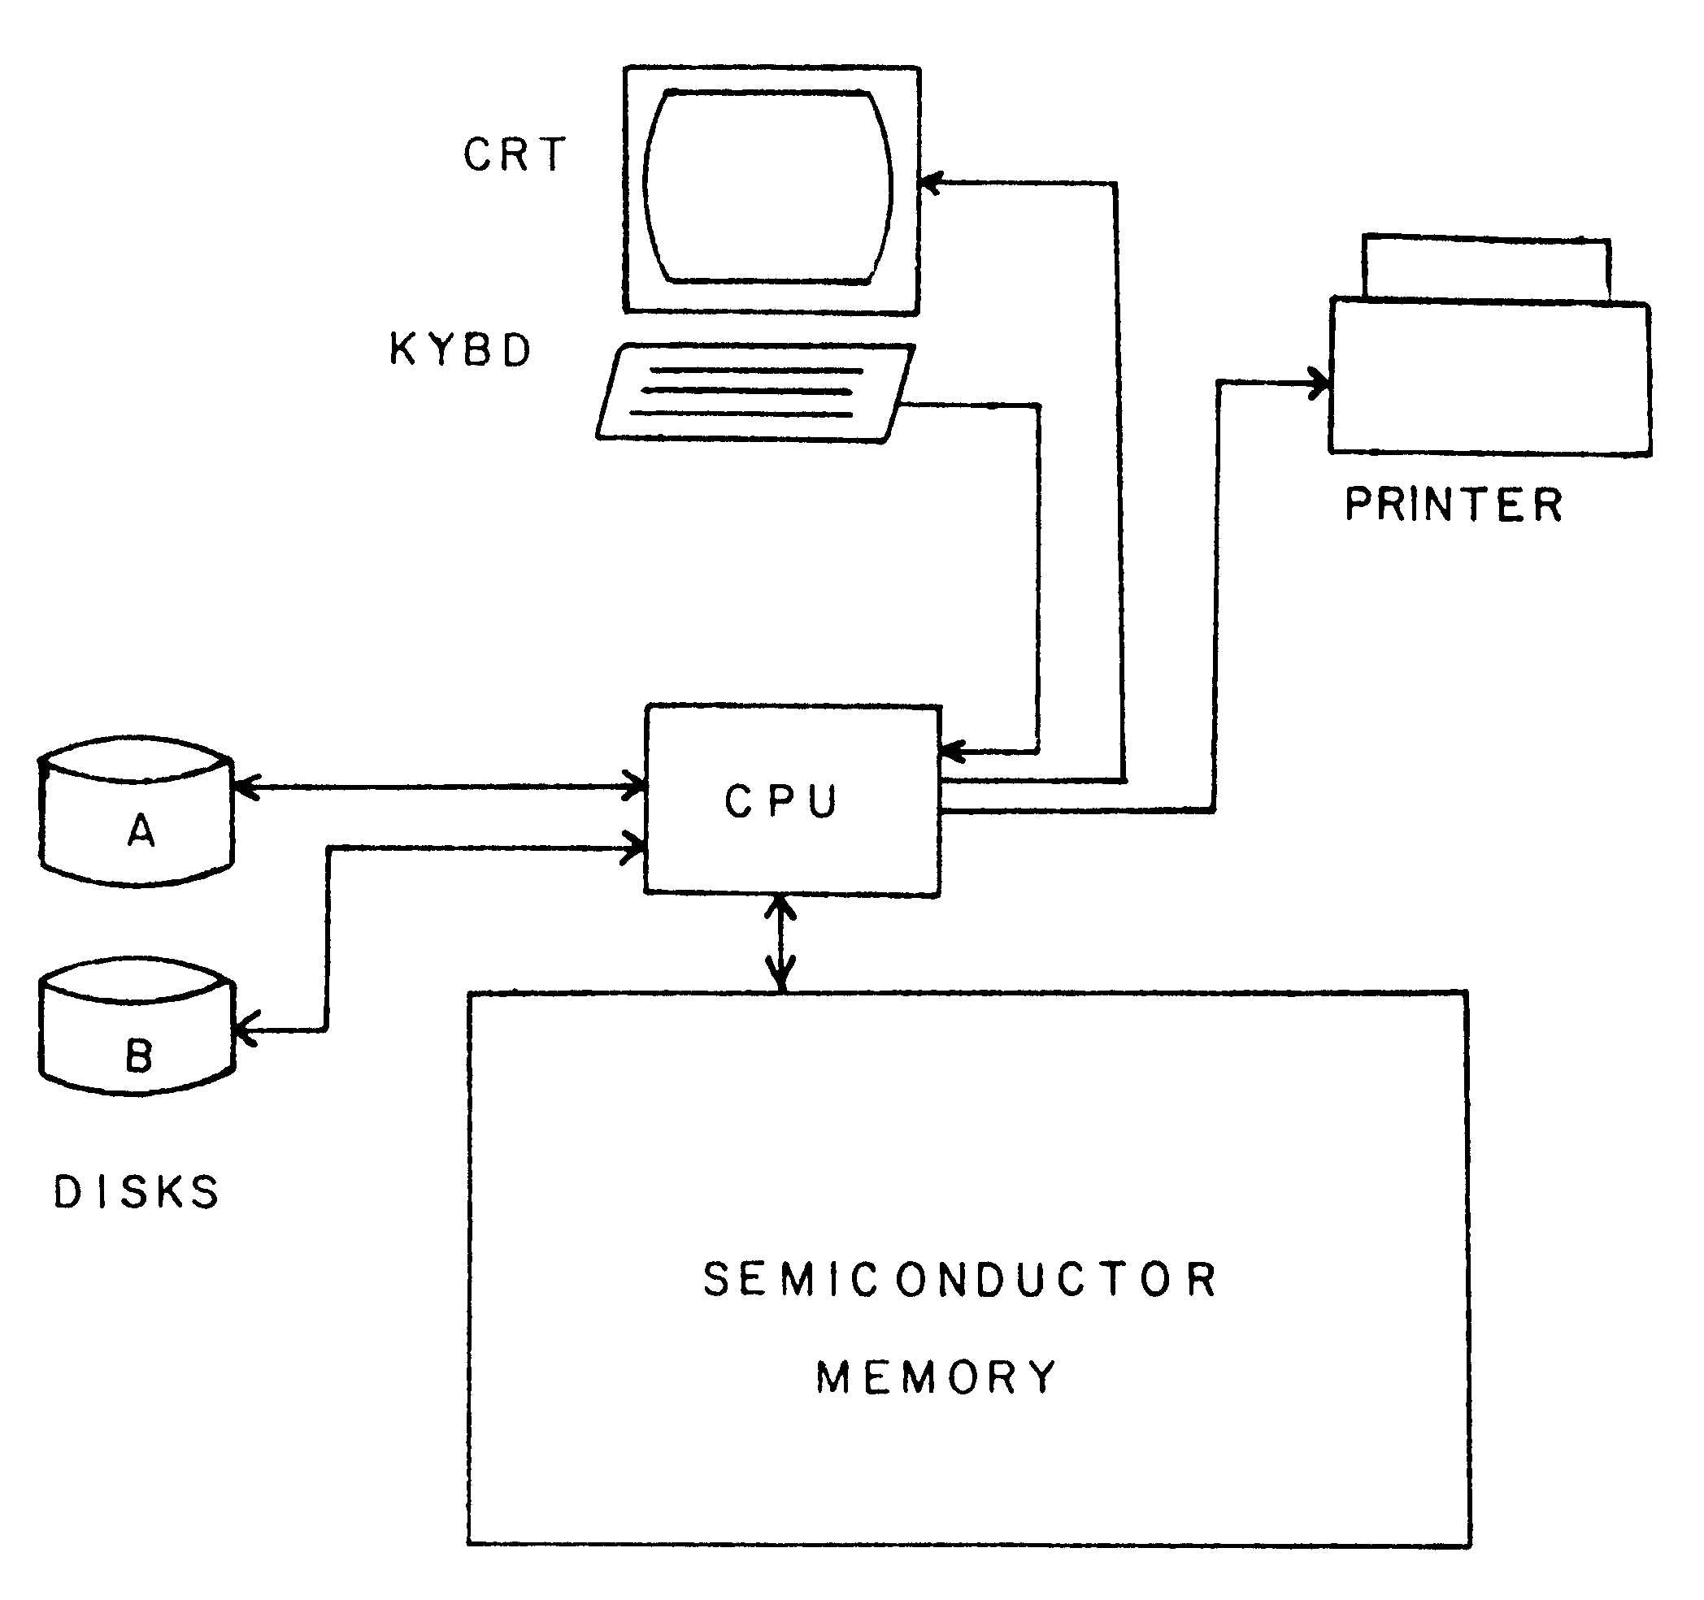
Figure 1

Overview of the CP/M Operating System
CP/M, a "Control Program for Microcomputers," is an operating system consisting of several parts. These parts include the Console Command Processor (CCP), the Basic Disk Operating System (BDOS), and the Basic Input/Output System (BIOS). The CCP interprets console commands and accesses one of the online disk drives: A, B, C, or D. The DBOS and BIOS control the interaction of the computer with the disk drive units and with the other I/O devices, respectively.

FILES
A file is an area of a disk, which is reserved for data and given a name. This data is a stream of characters, which varies depending on the nature of the file. A file may contain words and sentences, as in a TEX file or PRN file; or it may contain a machine language program, a COM file for instance, which can be read only by the computer. If the user types the DIR built-in command, CP/M will display the names of all the files residing on the disk in the logged-in disk drive. A file may be as large as 240k bytes (use STAT to determine file size), or it may be empty. Generally, for the TEX user, a file will contain either the text source statements (a TEX file for example), or formatted output statements (usually a PRN file). A file is designated by a filename of up to eight characters and a filetype of not more than three characters. The filename and filetype are separated by a period. The format of a filename is as follows:
xxxxxxxx.yyy
would designate a file of filename xxxxxxxx and filetype yyy. A file with no specified filetype is equivalent to one with a filetype of three blanks. Some examples of valid file designations are:
REPORT.ASM
TRUNK.COM
FLIGHT.PRN
FILE
The user should note the following conventions in naming files:
- Lower-case in filenames.
- The following special characters may not be used within a file designation:
. | [] | ; | : | = | ?
In searching for files, the symbol ? means "any character is a match." For example, if the following two files exist on the disk:
REPORT1.BAS
REPORT2.BAS
a search for REPORT?.BAS in the disk directory (refer to the DIR command in Section 1.3.) would find and list both files.
The use of the * symbol indicates "all." In the example above, a search for *.BAS would retrieve both the REPORT1.BAS and REPORT2.BAS files, as well as all other files with a filetype of BAS. A search for *.* would retrieve all files on the disk.

DISK ACCESS
In order to indicate which disk is currently accessed ("logged in"), CP/M prompts the user with an A>, B>, C>, or D> to indicate the current disk drive. If the A disk is logged in and the user wishes to access the B disk, the following command logs out the A disk and logs in the B disk:
B:<cr>
(Note that the symbol <cr> indicates a carriage return.) To return to the A drive, the following command would be typed:
A:<cr>
It is important to note that the user need not be logged in to a particular disk drive in order to access or refer to a file on that drive. To access a file not on the logged-in disk, simply preceed the filename with the appropriate disk drive name (A, B, C, or D), followed by a colon W.
For example, if the A disk is logged in, but the user wishes to view the contents of a TEX source file on disk D, then the following command is given:
A>TYPE D:FILEX.TEX
where A> is the prompt message indicating the logged-in disk, TYPE is the CP/M built-in command (see Section 1.3.) which types the contents of a file onto the console device, and D: is the disk designation of the TEX source file, FILEX.TEX.

CONTROL CHARACTERS
The following keyboard characters have special functions under the operation of CP/M:
DEL(delete) or RUB(rubout) | Deletes, echoes last character.
Any key but ^S | Aborts the typing of a file onto the console or printer.
^C | Reloads the CP/M operating System.
^I | Indicates a tab position. If a file is created using the ^I character (or TAB key) for spacing, each ^I character can be expanded into n spaces by using the PIP command with a Tn parameter (see Section 1.5.).
^L | Signifies the character pair <cr> <lf> (carriage return, line feed) in strings of characters in the edit environment. (See the ED User's Guide.)
^P | Copies all subsequent console output to the printer, as well as to the console. Typing ^P turns this feature on; typing ^P again, turns it off.
^R | Retypes the current line as it appears after deletions and corrections.
^S | Temporarily stops typing output onto the console or printer. Depressing any key (including ^S) restarts typing.
^U | Deletes an entire line.
^X | (Same as ^U.)
^Z | Ends an input string within the PIP and ED programs.
Table 1–1 Control Characters
NOTE: In the above list, the symbol ^ signifies a control character. The symbol ^U, pronounced "control u," is typed by holding the "ctrl" key down while typing a "u."

CP/M Commands
There are two general types of commands which can be executed under CP/M. The two types are referred to as "built-in commands" and "transient commands." (See Figure 2.)
The built-in commands are part of the CCP. These functions are available whenever the CP/M system is operating. The only software needed to use the built-in commands, therefore, is a disk containing the CP/M Operating System configured for the user's particular microcomputer hardware.
The transient commands are individual programs which reside on disk and are loaded from disk into memory when the command is typed at the console. Under the CP/M operating System, a large part of memory is left open for transient programs. Several transient programs are included as part of the CP/M system. These are listed in the section on standard transient commands. Other transient programs are those which are supplied by Digital Research or independent software suppliers. These programs may include sorting commands, text processing functions, and an infinite variety of other possibilities. Transient programs must have a filetype of COM (command) in order to execute under CP/M.
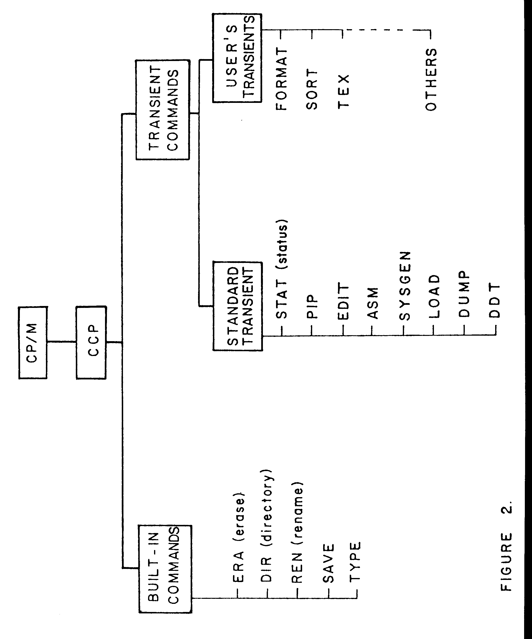
Figure 2

BUILT-IN COMMANDS
The following built-in commands are part of the CCP:
DIR (directory)
REN (rename)
SAVE
TYPE
ERA
ERASE A FILE
The ERA command erases files from the logged-in disk. Examples are as follows (assume that the A disk is logged in):
ERA RPT.BAS<cr> | Erases the file with filename RPT and filetype BAS from the A disk.
ERA *.BAS<cr> | Erases all files with the filetype BAS from the A disk.
ERA *.*<cr> | Erases all files from the A disk.
CAUTION: When using one of the above formats to execute the ERA command, the user should make certain that the file to be erased is on the logged-in disk; otherwise a file of the same name, residing on the currently logged-in disk, may inadvertently be erased. A file which is not on the logged-in disk may be erased by specifying the disk designation where the file resides. For example:
ERA D:*.PRN<cr> | Erases all PRN files from disk D.
DIR
DIRECTORY LISTING
The DIR command lists the requested files on the console. Some examples (again assume that the A disk is logged in):
DIR <cr> | Lists all files on the A disk.
DIR *.COM<cr> | Lists all files of filetype COM.
DIR X.Y<cr> | Lists only the file with the filename X and filetype Y, if such a file exists on disk A.
DIR C:<cr> | Lists all files on the C disk.
REN
RENAME A FILE
The REN command changes the filename and/or filetype of a file. Examples:
REN PROG1.OUT=PROG1.PRN<cr> | File PROG1.PRN is renamed as file PROG1.OUT.
REN XFILE.IN=YFILE.TEX<cr> | File YFILE.TEX is changed to file XFILE.IN.
REN C:X.Y=C:U.V<cr> | File U.V, on drive C, is renamed as file X.Y. This is an example of renaming a file not on the logged-in disk.
The REN command does not affect the contents of the file in any way. The file is not moved or copied; only the filename and/or the filetype is changed.
SAVE
SAVE A FILE IN MEMORY
The SAVE command is used to copy the contents of memory to a disk file. This occurs under certain circumstances, such as in making alterations to the CP/M system. The SAVE command is included here for completeness, but will not be used here. See the "CP/M Features and Facilities" manual for more information on this command.
TYPE
TYPE A FILE
The TYPE command displays the contents of an ASCII source file on the console. Examples:
TYPE SAMPLE.ASM<cr>
TYPE THESIS.TXT<cr>
TYPE B:THESIS.TEX<cr>
The TYPE command provides an easy method for viewing the contents of a TEX or PRN file on disk. Once the display of the file has begun, the console output can be stopped temporarily by pressing ctrl-S (see Section 1.2 CONTROL CHARACTERS); it can be restarted by pressing any key on the keyboard, such as another ctrl-S.

STANDARD TRANSIENT COMMANDS
Transient commands are programs which can be loaded by the user into the Transient Program Area (TPA) of CP/M. These commands are files which reside on the disk with a filetype of COM; they are loaded into memory from the disk each time they are executed. In order to use the transient commands, either the disk which is logged in must contain a copy of the transient command program, or the user must preceed the command with the prefix of the drive (A:, B:, C:, or D:) which contains the program. Standard transient commands included with the CP/M Operating System are:
STAT (Status) | Lists the amount of storage available on the logged-in disk (see Section 1.4.).
ASM (Assemble) | Loads and executes the 8080 assembler.
LOAD | Reads a hexadecimal file and produces a binary (object) file
PIP (Peripheral Interchange Program) | Copies or concatenates files (see Section 1.5.).
ED (Edit) | Used to create and edit TEX source files (Section 1.6.).
SYSGEN (System Generation) | Generates a new CP/M system disk.
SUBMIT | Executes a series of CP/M commands.
DUMP | Writes the contents of the specified file on the console in hexadecimal form. (Not used in this manual.)

The STAT Command
STAT is one of the standard transient programs supplied with the CP/M Operating System. Since STAT is transient, a copy of the file STAT.COM must be either on the logged-in disk, or on an accessible disk, in order to use the program.
The primary function of STAT is to provide the user with the status of all disks currently in use. STAT indicates whether the disks are in a read-write or read-only status, and gives the amount of usable space remaining on the disks. STAT can also be used to display the amount of disk space used by particular files.
Secondary functions of the STAT program are (a) to define disks as read-only and (b) to change the logical device assignments of the physical input/output devices. These secondary functions, however, are beyond the scope of this manual, and will not be discussed here. Refer to the "CP/M Features and Facilities" manual, for more information on the uses of STAT.
Possible forms of the STAT command are as follows:
- STAT<cr>
- STAT xxxxxxxx.yyy<cr>
- STAT *.*<cr>
The system will respond to form (a) with the read/write status of each disk and the number of kilobytes of space remaining on each disk.
The response to form (b) includes, for the file xxxxxxxx.yyy, the number of 128-byte records, the number of kilobytes, and the number of 128-byte record extensions used by the file.
The response to form (c) includes the same information as the second form, but for all files on the logged-in disk.
As with the built-in commands, any valid disk designation can be specified for a file accessed by the STAT program. For example:
STAT B:*.*<cr>
STAT C:*.PRN<cr>

The PIP Command
PIP, the Peripheral Interchange Program, is one of the transient programs which is a subsystem of CP/M. This program concatenates (merges several files), abstracts, or copies files on a single disk or from one disk to another. The PIP program also copies files onto the printer or the console from disk.
To enter the PIP program, simply type "PIP" following the usual CP/M "A>" prompt. While in the PIP environment, the system prompts the user with a "" symbol. To exit from the PIP environment and return to CP/M, type a carriage return.

COPYING FILES
To make copies of a file on a single disk, statements of the form
PIP XX1.ASM=XX.ASM <cr>
and
PIP REPORT.TEX=SENDFILE.TEX,OLDFILE.TEX <cr>
can be used. The first example creates a file named XXl.ASM and copies the existing file XX.ASM into the new one. The second example creates a file named REPORT.TEX and concatenates and copies into the new file both of the existing files, SENDFILE.TEX and OLDFILE.TEX.
CAUTION: If a file already exists with the name of the new file to be created under PIP, the old file will be erased by the PIP operation.
To copy files from one disk to another, the same general form is used, except that the filenames are prefixed with the disk designator A:, B:, C:, or D:. For example,
PIP B:THESIS.TXT=A:THESIS.TXT <cr>
copies the file named THESIS.TXT from the A disk onto the B disk. The statement
PIP A:XXX.YYY=B:OLD.ASM <cr>
creates a file named XXX.YYY on the A disk, and copies into this newly created file the B-disk file OLD.ASM. In certain instances shortened forms of these commands may be used. The user may consult the "CP/M Features and Facilities" manual to learn the short forms. It is, however, recommended that the forms given here be used until the user becomes thoroughly familiar with the CP/M system.
NOTE: The copying operation under PIP may be aborted by depressing any key on the keyboard.

PRINTING FILES
To print a "hard copy" (copy on paper) of a file, type the command LST:= followed by the filename. Examples:
PIP LST:= XXX.TEX <cr>
PIP LST:= REPORT.PRN <cr>
NOTE: Only files containing printable characters (for instance, filetypes TEX or PRN) can be freely listed on the printer.
If there are tab functions within the file, placing the notation [T81 in a PIP statement prints the file with tab settings every 8 spaces. For example:
PIP LST:= REPORT.PRN[T81 <cr>
would list the REPORT.PRN file on the printer with tabs every eight spaces.
There is a shorter form of the PIP command which eliminates the necessity of continually reentering the PIP environment when several PIP commands are to be executed. Refer to the "CP/M Features and Facilities" manual for this format.
Other options available with PIP, using parameters, include the following: the ability to specify a variable tab setting; the ability to delete all characters past a certain column; a capability for echoing the transferred data to the console; capabilities for deleting forms feeds and inserting line numbers; translation of alphabetic characters totally to upper-case or to lower-case. When the user becomes sufficiently familiar with the CP/M system, he may wish to consult the PIP section of the "CP/M Features and Facilities" manual for instruction on the use of these more sophisticated PIP options.

The ED Command
ED is another subsystem of the CP/M Operating System. It performs file creation and editing functions. To enter the edit environment, type ED and the filename and filetype of the file to be created. For example,
ED INSTRUC.TEX <cr>
opens the file INSTRUC.TEX for editing, or, if no such file exists, creates a new one by that name. After the ED command is given, the CP/M system loads the edit program from disk into memory and passes control to the program. The system is now in the "edit mode" or "edit environment."

LOADING THE FILE FOR EDITING
Before starting an edit session, the user should type the STAT command (see Section 1.4.) to ensure that there is enough space on the work disk to hold the edited file. For example, if the file THESIS.TEX is to be edited, the user can determine the size of the existing file by typing
STAT THESIS.TEX <cr>
If a subsequent STAT command does not indicate at least as much space remaining on the disk as the existing file occupies, then the user should take some action to acquire more space before editing. For instance, the user may erase unnecessary files (BAK files, PRN files) from the current disk, or he may use PIP to move the THESIS.TEX file to another disk which has more free space.
If no previous version of the file exists on the currently logged-in disk, the file is considered to be a new one and is automatically created. The "insert mode" must be entered, using the I command, in order to put information into this new file. Typing ^Z causes the editor to leave the insert mode and return to the edit mode. This input information is stored in memory, and the altered version is copied back onto disk for retention at the end of the edit session.
Figure 3 illustrates the steps which generally occur during an edit session.
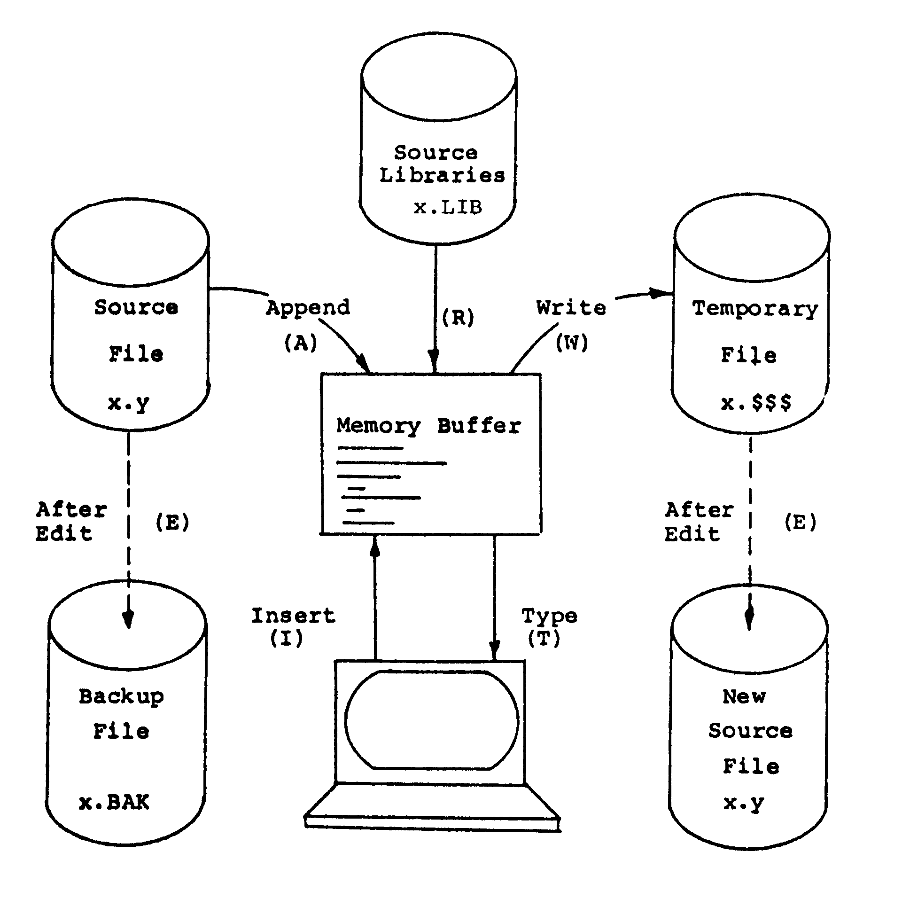
Figure 3 Illustration showing overall operation of the ED Context Editor.
The A (append) command is used to copy an existing file from disk to memory. Typing nA (where n is a positive integer less than 65535) brings the first n lines of the file from disk into memory. Typing the symbol "#" instead of a number brings the whole file into memory, if it will fit. If there is not enough memory space available for the entire file, #A brings in as many lines as will fit into memory.
If all of the file does not fit into memory, the first part can be edited; then n lines of the file can be written back to disk to free more space in memory for the next part of the file. This is done by typing nW, which moves the first n lines from memory to disk; or type #W to move all the lines in memory to disk, emptying the memory. Another append command can then be used to bring the next part of the file into memory. Files of virtually any length can be "paged" through in this fashion.
For convenience, the commands OA and OW can be used. The OA command will fill half of the available memory of the computer. The OW command will half empty the memory. Further, the N command, described below, can be used to automatically page through a file until a particular word or word-sequence is encountered.

EDITOR CHARACTER POINTER
In editing, the user must keep track of an imaginary character pointer. This will take some practice, but an understanding of the function of the character pointer is absolutely essential in learning to use the ed it program. (In this manual, we will designate the character pointer with the symbol <cp>.)
The character pointer is a device by which the editing program keeps track of the specific place at which some editing operation is to be performed in a file. For example, if a certain number of characters are to be deleted from a file, the D (delete) command is used. This command specifies the number of characters to be deleted, but not the location from which they are to be deleted. To delete specific characters, the user must move the character pointer to the desired location, and then give the delete command. This applies to almost all the edit commands.
At the start of an edit session, the <cp> is always positioned at the top of the file, before the first character. It can be moved ahead or back a certain number of character -positions using the C (character) command. (Note that a character position may contain a character or a blank.) It can be moved up or down a certain number of lines by using the L (line) command or by issuing a "line number:" when in the V (verify line numbers) mode. Refer to Figure 4 for an illustration of character pointer <cp> movement.
To illustrate the use of the <cp>, consider the following situation:
We have just entered the edit mode and copied the block of text shown below into memory. Note that the invisible carriage return and line feed characters are at the end of each line and are included in the character count.
Initially, the <cp> is positioned at the top of the file, just before the capital I (location 1). The command 8C will move the <cp> along the line to the point between the "w" and the "e" of the word "twelve" (location 2). The next command, -2C, will move the <cp> back, between the space and the "t" of the word "twelve" (location 3). The command 2L moves the <cp> to the beginning of the line, two lines down, just before the "a" of "aid" (location 4). In this way, the <cp> can be moved up or down, ahead or back, to the appropriate location for the editing function required.
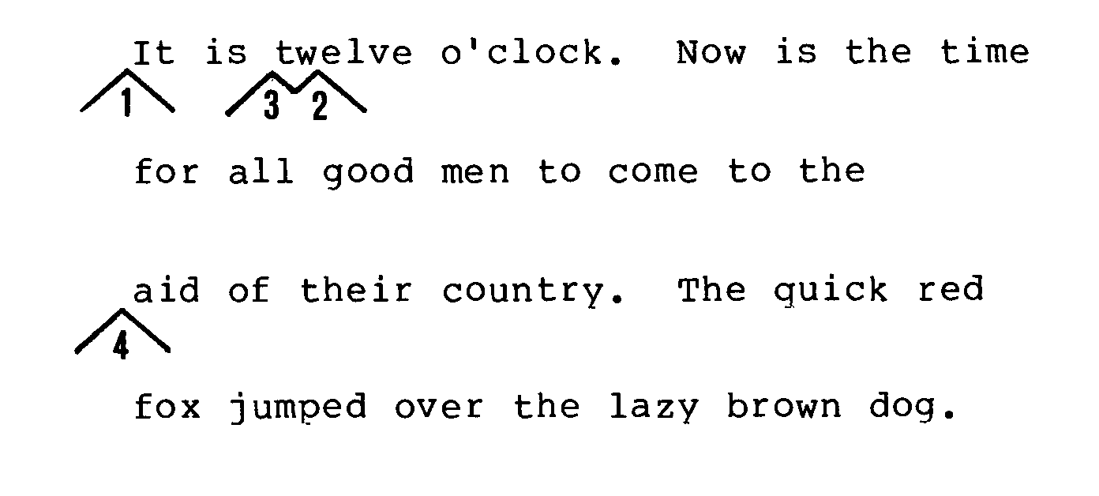
Figure 4 Illustration of text within a file, and the movement of the character pointer within the file for editing.

SUMMARY OF EDIT COMMANDS
The following is a summary of the more important commands used in the edit environment:
A
APPEND
#A Appends whole file into the memory buffer, if it will fit in the available memory space. If it will not, #A appends as much of the file into memory as will fit. After editing the first part of the file, the W command can be used to write part of the file from memory to disk, making more space in memory for the next part of the file.
OA Appends lines of the file until the buffer is half full or until all of the file is in memory. This is a special form of the A command which assures that enough memory space will be available to handle editing commands. In other words, if memory is completely filled with the file data, there may not be enough work space in which to satisfactorily edit the file.
nA Appends n lines of the file into the memory buffer.
B
BEGINNING/BOTTOM
B Moves the <cp> to the beginning of the memory buffer.
-B Moves the <cD> to the bottom of the text in the memory buffer.
C
CHARACTER
nC Moves <cp> n characters to the right.
-nC Moves <cp> n characters to the left.
D
DELETE CHARACTER
nD Delete the n characters after the <cp>.
-nD Delete the n characters before the <c-o>.
E
END EDIT
E Ends the edit session, copies the edited version of the file from memory onto disk, and returns control to the CP/M operating System.
F
FIND
nFxyz^Z Searches that portion of the buffer after <cl)> for the next occurrence of the character string "xyz". If the string is found n times, the <cp> is moved to a point immediately after the n-th occurrence of the string. If the string is not found n times, <cp> is moved to the position immediately after the last occurrence of the string. (Note the use of ^Z to denote the end of the character string.)
I
INSERT
I Inserts characters after the <cp> in the file. The command I, on a line by itself or as the last item in a command line, places the system in the insert mode, which is terminated only by typing a ^Z. While in the insert mode, as many lines of input as desired can be entered (up to the capacity of memory) at the point at which the character pointer was positioned before entering the insert mode.
Iabc^Z Inserts the character string "abc" into the file immediately preceeding the <cp>.
K
KILL LINE
nK Kills (deletes) the next n lines, including the characters in the current line after the <cp>.
-nK Kills (deletes) the last n lines, including the characters in the current line before the <cp>.
N
NEXT
nNabc^Z Searches the buffer after <cp> for the n-th occurrence of the "abc" character string. If the memory buffer is empty, or if the string is not in the buffer, text will be continuously appended and written in half-buffer increments (see the OA and OW commands) until either the n-th occurrence of the string is found or the end of the text file is reached. The repositioning of the <cp> is the same as for the F command. This command is a combination of the A (append), W (write), and F (find) commands.
L
LINE
OL Moves <cp> to beginning of current line.
nL Moves <cp> to beginning of line, n lines down.
-nL Moves <cp> to beginning of line, n lines up.
R
READ
R Reads the contents of the temporary library file, which was created by a previous X command, into the memory buffer. The characters are placed into the edited source file at the position immediately preceeding the character pointer <cp>.
Rf Reads the contents of some file having a filename denoted by f and filetype LIB, into the memory buffer.
Q
QUIT
Q Ends the edit session with no change to original version. All editing changes made during the session are lost. When this command is typed, ED responds with the message
Q-(Y/N)?
meaning "End this edit: Yes or No?". The user must respond with "Y" or "N" to indicate the desired action.
S
SUBSTITUTE
nSxyz^Zabc^Z Locates the next n occurrences of the string "xyz", and substitutes for each occurrence of that string, the string "abc". (Note the use of the ^Z function to show the ends of the strings.)
This command is actually a combination of the F (find), D (delete), and I (insert) commands.
T
TYPE
OT Types the contents of the current line up to <cp>.
T Types contents of the current line, from <cp> to the end of the line.
nT Types the current line, from the <cp> on, and the n-l lines which follow.
-nT Types the previous n lines, and the current line, up to the <cp>.
V
VERIFY LINE NUMBER
V Displays relative line numbers of format 41nnnnn:" before each line of text in file being edited.
-V Disables the line number display.
OV Prints the statistics of the memory buffer in the following format:
free / total
where "free" is the number of free bytes in the buffer and "total" is the size of the memory buffer.
W
Write
#W Writes all of the lines in the memory buffer into a temporary file (which will become the new edited file if the E command is given before ending the edit session).
OW Writes the first half of the buffer to the temporary file. The lines of text remaining in the buffer are shifted to the beginning of the buffer. This is a special form of the W command often used in conjunction with the OA command.
nW Writes the first n lines of the memory buffer to the temporary file. The remaining lines of text are shifted to the beginning of the buffer.
X
XFER (transfer)
nX Transfers the next n lines of text into a temporary library file. The X command does not erase the lines transferred; an nK command given after the nX command will accomplish this process, if desired.
OX Clears the temporary library file.
n
MOVE <CP> n LINES
n Moves <cp> to the beginning of the line n lines down, and types that line.
-n Moves <cp> to the beginning of the line n lines up, and types that line.
This command form is an abbreviated combination of the L (line) command and the T (type) command.

EDITING: AN EXAMPLE
For an example of how to delete and insert characters in a line, suppose the <cp> is positioned at the beginning of a line which reads: "Now is the time for all good men." We wish to change this to read: "Now is the place for all good men." The statement sequence which does this is:
Ftime<cr>
-4D<cr>
Iplace<cr>
A breakdown of this edit sequence is as follows:
Ftime<cr> Finds the character string "time" and positions the <cp> after the letter "e".
-4D<cr> Deletes the four characters (t, i, m, e) immediately preceeding the <cp>.
Iplace Inserts the string "place" at that point.
The above sequence could also have been typed as one continuous string of commands:
Ftime^Z-4DIplace^Z<cr>
Note the use of -Z to delimit the strings within the command sequence.

STORING THE EDITED FILE ON DISK
If an edit session is producing undesirable results, the user may wish to leave the edit mode and return to CP/M. The Q (quit) command is used to discard the edited version of the file, keeping, instead, the original, unedited version. All files are retained as they were before the edit session was begun.
Upon completion of a successful edit session, use the E (end) command to leave the edit environment and store the edited file on the disk. This stores the edited file under the original filename and filetype, but keeps the old file, with the original filename and the filetype, BAK (backup). If a BAK file for the file being edited already exists on the disk (from a previous edit), it will be automatically erased at this point by the ED program.
For instance, after editing the file REPORT.TEX, the following two files will reside on the disk containing the original file: REPORT.TEX, the new edited version; and REPORT.BAK, the original version, which is now the backup file. The BAK file can be erased as soon as the new file is checked for accuracy. Do not edit a BAK file as the backup version will be lost and no new BAK file will be created. If the BAK file must be edited, first rename it to TEX or some other filetype.

AN INTRODUCTION TO TEX
TEX is a text formatter program designed to run under the CP/M Operating System. To use the program, two-letter commands are interspersed with lines of text in a source file. The user creates a source file using ED, the CP/M Context Editor. The Text Formatter program is then loaded from disk to process the text lines in the source file according to the embedded TEX commands. The formatted output file is created by default on disk, or at run time may be redirected to the console or line printer (see Section 4.). The combination of TEX and ED, running under the CP/M Operating System, provides the user with powerful text formatting capabilities.
With TEX, the user has complete control over horizontal and vertical spacing, and pagination. For instance, TEX commands are available to accomplish the following functions: set the number of lines per page (PL); set the line spacing to single space (SS), double space (DS), or multiple line spacing (LS); justify the right margin (AD); set the left (PO) and right (LL) margins, as well as the top (MT) and bottom (MB) margins; define and place a page heading (HE) in the top margin and a page number (PN) in the bottom margin; indent by block (IN) or by line (TI); and paragraph (PP), center lines (CE), embed comments within the text (IG), and copy text in a literal mode, exactly as typed (LI).
Refer to Figure 5 for an illustration of the initial values of various TEX commands. This figure depicts a page setting as it appears at the invocation of the TEX program.
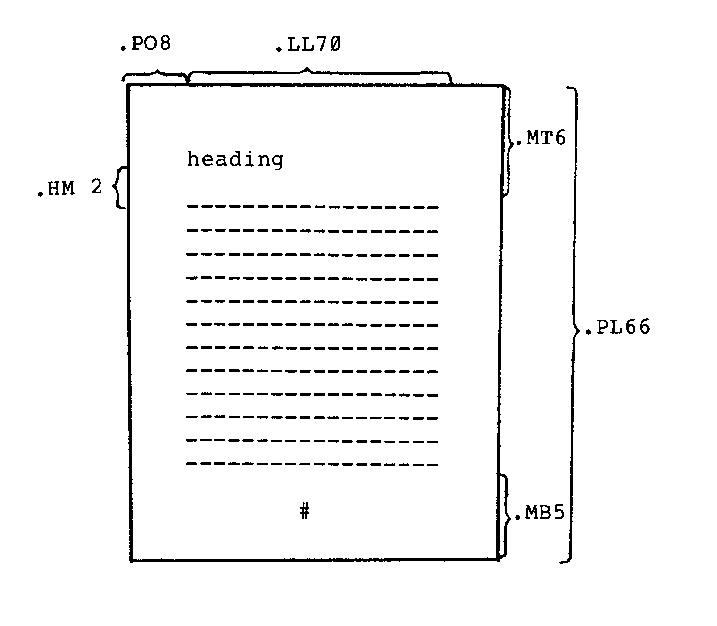
Figure 5 Illustration showing initial integer values of the spacing commands.
Vertical |  | Horizontal
.PL 66 |  | .PO 8
.MT 6 |  | .LL 70
.HM 2 |  | .IN 0
.MB 5

Executing the TEX Program
Unless otherwise specified, source files to be processed by the TEX program are assumed to have a filetype of TEX. The formatted output file created by the TEX program will default to a filetype of PRN if a filetype is not specified.
Once a source file is ready for processing, the call to execute the TEX program takes one of the following forms:
- TEX x
- TEX x u
- TEX x.y
- TEX x.y u.v
If form (a) is used, the source file is x.TEX and the output file is x.PRN.
If the form (b) is used, the source file is x.TEX and the output file is u.PRN.
Using form (c), the source file is x.y and the output file is x.PRN.
With form (d), the source file is x.y and the output file is u.v. Note that x and u may be the same in this case.
If the user wants the input file and the output file to be stored on different disks, the input or output filename can be prefixed with the appropriate disk designation. For example, if disk A is logged in, and the user wants the output file to appear on disk B, the correct command is in one of the following formats:
TEX x B:
TEX x B:u
TEX x.y B:u.v

TEX Command Format
The commands used by the TEX program are embedded within the source file. Each command occupies a line by itself; it begins at the left margin and is preceeded by a period. The commands control such features as margin size, line length, justification of the right-hand margin, line spacing, centering, and pagination with page numbers and headings. TEX commands take one of the following forms:
- ab
- ab n
- ab +n
- ab -n
where ab is a two-character keyword constituting the actual command and n is an integer value which may or may not be required, depending on the particular command. The integer will be either signed or unsigned. The keyword may be typed in upper-case or in lower-case. A space may separate the keyword and the integer value, but it is not required.
Form (a) represents a command which cannot take an integer value. Examples of this form are AD, BR, and DS.
Form (b) represents a command which requires an absolute, unsigned integer. Generally, a command of this form has a default value associated with it; therefore, if the integer value is omitted from a command, the default value is assumed. Commands of this format include CE n, .LS n, PA n, and PP n.
Commands of the forms (c) and (d) require either an absolute integer, n, or a relative integer value, +n or -n. The default value applies as in form (b). If a signed integer value is given, it specifies an incremental change to the previous value for this particular command function. Commands of form (c) and (d) include BP n, IN +n, LL -n, .MB+n, and MT n.
For example, LL is the command used to set the line length of the text in the formatted output file. Three possible forms of the LL command are:
.LL 72
.LL +3
.LL -12
The first form sets the length of all lines following this command to 72 characters. The second form increases the length of subsequent lines to three characters more (+3) than the length of preceeding lines. The third form decreases the current line length by twelve (-12) characters. By using this command, in one of its three forms, the line length can be changed at any point within a file.

DEFAULT VALUES
If an integer value is required by a particular command but the user omits the value, the TEX program generally assumes a default value for the command. Before omitting a required integer, however, the user should refer to Appendix A to determine that the default value exists and is satisfactory. If no default value is listed, an integer value should be specified in the command. otherwise, unpredictable results may occur.
The commands for the TEX program and their default values are given in the following section. Appendix A contains a brief reference table.

INITIAL VALUES
At the beginning of the TEX program, initial integer values are assigned to many of the commands. Therefore, if a required signed integer (see form (c) above) is used, but no previous absolute value has been specified, the command will increment or decrement the initial integer by +n or -n to produce the new integer value.
For instance, if the first occurrence in the text of the MB (bottom margin) command is MB+2, the bottom margin value will be set to 7 lines. That is, the initial value of 5, incremented by 2, yields 7.
If the initial value of a command parameter is satisfactory for the user's ouptut, then that command need not be specified. For example PL66, MT6, and PO 8.

BREAK
An important concept in TEX is the line-fill "break" which takes place when various commands are encountered. TEX automatically builds (or fills) output lines with input text to comDlete a line of the specified length (LL command). If a break occurs in a command, then the normal line fill ceases at precisely the location of the command in the text file. The remainder of the line is left blank. Some commands cause a break to occur; others do not.

Run-Time Parameters
The formatted output from a TEX run is directed to a disk file, usually a PRN file. However, the user can make certain decisions concerning the destination of the output at "run time," i. e., at the time of invoking the TEX program. This is accomplished by adding a "run-time parameter" in the initial startup of TEX. For example,
TEX FILE $L
redirects the output to the list device.
The user can choose to redirect the output to the console ($C), to the printing device ($L), or to suppress ($S) the output completely. Error messages can be directed to the list device instead of the console ($E). If continuous-form paper is not being used for printed output, the user can specify that TEX print in page mode ($P) to allow the user time to insert paper for each separate page of output. A forms feed ($F) option is also available. The user is referred to Section 4, which describes the run-time parameters in greater detail.

TEX COMMANDS
The following pages contain a brief description of each of the TEX commands. Each command is given in its various forms, with examples provided for clarification. Also included in these pages are the initial values and default conditions for each command function.
Note that there are often two or more commands which provide identical or similar formatting effects.
Following is a list of the TEX commands in the order of their appearance in this section.
AD | adjust margins
BP | begin page
BR | break
CE | center lines
CP | conditional page
DS | double space
HE | heading
HM | heading margin
IG | ignore
IN | indent
LI | literal
LL | line length
LS | line spacing
MB | bottom margin
MT | top margin
NA | no margin adjustment
OP | omit page numbers
PA | page advance
PL | page length
PN | number pages
PO | page offset
PP | paragraph
QI | quit indenting
SP | space lines
SS | single space
TI | temporary indent

.AD ADJUST MARGINS
The AD command adjusts the text by moving words up to fill lines or down to shorten lines, and by padding lines with spaces to align both the left and right margins. The adjust mode is the initial environment of the text formatter program.
Two other environments which affect the line fill of source text can be specified. If no line filling is desired, the literal mode can be specified, using the LI command. If line filling is desired, but justification of the right-hand margin is not desired, margin adjustment can be turned off with the NA command. Compare the following input and formatted output for these commands:
INPUT
.LL 40
.SP
.NA
The CP/M Operating System can be
easily altered to execute with almost any
microcomputer configuration.
.SP
.LI
The CP/M Operating System can be
easily altered to execute with almost any
microcomputer configuration.
.SP
.AD
The CP/M Operating System can be
easily altered to execute with almost any
microcomputer configuration.
OUTPUT
The CP/M Operating System can be easily altered to execute with almost any microcomputer configuration.

The CP/M Operating System can be easily altered to execute with almost any microcomputer configuration.

The CP/M Operating System can be easily altered to execute with almost any microcomputer configuration.

.BP +-n BEGIN PAGE
The BP command causes an eject to a new page. This command can take any one of the following forms:
- BP
- BP n
- BP +n
- BP -n
Form (a) simply begins a new page. Unless the OP option (omit page numbers) is in effect, the new page will be numbered with the next sequential integer. If the OP option is set, the new page will not be numbered.
Form (b) begins a new page and assigns the page number n to the new page. For example, if the command BP 16 is given, the next page will be page 16, regardless of the number of the previous page. Subsequent pages will be numbered sequentially from 16, unless a new n is later specified.
Forms (c) and (d) begin a new page with a page number equal to the current page number, plus or minus n. For example, if the current page number is 12 and a BP +4 command is given, a new page is begun with the page number 16.
The initial value, as well as the default value, for page numbering is +1. See Appendix C for an example of the BP command.
NOTE: If the page numbering option has been disabled with the OP command, form (a) above will not change the status of this option. However, forms (b), (c), and (d) will cause page numbering to resume according to the integer value specified.

.BR BREAK
The BR command causes TEX to stop filling the current output line with words from the next line. That is, the text following this command begins on a new line; it is not moved up to fill the previous line. As an example of the use of this command, consider the two input file lists below. The results are shown in the corresponding output file lists.
INPUT
LIST I: | LIST II:
ALPHA | br
BRAVO | ALPHA
CHARLIE | br
DELTA | BRAVO
ECHO | br
 | CHARLIE
 | .br
 | DELTA
 | .br
 | ECHO
 | .br
OUTPUT
LIST I: ALFA BRAVO CHARLIE DELTA ECHO

LIST II:
ALFA
BRAVO
CHARLIE
DELTA
ECHO

.CE n CENTER LINES
The CE command centers (horizontally) the next n lines of text. Forms for the CE command are as follows:
- CE
- CE n
The default value for n is 1; therefore, if form (a) is used, TEX will center the single line of text following the command.
If form (b) is used, the n lines of text following CE will be centered.
This function is very useful for centering letterheads and setting titles. As an example, the following block of input text will result in the output below:
INPUT
.in +8
.ce 5
TECHNICAL REPORT ON SITE VISIT
XYZ ANTENNA ARRAY SITE
GENERAL NOISE CORPORATION
NOWHERE, MONTANA
January 3, 1976
.pp
This report will provide the technical details of
the site visit by three engineers
from our research institute.
OUTPUT
TECHNICAL REPORT ON SITE VISIT
XYZ ANTENNA ARRAY SITE
GENERAL NOISE CORPORATION
NOWHERE, MONTANA
January 3, 1976

This report will provide the technical details of the site visit by three engineers from our research institute.

.CP n CONDITIONAL PAGE
The CP command is a "conditional begin-page" function. This command is valuable when the user desires to begin a new page if, and only if, the next n lines of text will not fit on the current page.
For instance, at the beginning of a new section of a report which contains a title, it would be undesirable for the title to appear at the bottom of a page with no text immediately following it. To avoid this situation, the user can precede the title and text with a CP n command, where n specifies the minimum number of lines the user wants printed on the same page. Following is an example of this situation:
INPUT
.cp 10
.ce
PERIOD OF REPORT
.pp
The period of this report is from January 12, 1977,
to October 30, 1977. The report covers all the
activities of this office during this period.
The activities of this office will be enumerated in
some detail, but will be discussed only in light of
their impact on the net worth of the corporation as
a whole. Activities of an internal nature will be
discussed in another report.
NOTE: The above entry in an input file causes the text formatter to count the number of lines which can fit on the current page. If 10 lines (beginning with the title line "PERIOD OF REPORT") cannot fit on the current page, then TEX begins a new page, starting with the title line.

.DS DOUBLE SPACE
The DS command causes the output text to be vertically double-spaced. This is equivalent to using the line spacing command LS 2.
INPUT
.ll 40
.ds
To produce a double-spaced report,
just code the keyword DS
or, optionally, code LS 2.
OUTPUT
To produce a double-spaced report, just code the keyword DS or, optionally, code LS 2.

.HE string HEADING
The HE command allows the user to define a heading to be printed at the top of subsequent pages. The exact location of the heading within the top margin is determined by the HM command. Once a heading is defined, it will print on every page following the command, unless the heading is changed or eliminated. A heading can be changed by simply entering another HE command to redefine the heading. A heading is eliminated, or nullified, by typing an empty HE command into the source file (see form (b) below).
Valid formats for the HE command are as follows:
- HE string
- HE
where "string" is any character string, not to exceed the line length set by the LL command. One space must separate ".HE" and the heading string. All character positions (characters, blanks, etc.) following this blank, and preceding the carriage return, are considered to be the contents of the heading. If the heading exceeds the current line length, it will be truncated (from the right) to the current line length. Form (b) sets the heading to blank.
NOTE: The left margin set by a PO command remains in effect when printing the heading; however, other indenting values are ignored.
Following are some examples showing the heading results of various HE input strings. Assume a page offset of 18 (.PO 18) and a line length of 45 (.LL45). (Note the truncation in the third example.)
INPUT
1-> .he THE CREATIVE PROGRAMMER Chapter 1
2-> .HE CENTERED TITLE
3-> .he Section Twenty
OUTPUT
1-> THE CREATIVE PROGRAMMER Chapter 1
2-> CENTERED TITLE
3-> Section Twen

.HM +-n HEADING MARGIN
The .HM command determines the location of the heading (see .HE command) within the top margin. It defines the number of lines to be left blank between the heading and the body of the text. The following command formats are valid:
- .HM n
- .HM +n
- .HM -n
Form (a) defines the absolute number of lines in the heading margin.
Form (b) defines an increase of n lines more than the initial, or previously defined, heading margin. The initial value of the heading margin is 2 lines.
Form (c) decreases the current heading margin by n lines.
Refer to the example of the following page for an illustration of the HM command.
NOTE: The size of the top margin should always be considered whenever the HM command is used. If the top margin does not contain at least one line more than the heading margin, TEX will automatically reduce the size of the heading margin in an attempt to fit the heading into the margin space available. A non-fatal message is printed to indicate the margin reset. If the user wishes to change the top margin and the heading margin simultaneously, the MT command should always be given first to avoid an automatic margin reset of this sort.
The following example illustrates the interaction of the HM (heading margin) command and the MT (top margin) command with the HE (heading) command. In the first example, the initial values for the top margin (.MT 6) and the heading margin (.HM 2) are in effect. Example 2 illustrates a simultaneous change to both margins, thus relocating the heading.
EXAMPLE 1:
INPUT
.he The CP/M Console Companion
OUTPUT
1:
2:
3:
4:The CP/M Console Companion
5:
6:
(body of text)

EXAMPLE 2:
INPUT
.MT 5
.HM 3
.HE Chapter Two: DYNAMIC DEBUGGING TOOL
OUTPUT
1:
2:Chapter Two: DYNAMIC DEBUGGING TOOL
3:
4:
5:
(body of text)

.IG IGNORE
The IG command causes the text formatter program to ignore completely all lines in the input file between the .IG command and the next command encountered. This allows the user to insert comments into the input file which will not be reproduced in the output file. For example:
INPUT
.LL 50
The parasitic oscillations were eliminated by
correcting the power supply filtration
inadequacies.
.ig
Note for technicians: The power supply problem was
caused by a leaky capacitor, C7.
.Ss
Elimination of the parasitics reduced the system
noise by about 87 decibels.
OUTPUT
The parasitic oscillations were eliminated by correcting the power supply filtration inadequacies. Elimination of the parasitics reduced the system noise by about 87 decibels.

.IN +-n INDENT
The IN command indents text on subsequent lines until either a QI (quit indenting) command or another IN command is given. The IN command can take one of the following forms:
- IN n
- IN +n
- IN -n
If form (a) is given, the subsequent text is indented spaces from the left-hand side of the page, or from the left margin, if a page offset value is in effect (see note below). Following the execution of this command, the current indent value is n.
Form (b) will increase the current indent position by n spaces. Note that the initial indent value is 0.
Form (c) will decrease the current indent position by n spaces, to a minimum value of 0. For instance, if the current indent value is 5 (.in 5) and a command is given- to move the indent position to the left 10 spaces (.in -10), the resulting indent value will be 0, or the equivalent of an IN -5 command. TEX will not allow an indent value less than 0, even if a previous PO command has been given to provide a constant left margin.
NOTE: It is important to distinguish between the PO (page offset) command and the IN (indent) command. Both commands can change the left margin. Generally the PO command is specified once at the beginning of a report to provide a constant left margin setting (the page offset defaults to 8 if not specified). If an indent value is set by the IN command, it will be added to the page offset value to indicate the total number of spaces from the left side of the page to skip. Under no circumstances will printing occur within the left margin, i.e., to the left of the page offset value.
Consider this example of the IN command:
INPUT
.in 8
.ll 45
System Startup of a Hypothetical Machine.
.pp
System startup under CP/M is simple
and straightforward, and
consists of the following steps. The steps
must be performed in sequence.
.in +5
.sp
1. Turn on system power (CPU, disk drives,
console).
2. Press the RESET switch.
3. Check to see that the CP/M sign-on message
appears on the console.
4. If message does not appear, retry steps l.-3.
.in -5
If any difficulties are encountered, call a
technician.
OUTPUT
System Startup of a Hypothetical Machine.

System startup under CP/M is simple and straightforward, and consists of the following steps. The steps must be performed in sequence.

1. Turn on system power (CPU, disk drives, console).
2. Press the RESET switch.
3. Check to see that the CP/M sign-on message appears on the console.

If any difficulties are encountered, call a technician.

Note that, in the input file above, the command in 5 could have been used instead of in +5, and that .qi could have been given in place of in -5.

.LI LITERAL
The LI command is used to discontinue the filling and justification functions of the text formatter. This is usually done to enable the insertion of tables or columnized information. For example, if the user wishes to print the list shown below without having to insert BR (break) commands after each line, the LI command could be used. This command is terminated by any other command, generally one which will have no effect, such as .SS or .AD.
INPUT
.li
ALFA ONE Al
BRAVO TWO B2
CHARLIE THREE C3
DELTA FOUR D4
ECHO FIVE E5
FOX six F6
OUTPUT
ALFA ONE Al
BRAVO TWO B2
CHARLIE THREE C3
DELTA FOUR D4
ECHO FIVE E5
FOX six F6

NOTE: The following commands, which set the physical limits of a page and define the margin contents, remain in effect during execution of the LI command:
PL | page length
PO | page offset
MT | top margin
HM | heading margin
HE | heading
MB | bottom margin
OP | omit page numbers
PN | number pages
Upon termination of the literal mode, these commands will again have control. All other commands are ignored during the literal copy.

.LL +-n LINE LENGTH
The LL command sets the line length (in character positions) of the formatted output text. The initial value is 70 characters per line. Following are the valid formats for this command:
- LL n
- LL +n
- LL -n
Form (a) sets the length of subsequent lines to n character positions.
Forms (b) and (c) increase and decrease, respectively, the current line length by n.
This command can be used at any point in a file to change the line length temporarily, as well as at the beginning of a file, to set the permanent line length for the width of the paper being used.
See the following page for an example of changing the line length in a file.
The line length of a file might be changed temporarily in order to leave space for the insertion of a picture or drawing on the page. Consider this example:
INPUT
The use of a telephone coupler enables a terminal
to be connected to an on-line computer or remote
terminal by utilizing the telephone networks.
.LL –30
The Model 899, outlined herein and pictured at the
right, operates specifically with the type A terminal.
The compact Model 899 coupler converts the terminal's
output data into selective tones, which are then
transmitted over standard voice-grade telephone lines.
Conversely, this Model 899 telephone coupler decodes
selective audio tones into digital signals for interface
to the terminal.
.LL +30
Full duplex and half duplex operation is selected at the
terminal. A data set or an automatic answering coupler
may be used to interface signals between the customer's
telephone line and the computer.

OUTPUT
The use of a telephone coupler enables a terminal to be connected to an on-line computer or remote terminal, by utilizing the telephone networks. The model 899, outlined herein and pictured at the right, operates specifically with the type A terminal. The compact Model 899 coupler converts the terminal output data into selective tones, which are then transmitted over standard voice-grade telephone lines. Conversely, this Model 899 coupler decodes selective audio tones into digital signals for interface to the terminal. Full duplex and half duplex operation is selected at the terminal. A data set or an automatic answering coupler may be used to interface signals between the customer's telephone line and the computer.

.LS n LINE SPACING
The LS command sets the vertical spacing between lines to n spaces. For single spacing the SS command may be used and is equivalent to LS 1; for double spacing the DS command may be used and is equivalent to LS 2.
The initial value of n is 1: (single spacing).
INPUT
.in8
.ls 1
One of the CP/M built-in commands is DIR (directory).
Typing DIR at the console lists the names of all
files which satisfy a given ambiguous filename.
Examples of valid commands are:
.br
.ls3
DIR x.y
.br
DIR x?z.c??
. br
DIR *.asm
OUTPUT
One of the CP/M built-in commands is DIR (directory). Typing DIR at the console lists the names of all files which satisfy a given ambiguous filename. Examples of valid commands are:

DIR x.y

DIR x?z.c?m

DIR *.asm

.MB +-n MARGIN, BOTTOM
The MB command sets the number of lines to be left blank at the bottom of each page. The initial value is 5 lines. These blank lines are the bottom page margin. The user may eliminate the bottom margin by coding MB 0. Forms for the MB command are as follows:
- MB n
- MB +n
- MB -n
Form (a) leaves a bottom margin of n lines.
Form (b) will increment the current bottom margin value by n. If no bottom margin has been given explicitly, the initial value of 5 is used as the current value.
Form (c) decreases the last bottom-margin specified by n lines.
NOTE: If the automatic page numbering feature is used, the page number will be centered vertically and horizontally within the bottom margin.

.MT +-n MARGIN, TOP
The MT command controls the size of the top margin. The number of lines to be left blank at the top of each page is specified by n. The initial value for n is 6 lines.
The top margin may be blank or may contain one heading line to be printed on each page (see the HM command). Formats for the MT command include
- MT n
- MT +n
- MT -n
Form (a) defines a top margin of n lines.
Form (b) defines a top margin containing n lines more than the top margin last specified. If no margin has been previously specified, the initial value of 6 is assumed.
Form (c) is identical to form (b) except that the current top margin value is decreased by n lines.
NOTE: If the user wishes to include a header title, the top margin must contain at least two lines. If the heading option is in effect, a change to the top margin value may affect the placement of the heading.

.NA NO ADJUST
The NA command suppresses the normal right-margin alignment function of the AD command. The filling of short lines with words from subsequent lines remains in effect. Following is an example of text processed with no margin adjustment.
INPUT
.ll 40
.na
The ED Context Editor contains a number
of commands which enhance its usefulness
in text editing. The improvements
are found in the addition of line numbers,
free space interrogation,
and improved error reporting.

OUTPUT
The Ed Context Editor contains a number of commands which enhance its usefulness in text editing. The improvements are found in the addition of line numbers, free space interrogation, and improved error reporting.

.OP OMIT PAGE NUMBERS
The OP command suppresses the printing of page numbers on each page. Page numbering will resume upon encountering the next BP command with n specified or the next PN command.
NOTE: This command does not cause a break, nor does it cause paging. It takes effect at the beginning of the page immediately following the OP command.

.PA n PAGE ADVANCE
The PA command causes n blank pages to eject. If the page numbering option is in effect, the pages will be numbered sequentially. Following are the possible formats of the PA command:
- PA
- PA n
If form (a) is used, the default value of 1 is assumed for n. Thus only the current page will eject. Note that this form is equivalent to the command BP (with no n value specified).
Using form (b) will cause n page ejects to occur. These pages will be numbered sequentially, provided the page numbering option has not been turned off with the OP command.
NOTE: The commands PA n and BP n are similar and should not be confused with one another.
- Both commands cause an immediate page eject. BP n will cause only one eject; PA n will cause n page ejects.
- The page numbering option is not affected by a PA n. Ejected pages are numbered consecutively, or not at all if the page numbering feature is turned off. The page numbering feature can be turned on, and the current page number reset, by a BP n.
Please refer to the paging example in Appendix C.

.PL +-n PAGE LENGTH
The PL command defines the length, in lines, of the paper being used for printing the formatted output file. This command is used in conjunction with the top and bottom margin commands to set the proper text length on each page. The initial value is 66 (the number of lines on a standard, 11-inch sheet of paper). Following are the forms for the page length command:
- PL n
- PL +n
- PL -n
Form (a) resets the logical page length to n lines.
Form (b) increases the current page length by n lines. If no PL command has been previously specified, the initial value of 66 is assumed.
Form (c) is the same as form (b) except that the current page length is decreased by n lines.
NOTE:
Compare Logical Page Length to Physical Page Length
Although the page length value is generally set to reflect the physical page size, it is possible to set the page length to any value; n determines the logical, not the physical, size of the page.
For a page length value which is less than the physical page size, consider using the forms-feed parameter at run time (see Section 4.) to automatically eject the pages. Of course, this option applies only to printing devices with a forms-feed capability.
When changing the page length with a PL command, it may be necessary to adjust the top and bottom margins accordingly. If margins exceed a new page length, TEX will automatically reduce them, giving a non-fatal error message on the error output device.
Please refer to the paging example in Appendix C.

.PN +-n PAGE NUMBER
The PN command turns on the page numbering option and sets the current page number according to the value of n. Subsequent pages are numbered consecutively. The page numbering option is in effect initially; it can be turned off by the OP command. The default page count value is 1 if n is omitted. Page numbering command formats are as follows:
- PN
- PN n
- PN +n
- PN -n
If form (a) is used, page numbering will resume with the current page number set to 1.
Form (b) sets the number of the current page to n.
Forms (c) and (d) will increment and decrement, respectively, the page number to print on the current page. For example, if the last page number is 3 and a PN+5 command is given, the new page number will be 9. That is, the next number to print is 4; add 5 to get a new page number of 9.
The PN command may be used to (1) turn on the page numbering option following an OP command, (2) begin the page numbering sequence at a number other than 1, or (3) change the sequence of page numbers.
EXAMPLE 1:
If the first page is a title page and the user desires to start numbering pages on page 2, the usual TEX commands inserted at the beginning of the source file should include OP, and PN 2 should be embedded within the text between the first and last lines of the title page.
EXAMPLE 2:
The file being processed is chapter 3 of a book; chapter 2, when processed, ends on page 41. If the command PN 42 is inserted at the top of the input file for chapter 3, then the first page of the chapter 3 output file will be numbered page 42.

.PO +-n PAGE OFFSET
The PO command sets the left page margin and provides a left-margin capability for those printers which do not have a mechanical margin setting. Although generally given at the beginning of a report, the page offset can be reset whenever necessary. The initial value for n is 8. Thus if no PO command is given, an automatic left margin of 8 spaces will be set. If the user does not want a left margin, a PO 0 should be specified at the beginning of the source file. Following are the forms for the PO command:
- (a) PO n
- (b) PO +n
- (c) PO -n
Form (a) offsets the formatted text n spaces to the right from the left-most printer position.
If form (b) is used, the text is offset n spaces more than the current page offset value. If no PO command has been previously issued, the text will be offset from the initial position of 8 spaces, or 8+n spaces.
Form (c) is similar to form (b), except that the current page offset value is decreased by n. If n is greater than the current value, the offset will be 0; printing will resume from the left-most printer position.
See the example on the following page.
INPUT
ED is the Context Editor for CP/M. With ED, the user
can create and alter CP/M source files.
.sp
.PO 0
In general, ED reads segments of the source file into
central memory, where the file is manipulated by the
user and subsequently written back to disk after
alterations.
.sp
.po 5
If the source file does not exist before editing,
it is created by ED and initialized to empty.

OUTPUT
ED is the Context Editor for CP/M. With ED, the user can create and alter CP/M source files.

In general, ED reads segments of the source file into central memory, where the file is manipulated by the user and subsequently written back to disk after alterations.

If the source file does not exist before editing, it is created by ED and initialized to empty.

NOTE: In the above example, remember that the initial page offset value is 8 spaces.
Note that the output example is simulated to demonstrate the relative differences between the various PO commands. An actual PO 0 would cause the text to print against the left-hand edge of the page and be lost in the binding.
Note also that the line length is not changed (this manual is printed with a line length of 60); therefore, an increase in the page offset value causes the entire print line to shift to the right. The IN command adjusts the line length to keep an even right margin; the PO command does not.

.PP n PARAGRAPH
The PP command inserts one blank line space and indents the next line of text n positions. This command is a combination of the SP (space) command and the TI (temporary indent) command. The initial value of n is 6 spaces. Forms for the paragraph command are
- PP
- PP n
Generally form (a) will be used for paragraph control; the last specified value of n is assumed. If no previous .PP n command has been given, the initial value of 6 spaces is assumed.
Form (b) indicates paragraphing with an indent value of n spaces. After issuing this command form, subsequent PP commands will also indent n spaces.
An example of the paragraph command is shown below.
INPUT
.ll 35
.pp
Good documentation is vital to
every EDP operation.
.pp 3
Documentation standards should be well-defined.
.pp
Active participation and support of EDP managers
in the process of standardization
is essential.

OUTPUT
Good documentation is vital to every EDP operation.

Documentation standards should be well-defined.

Active participation and support of EDP managers in the process of standardization is essential.

.QI QUIT INDENT
The QI command cancels a previously set IN (indent) command. The indent value is reset to 0. This command has no effect on the left margin value set by the PO (page offset) command.
Consider the following example of the QI command:
INPUT
.ll 45
TEX sets up two margins on the left side of the page.
.sp
.in 8
The left margin, or page offset, is controlled by the PO
command. The IN command controls the indent margin.
.sp
.qi
A QI command cancels only the indent margin.
The left margin is altered only by another PO command.

OUTPUT
TEX sets up two margins on the left side of the page.

The left margin, or page offset, is controlled by the PO command. The IN command controls the indent margin.

A QI command cancels only the indent margin. The left margin is altered only by another .PO command.

.SP n SPACE LINES
The SP command inserts n blank "line spaces" into the formatted output (see the note below). The initial value of n, as well as the default value, is 1. Valid forms for the SP command are as follows:
- SP
- SP n
Form (a) is the default form; it is identical to SP1. Entering this command in text will generate one blank line space (i.e., one blank line if single spacing, two blank lines if double spacing, and n blank lines if an LS n command is in effect) .
Form (b) will generate n blank line spaces. It is important to note that the SP n command will not allow spacing past the end of a page.
For example, if an SP 10 is encountered five lines from the bottom of a page, TEX will generate only enough blank line spaces to reach the bottom margin. The text following the SP10 command will print at the top of the next page, immediately after the top margin.
In some cases, it may be desirable to leave blank line spaces at the top ot a page. This is accomplished by preceding the SP command with a BP or PA command.
NOTE: One "line space" is the number of lines specified in a previous line spacing command:
.SS specifies 1 line per line space (default spacing).
.DS specifies 2 lines per line space.
.LS n specifies n lines per line space.

.SS SINGLE SPACE
The SS command sets the vertical line spacing to single space; this cancels a previously set LS command. The single space condition is the initial line spacing condition of the TEX program.
Note that SS is equivalent to the LS 1 command.

.TI +-n TEMPORARY INDENT
The TI command causes the next line (one line only) to indent from the left margin of the page. The temporary indent, like the indent function, will indent to the right starting at any page offset value in effect. The TI command will indent to the left past the indent margin (set by the IN command) currently in effect; however, TEX will not allow indentation to the left past the left margin boundary (set by the PO command).
The following forms are valid for the temporary indent command:
- TI n
- TI +n
- TI -n
Form (a) will indent the next line n print positions from the left margin (see the PO command). If an indent margin has previously been set with the IN command, this indent value will remain in effect for subsequent lines.
Form (b) will indent the next line n positions more than the current indent value.
Form (c) will indent the next line n positions less than the indent value currently in effect. For this form, n cannot have a value greater than the last specified indent value.
See the following page for an example illustrating the flexibility of the TI command.
INPUT
BDOS Error Messages
.sp
.ti +3
There are three error conditions which the CP/M BDOS
intercepts during file processing.
.sp
.in 12
.ti –12
BAD SECTOR Disk controller electronics have detected
an error condition in reading or writing the diskette.
.ti –12
SELECT An attempt has been made to address a drive
other than drive A, B, C, or D.
.ti –12
READ ONLY User has attempted to write to a diskette
which has been designated as read-only.

OUTPUT
BDOS Error Messages

There are three error conditions which the CP/M BDOS intercepts during file processing.

BAD SECTOR Disk controller electronics have detected an error condition in reading or writing the diskette.
SELECT An attempt has been made to address a drive other than drive A, B, C, or D.
READ ONLY User has attempted to write to a diskette which has been designated as read-only.

TEX RUN-TIME PARAMETERS
Normally, the formatted output from a TEX program execution is placed in a file on disk. However, if the user wishes to direct the output to the console device or to the list device, he may do so at the time of executing the TEX program. other decisions may be made at run time which concern the actual print form and hardware capabilities.
The user may specify one or more run-time parameters when calling the TEX program. The format of the TEX program invocation, including parameters, is as follows:
TEX file $p
where "file" is one of the filename forms described in Section 2.1., and "p" is a string of one or more run-time parameters as described below. The first parameter must be preceded by a "~" symbol. If additional parameters are specified, each one may be optionally preceded by a $ or blanks. Consider the following possible statements for calling TEX with multiple parameters specified at run time:
TEX ABC $L F
tex filex $pe
TEX XYZ $S $E
NOTE: If more than one parameter is listed in the TEX program call, the attribute of the parameter specified last is in effect if conflicting attributes exist. For instance, the parameter string $PC will list the output on the console device instead of the list device, stopping after each page until the user presses the carriage return <cr> key of the console device.

Parameters Redirecting Output
The following parameters redirect the output from the disk file (either the default PRN file or one specified by the user); the last parameter redirects the error messages only.
The first three parameters (L, C, and S) describe alternate destination options for the formatted output from a TEX run. The redirected output will be the only formatted version to result from the TEX run. A PRN file will NOT be placed on disk. only one of these parameters should be specified at a time. If more than one is inadvertently given at run time, the last parameter specified will be the one to affect the output destination. An exceptionally long listing which is directed to the console or printer will be aborted if the user presses the carriage return <cr> key.
The last parameter (E) in Section 4.1 specifies an alternate output for the messages which the TEX program displays when an error is detected. The formatted output will be placed on disk as usual, in a PRN or user-specified file, unless one of the output parameters is specified simultaneously.

$L OUTPUT TO LIST DEVICE
The L parameter causes the formatted output to print on whatever device the user has assigned as the logical LST: device while under control of the CP/M system. This is generally, but not necessarily, a printer device. Pressing the carriage return <cr> key will cause the listing to abort.

$C OUTPUT TO CONSOLE DEVICE
The C parameter causes the formatted output to print on the device which has been assigned to the CON: logical device name. This is usually a type of CRT console device. A listing display to the console device may be aborted by pressing the carriage return <cr> key.

$S SUPPRESS OUTPUT
The S parameter suppresses the formatted output completely. No output file is listed or preserved on file. Error messages, however, are still printed on the console device or on the list device (see the E parameter).
This parameter is particularly useful for a large text file which the user wishes to check for TEX errors before saving the formatted output.

$E ERRORS TO LIST DEVICE
The E parameter redirects the error messages to the list device. This parameter may be used in conjunction with any of the above parameters (L, C, or S), as it controls ONLY the error message output.
If a text input file has several errors, it is often difficult to read the error messages on a console. This parameter enables the user to obtain a hard copy of the error messages for closer analysis.

Printing Aids
The following run-time parameters are somewhat dependent upon the physical printing capabilities of the user's hardware. They may be used in conjunction with parameters from Section 4.1.

$P PAGE MODE
The P parameter specifies that printing is to occur in "page mode." This means that TEX will stop printing after each logical page is complete; printing will continue ONLY after the user presses the carriage return <cr> key on the console keyboard. If output is not directed to the console device, the TEX program will print a message on the console instructing the user to insert a new page and press the carriage return <cr> key to continue printing. If output is directed to the console device ($C), the instructions to the user will not be printed, but the same action is required: when the printing stops, the user should change paper (if applicable) and press the carriage return <cr> key.
This parameter is necessary if the user wishes to obtain any hard copy which is not on continuous form.

$F FORMS FEED
The F parameter utilizes the forms-feed capability which exists on many printers. This feature causes the printer to skip to the physical end of a page in one motion, instead of spacing line by line. TEX can only take advantage of a printer's forms-feed ability in the following situation:
If the logical page size differs from the physical page size of the continuous form being used, the F Parameter will cause one logical page to print on each physical sheet of paper. For example if the user is printing pages with page length 50 (.PL 50), but the continuous form used has 66 lines per sheet, the F parameter will cause a page eject, or a forms feed, to occur after printing each page.
APPENDICES

SUMMARY OF TEX COMMANDS
Function | Break? | Command Format | Initial Value | Default Value
Adjust Margins | yes | AD | on
Begin Page | yes | BP +-n |  | +1 *
Break | yes | BR
Center | yes | CE n |  | 1
Conditional Page | yes ** | CP n
Double Space | yes | DS | off
Heading | no | HE s | off | blank
Heading Margin | no | HM +-n | 2
Ignore | no | IG
Indent | yes | IN +-n | 0 | 0
Literal | yes | LI
Line Length | no | LL +-n | 70
Line Spacing | yes | LS n | 1
Margin, Bottom | no | MB +-n | 5
Margin, Top | no | MT +-n | 6
No Adjustment | yes | NA | off
Omit Page Numbers | no | OP | off
Page Advance | yes | PA n |  | 1
Page Length | no | PL +-n | 66
Page Number | no | PN +-n | 1 | 1
Page Offset | yes | PO +-n | 8 | 0
Paragraph | yes | PP n | 6 | last n
Quit Indentation | yes | QI
Space n Lines | yes | SP n | 1 | 1
Single Space | yes | SS | on
Temporary Indent | yes | TI +-n | 0
Table A–2
* only if page numbering is in effect
** only if page eject occurs

SUMMARY OF TEX RUN-TIME PARAMETERS
PARAMETER | FORMAT | ACTION
Console Listing | $C | Redirects output to print on console device.
Listing of Errors | $E | Redirects error messages to print on list device.
Forms-Feed | $F | Enables user to forms-feed on printer, if capability exists.
Printer Listing | $L | Redirects output to print on list device.
Page Mode | $P | Stops printing at end of page, for paper change; resumes printing with <cr>
Output Suppression | $S | Produces no output file; prints error messages as usual.
Table B–3

PAGING EXAMPLE
It is difficult to present examples of the paging commands in text, without losing track of the overall effect of the commands. Therefore, consider these simulated diagrams of text which demonstrate the use of the following commands:
.BP +-n Begin new page; number according to n.
.0p omit page numbering.
.PA n Advance n pages.
.PN +-n Number pages according to n.
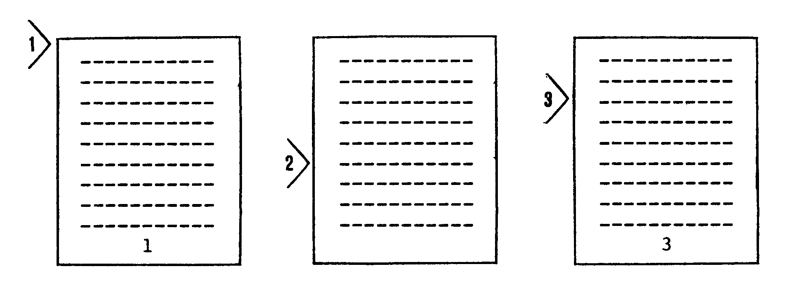

- Normal default page numbering.
- OP command issued at this point suppresses page numbering. Current PN value is 2.
- PN+1 instructs TEX to begin numbering pages, startinq at the current page number plus one.
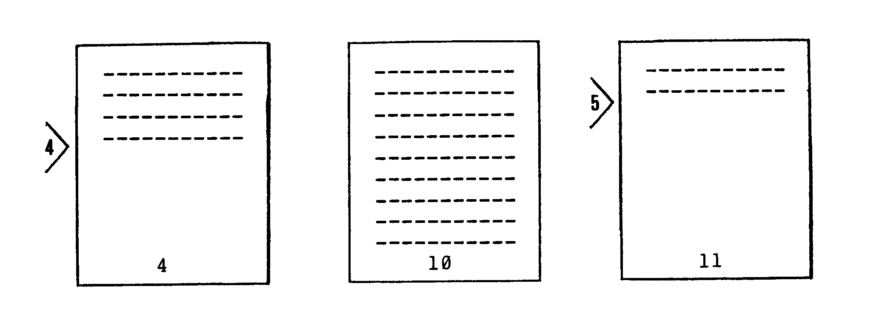

- BP10 causes a page eject; page number is reset to 10.
- PA 3 produces the eject of three pages, each of which is numbered consecutively.
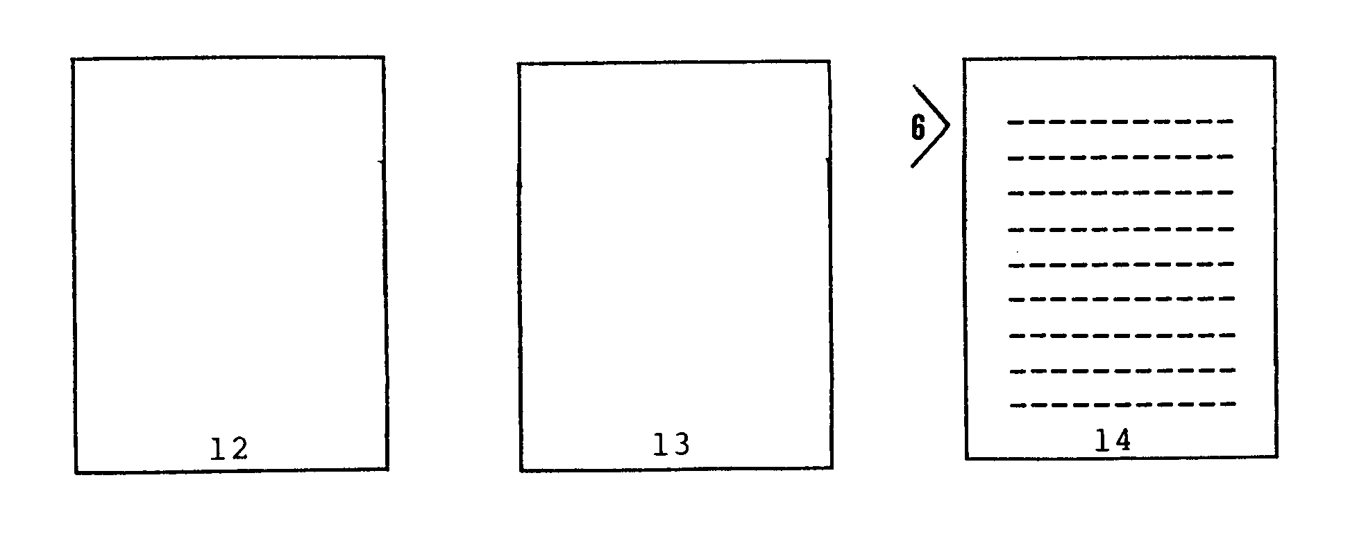

- Formatted text continues printing at the top of the third page.

SUMMARY OF TEX ERROR MESSAGES
TEX generates error messages to indicate various problems encountered in the input text file. Some of these messages are fatal, i.e., they cause the TEX program to terminate without further processing of the source file. Other messages merely indicate the occurrence of an error or of a problem situation. In such a non-fatal situation, TEX will continue to format the output as usual, following the printing of the error condition.
The format of all error messages is as follows:
ERROR DURING
error-condition statement
INPUT CONTEXT:
text containing error condition
If the error is a fatal error, an additional statement prints on the error device:
THIS ERROR TERMINATES TEX.
The error-condition statement will vary according to the error. See the following page for a summary of these conditions.
The text following the INPUT CONTEXT: designation is printed to give the user as much information as possible for locating the problem area. The error generally as found at the end of this segment of text.
ERROR-CONDITION STATEMENTS: | EXPLANATION CAUSE: | ACTION TO CORRECT:
OPENING SOURCE * | Invalid or missing source file name. | Correct source file name.
PARAMETER SCAN * | Invalid character in parameter string. | Correct parameter (see Section 4).
FILE READ | Invalid file format. | Input file cannot be random mode.
DISK WRITE | Cannot write output file from memory to disk. | Disk or disk director full; condense disk or transfer files.
READING EOF | End-of-file mark detected where not expected. | Check for missing command or <cr>.
FITTING A WORD | Usually, a long word cannot be formatted successfully into a short line length. | Reword text or increase line length.
COMMAND VERIFY | Invalid command after a "." at beginning of input line. | Correct command; check for accidental "." at beginning of line.
HM COMMAND | Heading margin value greater than or equal to top margin. | Correct HM or MT value if changing both, reset MT value first. (TEX resets HM=MT-1)
MB COMMAND | Bottom margin greater than or equal to PL value - MT value. | Correct MB or PL value if changing both, reset PL value first.
MT COMMAND | Top margin greater than or equal to PL value - MB value. | Correct MT or PL value if changing both, reset PL value first.
PP COMMAND | Paragraph indent value greater than line length. | Correct PP or LL value
Table D–4

